|  |  |
| --- | --- |
|  | **FPT ACADEMY INTERNATIONAL**  **FPT – APTECH COMPUTER EDUCATION** |

**Centre Name: ACE-HCMC-2-FPT.**

**Address: 590 Cach Mang Thang 8, District 3, Ho Chi Minh City, Viet Nam.**

installation guide

|  |  |  |
| --- | --- | --- |
| Faculty | Lê Mộng Thúy | |
| Bach No | T1.1907.M0 | |
| Nhóm | 3 | |
| Number | Roll No | Student Name |
|  | Student1208479 | Hoàng Minh Tâm |
|  | Student1215632 | Lương Trúc Quỳnh |
|  | Student1208495 | Ngô Thi Đoan Dung |
|  | Student1208492 | Võ Minh Thư |

I. System requirements:

- Hardware requirements:

+ Processor 1 GHz or faster

+ RAM 512 MB or larger

+ Internet connection

- Software required

+ Windows 10

+ PHP 7.0 and above, MySQL.

+ Browser: IE (8.0 or higher) or Google Chrome or Mozilla Firefox.

+ WAMP server.

IIS IIS 5.0 web server or higher.

II. Program setting:

1) Copy the GROUP2 folder to the working drive of the client you want to install the program (C, D, E, etc.)

2) Open the database:

- In MySQL, create file project.sql

+ Click New to create database with project.sql name

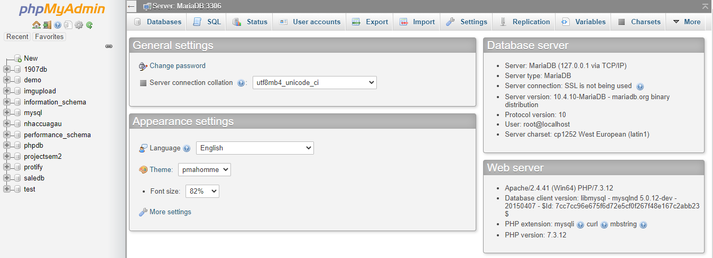

+ Open file protify.sql:

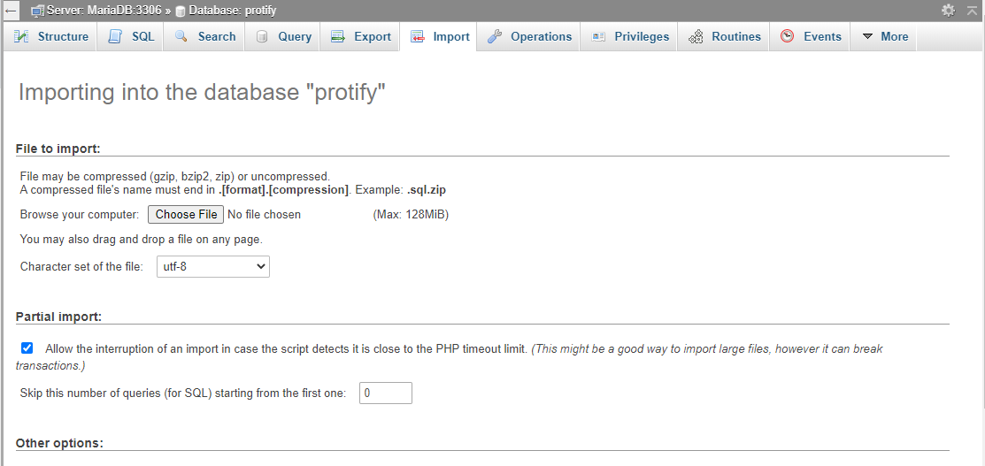



3) Open project in NetBeans

-Choose a file and run

4) Log in is required:



5) Run program:

-If log in as an admin:

+ **Email:** [admin@gmail.com](mailto:admin@gmail.com)

+ **Password:** admin

-If log in as a member:

+**Email:** [seohyun@gmail.com](mailto:seohyun@gmail.com)

+ **Password**: seohyun