|  |
| --- |
| LOTTERY SERVICES GLOBAL  PAYMENT BY LTR TOKEN, PAY BACK FOR PRIZE WINNER BY BITCOIN (BTC), ETH, LTR |
|  |

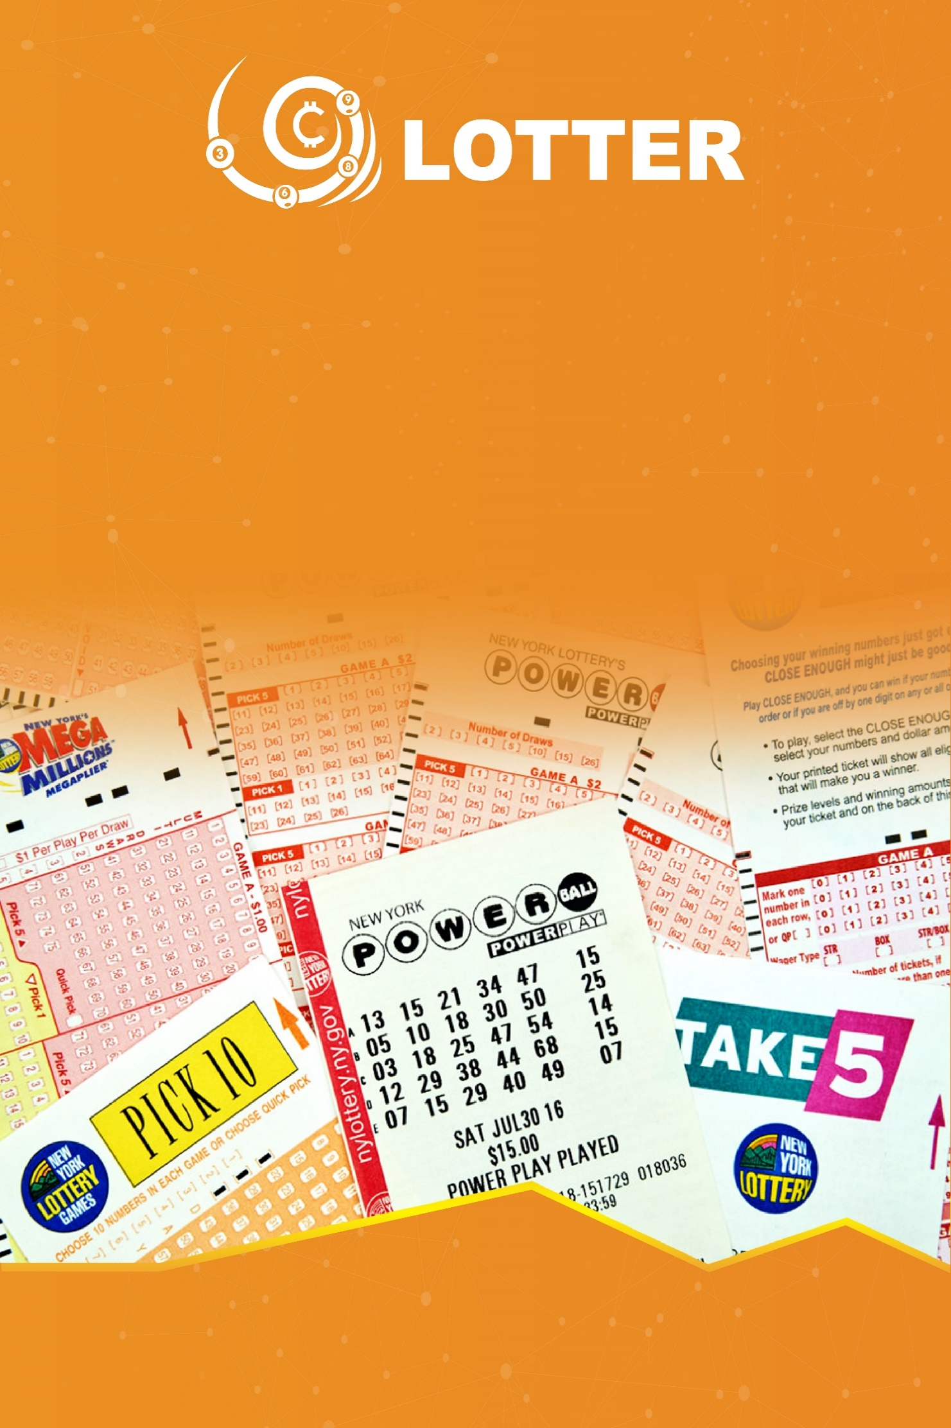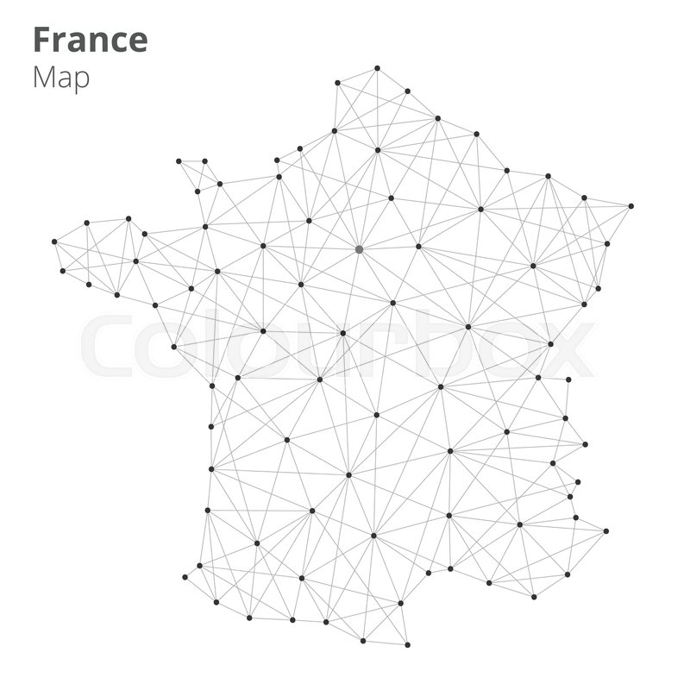



## LTR ICO PLAN

**LTR COIN PROJECT – HELPING TO BUY A GLOBAL LOTTERY**

1. **INTRODUCTION ABOUT LOTTERY AND LTR TOKEN SERVICE**
2. **ONLINE LOTTERY MARKET**

* The annual growth rates are about 4,3%. In 2016, the total value of the global lottery market is about $260 billion USD. Simultaneously, with the development of Internet and mobile phones, online lotteries have a tendency to grow on a global scale
* However, the lottery industry still have to face a number of challenges, the biggest challenge is how to ensure the fairness of the game
  + *Is the ticket really a lottery?*
  + *Is amount of money accumulated in the ticket?*
  + *Is it really random, safe, and transparent?*
  + *Is this the real jackpot winner?*
  + *Are prizes awarded properly in terms of amount and time?*
* Users from other countries don’t easily participate in the largest lottery in the world such as Mepa in the United States because of many barriers
* Some countries have passed strict regulations which prevent users from using online lottery services
* Some online sites allow players to buy lotteries around the world, but with high service fees, difficulty while using, fraudulent risks and poor management. Blockchain technology can address these issues about lottery, and especially online lottery
  1. **The market of buying lottery**
* Today, the world has not had any online lottery market for everybody to buy and receive prize by BTC or ETH, LTR.Thus, this can be considered the pioneer in online lottery market. People from every countries can buy tickets by LTR token and get the winning number everywhere at anytime. When people use LTR to buy tickets, these transactions will be realized by smartcontract and your PoW (Proof of Work) on blockchain will be confirmed by millions of people. Everything is therefore transparent: payment, tickets, winning number, and prize.
* There are certain times that the Powerball Lottery Prize has peaked at $759 million. Not only American citizens but also people around the world want to try their luck. According to the Power ball, players are not necessarily US citizens or long-term residents of the country. Players coming from inside or outside of the United States may buy Powerball tickets from a licensed retailer or authorized ticketing authority if they areover 18 years old. So, citizens ot the world w who wants to participate are allowed to buy Powerball tickets to win prizes. However, the finding of a licensed retailer or authorized Powerball lottery ticket sales are all conducted through sites such as https://www.thelotter.com/..
  1. **Advantages and disadvantages of current LOTTERY services**
* Services can assist customers in purchasing via Credit Card. There is no legal guarantee to pay the bonus, although the website claims to pay the full amount to the customers.
* High transaction costs due to complicated process: buy tickets, scan and confirm, slow transaction speed.
* Simply used for buying services which do not meet other needs (buy, sell, trade…) or buying their own lottery tickets, or converting to other forms of entertainment.

1. **LTR SOLUTION**

* LTR provides online lottery and online lottery ticket which is synthesized on blockchain technology:
* **online LOTTERY** (and other lottery entertainment services) on blockchain technology provided by LTR (at buylottery.org), everybody can buy LTR Lottery and pay by LTR Token, when customers have the winning number, they will immediately receive the prize paid by BitCoin(BTC) at their BTC Wallet, (and ETH, LTR Wallet). There are many kinds of lottery such as Mega, Jackpot, with minimum prize value ranging from 10 BTC to a thousand BTC.
* **Lottery purchase service** (via blockchain and smart contract is LTR token). Customer will use the app to get access to:
  + *Lottery options of countries like USA, Europe…and register lottery code*
  + *Based on information about lottery purchase requirements, the LTR smart contract provides the client with a proof of work and power of stake, which are blockchains-based and cannot be modified. All members of the blockchain network confirm history of your purchase of lottery tickets*
  + *Pay in LTR*
* **Payment services in coin is coded Itr for other bonus services such** as bonus football betting, predicting sports matches such as tennis, boxing…
  1. **Advantages of LTR Lottery technology:**
* Ensure the reliability of the transaction: Customers purchase lottery tickets via the LTR service, which is confirmed by the community through block technology, using authentication via PoW (Proof of Work) which is highly secured.
* Smart contract mechanism is completely automatically performed.
* Immediate trading: When customers buy lottery tickets, they will be confirmed immediately based on the term of the smart contract in the blockchain. When customer wins, we will pay them by BITCOIN(BTC) into BTC Wallet automatically (ETH and LTR is the same)
* Completely anonymous: Customers participate in the service will be completely anonymous whichensures privacy and information sercurity
  1. **How to use with LTR service users:**

- Use the application (web, mobile app) to access the service (at buylottery.org)

- Transfer token to your LTR Wallet account on buylottery.org (transfer from the LTR token trading platform: cryptocurrency exchange where LTR Token are listed)

- Select service and register the lottery code you want to buy, pay by LTR token. With lottery Mega Millions or Euro Jackpot, we will help you to buy and mail tickets to your mail and store on blockchain network. With a lottery ticket issued by BuyLottery.Org, we also store on blockchain e-ticket and confirm. The transparency of this purchase is confirmed by the ETH and BTC miner, you can check it out on https://etherscan.io.

- Based on the information of pair number, the application creates smart contracts with these following terms:

* Customer service, lottery name
* Purchasing code
* Quantity of purchase
* Total amount of money
* Time (day, month, year, hour, minute, second, millisecond)
* Smart contract terms

This system will store the transaction as blockchain, and you can check all the terms above by [etherscan.io](https://etherscan.io)

* 1. **Lottery ticket purchase service**

- You order lottery tickets through LTR application and pay by LTR tokens

- Our company purchase directly at the lottery companies of the countries which have signed with authorized agency so as to meet your requirements and the evidence of this transaction is saved by email. You can search via smart contract ERC 20, as well as the account on the buylottery.org website or through the app (android, ios). The evidence of the image, the code, the smart contract can not be modified or deleted. Therefore, when the customer has selected the number and ordered to pay in the LTR token, the contract is permanently saved on the block chain network and anyone has the right to see without editing it. It is the highest information security of the blockchain technology platform

- When a customer wins, we will reward and convert to cash or transfer directly to your bank account (type: for helping to buy lottery). In case buying by LTR token, customer will receive LTR, BTC, ETH. The prize money will automatically be paid to you according to the prize value when you purchase the ticket after deducting the tax amount of the host country. You do not have to pay any extra money.

- If customers want to go the place of reward, we will provide lawyer services and detailed instructions about legal and administrative procedures to receive awards directly in the country.

* 1. **Online LTR ticket service**
* You order LTR ticket through LTR issuers, LTR applications and LTR tokens. Daily LTR will issue online tickets 4 times/day, using random dialing technology. We use random winning numbers generation technology for special price, and we pay BTC for special prize, 1st prize, 2nd prize... You can withdraw from your wallet. We guarantee 50% of the proceeds from the ICO as a reserve fund and may check that fund with Etherscan.io.
* If a customer wins, the corresponding BTC will be automatically paid to you BTC wallet according to the BTC wallet field when you fill in form at Register form or Profile Account setting on BuyLottery.Org

1. **THE ROADMAP OF LTR SERVICE DEVELOPMENT**

* Stage 1 (2018):
  + Issue ICO – raising funds to launch LTC token project on ERC 20 platform - (August/2018 to January/2019)
  + Build a website to buy lottery tickets with LTR tokens and pay back by BTC, ETH, LTR (July/2018 to December/2018)
* Stage 2 (2019):
  + Launch buylottery.org website offering daily lottery with variety of Mega Award, Jackpot ..., customers can buy lottery tickets by LTR and pay by BTC, ETH, LTR
  + Lottery ticket purchase service in countries and territories
* Stage 3 (2019 onwards): Use LTR as an intermediate currency coded as payment for other services on buylottery.org such as predicted football and sports
  + Negotiate and sign contracs with important lottery partners in Asia, Europe and the US

**SALES REVENUE MODEL FOR LTR**

**-** revenue comes from ltr token, all ltr tokens are then purchased and sold on international cryptorcurrency exchanges. lottery buyers have to buy ltr tokens on those exchanges, the company can sell ltr tokens on the trading floor to convert to btc and other top cryptocurrency, buying and selling will increase ltr's maturity and liquidity.

- percentage discount when customers buy lottery tickets or buy ltr online lottery

- discount up to 100% on each purchase, for example, basis price $1, buying price $2

- discount % on each transaction when withdrawing ltr tokens

- this discount is used to pay for staff and management fees, server infrastructure, banking costs, audits and operating costs.

1. **HOW TOKEN WORKS AND USE LTR SERVICES ONLINE WORK?**

* Customers purchase and use LTR tokens so as to:

• Buy lottery tickets in the US, Europe and around the world

• Purchase lottery tickets product by BuyLottery.Org and rewards, automatically pay online

• Purchase of buylottery.org services for gambling, betting, soccer betting. Buylottery play an intermediary role in providing service platforms and LTR for customers to use

* Forms of LTR, using the online lottery service:

• Buy LTR token during crowdsale token and ICO

• Buying and selling LTR in the world

• LTR reward for inviting others to participate

• Play games and earn prizes in LTR

• Paying bonus by inviting others to use the service

1. **ROADMAP PROJECT**

* August, 2018: Announced the project and conducted ICO to create capital for the project, simultaneously programming application (web, mobile app) for the website buylottery.org to buy tickets in the world
* December, 2018: Run tests and test applications and service websites include:
  + LTR Lottery service launch test version, user who have invitation link can buy lottery and receive prize if have winning number via BTC, ETH or LTR Wallet.
* 2/2019: Purchasing ltr token on Internal or International cryptocurrencies exchange trading platform
* 3/2019: Official website buylottery.org launches and lottery ticket purchase applications start to operate.
* 2019-2020: Start Negotiate and sign contracts with the big lottery partners in Asia, Europe, and USA, Buy Lottery in Asian, European and American countries via web and application

1. **PROJECT ICO**
   1. **Number of token issued**

* LTR plans to issue 100 billions Itr tokens with a value of 0,001 USD/token via ERC 2.0 platform, buy token in Ethereum
* Presale, with ICO investors, will be offered 0.0005$/token. At the start of the ICO, the discount rate will decrease from 50% per month (August 2018) to 40%, 30%, 20% , 10%, 5% until the end of January 2019
  1. **How to allocate token**
* ICO will open to sell 30.000.000.000 tokens. The remaining 70.000.000.000 will be frozen within 1 year and the expected token allocation is as follows: 10% for the team to develop the project and 20% by founding team and advisor, 70% will be issued to reward users with beneficial behaviors such as buying online lottery tickets online through buylottery.org and making bonuses on the web
* Of the 30 billion tokens sold, ICO is expected to allocate funds to the project as follows:
  + *20% bonus for affiliate marketing (referral purchase)*
  + *20% for the project team (founder, team, advisor)*
  + *10% for marketing and promotion*
  + *50% for project development (setup prize fund, payment for winning number , buylottery.org web and Android application, IOS online lottery ticket)*

* 1. **The stages of ICO sale**

It is expected that the process of opening LTR sales is as follows:

* In July 2018: opening for sale to the original investors and founders
* In August 2018: sales through the ICO, referral program and affiliate marketing program token sales and free gifts when users advice their friends to buy LTR
* In December 2018: end the ICO, pay bonus and converts tokens for customers corresponding to the purchased tokens and bonuses
  1. **Payments**
* Customers move ETH into Wallet LTR to convert to LTR token number respectively
  1. **Token releasing plan**
* As soon as customer buy ico, their eths are converted immediately to ltr token, you can store by LTR wallet or withdraw to MEW wallet, for customter who send link invite friends to buy, we will pay the reward after the end of the sales phase, customers will be transferred to the registered token (paid) within 4 weeks.

1. **DEVELOPMENT TEAM, CONSULTANTS AND PARTNERS**

|  |  |
| --- | --- |
|  | **Giovanni Casagrande** Advisor  MA of Bologna University, co-founder of Black Marketing Guru, first growth hacker agency in Italy. |
|  | **Giacomo Arcaro**Advisor Co-founder of Black Marketing Guru, one of the most important European Growth Hackers featured on the Financial Times, IlSole24Ore and Los Angeles Times |
|  | **Manuel Arlotti**Advisor Sales and marketing advisor for the TOP #100 European Industries. #120 most followed profile on LinkedIn Europe, ICO ambassador and Advisor of the TOP #3 Italian ICO |
|  | **Gianmarco Tonini**Advisor Analysis and Monitoring Expert,,one of the italian's biggest experts in analytics |
|  | **Nguyen Huy**CEO Tech Expert, 15-year-experience in Software Development, Blockchain Expert. Deputy director of The online training Institute of University of Technology and Management (Vietnam) |
|  | **Nguyen Bach**COO 14-year-experience in Products and Services Development, Practical profession in Strategy, Market research and opportunities, Business plan, budget and P/L, Account Profile and Value proposition, coordinator and staff/working plan management. |
|  | **Le Quynh** BlockChain Developer  Senior full stack developer, BlockChain Developer, BA of Mathematics & Computer Science |
|  | **Carlotta Cisterni**Art Director & Media Management Carlotta is a cross-media artist with a focus on comics/graphics, short stories/illustrations and videos. She is a master of stage design and completed her study at the University of San Marino. |
|  | **Giorgia Palazzo**Chief Marketing Officer Over 15-year-experience in digital and technology field. Worked with numerous global brands including Warner Bros, DELL, Ryanair, Sony PlayStation Tim. Giorgia also has hands-on experience at channeling token sale projects and investors. |
|  | **Luca Mingazzini**SMM Manager A results-driven digital project manager with extensive experience in delivering social media campaigns and contents projects for global brands. 6+ years of working in the digital marketing sphere. |
|  | **Marco Stefani**Community and Project Management Marco is an experienced community manager, having worked for several blockchain projects and is an expert at community engagement. |
|  | **Alice Lottici**Content & Community Technology marketing professional, She is a creative storyteller that finds new ways to engage with key stakeholders. |