**GAM536-DPS936**

**Assignment Two**

**Due. Oct. 31 @ 11:59 PM**

In assignment one, you built your 3D model. In this assignment, you are required to implement an environment that your model can be placed into. For example, if you have built a ‘car’ as your model, ideal environments could be a racing track, street, etc. The design of the environment is open-topic and is left for you to decide. At the end, your deliverable for this assignment should contain:

1. **Environment**: Use a geometry as base and apply appropriate modifiers to obtain the geometry that you have in mind or your environment.

**Note: you can NOT use any pre-built model from any external resource.**

1. **Texture:** Apply appropriate texture to the environment to make it look real. You use images downloaded from external resources for your texture.
2. **Animation:** Create a meaningful and smooth animation from your model as it is moving in the developed environment.

**Note:**

1. The environment that you create will be further extended in assignment three. So, design it based on your final goal for assignment three.
2. Keep in mind that simply fulfilling the requirements of this assignment and future assignments does not guarantee a full grade. Instead, the quality of your work defines your grade. For instance, if you simply use a basic animation and apply a low-resolution texture to it, you will receive a low mark.
3. Hesitate from using short and simple paths for your animation, e.g. straight line, circle, ellipse and so on.
4. At any point of time, if you are in doubt, please contact me through MS-Teams so that I can help you out.

**Rubrics:**

* **Environment (8 marks):** Design and implement the geometry of the environment
* **Texture (4 marks):** Complete texture applied to all parts of the scene. No geometry should be left without texture. Use high-resolution and meaningful textures. Do not use simple solid-colours as a texture image.
* **Animation (8 marks):** The animation should be smooth and meaningful, i.e. take care of rotation, translation, correct motion paths, etc.

**To submit:**

Locate the original .max file along with the animation file in one of the movie formats (.wmv, .avi, etc.). If your file size is big and can not be submitted through blackboard, upload your file to a shared folder (drop-box, one-drive, google-drive, etc.) and submit your shared link (paste it in the comment area when submitting). The following link on youtube, shows you how to export your animation into a video format:

[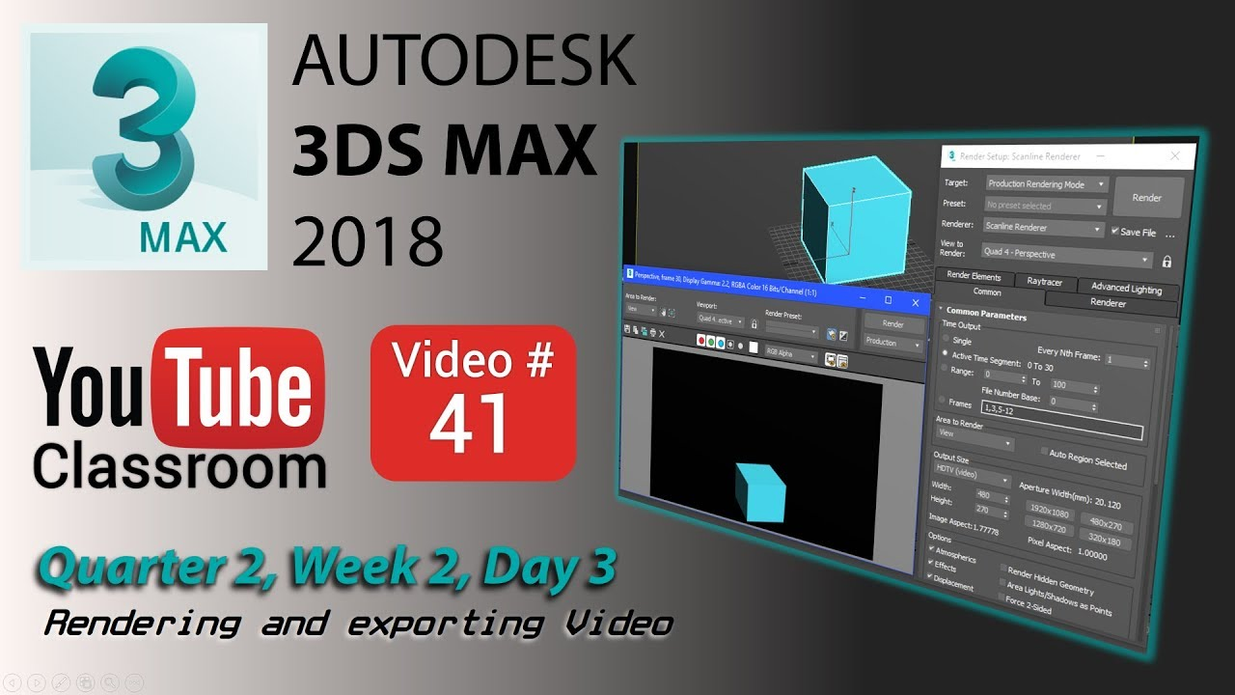](https://www.youtube.com/watch?v=bsMp0pmcc5I)