**GAM536-DPS936**

**Assignment Three**

**Due. Dec 5 @ 11:59 PM**

In this final assignment, you are required expand assignment two by adding more components to it. To accomplish this, you are required to develop the following components and add them to your work:

1. Physics, such as wind, force, collision, cloth, etc.
2. Particle System, such as rain, snow, fire, smoke, etc.
3. Fluid Simulation, such as pool, fountain, etc.

The design of these components and the way you apply them into your simulation, is up to you. But, keep in mind that at the in this assignment, you are expected to apply your knowledge and develop a professional work.

Also, in assignment two, you created the environment for your simulation. In this assignment, you are expected to expand the area of your environment to make it look nicer. If you need advise, or need assistance, please send me a message on MS-Teams.

**Rubrics:**

* **Physics (5 marks)**
* **Particle System (5 marks)**
* **Fluid Simulation (5 marks)**
* **Expansion of environment (5 marks)**

**To submit:**

Locate the original .max file along with the animation file in one of the movie formats (.wmv, .avi, etc.). If your file size is big and can not be submitted through blackboard, upload your file to a shared folder (drop-box, one-drive, google-drive, etc.) and submit your shared link (paste it in the comment area when submitting). The following link on youtube, shows you how to export your animation into a video format:

[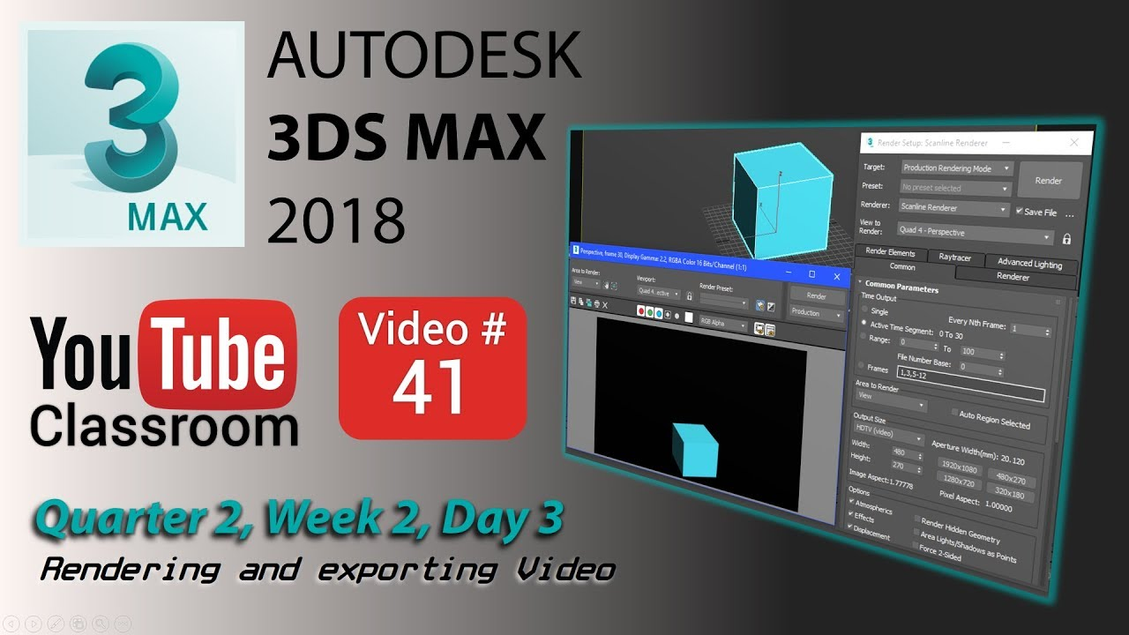](https://www.youtube.com/watch?v=bsMp0pmcc5I)