**Game Content Creation**

**Lab One**

**Due. Sep 12 @ 11:59 PM**

**Grade Weight: 2%**

For this lab, you are required to use 3DSMAX 2019 and create a 3D bicycle. The type and design of the bicycle is up to you, but you need to apply what we discussed in class on during our lecture this week. To start with:

* Think of the existing standard primitives that are close to the parts of the bicycle you have in mind.
* Create each part separately and “Attach” them together (“Attach” is one of the modifiers that you can find under “Edit Geometry” roll out, as illustrated below. As it comes from the name, you can merge separate geometries into one piece). Notice that “Attach” modifier appears only when you are in “Edit” mode.

**Note:** You are NOT required to develop a complex model. Instead, use your art and apply your knowledge to accomplish this task. (The picture on the next page sjows a sample)

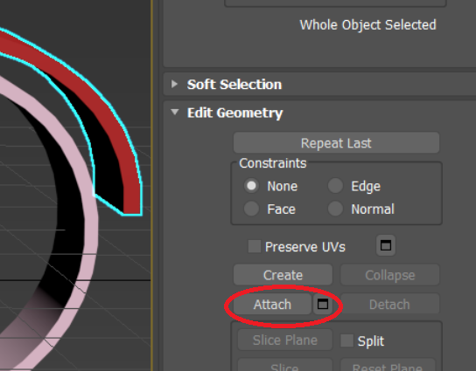

**To submit:**

1. Make sure that your model is complete
2. Make sure you are in “perspective” as your viewport
3. Make sure that your model is visible
4. Hold down “SHIFT” key and press “Q” on keyboard.
5. The “Render” Window pops up as illustrated below. The window shows your rendered model from the point-of-view that is set currently in the editor.
6. Click on the “Save” icon and save your image as “.png” or “.jpg”.
7. Repeat the same procedure and generate another file from different point-of-view.
8. You should have 2 rendered images and one .max file (created when you save the project).
9. Submit these three files through blackboard “individually” before the deadline. **DO NOT ZIP THEM.**

**Note: Late submissions will receive zero grade.**

