**Game Content Creation**

**Lab Two**

**Due. Sep 19 @ 11:59 PM**

**Grade Weight: 2%**

For this lab, you are requested to use 3DSMAX and create a tube of toothpaste. A sample of this model is shown below:

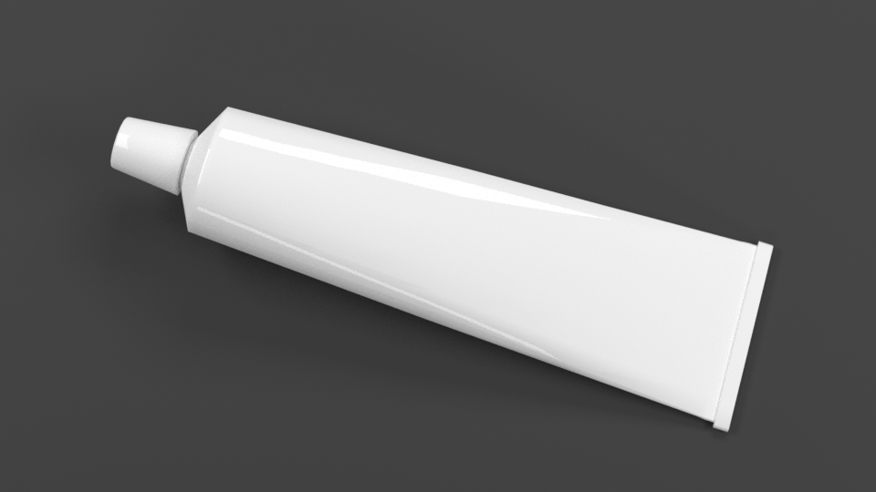

Model of a tube

**To submit:**

1. Once finished, render the building from three different perspectives and save them as individual .jpg images.
2. Submit these three files and your original .max file separately through blackboard before the deadline, i.e. **DO NOT ZIP THEM.**

**Note: Late submissions will receive zero grade.**