/**********************************************

**Workshop # 1**

**Course:** *JAC444 - Winter 2021*

**Last Name:** *Trokoz*

**First Name:** *Liubov*

**ID:** *139578199*

**Section:** *NBB*

*This assignment represents my own work in accordance with Seneca Academic Policy.*

*Signature*

**Date:** *29-01-2021*

**********************************************/

**Learning concepts in this workshop**

This workshop 1 covers the basic Java programming knowledge and includes two tasks. In the first task I learned how to build a Java program that scans a user's input and how to deal with arrays. The second task covered the more complicated logic for creating a game with the two dice.

This workshop gave me the opportunity to become familiar with Java, which is a new programming language for me. I learned it from scratch, how to build projects, learned new syntax and found out how similar it is with C and C++.

The hardest part for me was a logic solution in task 2 where I should get the right output according to the instruction. I have spent more time than was expected to figure out the game`s rules.

Overall, in this workshop I learned fundamental Java concepts like data types, arrays, classes, and methods.

**The instructions on how to run code**

1. Open IntelliJ and create project

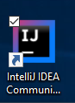 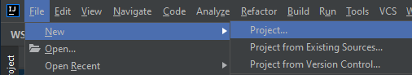

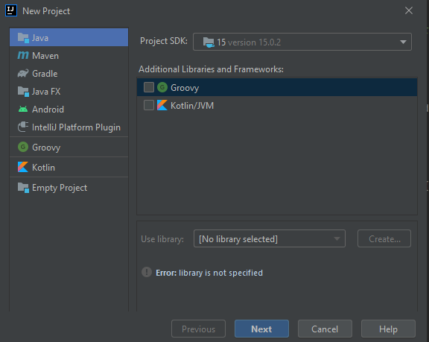

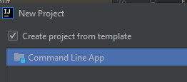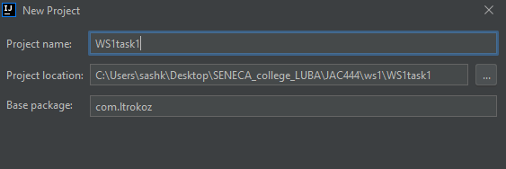

1. Write code

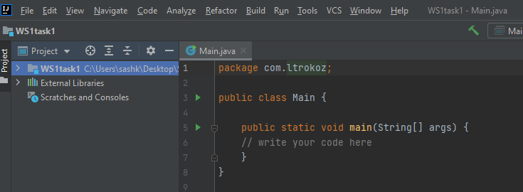

1. Run code – Shift + F10 (Microsoft)

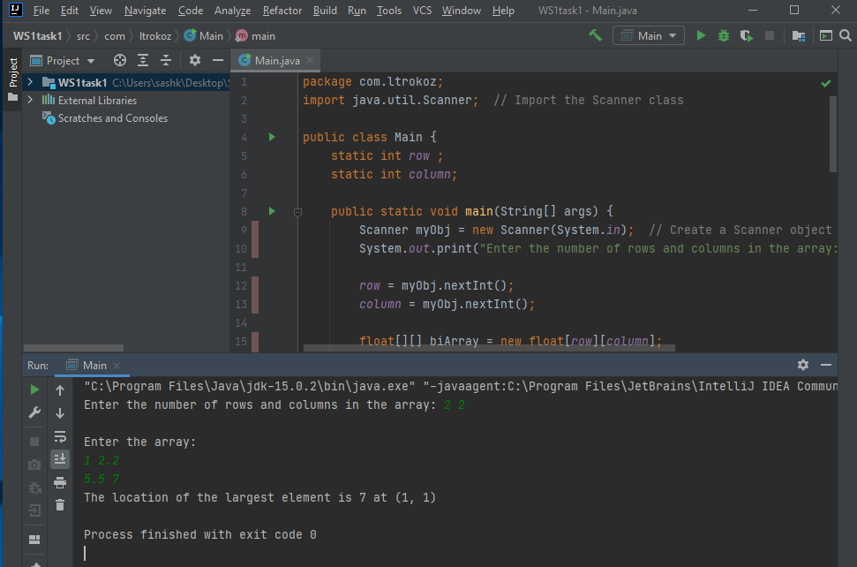

1. **Open existing program and Run code - Shift + F10 (Microsoft)**

