/**********************************************

**Workshop # 1**

**Course:** *JAC444 - Winter 2021*

**Last Name:** *Trokoz*

**First Name:** *Liubov*

**ID:** *139578199*

**Section:** *NBB*

*This assignment represents my own work in accordance with Seneca Academic Policy.*

*Signature*

**Date:** *29-01-2021*

**********************************************/

* 1. Detailed document includes screen shots of output:

**Task 1:**

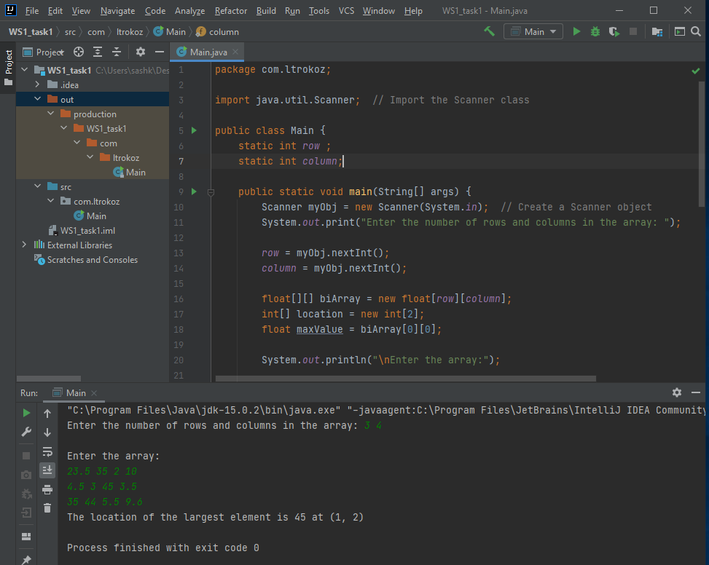

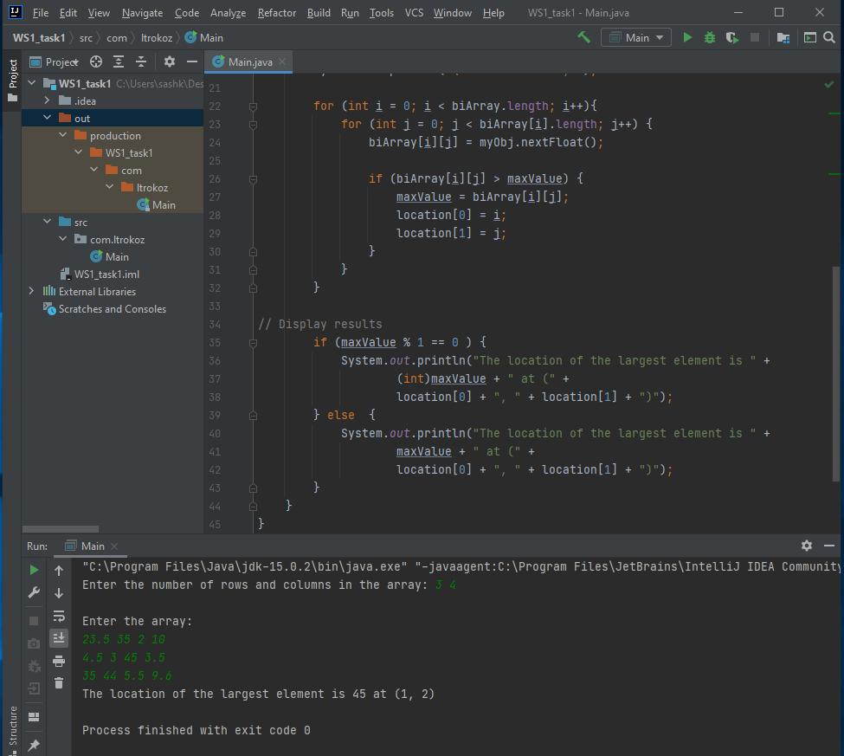

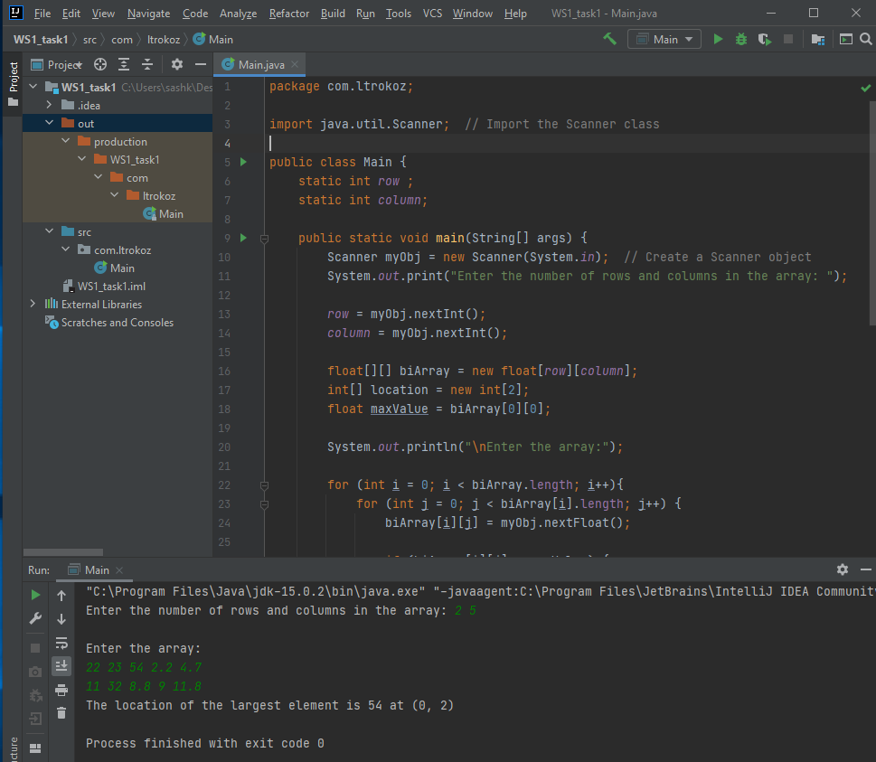

**Task 2:**

