/**********************************************

**Workshop # 3**

**Course:** *JAC444 - Winter 2021*

**Last Name:** *Trokoz*

**First Name:** *Liubov*

**ID:** *139578199*

**Section:** *NBB*

*This assignment represents my own work in accordance with Seneca Academic Policy.*

*Signature*

**Date:** *21-02-2021*

**********************************************/

* 1. Detailed document includes screen shots of output:
* GeometricObject.java

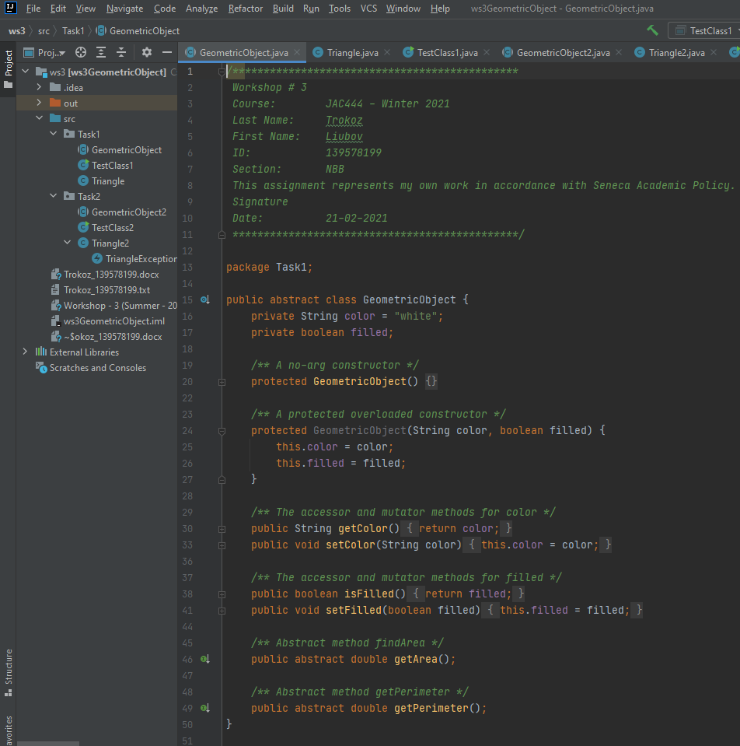

* Triangle.java

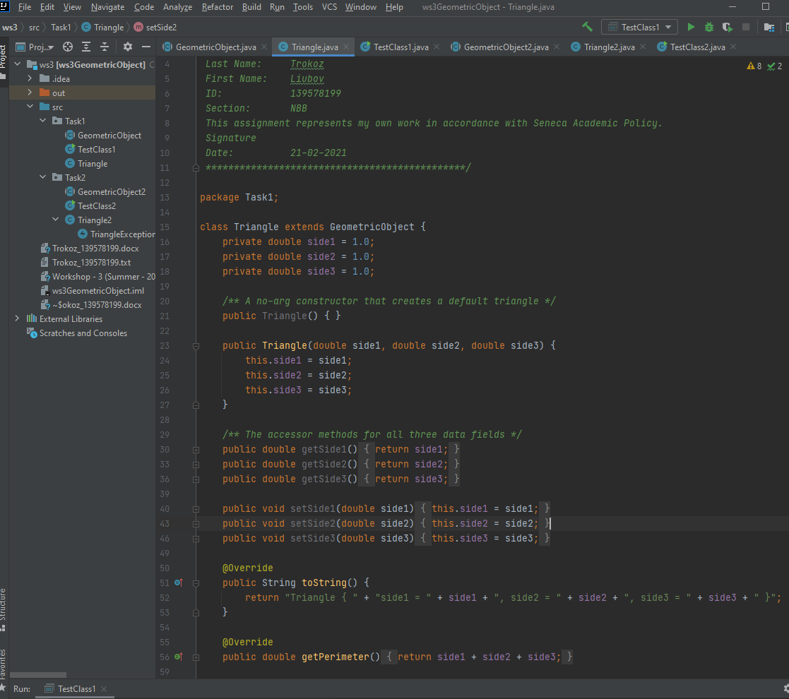

* TestClass1.java

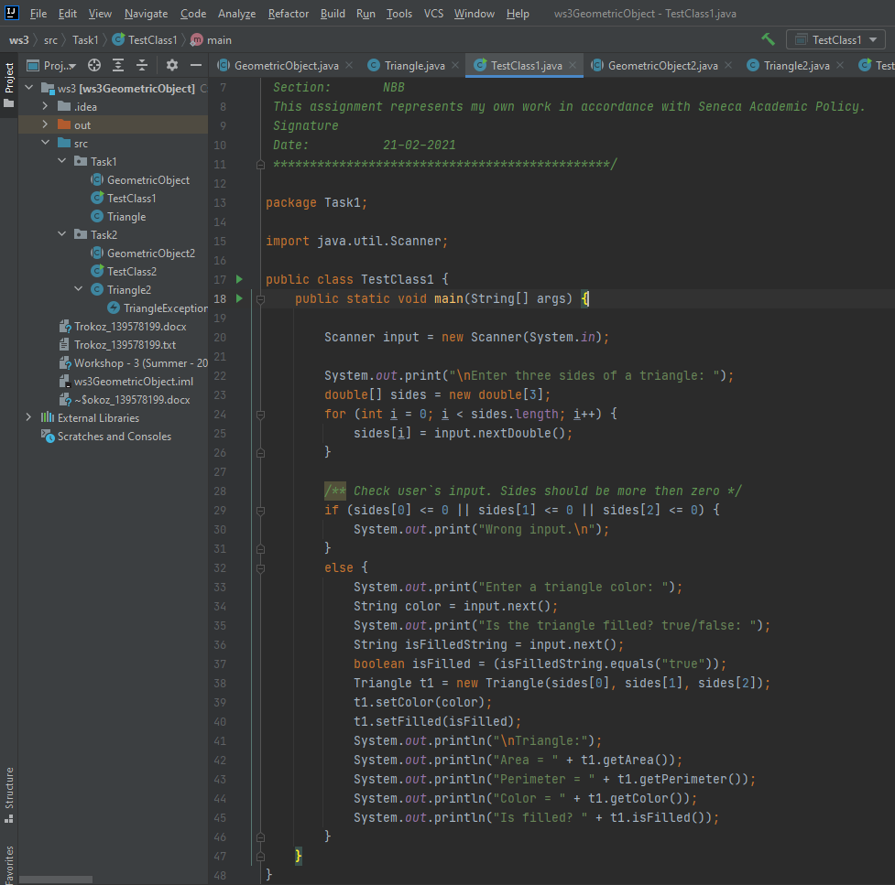

* Modified Triangle2.java

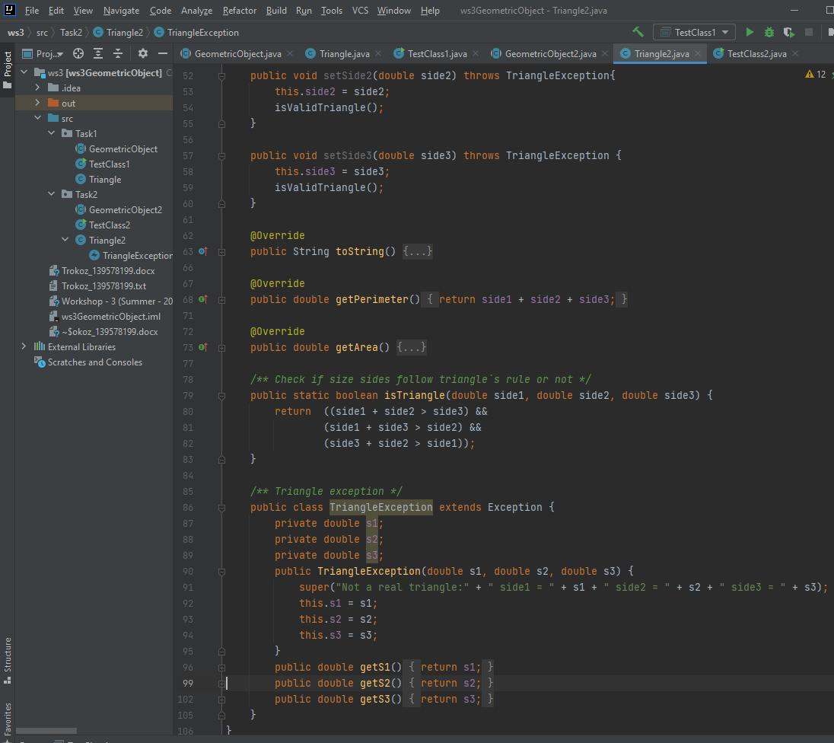

* TestClass2.java

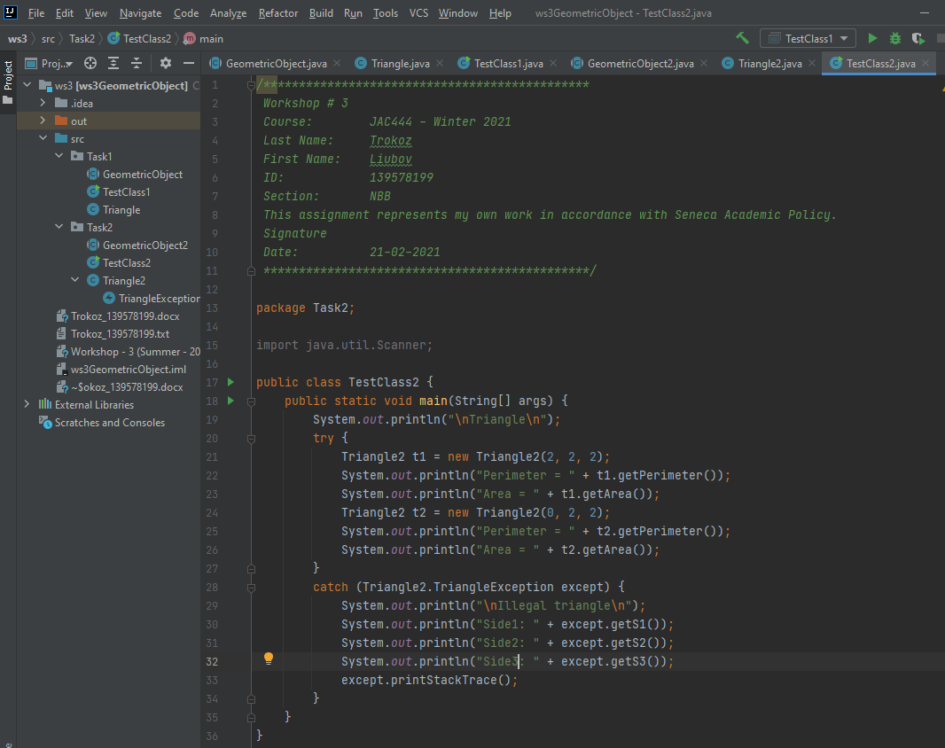

* Output for TestClass1.java

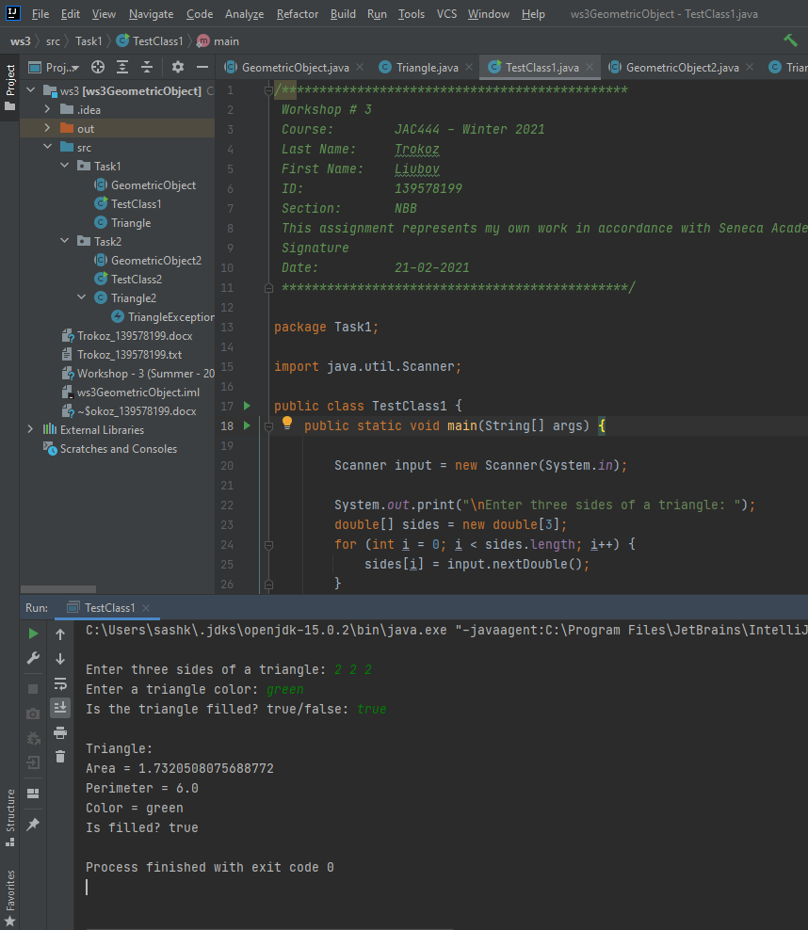

* Output for TestClass2.java

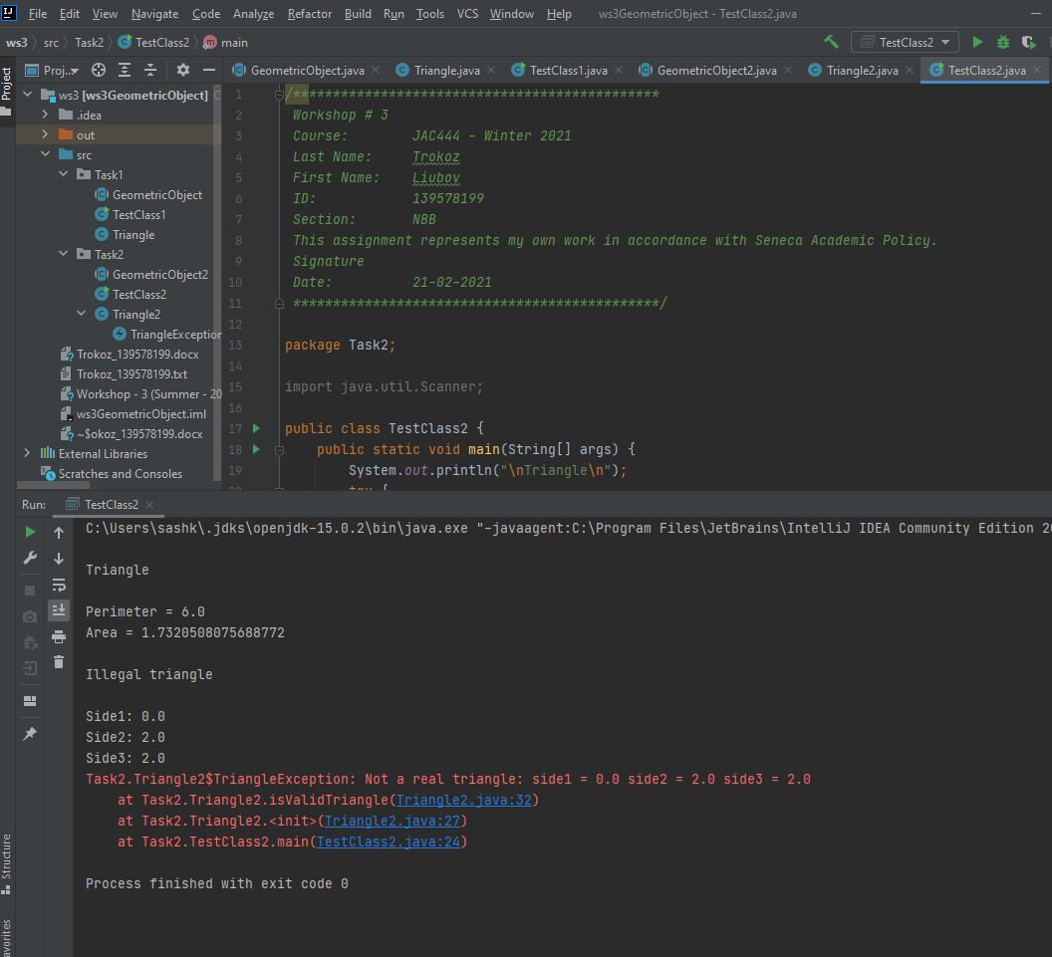

* Check user`s input and display warning message if user inputs a wrong number in TestClass1.java

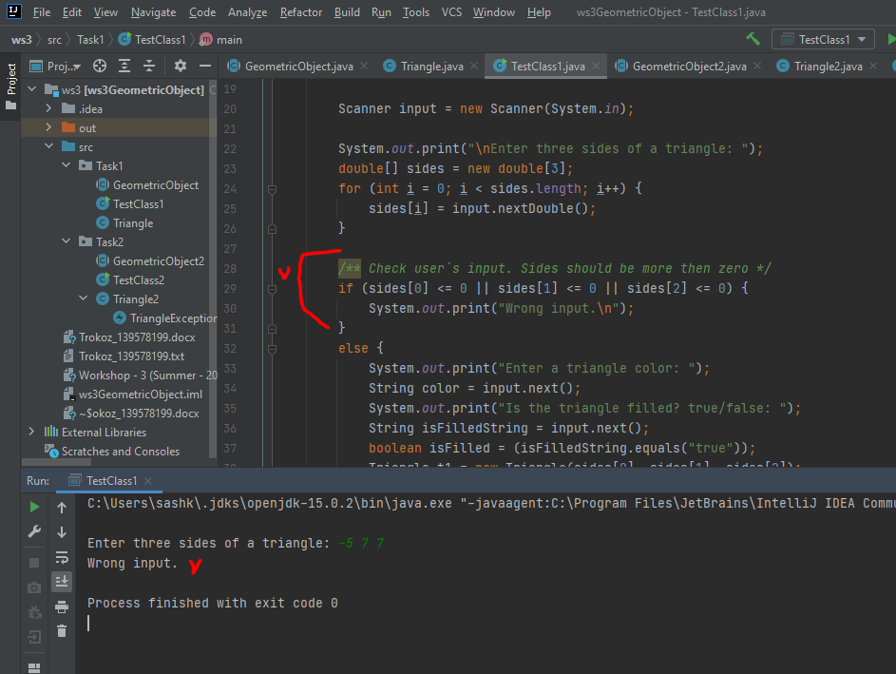

**The instructions on how to run code**

1. Open IntelliJ and create project

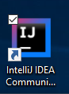

1. Open project

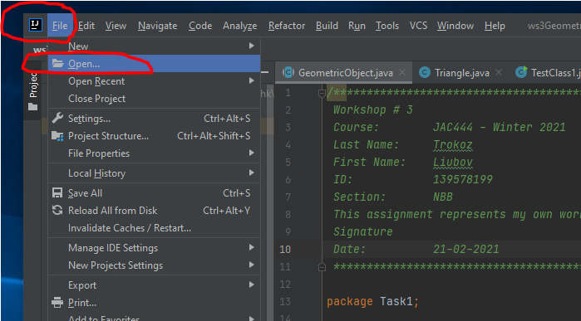

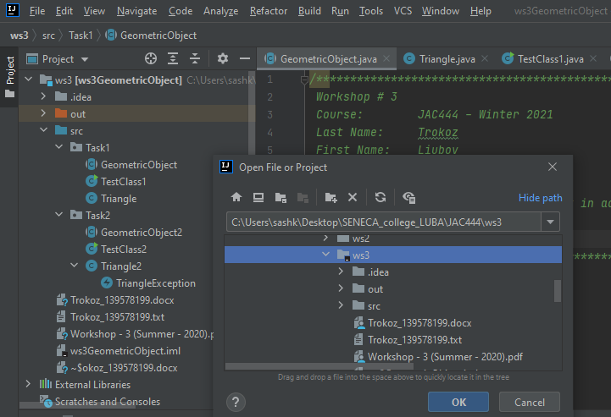

1. Run code – Shift + F10 (Microsoft)

