/**********************************************

**Workshop # 8**

**Course:** *JAC444 - Winter 2021*

**Last Name:** *Trokoz*

**First Name:** *Liubov*

**ID:** *139578199*

**Section:** *NBB*

*This assignment represents my own work in accordance with Seneca Academic Policy.*

*Signature*

**Date:** *05-04-2021*

**********************************************/

* 1. Detailed document includes screen shots of output.
* MatrixAddition.java for Task 1

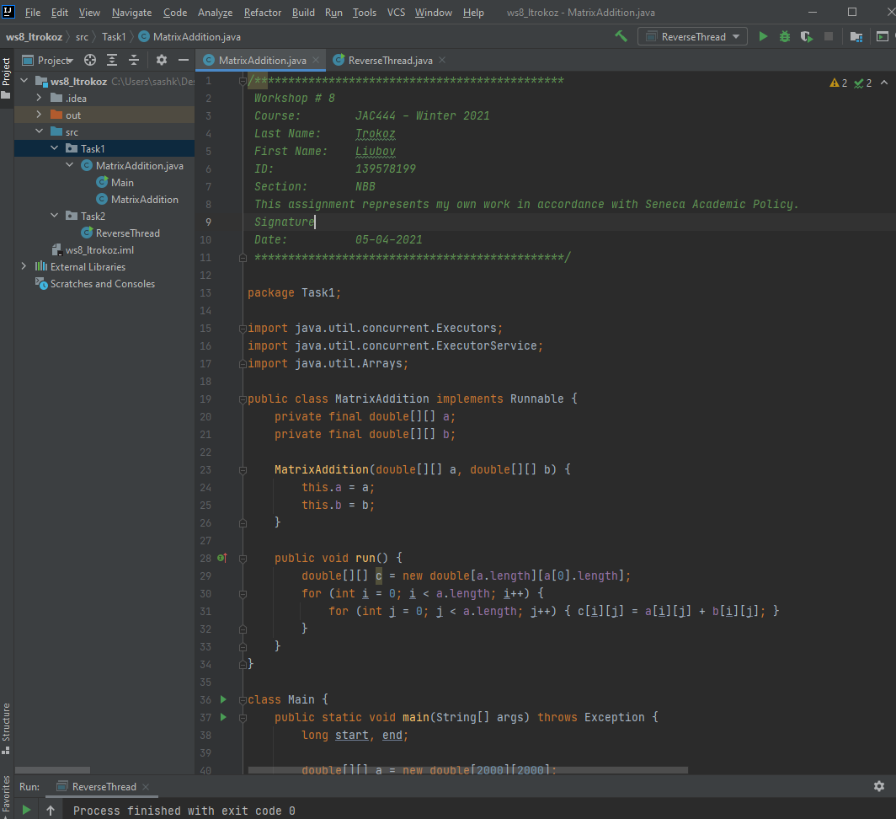

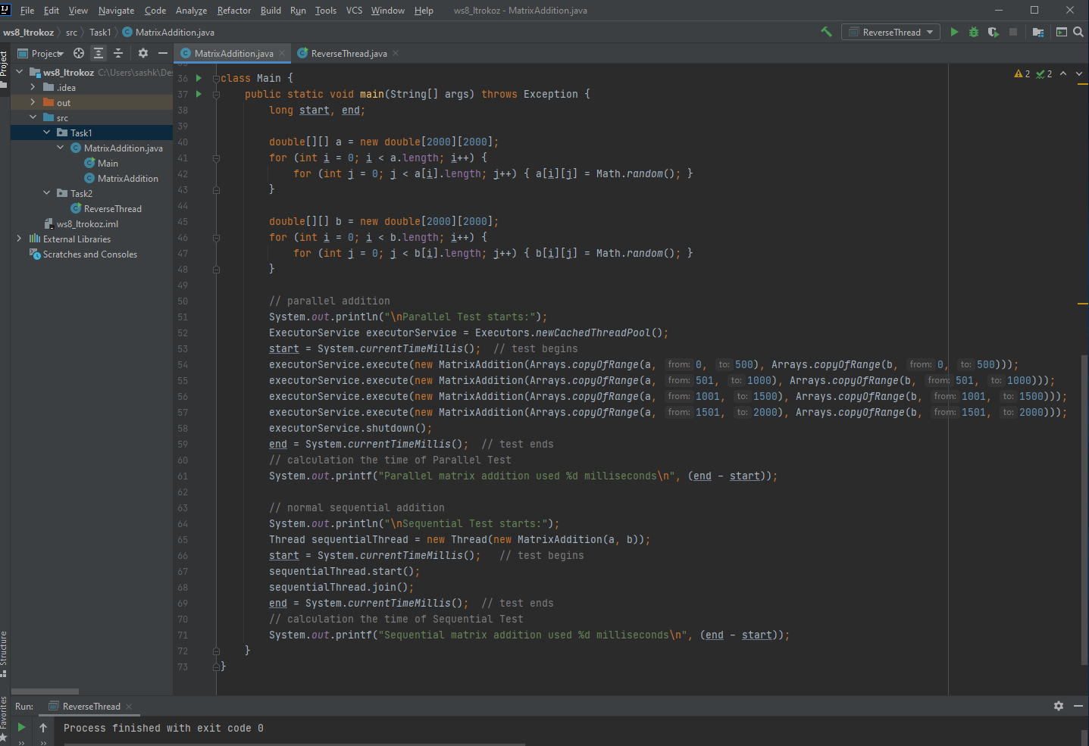

* ReverseThread.java from Task 2

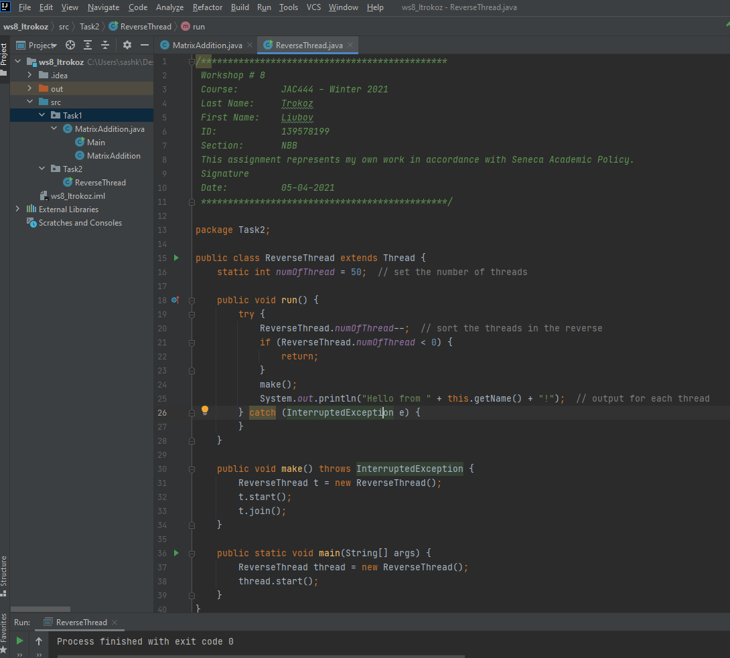

* Output for Task 1:

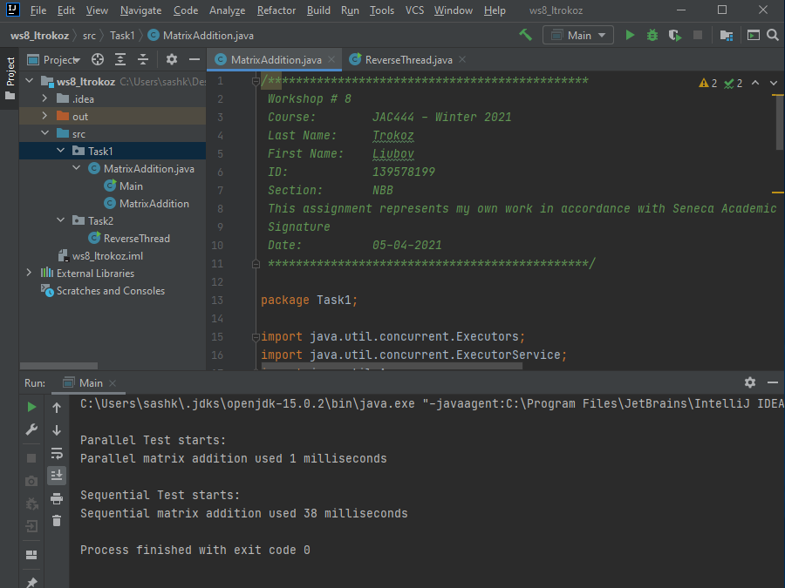

* Output for Task 2:

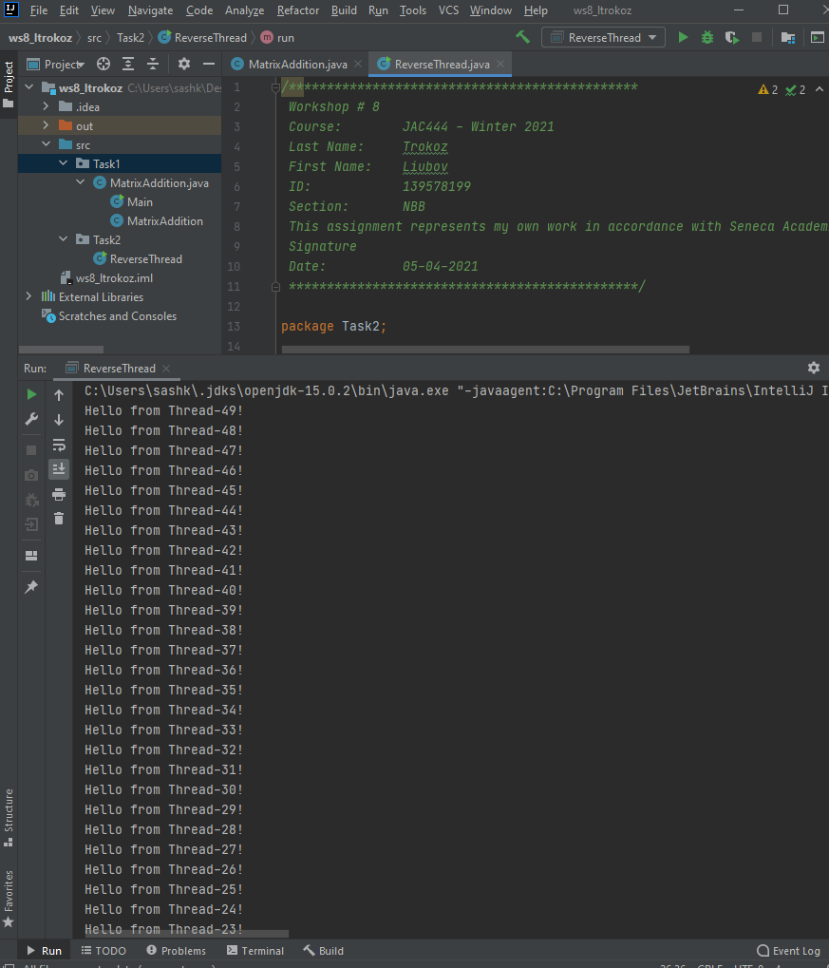

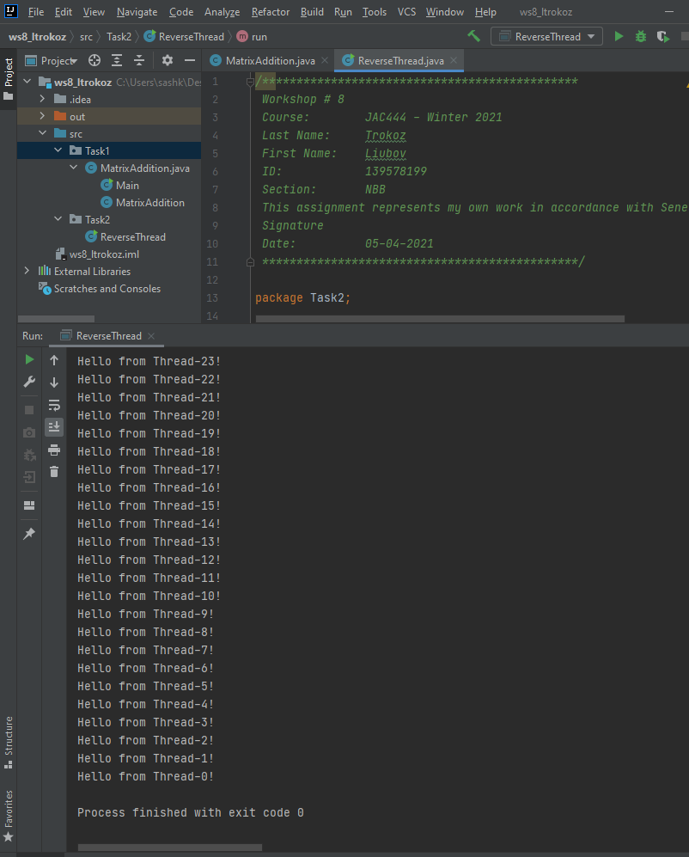

**The instructions on how to run code**

1. Open IntelliJ and create project

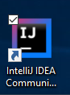

1. Open project

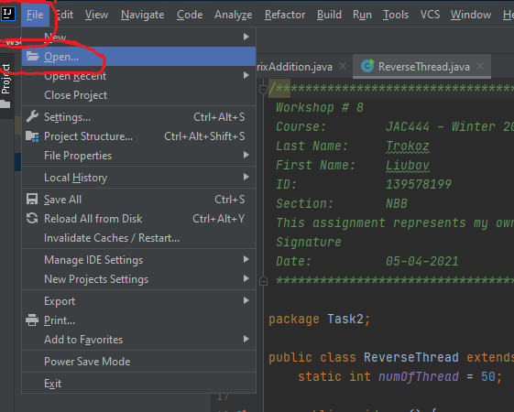

1. Run code – Shift + F10 (Microsoft)

