LTRR-SRP II : The Current Drought In Context: A Tree-Ring Based Evaluation Of Water Supply Variability For The Salt-Verde River Basin
PROGRESS REPORT #4
Aug 1, 2006

Katherine K. Hirschboeck & David M. Meko
Laboratory of Tree-Ring Research, The University of Arizona

WORK  PHASES | Month
WORK  PHASES | SRP Budget Year 1 |  |  |  |  |  |  |  |  |  | SRP Budget Year 2
WORK  PHASES | 2005 |  |  |  |  | 2006 |  |  |  |  |  |  |  |  |  |  |  |  | 2007
WORK  PHASES | A | S | O | N | D | J | F | M | A | M |  | J | J | A | S | O | N | D |  | J | F | M | A |  | M | J | J | A
1. Field collections
2. Processing & new chronologies
3.Re-calibration / update of reconstructions w/ climate analyses | Ongoing climatic analysis, building on LTRR-SRP I ➔
4. Snow study
5. Integration & final report

As of the end of July 2006, work has continued on all Work Phases except (1) & (5)

WORK PHASE 1: Collection and recollection of tree ring cores from selected sites in order to develop new chronologies and update existing chronologies.

No new field collections have taken place since last fall's collection at 18 sites. Additional field collections to supplement our current collections are planned for Fall 2006.

WORK PHASE 2: Processing of the new collections.

Since Report #3, two new site collections have been crossdated and a third is nearly complete, so that eight sites have currently been updated (see map , Figure 1). Angelika Clemens has joined Christine Hallman on the project's technical staff and is contributing her expertise in the challenging task of measuring earlywood and latewood. Jeremy Goral, a skilled measurer, was hired on a short-term basis to complete the measuring for Site 5. As of August 2006 the cores for three dated sites have been measured, including earlywood and latewood measurements for two of these sites. Other sites have been mounted and sanded, ready for dating (see Table 1). The newly dated sites continue to confirm the severity of the recent drought, especially the extreme year of 2002. Of the most recently dated sites, greater than 90% of the cores are missing the 2002 ring. Figure 2 shows a section of a core from one of the newly dated sites with HH and LL years indicated. It illustrates that an extremely narrow ring can occur within a multi-year HH period, just as some of our earlier observations showed that a single wide ring can occur during an extended LL period. The core in Figure 2, like most of the others at this site, was missing the 2002 ring.

As of August 1, we continue to be on schedule with the sample processing, dating, and measuring work phase, although it appears that the painstaking earlywood and latewood measurement process may take longer than originally planned. Angelika has noted that she needs to do some additional sanding of those samples to produce a better surface for viewing the earlywood-latewood transition.

Table 1. Status of Collections and Lab Work
Sites bolded and shaded have been dated through 2005; yellow shading indicates sites whose dating has been completed since Report #3; P indicates collections which have been prepared (mounted and sanded) since Progress Report #3, and are awaiting dating. M indicates that total ring widths have been measured for the site. EW/LW indicates sites for which earlywood & latewood ring widths have also been measured.
-----------------------------------------------------------------------------
Map# Site Name Species¹ Lat Long Elev(ft) T ² S ³ Date ⁴ N_{T} ⁵
-----------------------------------------------------------------------------
dating nearly
1 Black River Pine PIPO 33.81 -109.32 7921 B (D) 2005-11-17 25 complete
2 Black River Fir PSME 33.81 -109.32 6754 B M 2005-09-23 20 EW/LW
3 Black Mountain Lookout PSME 33.38 -108.22 8692 B P 2005-10-13 16
4 Dry Creek PIED 34.89 -111.82 4526 B R 2005-10-21 0
5 East Clear Creek PIPO 34.55 -111.16 6706 B M 2005-11-11 19
6 Gus Pearson PIPO 35.27 -111.74 7423 B D 2005-10-27 30
7 Jacks Canyon PIED 34.75 -111.11 6303 B P 2005-11-10 17
8 Mogollon Rim West Fir PSME 34.44 -111.29 7511 B R 2005-11-03 0
9 Oak Spring Canyon PIPO 33.92 -111.40 6199 B R 2005-10-19 0

10 Robinson Mountain PIPO 35.38 -111.56 7313 B D 2005-10-27 30
11 Red Butte PIED 35.83 -112.08 6332 B P 2005-10-28 16
12 Rocky Gulch PIPO 34.73 -111.52 6453 B D 2005-11-10 22
13 Slate Mountain PIPO 35.52 -111.83 7027 B P 2005-10-28 31
14 Sitgreaves Gravel Pit PIPO 34.25 -109.94 6740 B D 2005-09-24 24
15 Wahl Knoll PSME 34.00 -109.39 9625 B M 2005-11-19 18 EW/LW
16 Wolf Head Draw Fir PSME 33.40 -108.22 6593 B R 2005-10-13 7 in progress
17 Oak Creek Canyon PSME 35.03 -111.74 5904 E R 2005-10-21 4
18 Wolf Creek Campground PIPO 34.45 -112.45 5871 E R 2005-10-21 4
-----------------------------------------------------------------------------
²T: type of collection (B=chronology building, E=exploratory) ¹Species: PSME = Pseudotsuga menziesii; PIPO = Pinus ponderosa PIED = Pinus edulis ³S: status (R=reconnaisance or spot-sampled, S=full samples collected, P = prepared (mounted and sanded), D=dated D = newly dated sites, M=measured, C=chronology built ⁴N_{T}: number of trees sampled
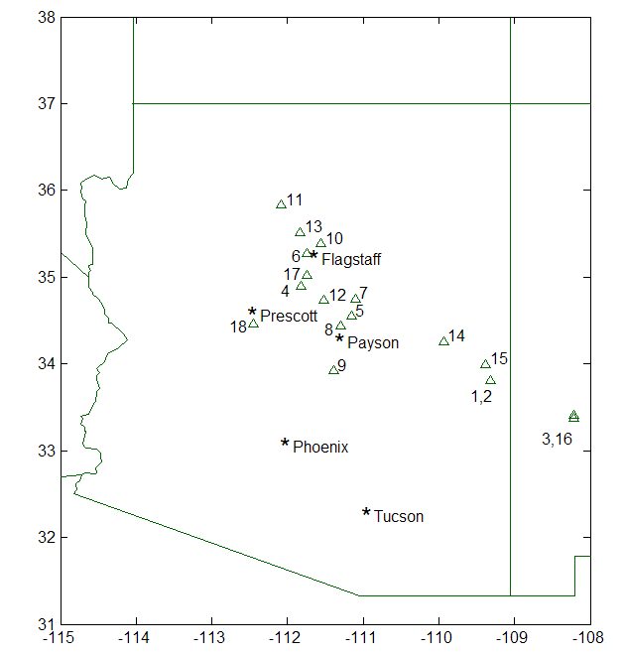

= dated through 2005
= newly dated through 2005
= EW/LW measurements

Figure 1. Locations of tree-ring sites which have been collected as of Aug 1, 2006

Figure 2. Close up of a core from Site 1 showing inter-annual variability of extreme years
Years from a decade in the first half of the 18th century are shown. This core
was also missing the 2002 year, as were most of the other cores from this site.
WORK PHASE 3: Analysis of droughts and high flow extreme years in the context of present and past climatic variability.

Geography graduate student Ashley Coles wrapped up her work on anomalous circulation patterns linked to the HH, LL, HL & LH extreme years. She is now funded by the CLIMAS project, but continues to lend logistical support to the SRP project. Atmospheric Sciences graduate student Jen Welti 's thesis work (funded under SRP-I ) has been able to benefit from Ashley's contributions. Jen is continuing this work as part of her thesis research in absentia. She is currently comparing the location and frequency of storm tracks (or the lack thereof) during the HH, LL, HL and LH years and developing a regionally tailored circulation index to distinguish the years. More details will be presented in a later report.

WORK PHASE 3: Preparation for Re-calibration Update of Reconstructions

We have completed the partial-width measurement and preliminary chronology development (earlywood and total-width) for Site 2-Black River Fir (a Douglas-fir site along the upper reach of the Black River) and are using that site as a template for our processing steps. To improve the earlier portion of the chronology, we obtained archived cores form the Graybill collection (cored in the 1980s) and measured some of the older trees from that collection for partial width. The chronology based on the merged set of cores is plotted in Figures 3 and 4.
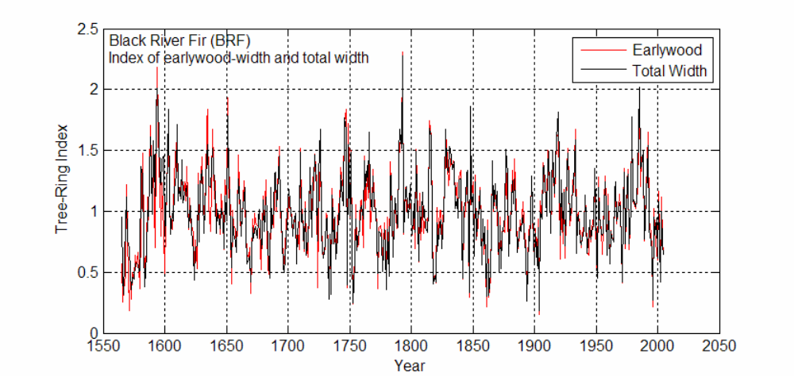
Figure 3. Time series plots of total and earlywood tree-ring indices for Site 2-Black River Fir. Late-1500s mega-drought and drought of last few years reflected in depressed growth indices. Total-width index tracks earlywood index closely because earlywood width is the main fraction of total ring width. We expect the earlywood index and total-width index to track one another most closely in the later part of the chronology because latewood typically becomes very thin and less variable after the first 150-200 years in the life of the tree, and the later part of the chronology is based on the outer parts of the cores.

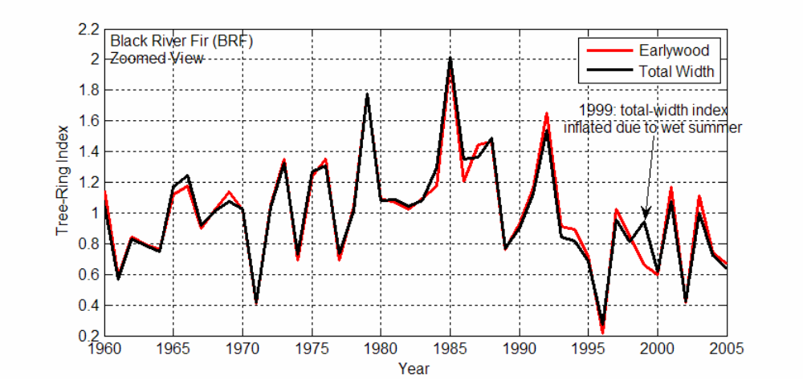
Figure 4. Most recent portion of Black River Fir tree-ring chronology showing total and earlywood tree-ring indices. Segment covers growth years 1960-2005. Notable dry winters of 1996 and 2002 are expressed as narrow total width and earlywood width. The largest departure of the earlywood index from the total-width index is 1999, when summer rainfall and latewood width were unusually great. In such a year, the earlywood index should be superior to the total-width index as a proxy for the precipitation component most important to annual river flows. Growth at this site was low in 2002, but not as low as in 1996. We expect this to vary regionally over the tree-ring network. The trees in this chronology did not respond to the exceptionally wetness of 2005, possibly because the high precipitation was concentrated in a few storms.

Chronology development for earlywood and total-width is straightforward, but much more quality control is required for latewood. Our exploratory studies suggest that we should use only the first 150-200 years of the latewood measurements to build the latewood site chronology, and that the fitted growth curve should be checked visually for each core to make sure we are not using the core's segment of latewood width after it becomes very narrow and invariable. We are modifying some of the chronology standardization in the Matlab software to automate this as much as possible.

WORK PHASE 4: Analysis of the relationship between tree-ring data and snow variables through remotely sensed observations.

Graduate student Ela Czyzowska’s renewal proposal to NASA has been funded and she is continuing the remote sensing aspects of the project. Her main focus right now is a vegetation classification based on Landsat imagery, which is an essential element of her Artificial Neural Network (ANN) snow cover algorithm development. The final ANN snow cover algorithm will include a vegetation classification based on data fusion between Landsat TM5 (30 m spatial resolution) and IKONOS images (1 m spatial resolution). This data fusion work is planned for Fall 2006.

SUMMARY

We are still on schedule with respect to our estimated timeline although the task of partial-width measurements may take longer than expected. The cores continue to show evidence of the severity of the year 2002 within the recent drought in the Salt-Verde Basin. We have begun to evaluate what the partial width measurements may be indicating with respect to seasonal streamflow as we develop our chronologies using these additional measurements. More field work is planned in the Fall to collect cores from remaining field sites, and as more samples get processed, dated, and measured we hope to be ready to proceed with the re-calibration and updates of the streamflow reconstructions later this year.

