LTRR-SRP II : The Current Drought In Context: A Tree-Ring Based Evaluation Of Water Supply Variability For The Salt-Verde River Basin
PROGRESS REPORT #7
For period March – May 2007 (submitted June 15, 2007)

Katherine K. Hirschboeck & David M. Meko
Laboratory of Tree-Ring Research, The University of Arizona

WORK  PHASES | Month
WORK  PHASES | SRP Budget Year 1 |  |  |  |  |  |  |  |  |  | SRP Budget Year 2
WORK  PHASES | 2005 |  |  |  |  | 2006 |  |  |  |  |  |  |  |  |  |  |  |  | 2007
WORK  PHASES | A | S | O | N | D | J | F | M | A | M |  | J | J | A | S | O | N | D |  | J | F | M | A |  | M | J | J | A | S
1. Field collections
2. Processing
& new chronologies
3.Re-calibration / update of reconstructions w/ climate analyses | Ongoing climatic analysis, building on LTRR-SRP I ➔
4. Snow study
5. Integration & final report
Original time line
Updated time line
Requested extension
= Work on phase in progress

WORK PHASE 1: Completed
WORK PHASE 2: Processing of the new collections

During the project period from February through the end of May 2007 our progress was somewhat delayed by ongoing technical problems with the LignoStation and illness of the technician working on this aspect of the project. Nevertheless, all but one of our sites have been processed, dated and measured. We are still behind schedule in chronology building.

Table 1 shows the status of Work Phase 2 as of the end of May 2007 and Figure 1shows the site completion status in map form.

Exploratory analysis of chronologies as they are being developed emphasizes the severity of the recent drought in a long-term context. Tree-growth in 2002 was particularly suppressed at several sites. The long-term severity of the 2002 growth suppression is illustrated in the time series plot of the chronology developed for Wahl Knoll, about 10 miles northeast of Mt. Baldy in the White Mountains (Figure 2). The 2002 site index for Wahl Knoll is lower than at any time since A.D. 1600. As the index can be interpreted as a fraction of normal growth (1.0 is normal), growth in 2002 was less than 50 percent of normal.

We are fairly confident that this most critical phase of the project will finally be completed by the end of June.

Table 1. Status of Collections, Lab Work & Chronology Development as of June 2007
----------------------------------------------------------------------------------
Map# Site Name Species¹ Lat Long El(ft) T² S³ E-L⁴ Date⁵ N_{T}⁶
----------------------------------------------------------------------------------
1 Black River Pine PIPO 33.81 -109.32 7921 B M ✓ 2005-11-17 25
2 Black River Fir PSME 33.81 -109.32 6754 B C ✓ 2005-09-23 20
3 Black Mountain Lookout PSME 33.38 -108.22 8692 B C 2005-10-13 15
4 Dry Creek PIED 34.89 -111.82 4526 E* N/A 2005-10-21 0
5 East Clear Creek PIPO 34.55 -111.16 6706 B M ✓ 2005-11-11 19
6 Gus Pearson PIPO 35.27 -111.74 7423 B C ✓ 2005-10-27 30
7 Jacks Canyon PIED 34.75 -111.11 6303 B C 2005-11-10 17
8 Mogollon Rim West Fir PSME 34.44 -111.29 7511 E C 2005-11-03 5
9 Oak Spring Canyon PIPO 33.92 -111.40 6199 E N/A 2005-10-19 0
10 Robinson Mountain PIPO 35.38 -111.56 7313 B M 2005-10-27 30
11 Red Butte PIED 35.83 -112.08 6332 B M 2005-10-28 16
12 Rocky Gulch PIPO 34.73 -111.52 6453 B C 005-11-10 22
13 Slate Mountain PIPO 35.52 -111.83 7027 B C 2005-10-28 31
14 Sitgreaves Gravel Pit PIPO 34.25 -109.94 6740 B (M) 2005-09-24 24
15 Wahl Knoll PSME 34.00 -109.39 9625 B C ✓ 2005-11-19 18
16 Wolf Head Draw Fir PSME 33.40 -108.22 6593 E M ✓ 2005-10-13 8
17 Oak Creek Canyon PSME 35.03 -111.74 5904 E* P 2005-10-21 4
18 Wolf Creek Campground PIPO 34.45 -112.45 5871 E* C 2005-10-21 4
-----------------------------------------------------------------------------
¹ Species: PSME = Pseudotsuga menziesii; PIPO = Pinus ponderosa PIED = Pinus edulis
² T: type of collection (B=full collection, sufficient for building chronology; E=exploratory, possibly to be expanded; E*=preliminary, with no plans for follow-up collection for building chronology)
³ S: status P=prepared +> D=dated => M=measured => C=chronology built
“( )” indicates the operation is still in progress.
NOTE: 4 Dry Creek . . .N/A means the site is not being used (collections not possible, trees no longer there, etc.)

⁴ E-L a check ✓ means Earlywood/Latewood measurements have been completed
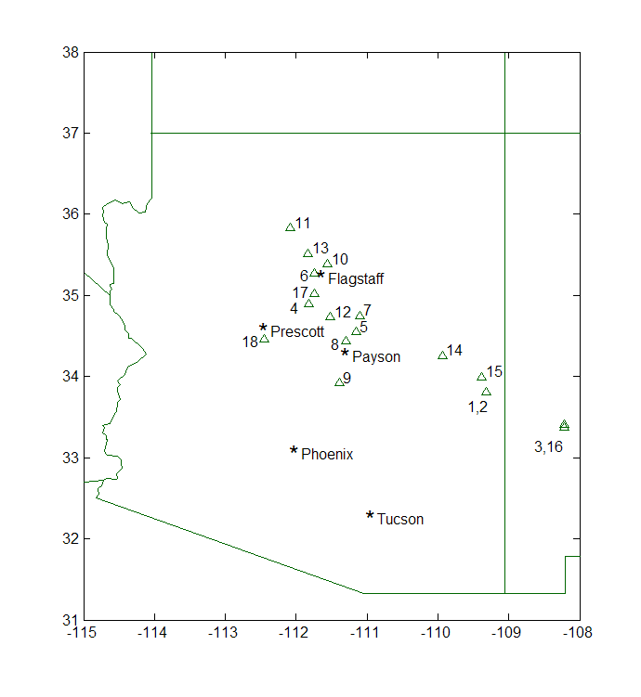
⁵ Date Collected ⁶ N_{T}: number of trees sampled
Figure 1. Locations & status of tree-ring sites collected or scouted as of February 2007.

= dated through 2005
= measured or being measured
= chronology has been built
(some w/ EW/LW measurements )

= eliminated sites

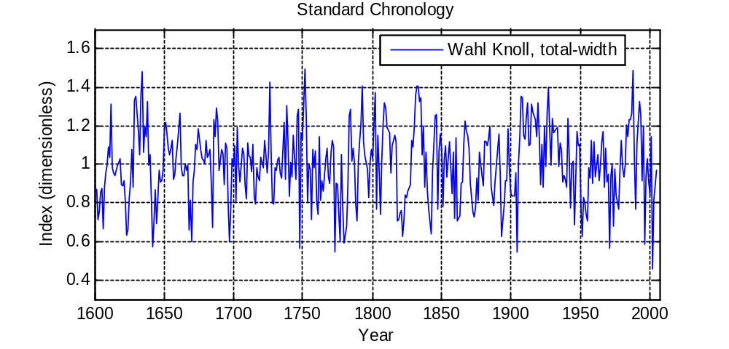
Figure 2 Time series plot of the chronology developed for Site 15 - Wahl Knoll
The plot indicates that tree-growth in 2002 was lower than at any time since A.D. 1600

WORK PHASE 3: Re-calibration / update of reconstructions w/ climate analyses

The re-calibration and updating of the Salt-Verde tree-ring streamflow reconstruction will begin when all the total-width and partial-width measurements are complete. We have continued refining the statistical procedure for reconstruction. The program for reconstruction now is a seamless sequence that begins with computation of the site chronologies from the ring-width series. This setup allows flexibility for checking the sensitivity of reconstructions to choices made in processing the ring widths (e.g, choice of stiffness of detrending curve). In preparation for the reconstructions we have begun updating of the computer files of streamflow series. As mentioned in the previous report, we have also organized PRISM precipitation data to quantify the site-specific precipitation signal at each tree-ring site.

The climatic analysis is proceeding by identifying circulation patterns linked to anomalous high and low flow episodes during the gaged record in the Salt/Verde Basin. We are testing various regionally tailored indices to see how well they capture the short-and long-term streamflow variability of drought episodes and flood events (as important determinants of the high flow years). Graduate student Ashley Coles has been collecting data so that we can update the flood hydroclimatology classification of the Salt-Verde basins (originally developed by Hirschboeck.) and tie it in with this project.

WORK PHASE 4: Analysis of the relationship between tree-ring data and snow variables through remotely sensed observations.

Ela Czyzowska’s project is progressing. Her third-year renewal proposal to NASA has been approved and she is working on the continuation of her algorithm development. (NOTE: Ela has been bed-ridden and working at home on doctor's orders related to a difficult pregnancy. We are happy to report that she gave birth to a healthy baby girl on May 17th and hopes to be back at work soon.)

WORK PHASE 5: Integration & final report.

Hirschboeck is about to begin a sabbatical (starting July 2007) during which she will be working on some complementary "integration" activities related to our SRP work: (1) completion of a manuscript for publication on the results of the SRP I project, (2) initiation of a manuscript on our evolving SRP II work, and (3) preparation of a handbook/guide for water resource managers on how to interpret tree-ring streamflow reconstruction results, using the reconstructions already developed for SRP I and those under development for SRP II. Activity (3) is being prepared as part of a project funded by the Arizona Water Institute on "Improved Tools for Drought Planning and Management" (P.I. Rick Shangraw, ASU Decision Theater, in cooperation with the East Valley Water Forum).

In anticipation of the final report for our SRP II project, we are continuing to organize our data files and write up parts of our methods sections for insertion into the report at project completion time.

SUMMARY

We are still behind schedule with respect to our original timeline because of the extra time needed to complete the measurement and chronology building of Phase 2. We expect to be in the re-calibration stage of Work Phase 3 and beginning the streamflow reconstructions by the end of June and are now aiming for project completion by the end of September. We therefore are requesting a one-month extension beyond our original end-of-August completion date.

