Example: ABC-1-A-A-1
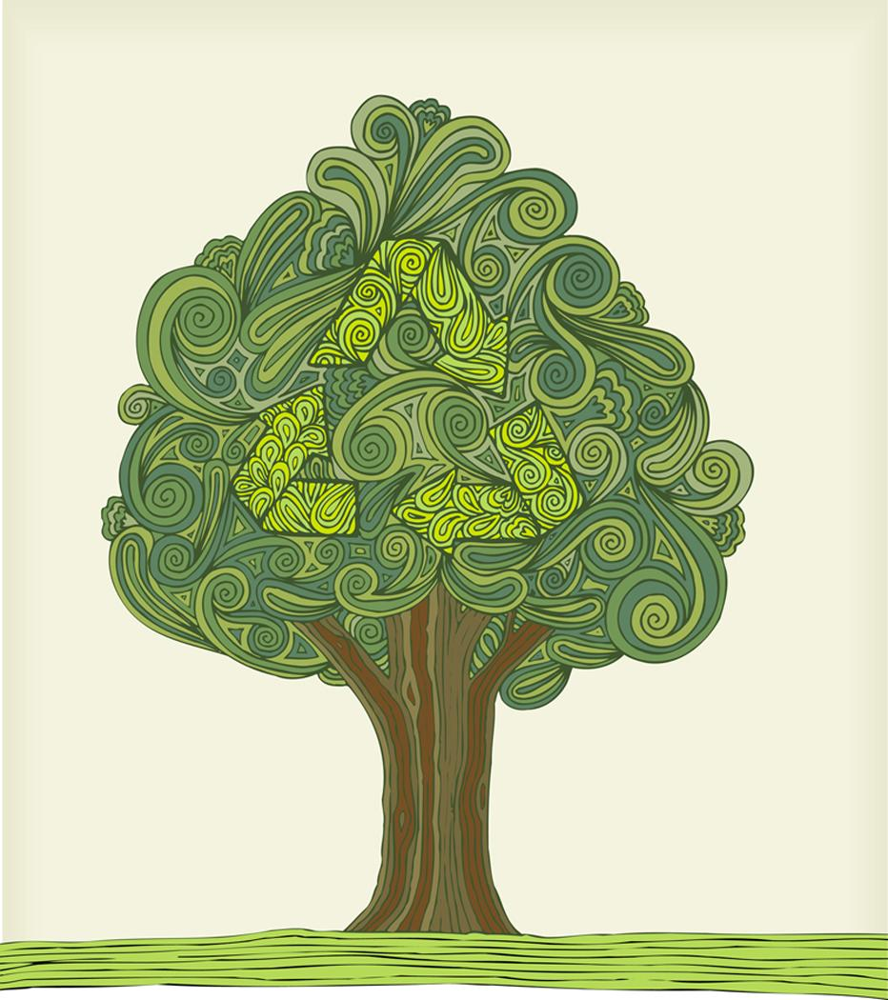
ABC-1
Element Code:
This tree grew at a site called ‘ABC’. It was the first tree sampled at the site and received the element code of 1.

Element 1

ABC-1-A
Sample Code:
Two samples were taken from tree 1. These were labeled A and B. If there were more than two samples (tends to happen with charcoal), the third and fourth would be labeled C and D and so on. The lab code we are constructing is for the first sample, A.

Sample
A
Sample
B

Radius A
ABC-1-A-A
ABC-1-A-A-1
Radius Code:
A sample may have many radii, the first radius receives the letter “A” and the second “B” and so on. For cores there is usually only one radius (A) to measure.
Radius B
Series
1

Series Code:
A radii will have at least 2 readings. The final letter in the lab code relates to the first or second reading. In this case we are constructing a code for the first reading '1'. The second reading would be '2' and so on.
Series
2

