TRUDU, Laurent

Koncierge50

Revision History

|  |  |  |  |
| --- | --- | --- | --- |
| Date | Author | Version | Comments |
| 3rd June 2025 | Laurent Trudu | 1.0 | Initial Version |
| 4th June 2025 | Laurent Trudu | 1.1 | Added EXPORT_REGISTERED_DATA and EXPORT_ATTENDEE_DATA element description in Config.json section.  Added Export Data section. |

1. Overview 4

2. Sample cards printed with the application 5

3. Pre-requisites 6

4. Installation 6

5. Licence 6

6. Workflow 7

1. Launching the application 7

2. Home Screen 7

3. Searching for an attendee 8

4. Welcome Screen 9

5. Register Screen 10

7. Setting up the application 12

1. Configuration files 12

2. Attendees.csv file 12

3. Config.json 14

4. font.ttf 17

5. logo.png 17

8. LED Color Module 17

9. VCard 17

10. VIP Mode 18

11. Export Data 19

12. Running on a landscape KC50 19

# Overview

The KonCierge50 is a demo application that can be used for hospitality use cases.

It allows the guest to retrieve their information from a pre-built CSV file or to enter their information manually.

The guest can register herself/himself/themselves with a register button.

If card printing is enabled, the application will print a badge on a ZC3XX card printer.

The badge will contain the first name, the last name, the company name and if enabled, the role of the guest.

A VCard printed as a QRCode can be added to the badge.

It will contain all the details of the guest that are either in the pre-built CSV or in the manual registration information.

The application can print a wristband as well if the guest has been identified as a VIP.

The Color LED add-on of the KC50 is supported if available.

The application is available in the following languages:

* English
* French
* Arab
* Greek
* Spanish
* Italian
* Portuguese
* Turkish

# Sample cards printed with the application

# Pre-requisites

Hardware:

* **A KC50 Portrait** (Landscape can be used with additional software, see section “Using a Landscape KC50” in this document)
* A LED RGB Module (optional)
* A ZC3XX Card Printer (optional)
* A Zebra Wristband printer (optional)

Software:

* The application has been tested on Android 13 (API 33) and Android 14 (API 34).

# Installation

Go to the release page of the KonCierge50 project and download the latest release:

<https://github.com/ltrudu/KonCierge50/releases>

It is advised to install the Release version; the Debug version is here in case of a problem to help solve the issue.

You can download the application from the KC50 web browser and install if with the File application.

Or you can install through adb using the following command:

**adb install KonCierge50-release.apk**

Or use StageNow or your favourite EMM to install the application.

**The application is designed to run in DARK MODE, so you should set your KC50 to Dark Mode to get the best graphical experience.**

# Licence

The software is available under the Zebra EULA License.

A copy of the license is available with the source code:

<https://github.com/ltrudu/KonCierge50/blob/master/LICENSE.md>

Or directly on the Zebra Devs repository:

[**https://github.com/ZebraDevs/About/blob/master/ZEBRA_EULA_LICENSE.md**](https://github.com/ZebraDevs/About/blob/master/ZEBRA_EULA_LICENSE.md)

As the license state, **THIS SOFTWARE USAGE IS LIMITED TO ZEBRA’s DEVICES**.

**IT CAN NOT BE MODIFIED TO BE USED ON OTHER BRAND DEVICES SINCE IT WILL BE A FAILURE TO COMPLY WITH THE LICENSE.**

# Workflow

## Launching the application

To launch the application, touch the KonCierge50 icon on the Android launcher:

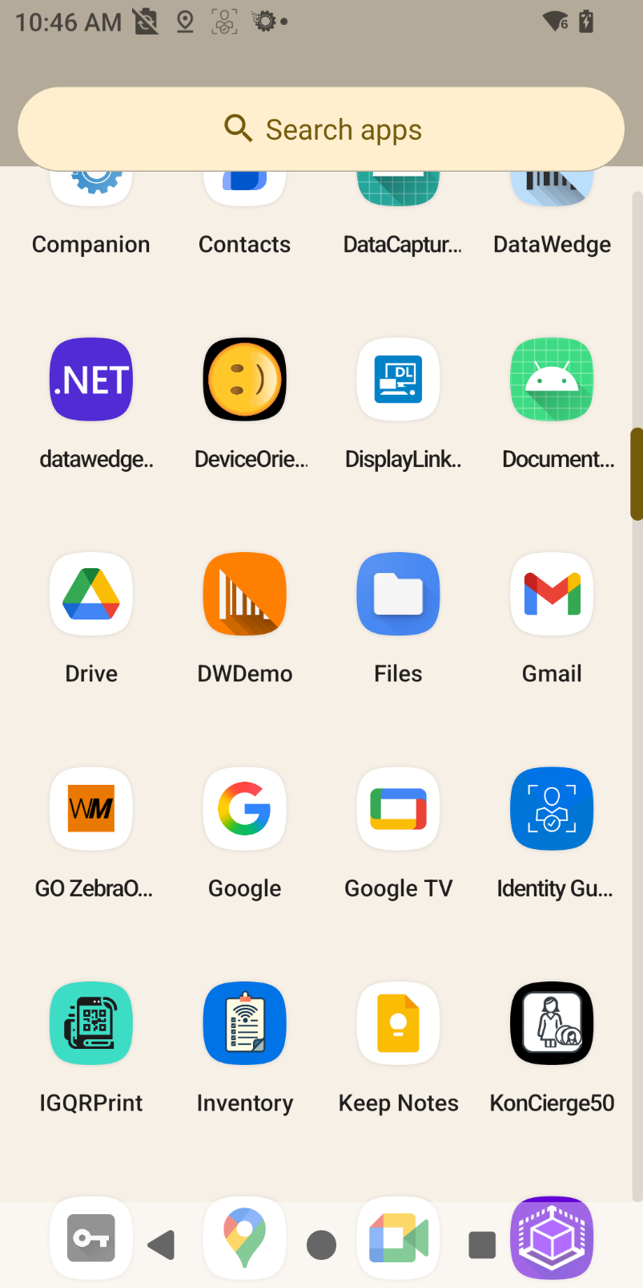

## Home Screen

After displaying a Splash Screen, the Home Screen of KonCierge50 will be displayed:

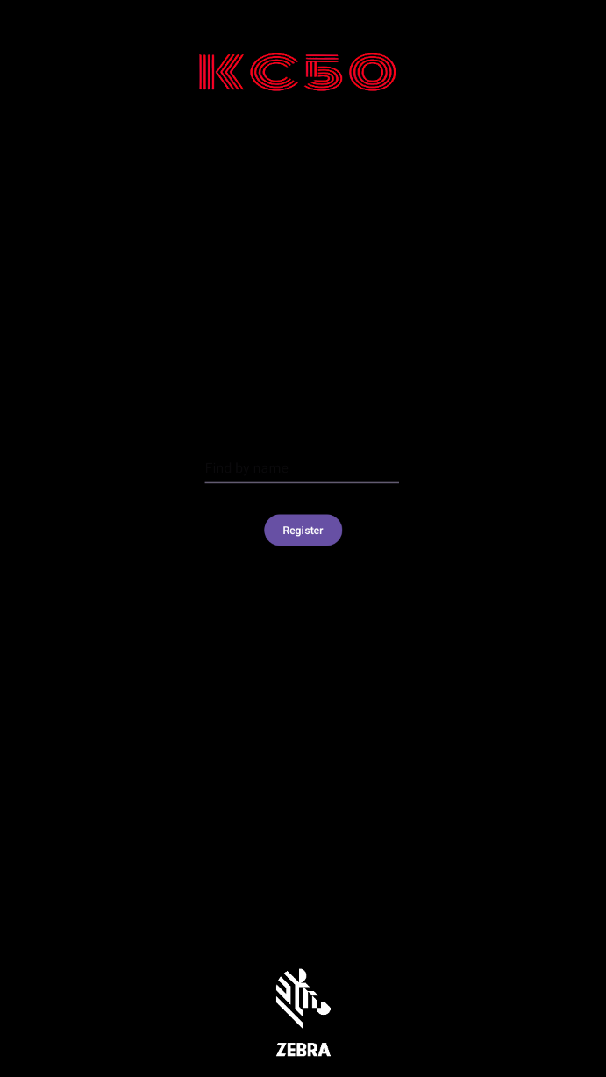

In this screen, if the ENABLE_SEARCH_MODE is set to true in the config.json file, the user will find a search input control that will allow to look for her/his/their name inside the list provided by the application (see Attendees.csv section of this document).

If the CAN_CREATE_CARD is set to true in the settings, a register button will allow the user to register herself/himself/themselves by providing her/his/their information to the application.

## Searching for an attendee

To search for herself/himself/themselves, the user must select the search input control to make the soft keyboard appears and enter search pattern.

Depending on the configuration (see NUMBER_OF_CHARACTERS_BEFORE_SEARCHING_FOR_CANDIDATES element in config.json section of this document), the user can enter a series of letters inside this search box before the search occurs.

When the number of letters defined in the configuration will be entered, the application will search for these letters inside the first and last names defined in the Attendees.csv file (see section Attendees.csv file of this document for more information).

A list of possible results will be displayed to the user:

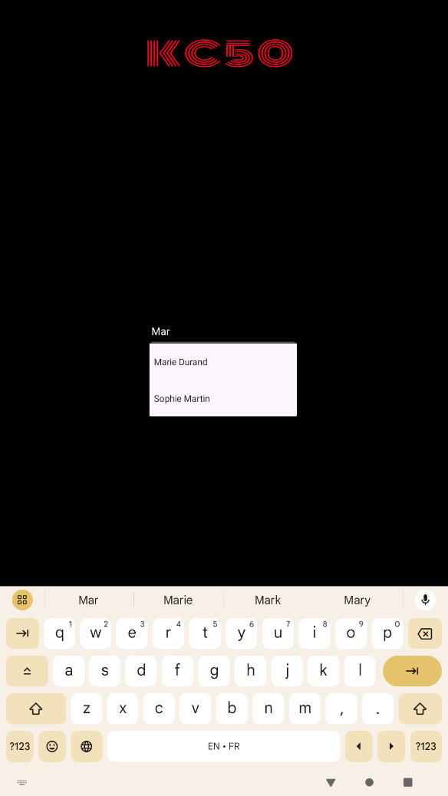

The user can now select her/his/their name inside the drop-down list that appears.

## Welcome Screen

Once the user has selected her/his/their name inside the drop-down list, the logos will disappear from the screen and a welcome screen will appear.

Depending on the value of VIP_MODE in the config.json file or if the user is or is not a VIP, one of these screens may appear:

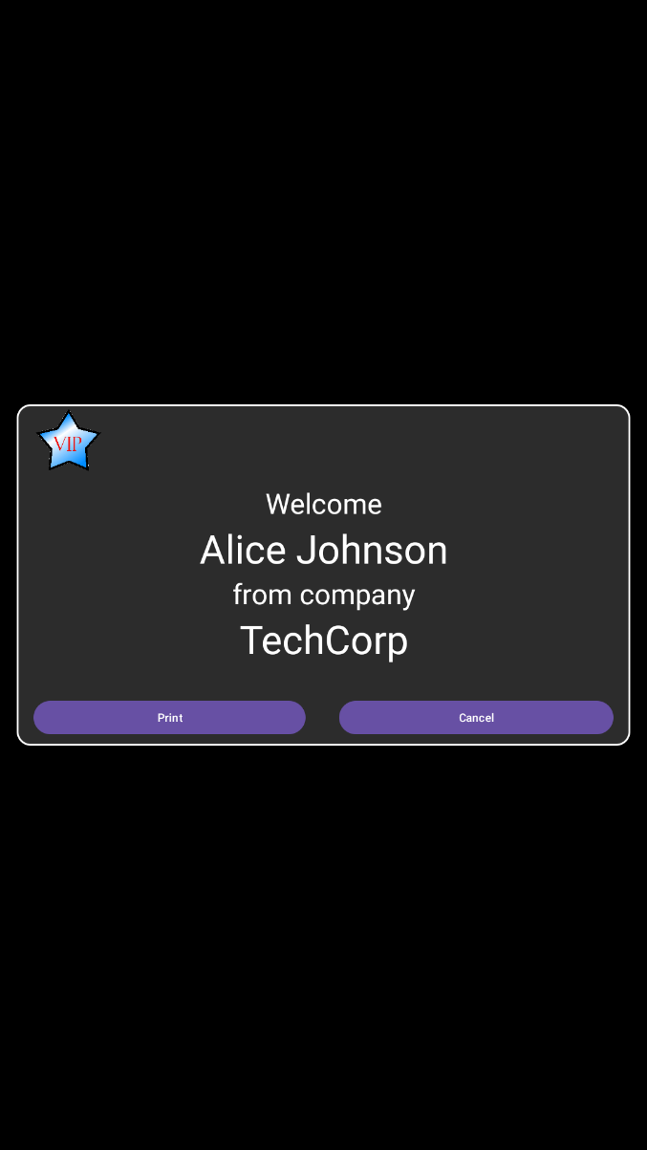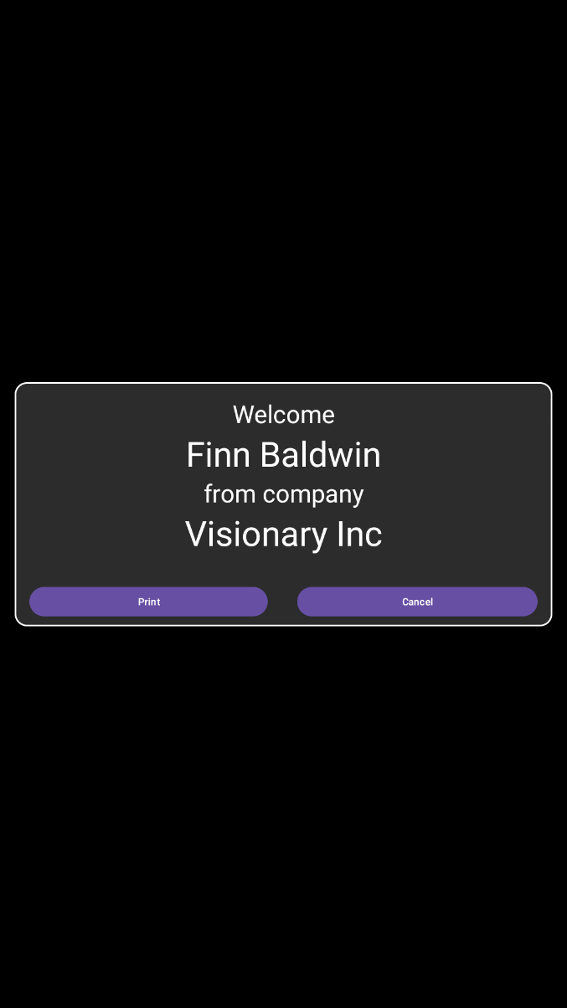

* VIP_MODE set to true and the user VIP status set to YES
* VIP_MODE set to false.
* VIP_MODE set to true and the user VIP status set to NO

Once the Welcome Screen appears, the user can:

* Touch the Cancel button and the Welcome Screen will disappear.
* Touch the Print button and a card will be printed on the ZC3XX printer that is setup in the settings file (see Config.json section for more information).  
  If a Wristband printer is setup in the settings file, the PRINT_WRISTBAND_FOR_VIP element is set to True and the user is a VIP, a Wristband with her/his/their name will be printed as well.

See “VIP Mode” section of this document for more information on VIP Mode.

**When the application is first run, the Welcome Screen may not appear as it should (the animation may not work properly at first search).**

**It is strongly recommended to make at least one search when you just ran the application to ensure that the attendees will get the best user experience in terms of animation.**

## Register Screen

When the user touches the button Register in the Home Screen, one of the following screens may appears depending on the settings of the application:

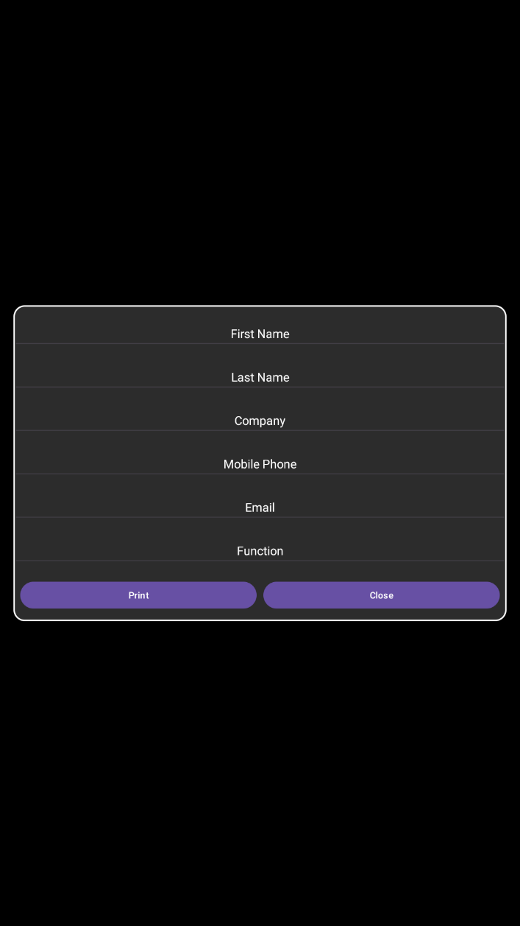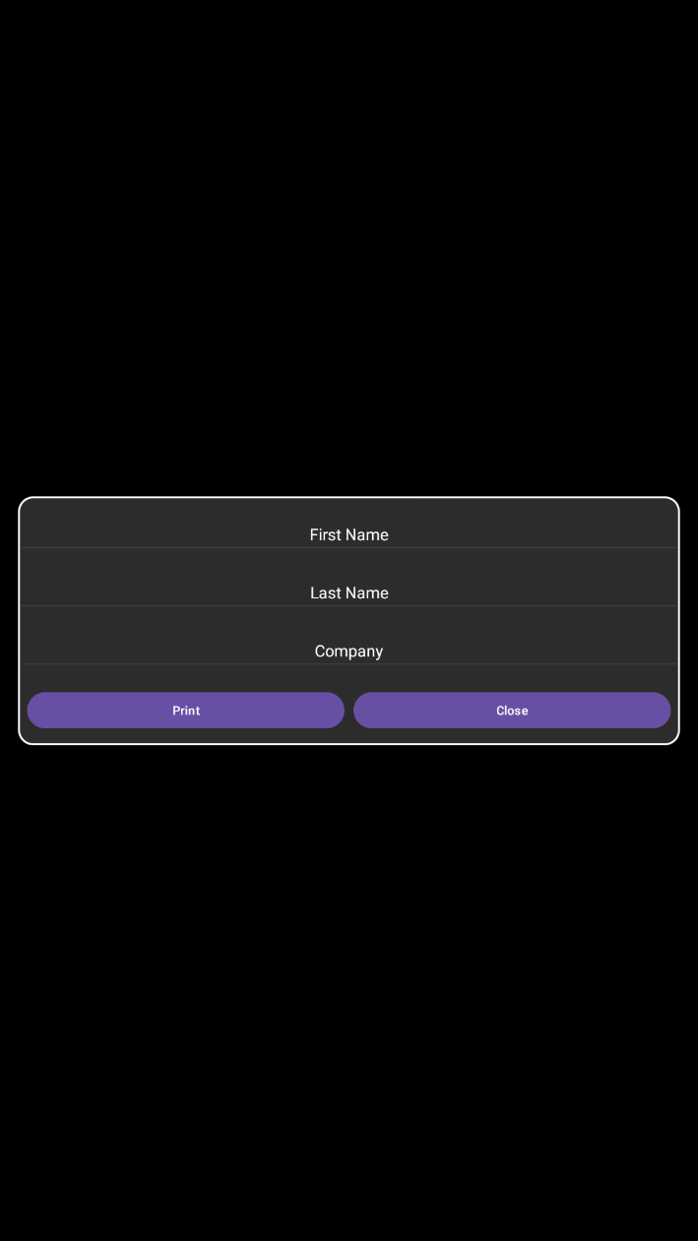

* CAN_CREATE_VCARD set to true
* CAN_CREATE_VCARD set to false

Depending on the value of the CAN_CREATE_VCARD element of the config.json file, the user will be able to enter a limited number of personal information, or a complete information set.

If the user touches the Cancel button, the Register screen will disappear, and the application will return to the Home Screen.

If card printing is disabled, the user will be able to register himself using the “Register” button.

If the export data is enabled, his registration will be added to the log file.

If card printing is enabled, the user can touch the Print button.

Then a card will be printed containing information depending on the settings of the application (see Config.json section of this document for more information).

Note that in VCARD mode, the user is not forced to enter all the elements presented in the Register screen.

**Only the elements First Name, Last Name and Company are mandatory to register the user / create a new card.**

If the PRINT_QRCODE is set to true in the settings, the application will only print the available data inside the VCard QRCode.

See VCard section of this document for more information.

# Setting up the application

## Configuration files

When the application is launched for the first time, it will create a KonCierge50 folder at the root of the Android SDCard.

This folder will contain the following files:

* Attendees.csv
* config.json
* font.ttf
* logo.png

All these files can be modified to customize the application behaviour, its look and feel, and the look and feel of the cards that will be printed on the ZC3XX printer.

## Attendees.csv file

The Attendees.csv file contains the list of the people that are expected to be welcomed or to participate to an event.

It is opened when the application is launched.

If you change it while the application is running, you’ll need to kill the app using the Android Tasks screen, and then restart the application.

The file respects the coma separated file (CSV) format.

The file format MUST be UTF-8 with CR/LF ending on each line.

You can check the format with the Notepad++ application ([Download Notepad++](https://notepad-plus-plus.org/downloads/)).

The application should display this information on the right bottom of the window:

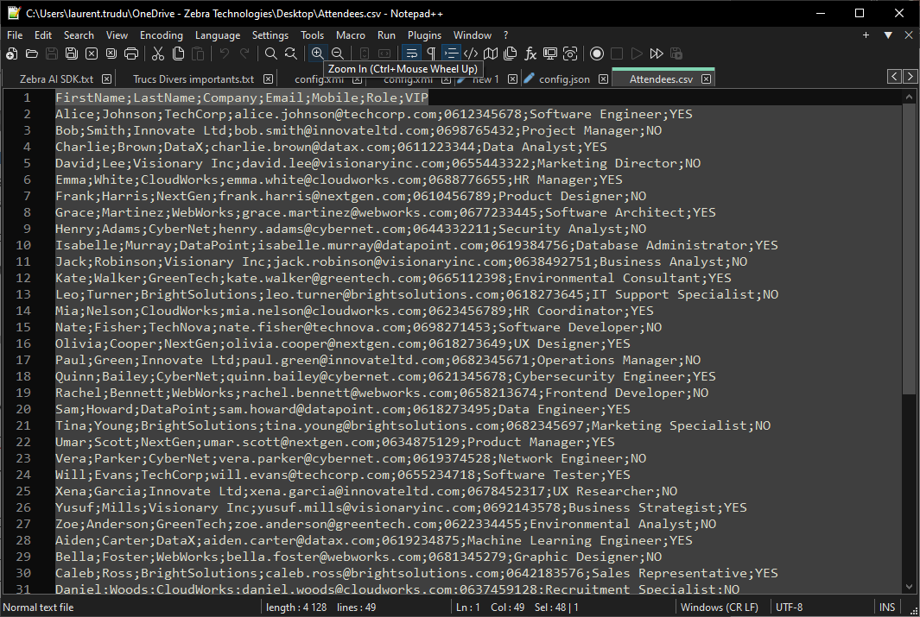

If the format is not CR LF or not UTF-8, right click on the corresponding item to change it.

The first line of the document **MUST** contain the following data to be interpreted by the application:

FirstName;LastName;Company;Email;Mobile;Role;VIP

This corresponds to the data that will be provided regarding the attendees expected to use the application.

The following lines are the description of each attendee.

Ex:

|  |  |  |
| --- | --- | --- |
| Element Name | Value | Content |
| FirstName | String | The first name of the attendee. |
| LastName | String | The last name of the attendee. |
| Company | String | The company name of the attendee. |
| Email | String | The email of the attendee. |
| Mobile | String | The phone number of the attendee. |
| Role | String | The company role of the attendee. |
| VIP | YES or NO | If set to YES, the attendee will be treated as a VIP (see VIP Mode section in this document for more information) |

**If some data are not available, you MUST keep the number of entries to 7, but you’ll keep the data empty between the commas.**

**The VIP data is mandatory, you can set to YES or NO if you don’t use the VIP Mode, but you MUST set a value.**

Example line that does not contain the phone number and the email address:

Frank;Harris;NextGen;;;Product Designer;NO

**The last line of the Attendees.csv file MUST be a line that contains data, avoid putting a carriage return after the last line data as the application cannot interpret blank lines.**

Note that if the PRINT_QRCODE feature is used, the VCard QRCode that will be printed on the card will only contain the data that has be entered in the CSV file.

For example, if the phone number is missing, the VCard will not contain a phone number.

If you want the edition to be more user friendly, you can open the file that you’ll find in the KonCierge50 folder directly inside Excel. Copy it on your computer first, edit it, and then upload it inside the KonCierge50 folder.

## Config.json

The config.json file is used by the application to read its settings and configuration.

It is opened when the application is launched.

If you change it while the application is running, you need to kill it using the Android tasks screen and relaunch it to take any modification into account.

Here is a description of the elements you’ll find inside this file:

|  |  |  |
| --- | --- | --- |
| Element Name | Type / Values | Content |
| DISABLE_CARD_PRINTING | Boolean   * True * False | Disable the card printing feature if you do not have a ZC3XX printer.  It is set to true by default, so card printing is disabled by default.  In that case, it is advised to let the EXPORT_REGISTERED_DATA and EXPORT_ATTENDEE_DATA elements to true. |
| CAN_CREATE_CARD | Boolean   * True * False | If set to True, it will enable the “Add new attendee” button in the Welcome Screen.  If set to False, the “Add new attendee” button will be hidden. |
| CAN_CREATE_VCARD | Boolean   * True * False | If set to False, and if the CAN_CREATE_CARD is set to True as well, the Register window will contain a reduced set of data:   * First Name * Last Name * Company   If set to True and if the CAN_CREATE_CARD is set to True as well, the Register window will contain the full data set describing an attendee:   * First Name * Last Name * Company * Mobile Phone * Email * Function (Role)   Note that if you use this feature in conjunction with the PRINT_QRCODE feature, the QRCODE printed will contain a VCard with only the data that the user has entered. |
| ENABLE_SEARCH_MODE | Boolean   * True * False | If set to true, a search input control will be available at the home screen to allow the attendees to search for their data inside the Attendees.csv file.  The search is done on the first and last name of the attendees.  If set to false, the search input control will be hidden. |
| VIP_MODE | Boolean   * True * False | If set to true, the application will interpret the VIP column of the Attendees.csv file.  See VIP Mode section for more information. |
| NUMBER_OF_CHARACTERS_BEFORE  _SEARCHING_FOR_CANDIDATES | Integer  Number >= 1 | The number of characters to be entered before the application start to find a candidate in the Attendees.csv file date.  The search is done on the first and last name of the attendees. |
| CARD_PRINTER_IP | String  IP format. | The IP of the ZC3XX card printer that will be used to print the cards. |
| CARD_PRINTER_PORT | Integer  Number >= 0 | The port number that will be used to connect to the card printer. |
| CARD_ORIENTATION | String  Value can be:   * Portrait * Landscape | The orientation of the card.  Default orientation is Landscape.  If you change this value to Portrait, don’t forget to update the FIRST_NAME_CONFIG, LAST_NAME_CONFIG, COMPANY_CONFIG, FUNCTION_CONFIG and QRCODE_CONFIG accordingly.  Default value of theses CONFIG data have an orientation set to 90°.  You’ll have to change the orientation as well as the x and y parameters if you change the orientation of the card. |
| PRINT_COMPANY | Boolean   * True * False | If set to true, the company name of the attendee will be printed on the card using the COMPANY_CONFIG parameters |
| PRINT_FUNCTION | Boolean   * True * False | If set to true, the function (role) of the attendee will be print on the card using the FUNCTION_CONFIG parameters. |
| PRINT_QRCODE | Boolean   * True * False | If set to true, a QRCode containing a VCard will be printed on the card using the QRCODE_CONFIG parameters. |
| USE_CUSTOM_FONT | Boolean   * True * False | If set to true, the application will load the file font.ttf contained in the KonCierge50 folder and use this font to print characters on the card. |
| PRINT_WRISTBAND_FOR_VIP | Boolean   * True * False | If set to true, a wristband will be printed if the attendee is marked as VIP in the Attendees.csv file.  See VIP Mode section of this document for more information. |
| WRISTBAND_PRINTER_IP | String  IP format. | The IP of the wristband printer. |
| WRISTBAND_PRINTER_PORT | Integer  Number >= 1 | The port that will be used to connect to the wristband printer. |
|  |  |  |
| FIRST_NAME_CONFIG  LAST_NAME_CONFIG  COMPANY_CONFIG  FUNCTION_CONFIG | Composite element. | The configuration of the information that will be printed on the card.  The default value is for the landscape orientation of the card.  This composite element contains the following sub-elements:   * fontsize: an integer >= 1 that represent the size of the font. * height : the height of the textbox that will be printed. * width: the width of the textbox that will be printed. * x: the x coordinate of the textbox that will be printed. * y: the y coordinate of the textbox that will be printed. * horizontalAlignment: the horizontal alignment of the text that will be printed in the textbox. This value can be: - Center - Left - Right - Top - Bottom * verticalAlignment: the vertical alignment of the text that will be printed in the textbox. This value can be: - Center - Left - Right - Top - Bottom * rotation: the rotation that must be applied to the text printed in the textbox in degrees. Supported values are: - 0 - 90 - 180 - 270   For more information on these values, read the documentation of the method void drawText(String text, int x, int y, int width, int height, int angle, float textSize, int textColor)  of the interface ZebraGraphics in the android_card documentation of the link_os SDK. |
| EXPORT_ATTENDEE_DATA | Boolean   * True * False | Export attendee data when the card is printed.  See Export Data section for more information. |
| EXPORT_REGISTERED_DATA | Boolean   * True * False | Export New Attendee data when they register and print their card.  See Export Data section for more information. |
| QRCODE_CONFIG | Composite element. | The configuration of the QRCode that contains a VCard and will be printed on the card.  The default value is for the landscape orientation of the card.  This composite element contains the following sub-elements:   * x: the x coordinate of the QRCode * y: the y coordinate of the QRCode * height: the height of the QRCode * width : the width of the QRCode * rotation: a rotation that will be applied to the QRCode.  Supported values are:  - 0 - 90 - 180 - 270   For more information on these values, check the documentation of the method void drawBarcode(String data, int x, int y, int width, int height, Rotation rotation)  of the interface CodeQRUtil in the android_card documentation of the link_os SDK. |

## font.ttf

If the element USE_CUSTOM_FONT is set to true in the config.json file, the application will load the file font.ttf contained in the KonCierge50 folder and use it to print on the card.

This font will replace the default font with a custom font allowing the administrator to customize the text printing.

## logo.png

A default logo is displayed on the Home Screen:



This logo can be replaced with a custom logo.

The resolution of the default logo is 2400x1200.

On the application it is stretched to 341dp by 123dp.

Feel free to replace this image by your own logo.

It is recommended to maintain the aspect ratio of the original logo, but you can test other aspects ratios as well.

# LED Color Module

If the LED Color Module is attached to the KC50, it will be used by the application.

When the application displays the home screen, the led colors will animate to all the possible colors in the RGB spectrum.

When the application displays the welcome screen of a non-VIP attendee, the led color will be set to BLUE.

When the application displays the welcome screen of a VIP attendee, the led color will be set to GREEN.

# VCard

If the element PRINT_QRCODE in the config.json file is set to true, a QR code will be printed on the card.

This QR code will use the QRCODE_CONFIG settings as parameters.

The QRCode will contain a VCard string encoded as this (variable elements are in bold):

BEGIN:VCARD   
VERSION:3.0  
N:**LastName**;**FirstName**  
FN:**FirstName** **LastName**  
TEL;CELL:**MobilePhone**  
EMAIL;WORK;INTERNET:**Email**  
TITLE:**Function**  
ORG:**Company**  
END:VCARD

The VCard will contain only the available information.

For example, if the email is missing, the EMAIL;WORK;INTERNET won’t be added to the VCard.

# VIP Mode

If the VIP_MODE element is set to true in the config.json file, the application will run in VIP mode.

Consequently, it will process the VIP column of the Attendees.csv file.

If an attendee is a VIP, the first consequence will be the addition of an animated logo “VIP” on the top left of the welcome screen.

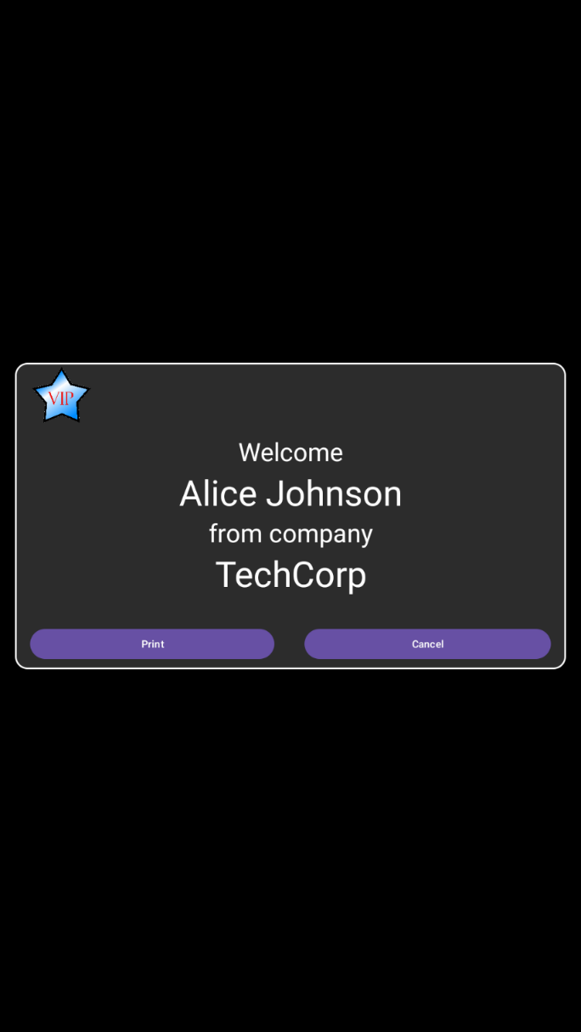

If the PRINT_WRISTBAND_FOR_VIP element of the config.json file is set to true, a wristband will be printed using a Zebra’s wristband printer.

To work, you’ll have to set up the WRISTBAND_PRINTER_IP and WRISTBAND_PRINTER_PORT of the config.json file.

You’ll have to upload a VIP.ZPL file to the wristband printer.

This file will be called by the application to print the attendee wristband.

Note that the data printed is not variable (no dynamic field passed to the VIP.ZPL file), so it is limited to what you put inside the zpl file.

This feature allows you to automatically print the wristband in parallel of the card printing so your VIP attendee will receive a card with her/his/their information printed as well as a wristband that will identify her/him/their as a VIP (for example : VIP access to specific exhibition zones).

# Export Data

If the EXPORT_ATTENDEE_DATA element of the config.json file is set to true, every time an attendee prints her/his/their card, a new line will be added to an export CSV file.

If the EXPORT_REGISTERED_DATA element of the config.json file is set to true, every time a newly registered attendee prints her/his/their card, a new line will be added to an export CSV file.

The file is created in a sub folder of the KonCierge50 folder that is created at the root of the SDCard.

The export folder is called: “Export”.

There is only one file per day that is created inside this folder.

The file will be named with the following format: YearMonthDay.csv

The format of the CSV file is the following:

FirstName;LastName;Company;Email;Mobile;Role;New;TimeStamp

Description of the fields inside the CSV file:

|  |  |  |
| --- | --- | --- |
| Field Name | Format / Values | Content |
| FirstName | String | First name of the attendee. |
| LastName | String | Last name of the attendee. |
| Company | String | The company of the attendee. |
| Email | String | The email of the attendee. |
| Mobile | String | The phone number of the attendee. |
| Role | String | The company role of the attendee. |
| New | String   * Yes * No | If the value is No, it means that the attendee was already listed inside the Attendee.csv file, and that her/he/their used the search feature to look for their data.  If the value is Yes, it means that the attendee has been added using the Register button. |
| TimeStamp | String | The time when the attendee printed her/his/their card with the format Hours:Minutes:Seconds. |

Each time a card is printed, the information about the attendee is added at the end of the export file.

If data is not available an empty value will be added to the line between the comas.

This issue can happen in the following scenarios:

* Printing a card of an attendee that comes from the Attendee.csv file, when the Attendee.csv file does not have all its columns filled with data.
* When registering a new user, the user does not fill the one of the optional input boxes.

# Running on a landscape KC50

The KonCierge50 application has been designed to run in portrait mode.

But you can still use it on a landscape KC50 if you force the orientation to portrait and if you present the KC50 in the portrait orientation.

Trying to run it in landscape mode will result in a degraded graphical user experience.

To force portrait mode on a landscape KC50 you can use MX with StageNow.

You’ll have to create a profile containing Display Manager CSP.

You’ll need to set the Auto-Rotate to Off:

<https://techdocs.zebra.com/mx/displaymgr/#auto-rotate-onoff>

And force the Primary Locked Orientation to Portrait:

<https://techdocs.zebra.com/mx/displaymgr/#primary-locked-orientation>

Alternatively, if you can’t use StageNow, you can use the Device Orientation Service.

You’ll find the source code of the service at the following GitHub:

<https://github.com/ltrudu/DeviceOrientationService>

You can download the latest release at the following link:

<https://github.com/ltrudu/DeviceOrientationService/releases>

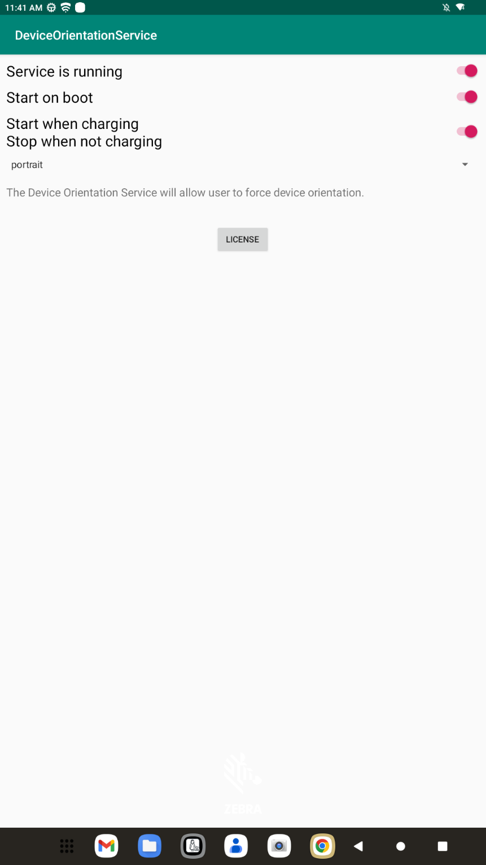You’ll just have to set all the switches to true and the drop-down list to portrait: