* Download [or build] then install qBittorrent : <https://www.qbittorrent.org/>
* Enable the embedded tracker on qBittorrent: <https://github.com/qbittorrent/qBittorrent/wiki/How-to-use-qBittorrent-as-a-tracker> and strict super seeding  
  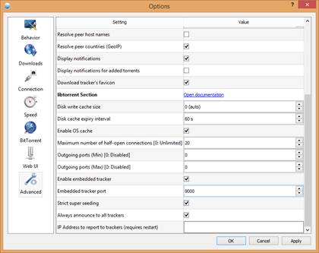
* Disable Peer Exchange and DHT, enable local peer discovery (you can force encryption too if needed)  
  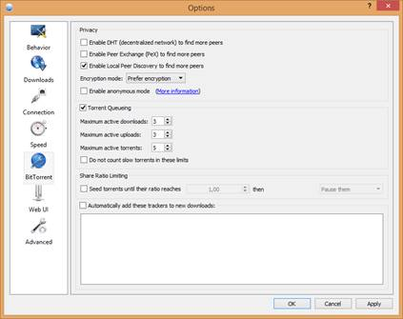
* Create your torrent with the torrent creator (Ctrl+N), set it as Private, tracker url should be already filled (add the tracker address if not)  
  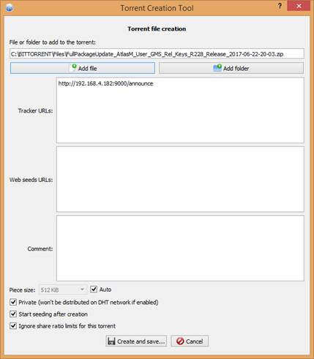
* It will create a .torrent file. Only device with the file will be able to share it since it is a private torrent (no DHT distribution, but this shouldn’t be a problem since our customer networks are usually not connected to the internet)
* Build or install libretorrent modified version (select the release 1.4_custom_action_loadtorrent) on your Android device  
  <https://github.com/ltrudu/libretorrent/releases>
* Send the torrent file to the device with an MDM, or any other method
* Execute the android action with the absolute path to the torrent in the extra with your favorite Mdm or adb

Android action: ***org.proninyaroslav.libretorrent.loadtorrent***  
Extra parameter for filepath: ***TorrentFilePath***  
Extra parameter for destination (optional): ***DownloadFolder***Java code snippet:  
public void downloadTorrent(Context aContext, String filePath, String destinationPath)  
{  
    Intent torrentIntent=new Intent();  
    torrentIntent.setAction(ACTION_LOADTORRENT);  
    torrentIntent.putExtra(EXTRA_TORRENT_FILEPATH, filePath);  
    torrentIntent.putExtra(EXTRA_TORRENT_DOWNLOADFOLDER, destinationPath);  
    torrentIntent.addFlags(Intent.FLAG_ACTIVITY_NEW_TASK);  
    aContext.startActivity(torrentIntent);  
}

Adb command:  
Torrent location: /sdcard/Download/4-182-FullPackageUpdate_20-03.torrent

**adb shell am start -a org.proninyaroslav.libretorrent.loadtorrent -c android.intent.category.DEFAULT -e TorrentFilePath** /sdcard/Download/4-182-FullPackageUpdate_20-03.torrent

* Watch the file being downloaded on your device…..