# Friction coefficien data normalizition modeling

import numpy as np  
import pandas as pd  
import matplotlib.pyplot as plt  
import matplotlib.ticker as ticker  
from sklearn.preprocessing import StandardScaler  
from sklearn.gaussian_process import GaussianProcessRegressor  
from sklearn.gaussian_process.kernels import RBF,ConstantKernel as c  
from sklearn.gaussian_process.kernels import WhiteKernel, ConstantKernel  
from sklearn.model_selection import ShuffleSplit  
from sklearn.metrics import mean_absolute_error, mean_squared_error  
from mpl_toolkits.mplot3d import Axes3D  
import seaborn as sns  
from matplotlib.colors import LogNorm  
from matplotlib import cm  
from matplotlib.pyplot import MultipleLocator  
import xlwt  
import warnings

sns.set()  
warnings.filterwarnings('ignore')

plt.rcParams['font.sans-serif'] = 'SimSun'  
plt.rcParams['axes.unicode_minus'] = False

font1 = {  
 'family': 'SimSun',  
 'weight': 'bold',  
 'size': 18  
}  
font2 = {  
 'family': 'Times New Roman',  
 'weight': 'normal',  
 'size': 15  
}  
font3 = {  
 'family': 'Times New Roman',  
 'weight': 'normal',  
 'size': 10  
}

## Load data

filepath = r'C:\Users\Administrator\Desktop\experimental_data\30%-friction coefficient.xlsx'# dataset address  
df = pd.read_excel(filepath, skiprows=0)  
df.head()

power

feed rate

friction

0

700

1.0

0.6200

1

800

1.0

0.6315

2

900

1.0

0.6163

3

1000

1.0

0.6004

4

1100

1.0

0.5800

# remove missing values  
df.dropna(axis=0,inplace=True)  
df.shape  
df

power

feed rate

friction

0

700

1.00

0.6200

1

800

1.00

0.6315

2

900

1.00

0.6163

3

1000

1.00

0.6004

4

1100

1.00

0.5800

5

1200

1.00

0.6048

6

700

0.85

0.6442

7

800

0.85

0.6277

8

900

0.85

0.5909

9

1000

0.85

0.6417

10

1100

0.85

0.5850

11

1200

0.85

0.6134

12

700

0.70

0.6788

13

800

0.70

0.6312

14

900

0.70

0.6201

15

1000

0.70

0.6305

16

1100

0.70

0.5628

17

1200

0.70

0.5590

18

700

0.55

0.6181

19

800

0.55

0.6083

20

900

0.55

0.6050

21

1000

0.55

0.5933

22

1100

0.55

0.5857

23

1200

0.55

0.5432

# examine friction coefficient distribution   
sns.scatterplot(x='power', y='feed rate', size='friction',\  
 data=df)

<Axes: xlabel='power', ylabel='feed rate'>

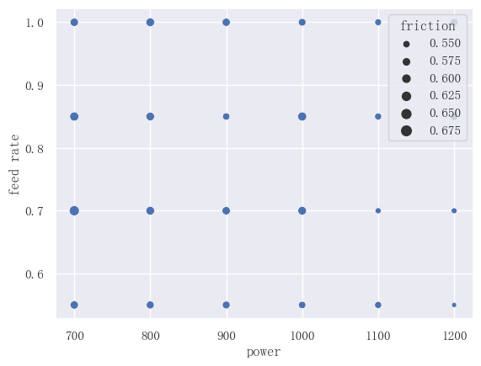

png

sns.set_style('darkgrid')  
fig = plt.figure(figsize=(12, 10))  
ax = Axes3D(fig)  
fig.add_axes(ax)  
ax_obj = ax.scatter(df['power'], df['feed rate'],c=df['friction'],\  
 cmap=cm.plasma)  
plt.colorbar(ax_obj, shrink=0.7)  
ax.set_title('Friction coefficient Distribution', fontdict=font1)  
ax.set_xlabel('\nPower(w)', fontdict=font1)  
ax.set_ylabel('\nFeed rate(rad/min)', fontdict=font1)  
plt.tick_params(labelsize=13)  
plt.show()

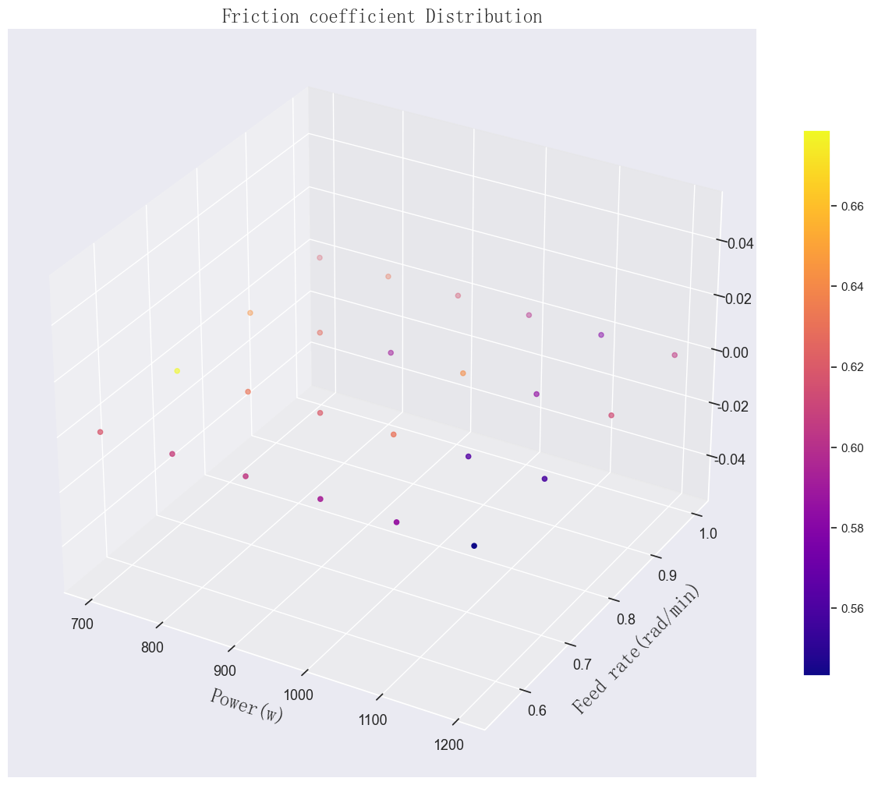

png

data = df.pivot(index='power', columns='feed rate', values='friction').T  
data.sort_index(ascending=False, inplace=True)  
data

power

700

800

900

1000

1100

1200

feed rate

1.00

0.6200

0.6315

0.6163

0.6004

0.5800

0.6048

0.85

0.6442

0.6277

0.5909

0.6417

0.5850

0.6134

0.70

0.6788

0.6312

0.6201

0.6305

0.5628

0.5590

0.55

0.6181

0.6083

0.6050

0.5933

0.5857

0.5432

# plot the color map  
fig= plt.subplots(figsize=(10,6))  
ax_obj1 = sns.heatmap(data, annot=True, fmt="f", linewidths=.6)  
plt.title('Friction distribution', fontdict=font1)  
plt.xlabel('\nLaser power(W)', fontdict=font1)  
plt.ylabel('\nPowder feed rate(rad/s)', fontdict=font1)  
a, b = data.shape  
plt.show()

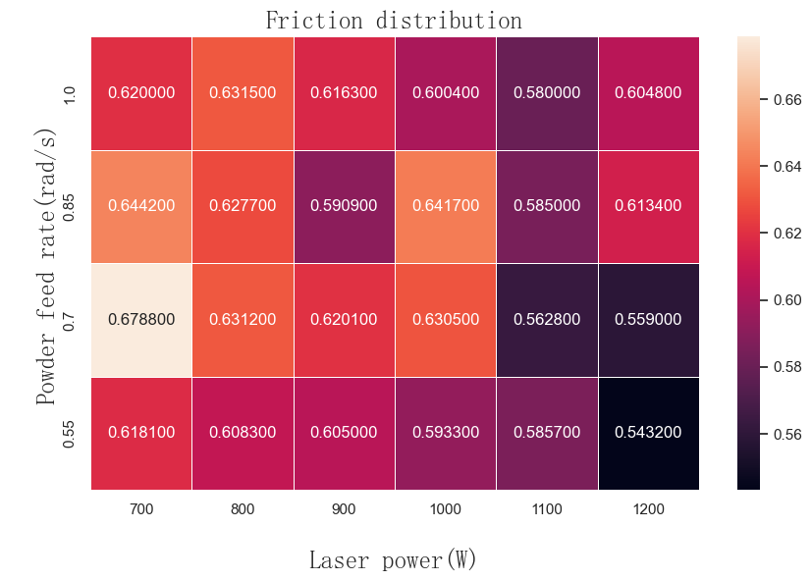

png

## Data normalization, 0 mean, 1 variance

scaler_X = StandardScaler().fit(df[['power', 'feed rate']])  
scaler_X.mean_  
new_X = scaler_X.transform(df[['power', 'feed rate']])

scaler_Y = StandardScaler().fit(df[['friction']])  
scaler_Y.mean_  
scaler_Y.scale_  
new_Y = scaler_Y.transform(df[['friction']])

# standardized data table  
new_df = pd.DataFrame()  
new_df['power'] = new_X[:, 0].ravel()  
new_df['feed rate'] = new_X[:, 1].ravel()  
new_df['friction'] = new_Y.ravel()

new_df.head()

power

feed rate

friction

0

-1.46385

1.341641

0.406076

1

-0.87831

1.341641

0.795097

2

-0.29277

1.341641

0.280913

3

0.29277

1.341641

-0.256951

4

0.87831

1.341641

-0.947040

# check the distribution of the standardized data  
sns.set_style('darkgrid')  
fig = plt.figure(figsize=(12, 10))  
ax = Axes3D(fig)  
fig.add_axes(ax)  
ax_obj = ax.scatter(new_df['power'], new_df['feed rate'],c=new_df['friction'],\  
 cmap=cm.plasma)  
plt.colorbar(ax_obj, shrink=0.7)  
ax.set_title('Distribution After Standardization', fontdict=font1)  
ax.set_xlabel('Power', fontdict=font1)  
ax.set_ylabel('Feed rate', fontdict=font1)  
plt.tick_params(labelsize=13)  
plt.show()

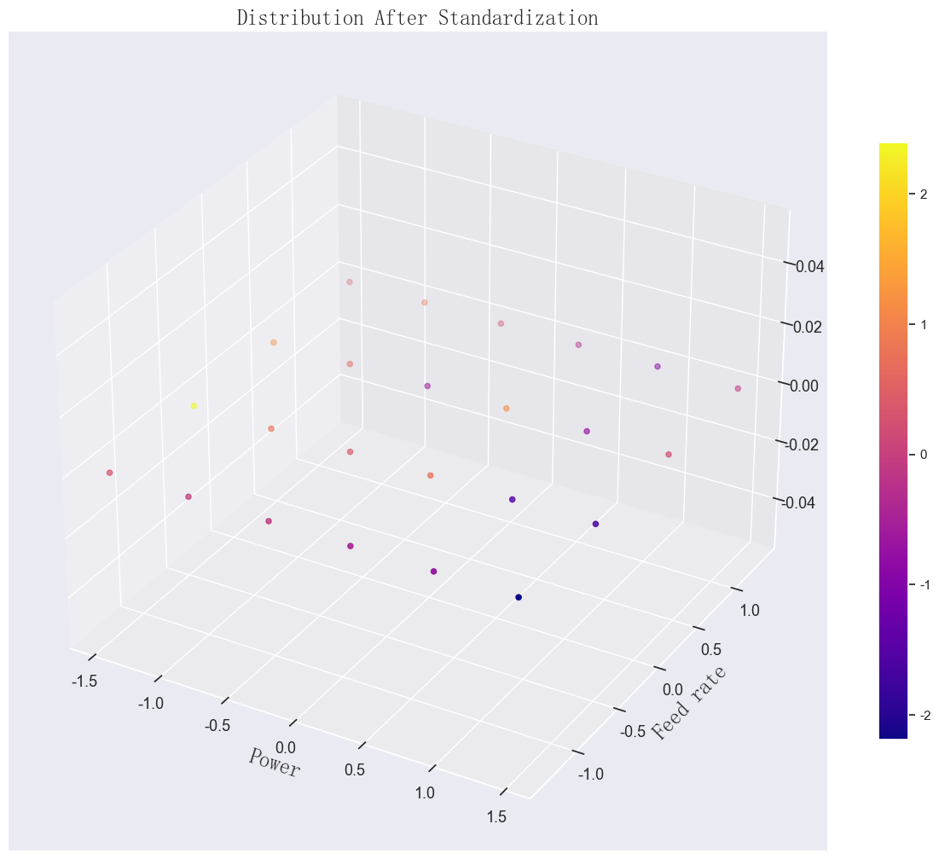

png

# Cross-validation model evaluation

## approximately 10-fold

new_df.shape

(24, 3)

shuffle = ShuffleSplit(n_splits=10, test_size=10, random_state=42)  
index = np.arange(24)  
for train_index, test_index in shuffle.split(index):  
 print(train_index)  
 print(test_index)

[ 2 12 15 3 4 22 17 20 23 7 10 14 19 6]  
[ 8 16 0 18 11 9 13 1 21 5]  
[ 8 3 6 22 2 13 17 14 15 9 16 23 21 11]  
[ 5 18 1 7 0 10 12 19 4 20]  
[19 3 0 2 7 12 11 6 14 1 20 8 17 13]  
[23 15 4 21 9 22 5 10 16 18]  
[23 8 22 6 18 7 14 15 13 3 9 1 11 17]  
[ 5 2 10 19 0 12 20 16 21 4]  
[15 18 2 10 23 16 7 11 21 8 6 0 12 14]  
[ 3 13 5 20 1 4 19 17 9 22]  
[17 10 5 21 20 2 4 15 0 1 11 7 8 6]  
[13 19 3 9 22 12 23 16 14 18]  
[11 3 0 21 18 2 12 9 19 14 8 6 13 22]  
[ 5 1 16 10 7 15 17 20 23 4]  
[23 19 10 13 3 16 11 5 12 9 1 21 18 6]  
[14 4 20 2 7 15 0 17 22 8]  
[17 9 20 0 4 13 21 7 5 6 2 8 12 19]  
[22 14 23 1 11 16 3 15 10 18]  
[ 0 20 6 5 11 17 23 18 19 21 4 16 2 1]  
[ 9 8 7 12 3 14 15 13 22 10]

x2 = [0.5, 0.54, 0.58, 0.62, 0.66, 0.7]  
sns.set_style('darkgrid')

def cv_loop2(reg):  
 mses = []  
 maes = []  
 y_test_res = []  
 y_predict_res = []  
 maes_relative = []  
 i = 1  
 indx = [1,2,3, 4, 8, 10]  
 plt.figure(figsize=(8, 6))  
 for train_index, test_index in shuffle.split(index):  
 # extract the training and test datasets  
 x_train = new_df[['power', 'feed rate']].iloc[train_index]  
 y_train = new_df['friction'].iloc[train_index]  
 x_test = new_df[['power', 'feed rate']].iloc[test_index]  
 y_test = new_df['friction'].iloc[test_index]  
 # model prediction and training  
 reg.fit(x_train, y_train)  
 print(reg.log_marginal_likelihood())  
 y_predict = reg.predict(x_test).reshape(-1,1)  
 y_test_arr = np.array(y_test.tolist())  
 y_test_arr = y_test_arr.reshape(-1,1)  
 y_test_inverse = scaler_Y.inverse_transform(y_test_arr)  
 y_predict_inverse = scaler_Y.inverse_transform(y_predict)  
 if i in indx:  
 plt.scatter(y_test_inverse, y_predict_inverse)  
 y_test_res.append(y_test_inverse)  
 y_predict_res.append(y_predict_inverse)  
 mse = mean_squared_error(y_test_inverse, y_predict_inverse, squared=False)  
 mses.append(mse)  
 mae = mean_absolute_error(y_test_inverse, y_predict_inverse)  
 maes.append(mae)  
 maes.append(mae)  
 maes_relative.append(mae/np.mean(y_test_inverse))  
 i += 1  
 plt.plot(x2, x2, 'r-')  
 plt.xlim(0.5, 0.7)  
 plt.ylim(0.5, 0.7)  
 plt.xticks(x2)  
 plt.yticks(x2)  
 plt.tick_params(labelsize=15)  
 plt.xlabel('Test value', fontdict=font2)  
 plt.ylabel('Predicted value', fontdict=font2)  
 plt.show()  
 return mses, maes, maes_relative, y_test_res, y_predict_res

kernel_1 = 1.0 * RBF(length_scale=1,\  
 length_scale_bounds=(1e-3, 1e3)) +\  
WhiteKernel(noise_level=1e-4, noise_level_bounds=(1e-10, 1e+2))  
reg_1 = GaussianProcessRegressor(kernel=kernel_1,\  
 n_restarts_optimizer=20,\  
 alpha=0, random_state=42)

mses2, maes2, maes_relative, y_test_res, y_predict_res = cv_loop2(reg_1)  
mses2

-17.354545998419084  
-19.090632559738403  
-16.630513425402164  
-18.50601037931942  
-19.840376660686147  
-15.498906265103779  
-17.001476449070683  
-19.38757890264254  
-18.88130649000571  
-12.95110844810442

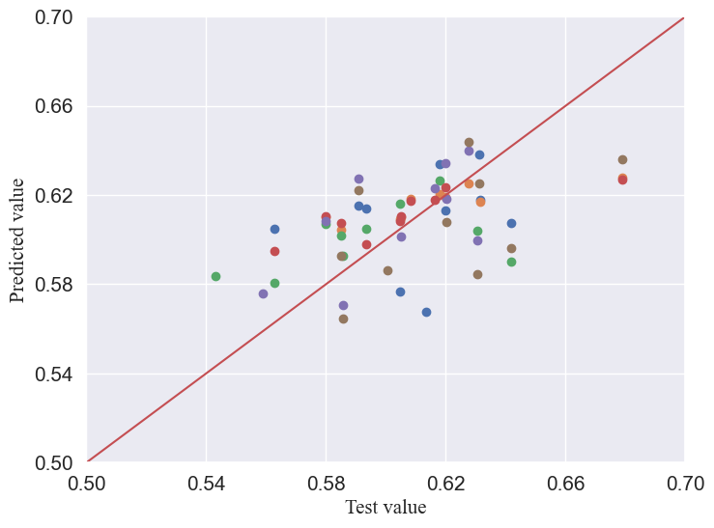

png

[0.027175344674240366,  
 0.020632481292177724,  
 0.02586067575025751,  
 0.02310308652681755,  
 0.017362005300649838,  
 0.034477063061697,  
 0.030962911885091753,  
 0.020059619753770744,  
 0.020884420508134095,  
 0.028598368044668185]

#output RMSE, MAE, RMD  
np.mean(mses2), np.mean(maes2), np.mean(maes_relative)

(0.02491159767975048, 0.019782432686140206, 0.032679887703016684)

# Gaussian Process Regression

## noisy kernel function, Gaussian kernel with White noise kernel

kernel_1 = 1.0 * RBF(length_scale=50.0,\  
 length_scale_bounds=(1, 1e2))+ WhiteKernel(noise_level=1e-1, noise_level_bounds=(1e-3, 1e-1))  
reg_1 = GaussianProcessRegressor(kernel=kernel_1,\  
 n_restarts_optimizer=10,\  
 alpha=0.1, random_state=42)  
reg_1.fit(new_df[['power', 'feed rate']], new_df['friction'])

In a Jupyter environment, please rerun this cell to show the HTML representation or trust the notebook. On GitHub, the HTML representation is unable to render, please try loading this page with nbviewer.org.

GaussianProcessRegressor

reg_1.kernel

1**2 * RBF(length_scale=50) + WhiteKernel(noise_level=0.1)

## Export hyperparameters

reg_1.get_params(),reg_1.log_marginal_likelihood()

({'alpha': 0.1,  
 'copy_X_train': True,  
 'kernel__k1': 1**2 * RBF(length_scale=50),  
 'kernel__k2': WhiteKernel(noise_level=0.1),  
 'kernel__k1__k1': 1**2,  
 'kernel__k1__k2': RBF(length_scale=50),  
 'kernel__k1__k1__constant_value': 1.0,  
 'kernel__k1__k1__constant_value_bounds': (1e-05, 100000.0),  
 'kernel__k1__k2__length_scale': 50.0,  
 'kernel__k1__k2__length_scale_bounds': (1, 100.0),  
 'kernel__k2__noise_level': 0.1,  
 'kernel__k2__noise_level_bounds': (0.001, 0.1),  
 'kernel': 1**2 * RBF(length_scale=50) + WhiteKernel(noise_level=0.1),  
 'n_restarts_optimizer': 10,  
 'n_targets': None,  
 'normalize_y': False,  
 'optimizer': 'fmin_l_bfgs_b',  
 'random_state': 42},  
 -32.73118684086089)

# create a grid for plotting test dat  
p_min, p_max = new_df['power'].min(),\  
new_df['power'].max()  
s_min, s_max = new_df['feed rate'].min(),\  
new_df['feed rate'].max()  
print(p_max, p_min)  
print(s_max, s_min)  
p_set1, s_set1 = np.meshgrid(np.arange(p_min, p_max + 0.3, 0.01),\  
 np.arange(s_min, s_max + 0.3, 0.01))

1.4638501094227996 -1.4638501094227996  
1.3416407864998738 -1.3416407864998738

p_set1.shape

(299, 323)

output1, std = reg_1.predict(np.c_[p_set1.ravel(), s_set1.ravel()]\  
 , return_std=True)  
output1, std = output1.reshape(p_set1.shape), std.reshape(p_set1.shape)

# Upper and lower confidence intervals

up, down = output1 * (1 + 1.96*std), output1 * (1 - 1.96*std)

output1

array([[ 0.50236006, 0.49623104, 0.49005578, ..., -1.86383876,  
 -1.86298419, -1.86188353],  
 [ 0.51811274, 0.51195099, 0.50574162, ..., -1.86960029,  
 -1.86872765, -1.86760791],  
 [ 0.53392203, 0.52772763, 0.52148422, ..., -1.87517721,  
 -1.87428649, -1.87314765],  
 ...,  
 [ 0.47997118, 0.48203047, 0.4840355 , ..., -0.15367611,  
 -0.14645806, -0.13926091],  
 [ 0.47773166, 0.47983515, 0.48188468, ..., -0.15704468,  
 -0.14983232, -0.14264068],  
 [ 0.47551302, 0.47765977, 0.47975285, ..., -0.16038489,  
 -0.15317901, -0.14599368]])

# lower bound of the Ggaussian confidence interval  
ucb_1 = output1 + 0.1*std  
ucb_2 = output1 + 1*std  
ucb_3 = output1 + 100*std

output1_data = pd.DataFrame(columns=['power', 'feed rate', 'friction'])  
output1_data['power'] = p_set1.ravel()  
output1_data['feed rate'] = s_set1.ravel()  
output1_data['friction'] = output1.ravel()  
output1_data.shape

(96577, 3)

# denormalization of predicted data  
scale_X = scaler_X.inverse_transform(output1_data[['power', 'feed rate']])  
scale_Y = scaler_Y.inverse_transform(output1_data[['friction']])

# variance denormalization  
scale_std = scaler_Y.inverse_transform(std)

new_output = pd.DataFrame(columns=['power', 'feed rate', 'friction'])  
new_output['power'] = scale_X[:, 0].ravel()  
new_output['feed rate'] = scale_X[:, 1].ravel()  
new_output['friction'] = scale_Y.ravel()

p_inverse = scale_X[:, 0].reshape(p_set1.shape)  
s_inverse = scale_X[:, 1].reshape(s_set1.shape)  
out_inverse = scale_Y.reshape(p_set1.shape)

p_inverse.max()  
s_inverse.max()

1.0497611929712034

output_pivot = new_output.pivot(index='power', columns='feed rate', values='friction')  
f, ax = plt.subplots(figsize=(12,6))  
sns.heatmap(output_pivot, ax=ax)  
ax.set_title('noise kernel heatmap', fontsize=30)

Text(0.5, 1.0, 'noise kernel heatmap')

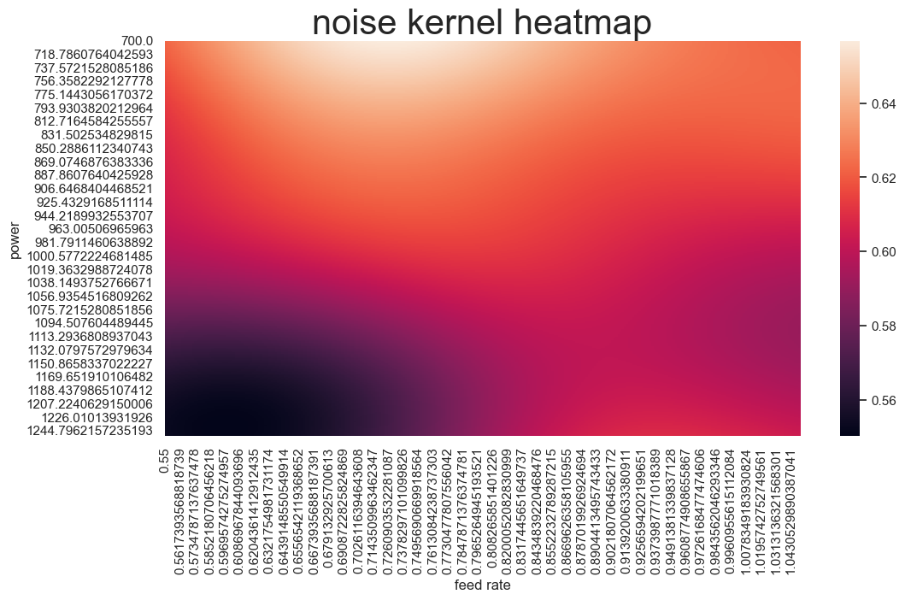

png

df.iloc[:,2].max(),df.iloc[:,2].min()

(0.6788, 0.5432)

# plot surface, contour, and combined scatter plot  
sns.set(  
 style='darkgrid',  
 font='Times New Roman',  
 font_scale=1.8  
)  
fig = plt.figure(figsize=(10, 6), facecolor='#ebecf2')  
ax = Axes3D(fig)  
fig.add_axes(ax)  
surface = ax.plot_surface(p_inverse, s_inverse, out_inverse,\  
 cmap=cm.coolwarm, linewidth=0,\  
 alpha=0.8, antialiased=False)  
ax.scatter(df['power'], df['feed rate'], df['friction'],\  
 c=df['friction'], cmap=cm.coolwarm)  
ax.contourf(p_inverse, s_inverse, out_inverse, np.arange(0.5, 0.7, 0.01),\  
 zdir='output1', offset=0.53, cmap=cm.coolwarm, alpha=0.8)  
ax.set_xlabel('\nLaser Power(W)', fontdict=font2)  
ax.set_ylabel('\nPowder feed rate(rad/s)', fontdict=font2)  
ax.zaxis.set_major_formatter(ticker.FormatStrFormatter('%.3f'))  
plt.colorbar(surface, shrink=0.9)  
plt.tick_params(labelsize=13)  
plt.show()

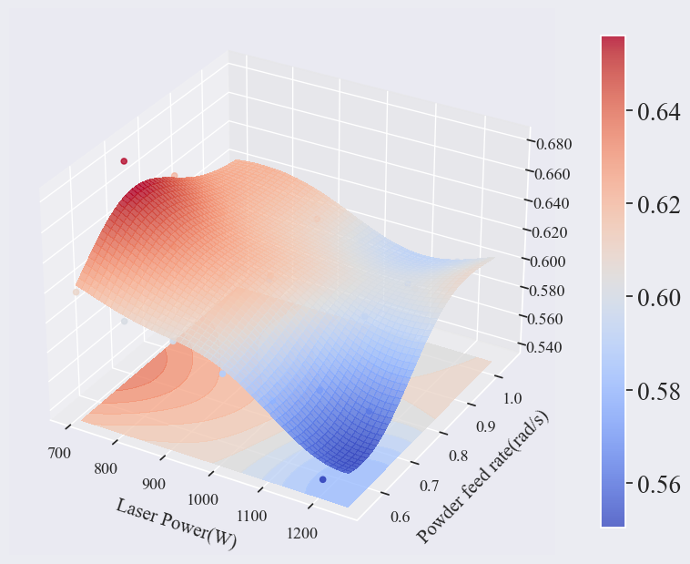

png

## Marginal likelihood visualization

plt.figure(figsize=(12, 8))  
theta0 = np.logspace(-2, 4, 50)  
theta1 = np.logspace(-2, 1, 50)  
Theta0, Theta1 = np.meshgrid(theta0, theta1)  
LML = [reg_1.log_marginal_likelihood(np.log([0.36, t0, t1]))  
 for t0, t1 in zip(Theta0.ravel(), Theta1.ravel())]  
LML = np.reshape(LML, newshape=Theta0.shape)  
vmin, vmax = (-LML).min(), 50  
print(vmax)  
print(vmin)  
level = np.around(np.logspace(np.log10(vmin), np.log10(vmax), num=50), decimals=1)  
plt.contour(Theta0, Theta1, -LML, level, cmap=cm.coolwarm)  
plt.colorbar()  
plt.xscale("log")  
plt.yscale("log")  
plt.xlabel("Length-scale")  
plt.ylabel("Noise-level")  
plt.title("Log-marginal-likelihood")  
plt.tight_layout()  
plt.show()

50  
30.39445349060818

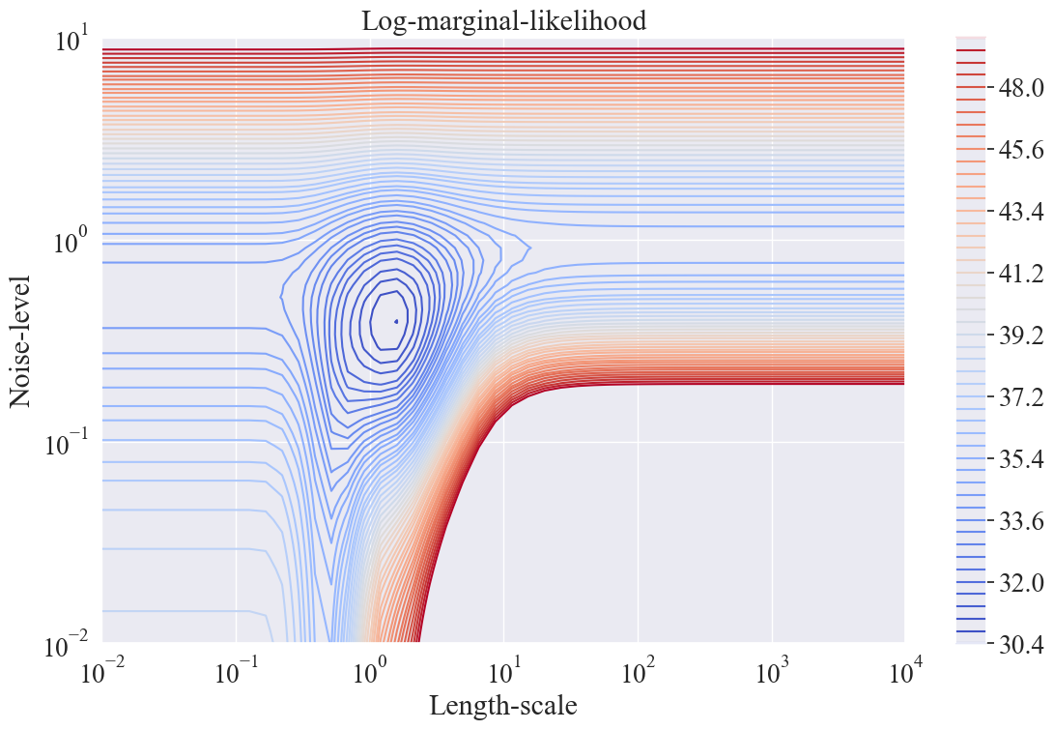

png

# surface visualization  
x = p_inverse.ravel()  
y = s_inverse.ravel()  
z = out_inverse.ravel()  
point_obj = zip(x, y, z)  
data = []  
for point in point_obj:  
 data.append(point)  
len(data)

96577

sns.set_style('white')  
font1 = {  
 'family': 'Times New Roman',  
 'weight': 'bold',  
 'size': 30  
}  
font2 = {  
 'family': 'Times New Roman',  
 'weight': 'normal',  
 'size': 15  
}  
font3 = {  
 'family': 'Times New Roman',  
 'weight': 'normal',  
 'size': 30  
}

# plot contour map  
fig, ax = plt.subplots(figsize=(12,6))  
plt.contourf(p_inverse, s_inverse,\  
 out_inverse, np.arange(0.5, 0.7, 0.001),\  
 offset=0, cmap=cm.coolwarm,\  
 alpha=0.8)  
sns.scatterplot(x='power', y='feed rate', size='friction',\  
 data=df, sizes=(10, 100))  
plt.legend(loc='upper left', prop=font2)  
plt.tick_params(labelsize=24)  
labels = ax.get_xticklabels() + ax.get_yticklabels()  
[label.set_fontname('Times New Roman') for label in labels]  
cb = plt.colorbar()  
cb_labels = cb.ax.yaxis.get_ticklabels()  
for cb_label in cb_labels:  
 cb_label.set_family('Times New Roman')  
 cb_label.set_fontsize(18)  
x_tick = [700 + i*100 for i in range(6)]  
y_tick = [0.55 + j*0.15 for j in range(6)]  
plt.xticks(x_tick, fontsize=16)  
plt.yticks(y_tick, fontsize=16)  
plt.xlim(700, 1250)  
plt.ylim(0.55, 1.05)  
plt.title('Friction Contour Distribution', fontdict=font2)  
plt.xlabel('Laser Power (W)', fontdict=font2)  
plt.ylabel('Feed rate (rad/min)', fontdict=font2)  
plt.show()

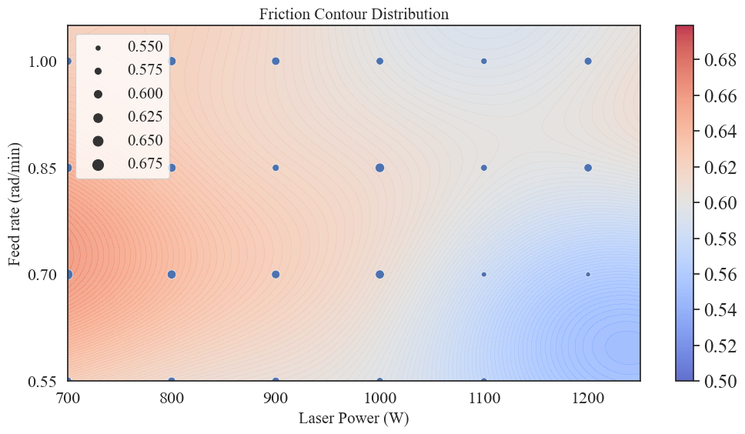

png

out_inverse.min(),out_inverse.max()

(0.5503183663548279, 0.6568872244464126)

# plot contour map  
plt.figure(figsize=(12,6))  
contour = plt.contour(p_inverse, s_inverse, out_inverse,\  
 np.arange(out_inverse.min(), out_inverse.max(), 0.002),  
 off_set=0, cmap=cm.coolwarm, alpha=0.7)  
plt.colorbar()  
plt.title('Friction Contour Distribution', fontdict=font2)  
plt.xlabel('power', fontdict=font2)  
plt.ylabel('feed rate', fontdict=font2)  
plt.clabel(contour)  
plt.tick_params(labelsize=24)  
plt.show()

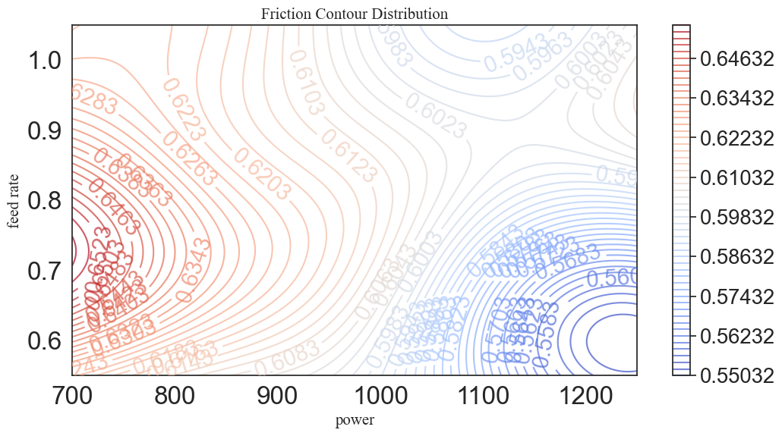

png

# UCB point selection

# upper bound of the confidence interval  
#β values of 0.1, 1, 10, 100  
ucb_1 = out_inverse + 0.01*std  
ucb_2 = out_inverse + 0.1*std  
ucb_3 = out_inverse + 1*std  
ucb_4 = out_inverse + 10*std

# calculate UCB data  
output1_data = pd.DataFrame(columns=['power', 'feed rate', 'friction'])  
output1_data['power'] = p_inverse.ravel()  
output1_data['feed rate'] = s_inverse.ravel()  
output1_data['friction'] = out_inverse.ravel()  
output1_data['ucb-0.01'] = ucb_1.ravel()  
output1_data['ucb-0.1'] = ucb_2.ravel()  
output1_data['ucb-1'] = ucb_3.ravel()  
output1_data['ucb-10'] = ucb_4.ravel()  
output1_data.head()

power

feed rate

friction

ucb-0.01

ucb-0.1

ucb-1

ucb-10

0

700.000000

0.55

0.622846

0.627526

0.669639

1.090770

5.302083

1

701.707825

0.55

0.622665

0.627325

0.669259

1.088609

5.282103

2

703.415650

0.55

0.622483

0.627123

0.668885

1.086509

5.262751

3

705.123475

0.55

0.622299

0.626920

0.668516

1.084471

5.244023

4

706.831301

0.55

0.622114

0.626717

0.668152

1.082494

5.225913

a = (p_inverse.min() + p_inverse.max())/2  
b = (s_inverse.min() + s_inverse.max())/2

x1, y1, x2, y2 = [], [], [], []  
for i in range(11):  
 x1.append(a)  
 y1.append(600 + 112*i)  
 x2.append(100 + 26*i)  
 y2.append(b)

a,b

(974.9598455532495, 0.7998805964856017)

# divide regions based on UCB for point selection  
temp1 = output1_data[(output1_data['power'] <= a) &\  
 (output1_data['feed rate'] <= b)]  
temp2 = output1_data[(output1_data['power'] > a) &\  
 (output1_data['feed rate'] <= b)]  
temp3 = output1_data[(output1_data['power'] <= a) &\  
 (output1_data['feed rate'] > b)]  
temp4 = output1_data[(output1_data['power'] > a) &\  
 (output1_data['feed rate'] > b)]

ucb_res = pd.DataFrame(columns=['power', 'feed rate', 'friction', 'ucb'])  
temp = [output1_data]  
ucb = ['ucb-0.01', 'ucb-0.1', 'ucb-1', 'ucb-10']  
k = 1  
for t in temp:  
 for u in ucb:  
 sort_data = t.sort_values(by=u, ascending=True)  
 filter_data = sort_data[['power', 'feed rate', 'friction', u]].iloc[0:k]  
 index = [u]  
 filter_data.index = index  
 filter_data.columns = ucb_res.columns  
 ucb_res = pd.concat([ucb_res, filter_data])

ucb_data = ucb_res.drop_duplicates(subset=['power', 'feed rate'], keep='first')  
ucb_data['ucbβ'] = ucb_data.index  
ucb_data = ucb_data[['ucbβ', 'power', 'feed rate', 'friction', 'ucb']]  
ucb_data.shape

(4, 5)

# write UCB selected data  
save_path =r'C:\Users\Administrator\Desktop\3.xls'  
size = ucb_data.shape  
work_book = xlwt.Workbook(encoding='utf-8')  
work_sheet = work_book.add_sheet('_ucb')  
columns = list(ucb_data.columns)  
for i in range(size[1]):  
 work_sheet.write(0, i, columns[i])  
for i in range(size[0]):  
 for j in range(size[1]):  
 work_sheet.write(i+1, j, ucb_data.iloc[i, j])  
work_book.save(save_path)  
print('Done!')

Done!

# visualize and compare UCB selected points  
# plot contour map   
sns.set_style('white')  
fig, ax = plt.subplots(figsize=(10,6))  
plt.contourf(p_inverse, s_inverse,\  
 out_inverse, np.arange(0.5, 0.7, 0.001),\  
 offset=0, cmap=cm.coolwarm,\  
 alpha=0.8)  
p1 = sns.scatterplot(x='power', y='feed rate', size='friction',\  
 hue='ucbβ',\  
 hue_order=['ucb-0.01', 'ucb-0.1', 'ucb-1', 'ucb-10'],\  
 sizes=(20, 100), data=ucb_data, legend=False)  
plt.tick_params(labelsize=13)  
labels = ax.get_xticklabels() + ax.get_yticklabels()  
[label.set_fontname('Times New Roman') for label in labels]  
cb = plt.colorbar()  
cb_labels = cb.ax.yaxis.get_ticklabels()  
for cb_label in cb_labels:  
 cb_label.set_family('Times New Roman')  
 cb_label.set_fontsize(13)  
x_tick = [600 + i*100 for i in range(7)]  
y_tick = [0.55 + j*0.15 for j in range(4)]  
plt.xticks(x_tick, fontsize=13)  
plt.yticks(y_tick, fontsize=13)  
plt.xlim(700, 1250)  
plt.ylim(0.55, 1.05)  
plt.plot(x1, y1)  
plt.plot(x2, y2, 'r')  
plt.title('Friction UCB', fontdict=font2)  
plt.xlabel('Laser power(W)', fontdict=font2)  
plt.ylabel('Powder feed rate(rad/s)', fontdict=font2)  
plt.show()

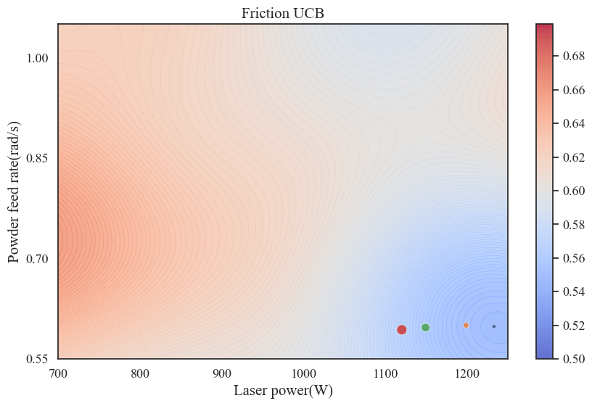

png

# Variance visualization

sns.set_style('darkgrid')  
fig1 = plt.figure(figsize=(12,10))  
ax1 = fig1.add_subplot(111, projection='3d')  
surf = ax1.plot_surface(p_inverse, s_inverse, std, rstride=8,\  
 cstride=3, linewidth=0, alpha=0.4,\  
 antialiased=True, cmap=cm.plasma)  
ax1.set_title('Friction Variance', fontdict=font2)  
ax1.set_xlabel('\nLaser power(W)', fontdict=font2)  
ax1.set_ylabel('\nPowder feed rate(rad/s)', fontdict=font2)  
cb1 = plt.colorbar(surf, shrink=0.9)  
cb1.set_ticks([0.45, 0.5, 0.55, 0.6])  
cb1.update_ticks()  
ax1.set_zticks([0.4, 0.45, 0.5, 0.55, 0.6])  
plt.tick_params(labelsize=13)  
plt.show()

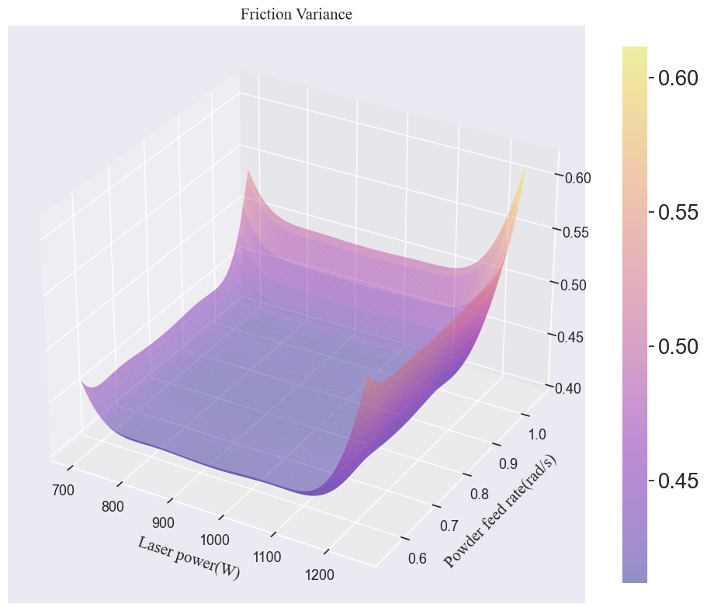

png

std.min()

0.41176257547792056