## Accelerator Actuator / Throttle Position Sensor

*Describe the accelerator actuator and throttle position sensor(s) used, describe additional circuitry used to check or condition the signal going to the motor controller. Describe wiring, cables and connectors used. Provide schematics and a description of the method of operation of any team-built signal conditioning electronics. Explain how your design meets all of the requirements of FH Rules* ***IC1.6*** *and* ***EV2***

Our vehicle utilizes a Penny & Giles TPS280DP Contactless Hall-Effect sensor for our throttle position sensor. The sensor will output on two channels, providing 0.33 VDC to 2.97 VDC, representing the rotational angle of the throttle peddle. This analog output is routed to our micro-controller, a LPC1768. This controller is known as our Powertrain Integration Module (PIM). The PIM will encode the throttle position sensor signal for two output control signals; one to our throttle body's motor controller and the other to our electric motor's motor controller.

The control signal to the throttle body's motor controller, a Pololu Jrk 12v12 USB Motor Controller with Feedback, is a pulse-width modulated (PWM) digital signal. It indicates the desired angle position for the butterfly-value within the throttle body, thus controlling airflow into the combustion engine. The motor controller will automatically utilize analog feedback from the throttle body to achieve the desired position.

The electric motor’s motor controller, a Sevcon Gen 4 size 8, utilizes an analog 0.00 VDC to 3.30 VDC analog control signal. This control signal is used to dictate the torque output desired from the Yasa electric motor, in a linear fashion.

All wiring used between the throttle peddle position sensor to the microcontroller, and from the microcontroller to both the motor controllers, will be 22 AWG, Southwire TWN75-T90 wires. [mention cabling and connectors]

Lastly, a safety feature has been included for the system. Due to the possibility of encountering a large outputted-torque difference between the Yasa electric motor and our combustion engine, the PIM will monitor the combustion engine’s internal RPM to ensure that it does not reach a threshold to redline. This is achieved by reading the engine’s RPM via CAN messages sent from the vehicle’s ECU. If the engine’s RPM is at or above a threshold of 13,000 RPM, (a safe threshold under the redline limit for the ICE), all torque production from the Yasa is ceased until below the threshold.

Our design meets all of the requirements of FH Rules IC1.6 and EV2 in the following manner described. Firstly, because the throttle position sensor operates within a voltage range of 0.33 VDC minimum to 2.97 VDC max, an output voltage below 0.33 VDC will be considered a short to ground / open circuit, and an output voltage above 2.97 VDC will be assumed to be a short to supply. In either case, the PIM will detect the analog voltage as residing outside the expected threshold, and will cease torque production to both the engine and the motor.

In the event that a short circuit to supply, short to ground, or open circuit occurs between the PIM and the motor controller for the throttle body occurs, the throttle body’s air intake value will close, resulting in idling the engine. This is because a PWM signal is required to control the motor controller, and a lack of such a PWM signal will automatically result in the motor controller closing the throttle body’s intake valve.

The Sevcon motor controller for the Yasa motor has built-in functionality to automatically detect shorts to ground, shorts to supply, and open circuits. Upon detecting a fault, it will cease torque production from the Yasa.

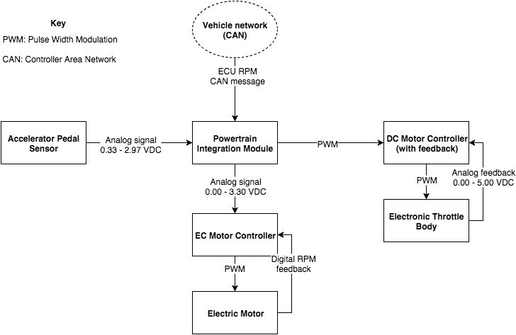

High-level schematic of Throttle control

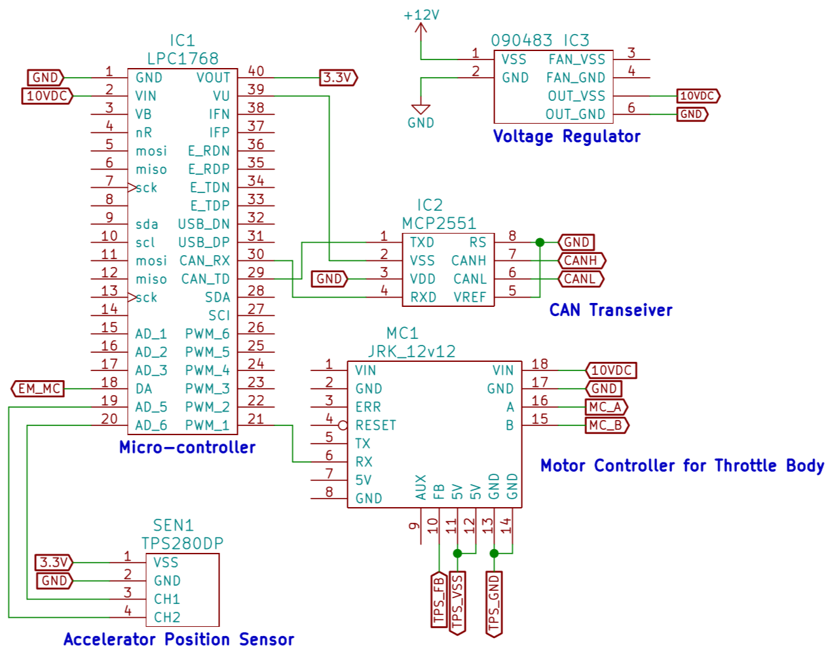

Low-level schematic of Throttle control

|  |  |
| --- | --- |
| Actuator / Encoder manufacturer and model: | Penny & Giles TPS280DP |
| Encoder principle (e.g.Potentiometer): | Contactless Hall-effect Sensor |
| Output: | Duel and Linear. 0.33-2.97 VDC, 2.97-0.33 VDC |
| Is motor controller accelerator signal isolated from TSV? | Yes /  No |
| If no, how will you satisfy rule **EV2.3**? |  |

Table 16 - Throttle Position encoder data

## Accelerator / throttle position encoder error check

*Describe how the system reacts if an error (e.g. short circuit or open circuit or equivalent) is detected. Describe circuitry used to check or condition the signal going to the motor controller. Describe how failures (e.g. Implausibility, short circuit, open circuit etc.) are detected and how the system reacts if an error is detected. State how you comply with* ***EV2.2***

To meet the requirements of EV2.2.1, our accelerator system has been setup to cease torque production upon an open circuit, short to ground, and short to power supply between each of our components within the system.

The motor controller for our electric motor has built-in functionality to detect the above conditions and cease production of torque from the electric motor should they occur.

Additionally, if any of the above conditions occur between the PIM and the motor controller for the throttle body, the motor controller will close the throttle body’s air intake value, ceasing torque production from the combustion engine. This would occur as the motor controller has been programmed to expect a control signal in the form of a pulse-width modulated signal. As such, any circuit fault highlighted above would not be of the required signal structure, and thus cause the motor controller to respond accordingly by preventing further torque output.

Finally, a circuit fault between the throttle position sensor and the PIM which resulted in a voltage to the PIM lower than 0.33 VDC or greater than 2.79 will cause the PIM to send idle signals to both motor controllers. This is because the output threshold for the throttle position sensor is between 0.33 VDC and 2.97 VDC, and as such, a voltage outside this range can be considered an erroneous signal, and will result in a prevention of any further torque production.