1. Count total number of flights per carrier in 2007

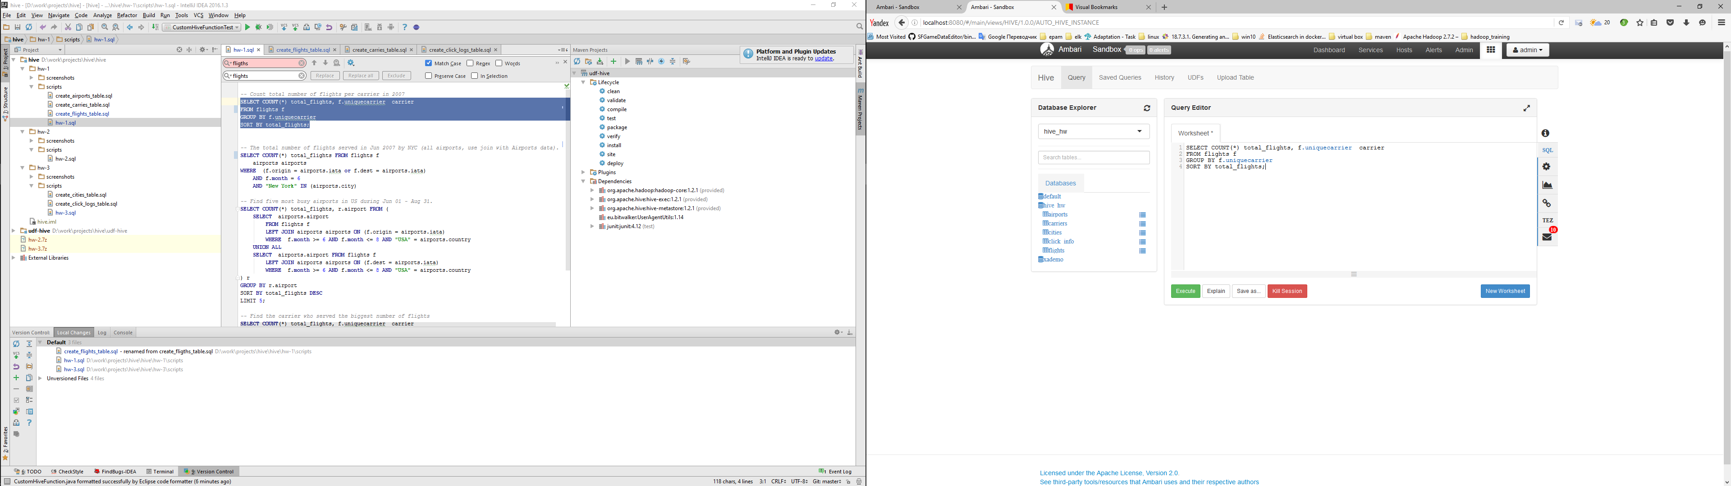

Query:

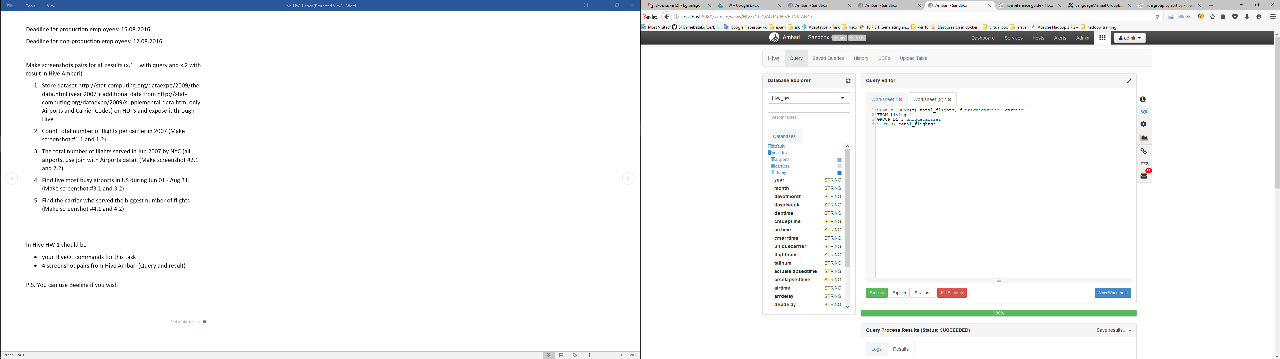

Result:

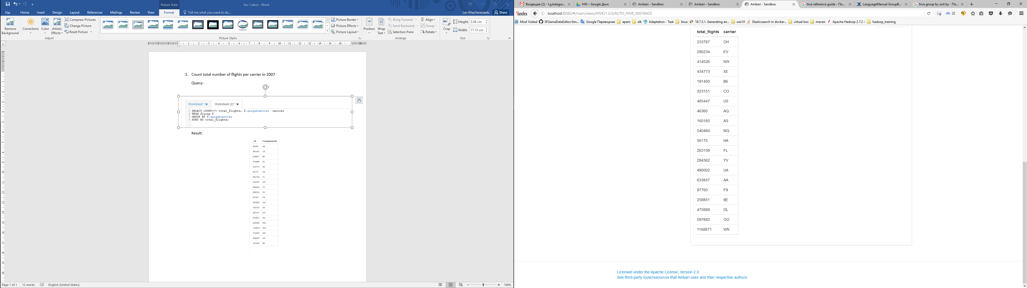

1. The total number of flights served in Jun 2007 by NYC (all airports, use join with Airports data).

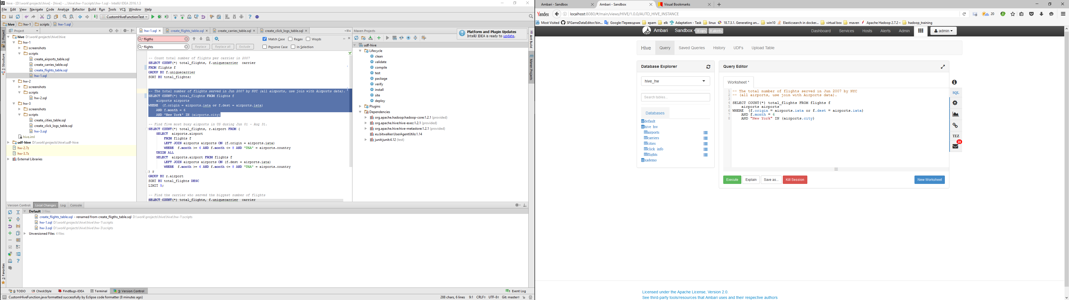

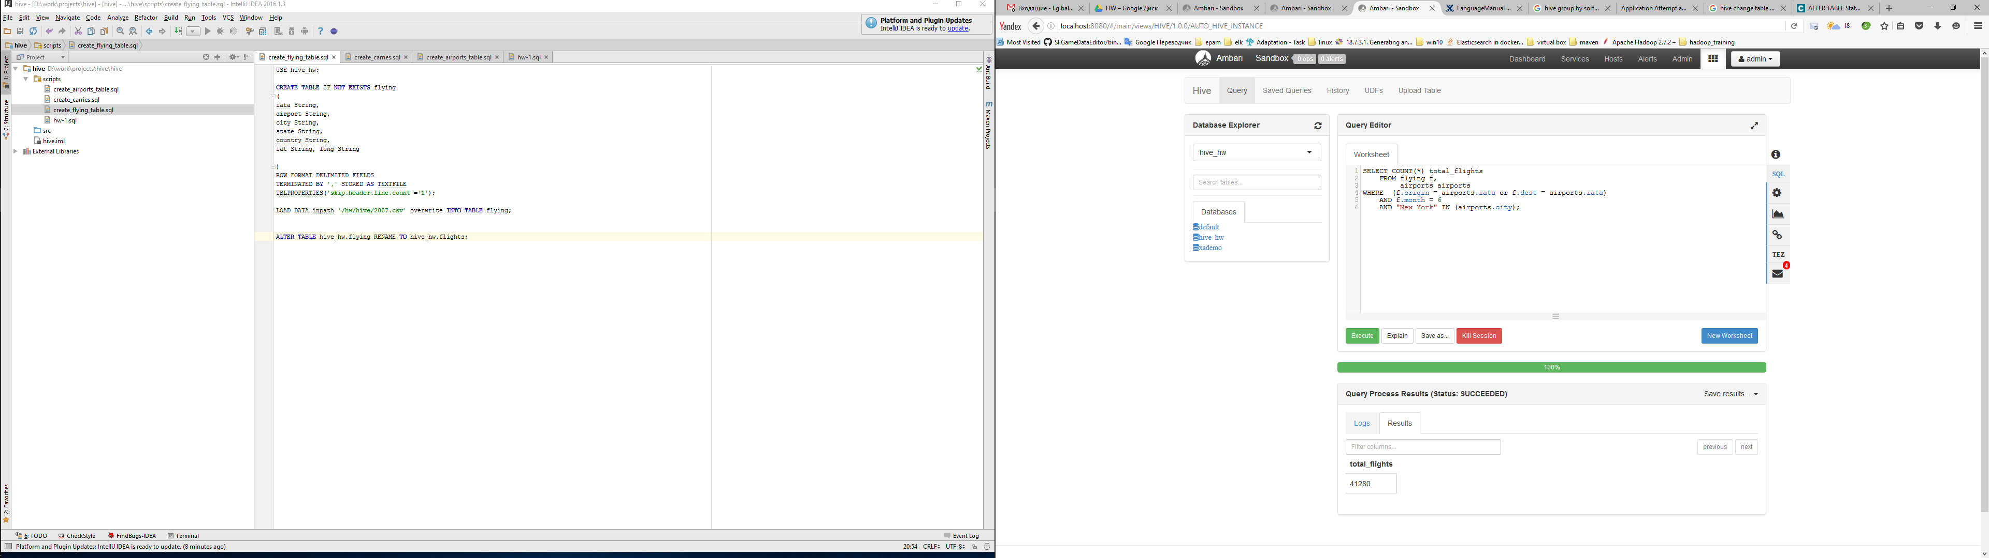

1. Find five most busy airports in US during Jun 01 - Aug 31.

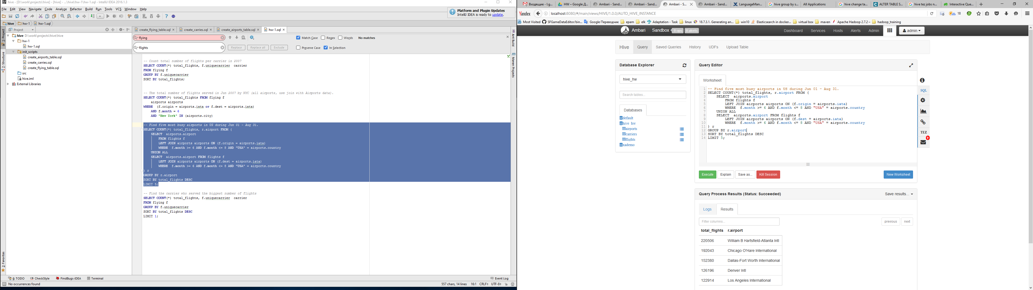

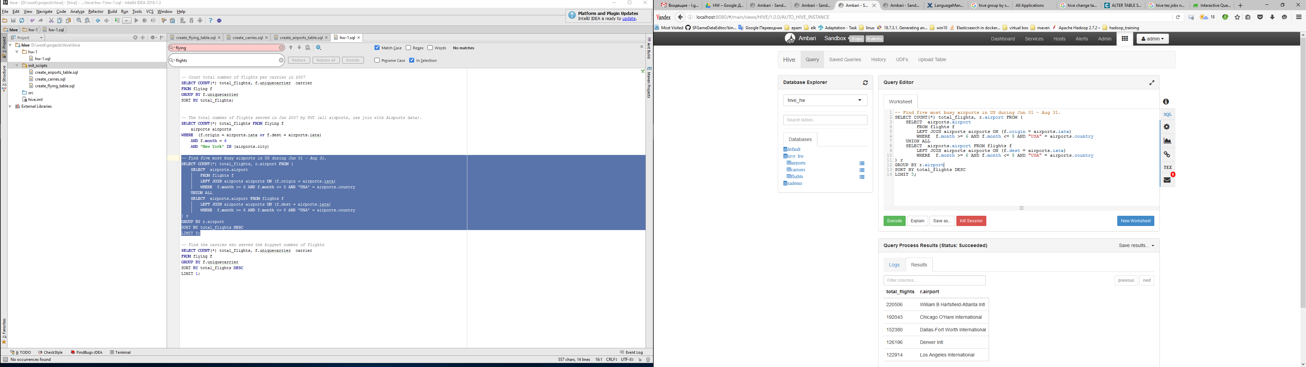

1. Find the carrier who served the biggest number of flights

