Find all carriers who cancelled more than 1 flights during 2007, order them from biggest to lowest

by number of cancelled flights and list in each record all departure cities where cancellation

happened.

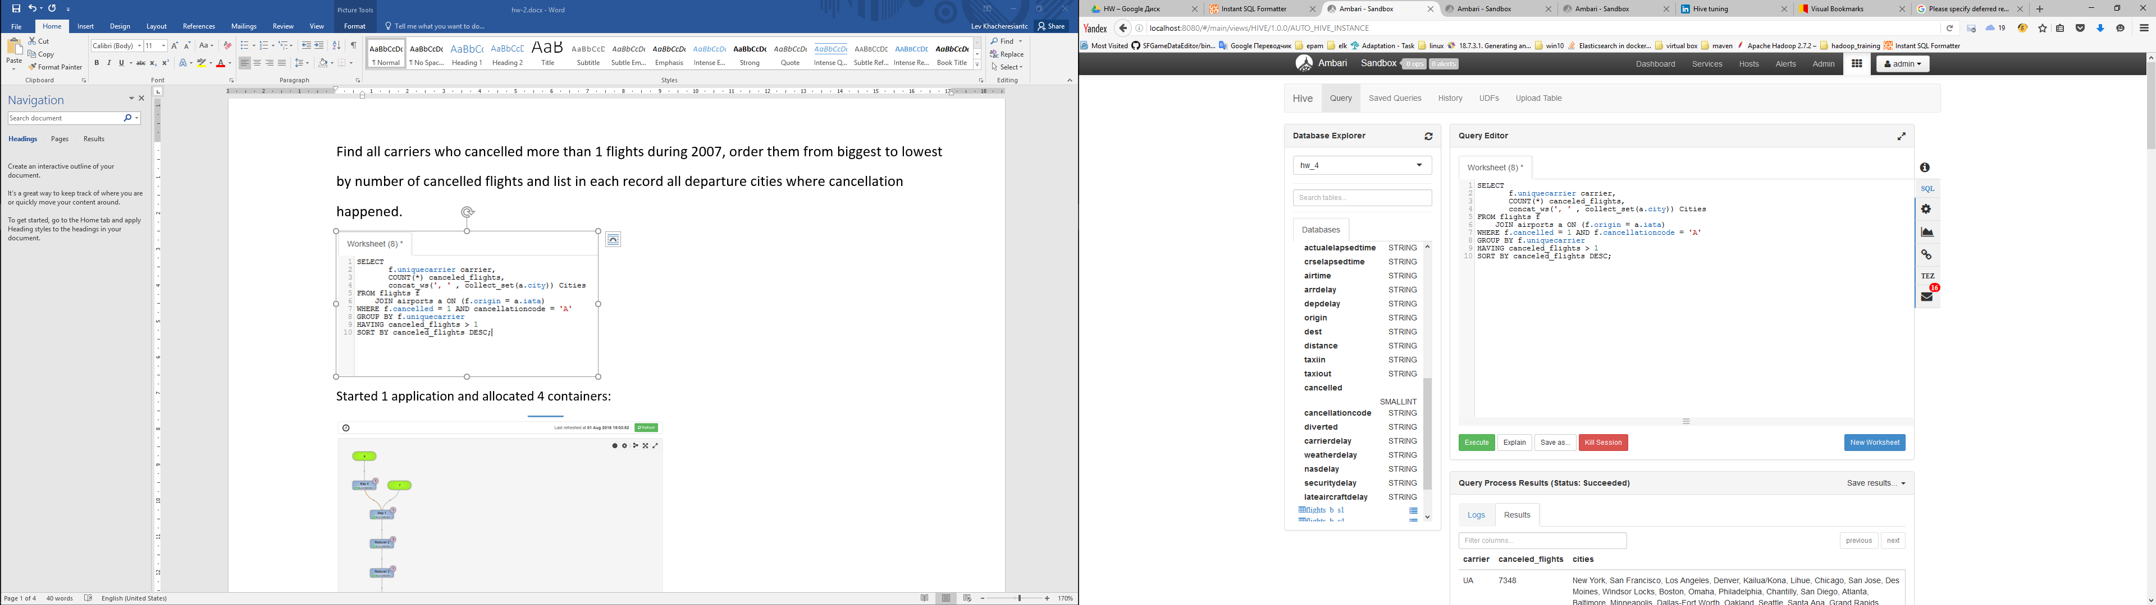

Started 1 application and allocated 4 containers:





