1. Use data from you UDF and find most popular device, browser, OS for each city.
   1. Most popular devices

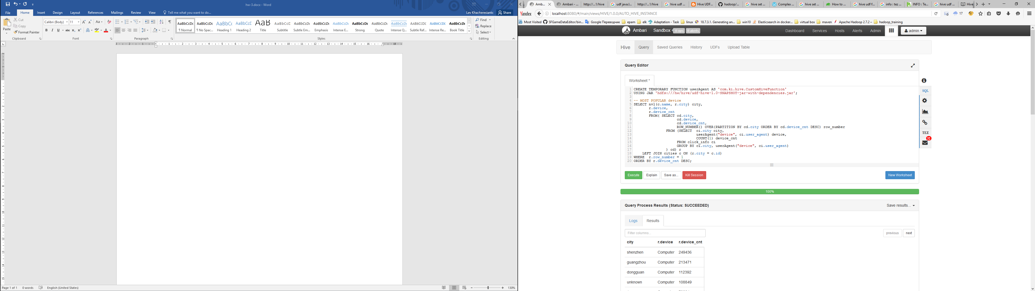

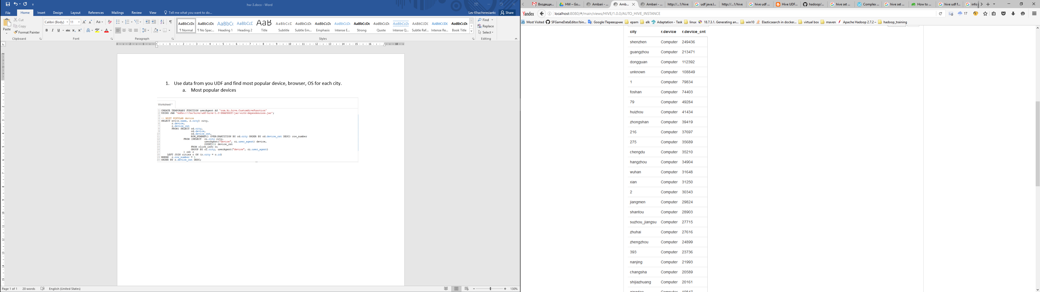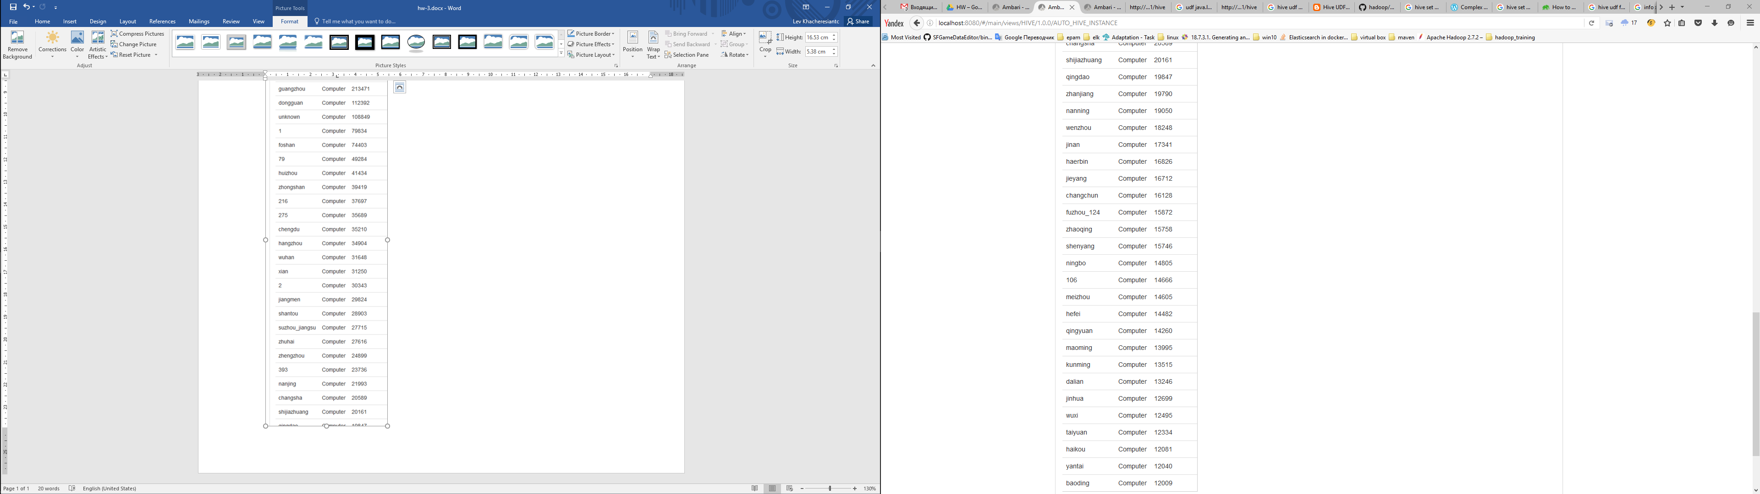

* 1. Most popular Browsers

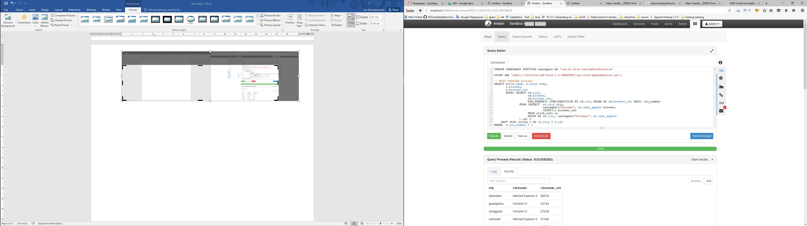

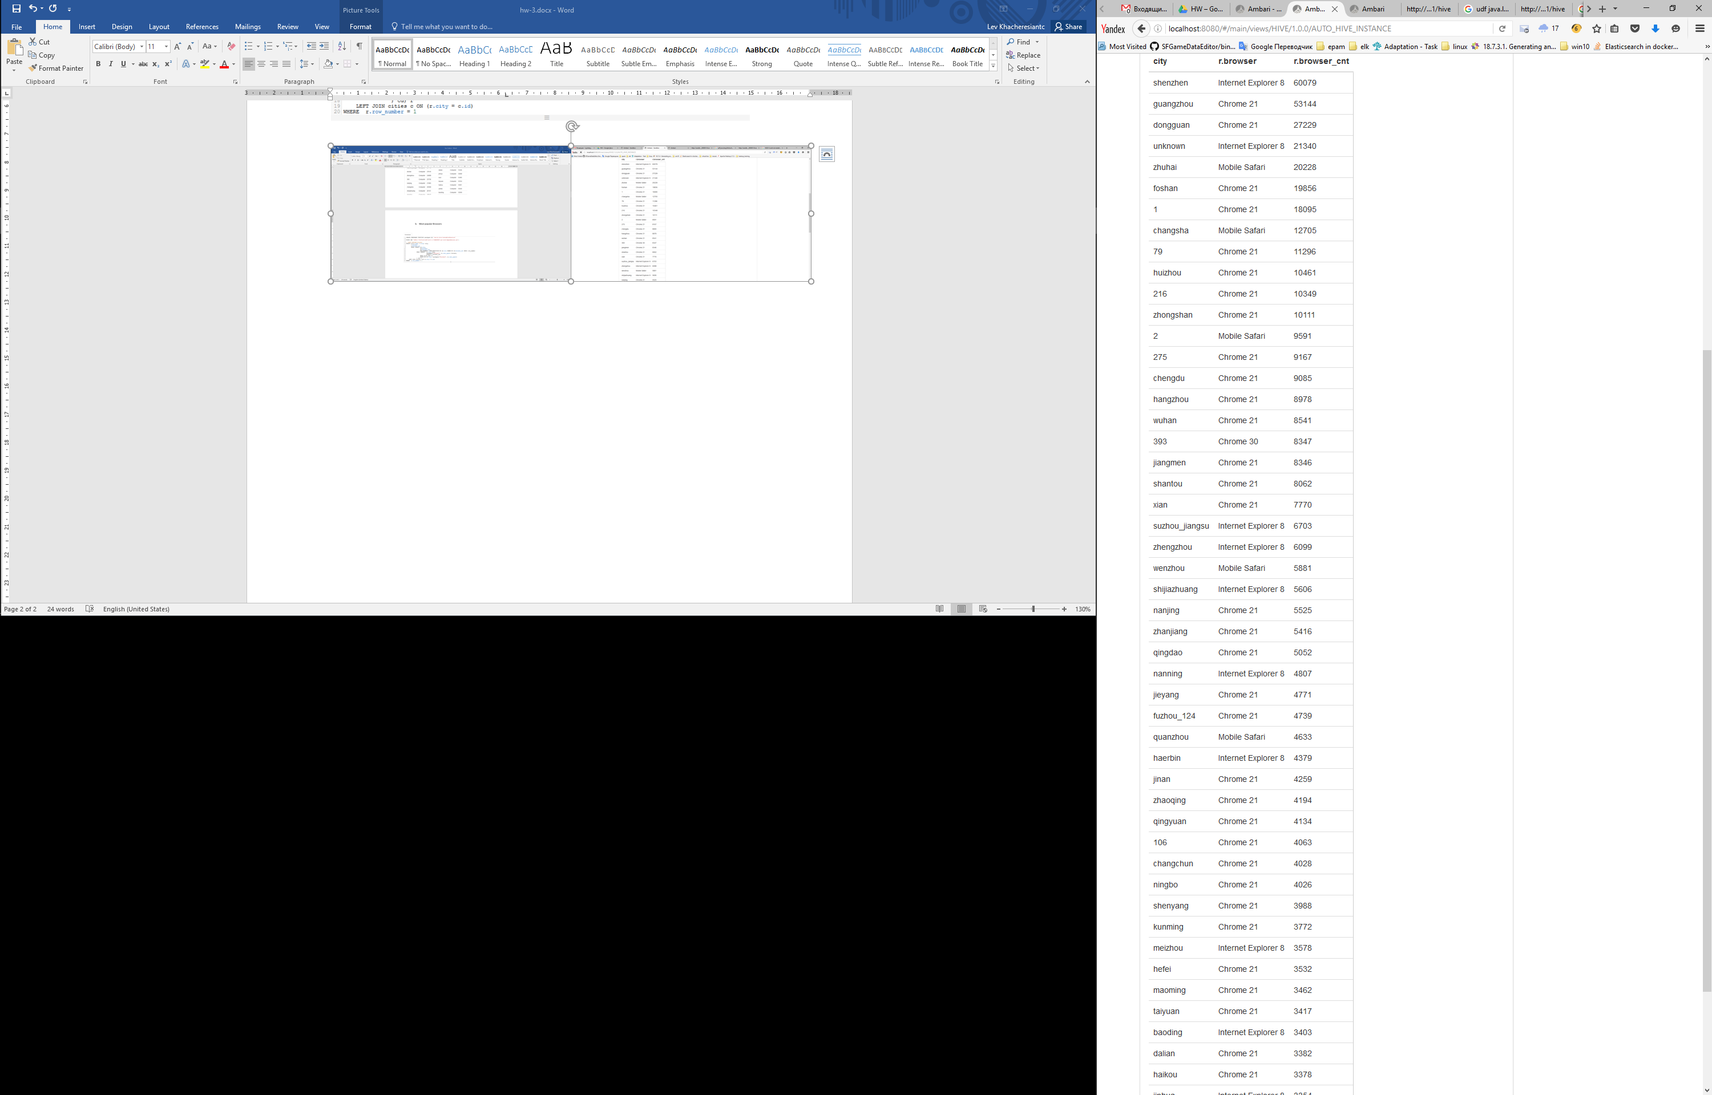

* 1. Most popular OS

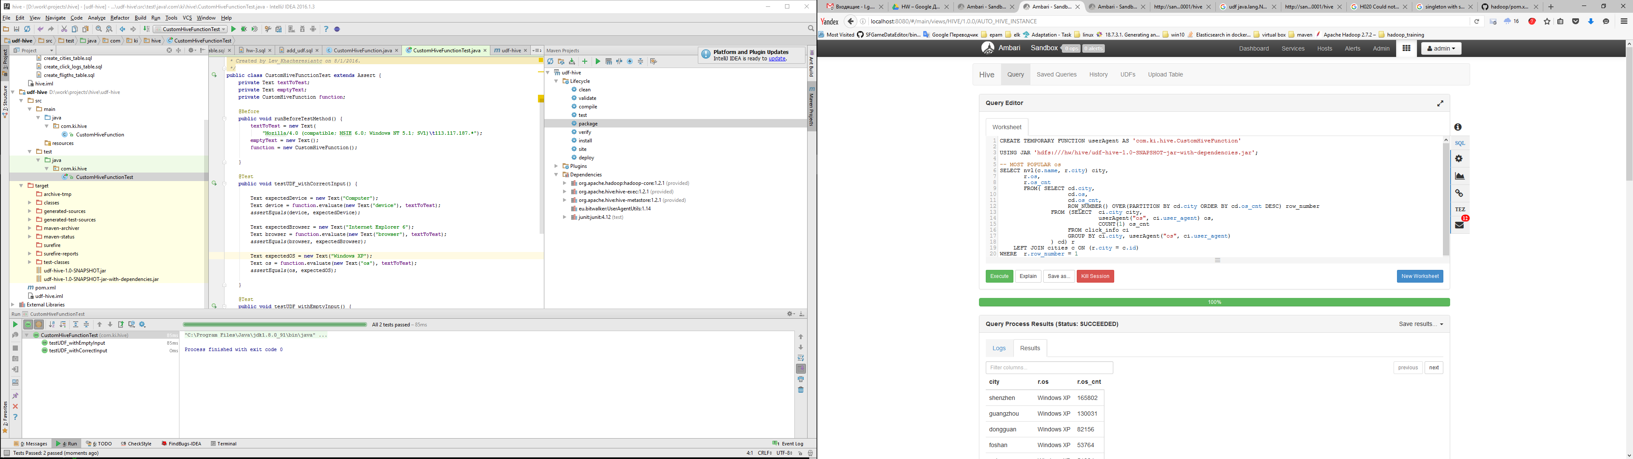

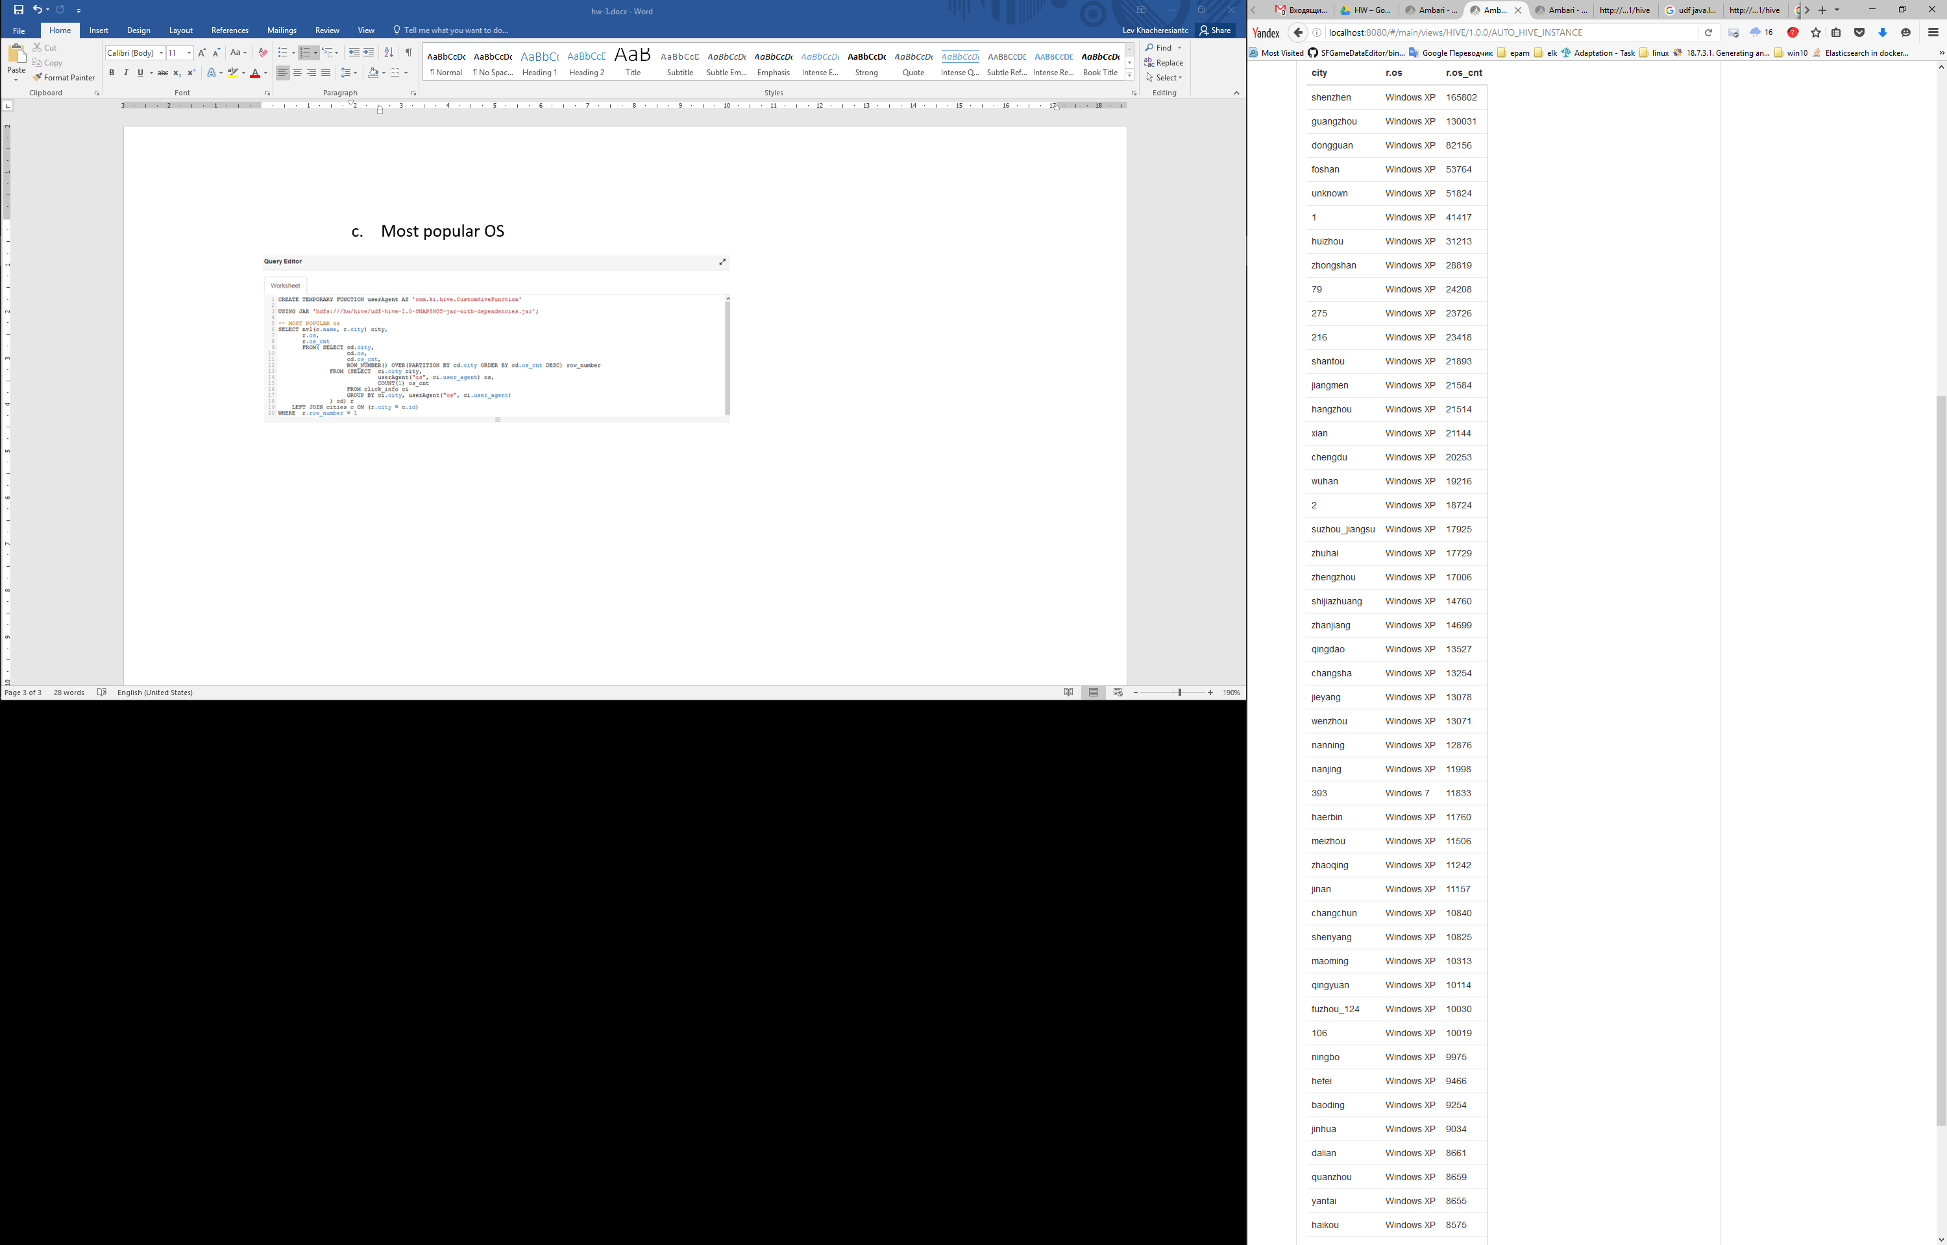

Результат всех трех запросов вместе:

