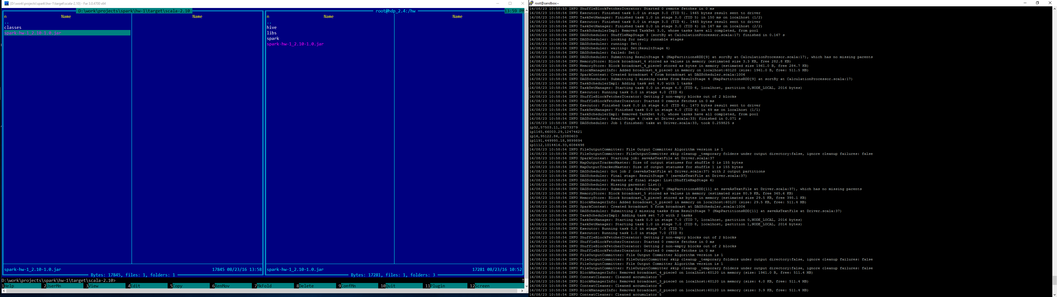

1. First run (top 5)

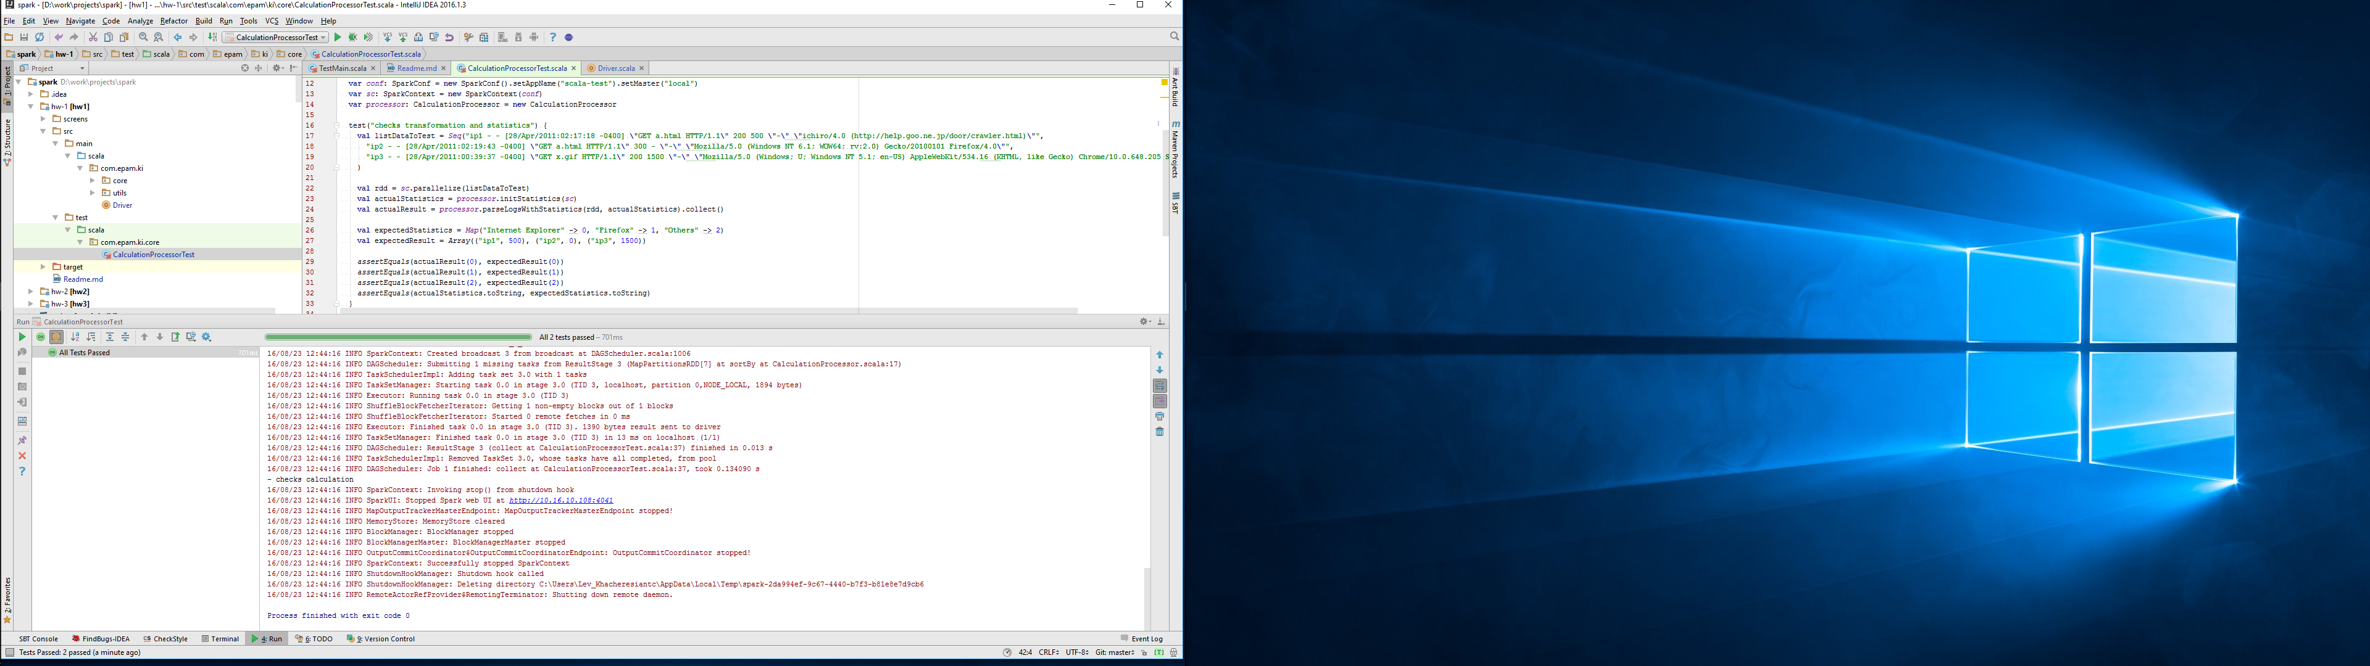

1. Run tests

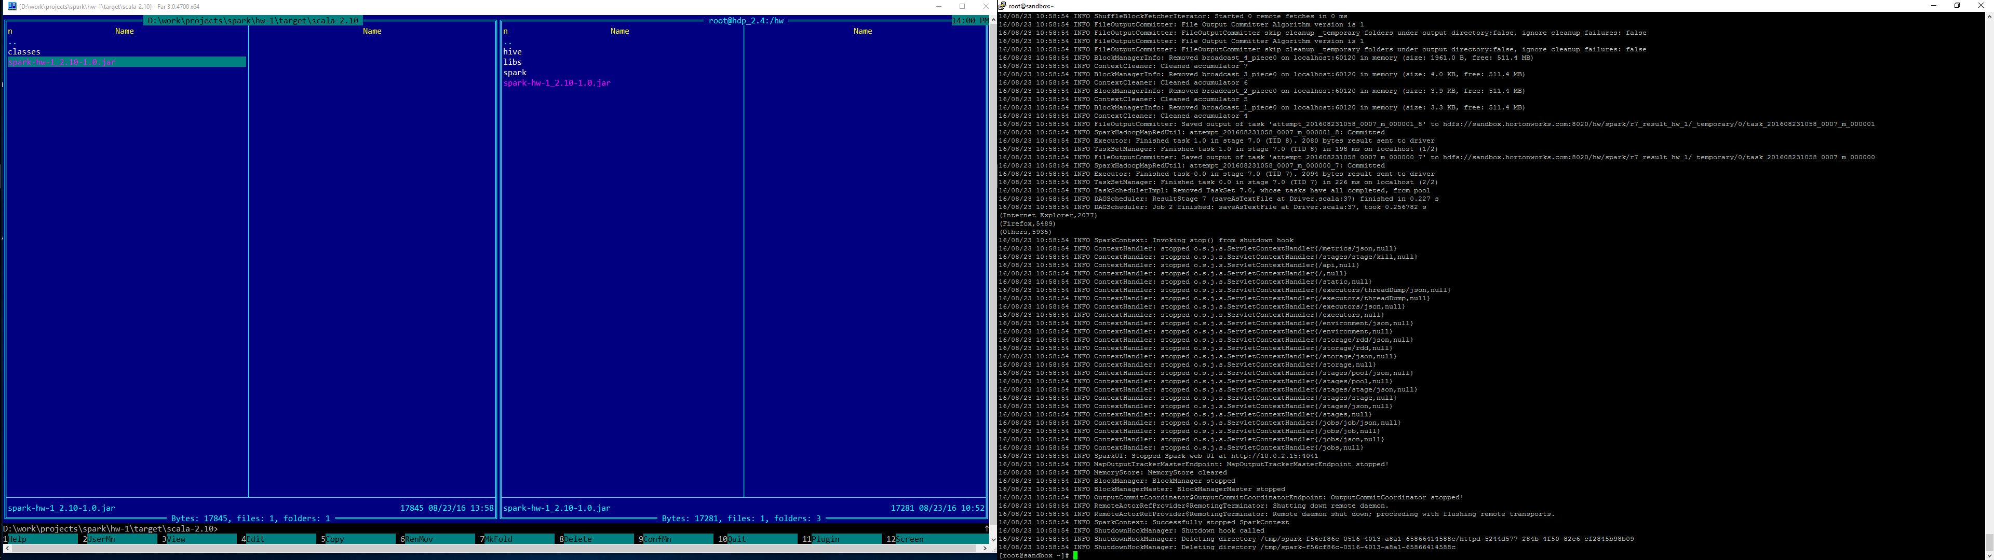

1. With browser statistics