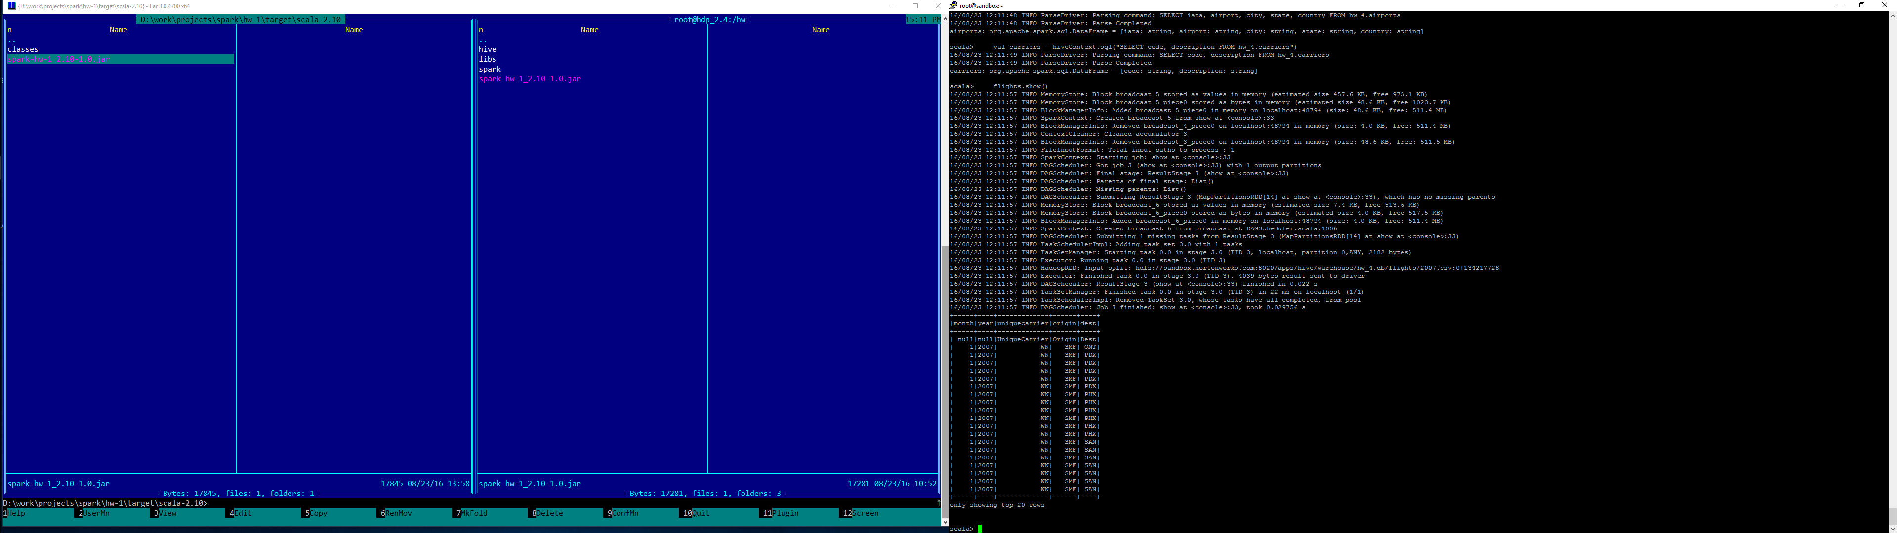

* 1. Flights dataframe

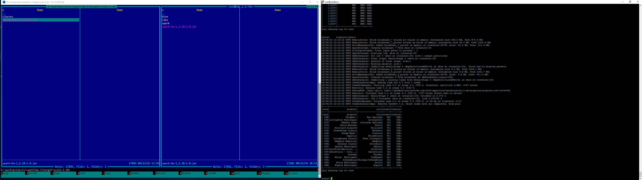

* 1. Airports dataframe

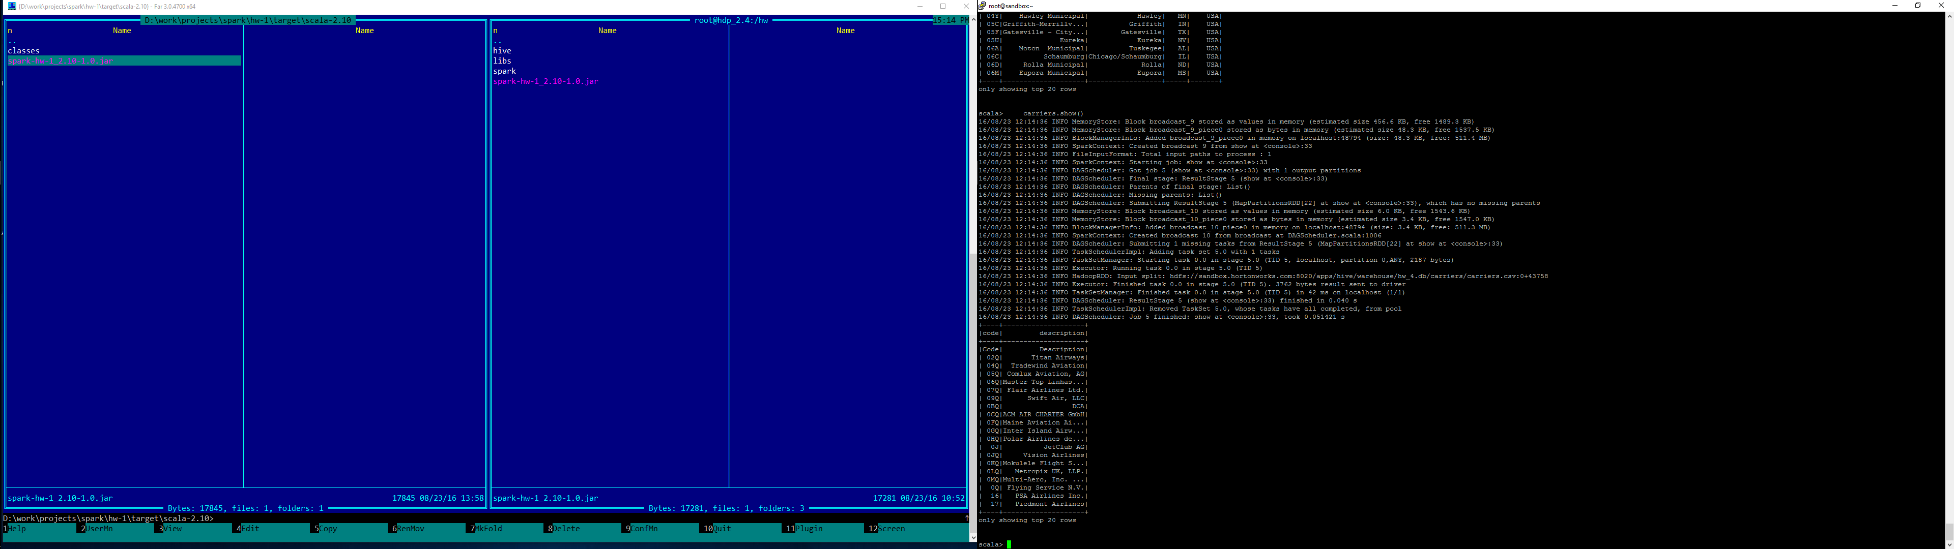

* 1. Carriers dataframe

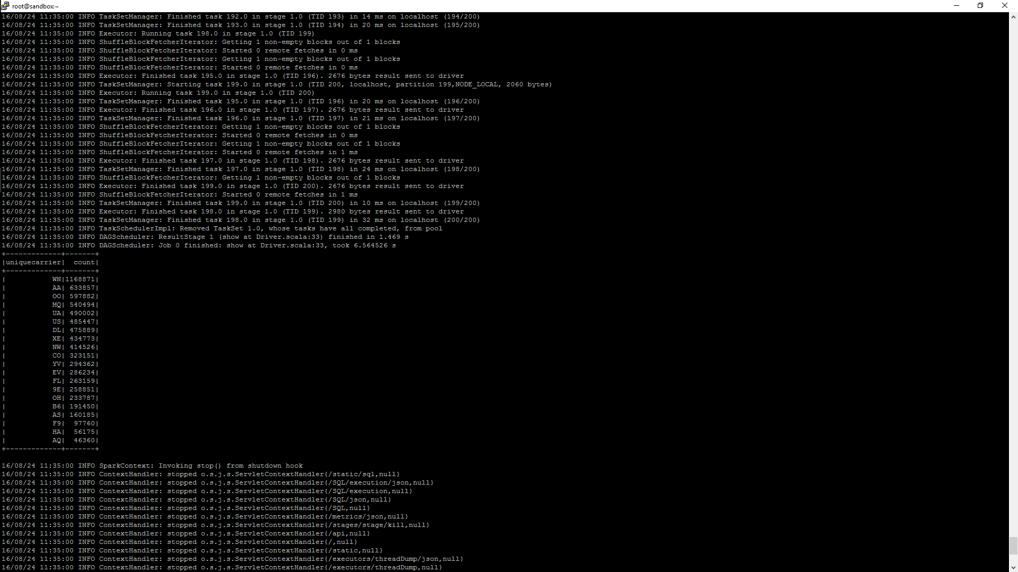

2.1 Total flights per carrier

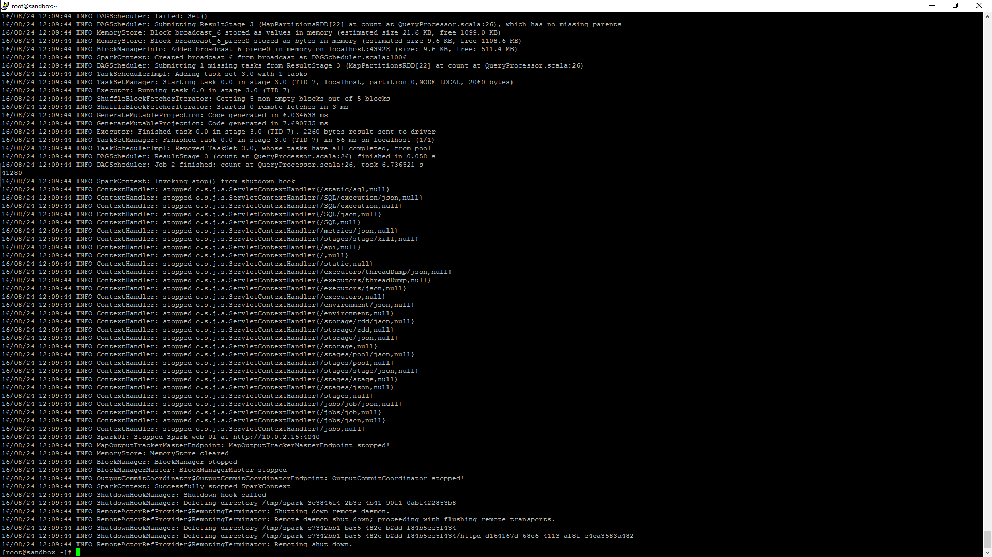

3.1 Flights in June 2007 only New York’s airports

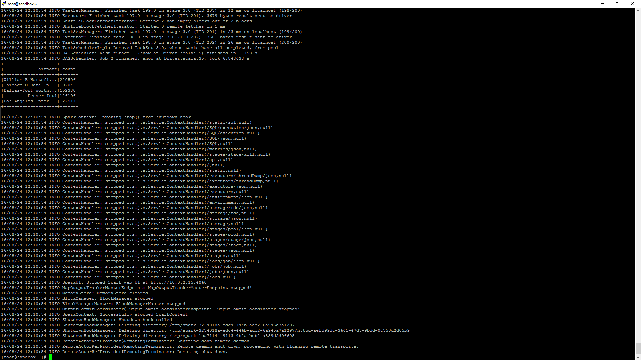

4.1 Top 5 airports served bigger number of flights

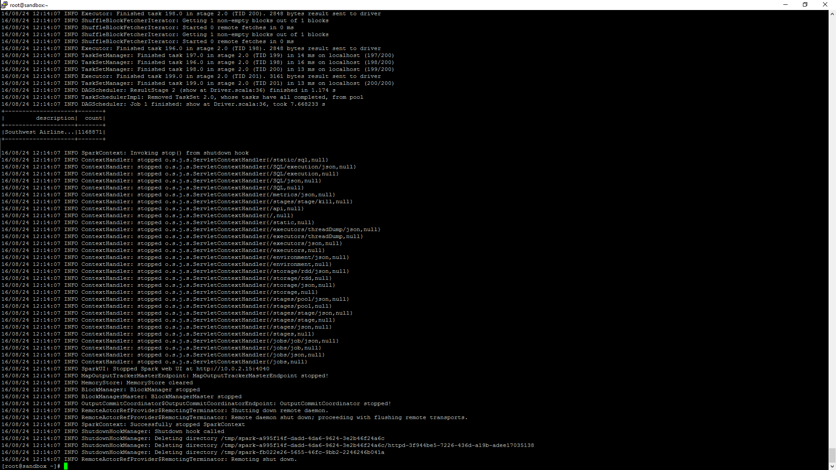

5. Carrier who served biggest number of flights