Final Semester Project – STAT-318

Project Outline
Congratulations! You have been hired a Business Analytics Team Member at Spoehr Family Inc. Spoehr Family Inc. has a storied history of being one of the premier analyst groups of commodities, financial stocks, and other assets throughout the world. Unfortunately, history is just that – history. Currently, Spoehr Family Inc. has experienced a bit of turmoil and there has been mass firings and people quitting. Thus, the Spoehr Family Inc. team desperately needs your help with some analytics to impress their clients. Your inept boss, Thomas, wants you to make a portfolio of analytical results so that way he can show this off to potential clients in hopes of impressing them enough to be able enlist them for his data analytical services.
Timeline
- A brief project update is due either Wednesday, March 25th, 2026 or Friday, March 27th, 2026. The expectations for this presentation are detailed below.
- 2 – 2.5 minutes long
- Technologically aided – (PowerPoint)
- Names of group members
- Display accurate tabulation and tracking of relevant data
- One visualization in both R and Microsoft Excel
- Plans moving forward – what are other topics are you interested in, which group member is doing what, how they plan to complete the rest of the project.
- Final Project Presentations will begin on Monday, April 27th, 2026, (3 presentations), continue to Wednesday, April 29th, 2026 (3 presentations). We will not have class Friday, May 1st, 2026. We will conclude presentations on Friday, May 8th, 2026 (5 presentations).
- Final paper and accompanying group evaluations will be due at 11:59pm Friday, May 1st, 2026.
Data Collection
Students should collect data from resources such as stock prices, assets, temperatures or other daily updated figures. The biggest point of concern is the data must be updated daily (regularly) so that way it is readily available for the researchers. Also, note that there should be data collected from 9 sources where sources are updated in subsets of three. Please see the example data for reference and ask Thomas if this is not clear.

Content
Each student in each group will choose one of the following topics of interest. In addition to each student choosing one topic, each group member will be expected to have a data visualization incorporated within their individual presentation. See the topics and expectations below.
- Basic Statistical Inference - Use one (or more) of the tests discussed in Unit 1 (Weeks 1-3) to compare your data. Be sure to address the following:
  - Are the tests significant why or why not?
  - Why are the tests your making not valid?
  - Assuming the tests were valid, what conclusions could you make?
  - Which of the test results is most interesting? Why?
- One Way ANOVA – Suppose Thomas is interested if a certain type of pitch makes clients more likely to sign on with Spoehr Family Inc. He has four different pitch types – a pitch without a PowerPoint, a pitch with a PowerPoint, a pitch with a pamphlet of past client success, and a pitch with him just talking. He randomly selects a 32-client representative sample of potential clients that might sign on with Spoehr Family Inc. After the pitch, he asks clients to give a rating between 0-100 where 0 is they will definitely not sign on with Spoehr Family Inc. and 100 being they will sign on with Spoehr Family Inc. The data is tabulated at the end of the document. To properly assess and analyze this data perform the following,
- Figure out a way to fill in the missing cells of data – there is no correct answer here but your solution should be explained in a logical manner
- Once you have filled in the missing cells of data – perform a one-way ANOVA in R.
- Perform a post-Hoc Tukey test to make conclusions about the differences of the groups.
- Analyze and interpret all results. Make a detailed and thorough suggestion to Thomas about what pitch should be employed and why.

- Two Way ANOVA – Continuing with his ambition to find the ideal setting for clients, Thomas tests a combination of treatment factors to assess if a combination of treatments is more advantageous to having clients sign on with Spoehr Family Inc. Thomas now gives a combination of pamphlet or no pamphlet along with a discount or no discount. He again randomly selects a 32-client representative sample of potential clients that might sign on with Spoehr Family Inc. After the pitch, he asks clients to give a rating between 0-100 where 0 is they will definitely not sign on with Spoehr Family Inc. and 100 being they will sign on with Spoehr Family Inc. The data is tabulated at the end of the document. To properly assess and analyze this data perform the following,
- Figure out a way to fill in the missing cells of data – there is no correct answer here but your solution should be explained in a logical manner
- Once you have filled in the missing cells of data – perform a two-way ANOVA in R
- Create an interaction plot (this is not part of the data visualization portion of the project). Comment on whether this plot confirms or contradicts the results found earlier.
- Analyze and interpret all results. Make a detailed and through suggestion to Thomas about what pitch should be employed.

- Experimental Design – In his never-ending effort to market to the correct audience Thomas again runs an experiment – only this time he blocks on business type. He decides to pitch to three perspective clients from four types of businesses – agriculture, finance, tourism, and grocery. He uses on four business pitches - a pitch without a PowerPoint, a pitch with a PowerPoint, a pitch with a pamphlet of past client success, and a pitch with him just talking. After the pitch, he asks clients to give a rating between 0-100 where 0 is they will definitely not sign on with Spoehr Family Inc. and 100 being they will sign on with Spoehr Family Inc. The data is tabulated at the end of the document. To properly assess and analyze this data perform the following,
- Draw a visual depiction of the experimental design.
- Using an RCBD and R analyze the data.
- Analyze and interpret all results. Make a detailed and through suggestion to Thomas about what pitch should be employed.
- Suppose Thomas is worried there might be a block by treatment interaction. What do you suggest to Thomas and why?

- Simple Linear Regression - Use the data you collected. Pick one of the nine content blocks you have chosen to track. Analyze this data using R and a simple linear regression model. To properly analyze this data perform the following,
- Plot the data and obtain the correlation coefficient. Comment on the appropriateness of simple linear regression
- Use R to perform a simple linear regression.
- Comment on the significance of the slope and intercept. Interpret these in context of the problem. Also calculate the R-squared value and interpret this.
- Use your model to make 5 meaningful predictions from the data

- Multiple Linear Regression - Use the data you collected. Pick one of the nine content blocks you have chosen to track. Analyze this data using R and a multiple linear regression model. To properly analyze this data perform the following,
- Initially start out using all the other data (eight subsets of groups and time) as independent variables. Check for multiple collinearity using tests of tolerance and VIF.
- Using the results from above, perform a multiple linear regression on the data
- Interpret all coefficients and the corresponding R output in layman’s terms
- Use your model to make 5 meaningful predictions from the data

- Data Visualization – (**Every group member must incorporate**) With the data you’ve tracked and tabulated create data visualizations in both R and Microsoft Excel that you think would be useful for Spoehr Family Inc.
- Create one meaningful data visualization in both R (using the ggplot2 library) and in Excel
- Put these two data visualizations side by side
- Compare and contrast. Which do you prefer?

Report

For the report students will be expected to include/adhere to the following:

- Times New Roman, 12pt. font
- The report should have a title page
- The title should be professional in nature and include all authors
- The report should have an introduction and conclusion
- The introduction should include the purpose of the document. This should also allude to topics covered and foreshadow any interesting results. The topic should also briefly mention the data collected and how the data are related to one another.
- The conclusion should include major findings, a reflection on what the group would have done differently, and why a client should come on with Spoehr Family Inc.
- Of the topics covered, there should be clearly marked sections along with headers. After the header, the author of that section should be included.
- Each of the topics covered should have at least one visualization (see data visualization portion).
- The report is fairly fluid in nature. Have fun, be daring, and be creative – the report should be professional in nature but imaginative as well.

One Way ANOVA Data
Client # | Pitch Type | Rating
1 | No PowerPoint | 65
2 | No PowerPoint | 63
3 | No PowerPoint | 67
4 | No PowerPoint | 64
5 | No PowerPoint | 66
6 | No PowerPoint | 62
7 | No PowerPoint | 65
8 | No PowerPoint | 64
9 | PowerPoint | 75
10 | PowerPoint | --
11 | PowerPoint | 78
12 | PowerPoint | 76
13 | PowerPoint | 74
14 | PowerPoint | 77
15 | PowerPoint | 76
16 | PowerPoint | 75
17 | Pamphlet (Past Success) | 88
18 | Pamphlet (Past Success) | 90
19 | Pamphlet (Past Success) | 87
20 | Pamphlet (Past Success) | --
21 | Pamphlet (Past Success) | 89
22 | Pamphlet (Past Success) | 92
23 | Pamphlet (Past Success) | 90
24 | Pamphlet (Past Success) | 88
25 | Just Talking | 45
26 | Just Talking | 50
27 | Just Talking | 48
28 | Just Talking | --
29 | Just Talking | 49
30 | Just Talking | 47
31 | Just Talking | 44
32 | Just Talking | --

Client # | Pamphlet | Discount | Rating
1 | No | No | 55
2 | No | No | 53
3 | No | No | --
4 | No | No | 56
5 | No | No | --
6 | No | No | 54
7 | No | No | 56
8 | No | No | 55
9 | No | Yes | 65
10 | No | Yes | 66
11 | No | Yes | 64
12 | No | Yes | 65
13 | No | Yes | 66
14 | No | Yes | 65
15 | No | Yes | --
16 | No | Yes | 65
17 | Yes | No | 57
18 | Yes | No | 58
19 | Yes | No | 56
20 | Yes | No | 57
21 | Yes | No | 58
22 | Yes | No | 57
23 | Yes | No | --
24 | Yes | No | 57
25 | Yes | Yes | 67
26 | Yes | Yes | 68
27 | Yes | Yes | 66
28 | Yes | Yes | 67
29 | Yes | Yes | 68
30 | Yes | Yes | 67
31 | Yes | Yes | --
32 | Yes | Yes | 67
Two Way ANOVA Data
Business Type | Client # | Pitch Type | Rating
Agriculture | 1 | No PowerPoint | 55
Agriculture | 2 | PowerPoint | 68
Agriculture | 3 | Pamphlet | 78
Agriculture | 4 | Just Talking | 45
Agriculture | 5 | No PowerPoint | 56
Agriculture | 6 | PowerPoint | 67
Agriculture | 7 | Pamphlet | 77
Agriculture | 8 | Just Talking | 46
Finance | 9 | No PowerPoint | 70
Finance | 10 | PowerPoint | 83
Finance | 11 | Pamphlet | 93
Finance | 12 | Just Talking | 60
Finance | 13 | No PowerPoint | 71
Finance | 14 | PowerPoint | 82
Finance | 15 | Pamphlet | 92
Finance | 16 | Just Talking | 61
Tourism | 17 | No PowerPoint | 62
Tourism | 18 | PowerPoint | 75
Tourism | 19 | Pamphlet | 85
Tourism | 20 | Just Talking | 50
Tourism | 21 | No PowerPoint | 63
Tourism | 22 | PowerPoint | 76
Tourism | 23 | Pamphlet | 86
Tourism | 24 | Just Talking | 51
Grocery | 25 | No PowerPoint | 65
Grocery | 26 | PowerPoint | 78
Grocery | 27 | Pamphlet | 88
Grocery | 28 | Just Talking | 53
Grocery | 29 | No PowerPoint | 66
Grocery | 30 | PowerPoint | 79
Grocery | 31 | Pamphlet | 89
Grocery | 32 | Just Talking | 54
Final Paper

Ian’s Section: Multiple Linear Regression

- Multiple Linear Regression: Check multicollinearity (VIF/tolerance), run regression in R, interpret coefficients in plain language, and make 5 predictions.
- Airports: KLNK (Lincoln), KSUS (Spirit of St. Louis), KOMA
- Features: Air Temperature, Dew Point, Sea Level Pressure, Station
Step 1: Exploratory Data Analysis
Before doing a regression model, you have to understand the relationships between the variables. We want to remove any highly correlated variables as these will cause the model to overfit. To test this we can use a correlation matrix. Omaha and Lincoln are close enough to each other that the differences in temperature between the two cities are negligible, thus making the correlation 1. Because Omaha’s temperature provides no unique information that isn’t already added by Lincoln, I removed it from the final model. I applied this to the dew point as well. 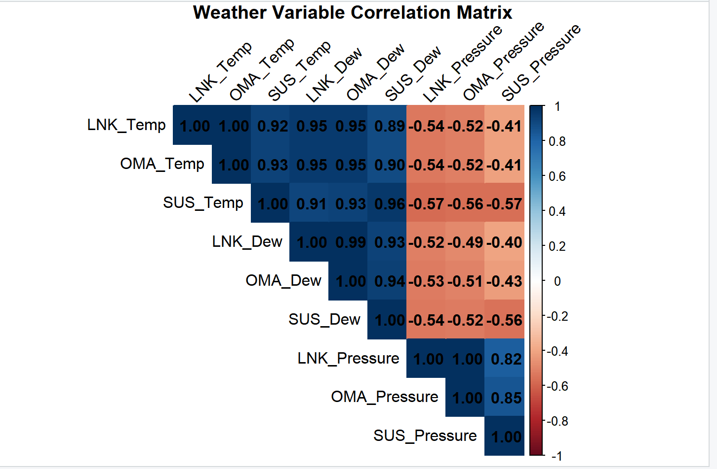
Step 2: Validation
A regression model is only valid if the underlying data meets core statistical assumptions. After training it is important to test using residuals vs fitted to check linearity, Q-Q plots, Scale-Location (Homoscedasticity), and residuals versus leverage (outliers).
Residuals versus fitted: The red trend line says flat and centered around zero across the fitted values. This confirms the relationship between Nebraska weather and St, Louis temperature us linear.
Normal Q-Q: For a model’s p-value to be valid, the errors must be normally distributed. The data points tightly hug the line indicating a normal distribution.
Scale-Location: This tests if the variance of the errors remains consistent. The horizontal red line and evenly scattered points confirm the model is just as good at predicting cold winter days as hot summer days.
Residuals vs. Leverage: This plot ensures no large outlier weather events are steering the whole model. The vast majority are in the standard bounds.
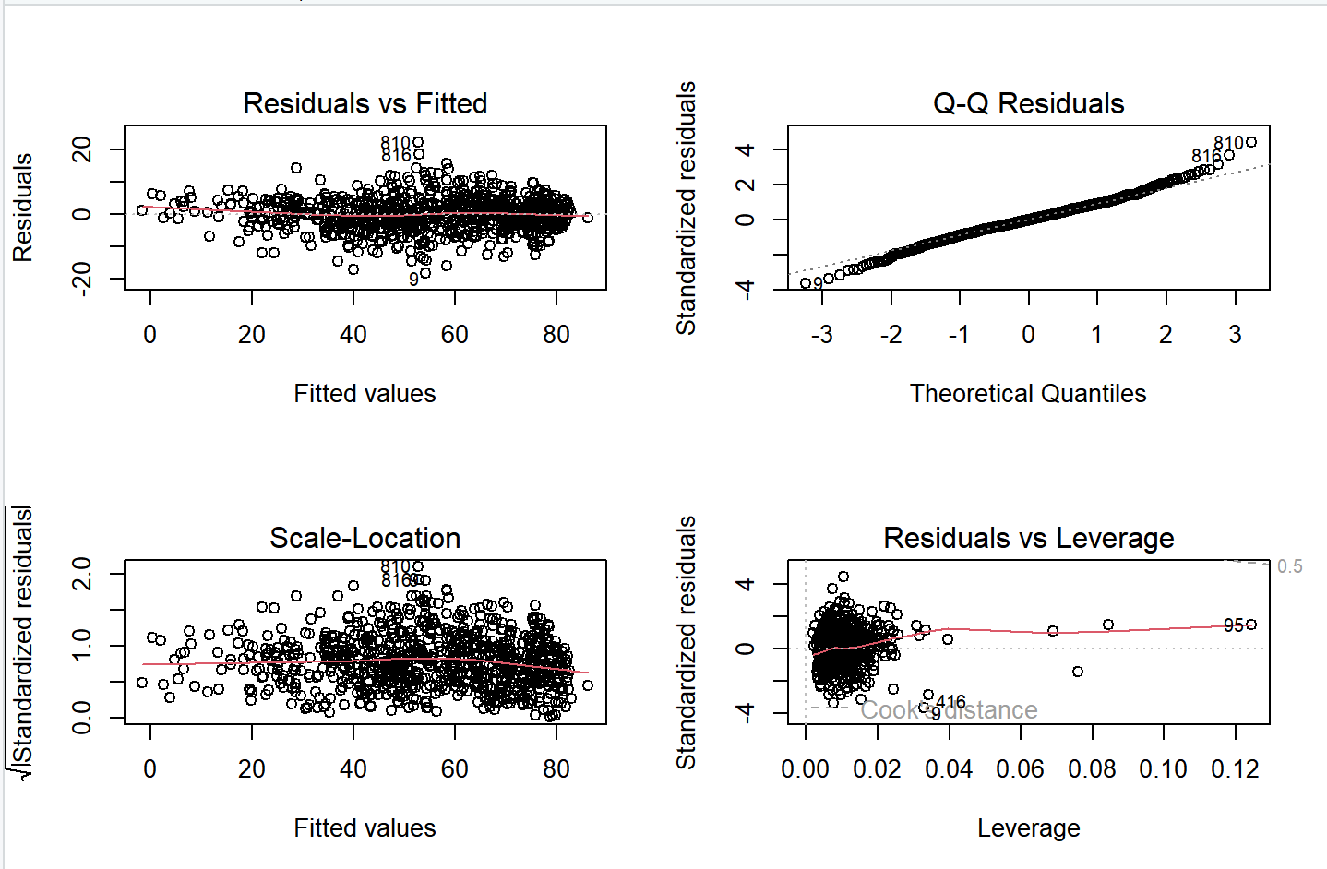
Step 3: Model Evaluation & Application
With the model validated, the final step is to check the accuracy by comparing the predictions against historical reality. Comparing the actual vs predicted St. Louis temperature, the predicted red line follows very closely with the actual blue line. The overlap strongly reinforces the hypothesis that prevailing winds consistently push weather systems West to East and that tracking the temp, dew point, and sea level pressure of OMA and LNK are very reliable predictors of SUS temperatures a short time later.
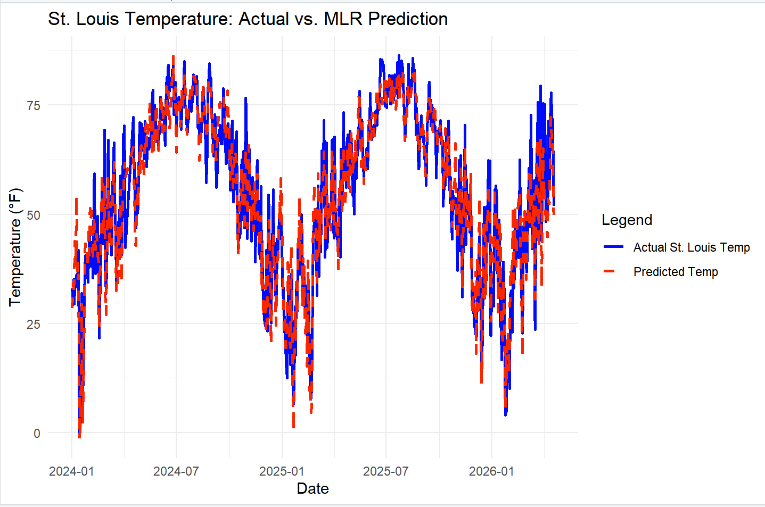

Simple Linear Regression: Max Murray

Simple Linear regression allows us to make both determine linearity between two quantitative variables, and make predictions from an input variable that gives a response variable. In this project, I wanted to see if there was a linear relationship between the air temperature in Lincoln Nebraska to its dew point temperature in Lincoln Nebraska.

Air temperature is the temperature of the air measured in degrees Fahrenheit. Dew temperature (measured in degrees Fahrenheit) is the temperature measured; that the air temperature needs to be in order for water vapor into the air to condense and create either fog or clouds. Because these are both physically related properties of air, I wanted to see if they were related.

Data:
I used the Lincoln weather data provided by the Iowa Environmental Mesonet. Our original dataset measured the air temperature and dew point temperature every hour from January 1st, 2025, to March 22nd, 2026. Because of the number of data points, I opted to take an average of air temperature and dew point temperature for each day. This way, I could still see if there is a relationship while not having an excess of data points.

Model:

After uploading the data to R, I created a linear model of the data using the “lm” function and asked for a summary of the model. The Linear model given is shown:

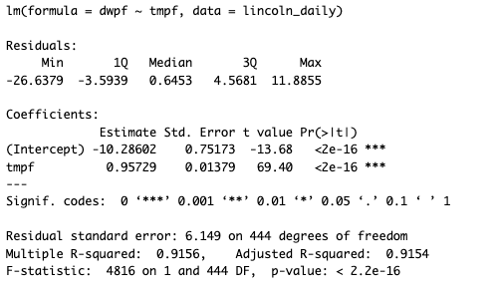

Yi = -10.28602 + 0.95729 * (Xi)

Yi – the ith dew point temperature (ºF)
This is the response variable

Xi – The ith air temperature (ºF)
This is the explanatory variable
For every 1 degree Fahrenheit increased, we can expect the dew point temperature to increase by 0.95729 degrees Fahrenehit.

The Adjusted R-squared value of 0.9154 indicates there is a strong positive association between air temperature and dew point temperature. A plot of the data points is given below:
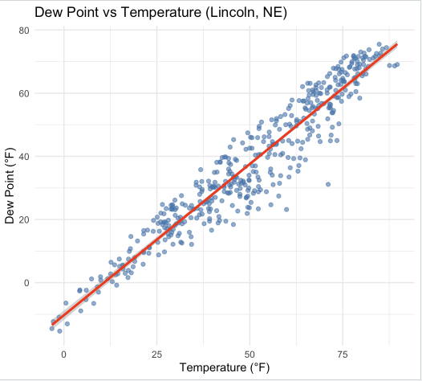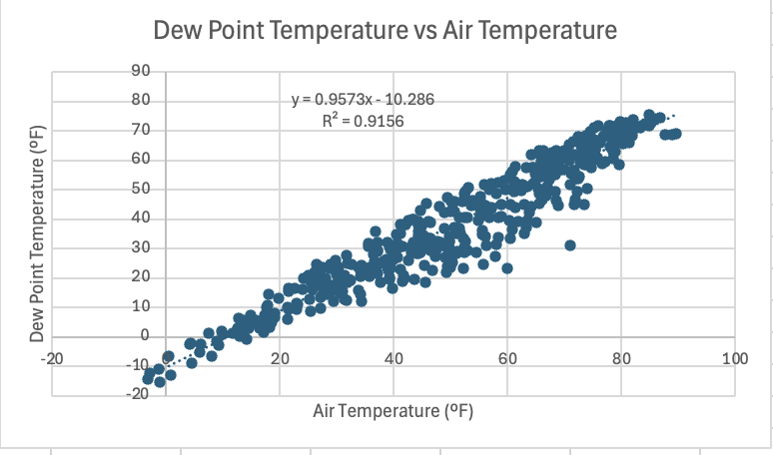

The plotted data using both R and Microsoft Excel both indicate a strong positive linear association between Air Temperature and Dew Point temperature. Both Microsoft Excel and R both gave the same equation for simple linear regression and also the same R2 value. The high R2 values are apparent on the plots because the points show a pretty clear linear trend.

Residual and QQ plot:

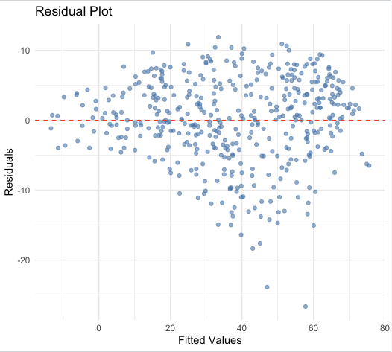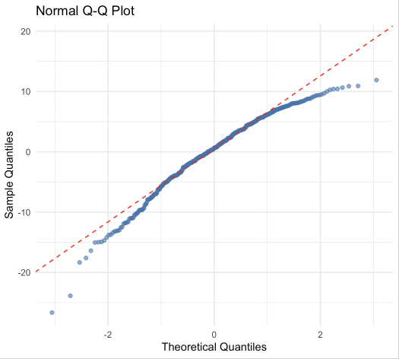

The figure on the left shows the residual plot of the linear model, and the figure on the right shows a Normal QQ plot. The residual plot generally maintains homogeneity in variance. The only exception is between 40-60 degrees, where the data appears to vary a little more. Other than those points, the data maintains homogeneity in variance. The Normal QQ plot tells a similar story. Most of the data follows the normal line very well. The tails begin to fall away with the line, but overall, the data appears to also follow a normal trend. We can deduce from both plots that a linear model is a good fit for the data.

Predictions:

Now that we have established that the linear model is a good fit for the data, we are able to make predictions using the model. The predict function in R is able to fit inputs into the linear model while also giving a 95% confidence interval of what the data could be.

Air Temperature (input)(ºF) | Dew Point Temperature (prediction)(ºF) | Lower bound of interval | Upper bound of interval
20 | 8.859 | 7.859 | 9.859
40 | 28.005 | 27.369 | 28.641
60 | 47.151 | 46.521 | 47.781
70 | 56.724 | 55.941 | 57.707
90 | 75.869 | 74.649 | 77.091

In Conclusion, Air Temperature and Dew Point temperature share a linear relationship. The residual and QQ plot indicated that the model generated is a good fit for the model. We can use the model in order to make fairly accurate predictions for Dew Point temperature in Lincoln Nebraska given the Air Temperature.

Oliver Luebcke: One-way ANOVA

Purpose:
The purpose of my section of the project is to analyze the daily temperature variability of 9 different weather stations across Nebraska. This section will show how statistical analysis can be used to help identify weather patterns that can support planning accuracy and decisions in many fields. Variability is defined as the daily high temperature minus the low temperature. My goal is to see if the different locations behave differently when tested.

I took the data from the 9 weather stations and calculated a daily temperature range for each day. My response variable is the daily temperature range, and the explanatory variable is the specific weather station. I then compared these ranges across all locations using a one-way ANOVA. The p-value was less than 2e-16. This tells me that I can reject the null hypothesis because the p-value is extremely small. There is strong evidence that temperature variability differs between the locations.

Model:
Yij =μ+τi +εij
Yij = the daily temperature range for day j at station i
μ = overall mean daily temperature range
τi = effect of the ith station
εij = random error term

Results:
I found that some locations have larger daily swings while others are more stable. Alliance and Scottsbluff had the highest variability, while Blair and Omaha were the most stable. This makes sense because western Nebraska tends to have larger swings in temperature, while eastern Nebraska is generally more stable.

Additional Insight:
After finding these location differences, I wanted to see if there were any other variables that could help explain the weather patterns. I analyzed the relationship between temperature variability and humidity and found a moderate negative relationship between the two variables. This means that more humid days tend to be associated with smaller temperature swings. Humidity is likely not the only factor affecting weather patterns, but it does provide useful context for the ANOVA results.

Conclusion:
These findings can have real-world implications in agriculture, travel, and energy. Overall, my analysis shows that statistical methods can be used to identify differences in weather patterns across Nebraska and help explain part of why those differences occur.
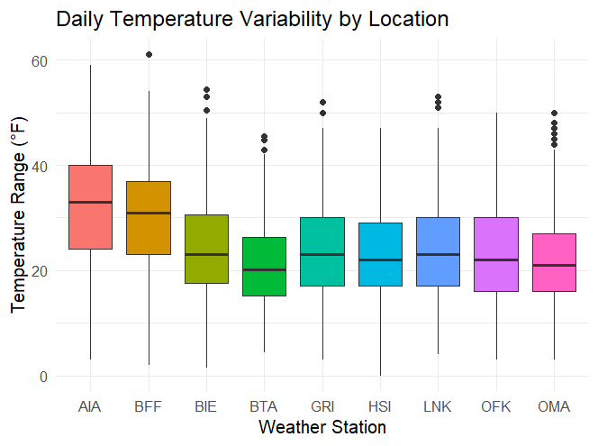

This boxplot shows the temp variability across
stations. Alliance and Scottsbluff have higher
variability, while Omaha and Blair appear
more stable.

Source | Df | Sum Sq | Mean Sq | F Value | Pr(>F)
Station | 8 | 44918 | 5615 | 60.98 | < 2e-16
Residuals | 3936 | 362410 | 92

This ANOVA table shows a significant p-value, giving strong evidence that temperature
variability differs by weather station.

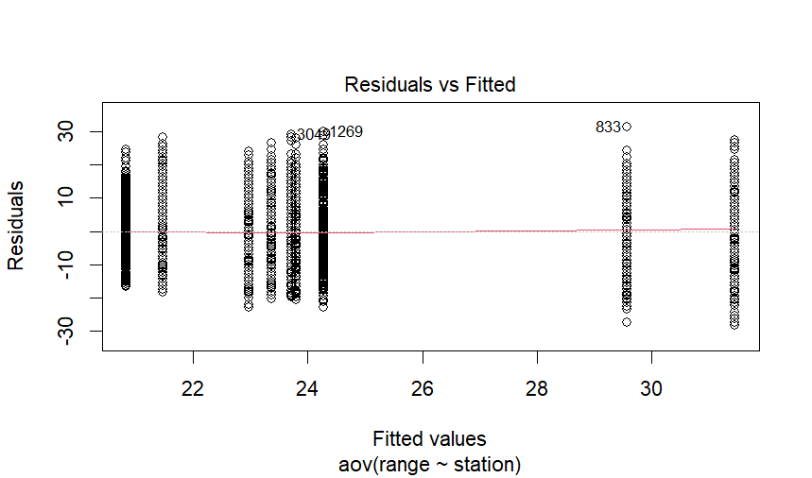
The residual vs fitted plot looks random around zero with no major patterns present. This tells me that the model fits the data well. The vertical stacks of data represent the different weather stations.

The Q-Q plot suggests that the residuals are close enough to the line for the ANOVA model to be acceptable.
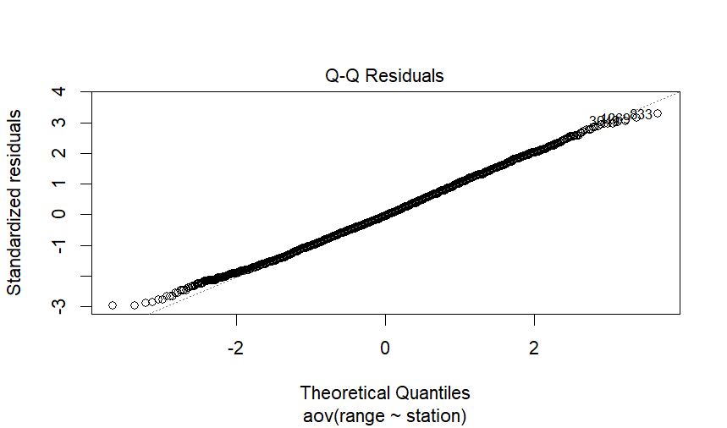
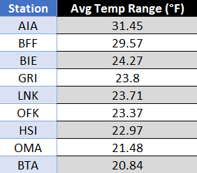

This table (right) shows the daily average temp range for each station and makes it easy to compare which locations have the highest and lowest temp ranges.

To conclude the one-way ANOVA section, I wanted to note that the data used for the test is observational. Our ANOVA suggests there is association between avg daily temp and location, but it is not strong enough proof to convince causation.

Luke Walsdorf – Experimental Design

One of the most difficult things in weather analysis is separating the variable that you actually care about from the confounding variables that might be affecting it. The purpose of this analysis is to analyze the differences in relative humidities of the 9 different airports that we collected data from. There are a lot of factors in the location and climate of these 9 locations that could have a large impact on relative humidity, including geography, elevation, and proximity to water sources. However, the strongest indicator of relative humidity is air temperature. The same amount of water vapor produces dramatically lower relative humidity in warmer air simply because warm air can hold more moisture. If we just compared the average relative humidities of these stations, most of the variation will be an effect of the variation in air temperature, not the variation in location.

A Randomized Complete Block Design (RCBD) provides a great solution for eliminating the effect of this confounding variable in air temperature. By grouping our observations into temperature bins and computing a mean relative humidity per temperature bin per station, we can hold the air temperature consistent when computing the differences in humidity between weather stations. This will allow us to fairly compare the relative humidity of these stations without the biggest confounding variable.

Below is a visual depiction of the experimental design.
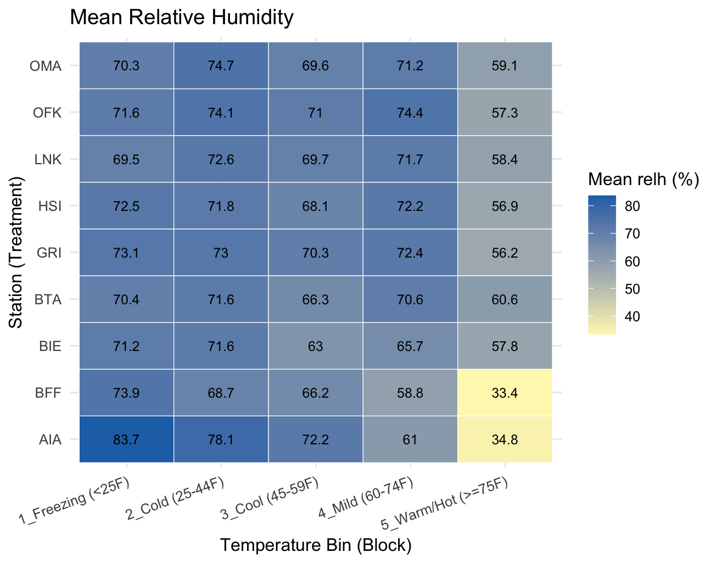

Any hourly observation missing either relative humidity or air temperature was
dropped before analysis, leaving 120,462 valid records across all nine stations
with every one of the 45 cells supported by at least 1,000 observations.

The RCBD model was fit in R as aov(mean_relh ~ station + temp_bin). The ANOVA table showed that the block effect (temperature bin) was highly significant (p < 0.001), while the station (treatment) effect was not statistically significant (p = 0.296). This means that after holding temperature constant across blocks, we cannot conclude that any station is meaningfully more or less humid than the others. The block doing its job so effectively is actually a good sign. It confirms that temperature was the dominant driver of humidity variation and that the design successfully removed that noise.
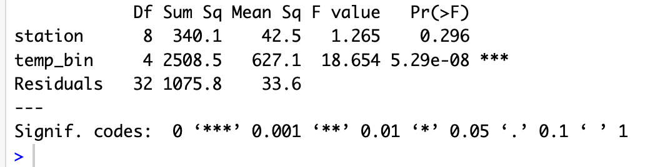
A Tukey HSD post-hoc test was run on the station factor to examine all 36 pairwise comparisons. None of the comparisons reached statistical significance (p = 0.05). While Scottsbluff (BFF) posted the lowest overall mean humidity at 60.2% and Norfolk (OFK) posted the highest at 69.7%, a nearly 10-point gap, these differences were not large enough to be declared statistically distinguishable from random variation given the spread in the data. Based on these results, no single station can be confidently recommended over another based on relative humidity alone.
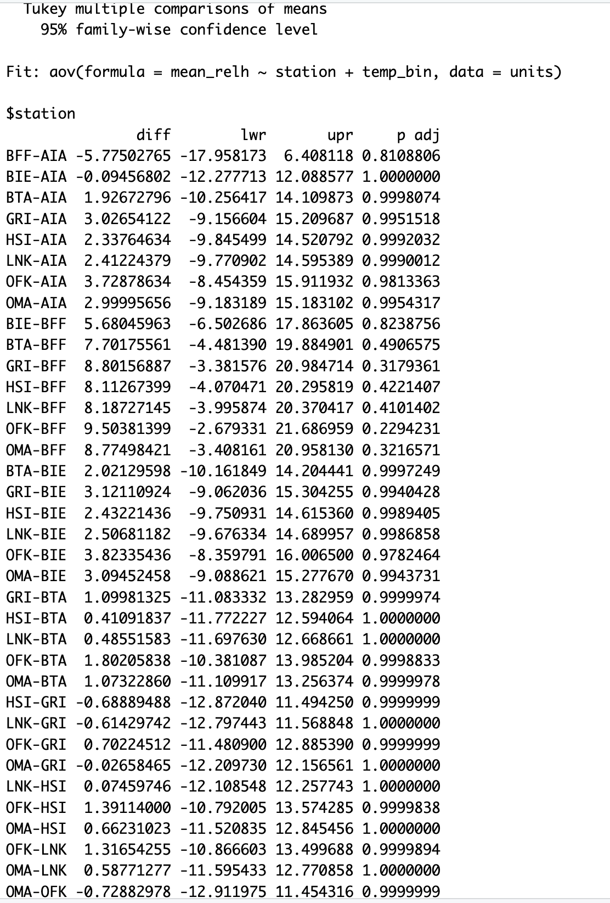

The four diagnostic plots below show that the model is a reasonable fit. The Residuals vs Fitted plot is generally centered around zero with no strong pattern. The Q-Q plot shows the standardized residuals tracking the diagonal line closely through the middle with slight tail deviations. The Scale-Location plot shows a slight downward trend, but no serious heteroskedasticity. The Residuals vs Factor Levels plot shows residuals spread evenly across all nine stations with no station showing a systematic pattern, which is reassuring that the model is not misfitting any location.

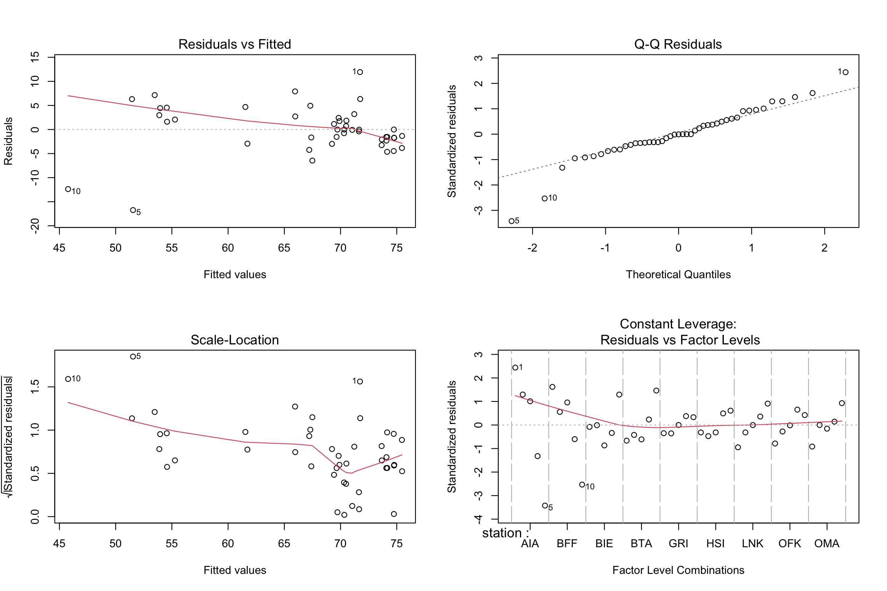
After blocking on temperature to remove the dominant confounding variable, we fail to reject the null hypothesis that mean relative humidity is equal across all nine stations (p = 0.296), meaning there is not sufficient evidence to conclude that any station is significantly more or less humid than the others.

