- 打开文件\fw-AC79_AIoT_SDK-release-AC79NN_SDK_V1.2.0\fw-AC79_AIoT_SDK-release-AC79NN_SDK_V1.2.0\cpu\wl82\tools\isd_config_rule.c
红色框的地方改为1M
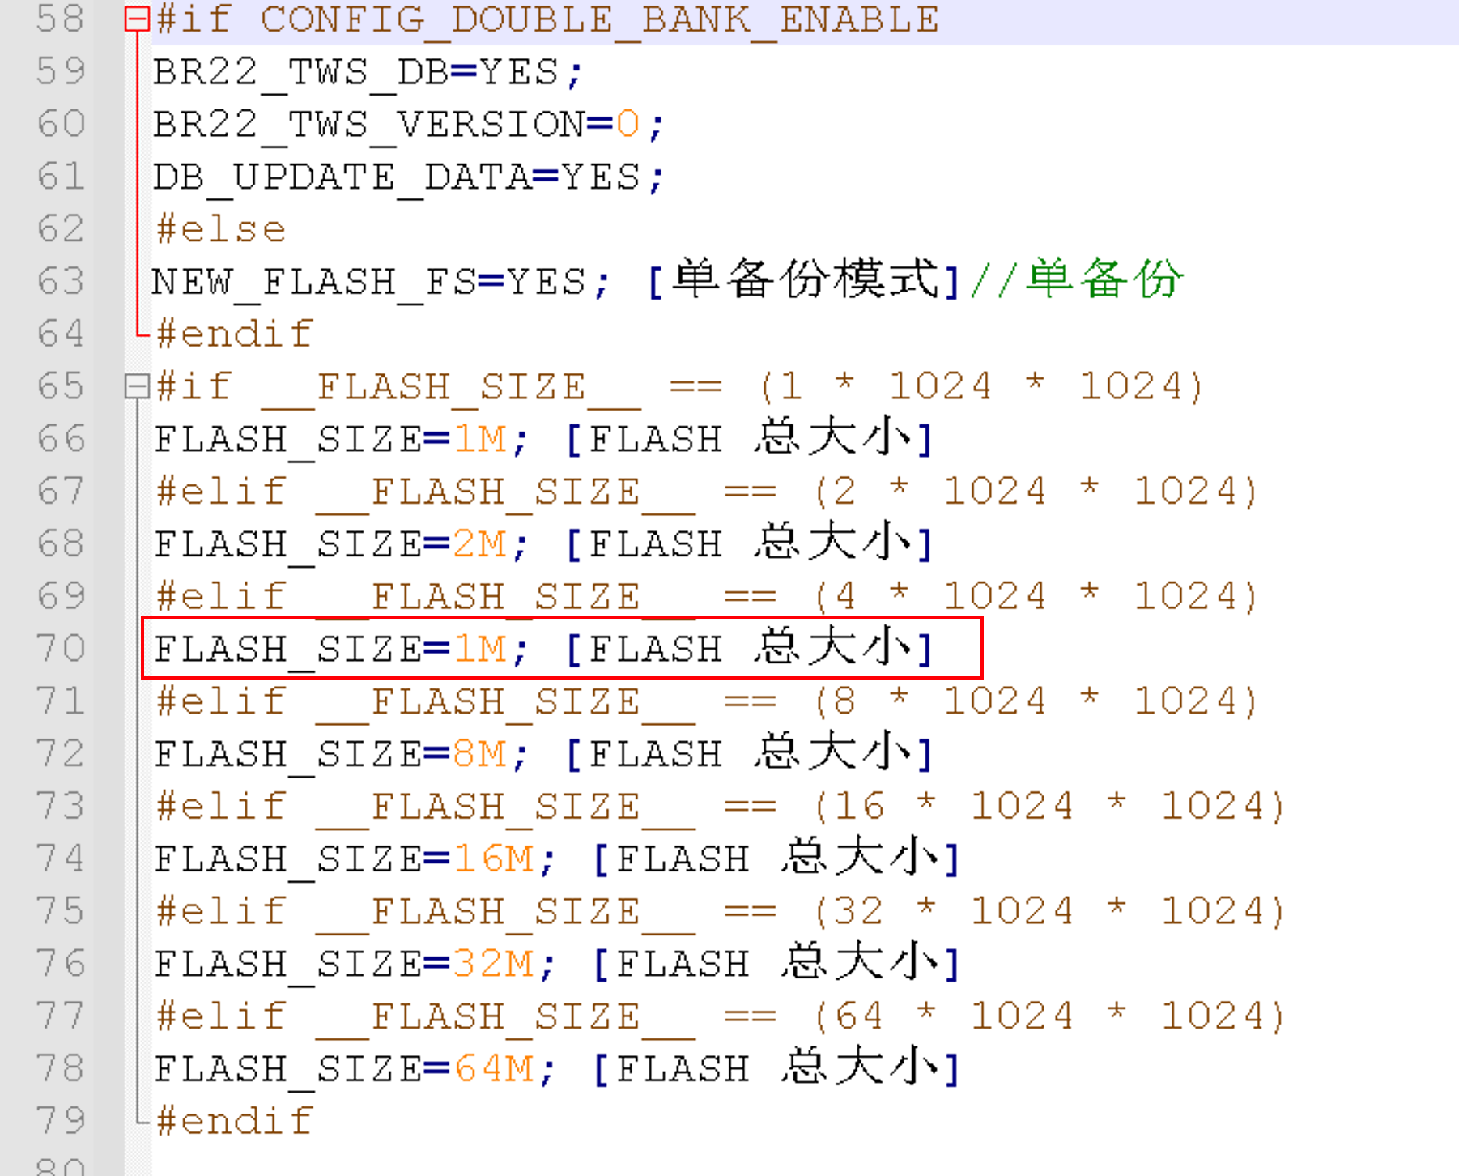
- 删除下面目录下的mp3音频资源文件
\fw-AC79_AIoT_SDK-release-AC79NN_SDK_V1.2.0\fw-AC79_AIoT_SDK-release-AC79NN_SDK_V1.2.0\cpu\wl82\tools\audlogo

