1. **1Abaqus prework**

I restart Abaqus directly and change the loads combination.

Fx = [-1000, -666, -333, 0, 333, 666 ,1000]

Fy = [-1000, -666, -333, 0, 333, 666 ,1000]

therefor we have 49 different loads combination.

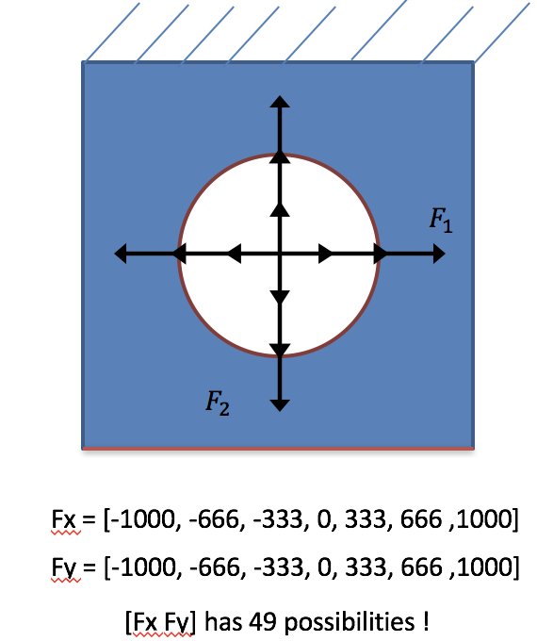

1. **Maximum Principle Stress for each load combination**

After the Abaqus simulation, I got the Max Stress for these 49 different loads combinations. 49 different load combinations were obtained.

* 1. **7 testing Points method**

Before using all these 49 points as training data, Matlab code was written to select 7 random points as testing data, leaving the remaining 42 as training data. The testing points changed every time. After having predicted and simulated values for RMSE, it was correctly calculated and a line was plotted representing the similarity between the prediction and the real value. After training, RMSE between GP prediction and simulation result is calculated and a line who could represent the similarity between prediction and real value is fitted. Because the testing points changes every time, I just take un example. The graph is only an example because of varying testing points.

Figure 1 is the result of the GP Process prediction. In this example, testing points are [-333 0; -1000 333; -666 666; 666 1000; 0 -333; -1000 -666;-333 -1000]. The black points represent the 42 training data once, the blue points represent their true value and the red points represent the GP prediction. By this example, RMSE between GP prediction and simulation result is 1.7492. The average RMSE after running the code for 5 times is 2.77. As seeing in this example, the RMSE result from GP prediction and simulation is 1.7492.

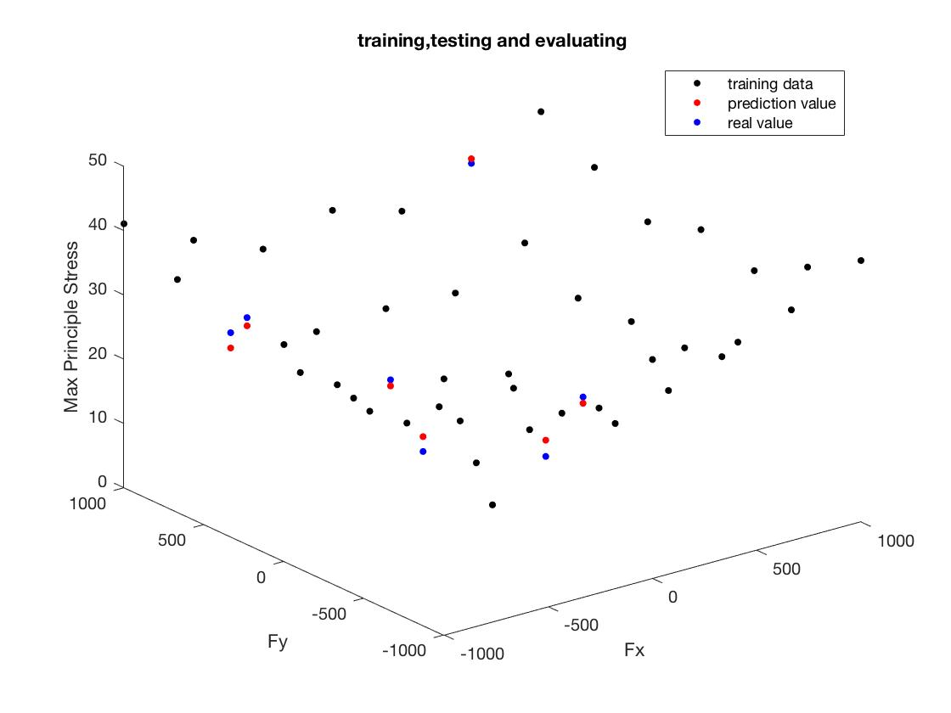

figure 1. GP prediction results

Figure 2 shows the fitting line, with its function y=1.1x – 3.6. By picking 7 data points as testing points, the most suitable mean function as well as covariance function are selected. It can be used for the prediction for new data points.

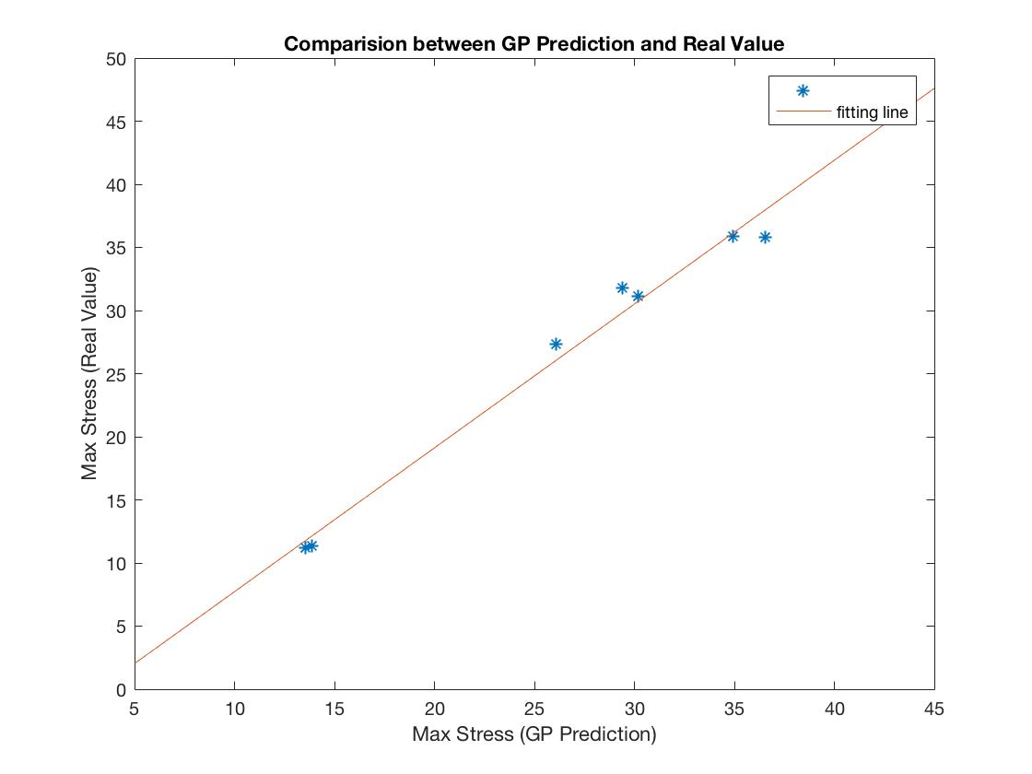

figure 2. fitting line

* 1. **Prediction in new data**

Once the mean function and covariance function are chosen, we were able to give the prediction in new data. 14 different load combination are randomly generated and we use GP progress to give the prediction of

maximum stress. In the meanwhile, the simulation results are compared with GP prediction.

Figure 3 shows the result of GP Process prediction. For these 14 new load combination, RMSE between GP prediction and simulation result is 1.9792

Figure 4 shows the fitting line, with its function y=1.09x – 0.3011. Gradient is very close to 1 and intercept is very close to 0.

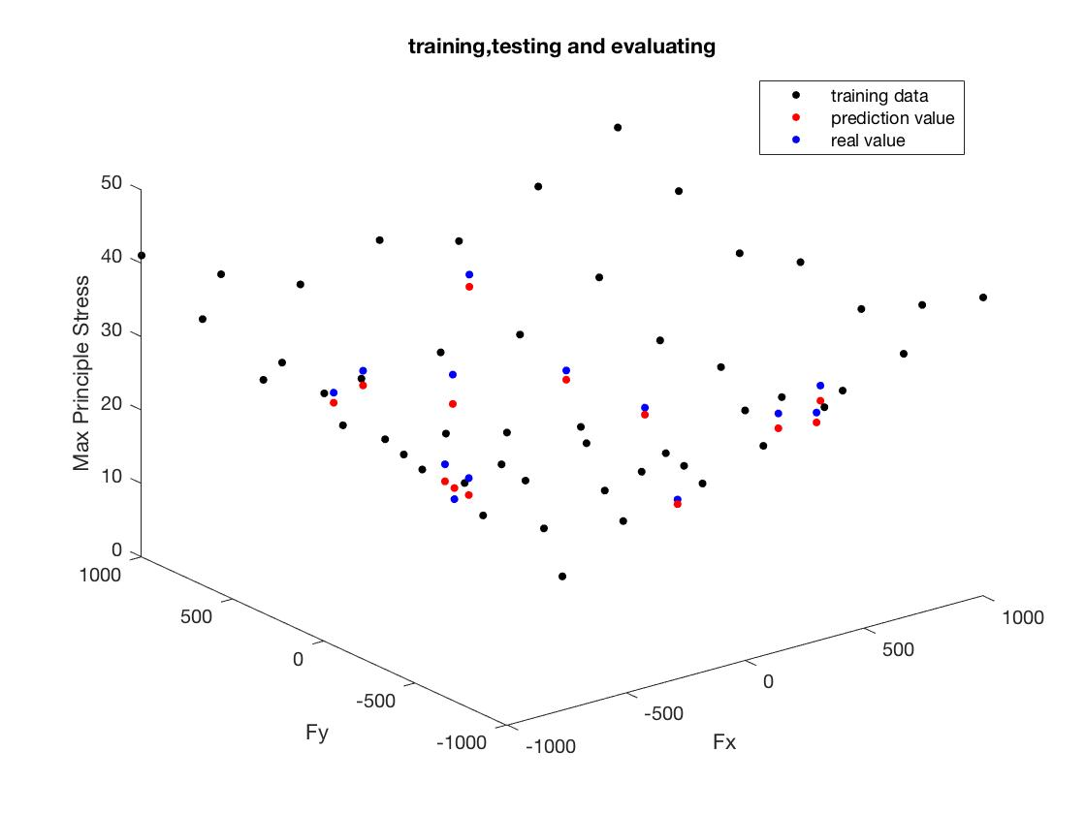

figure 3. GP prediction results in new data

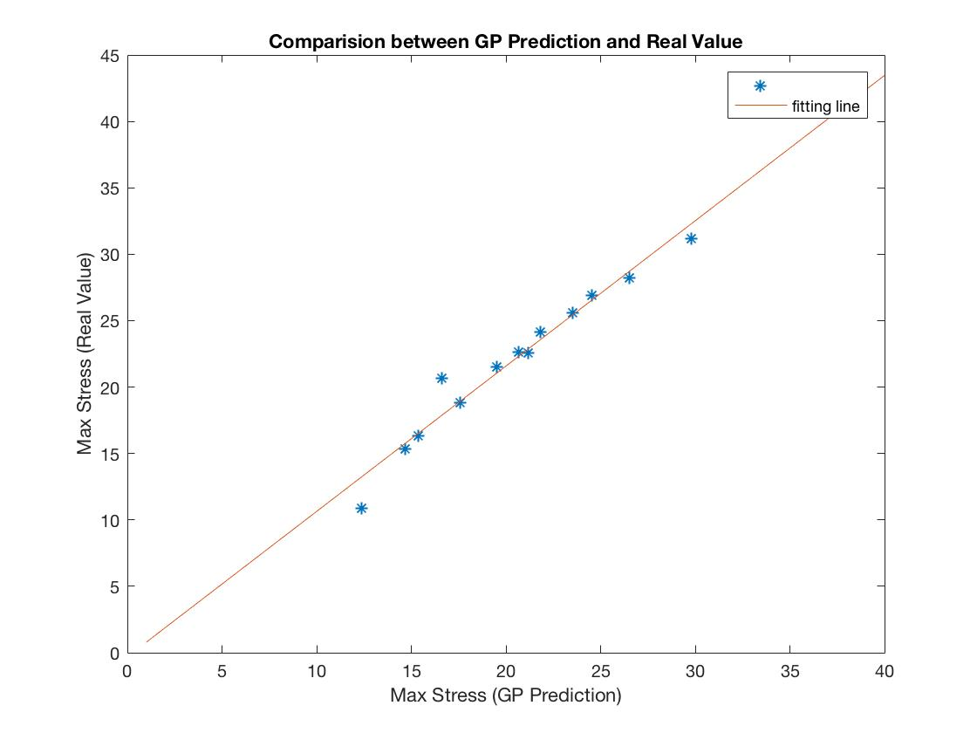

figure 4. fitting line

1. **Max Stress Coordinat Prediction**

Furthermore, prediction of the max stress coordinate was given in addition.

I do the training of x coordinate and consequence y coordinate (here I thought x and y is not related ). The results are pretty good. But I find that the max stress coordinate x and y actually has a relation. Because the max stress always occurs in the inner cycle of our model.

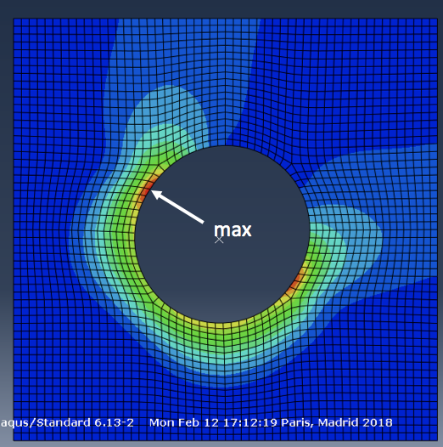

figure 5. position of max stress

In this way, equation **(x-a)²+(y-b)²=r²** should be satisfied.

I am now trying to encode this equation to the training process. The thesis of Chiplunkar mentioned this so I am reading this thesis and its code. But there is just the code of joint covariance provided in his thesis so it is pretty hard.