**Bug Report:** Broken Model Image

**Report by:** Luciane Martins

**Severity:**  Critical  Major  Minor  Trivial

**Priority:**  High  Medium  Low

**Description:**

On the web page "https://buggy.justtestit.org/overall," the model image used to display Lancia model is broken or not loading correctly. This results in a missing or distorted image representation of the model, affecting the visual presentation of the content.

**Environment:**

Cypress Version: 12.17.4

Browser: Google Chrome 116.0.5845.97

Operating System: Windows 10

**Steps to Reproduce:**

1. Navigate to "https://buggy.justtestit.org/overall."
2. Order model by ‘Engine’
3. Observe that the image representing the Lancia model is either missing, displayed as a broken image icon, or distorted.

**Expected result:**

The model image should load correctly and be displayed in its intended format, providing users with an accurate visual representation of the model described on the page.

**Actual result:**

The broken model image detracts from the quality of the page's content and may give users an inaccurate impression of the model being discussed. It's essential to identify and fix the issue to maintain the website's credibility and visual appeal.

**Screenshot:**

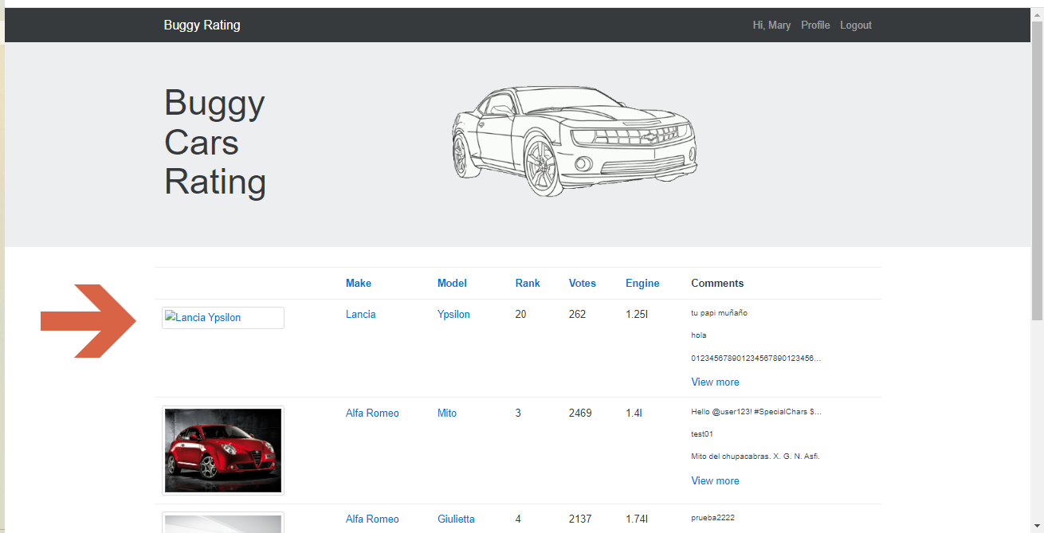

After clicking on broken image:

