**Bug Report:** Profile allows to input a gender that not exists in the gender list

**Report by:** Luciane Martins

**Severity:**  Critical  Major  Minor  Trivial

**Priority:**  High  Medium  Low

**Description:**

I identified a critical issue while testing the profile creation functionality on the website https://buggy.justtestit.org/. The bug allows users to save a profile inputting a gender that was not in the dropdown.

**Environment:**

Cypress Version: 12.17.4

Browser: Google Chrome 116.0.5845.97

Operating System: Windows 10

**Steps to Reproduce:**

1. Navigate to the website: <https://buggy.justtestit.org/>.
2. Login with username “maryjane83” and password “Password1!”
3. Click on the "Profile" button to access the form.
4. Fill in the gender field as “Transgender” on the Additional Info
5. Save the form clicking on “Save” button

**Expected result:**

The gender selection dropdown should only allow valid options from the provided list.

**Actual result:**

The form allows users to input a gender option that is not present in the provided list. Upon submitting the form, the system displays a vague "Unknown Error" message, which does not provide any information about the issue or how to resolve it.

**Screenshots:**

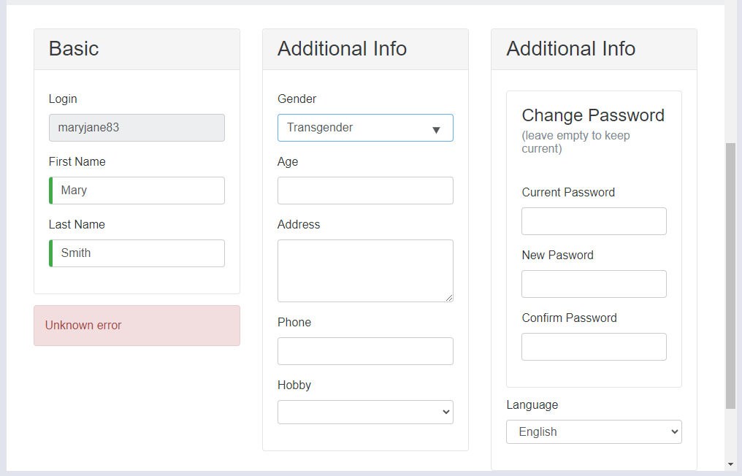

**Additional Notes:**

The "Unknown Error" message does not guide users on how to rectify the issue or provide any information for troubleshooting.