**Bug Report:** Profile allows to save a gender that not exists in the gender list

**Report by:** Luciane Martins

**Severity:**  Critical  Major  Minor  Trivial

**Priority:**  High  Medium  Low

**Description:**

I identified a critical issue while testing the profile creation functionality on the website https://buggy.justtestit.org/. I identified a critical issue related to gender selection. The bug allows users to successfully save a profile with the gender option "Bissexual," even though this value is not included in the predefined list of gender options.

**Environment:**

Cypress Version: 12.17.4

Browser: Google Chrome 116.0.5845.97

Operating System: Windows 10

**Steps to Reproduce:**

1. Navigate to the website: <https://buggy.justtestit.org/>.
2. Login with username “maryjane83” and password “Password1!”
3. Click on the "Profile" button to access the form.
4. Fill in the gender field as “Bissexual” on the Additional Info
5. Save the form clicking on “Save” button

**Expected result:**

The gender selection dropdown should only allow valid options from the predefined list. If an invalid option such as "Bissexual" is selected, the form submission should be prevented, and an appropriate error message should be displayed indicating the invalid gender selection..

**Actual result:**

Contrary to expectations, the form allows users to successfully save a profile with the gender option "Bissexual," even though this value is not present in the predefined gender options list. No error message is displayed, and the system treats the invalid gender value as valid.

**Screenshots:**

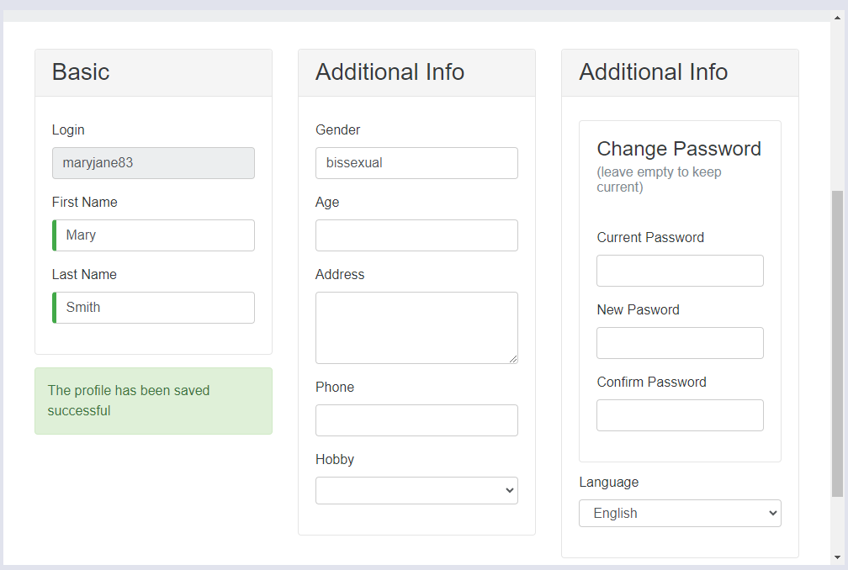

**Additional Notes:**

Clearing browser cache and cookies does not resolve the issue.

The successful saving of an invalid gender value compromises the integrity of user data and application functionality.