**Bug Report:** Profile Allows Input of Non-Numeric Value in Age Field; Displays "Unknown Error" After Saving

**Report by:** Luciane Martins

**Severity:**  Critical  Major  Minor  Trivial

**Priority:**  High  Medium  Low

**Description:**

I identified a critical issue while testing the profile creation functionality on the website https://buggy.justtestit.org/. I encountered a critical issue related to the age field. The bug allows users to input a non-numeric string in the age field. Subsequently, upon saving the profile, the system displays an uninformative "Unknown Error" message.

**Environment:**

Cypress Version: 12.17.4

Browser: Google Chrome 116.0.5845.97

Operating System: Windows 10

**Steps to Reproduce:**

1. Navigate to the website: <https://buggy.justtestit.org/>.
2. Login with username “maryjane83” and password “Password1!”
3. Click on the "Profile" button to access the form.
4. In the "Age" field, input a non-numeric string value (e.g., "twenty-five").
5. Save the form clicking on “Save” button

**Expected result:**

The "Age" field should only accept numeric values. If a non-numeric value is entered, the form submission should be prevented, and an appropriate error message should be displayed indicating the issue with the age input.

**Actual result:**

Contrary to expectations, the form allows users to input a non-numeric string value (e.g., "twenty-five") in the "Age" field. Upon saving the profile, the system displays a vague "Unknown Error" message, which provides no insight into the nature of the issue.

**Screenshots:**

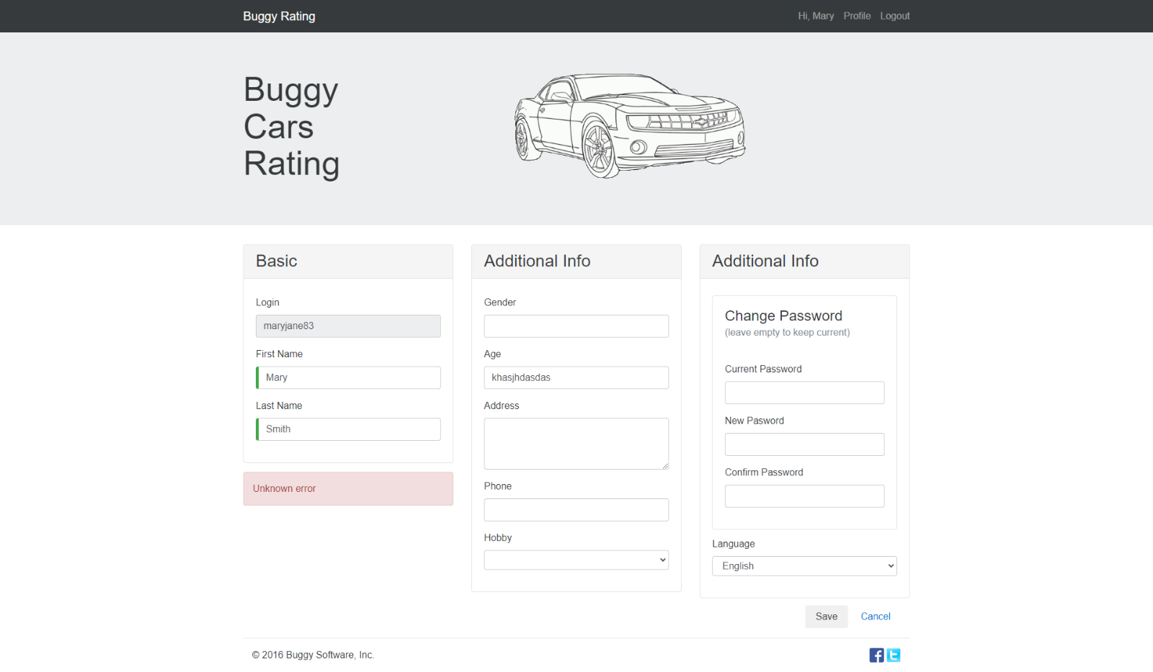

**Additional Notes:**

The issue is reproducible across different browser sessions and devices.

Clearing browser cache and cookies did not resolve the issue.

The lack of informative error messaging hinders users from understanding and addressing the error, potentially leading to confusion and frustration.