**Bug Report:** Phone number allows to input an invalid number.

**Report by:** Luciane Martins

**Severity:**  Critical  Major  Minor  Trivial

**Priority:**  High  Medium  Low

**Description:**

I identified an issue while testing the profile creation functionality on the website https://buggy.justtestit.org/. The phone number field in the application's user profile form is allowing users to save phone numbers with invalid formats and lacks a character limit. This leads to incorrect or inconsistent data being stored in the system, causing potential usability and data integrity issues.

**Environment:**

Cypress Version: 12.17.4

Browser: Google Chrome 116.0.5845.97

Operating System: Windows 10

**Steps to Reproduce:**

1. Navigate to the website: <https://buggy.justtestit.org/>.
2. Login with username “maryjane83” and password “Password1!”
3. Click on the "Profile" button to access the form.
4. In the "Phone" field, Enter a phone number with more than 20 numbers.
5. Save the form clicking on “Save” button.

**Expected result:**

The phone number field should only accept valid phone number formats (e.g., +1 123-456-7890) and should reject inputs with letters or special characters.

There should be a clear error message or validation warning when attempting to input an invalid format.

The phone number field should have a reasonable character limit to prevent excessively long entries that might cause data storage issues.

**Actual result:**

The phone number field does not have any character limit, allowing excessively long entries.

**Screenshots:**

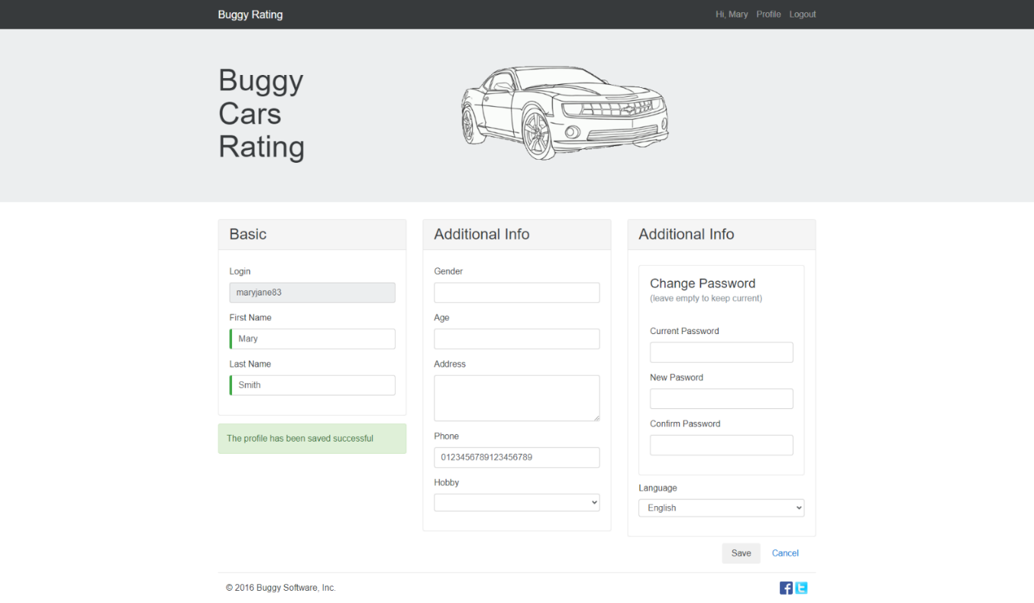

**Additional Notes:**

The inconsistent and incorrect phone number data can impact user communication and system functionality.

Proper validation and character limits are necessary to ensure data integrity and maintain a high standard of usability.