**Bug Report:** Premature Password Mismatch Error in Confirm Password Field

**Report by:** Luciane Martins

**Severity:**  Critical  Major  Minor  Trivial

**Priority:**  High  Medium  Low

**Description:**

The confirm password field is currently validating password matching before the user has a chance to type their password. This premature validation leads to confusion and prevents users from entering their passwords correctly during registration.

**Environment:**

Cypress Version: 12.17.4

Browser: Google Chrome 116.0.5845.97

Operating System: Windows 10

**Steps to Reproduce:**

1. Navigate to the website: <https://buggy.justtestit.org/>.
2. Login with username “maryjane83” and password “Password1!”
3. Click on the "Profile" button to access the form.
4. In the "New Password" field, enter a new value

**Expected result:**

The "Confirm Password" field should not display an error message regarding password mismatch until the user attempts to save the form.

The validation should only occur after the user has entered both a password and a matching value in the "Confirm Password" field and then proceeds to save the form.

**Actual result:**

The "Confirm Password" field displays an error message indicating password mismatch even before a password is entered.

The error message is shown prematurely, causing confusion for users.

**Screenshots:**

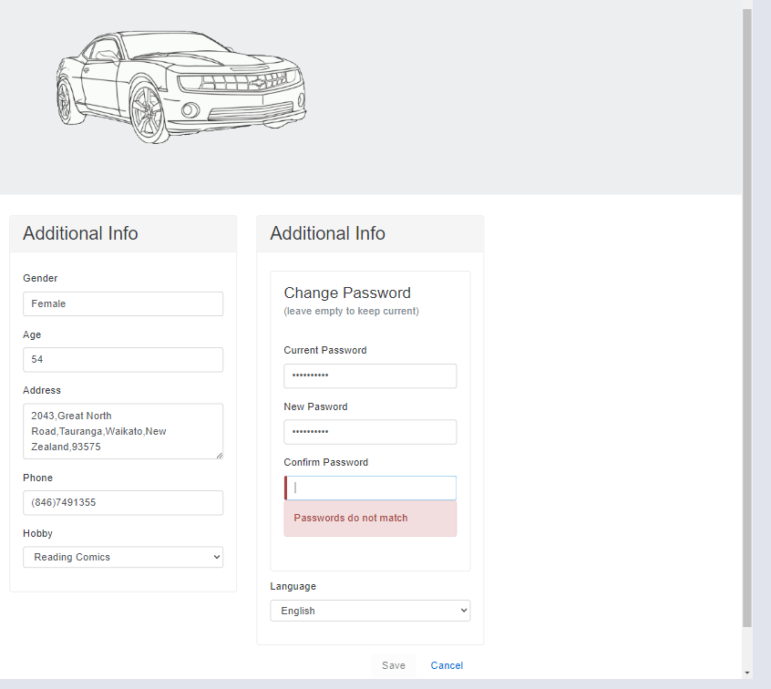

**Additional Notes:**

The inconsistent and incorrect phone number data can impact user communication and system functionality.

Proper validation and character limits are necessary to ensure data integrity and maintain a high standard of usability.