Linear models and critical perspectives on science and knowledge
Rob Davies

1 PSYC122: Classes in weeks 16-20
- My name is Dr Rob Davies, I am an expert in communication, individual differences, and methods
 Tip
Ask me anything:
- questions during class in person or anonymously through slido;
- all other questions on discussion forum

2 Week 19: Linear models – critical perspectives
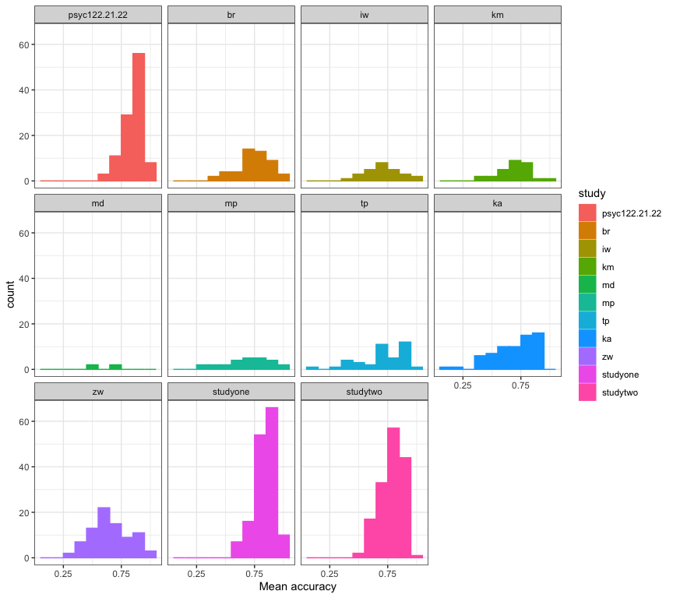
Figure 1: Histograms showing the distribution of mean accuracy scores in 11 studies

3 Targets for weeks 16-19: Concepts
We are working together to develop concepts:
- Week 16 — Hypotheses, measurement and associations
- Week 17 — Predicting people using linear models
- Week 18 — Everything is some kind of linear model
- Week 19 — The real challenge in psychological science

4 Targets for weeks 16-19: Skills
We are working together to develop skills:
- Week 16 — Visualizing, estimating, and reporting associations
- Week 17 — Using data to predict people
- Week 18 — Going deeper on linear models
- Week 19 — Evaluating evidence across multiple studies

5 Learning targets for this week
- Concepts – To engage with the real challenges in psychological science:
- People vary
- Results vary

6 Learning targets for this week
- Skills – To engage with the real challenges in data analysis skills development:
- Growing in independence
- Exploiting the R knowledge ecosystem

7 Why these targets? Key ideas
Science (including psychological science) has undergone a rolling series of crises:
- Replicability or replication crisis (Pashler & Wagenmakers, 2012)
- Statistical crisis (A. Gelman & Loken, 2014)
- Generalizability crisis (Yarkoni, 2022)

8 The triggers for crisis
- Failures to replicate influential claims (Nosek et al., 2022)
- Questionable research practices (John et al., 2012)
- Questionable measurement practices (Flake & Fried, 2020)
- Limited samples (Button et al., 2013; Henrich et al., 2010; Wild et al., 2022)

9 The credibility revolution: responses
- Pre-registration (Nosek et al., 2018, 2019) and registered reports (Nosek & Lakens, 2014)
- Replication studies (e.g. Aarts et al., 2015)
- Identification of open science principles (Munafò et al., 2017)

10 The credibility revolution: replication is recognised as crucial to building a science of psychology
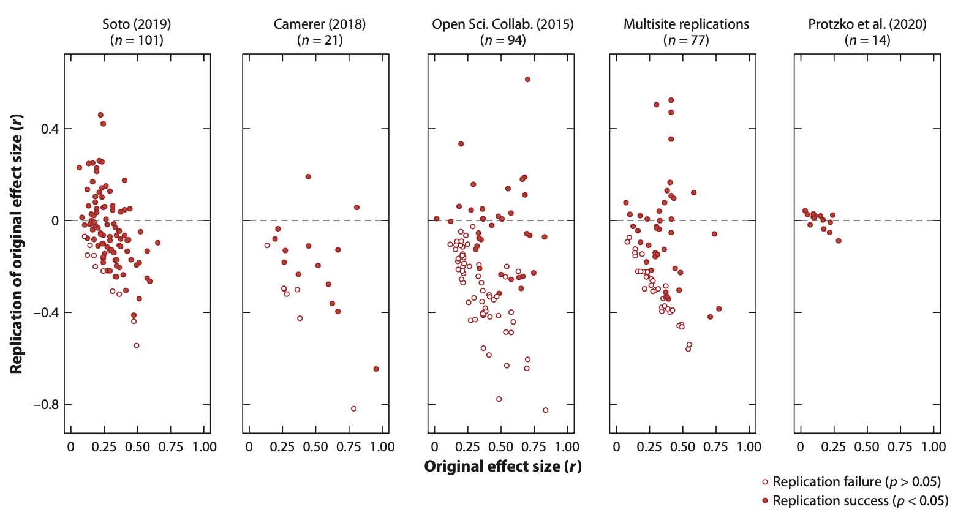
Nosek et al. (2022): replication outcomes for three systematic replication studies

11 The real challenge: people vary
- The real challenges we face as psychologists: people vary
- We examine the impact of this variation
- And we explore if or how we can reproduce or generalize findings in psychological science
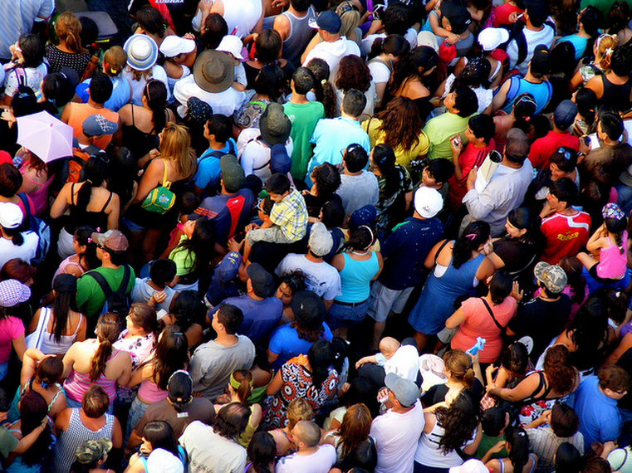
flickr, Cat Walker ‘crowd’

12 The real challenge: results vary
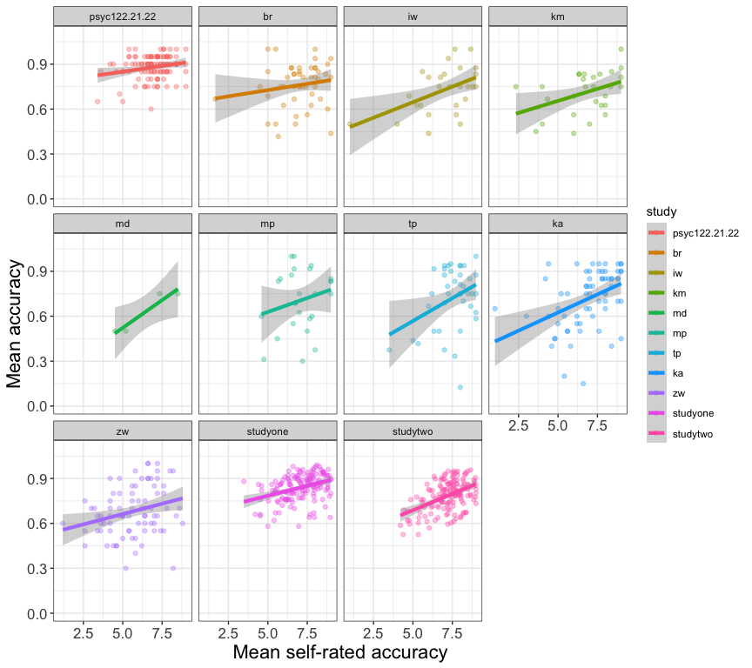
Figure 2: Scatterplots showing the association between mean accuracy and self-rated accuracy of understanding, of health information, in 11 studies

13 Variation and replication
Psychological and social processes show much more variability than the usual phenomena in the physical sciences (a. Gelman, 2015)
- The patterns or effects that interest us may (maybe will) vary between places, people, and times
- Because treatment effects can be expected to vary then we may not see replication of effects
- So we investigate how effects vary and we open our workflow

14 The professional data analysis workflow: from raw data to results
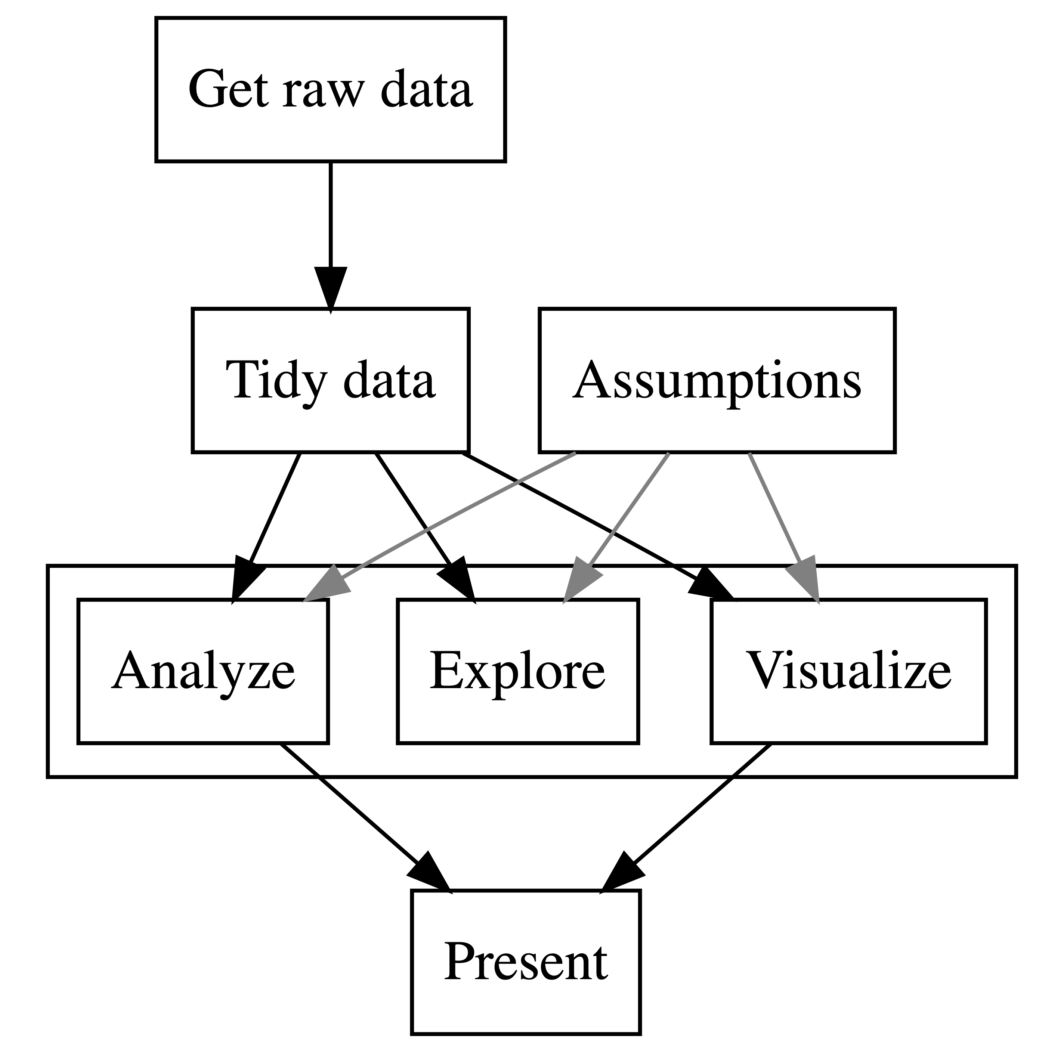

Figure 3: The data analysis pipeline or workflow

15 The data analysis workflow
- Get some data
- Process or tidy the data
- Explore, visualize, and analyze the data
- Present or report your findings
Tip
- Identify the elements and the order in your work as the parts of a pipeline or the stages in a workflow

16 Analysis multiverse
Different researchers: different choices (Silberzahn & Uhlmann, 2015)
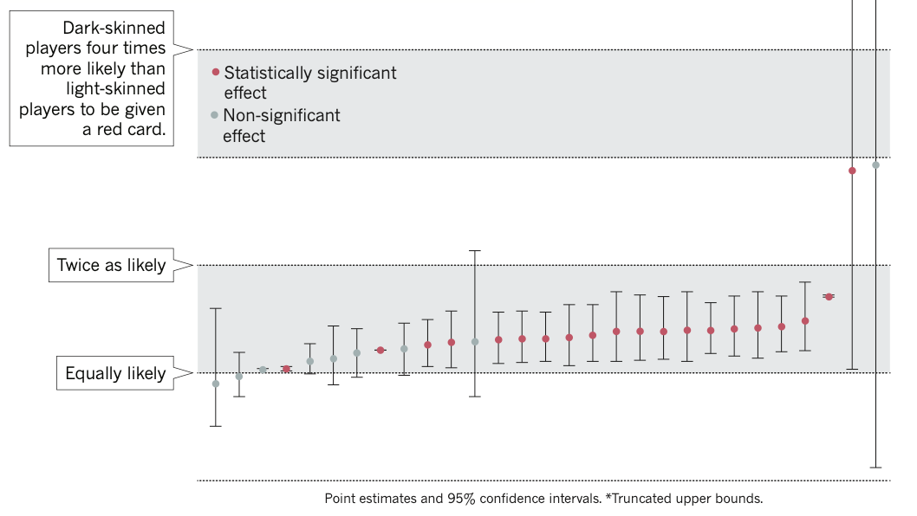
Silberzahn and Uhlmann (2015): Twenty-nine research teams reached a wide variety of conclusions using different methods on the same data set to answer the same question.

17 Kinds of reproducibility
Gilmore et al. (2017; following Goodman et al., 2016) present three kinds of reproducibility:
- Methods reproducibility
- Results reproducibility
- Inferential reproducibility

18 Inferential reproducibility
If researchers repeat a study (results reproducibility) or re-analyze original data (methods reproducibility) then they should come to similar conclusions as original authors
But …
- reproducibility attempt could reveal problems, uncertainty over choices
- different researchers could apply different prior expectations over the probability of possible effects

19 Lessons learned from crises mean we now hope to see that researchers:
- Share data and code
- Publish research reports in ways that enable others to check or query analyses

20 Let’s take a break
- End of part 1

21 Health comprehension project – answers to our questions
- We have been working in the context of a live research project: What makes it easy or difficult to understand written health information?

flickr, Sasin Tipchair ‘Senior woman in wheelchair talking to a nurse in a hospital’

22 Health comprehension project: questions and analyses
- Our research questions are:
 Note
- What person attributes predict success in understanding?
- Can people accurately evaluate whether they correctly understand written health information?

23 Theory: Models of comprehension accuracy should include predictors:
(1.) experience HLVA, SHIPLEY and (2.) reasoning ability (FACTOR3, reading strategy) (Freed et al., 2017)
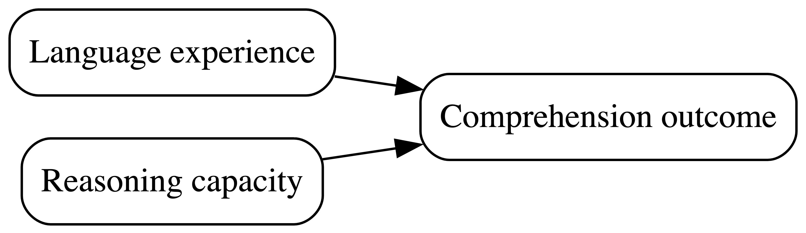

Figure 4: Understanding text depends on (1.) language experience and (2.) reasoning ability (Freed et al., 2017)

24 Multiple candidate predictor variables
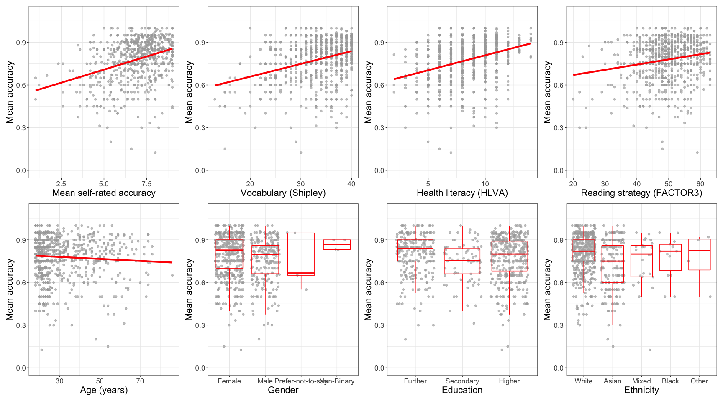
Figure 5: Scatterplots showing the potential association between accuracy of comprehension and variation on each of a series of potential predictor variables.

25 Critical thinking: data analysis assumptions
- validity: that differences in knowledge or ability cause differences in test scores
- measurement: that this is equally true across the different kinds of people we tested
- generalizability: that the sample of people we recruited resembles the population

26 Critical thinking: uncertainty
There are three levels of uncertainty when we look at sample data (McElreath, 2020) – uncertainty over:
- The nature of the expected change in outcome
- The ways that expected changes might vary between individual participants or between groups of participants
- The random ways that specific responses can be produced

27 Critical thinking: working with samples
- We test who we can – convenience sampling – and who we can test has an impact on the quality of evidence (Bornstein et al., 2013)
Tip
Practice critical evaluation:
- If age, ethnicity or gender are not balanced $→$ does this matter to your research question?
- If samples are limited in size $→$ how does that affect our uncertainty over effects estimates?

28 Let’s take a break
- End of part 2

29 11 health comprehension studies
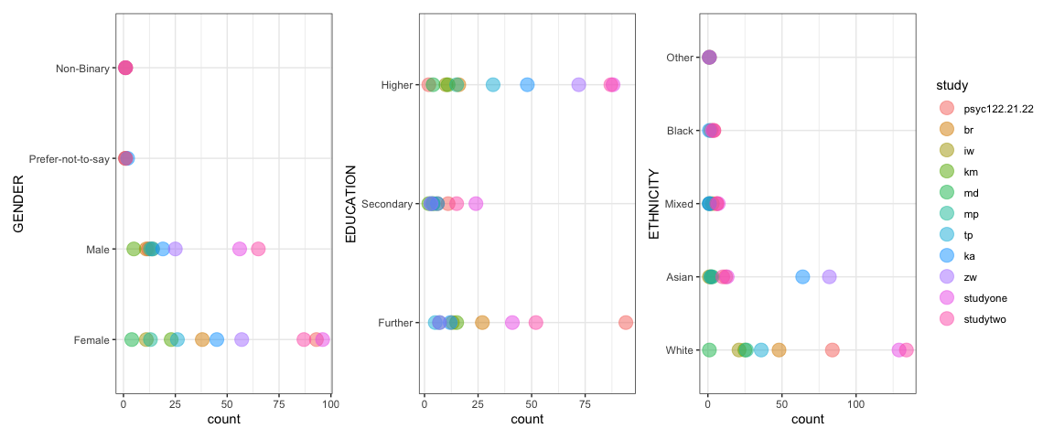
Figure 6: Dotplots showing the gender, education and ethnicity of participants across 11 studies

30 Participants vary in accuracy
Figure 7: Grid of histograms showing the distribution of mean accuracy scores in each of 11 studies

31 Participants vary in age
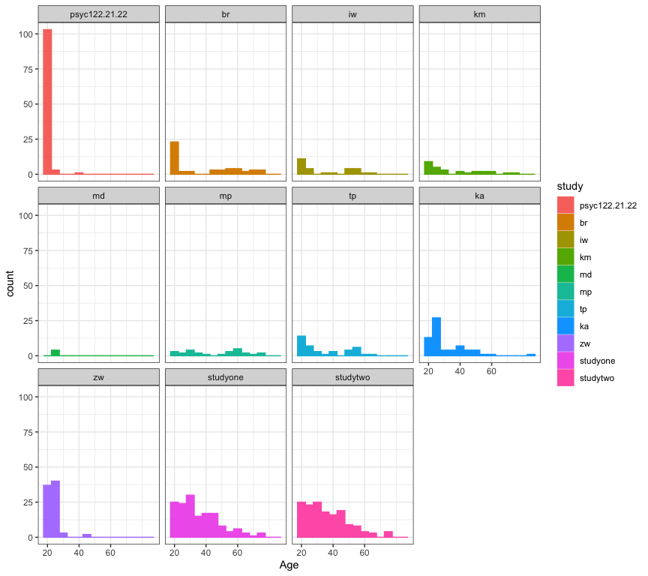
Figure 8: Grid of histograms showing the distribution of participant ages in each of 11 studies

32 Participants vary in health literacy
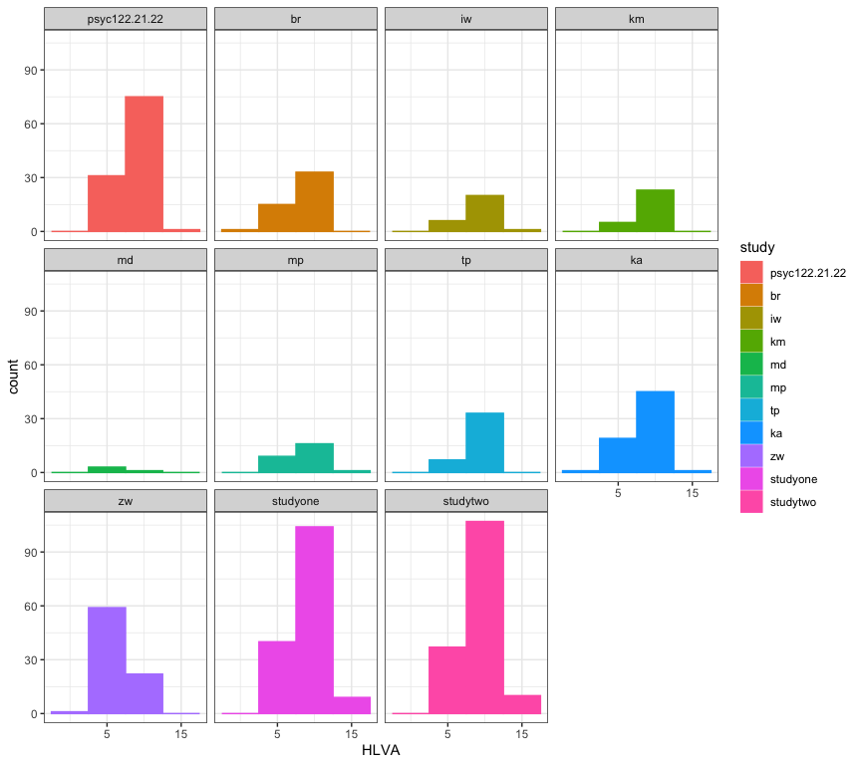
Figure 9: Grid of histograms showing the distribution of health literacy (HLVA) scores in each of 11 studies

33 Participants vary in vocabulary
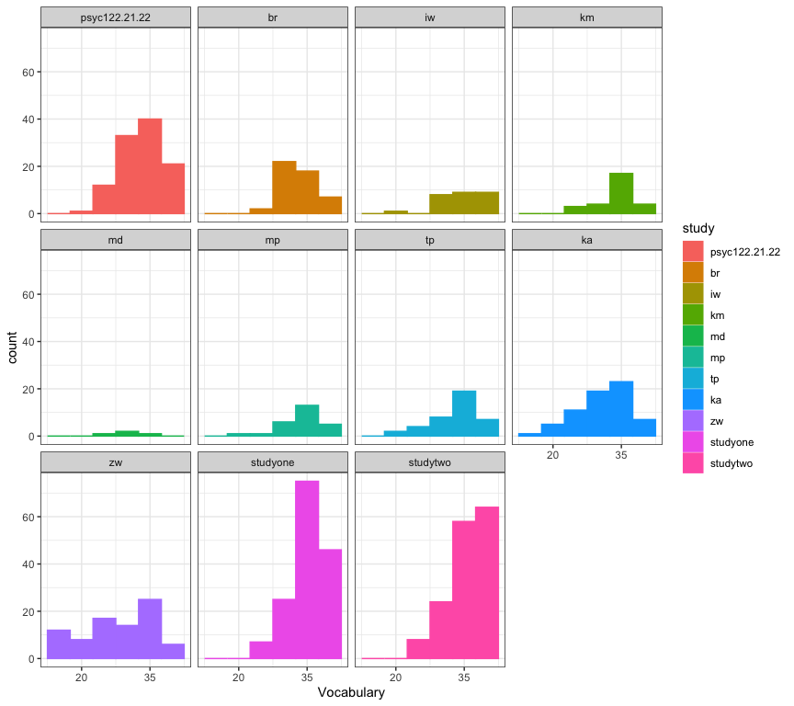
Figure 10: Grid of histograms showing the distribution of vocabulary (Shipley) scores in each of 11 studies

34 Participants vary in reading strategy
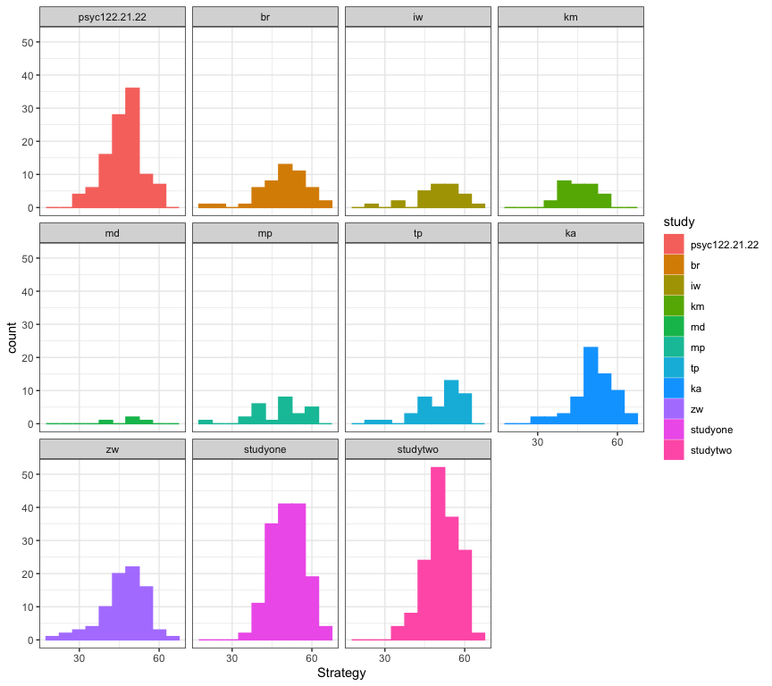
Figure 11: Grid of histograms showing the distribution of reading strategy (FACTOR3) scores in each of 11 studies

35 Associations vary
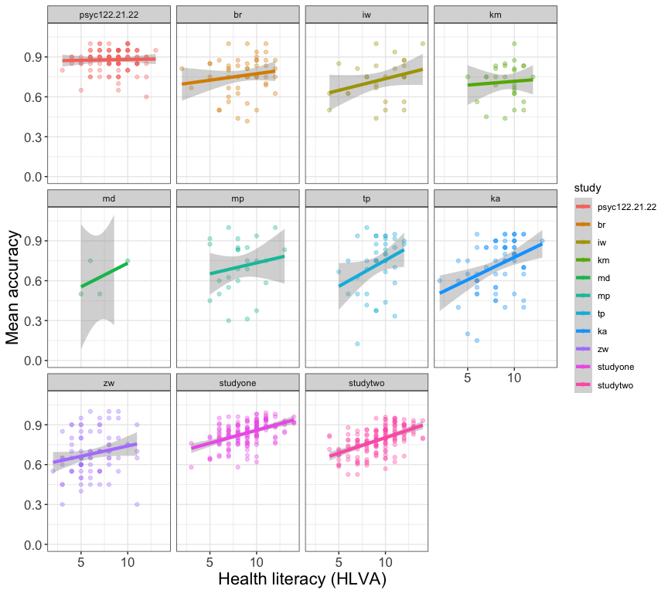
Figure 12: Association between mean accuracy and health literacy

36 Associations vary
Figure 13: Association between mean accuracy and mean self-rated accuracy

37 Health comprehension project: answers
Note
- What person attributes predict success in understanding?
- Health literacy, vocabulary, and reading strategy
- Can people accurately evaluate whether they correctly understand written health information?
- Yes but not very well

38 Do we see replication across studies?
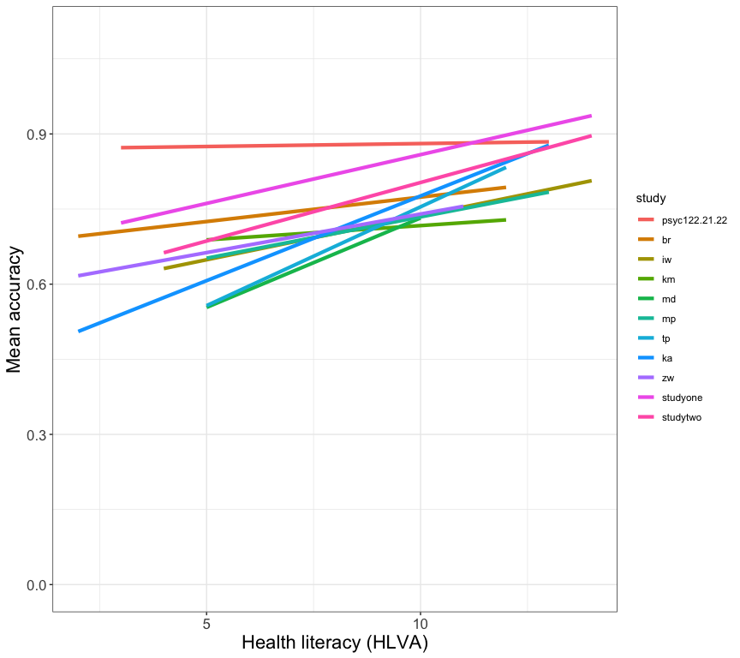
Figure 14: Varying estimated association between mean accuracy and health literacy

39 Do we see replication across studies?
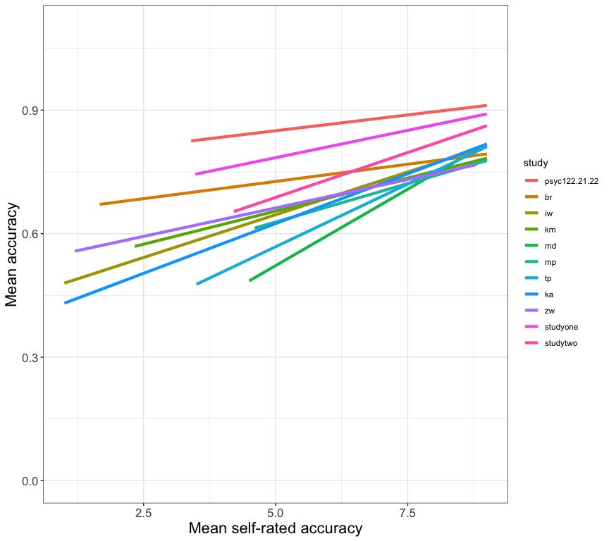
Figure 15: Varying association between mean accuracy and mean self-rated accuracy

40 Results reproducibility
- If a researcher finds a pattern in human behaviour or in individual differences
- We may critically evaluate the robustness or the generalizability of the finding
 Important
Results reproducibility means that a new study with new data, collected following the original procedures as closely as possible, yields the same outcomes Gilmore et al. (2017)

41 Health comprehension studies evidence
- Maybe it is wiser – given levels of uncertainty – to expect some variation in results
Tip
What is your view?
- Do we see robust prediction of accuracy of understanding of health information, given measures of vocabulary, health literacy, and reading strategy?

42 PSYC122 response data
- What will we see in a new study: with your data?
Tip
Will we see the same or different patterns?
- Do the practical work to find out

43 Let’s take a break
- End of part 3

44 Kinds of reproducibility
Gilmore et al. (2017; following Goodman et al., 2016) present three kinds of reproducibility:
- Methods reproducibility
- Results reproducibility
- Inferential reproducibility

45 Methods reproducibility
- Other researchers should be able to get the same results if they use the analysis methods with the same data
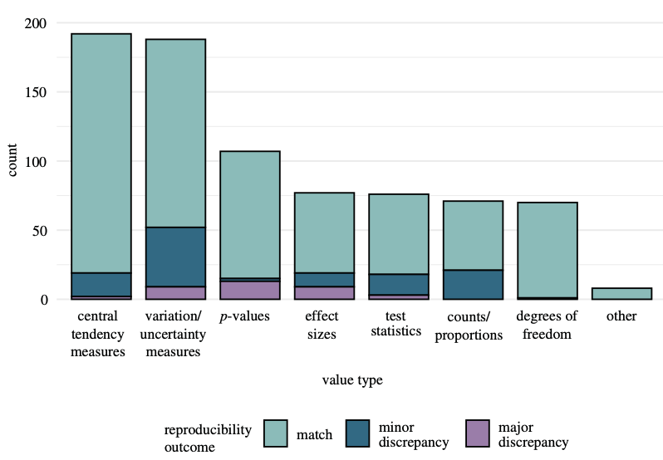
Hardwicke et al. (2021): Frequency of reproducibility outcomes by value type.

46 Require data and code sharing
- Analyses by Kidwell et al. (2016) and analyses reviewed by Nosek et al. (2022): study data increasingly available
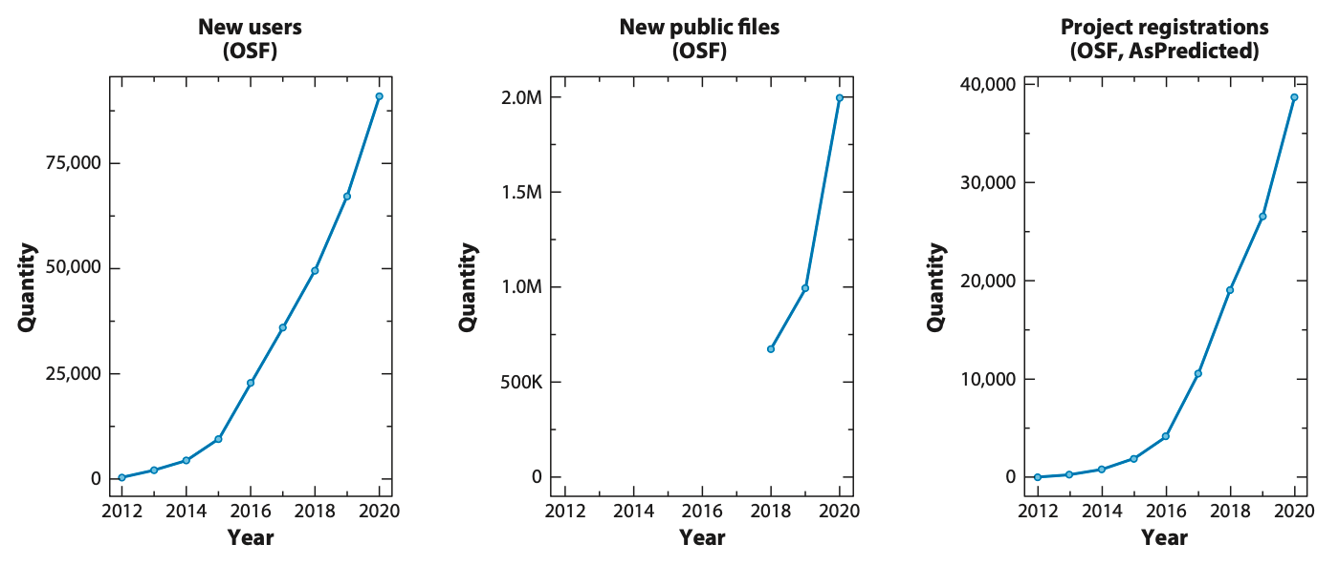
Nosek et al. (2022): Yearly counts of users, sharing of files (research data, materials, code), and registration of studies on OSF and AsPredicted.

47 Why we use R: We can share data and code helpfully
It is great that data are shared but analyses show they are not always readily usable (Towse et al., 2021) but should be
- completeness: are all the data and the data descriptors supporting a study’s findings publicly available?
- reusability: how readily can the data be accessed and understood by others?

48 Why we use R: We can write self-documented code
# Here: fit a linear model
lm(mean.acc ~ SHIPLEY + HLVA + FACTOR3 + AGE + NATIVE.LANGUAGE, ...)
Tip
- R will ignore everything after #
- Add a # comment after each step to briefly explain to yourself and others what is going on

49 The R knowledge ecosystem
R is:
- a language
- a computing environment
- a knowledge ecosystem

50 R is a language
We use:
- functions like lm() in the same way we use verbs to describe doing things
- arguments like (mean.acc ~ HLVA) in the same way we use nouns to identify who does what to whom
# Here: fit a linear model
lm(mean.acc ~ SHIPLEY + HLVA + FACTOR3 + AGE + NATIVE.LANGUAGE, ...)

51 R is a language
Like every language, we can often say the same thing using different words or accents
# This code does essentially the same job
data <- read_csv("mydata.csv")
# As this code
data <- read.csv("mydata.csv")

52 Languages have dialects
R has four different ways to draw plots: base, {lattice}, {grid}, {ggplot2}
# Base R graphics histogram of HLVA scores
hist(all.subjects$HLVA)
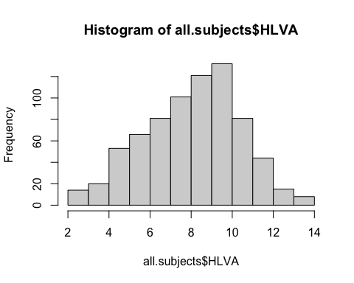

53 The R knowledge ecosystem
Above all, R is free:
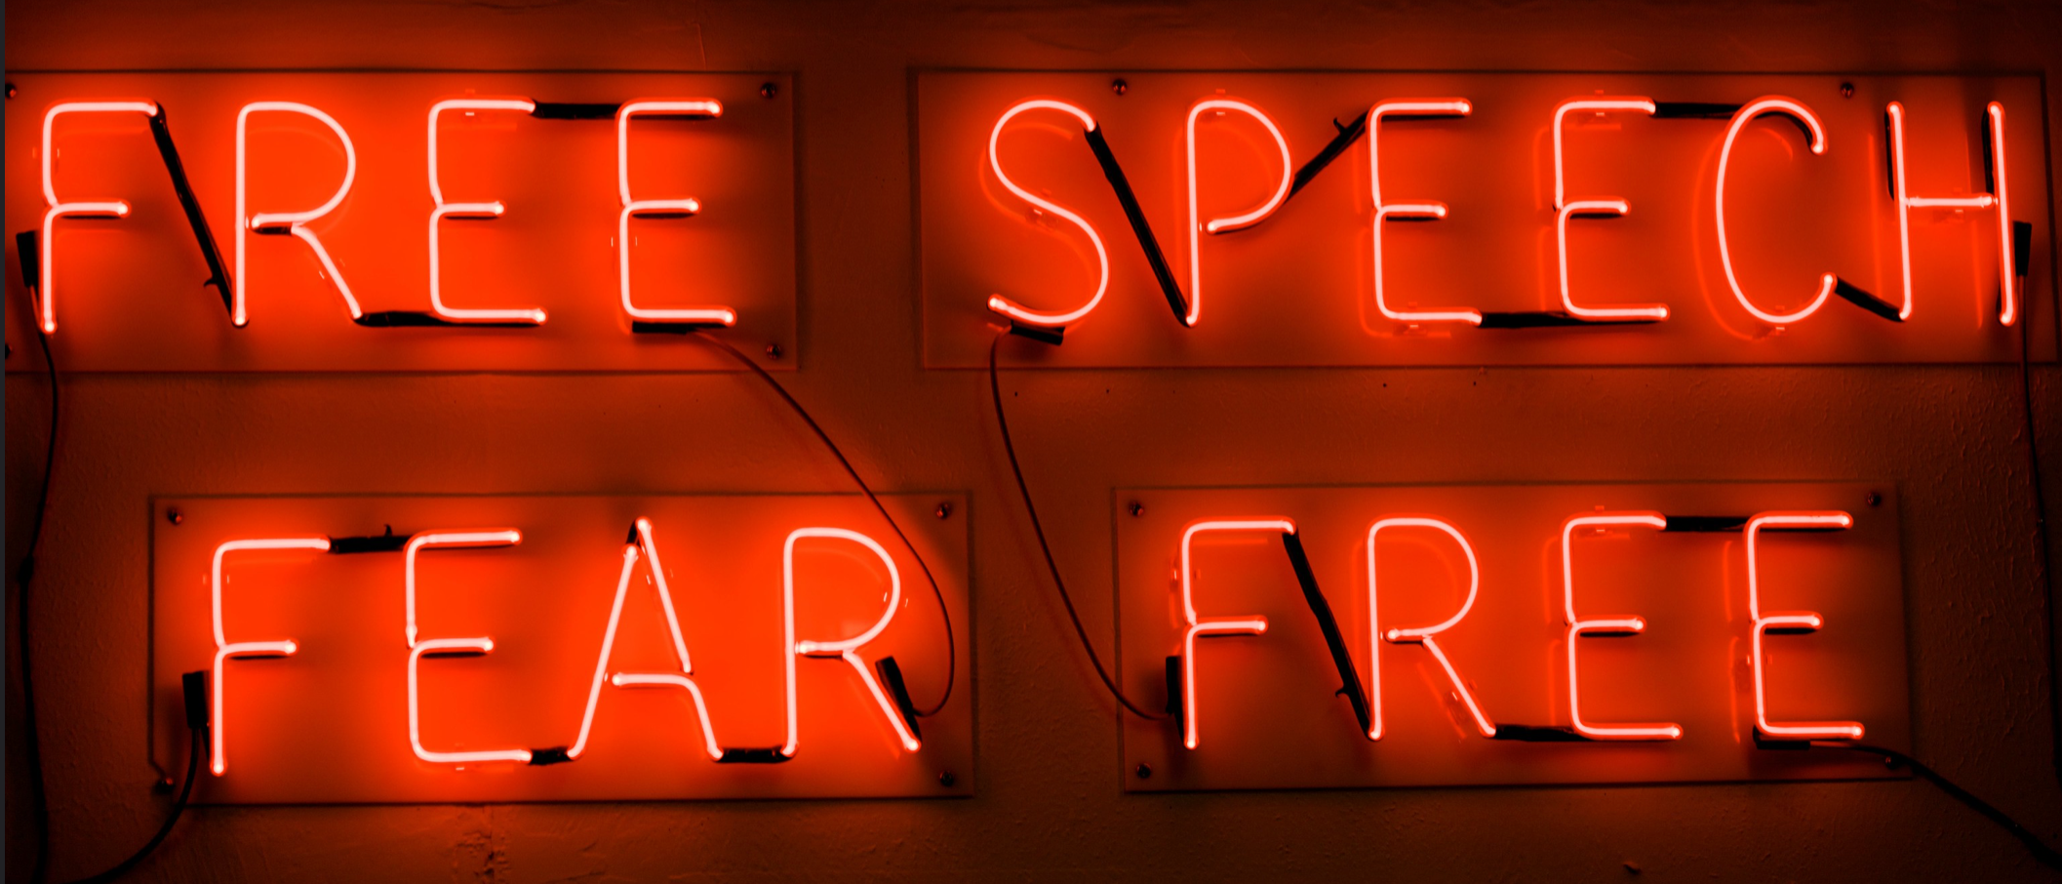

54 The R knowledge ecosystem
Tip
Every problem you ever have:
- someone has had it before
- solved it
- and written a blog (or tweet or toot) or recorded a YouTube or TikTok about it

55 The R knowledge ecosystem
- R is free open statistical software: everything you use is contributed, discussed and taught by a community of R users online, in open forums
- Learning to navigate this knowledge is an introduction to the future of knowledge sharing
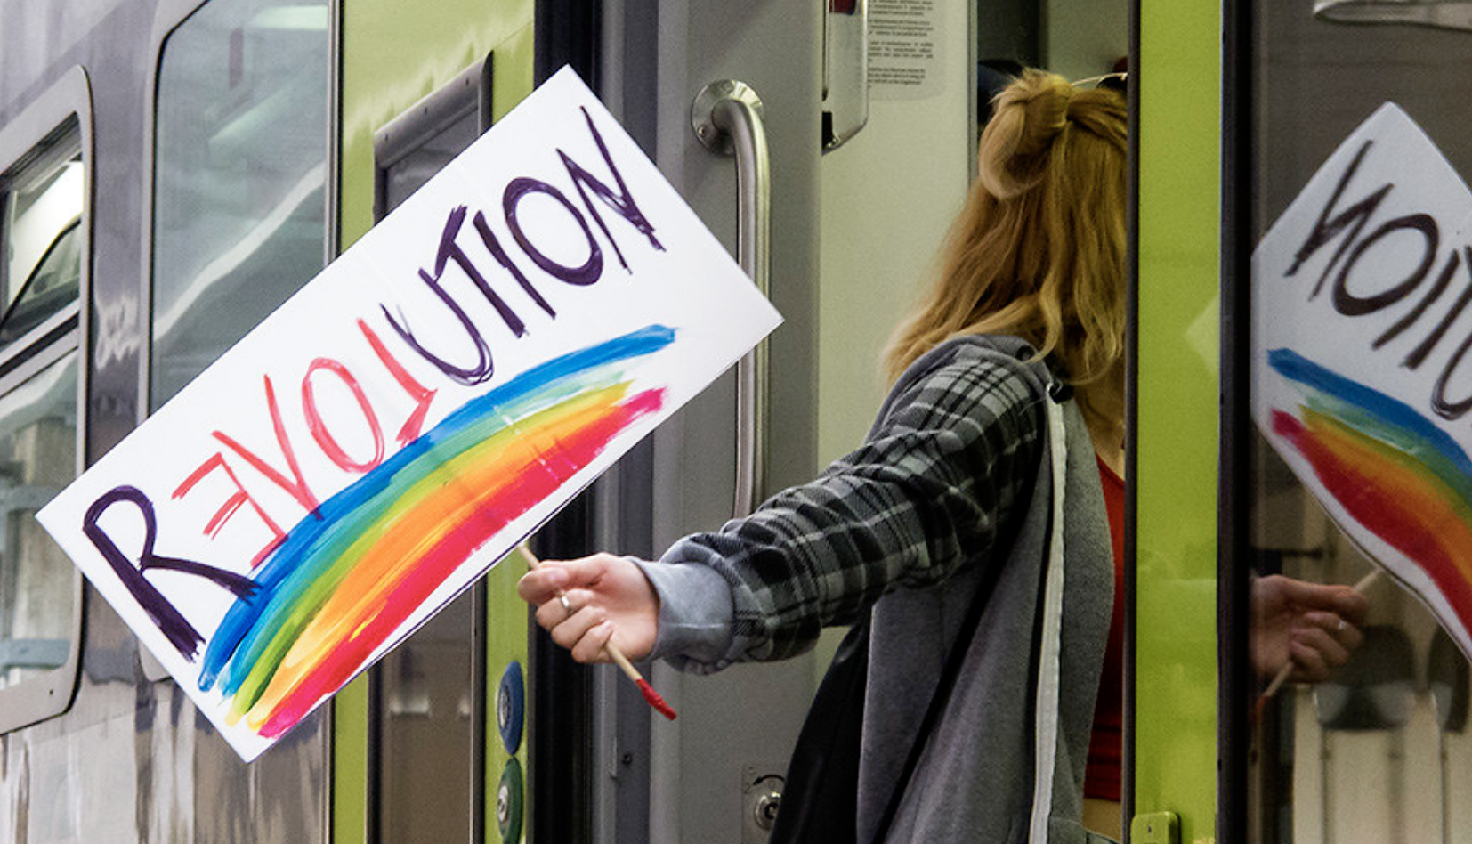
flickr, Cesar Salvadeo ‘Revolution’

56 How to find things out when you know what you need
- R has a built-in help system: typing
help(geom_histogram)
- Gets you detailed technical information
… Examples ggplot(diamonds, aes(carat)) + geom_histogram() …
Tip
Start with the examples

57 How to find things out when you don’t know what you need
This code won’t work
all.subjects %>%
ggplot(aes(x = AGE, y = mean.acc)) +
geom_histogram()
Error in `f()`:
! stat_bin() can only have an x or y aesthetic.
Backtrace:

58 How to find things out when you don’t know what you need
Tip
Just google it:
- Copy warning or error messages from R-Studio and paste them into a search engine

59 Copying an error message into google gets you a list of web pages
stat_bin() can only have an x or y aesthetic.


60 Stack Overflow lists question and answer discussions
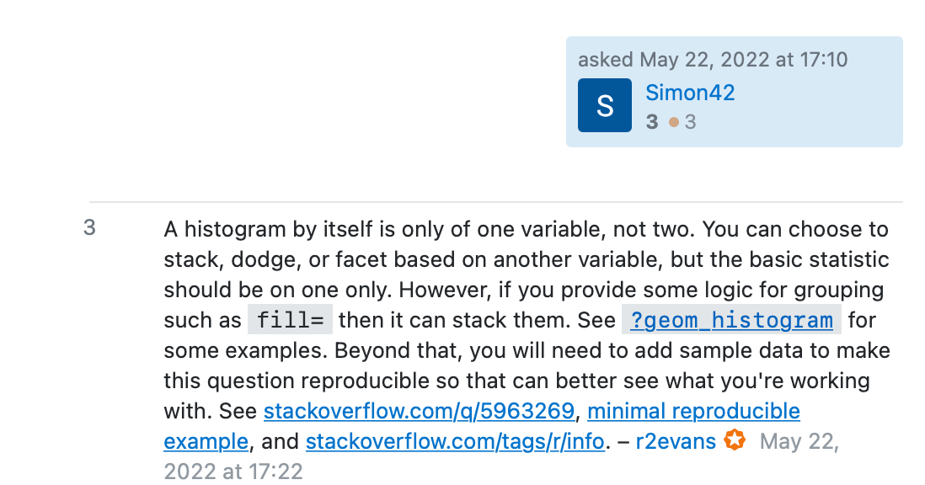

61 How to find things out when you don’t know what you need
- Stack Overflow pages identify:
- Questions asked
- Answers, often with code solutions to problems, and helpful discussions
- With questions and answers ranked by usefulness

62 The wider revolution in building and sharing knowledge
We can find many excellent free online books like:
https://r4ds.had.co.nz
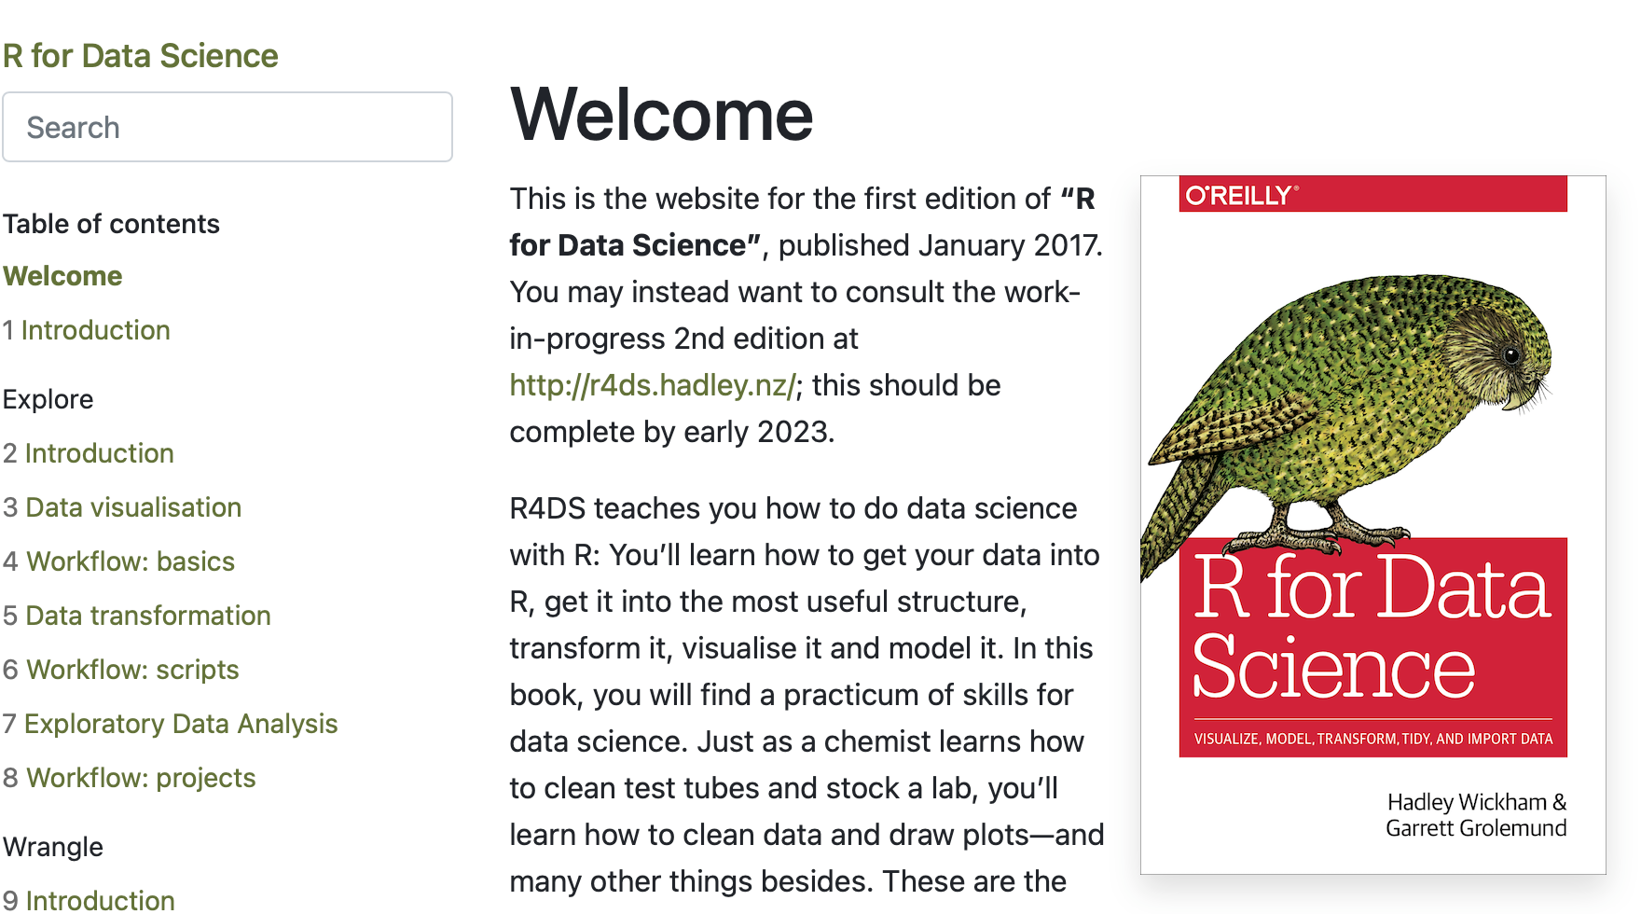

63 A worldwide community of knowledge sharing
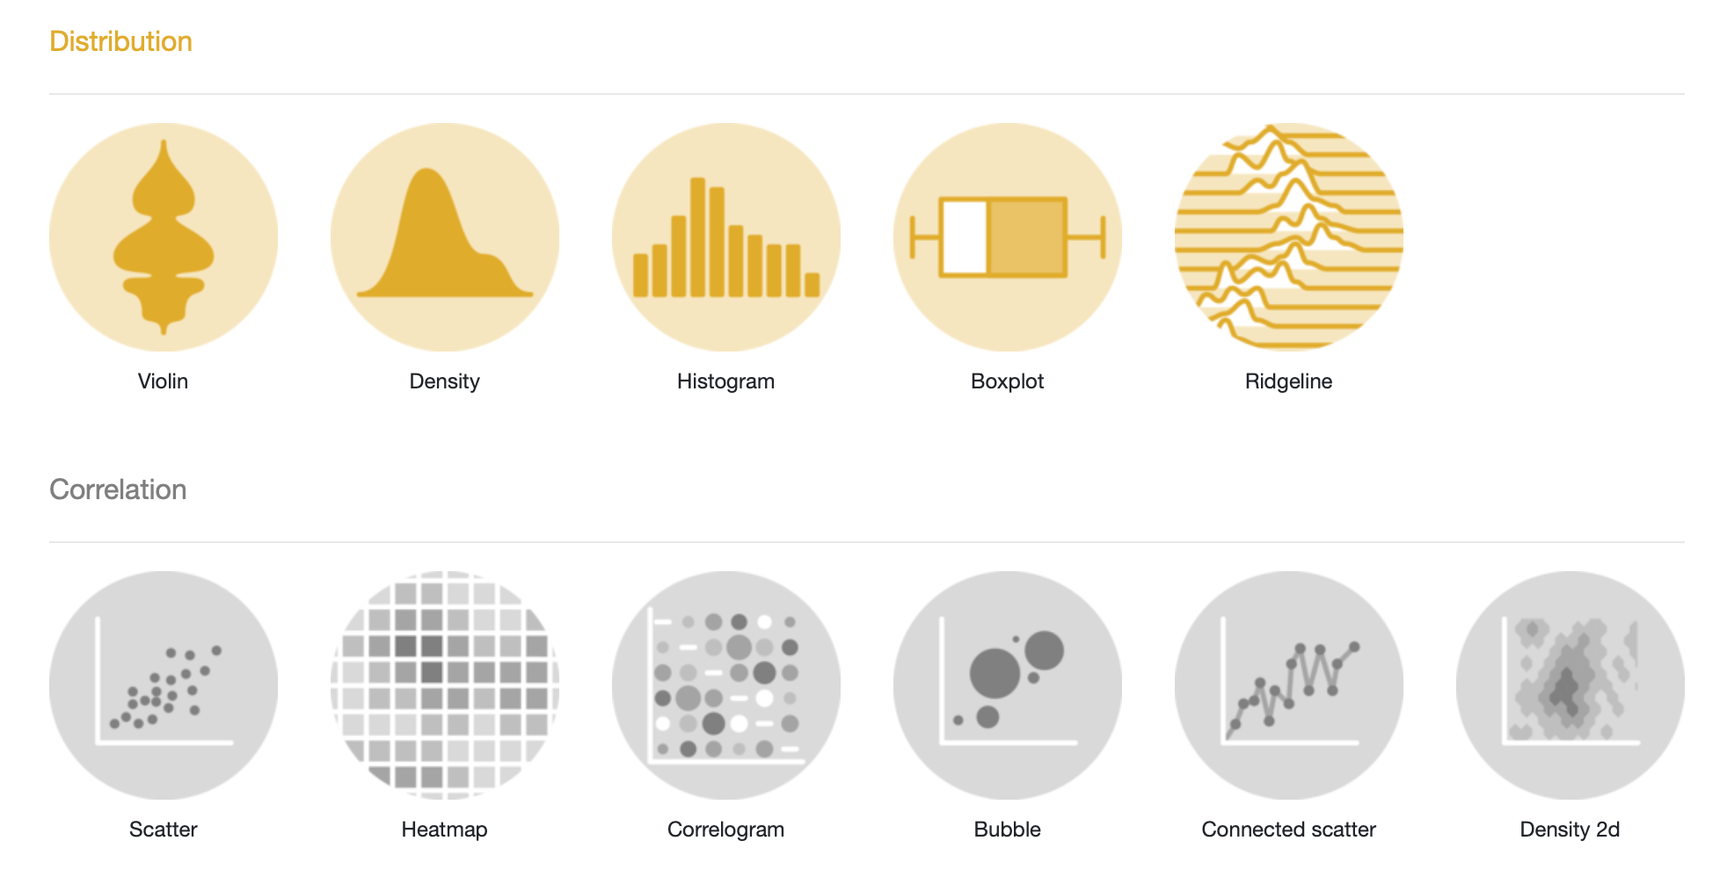
Screenshot of front page of ggplot gallery

64 Summary
- In the health comprehension project: accuracy of understanding of health information can be predicted by vocabulary knowledge, health literacy and reading strategy
- People can judge their own accuracy of understanding but not well
Tip
- What do your PSYC122 response data say?

65 Summary: critical thinking
- We can expect results – associations, effects, patterns – to vary between times, places, people
- Samples will be limited, measurement under uncertainty
- Data analysis choices will vary between researchers
- So we share data and code and critically evaluate results

66 Summary: grow in independence
- Comment your code in your .R scripts to explain what you are doing and how
- Use online information sources to understand choices and options
Tip
- Someone has already solved your problem: you just need to find the blog/Stack Overflow discussion/TikTok where they explain the solution

67 End of week 19

68 References
Aarts, E., Dolan, C. V., Verhage, M., & Van der Sluis, S. (2015). Multilevel analysis quantifies variation in the experimental effect while optimizing power and preventing false positives. BMC Neuroscience, 16(1), 1–15. https://doi.org/10.1186/s12868-015-0228-5
Bornstein, M. H., Jager, J., & Putnick, D. L. (2013). Sampling in developmental science: Situations, shortcomings, solutions, and standards. Developmental Review, 33(4), 357–370. https://doi.org/10.1016/j.dr.2013.08.003
Button, K. S., Ioannidis, J. P. A., Mokrysz, C., Nosek, B. A., Flint, J., Robinson, E. S. J., & Munafò, M. R. (2013). Power failure: Why small sample size undermines the reliability of neuroscience. Nature Reviews Neuroscience, 14(5), 365–376.
Flake, J. K., & Fried, E. I. (2020). Measurement Schmeasurement: Questionable Measurement Practices and How to Avoid Them. Advances in Methods and Practices in Psychological Science, 3(4), 456–465. https://doi.org/10.1177/2515245920952393
Freed, E. M., Hamilton, S. T., & Long, D. L. (2017). Comprehension in proficient readers: The nature of individual variation. Journal of Memory and Language, 97, 135–153. https://doi.org/10.1016/j.jml.2017.07.008
Gelman, a. (2015). The connection between varying treatment effects and the crisis of unreplicable research: A bayesian perspective. Journal of Management, 41(2), 632–643. https://doi.org/10.1177/0149206314525208
Gelman, A., & Loken, E. (2014). The statistical crisis in science. American Scientist, 102(6), 460–465. https://doi.org/10.1511/2014.111.460
Gilmore, R. O., Diaz, M. T., Wyble, B. A., & Yarkoni, T. (2017). Progress toward openness, transparency, and reproducibility in cognitive neuroscience. Annals of the New York Academy of Sciences, 1396, 5–18. https://doi.org/10.1111/nyas.13325
Goodman, S. N., Fanelli, D., & Ioannidis, J. P. A. (2016). What does research reproducibility mean? Science Translational Medicine, 8(341).
Henrich, J., Heine, S. J., & Norenzayan, A. (2010). The weirdest people in the world? The Behavioral and Brain Sciences, 33(2-3). https://doi.org/10.1017/S0140525X0999152X
John, L. K., Loewenstein, G., & Prelec, D. (2012). Measuring the prevalence of questionable research practices with incentives for truth telling. Psychological Science, 23(5), 524–532. https://doi.org/10.1177/0956797611430953
Kidwell, M. C., Lazarević, L. B., Baranski, E., Hardwicke, T. E., Piechowski, S., Falkenberg, L. S., Kennett, C., Slowik, A., Sonnleitner, C., Hess-Holden, C., Errington, T. M., Fiedler, S., & Nosek, B. A. (2016). Badges to acknowledge open practices: A simple, low-cost, effective method for increasing transparency. PLoS Biology, 14(5), 1–15. https://doi.org/10.1371/journal.pbio.1002456
McElreath, R. (2020). Statistical rethinking. Chapman; Hall/CRC. https://doi.org/10.1201/9780429029608
Munafò, M. R., Nosek, B. A., Bishop, D. V. M., Button, K. S., Chambers, C. D., Percie Du Sert, N., Simonsohn, U., Wagenmakers, E. J., Ware, J. J., & Ioannidis, J. P. A. (2017). A manifesto for reproducible science. Nature Human Behaviour, 1(1), 1–9. https://doi.org/10.1038/s41562-016-0021
Nosek, B. A., Beck, E. D., Campbell, L., Flake, J. K., Hardwicke, T. E., Mellor, D. T., van?t Veer, A. E., & Vazire, S. (2019). Preregistration is hard, and worthwhile. Trends in Cognitive Sciences, 23(10), 815–818.
Nosek, B. A., Ebersole, C. R., DeHaven, A. C., & Mellor, D. T. (2018). The preregistration revolution. Proceedings of the National Academy of Sciences, 115(11), 2600–2606.
Nosek, B. A., Hardwicke, T. E., Moshontz, H., Allard, A., Corker, K. S., Dreber, A., Fidler, F., Hilgard, J., Kline Struhl, M., Nuijten, M. B., Rohrer, J. M., Romero, F., Scheel, A. M., Scherer, L. D., Schönbrodt, F. D., & Vazire, S. (2022). Replicability, Robustness, and Reproducibility in Psychological Science. Annual Review of Psychology, 73, 719–748. https://doi.org/10.1146/annurev-psych-020821-114157
Nosek, B. A., & Lakens, D. (2014). Registered reports: A method to increase the credibility of published results. Social Psychology, 45(3), 137–141. https://doi.org/10.1027/1864-9335/a000192
Pashler, H., & Wagenmakers, E. J. (2012). Editors’ introduction to the special section on replicability in psychological science: A crisis of confidence? Perspectives on Psychological Science, 7(6), 528–530. https://doi.org/10.1177/1745691612465253
Silberzahn, R., & Uhlmann, E. L. (2015). Crowdsourced research: Many hands make tight work. Nature, 526(7572), 189–191. https://doi.org/10.1038/526189a
Towse, J. N., Ellis, D. A., & Towse, A. S. (2021). Opening Pandora’s Box: Peeking inside Psychology’s data sharing practices, and seven recommendations for change. Behavior Research Methods, 53(4), 1455–1468. https://doi.org/10.3758/s13428-020-01486-1
Wild, H., Kyröläinen, A.-J., & Kuperman, V. (2022). How representative are student convenience samples? A study of literacy and numeracy skills in 32 countries. PLOS ONE, 17(7), e0271191. https://doi.org/10.1371/journal.pone.0271191
Yarkoni, T. (2022). The generalizability crisis. Behavioral and Brain Sciences, 45, e1. https://doi.org/10.1017/S0140525X20001685

