Developing the linear model
Rob Davies

1 PSYC122: Classes in weeks 16-20
- My name is Dr Rob Davies, I am an expert in communication, individual differences, and methods
 Tip
Ask me anything:
- questions during class in person or anonymously through slido;
- all other questions on discussion forum

2 Week 18: Developing the linear model
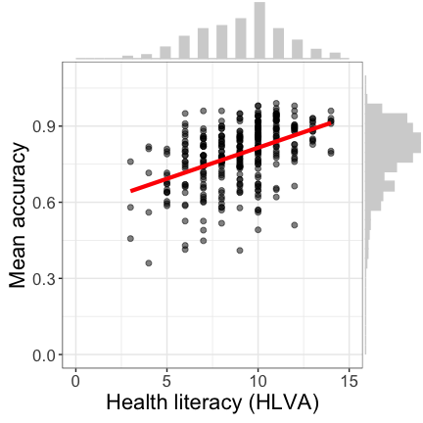
Figure 1: Scatterplot showing the potential association between accuracy of comprehension and health literacy

3 Targets for weeks 16-19: Concepts
We are working together to develop concepts:
- Week 16 — Hypotheses, measurement and associations
- Week 17 — Predicting people using linear models
- Week 18 — Everything is some kind of linear model
- Week 19 — The real challenge in psychological science

4 Targets for weeks 16-19: Skills
We are working together to develop skills:
- Week 16 — Visualizing, estimating, and reporting associations
- Week 17 — Using data to predict people
- Week 18 — Going deeper on linear models
- Week 19 — Evaluating evidence across multiple studies

5 Learning targets for this week
- Skills – We need only a limited change to R code
- Concepts – To specify a model with multiple predictors

6 How we estimate the association between two variables: One outcome and one predictor
model <- lm(mean.acc ~ SHIPLEY,
data = clearly.both.subjects)
summary(model)
- Specify the lm function and the model mean.acc ~ ...
- Specify what data we use data = clearly.both.subjects
- Get the results summary(model)

7 How we estimate the association between multiple variables: One outcome and multiple predictors
model <- lm(mean.acc ~ SHIPLEY + HLVA + FACTOR3 + AGE + NATIVE.LANGUAGE,
data = clearly.both.subjects)
summary(model)
- Specify the lm function and the model:
- mean.acc ~ SHIPLEY + HLVA + FACTOR3 + AGE + NATIVE.LANGUAGE

8 The sentence structure of model code in R
Take a good look:
lm(mean.acc ~ SHIPLEY + HLVA + FACTOR3 + AGE + NATIVE.LANGUAGE, ...)
You will see this sentence structure in coding for many different analysis types
- method(outcome ~ predictors)
- predictors could be SHIPLEY + HLVA + FACTOR3 + AGE + NATIVE.LANGUAGE ...

9 Extensions to the linear model: Multiple predictors
- We assume that the outcome prediction errors residuals are normally distributed
- We do not assume that the distributions of predictor variables are normal

10 Revision: Differences between observed and predicted outcomes
- Differences between observed and predicted outcomes are outcome prediction errors: residuals
- These differences are shown by the vertical grey lines joining the points in Figure 2
- Better models should show smaller differences between observed and predicted outcome values
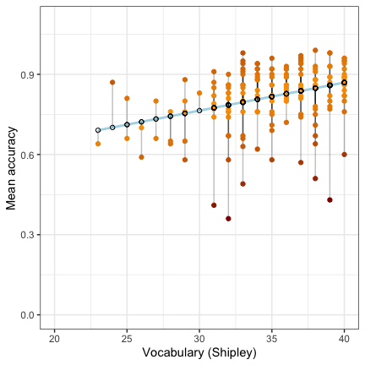
Figure 2: The predicted change in mean comprehension accuracy, given variation in vocabulary scores. Observed values are shown in orange-red. Predicted values are shown in blue

11 Revision: We typically assume that the residuals are normally distributed
- Some outcome prediction errors – residuals – are positive
- Some residuals are negative
- The average of the residuals will be zero overall
- Because there is a balance of positive and negative prediction errors
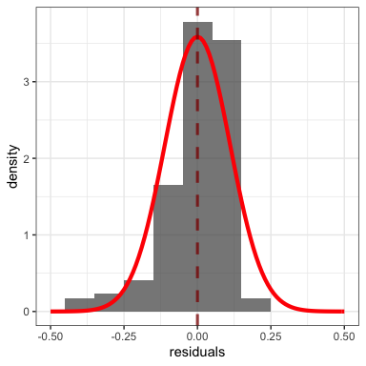
Figure 3: Plot showing the distribution of prediction errors – residuals – for the linear model of comprehension accuracy

12 Multiple candidate predictor variables
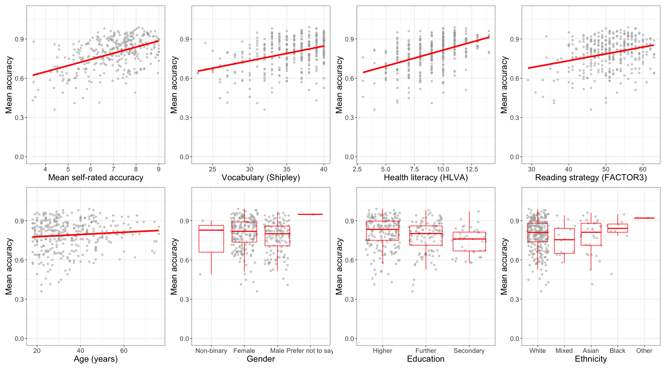
Figure 4: Scatterplots showing the potential association between accuracy of comprehension and variation on each of a series of potential predictor variables. Data are from two studies

13 We do not assume normal predictors
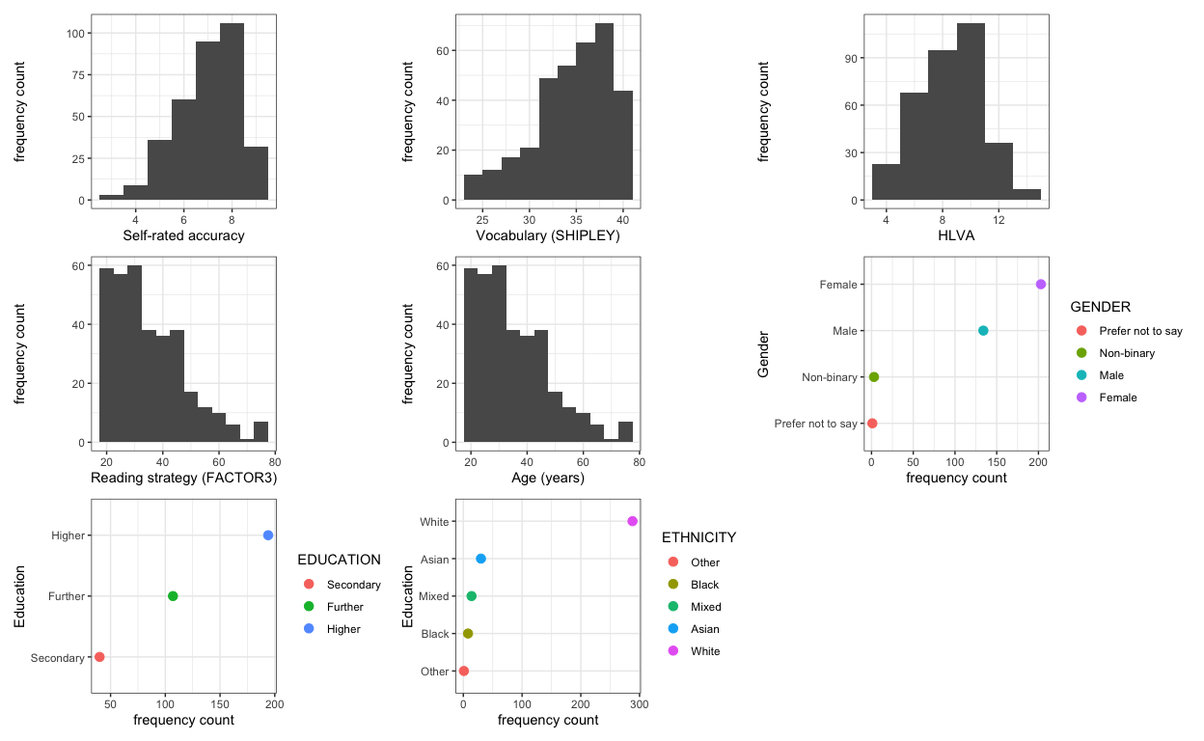
Figure 5: Grid of plots showing the distribution of potential predictor variables

14 Extensions to the linear model: Multiple predictors
 Warning
We can try to model anything using linear models: that is the real challenge we face
- Any analysis you learn can instead be done using some form of (general) linear model: ANOVA, t-test, correlation, $χ^{2}$ test, …
- We can work with any kind of dependent or independent variable you can think of
This is why we need to be careful

15 Analyses are done in context so when we conduct analyses we must use contextual information
- We want to know: What makes it easy or difficult to understand written health information?
- So our research questions include:
 Note
- What person attributes predict success in understanding?

16 Given theory, a model of comprehension accuracy should include – as predictors:
(1.) experience HLVA, SHIPLEY and (2.) reasoning ability (FACTOR3, reading strategy) (Freed et al., 2017)
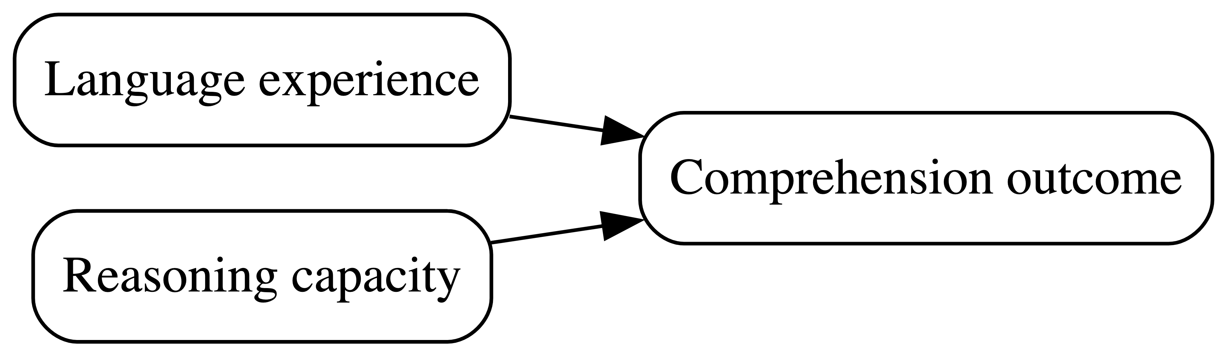

Figure 6: Understanding text depends on (1.) language experience and (2.) reasoning ability (Freed et al., 2017)

17 The flexibility and power of linear models requires us to be aware of the garden of forking paths
- Which variables should be included in an analysis?
- Why?
- Flexibility in choosing predictors can impact results (A. Gelman & Loken, 2013)
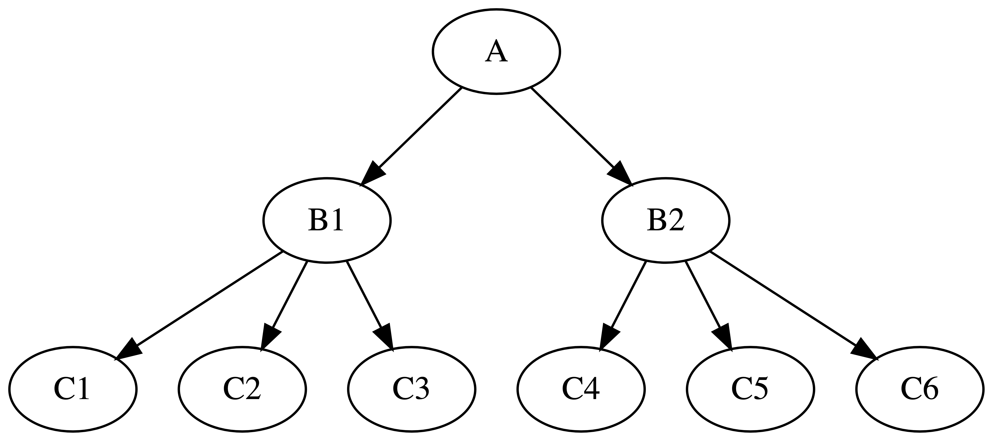

Figure 7: Forking paths in data analysis

18 Different researchers can reasonably make different choices
This is why we teach:
- Evidence reviews like meta-analysis $→$ theory- and evidence-based selection of critical variables for analysis
- Open science: we share usable data and analysis code in open repositories $→$ so others can critically evaluate our work

19 Let’s take a break
- End of part 1

20 Coding, thinking about, and reporting linear models with multiple predictors
lm(mean.acc ~ SHIPLEY + HLVA + FACTOR3 + AGE + NATIVE.LANGUAGE, ...)

21 Coding the linear model with multiple predictors
lm(mean.acc ~ SHIPLEY + HLVA + FACTOR3 + AGE + NATIVE.LANGUAGE, ...)
- The code represents a linear model with multiple predictors:
- $y=β_{0}+β_{1}x_{1}+β_{2}x_{2}+…+ϵ$

22 Thinking about the linear model with multiple predictors
$$y=β_{0}+β_{1}x_{1}+β_{2}x_{2}+…+ϵ$$
Outcome $y$ is calculated as the sum of:
- The intercept $β_{0}$ plus
- The product of the coefficient of the effect of e.g. AGE $β_{1}$ multiplied by $x_{1}$ a person’s age +
- + any number of other variables +
- The error $ϵ$: mismatches between observed and predicted outcomes

23 Identifying key information in results
Call:
lm(formula = mean.acc ~ SHIPLEY + HLVA + FACTOR3 + AGE, data = clearly.both.subjects)
Residuals:
Min 1Q Median 3Q Max
-0.38092 -0.05889 0.01296 0.06780 0.21677
Coefficients:
Estimate Std. Error t value Pr(>|t|)
(Intercept) 0.2372834 0.0591436 4.012 7.43e-05 ***
SHIPLEY 0.0067294 0.0015225 4.420 1.33e-05 ***
HLVA 0.0179228 0.0026682 6.717 7.93e-11 ***
FACTOR3 0.0032872 0.0008595 3.824 0.000156 ***
AGE -0.0003125 0.0004374 -0.715 0.475391
---
Signif. codes: 0 '***' 0.001 '**' 0.01 '*' 0.05 '.' 0.1 ' ' 1
Residual standard error: 0.101 on 336 degrees of freedom
Multiple R-squared: 0.2938, Adjusted R-squared: 0.2854
F-statistic: 34.94 on 4 and 336 DF, p-value: < 2.2e-16

24 Identifying key information in results
- The summary() of the linear model shows:
- Estimates of the coefficients of the effects of the predictors we included, with null hypothesis significance tests of those estimates
- Model fit statistics including R-squared and F-statistic estimates

25 For each predictor, e.g. HLVA, we see
Call:
lm(formula = mean.acc ~ SHIPLEY + HLVA + FACTOR3 + AGE, data = clearly.both.subjects)
Residuals:
Min 1Q Median 3Q Max
-0.38092 -0.05889 0.01296 0.06780 0.21677
Coefficients:
Estimate Std. Error t value Pr(>|t|)
(Intercept) 0.2372834 0.0591436 4.012 7.43e-05 ***
SHIPLEY 0.0067294 0.0015225 4.420 1.33e-05 ***
HLVA 0.0179228 0.0026682 6.717 7.93e-11 ***
FACTOR3 0.0032872 0.0008595 3.824 0.000156 ***
AGE -0.0003125 0.0004374 -0.715 0.475391
---
Signif. codes: 0 '***' 0.001 '**' 0.01 '*' 0.05 '.' 0.1 ' ' 1
Residual standard error: 0.101 on 336 degrees of freedom
Multiple R-squared: 0.2938, Adjusted R-squared: 0.2854
F-statistic: 34.94 on 4 and 336 DF, p-value: < 2.2e-16
- The Coefficient Estimate: 0.0179228 for the slope of the effect of variation in HLVA scores
- The Std. Error (standard error) 0.0026682 for the estimate
- The t value of 6.717 and associated Pr(>|t|) p-value 7.93e-11 for the null hypothesis test of the coefficient

26 Identifying the key information in the linear model results: Coefficients
Call:
lm(formula = mean.acc ~ SHIPLEY + HLVA + FACTOR3 + AGE, data = clearly.both.subjects)
Residuals:
Min 1Q Median 3Q Max
-0.38092 -0.05889 0.01296 0.06780 0.21677
Coefficients:
Estimate Std. Error t value Pr(>|t|)
(Intercept) 0.2372834 0.0591436 4.012 7.43e-05 ***
SHIPLEY 0.0067294 0.0015225 4.420 1.33e-05 ***
HLVA 0.0179228 0.0026682 6.717 7.93e-11 ***
FACTOR3 0.0032872 0.0008595 3.824 0.000156 ***
AGE -0.0003125 0.0004374 -0.715 0.475391
---
Signif. codes: 0 '***' 0.001 '**' 0.01 '*' 0.05 '.' 0.1 ' ' 1
Residual standard error: 0.101 on 336 degrees of freedom
Multiple R-squared: 0.2938, Adjusted R-squared: 0.2854
F-statistic: 34.94 on 4 and 336 DF, p-value: < 2.2e-16
- Pay attention to sign and the size of coefficient estimate:
- Is the coefficient (e.g., HLVA 0.0179228) a positive or a negative number? is it relatively large or small?

27 Identifying the key information in the linear model results: R-squared
Call:
lm(formula = mean.acc ~ SHIPLEY + HLVA + FACTOR3 + AGE, data = clearly.both.subjects)
Residuals:
Min 1Q Median 3Q Max
-0.38092 -0.05889 0.01296 0.06780 0.21677
Coefficients:
Estimate Std. Error t value Pr(>|t|)
(Intercept) 0.2372834 0.0591436 4.012 7.43e-05 ***
SHIPLEY 0.0067294 0.0015225 4.420 1.33e-05 ***
HLVA 0.0179228 0.0026682 6.717 7.93e-11 ***
FACTOR3 0.0032872 0.0008595 3.824 0.000156 ***
AGE -0.0003125 0.0004374 -0.715 0.475391
---
Signif. codes: 0 '***' 0.001 '**' 0.01 '*' 0.05 '.' 0.1 ' ' 1
Residual standard error: 0.101 on 336 degrees of freedom
Multiple R-squared: 0.2938, Adjusted R-squared: 0.2854
F-statistic: 34.94 on 4 and 336 DF, p-value: < 2.2e-16
- Revision: Pay attention to R-squared
- R-squared indicates how much outcome variation we can predict, given our model
- Revision: we report Adjusted R-squared because it tends to be more accurate

28 Identifying the key information in the linear model results: F
Call:
lm(formula = mean.acc ~ SHIPLEY + HLVA + FACTOR3 + AGE, data = clearly.both.subjects)
Residuals:
Min 1Q Median 3Q Max
-0.38092 -0.05889 0.01296 0.06780 0.21677
Coefficients:
Estimate Std. Error t value Pr(>|t|)
(Intercept) 0.2372834 0.0591436 4.012 7.43e-05 ***
SHIPLEY 0.0067294 0.0015225 4.420 1.33e-05 ***
HLVA 0.0179228 0.0026682 6.717 7.93e-11 ***
FACTOR3 0.0032872 0.0008595 3.824 0.000156 ***
AGE -0.0003125 0.0004374 -0.715 0.475391
---
Signif. codes: 0 '***' 0.001 '**' 0.01 '*' 0.05 '.' 0.1 ' ' 1
Residual standard error: 0.101 on 336 degrees of freedom
Multiple R-squared: 0.2938, Adjusted R-squared: 0.2854
F-statistic: 34.94 on 4 and 336 DF, p-value: < 2.2e-16
- The model summary gives us the F-statistic:
- Revision: the F-test of the null hypothesis that the model does not predict the outcome

29 Plot predictions to interpret effects
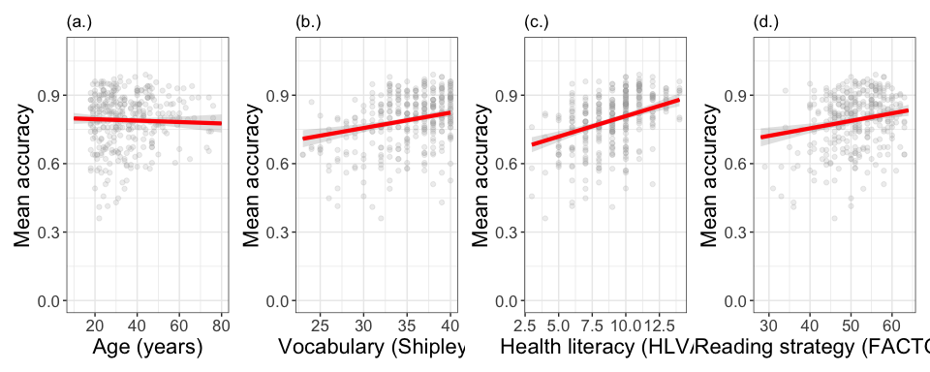
Figure 8: A grid of plots showing model predictions, for outcome accuracy, given variation in (a.) age, (b.) vocabulary, (c.) health literacy, and (d) reading strategy

30 Compare estimates with effects plots
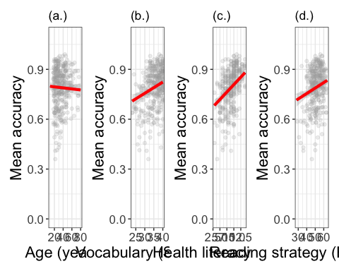

- Coefficients estimates in the summary match what we see
- Positive coefficients show upward slopes
- Larger coefficients show steeper slopes

31 The language and style of reporting linear model results
We fitted a linear model with mean comprehension accuracy as the outcome and vocabulary knowledge (Shipley), health literacy (HLVA), reading strategy (FACTOR3), and age (years) as predictors. The model is significant overall, with $F\left(4,336\right)=34.94,p<.001$, and explains 29% of variance ($\text{adjusted }R^{2}=0.29$). The model estimates showed that the accuracy of comprehension increased with higher levels of participant vocabulary knowledge ($β=.007,t=4.42,p<.001$), health literacy ($β=.018,t=6.72,p<.001$), and reading strategy ($β=.003,t=3.82,p<.001$). Younger participants ($β=-0.0003,t=-.72,p=.475$) tended to show lower levels of accuracy but the age effect was not significant.

32 Look at what we do with the text
We fitted a linear model with mean comprehension accuracy as the outcome and vocabulary knowledge (Shipley), health literacy (HLVA), reading strategy (FACTOR3), and age (years) as predictors. The model is significant overall, with $F\left(4,336\right)=34.94,p<.001$, and explains 29% of variance ($\text{adjusted }R^{2}=0.29$). The model estimates showed that the accuracy of comprehension increased with higher levels of participant vocabulary knowledge ($β=.007,t=4.42,p<.001$), health literacy ($β=.018,t=6.72,p<.001$), and reading strategy ($β=.003,t=3.82,p<.001$). Younger participants ($β=-0.0003,t=-.72,p=.475$) tended to show lower levels of accuracy but the age effect was not significant.
- Explain: the method (linear model); the outcome (accuracy) and the predictors
- Report the model fit statistics overall ($F,R^{2}$)
- Report the significant effects ($β,t,p$) and describe the nature of the effects

33 Let’s take a break
- End of part 2

34 Critically evaluating the results of analyses involving linear models
There are three levels of uncertainty when we look at sample data (McElreath, 2020) – uncertainty over:
- The nature of the expected change in outcome
- The ways that expected changes might vary between individual participants or between groups of participants
- The random ways that specific responses can be produced

35 Critically evaluating the results of analyses involving linear models
- These uncertainties require us to carefully qualify the conclusions we draw from data analyses
- This does not mean we should avoid causal language when we think that psychological processes cause the behaviours we examine (Grosz et al., 2020)
- But it does mean we can be careful to identify the limits in the evidence we analyse

36 Revision: As we move into thinking about the data analysis, we need to identify our assumptions
- validity: that differences in knowledge or ability cause differences in test scores
- measurement: that this is equally true across the different kinds of people we tested
- generalizability: that the sample of people we recruited resembles the population

37 How do you do this work?
- validity
- We want to work with valid measures but validity requires explaining (Borsboom et al., 2004):
- Does the thing exist in the world?
- Is variation in that thing be reflected in variation in our measurement?
- What you can do: literature review $→$ to identify your reasoning in answer to these questions

38 How do you do this work?
- measurement
- generalizability
- It is most helpful to assume from the start that effects estimates will vary (a. Gelman, 2015; Vasishth & Gelman, 2021)
- So then we ask ourselves: will this test work in the same way in different groups?
- And we ask: how will these effects estimates vary across different groups

39 Why we need replication studies
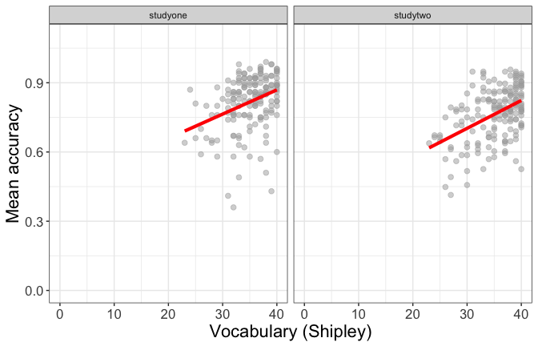
Figure 9: Scatterplot showing the potential association between accuracy of comprehension and vocabulary scores: Data from eight studies. Effects will vary between different samples so: expect the variation (a. Gelman, 2015; Vasishth & Gelman, 2021) >>> important to evaluating claims in the literature, and to evaluation of your own results

40 Why we need to consider the generalizability of sample data
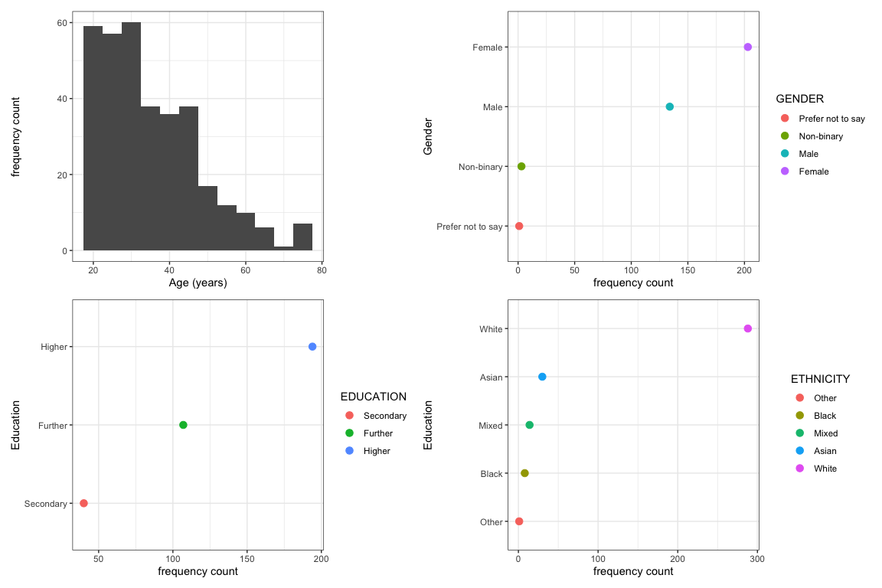
Figure 10: Grid of plots showing the distribution of potential predictor variables

41 Convenience samples are common in Psychology
- We test who we can – convenience sampling – and who we can test has an impact on the quality of evidence (Bornstein et al., 2013)
 Tip
Practice critical evaluation:
- If age, ethnicity or gender are not balanced $→$ does this matter to your research question?
- If samples are limited in size $→$ how does that affect our uncertainty over effects estimates?

42 Let’s take a break
- End of part 3

43 Everything is some kind of linear model
 Important
Most common statistical tests are special cases of linear models, or are close approximations
- Most introductory statistics classes teach each statistical test as if they are independent

44 The t-test as linear model
$$y_{i}=β_{0}+β_{1}X$$
- If you have two groups, with a variable X coding for group membership
- Then the mean outcome for one group $=β_{0}$
- The estimate of the slope $β_{1}$ tells about the average difference between groups
- And we can code the model like this: lm(y ~ group)

45 ANOVA as linear model
$$y_{i}=β_{0}+β_{1}X+β_{2}Z+β_{3}XZ$$
- If you have a 2 x 2 factorial design, with two factors factor.1, factor.2, and a dataset with variables X, Z coding for group membership
- Then the mean outcome for baseline conditions $=β_{0}$
- The estimates of the slopes $β_{1},β_{2}$ tells about the average difference between groups
- The estimate of the slope $β_{3}$ tells us about the interaction
- And we can code the model like this: lm(y ~ factor.1*factor.2)
- Or this Anova(aov(y ~ factor.1*factor.2, data), type='II')

46 Extensions to the linear model
$$outcome predictors+error$$
- outcome can generalize to analyse data that are not metric, do not come from normal distributions
- predictors can be curvilinear, categorical, involve interactions
- error can be independent; can be non-independent

47 Extensions to the linear model – binary or dichotomous outcomes
- Binary outcomes are very common in Psychology: yes or no; correct or incorrect; left or right visual field etc.
- The change in coding is e.g. glm(ratings ~ predictors, family = "binomial")

48 Extensions to the linear model – non-independence of observations
- Much – maybe most – psychological data are collected in ways that guarantee the non-independence of observations
- We test children in classes, patients in clinics, individuals in regions
- We test participants in multiple trials in an experiment, recording responses to multiple stimuli
- These data should be analysed using linear mixed-effects models (Meteyard & Davies, 2020) which we study at MSc

49 General advice
An old saying goes:
All models are wrong but some are useful
(attributed to George Box).
 Tip
- Sometimes, it can be useful to adopt a simpler approach as a way to approximate get closer to better methods
- Box also advises “Since all models are wrong the scientist must be alert to what is importantly wrong. It is inappropriate to be concerned about mice when there are tigers abroad.”
- Here, we focus on validity, measurement, generalizability and critical thinking

50 Summary
- Linear models are a very general, flexible, and powerful analysis method
- We can use assuming that prediction outcomes (residuals) are normally distributed
- With potentially multiple predictor variables

51 Summary
- When we plan an analysis we should try to use contextual information – theory and measurement understanding – to specify our model
- When we critically evaluate our or others’ findings, we should consider validity, measurement, and generalizability

52 Summary
- When we report an analysis, we should report:
- Explain what I did, specifying the method (linear model), the outcome variable (accuracy) and the predictor variables (health literacy, reading strategy, reading skill and vocabulary)
- Report the model fit statistics overall ($F,R^{2}$)
- Report the significant effects ($β,t,p$) and describe the nature of the effects (does the outcome increase or decrease?)

53 End of week 18

54 References
Bornstein, M. H., Jager, J., & Putnick, D. L. (2013). Sampling in developmental science: Situations, shortcomings, solutions, and standards. Developmental Review, 33(4), 357–370. https://doi.org/10.1016/j.dr.2013.08.003
Borsboom, D., Mellenbergh, G. J., & Heerden, J. van. (2004). The concept of validity. Psychological Review, 111(4), 1061–1071. https://doi.org/10.1037/0033-295X.111.4.1061
Freed, E. M., Hamilton, S. T., & Long, D. L. (2017). Comprehension in proficient readers: The nature of individual variation. Journal of Memory and Language, 97, 135–153. https://doi.org/10.1016/j.jml.2017.07.008
Gelman, a. (2015). The connection between varying treatment effects and the crisis of unreplicable research: A bayesian perspective. Journal of Management, 41(2), 632–643. https://doi.org/10.1177/0149206314525208
Gelman, A., & Loken, E. (2013). The garden of forking paths: Why multiple comparisons can be a problem, even when there is no ?fishing expedition? Or ?p-hacking? And the research hypothesis was posited ahead of time. Department of Statistics, Columbia University.
Grosz, M. P., Rohrer, J. M., & Thoemmes, F. (2020). The Taboo Against Explicit Causal Inference in Nonexperimental Psychology. Perspectives on Psychological Science, 15(5), 1243–1255. https://doi.org/10.1177/1745691620921521
McElreath, R. (2020). Statistical rethinking. Chapman; Hall/CRC. https://doi.org/10.1201/9780429029608
Meteyard, L., & Davies, R. A. I. (2020). Best practice guidance for linear mixed-effects models in psychological science. Journal of Memory and Language, 112, 104092.
Vasishth, S., & Gelman, A. (2021). How to embrace variation and accept uncertainty in linguistic and psycholinguistic data analysis. Linguistics, 59(5), 1311–1342. https://doi.org/10.1515/ling-2019-0051

