Adam Bruce

BIOL 345 WLE S23

**Utilizing Acoustic Monitoring to Measure Activity and Richness of Bats in Relation to Potential Influences of Pond Characteristics in East-Central, Wisconsin**

**Introduction:** Bats provide a plethora of valuable ecosystem services, including arthropod suppression, seed dispersal, and pollination, which increase human well-being (Kunz et al. 2011). Therefore, they are economically and environmentally important, which makes maintaining healthy and diverse populations invaluable (e.g. Boyles et al. 2011; Kasso and Balakrishnan 2013). However, bats rely heavily on aquatic habitats, predominantly as drinking and foraging sources, which have suffered drastic declines due to human-led intensification of both housing and agriculture development in the United States (Bohn and Kershner 2001). As a result, many studies have begun quantifying characteristics of aquatic habitats in tandem with acoustic monitoring to investigate differences in activity and richness of local bat species at the sites (e.g. Razgour et al. 2011; Straka et al. 2016).

Of the potential aquatic habitats to study in relation to bat conservation, perhaps the most valuable is the pond. Foundationally, ponds are shallow bodies of standing water in which light can penetrate to the bottom sediments. It has been estimated that 90% of all standing waterbodies on earth are ponds, and their artificial prevalence has been increasing rapidly (Downing et al. 2006). Additionally, implementation of artificial ponds has been shown to support bats in both urban and agricultural settings (e.g. Stahlschmidt et al. 2012; Ancilloto et al. 2019). However, much of the literature on pond characteristic preferences of bats has been developed outside of the United States, which necessitates research on the topic internally.

Here, passive acoustic monitoring was used to collect data on species activity and richness of bats at ponds found throughout Bubolz Nature Preserve and Heckrodt Wetland Preserve in East-Central Wisconsin. We aimed to quantify how bat richness and activity varied across ponds of the Appleton-area. Additionally, we recorded pond characteristics, namely canopy cover, surrounding vegetation density, surface water scale, average nightly temperature, and pond size with the aim of relating them to bat preferences through our acoustic data. Because local bats vary immensely in prevalence, echolocation behavior, and flight morphology, and we have formulated our hypothesis around data on these facts (Norberg and Rayner 1987).

Huebschman (2019) recently published longitudinal Wisconsin bat population data and found that ninety percent of captures from 2004 to 2017 were of the species Little Brown Bat (*Myotis Lucifigus)*, Big Brown Bat (*Eptesicus fuscus)*, and Eastern Red Bat (*Lasiurus borealis).* Meanwhile, Brooks and Ford (2005) found that bats in Central Massachusetts with high aspect ratios and longer echolocation calls, namely Big Brown Bats, Eastern Red Bats, and Hoary Bats *(Lasiurus cinereus),* were most prevalent in open-uncluttered aquatic habitats while low aspect ratio bats, like the Little Brown Bat, were ubiquitous. Therefore, we hypothesized that Big Brown Bats and Eastern Red Bats would be most active overall. Additionally, we believed that ponds with low canopy cover, vegetation density, and surface water scale measurements and high areas would be most preferable, resulting in higher species activity at those sites. Finally, we conferred that there would be no difference in species richness overall due to the ubiquity of low aspect ratio species.

**Methods:**

At the time of our study, the Gordon Bubolz Nature Preserve (Appleton, Wisconsin) and Heckrodt Wetland Reserve (Menasha, Wisconsin) each featured prairies, forested wetlands, and open water bodies (Appendix A). Throughout each site, we placed acoustic monitoring systems at ponds. At Bubolz, we placed four Song Meter SM4BAT FS Full-Spectrum recorders (Wildlife Acoustics, Massachusetts, United States) at four ponds, namely Sedge Meadow Pond, Quarry Pond, Turtle Pond, and North Channel, and passively recorded from May 9th to May 15th, 2023. At Heckrodt, a total of three ponds, namely Bartz Pond, Lopas Pond, and Heckrodt 15, were surveyed with one Wildlife Acoustics Song Meter SM4BAT FS Full-Spectrum recorder and two Anabat II Zero-Crossing recorders (Titley Electronics, Ballina, Australia) from May 11th to May 15th, 2023. Prior to detector placement, we programmed all detectors to monitor for calls from 7:30 PM CST TO 7:30 AM CST, which represented a single night of recording. In addition, to ensure recorded calls were consistent, we standardized program settings across all detectors. To ensure equal sampling across sites, we used only data from the four simultaneously surveyed nights (May 11th to May 15th) for a total of four sub-samples per pond.

To investigate potential preferences in pond characteristics, and account for confounding factors, we recorded data on covariates at each site. Canopy cover, vegetation density, and surface water scale were recorded on a discrete scale from 1 to 3. For canopy cover, 1 represented completely open pond area, 2 represented a partially covered area, and 3 was fully covered. Meanwhile, vegetation density was recorded within 5 meters of the pond perimeter, where 1 represented no vegetation, 2 represented sparse vegetation, and 3 was full coverage of grass and shrubs. Finally, the surface water scale denoted the amount of clutter on the top surface of the water where 1 represented a smooth surface, 2 was a partially covered surface, and 3 was a fully covered surface.

In addition, we recorded continuous variables in pond area and average nightly temperature. Pond area was calculated using Google Earth Software (Google LLC, California, USA) area measurements, while average nightly temperature was taken from WunderGround (TWC Product and Technology LLC, Atlanta, United States) by averaging hourly temperatures on survey nights. We also recorded water quality variables, namely temperature, dissolved oxygen percentage, dissolved oxygen, pH, conductivity, chlorophyll, and salinity at six of our seven ponds using the HydroLab HL7 Sondes (OTT HydroMet Corp, Virginia, United States). Upon completion of the fourth survey night, all systems were retrieved and taken for analysis.

Initially, data were downloaded by pond and sorted by species through echolocation comparisons against known Wisconsin species using Wildlife Acoustics Kaleidoscope Pro Analysis Software (Titley Electronics, Ballina, Australia). Afterwards, data were sorted into a master file using Microsoft Excel (Microsoft Corp, Washington, United States). We considered each unique file as a measurement of activity, but files identified by Kaleidoscope as “NoID”, “Noise”, and “PERSUB” calls were discarded. “NoID” referred to calls that could not be accurately deciphered while “Noise” referred to data files resulting from triggers that were not bat species (i.e. insects). “PERSUB” represented calls matched to the Tricolored Bat (*Perimyotis subflavus*), but our survey area was outside of the range of the species in Wisconsin (WI Bat Program, 2011; WDNR 2013, Kurta 1995). Therefore, perceived calls of this species were not considered for statistical analysis.

After processing, data analysis was performed using R Programming Software (R Core Team, 2013). Initially, scatter plots with linear lines of best fit were created for activity by pond area (, average nightly temperature (, and water chlorophyll levels (. Next, investigative boxplots were created for activity, richness, and individual species activity by pond. Additional boxplots were also created for activity by canopy cover, vegetation density, and surface water scale. For statistical testing, tests of normality and equality of variance were performed with Shapiro-Wilk’s and Levene’s Test respectively. Based on these results, formal comparisons of means were performed using either a One-Way Anova, Kruskal-Wallis Test, or Wilcoxon Rank-Sums Test.

**Results:**

Collectively, we observed 4501 calls between both study sites over the four survey nights. Of the ponds, Lopas Pond (here after H_LP) and Turtle Pond (here after B_TP) were most active (n = 1152, n = 1040). The fewest calls were recorded at Sedge Meadow (here after B_SM) and North Channel (here after B_NC) (n = 138, n = 258). All ponds had richness values of 5 across the four nights, except for Bartz Pond (here after H_BP) and Heckrodt 15 (here after H_15) at 4. On average, B_TP and B_NC had the highest richness per night at 4.5. Of the five species of bats observed, the Big Brown Bat (here after EPTFUS) was the most active followed by the Silver-Haired Bat (here after LASNOC) and Hoary Bat (here after LASCIN) (n = 2208, n = 1211, n = 906). Alternatively, the Little Brown Bat (here after MYOLUC) and Eastern Red Bat (here after LASBOR) where the least active (n = 141, n = 35).

For characteristics, activity was highest at ponds with low canopy cover compared to those with higher cover (value 1 = 2618, value 2 = 1883). Meanwhile, ponds with higher surrounding edge vegetation were more active than lower ranking ponds (value 3 = 2729, value 2 = 1772). Finally, activity progressively decreased as surface water cover increased (value 1 = 3223, value 2 = 990, value 3 = 288). Of the three numeric measurements, positive relationships with activity were observed for area and average nightly temperature, and a negative A picture containing line, screenshot, diagram, plot
relationship was observed with pond chlorophyll levels (Figure 1).

**Figure 1:** Scatter plots with linear fits (red line) for bat activity versus numeric measurements of interest. Standard error of estimates is depicted in gray.

Shapiro-Wilks testing for normality was carried out for seven numeric variables. This included activity, richness, and activity measurements for individual species (i.e. Activity EPTFUS). Results indicated abnormal distributions for all variables (Appendix B). Additionally, Levene’s Test for equality of variance was carried out for eleven categorical variables of numeric data. This included activity per pond, richness per pond, activity measurements for individual bat species per pond (i.e. LASBOR/pond), and activity measurements for the pond characteristic variables (i.e. activity/Canopy Cover). Results indicated equal variance for seven of the eleven variables (Appendix B).Based on results of Shapiro-Wilks and Levene’s Test, formal testing of mean or median differences was performed for 10 variables at an alpha of 0.05.

For cases where the number of sub-categories was greater than two, variance was equal, and distributions were abnormal, One-Way Anova comparisons of means were performed (Appendix C). This included activity per pond, richness per pond, EPTFUS activity per pond, LASBOR activity per pond, and MYOLUC activity per pond. Overall, a significant difference amongst means was recorded for EPTFUS per pond with B_SM and B_NC significantly lower than other group means. All other tests yielded insignificant P-Values overall, but some ponds in the activity per pond and LASBOR per pond groups did have noted differences in means individually(Figure 2; P = 0.097, P = 0.067, P = 0.019, P = 0.35, P = 0.22).

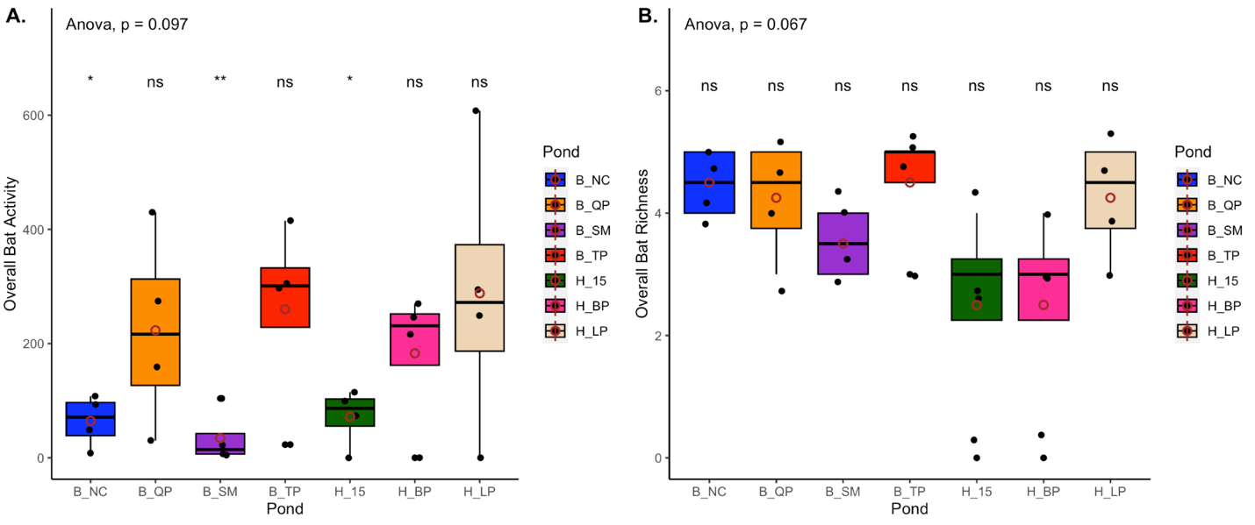**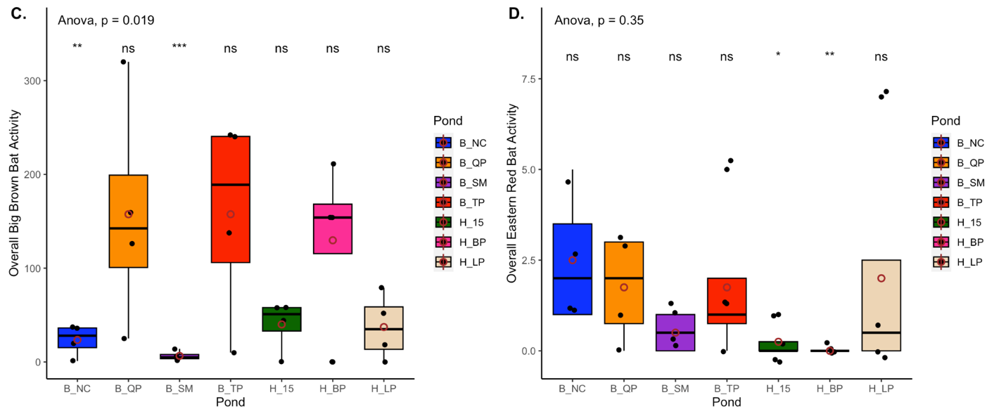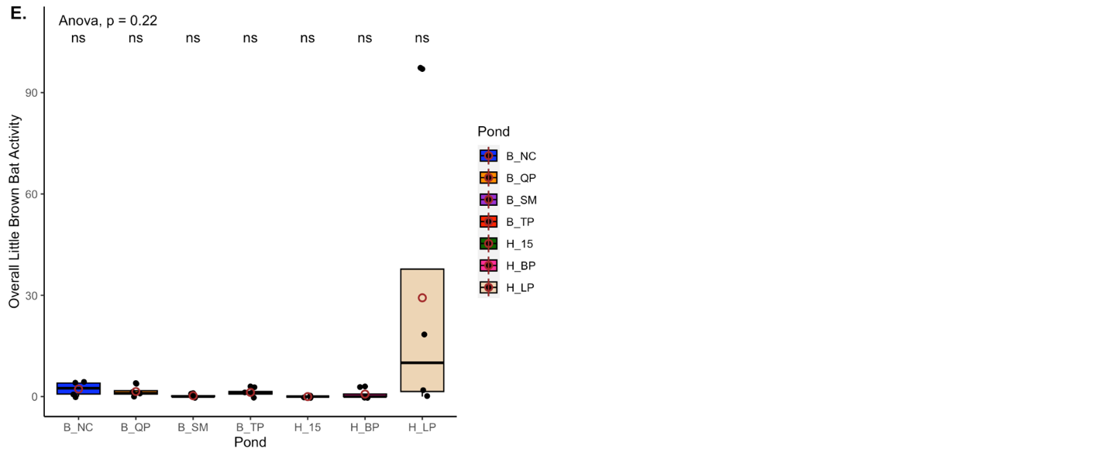Figure 1:** Boxplots with One-Way Anova results for activity, richness, and individual species activity. Associated Anova P-values are depicted with individual mean comparison results. Ponds marked with ns indicate no significant mean difference, while those with asterisks (*) indicate significant mean differences compared to other groups.

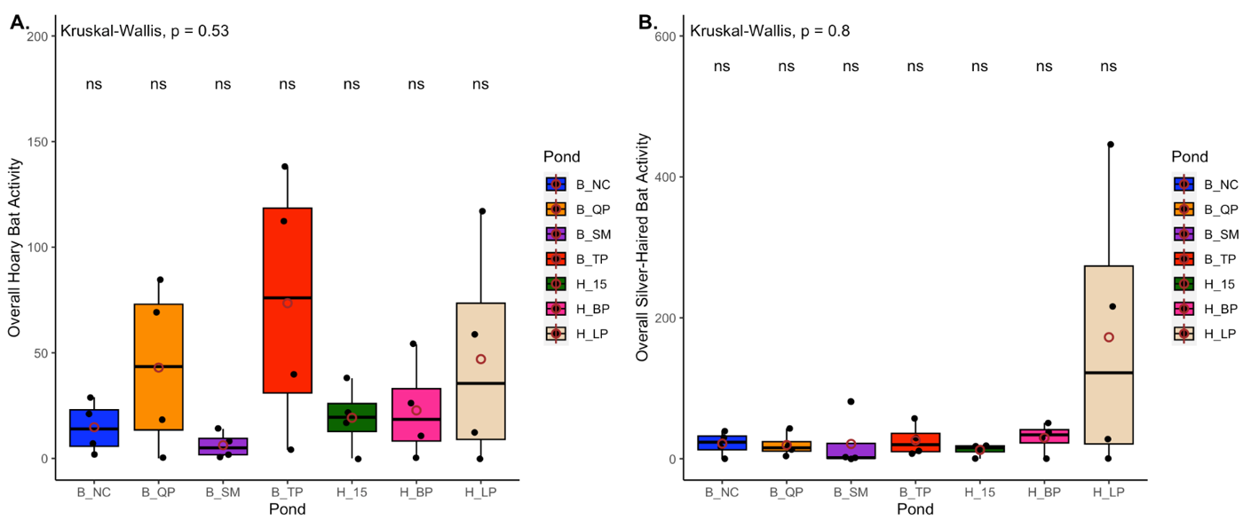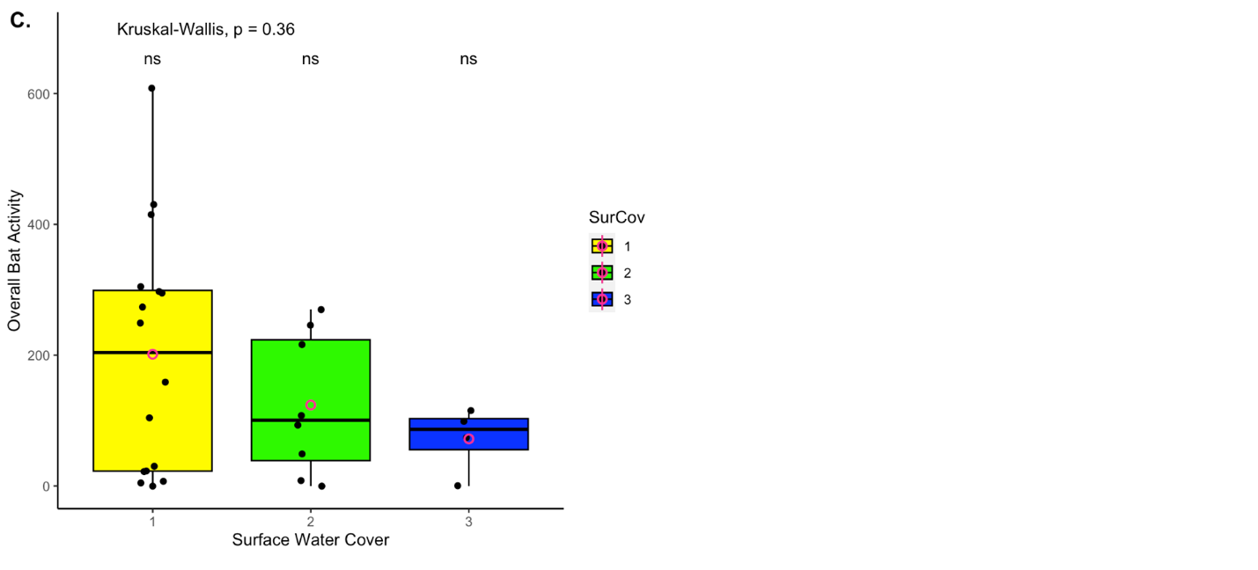For cases where the number of sub-categories was greater than two, variance was unequal, and distributions were abnormal, the non-parametric Kruskal-Wallis Test of means was performed (Appendix C). This included LASCIN per pond, LASNOC per pond, and activity per surface cover. In these cases, no significant differences in means were reported overall or for individual instances (Figure 3; P = 0.5253, P = 0.802, P = 0.3611). Finally, for variables with two sub-categories, equal variance, and abnormal distributions Wilcoxon Ranked Sums Test of Medians was performed (Appendix C). This included activity per canopy cover and activity per vegetation density. Again, this test did not produce significant differences between any of the medians (Figure 4; P = 0.8709, P = 0.1775).

**Figure 2:** Boxplots with Kruskal-Wallis results for individual species activity and surface water cover. P-values are depicted with individual median comparison results. Values of ns indicate no significant median difference.

**Discussion:**

**Acknowledgements**

I would like to thank Professor Jodi Sedlock of Lawrence University for guiding us in our study design and providing valuable insights throughout this project. I would also like to thank my lab members Lindsey Gulliksen, Alyssa Kucharski, Grace Hanson, Esther Mullen, Kayci King, Wynter Burns, and Emma Nord for their work during data collection at Bubolz. Finally, I would like to thank the rest of my peers in Wildlife Ecology at Lawrence University during the Spring of 2023 who worked so hard to collect data for our reports. IHRTLUHC!

**Project Repository**

The R code for all tests and plots as well as all supplementary materials for this report can be found at my Github repository:

Kupfer, J. A., Malanson, G. P. and Franklin, S. B. (2006). Not seeing the ocean for the islands: the

mediating influence of matrix-based process on forest fragmentation effects. *Global Ecology and Biogeography.* 15, 8-20.

**Sources**

Ancillotto, L., Bosso, L., Salinas-Ramos, V. B. and Russo, D. (2019). The importance of ponds for

the conservation of bats in urban landscapes. *Landscape and Urban Planning.* 190, <https://doi.org/10.1016/j.landurbplan.2019.103607>

Bohn, B. A. and Kershner, J. L. (2001). Establishing aquatic restoration priorities using a

watershed approach. *Journal of Environmental Management.* 64, 1-9.

Boyles, J. G., Cryan, P. M., McCracken, C. F. and Kunz, T. H. (2011). Economic importance of bats

in agriculture. *Science. 332*(6025), 41-42.

Brooks, R. T. and Ford, W. M. (2005). Bat activity in a forest landscape of central Massachusetts.

*Northeastern Naturalist. 12*(4), 447-462.

* Kunz 2011 <https://www.landcan.org/pdfs/wns%20kunz%20april%205%20%202011.pdf>
* Kasso: <https://downloads.hindawi.com/archive/2013/187415.pdf>
* Straka 2016: <https://onlinelibrary.wiley.com/doi/pdf/10.1002/ece3.2224>
* Razgour 2011: IN STRAKA SOURCES!
* Downing 2006: Downing, J. A., J. J. Cole, J. J. Middelburg, R. G. Striegl, C. M. Duarte, P. Kortelainen, Y. T. Prairie & K. A. Laube, 2008. Sediment organic carbon burial in agriculturally eutrophic impoundments over the last century. Global Biogeochemical Cycles 22: GB1018. doi:10.1029/2006GB002854.
* Stahlschmidt: <https://www.researchgate.net/profile/Ralf-Schulz/publication/257585853_Constructed_wetlands_support_bats_in_agricultural_landscapes/links/5a6f8a3a458515015e6164ea/Constructed-wetlands-support-bats-in-agricultural-landscapes.pdf>
* Norberg and Rayner 1987: <file:///Users/adam.bruce/Downloads/NorbergRayner1987EcologicalMorphologyinbatsPTRS.pdf>
* Heubschman 2019: file:///Users/adam.bruce/Downloads/045.026.0115 (1).pdf
* Brooks and Ford 2005: file:///Users/adam.bruce/Downloads/1092-6194_2005_012_0447_BAIAFL_2.0.CO_2 (2).pdf
* Kurta, WI Bat Program, WDRNR: <https://dnr.wi.gov/files/pdf/pubs/er/er0706.pdf>

**Appendix A**

Maps of Gordon Bubolz Nature Preserve (Left) and Heckrodt Wetland Reserve (Right) with 6 of 7 sampled ponds labeled.

**Appendix B**

Results of Shapiro-Wilk’s Test of normality (Top) and Levene’s Test of equal variance (Bottom) are depicted. Interpretations of test results based on P-Values are provided in the tables. Sample sizes per distribution were n = 28, meaning Shapiro-Wilks had to be performed on each variable as n > 30 is required for use of the Central-Limit Theorem assumption of normality.

**Appendix C**

Bat variables with specific statistical testing results. Interpretations of test hypothesis are shown along with associated P-values. * Indicates significance at 0.10 alpha. Though we utilized alpha of 0.05, statistical tests are often powerful enough to give significance up to 0.10. However, 0.05 is the most widely used confidence value at 95%.

