Adam Bruce

BIOL 345 WLE S23

**Life on the Edge: Using Avian Diversity to Quantify Differences Between Core**

**and Edge Sites at Bruce B. Purdy Nature Preserve in Appleton, Wisconsin**

**Introduction:**

Native forests have suffered drastic habitat degradation due to human-led intensification of both housing and agriculture development in the United States (e.g. Pidgeon et al. 2007). Primarily, this has resulted in a landscape littered with isolated forests surrounded by a human-derived matrix (Kupfer et al. 2006). This phenomenon is known as forest fragmentation, and it has been focal to many ecological studies concerning biodiversity loss (Fahrig, 2003). Several factors have been emerged as plausible causes for the biodiversity loss in forest fragments from these studies. Namely, examples include reduced forest size, isolation, and edge effects (Zuidema et al. 1996). In this study, the factor of edge effects was of focal importance as it related to difference between forest edges and interior cores.

As forests fragments emerge from development, new and often extensive boundaries are created. These boundaries are known ecologically as edges, and almost immediately, they become clear separation points between two distinct environments (Cadenasso et al., 2003). Over time, the forest-core habitat characteristics which these edges previously featured fade, as the edges become distinguishably unique. Often, this involves extensive increases in understory vegetation (Ries et al. 2004). It is this change from a forests original core habitat to a new edge habitat that necessitates comparative research on differences between the two.

A key difference quantification can be obtained through measuring diversity at each habitat. We utilized birds as diversity indicator species because they are an integral part of forest ecological networks, and they show highly selective habitat preferences (Schuldt et al. 2022). Therefore, quantifying their richness and abundance allowed for investigative comparisons between edge and core sites at the Bruce B. Purdy Nature Preserve in Appleton, Wisconsin. Interestingly, the impacts of edge effects have shown mixed results across previous studies (e.g. Murcia 1995; Ries et al. 2004; Laurance et al. 2007). However, Brands (2004) found extensive evidence that birds requiring mesic conditions are likely to experience negative responses to forest edges. Since Wisconsin forests are primarily mesic in nature, we hypothesize that both bird richness and abundance will be higher in the forest core than on the edge.

**Methods:**

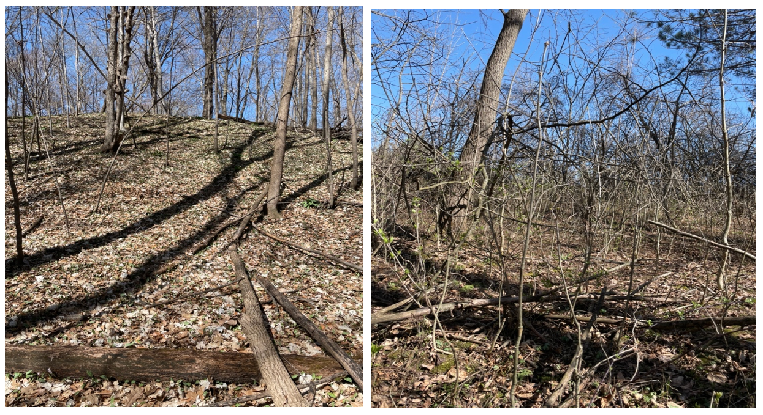 Located on the Appleton’s north-side, the Bruce B. Purdy Nature preserve was created through a donation of 104 acres of land in 2005 (Appendix A). At the time of our study, the site featured a core of wooded hills, ravines, ponds, and pine plantations littered with recreational hiking trails. Alternatively, its edges featured open fields, restored prairies, and wetlands (Figure 1). Utilizing the full range of edge and core environments, we dispersed a total of 18 study sites at each level. Each site was contained within a 50-meter by 50-meter square, with edge site centers being 25 meters inward from forest perimeters and core sites centers at least 75 meters from perimeters. By defining these placements, we ensured we had true replicates because there were no site overlaps and we had at least 50-meters between centers. From each center, we defined an evaluation until as a circle with a 25-meter radius. Within this circle, 10-minute point counts were carried out by groups of 2 to 3 individuals according to standard practices.

**Figure 1:** Core Site 11 (left) and Edge Site 12 (Right) depict the wooded hills/ravines of the core sites and dense understory of the edges. See Appendix A for complete map of study sites throughout the preserve.

However, only observed birds were recorded, and to minimize the risk of double counting individual birds, group counts were conducted approximately simultaneously. In full, point counts were conducted across a two-week period in early spring (April) 2023. Specifically, counts were performed on Tuesday and Thursday of each week from 1 until 4 PM CST, which controlled for temporal variability in bird activity. Weather patterns ranged from 46 5o 82 degrees Fahrenheit, mixed cloudy and sunny days. Additionally, we controlled for observer skill-levels by randomly assigning sites to each group. Naturally, additional variability between sites was a cause of concern, so we recorded covariates on understory density and noise level. Understory density ranged from 0 to 5 and represented the total number of woody stems observed, in increments of 10 per 1 unit increase, within a 5 by 5-meter square from the center of each site. Meanwhile, noise level ranged from 0 to 1, with a 1 denoting any anthropogenic noise heard at the site prior to or during recording.

Ideally, we aimed to achieve two sub-samples per site, but limitations in time and individuals resulted in only sites 1 through 15 at the core level and 1 through 16 at the edge level achieving this mark. Therefore, core sites 16, 17 and 18 in addition to edge sites 17 and 18 were excluded from final data analysis. All analysis was performed using R software. Initially, summary statistics, namely mean, standard deviation, min, max, and sample size, were calculated by habitat type for abundance and richness respectively. Similar summaries were also produced for the understory density and noise level covariates. Boxplots of abundance and richness by habitat type were also created. For formal statistical testing of abundance and richness differences between edge and core sites, normality and equality of variance was first checked using Shapiro-Wilk’s Test and Levene’s Test respectively. Based on these results, habitat differences in mean abundance were compared using a Student’s T-Test, while median richness differences were compared using a non-parametric Wilcoxon Test. All tests utilized an alpha significance level of 0.05.

**Results:**

Overall, a total of 216 birds of 26 unique species were observed over the duration of our study. Collectively, edge sites had higher mean, median, variability, and maximum abundance and richness measurements compared to core sites (Figure 2). Covariate summaries indicated that edge sites were predominately heavy in understory and anthropogenic noise, while core sites were largely lacking intense understories and noise (Appendix B). While mean abundance was relatively similar between understory levels with the highest sample sizes, mean richness levels varied more for each habitat. Finally, edge sites with noise had higher mean abundance Graphical user interface, application
and richness levels than core sites without noise.

**Figure 2:** Summary statistics for each habitat type are indicated based on bird abundance (Top) and richness (Bottom) based on all data points. Min and Max depict low and high values observed at across all habitat sites.

Formal statistical testing with Shapiro-Wilks Test of normality indicated abundance was not normally distributed, while richness was normally distributed for all data points (Appendix C, W = 0.92379 & W = 0.94747, P = 0.0298 & P = 0.01329). Meanwhile, Levene’s Test on both abundance and richness determined that variance was equal overall (Appendix C, F = 0.0073 & F = 0.1871, P = 0.9327 & P = 0.6685). The non-parametric Wilcoxon Test of medians performed on abundance did not produce a significant p-value, and therefore the null hypothesis was not rejected (Figure 3, W = 98, P = 0.394). Thus, it is plausible that there was no difference in bird abundance between core and edge sites. However, the Student’s T-Test performed on richness by habitat did yield a statistically significant p-value (Figure 3, t = -2.2925, P = 0.02919). Therefore, the null hypothesis was rejected resulting in evidence that mean richness was higher at edge sites than core sites. Collectively, boxplots of abundance and richness by habitat type provide visual support to the Wilcoxon and Students T-Test results (Figure 3).

**Figure 3:** Boxplot of abundance by habitat (Top Left) and Richness by habitat (Top Right) in conjunction with their formal statistical testing results (Bottom). Standard deviation bars and median lines are depicted in the boxplots. Additionally, sample means are represented by open circles. Hypothesis Tests with P-Values are shown in the top left of each plot, with significance levels (ns = no significance, * = significant at 0.05). Summary table includes results of hypothesis tests with interpretation.

**Discussion:**

This study sought to quantify differences in bird abundance and richness between core and edge sites at the Bruce P. Purdy Nature Preserve in Appleton, Wisconsin. Regarding abundance, studies have reported a mix of positive and negative edge effects (e.g. Fagan et al. 1999; Burke and Nol 1998). Overall, our findings do not support any of these studies, as we found a non-significant (Neutral) effect of habitat type on abundance. Alternatively, many researchers have recently indicated increases in species richness along forest edges (Melin et al. 2018; Willmer et al. 2022). Our statistical findings here support this notion and provide plausible insights into the cause of this increase.

While our findings on abundance fail to support previous research, there is a very compelling argument as to why. Specifically, it is likely that no evidence of this trend exists due to publishing bias. Ries and Sisk (2004) highlighted this argument by noting that neutral studies likely receive little attention by publishers despite their role in understanding underlying edge effects mechanisms. As for richness, our understory density covariate summary statistics provide primary support for a mechanism behind increased richness at edge sites. For example, the highest sample sized sites by understory density were Core 1 and Edge 5, which had richness values of at 2.875 and 4.00 respectively. This suggests edge sites have much more understory density. Well, Willmer et al. (2022) found that bird richness increased most significantly at sites featuring the highest understory densities, which was always edge habitats in their study. Therefore, we our findings support the notion that shrub density of the understory significantly increases avian richness when compared to core habitat.

In full, we found that edge and core sites differ primarily in bird species richness but not in overall abundance. Certainly, this necessitates future research focused on identifying which species are predominantly found on the exterior versus the interior of these habitats and why they prefer each location. Going forward, these types of studies could provide valuable insights for future conservation management. However, the results of our study and the variability of other studies also suggests that avian species may not be ideal indicators of the negative ecological effects of increased forest edges and loss of core habitat via fragmentation. Undeniably, forest fragmentation has had profoundly negative diversity impacts for some species, and therefore, future studies looking to characterize these effects should consider focusing on another indicator species.

**Acknowledgements**

I would like to thank Professor Jodi Sedlock of Lawrence University for guiding us in our study design and providing valuable insights throughout this project. I would also like to thank my group mates Alyssa Kucharski and Lindsey Gulliksen for their work during data collection. Finally, I would like to thank my peers in Wildlife Ecology at Lawrence University during the Spring of 2023 who worked so hard to collect this data for our reports. IHRTLUHC!

**Project Repository**

The R code for all tests and plots as well as all supplementary materials for this report can be found at my Github repository: <https://github.com/lu2021adam/BIOL345_BIRDPAPER_ANALYSIS>

**Sources**

Brands, L. A. (2004). Prediction and assessment of edge response and abundance for desert

riparian birds in southeastern Arizona. *Dissertation*. Colorado State University, Fort Collins, Colorado, USA.

Burke, D. M. and Nol, E. (1998). Influence of food abundance, nest-site habitat, and forest

fragmentation on breeding ovenbirds. *Auk.* 115, 96–104.

Cadenasso, M. L., Traynor, M. M., and Pickett, S. T. A. (1997). Functional location of forest edges:

gradients of multiple physical factors. *Canadian Journal of Forest Research-Revue.* 27, 774-782.

Fagan, W. E., Cantrell, R. S., and Cosner, C. (1999). How habitat edges change species

interactions. *American Naturalist.* 153, 165–182.

Fahrig, L. (2003). Effects of habitat fragmentation on biodiversity. *Annual Review of Ecology,*

*Evolution, and Systematics. 34*(1), 487-515.

Kupfer, J. A., Malanson, G. P. and Franklin, S. B. (2006). Not seeing the ocean for the islands: the

mediating influence of matrix-based process on forest fragmentation effects. *Global Ecology and Biogeography.* 15, 8-20.

Laurance, W. F., Nascimento, H. E. M., Laurance, S. G., Andrade, A., Ewers, R. M., Harms, K. E.,

Luizao, R. C. C. and Ribeiro, J. E. (2007). Habitat fragmentation, variable edge effects, and the landscape-divergence hypothesis. *Public Library of Science ONE*. DOI: 10.1371/journal.pone.000101

Melin, M., Hinsley, S.A., Broughton, R.K. et al. (2018). Living on the edge: utilising lidar data to

assess the importance of vegetation structure for avian diversity in fragmented woodlands and their edges. *Landscape Ecolology.* 33, 895–910.

Murcia, C. (1995). Edge effects in fragmented forests: implications for conservation. T*rends in*

*Ecology and Evolution.* 10, 58–62.

Pidgeon, A. M., Redeloff, V. C., Flather, C. H., Lepczyk, C. A., Clayton, M. K., Hawbaker, T. J. and

Hammer, R. B. (2007). Associations of forest bird species with housing and landscape patterns across the United States. *Ecological Applications. 17*(7), 1989-2010.

Ries, L. and Sisk, T. D. (2004). A predictive model of edge effects. *Ecology. 85*(11), 2917-2926.

Schuldt, A., Huke, P., Glatthorn, J., Hagge, J., Wildermuth, B. and Matevski, D. (2022). Tree

mixtures mediate negative effects of introduced tree species on bird taxonomic and functional diversity. *Journal of Applied Ecology.* 59, 3049-3060.

Willmer, J. N. G., Püttker, T. and Prevedello, J. A. (2022). Global impacts of edge effects on

species richness. *Biological Conservation.* 272, DOI: https://doi.org/10.1016/j.biocon.2022.109654

Zuidema, P. A., Sayer, J. A. and Dijkman, W. (1996). Forest fragmentation and biodiversity: the

case for intermediate-sized conservation areas. *Environmental Conservation. 23*(4), 290-297.

**Appendix A**

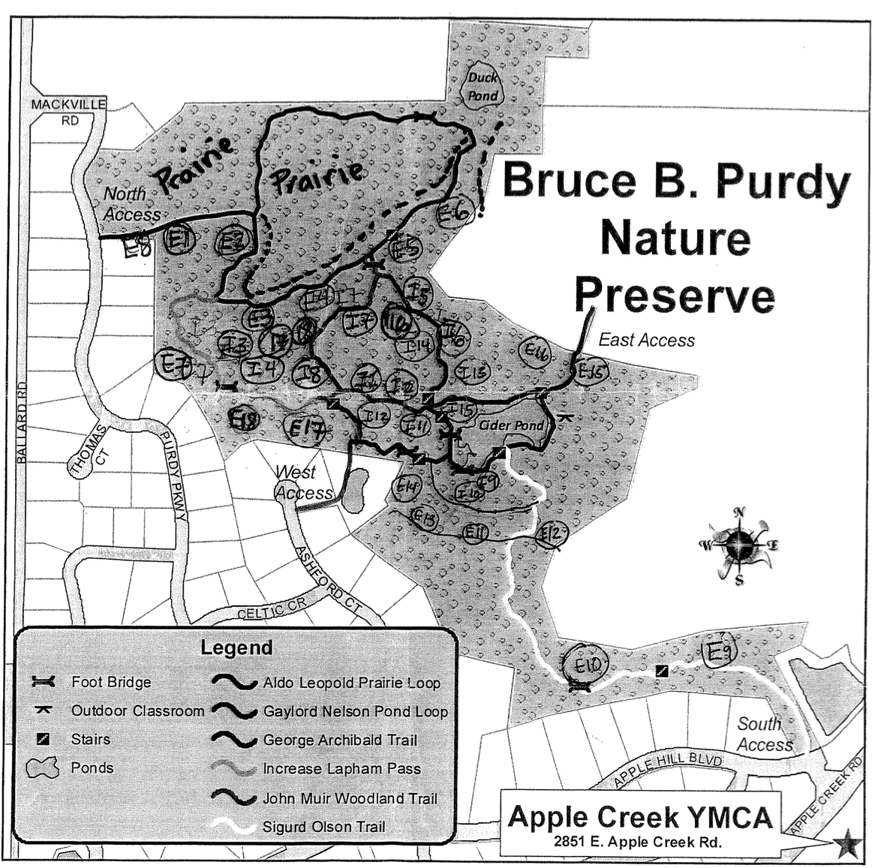Map of Bruce B. Purdy Nature Preserve with approximate location of all study sites is pictured.

Appendix B

Summary statistics for abundance by understory density (Top Left) and noise level (Bottom Left) in addition to those for richness understory density (Top Right) and noise level (Bottom Right). Though not formally tested (i.e. T.Test, Wilcox Test, ect..) these values provide valuable insight into plausible causes for differences between edge and core sites. Specifically, they provide evidence as to why Richness differences between habitats was found in the T-Test and why lack of evidence for differences was found for abundance.

**Appendix C**

Results of Levene’s Test of equal variance (Top) and Shapiro-Wilk’s Test of normality (Bottom) are depicted. Interpretations of test results based on P-Values are provided in the tables.