STATUS OF CORAL REEFS OF LITTLE CAYMAN AND GRAND CAYMAN, BRITISH WEST INDIES, IN 1999 (PART 2: FISHES)

* Higher harvest pressure on GC was reflected in the lower density and size of large groupers, parrotfishes and snappers (Table 4) and lower sighting frequencies of large groupers (Table 3)
* In a simple system, one might expect the presence and density of herbivorous species to be negatively correlated with algal abundance and height. In other words, a site with many herbivorous fish would have relatively low algal abundance due to grazing. Our analysis at the site level indicates that this expectation holds true for surgeonfish. However, the inverse is evident in parrotfish. This implies either or both of the following: 1) there is a direct or indirect interaction between parrotfish and surgeonfish, or, more generally 2) the dynamic spatial and temporal characteristics of reef fish confound simple relationships between resource availability and fish abundance.
* Because certain fish species dominate the top of coral reef food webs, a baseline of fish community composition and richness provides a useful tool for future assessment of reef health, given that a change in reef communities at lower trophic levels will most likely result in changes in the reef fish community composition (Choat, 1991; Jones et al., 1991). Additionally, because fish tend to be the most charismatic group of reef community members, changes in their community are most likely to be noticed and documented.

Rapid Build-up of Fish Biomass in a Caribbean Marine Reserve

* This study reports on the effects of marine reserve protection on fish populations surrounding the Caribbean island of Saba in the Netherlands Antilles. The re- sults show that populations have responded rapidly to protection with increases in numbers, sizes, and overall biomass of many species. These findings suggest that the predicted fishery management and species conservation functions of reserves may be achieved relatively quickly after reserve establishment.
* and those in the unfished area have continued to increase at a slower rate.
* that differences between fished and unfished zones detected in the first survey were probably a result of protection from fishing. Intriguingly, while biomass typically remained higher in the unfished area

**HERBIVORE ABUNDANCE AND GRAZING INTENSITY ON A CARIBBEAN CORAL REEF**

* While the present study did not estimate density of pomacentrid fishes, which defend territories against free-ranging herbivores, measurements of pomacentrid den- sities at four ofthe sites studied here (J. Bohnsack, pers. comm.) suggest that acanthurid and scarid abundance may be inversely related to pomacentrid density. across the Belizean barrier reef

**Effects of a predatory fish on the recruitment and abundance of Caribbean coral reef fishes**

* the first experiment, conducted during a large pulse of settle- ment, greater numbers of *H. adscensionis* had a signif- icant negative effect on the abundance of grunt recruits, larger juvenile tomtate *Haemulon aurolinea- turn,* and resident fishes. In the second experiment, conducted following the peak recruitment period, removal of H. *adscensjonis* again resulted in a signifi- cantly greater number of juvenile grunts on
* in the present study, removal of a single predator, olocentrus adscensionis, had a negative effect on abundances of grunts and resident fishes
* demonstrated that resident predator removals on experimental reefs had significant effects on the survivorship of newly settled recruits of damselfish Chromis cyanea and wrasse Halichoeres pjctu
* High densities of Holocentrus adscensionis resulted in lower densities of grunts
* In conclusion, the squirrelfish-grunt interactions observed during this experiment support the impor- tance of predation in structuring coral reef fish assemblage

**What controls tropical reef fish populations: recruitment or benthic mortality? An example in the Caribbean reef fish *Haemulon flavolineatum***

* by snappers *Lutjanus mahogoni, L, buccanella, Ocyurus chrysurus,* and jack *Caranx ruber* (Shulman et al. 1983, Ogden unpubl. data).
* dult snappers and jacks, frequently foraging in schools, will make repeated passes through groups of small grunts, attempting to strike on each pass.
* We suspect that the major source of mortality in young grunts is predation.
* Is there evidence that the benthic mortality in French grunts is density dependent? This study was not designed to test for the presence of absence of density- dependent mortality or to determine the effects o
* resource availabdity on benthic mortality. However, aggression in grunt schools has been observed to affect individual access to shelter sites (McFarland & Hillis 1982, Shulman 1985b);these behaviors might possibly result in density-dependent mortality, but that has not yet been demonstrate

Non-linear effects of invasive lionfish density on native coral-reef fish communities

* Increasing lionfish density negatively affected the abundance and biomass of prey-sized native reef fishes over the course of the experiment. The largest declines in native fish abundance and biomass occurred between the zero and one lionfish treatments
* The Pacific red lionfish (Pterois volitans) is an invasive predator that is a top global conservation issue
* A likely explanation for such a leveling off of impacts at higher lionfish densities is intraspecific competition among lionfish. The juvenile lionfish in this study experienced slower growth rates in both length and mass with increasing density
* bridled goby (Coryphopterus glaucofraenum), followed by the beaugregory dam- selfish (Stegastes leucostictus), and the rosy blenny (Malacoctenus macropus). This result is consistent with those of Albins and Hixon (2008)
* However, at the highest experimental lionfish density, populations of all native species were severely depleted, with only a single native fish recruit present on the reef at the end of the experiment.

Large-scale associations between macroalgal cover and grazer

biomass on mid-depth reefs in the Caribbean

* Since the 1970s, macroalgae have become considerably more abundant on many Caribbean reefs and over-fishing of grazing fishes has been implicated as a contributory factor.
* correlation between herbivorous fish biomass and macroalgal cover. Correlations cannot prove causality, but the patterns we found were consistent with the hypothesis that biomass of herbivorous fish was an important factor in the cover of macroalgae. Clearly, a linear relationship between herbivorous fish biomass and planar percent macroalgal cover is a simplistic model of mac- roalgal±grazer interaction in the habitat concerned and
* Within locations, the reef areas we surveyed were rather similar in terms of herbivore biomass and algal cover 􏰶Figs. 2 and 3, Table 2), and it was therefore only by surveying at several locations that we were able to investigate patterns from reef areas encompassing a wide range of benthic algal cover and herbivore biomass. A drawbackofsamplingatseverallocationsatdi􏰷erent time periods 􏰶Table 1) is that the overall patterns we detected might have been confounded by undetected di􏰷erencesamonglocationsdriven,forexample,by seasonal and interannual variability. We believe that seasonality is unlikely to have been an important factor indi􏰷erencesamongareasasmostsurveyswerecarried out in early to mid-summer 􏰶Table 1), and similarly we think it improbable that interannual variability was an important factor, as the associations between algal cover and herbivore biomass appear similar regardless of the year in which locations were surveyed
* Furthermore, even if Diadema had generally been rare on lightly ®shed reefs 􏰶Hay 1984) particularly at the depths we surveyed, sea urchins could still have been locally important in locations that had lost cover of otherlivingbenthos

Simplification of Caribbean Reef-Fish

Assemblages over Decades of Coral Reef

Degradation

* we assess whether changes in fish assemblages have been non-random over several decades of declining reef structure. More specifically, we predicted that species that depend exclusively on coral reef habitat (i.e., habitat special- ists) should be at a disadvantage compared to those that use a broader array of habitats (i.e., habitat generalists)
* 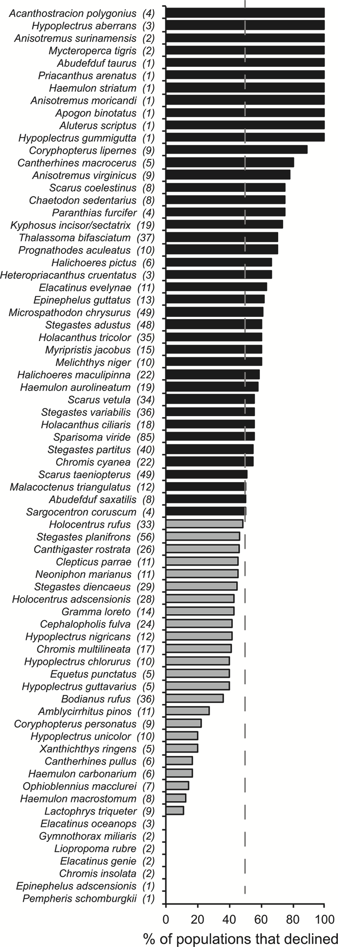
* Our results indicate that Caribbean reef-fish assemblages have been experiencing profound changes in community composition since 1980, probably largely due to habitat degradation. We found evidence of an apparent replacement of habitat-specialists by generalist species over a 30-year period.

**An Evaluation of Grand Cayman MPA performance: a comparative study of coral reef fish communities**

* nor were there any significant differences in density between protected and non protected sites.
* Marine Protected Areas (MPAs) were established in 1986, with the main objectives of protecting coral reefs and their associated organisms (including fish communities)
* Additionally specific biomass of fish families was also higher inside the MPA; showing two times higher for the Scaridae, four times higher for the Lutjanidae, and three times higher for the Carangidae
* The MPA is dominated by herbivores, which is very important for ecological health, considering the absence of the echinoid, Diadema antillarum, in large numbers on Caribbean reefs, a major herbivore which suffered almost concurrent mass mortality throughout its entire geographic range in 1982 - 1983 due to a species-specific pathogen (Hughes,1993).
* Another salient point that lends weight to the efficien- cy of the MPA system of Grand Cayman is that there are no significant differences in the density of fish when protected sites within the MPA are compared to non protected sites outside the MPA, indicative of an efficient MPA design.
* The MPA allows the development of higher biomass by means of allowing individuals to grow to a larger size class as well as the specific composition of sites, not by the density of individuals.
* 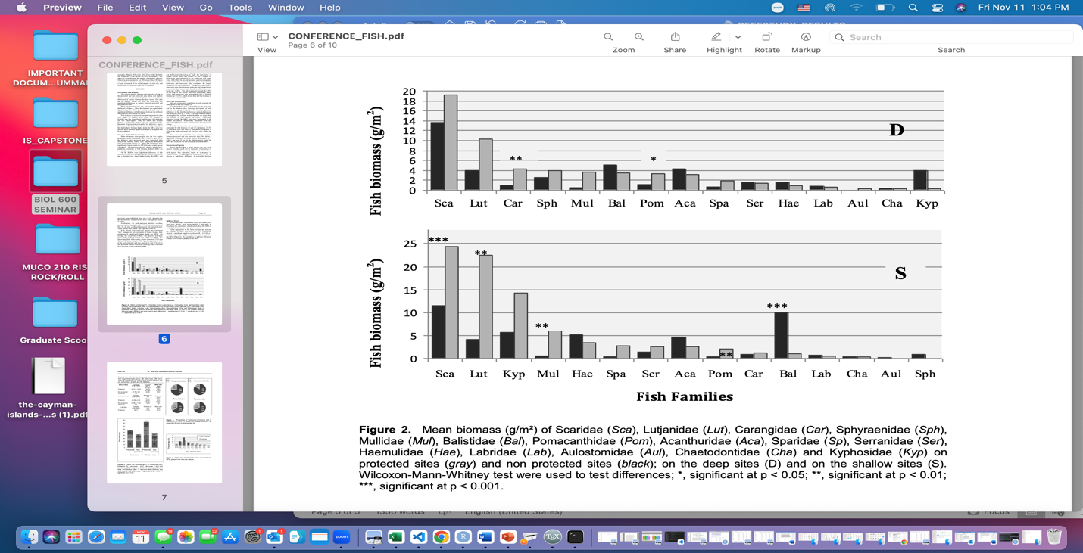The data suggest that when all species are considered, there is a more homogenous distribution within the protected MPA sites which again adds weight to the effectiveness of the MPA. When the “rare” species (abundance lesser than 1%) are considered, Holocanthus ciliaris (Linnaeus, 1758) was six times, Pomacanthus arcuatus (Linnaeus, 1758) five times, Mysteroperca tigris (Valenciennes, 1833) four times, and Lutjanus jocu (Schneider, 1801) is 3.6 times more likely to be found at the protected sites, within the MPA.