 | R.M.K. ENGINEERING COLLEGE  (An Autonomous Institution)  R.S.M Nagar, Kavaraipettai, Gummidipoondi Taluk, Thiruvallur District, Tamil Nadu- 601206 Affiliated to Anna University, Chennai / Approved by AICTE, New Delhi  Accredited by NAAC with A+ Grade /An ISO 21001:2018 Certified Institution All the Eligible UG Programs are Accredited by NBA, New Delhi | 
24ME511- PRODUCT DEVELOPMENT LAB – III

REPORT ON

MOVIEMIND: AI-POWERED MOVIE
RECOMMENDATION SYSTEM
Submitted By
Vikranath A – 111724203119

BACHELOR OF TECHNOLOGY
IN
INFORMATION TECHNOLOGY
R.M.K ENGINEERING COLLEGE
(An Autonomous Institution)

R.S.M Nagar, Kavaraipettai - 601 206
NOVEMBER 2026

BONAFIDE CERTIFICATE
Certified that this Product Development Lab III report "MovieMind: AI-Powered Movie Recommendation System" is the bonafide work of “ Vikranath A (111724203119) ” who carried out the 24ME511 – Product Development Lab III under my supervision.

SIGNATURE SIGNATURE
Dr. Sheerin Banu M, M.Tech, Ph.D Ms. S. Nandhini,
Professor and Head, Supervisor, Assistant Professor,
Dept of Information Technology, Dept of Information Technology,
R.M.K. Engineering College, R.M.K. Engineering College,
R.S.M. Nagar, R.S.M Nagar,
Kavarapettai - 601206. Kavarapettai - 601206.

CERTIFICATE OF EVALUATION
College Name : R.M.K. ENGINEERING COLLEGE
Department : INFORMATION TECHNOLOGY
Semester : 05
Title of Project | Name of the Students | Name of the Supervisor with designation
MovieMind: AI-Powered Movie Recommendation System | Vikranath A (111724203119) | Ms. S. Nandhini, Assistant Professor

The report of the Product Development work submitted by the above students in partial fulfilment for the award of Bachelor of Technology Degree in INFORMATION TECHNOLOGY of Anna University was evaluated and confirmed to be the report of the work done by the above students and then evaluated.

Submitted for the project viva-voce examination held on ...........................................

INTERNAL EXAMINER EXTERNAL EXAMINER

ACKNOWLEDGEMENT
We earnestly portray our sincere gratitude and regards to our beloved Founder Chairman, Thiru. R. S. MUNIRATHINAM for giving us the infrastructure for conducting the project work and our Chairperson Tmt. MANJULA MUNIRATHINAM for her blessings. We also thank our Vice Chairman, Thiru. R. M. KISHORE and our Director, Thiru. R. JOTHI NAIDU for their constant support and affection shown towards us throughout the course.
We are extremely thankful to our Principal, Dr. K. A. MOHAMED JUNAID, for being the source of inspiration in this college.
We reveal our sincere thanks to our Professor and Head of the Department, Information Technology, Dr. M. SHEERIN BANU, for her commendable support and encouragement for the completion of our project.
We would like to express our sincere gratitude to our Course Coordinator Dr. [Course Coordinator name], for her/his valuable suggestions towards the successful completion of this project.
We wish to record our thanks to our project supervisor Ms. S. Nandhini, for her valuable guidance and support during each stage of our project.
We take this opportunity to extend our thanks to all the faculty members of the Department of Information Technology, our parents and friends for their care and support towards the completion of our project.

ABSTRACT
Choosing what to watch is a problem of abundance. Streaming catalogues hold tens of thousands of titles, yet most recommender systems describe a viewer with a fixed profile, such as a list of liked genres or a row of past ratings, and treat the viewer's current mood either as a hard genre filter or not at all. Genre labels are too coarse to describe what a film feels like, keyword-based text matching such as TF-IDF cannot connect synonyms, and a mood filter that ignores taste can return films the viewer would never enjoy.
This project presents MovieMind, a web-based movie recommendation system built around one idea: movies, users and moods can live in the same mathematical space. Each movie is converted into a 384-dimensional vector by the all-MiniLM-L6-v2 Sentence Transformer applied to its plot, tagline, genres, keywords, director and cast. A user is represented by the centroid of the vectors of the movies they like. Each of ten moods is represented by a direction vector computed as the mean of a set of exemplar movies minus the mean of all movies. A recommendation is the set of movies nearest to the search position user_taste + λ × mood_direction, where λ is a number between 0 and 1 that the viewer controls with a slider.
Because the user, the movies and the mood share one space, the system also explains each recommendation from the geometry: how well it matches the user's taste, how much the mood shift changed its ranking, and which previously liked movie it is closest to. The system is implemented with Flask, SQLite, NumPy and scikit-learn, runs on a CPU with no paid API, and adds a single dependency, sentence-transformers, to the earlier TF-IDF version of the project.
The approach is evaluated offline on the MovieLens ml-latest-small dataset (531 of 610 users qualified) against a TF-IDF and genre baseline (the earlier version of the system), a no-mood semantic baseline and a genre-boost mood baseline, using Hit Rate@10, NDCG@10, Diversity@10 and Serendipity@10, with a sweep of λ from 0.0 to 1.0. The results are mixed and are reported as measured. With a mood that is known exactly (an oracle diagnostic) the λ-shifted search raises hit rate from 0.109 to 0.149, so the mechanism works. With the only mood signal available offline, a proxy from recent viewing, the shift did not help (0.073 against 0.109 without mood), and content embeddings alone trailed a popularity reference and the earlier engine, which uses a rating prior. Whether a mood chosen by the user improves their experience therefore remains untested and needs real mood data or a user study. The system was implemented end to end with 73 automated tests, answers a request in a median of 4.5 ms on a CPU, and has a redesigned interface built around a λ ruler.
The report documents the design, implementation, results, limitations and a roadmap that includes quality and collaborative signals, multi-mood blending, per-user λ and a user study.
Keywords: Recommender System, Sentence Embeddings, Semantic Search, Mood-Aware Recommendation, Explainable AI, Content-Based Filtering, Cosine Similarity, Flask, MovieLens.

TABLE OF CONTENTS
Ch. No. | Title | Page No.
 | Acknowledgement | 4
 | Abstract | 5
 | List of Figures | 9
 | List of Tables | 10
 | List of Abbreviations | 11
1 | INTRODUCTION | 12
 | 1.1 Overview | 12
 | 1.2 Scope of the Project | 13
 | 1.3 Objectives | 13
 | 1.4 Existing System | 14
 | 1.5 Existing System Disadvantages | 14
 | 1.6 Literature Review | 15
 | 1.7 Proposed System | 18
 | 1.8 Proposed System Advantages | 19
 | 1.9 Hardware and Software Requirements | 20
 | 1.10 Non-Functional Requirements | 20
 | 1.11 Comparison with Alternative Approaches | 21
2 | SYSTEM DESIGN | 22
 | 2.1 General Description | 22
 | 2.2 Prototype / Block Diagram | 22
 | 2.3 System Architecture (Data Flow Diagram) | 22
 | 2.4 Use Case Diagram | 23
 | 2.5 Activity Diagram (Algorithm Flowchart) | 24
 | 2.6 UML Collaboration Diagram | 25
 | 2.7 UML Class Diagram | 26
 | 2.8 Database Design | 27
 | 2.9 API Design | 27
3 | SYSTEM IMPLEMENTATION | 29
 | 3.1 Module Description | 29
 | 3.2 Module Interaction Summary | 31
 | 3.3 Testing Strategy | 32
 | 3.4 Deployment and Installation Procedure | 32
4 | TECHNOLOGY STACK | 34
 | 4.1 Software Components | 34
 | 4.2 Software Tools | 36
 | 4.3 Communication Protocol Stack | 36
 | 4.4 Resource and Cost Estimation | 37
 | 4.5 Comparison with Alternative Embedding Choices | 37
 | 4.6 Privacy, Security and Reliability | 38
 | 4.7 Scalability | 38
 | 4.8 Overall Technical Justification | 38
5 | SCREENSHOTS | 39
 | 5.1 System Configuration | 39
 | 5.2 Application Screenshots | 39
 | 5.3 Console Output | 40
 | 5.4 System Response and Validation | 41
6 | SAMPLE CODING | 42
 | 6.1 Embeddings and Mood Vectors | 42
 | 6.2 Embedding Store and Mood-Shifted Search | 42
 | 6.3 User Taste Centroid | 43
 | 6.4 Recommendation Engine | 43
 | 6.5 Geometric Explanations | 44
 | 6.6 REST Endpoint | 45
 | 6.7 API Quick Reference | 46
7 | RESULT AND DISCUSSION | 47
 | 7.1 Experimental Setup | 47
 | 7.2 Result | 47
 | 7.3 Performance Metrics | 48
 | 7.4 Discussion | 50
 | 7.5 Limitations of the Current Prototype | 51
8 | CONCLUSION AND FUTURE ENHANCEMENT | 53
 | 8.1 Conclusion | 53
 | 8.2 Applications | 53
 | 8.3 Future Enhancement | 54
 | 8.4 Societal and Ethical Considerations | 54
 | 8.5 Deployment Considerations | 55
9 | REFERENCES | 56
 | Patent / Paper Publication Proof | 57

LIST OF FIGURES
Figure No. | Description | Page No.
1.1 | Schematic Semantic Map of Movies, User Taste and Mood (illustrative) | 19
2.1 | System Block Diagram | 22
2.2 | Data Flow / System Architecture Diagram | 23
2.3 | Use Case Diagram | 24
2.4 | Activity Diagram - Mood-Shifted Recommendation | 25
2.5 | UML Collaboration Diagram | 26
2.6 | UML Class Diagram | 27
3.1 | Computing a Mood Direction Vector (schematic) | 30
3.2 | Effect of λ on the Search Position (schematic) | 31
4.1 | Layered Software Architecture | 34
4.2 | Movie Encoding Pipeline | 35
5.1 | Login and Sign-up Page [placeholder] | 39
5.2 | Dashboard with Mood Selector and λ Slider [placeholder] | 40
5.3 | Recommendations with Geometric Explanations [placeholder] | 40
7.1 | HR@10 and NDCG@10 versus λ for proxy, random and oracle moods (shaded: 95% CI) | 50
7.2 | Comparison of Baselines and Proposed Method (95% bootstrap CI) | 50

LIST OF TABLES
Table No. | Description | Page No.
1.1 | Comparison of Existing and Proposed Approaches | 15
1.2 | Summary of Literature Survey | 18
1.3 | Hardware Requirements | 20
1.4 | Software Requirements | 20
1.5 | Comparison with Alternative Recommendation Approaches | 21
2.1 | Database Tables | 27
2.2 | REST API Endpoints | 28
3.1 | Exemplar Movies per Mood | 30
3.2 | Module Interaction Summary | 31
3.3 | Test Cases and Results | 32
3.4 | Deployment and Installation Procedure | 33
4.1 | Embedding Model Properties | 34
4.2 | Tools Used in the Project | 36
4.3 | Communication Layers and Measured Latency | 36
4.4 | Resource Estimate | 37
4.5 | Comparison with Alternative Representations | 37
5.1 | System Configuration Parameters | 39
6.1 | Recommendation Endpoint Parameters (liked movies are always excluded) | 46
7.1 | Recommendation Quality at k = 10 (531 users; 95% bootstrap CI for HR) | 48
7.2 | Paired Difference, Proposed (λ = 0.3, proxy mood) minus B2 (same users) | 48
7.3 | Effect of λ on HR@10 for Three Mood Sources (oracle uses test items; upper bound only) | 48
7.4 | Diagnostics (not proposed methods): Quality Prior and Diversity Filter on the Semantic Centroid | 49
7.5 | Latency and Resource Measurements | 49

LIST OF ABBREVIATIONS
Abbreviation | Expansion
NLP | Natural Language Processing
SBERT | Sentence-BERT
MiniLM | Mini Language Model (distilled Transformer)
TF-IDF | Term Frequency – Inverse Document Frequency
CF | Collaborative Filtering
HR | Hit Rate
NDCG | Normalised Discounted Cumulative Gain
TMDB | The Movie Database
API | Application Programming Interface
REST | Representational State Transfer
JSON | JavaScript Object Notation
HTTP | Hypertext Transfer Protocol
ORM | Object-Relational Mapping
SQL | Structured Query Language
UI | User Interface
CPU | Central Processing Unit
GPU | Graphics Processing Unit
ANN | Approximate Nearest Neighbour
UML | Unified Modeling Language
CSV | Comma-Separated Values
ML | Machine Learning
IDE | Integrated Development Environment
TC | Test Case
λ | Lambda – mood-shift weight

CHAPTER 1
INTRODUCTION

1.1 Overview
Choosing what to watch has become a problem of abundance rather than scarcity. Streaming catalogues contain tens of thousands of titles, and a viewer who opens an application on a tired weeknight is rarely looking for the same experience they wanted on Saturday afternoon. Recommender systems exist to narrow this space, but most of them model a viewer with a single, fixed profile: a list of genres liked in the past, or a row in a ratings matrix. Neither representation captures the fact that the same person wants different things on different days.
This project presents MovieMind, a web-based movie recommendation system whose central idea is that movies, users and moods can all be placed in the same mathematical space. Every movie is converted into a 384-dimensional semantic vector (an embedding) by a pre-trained Sentence Transformer; a user is represented by the centroid of the embeddings of the movies they have liked; and each mood (happy, sad, excited, relaxed, and so on) is represented by a direction vector in that same space. A recommendation is produced by taking the user's position, nudging it a controllable distance in the direction of the current mood, and returning the nearest movies.
The idea is summarised by a single equation, which the rest of this report develops:
search_position = user_taste + λ × mood_direction
Here λ (lambda) is a number between 0 and 1 that the user can change with a slider. With λ = 0 the system recommends purely from long-term taste; with λ = 1 it recommends purely from the selected mood; values in between let the viewer say "my usual taste, but a little more exciting today". Because the user, the movies and the mood live in the same space, the system can also explain every recommendation geometrically, for example by naming the liked movie that a suggestion is closest to and reporting how much of its ranking came from the mood shift.
MovieMind is implemented as a Flask application with a SQLite database, NumPy and scikit-learn for vector arithmetic, and the sentence-transformers library for encoding. It runs entirely on a local machine, requires no GPU at query time, and uses no paid API. An earlier version of the system (referred to as v1 in this report) used TF-IDF vectors, genre-based taste profiles and a hard-coded mood-to-genre table; v1 is retained as the baseline against which the proposed approach is evaluated.

1.2 Scope of the Project
MovieMind is designed as a complete, small-scale recommendation product rather than an isolated algorithm. Its scope covers the following areas:
- Semantic content representation: converting plot summaries, taglines, genres, keywords, director and cast into dense embeddings for a catalogue of roughly five thousand movies.
- Personalisation: maintaining a per-user taste vector that updates whenever a movie is liked or unliked.
- Mood-aware discovery: ten selectable moods, each backed by a learned direction vector, with a user-controlled intensity (λ).
- Explainable output: every recommendation is returned together with geometry-based reasons (taste match, mood effect, nearest liked movie).
- Web application: user registration and login, movie browsing and search, favourites, a profile page and a dashboard containing the mood selector and λ slider.
- Evaluation: an offline experiment on the MovieLens dataset comparing the proposed method against three baselines and sweeping λ from 0.0 to 1.0.
The project deliberately does not attempt large-scale deployment, real-time streaming-platform integration or an online user study; these are discussed as future work in Chapter 8.

1.3 Objectives
- To replace sparse TF-IDF movie vectors with dense semantic embeddings so that related concepts (for example "heist", "robbery" and "caper") are recognised as similar even when they share no words.
- To represent each user as a point in the same embedding space as the movies, computed as the centroid of the movies the user likes.
- To learn a direction vector for each of ten moods from the data itself, instead of using a hand-written genre lookup table.
- To generate recommendations by a single operation, a λ-shifted nearest-neighbour search, and to expose λ as a user-facing slider.
- To produce explanations computed from actual vector relationships rather than from fixed text templates.
- To evaluate the approach against baselines using Hit Rate@10, NDCG@10, Diversity@10 and Serendipity@10, and to measure how quality changes as λ varies.
- To keep the whole system lightweight: CPU-only, locally runnable and free of paid services.

1.4 Existing System
The existing system (v1) is the first version of MovieMind. It is a conventional hybrid content-based recommender with the following behaviour:
- TF-IDF content vectors: each movie's plot, genres, cast and keywords are converted to a sparse TF-IDF vector; similarity between two movies is the cosine of their vectors.
- Genre-based taste profile: a user is represented by a dictionary of genre weights, e.g. {Drama: 0.8, Thriller: 0.4}, updated by an exponential moving average with learning rate α = 0.2 whenever a movie is liked.
- Hard-coded mood table: each mood maps to a fixed set of genres with boost factors (for example "excited" boosts Action 1.5, Adventure 1.4, Thriller 1.3). Movies whose genres match are multiplied by the boost.
- Weighted scoring: the final score is a weighted sum of content similarity, genre match and mood boost, followed by a per-genre diversity cap.
- Template explanations: the explanation shown to the user is chosen from fixed sentence templates filled with a genre or movie name.

1.5 Existing System Disadvantages
- Genre labels do not describe experience: four films tagged "Thriller" may be a witty heist comedy, a slow-burn occult horror, a twisty domestic drama and a gritty procedural. A genre-based profile treats them as interchangeable.
- Keyword matching misses meaning: TF-IDF gives zero similarity to "bank heist" versus "robbery" or "mind-bending" versus "cerebral", because it only counts shared words.
- Mood and taste are disconnected: the mood table overrides what the system knows about the user. A viewer who only watches slow dramas and selects "Excited" is shown generic action films they are unlikely to enjoy.
- Mood is binary: mood is either applied or not; there is no way to ask for a little more excitement.
- Explanations are not grounded: template sentences are not computed from the model, so they can be generic or misleading.
Table 1.1 summarises how the proposed approach compares with the existing system on six practical criteria.
Table 1.1: Comparison of Existing and Proposed Approaches
Criterion | TF-IDF + Genre (v1) | Collaborative Filtering | Proposed MovieMind v2
Understands synonyms / meaning | No (word overlap) | Not applicable | Yes (sentence embeddings)
User representation | Genre-weight dictionary | Row of ratings / latent factors | 384-d centroid in movie space
Mood handling | Genre lookup table | Usually none | Direction vector in same space
Mood intensity control | None (on / off) | None | Continuous λ ∈ [0, 1]
Cold-start for new movies | Works (content) | Fails (no ratings) | Works (content)
Explanation basis | Fixed templates | Opaque factors | Geometric: taste, mood, nearest liked

1.6 Literature Review
A review of prior published work was carried out to position MovieMind relative to existing research on semantic text embeddings, content-based and embedding-based recommendation, affective (emotion- and mood-aware) recommendation, and evaluation methodology. Only sources whose existence and bibliographic details were confirmed against a publisher, repository or archive page are cited; the full list is in Chapter 9.

Sentence-BERT: Sentence Embeddings using Siamese BERT-Networks
N. Reimers and I. Gurevych, EMNLP-IJCNLP, 2019
The paper fine-tunes BERT in a siamese setting so that whole sentences are mapped to vectors that can be compared directly with cosine similarity. It reports that finding the most similar pair among 10,000 sentences drops from about 65 hours with raw BERT to about 5 seconds. This is the basis for MovieMind's shared embedding space and its cosine nearest-neighbour search [1].

MiniLM: Deep Self-Attention Distillation for Task-Agnostic Compression of Pre-Trained Transformers
W. Wang et al., arXiv:2002.10957, 2020
MiniLM compresses large Transformer models by distilling the self-attention behaviour of the final layer into a much smaller student. The all-MiniLM-L6-v2 encoder used in this project builds on this compact architecture, which is why encoding a catalogue of several thousand movies is practical on a CPU [2].

The MovieLens Datasets: History and Context
F. M. Harper and J. A. Konstan, ACM TiiS, 2015
This paper describes the origin of the MovieLens datasets, how they are released and the limitations that apply when they are used for research. It justifies the use of MovieLens for the offline evaluation in this project and informs the limitations discussed in Chapter 7 [3].

Content-based Recommender Systems: State of the Art and Trends
P. Lops, M. de Gemmis and G. Semeraro, Recommender Systems Handbook, 2011
The chapter surveys how items and user profiles are represented in content-based systems and how profiles are learned from item descriptions. It supports both the v1 TF-IDF baseline and the idea of building a user profile from the content of liked items [4].

Item2Vec: Neural Item Embedding for Collaborative Filtering
O. Barkan and N. Koenigstein, IEEE MLSP, 2016
Item2Vec adapts the word2vec skip-gram model to learn item embeddings from sets of co-occurring items and reports results competitive with SVD-based collaborative filtering. It supports the premise that items can be represented as points in a vector space where distance reflects similarity [5].

Neural Collaborative Filtering
X. He et al., WWW, 2017
The paper replaces the inner product of matrix factorisation with a learned neural interaction function over user and item embeddings. MovieMind differs by using a fixed, content-derived embedding and a simple centroid for the user, trading some accuracy potential for transparency and cold-start robustness [6].

A Survey of Affective Recommender Systems: Modeling Attitudes, Emotions, and Moods for Personalization
T. Hasan and R. Bunescu, arXiv:2508.20289, 2025
This survey classifies affect-aware recommenders into attitude-, emotion-, mood- and hybrid categories, and discusses how affect is extracted and used. It is the main source used to situate MovieMind's mood-aware design and to frame the gap addressed here: affect is usually handled as a separate signal rather than as a direction in the same space as the content. It is an arXiv preprint [7].

Cumulated Gain-Based Evaluation of IR Techniques
K. Järvelin and J. Kekäläinen, ACM TOIS, 2002
The paper introduces cumulated gain, discounted cumulated gain and their normalised form (nDCG), which reward placing relevant items near the top of a ranking. nDCG@10 is one of the main metrics used in the evaluation plan [8].

Diversity, Serendipity, Novelty, and Coverage: A Survey and Empirical Analysis of Beyond-Accuracy Objectives in Recommender Systems
M. Kaminskas and D. Bridge, ACM TiiS, 2016
The authors survey beyond-accuracy objectives and show how optimising one affects the others. This motivates reporting Diversity@10 and Serendipity@10 alongside accuracy, and suggests that increasing λ may trade some accuracy for novelty [9].

Linguistic Regularities in Continuous Space Word Representations
T. Mikolov, W.-t. Yih and G. Zweig, NAACL-HLT, 2013
The paper shows that semantic relations appear as consistent vector offsets in learned word spaces (the well-known king − man + woman ≈ queen example). This is the direct precedent for treating a mood as an offset, mean(mood exemplars) − mean(all movies), and adding it to a taste vector [10].

Efficient Estimation of Word Representations in Vector Space
T. Mikolov et al., arXiv:1301.3781, 2013
The paper introduces the CBOW and skip-gram models for learning word vectors efficiently from large corpora, and underlies the idea that meaning can be encoded geometrically [11].

Scikit-learn: Machine Learning in Python
F. Pedregosa et al., JMLR, 2011
The paper describes the scikit-learn library, from which the TF-IDF vectoriser and cosine-similarity routines used by the baseline system are taken [12].
Table 1.2 consolidates the literature survey and shows where each source is applied in the project.
Table 1.2: Summary of Literature Survey
Ref. | Contribution | Applied To
[1] | Sentence embeddings comparable by cosine | Movie encoding, nearest-neighbour search
[2] | Compact distilled Transformer encoder | all-MiniLM-L6-v2 model choice
[3] | MovieLens dataset history and limits | Evaluation dataset, limitations
[4] | Content-based profiles from item text | v1 baseline, user centroid
[5] | Item embeddings for recommendation | Items as points in a vector space
[6] | Neural user / item embeddings | Contrast with centroid user model
[7] | Survey of affective recommenders | Research gap, mood modelling
[8] | nDCG ranking metric | NDCG@10
[9] | Diversity and serendipity metrics | Diversity@10, Serendipity@10
[10] | Vector offsets encode relations | Mood direction vector
[11] | Word-vector learning | Embedding-space intuition
[12] | scikit-learn library | TF-IDF baseline, cosine similarity

1.7 Proposed System
- MovieMind v2 encodes every movie into a 384-dimensional vector using the all-MiniLM-L6-v2 Sentence Transformer applied to a rich text built from plot, tagline, genres, keywords, director and cast. The vectors are computed once, offline, and stored as a NumPy matrix.
- A user's taste is the unit centroid of the embeddings of liked movies, stored as 384 numbers in a new users.taste_embedding column (the original genre profile is kept so that v1 can run as a baseline). Unliking a movie recomputes the centroid from the remaining likes.
- Ten mood direction vectors are computed once from the data: for each mood, the mean embedding of a set of exemplar movies minus the mean embedding of all movies, normalised to unit length.
- To recommend, the system forms search_position = user_taste + λ × mood_direction, computes the cosine similarity to every movie embedding, removes already-liked movies, applies a diversity filter and returns the top k.
- Each result carries a geometric explanation: taste contribution, mood contribution and the nearest liked movie.
- The user controls λ with a slider on the dashboard; the default is 0.3.
Figure 1.1 illustrates the idea schematically: movies form neighbourhoods by experience rather than by genre label, the user sits in one neighbourhood, and the mood moves the search point a controlled distance toward another region.
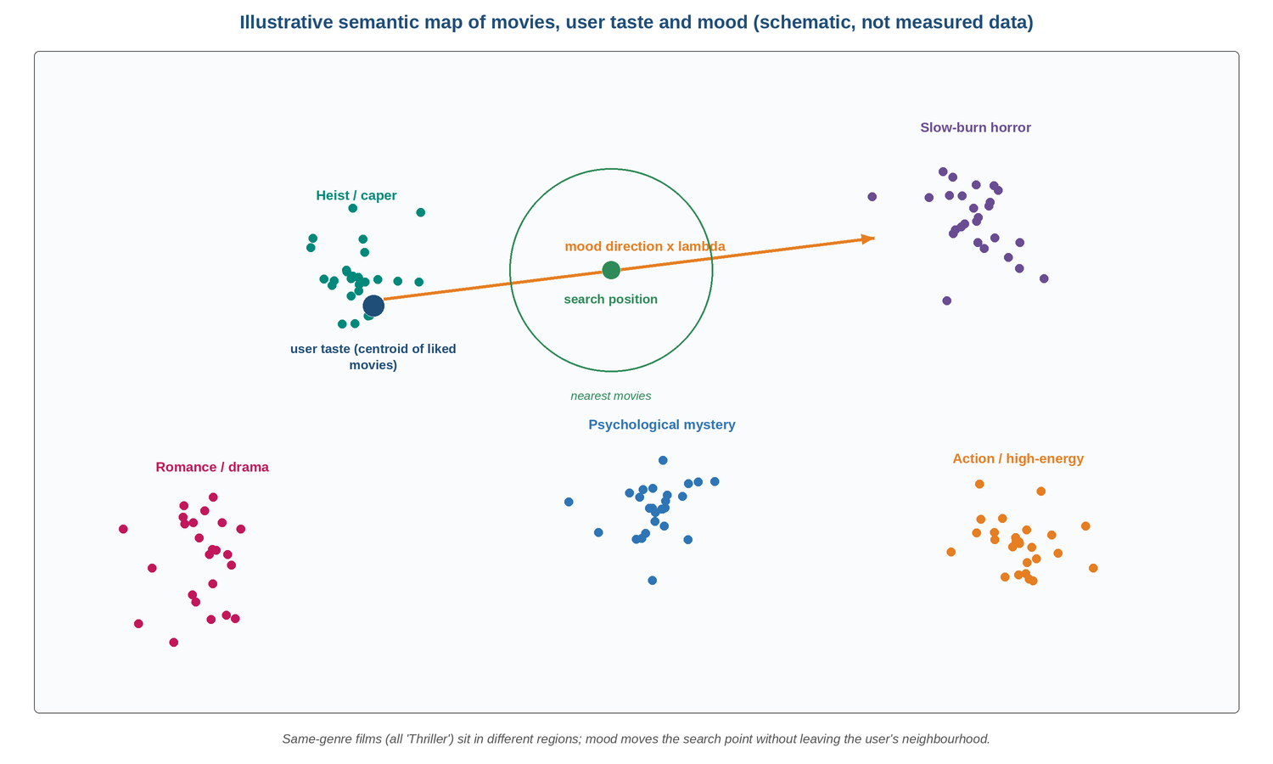
Figure 1.1: Schematic Semantic Map of Movies, User Taste and Mood (illustrative)

1.8 Proposed System Advantages
- Semantic understanding: related concepts are close in the space even when they share no words.
- Mood that respects identity: the mood shifts the taste vector rather than replacing it, so results stay in the user's neighbourhood.
- Controllable intensity: λ gives both the user and the evaluator a continuous control from pure taste to pure mood.
- Explainable by construction: explanations are computed from distances in the same space the recommendation was made in.
- Cold-start friendly: a new user starts at the global mean embedding; new movies need only a description to be placed in the space.
- Simple and light: one recommendation path, one similarity function, one extra dependency (sentence-transformers), no GPU at query time and no paid API.

1.9 Hardware and Software Requirements
Tables 1.3 and 1.4 list the minimum hardware and software needed to reproduce the project. No specialised hardware is required.
Table 1.3: Hardware Requirements
Component | Specification | Purpose
Processor | Any modern x86-64 / ARM CPU (4 cores recommended) | Offline encoding, query-time vector maths
Memory | 4 GB RAM minimum (8 GB recommended) | Model load (~80 MB) and embedding matrices (~8 MB)
Storage | 1 GB free disk | Environment, model cache, SQLite database, datasets
GPU | Not required | Encoding of ~5,000 movies is feasible on CPU
Network | Internet for first setup only | Download dependencies and model; TMDB metadata fetch

Table 1.4: Software Requirements
Software / Library | Version | Purpose
Python | 3.10+ | Implementation language
Flask, Flask-SQLAlchemy, Flask-Login, Flask-CORS | 3.0+ | Web framework, ORM, sessions
sentence-transformers | 3.0+ | all-MiniLM-L6-v2 encoder (new in v2)
NumPy, SciPy, scikit-learn | 1.26+ / 1.12+ / 1.4+ | Vector arithmetic, cosine similarity, TF-IDF baseline
pandas | 2.1+ | Data preparation and evaluation
SQLite / SQLAlchemy | SQLAlchemy 2.0+ | Persistence of movies, users, favourites
Custom CSS + vanilla JavaScript | — | Front-end design system, mood list, λ ruler, vibe map
pytest, pytest-cov | 8.0+ / 4.1+ | Automated tests
Git | Any recent | Version control

1.10 Non-Functional Requirements
- Latency: a recommendation request should complete in well under one second for a catalogue of about 5,000 movies, because it is a single matrix–vector product. Measured end-to-end through Flask (100 requests, 5 liked movies) it takes a median of 4.5 ms and 95% finish within 6.6 ms (Chapter 7).
- Reproducibility: embeddings and mood vectors are generated by a script (build_embeddings.py) so that the whole pipeline can be rebuilt from the database.
- Local operation: no cloud service or paid API is needed at any stage.
- Maintainability: the recommendation logic is isolated in app/ml/; routes only call it.
- Security: passwords are stored as hashes and all personal endpoints require an authenticated session.
- Transparency: every recommendation must be accompanied by a reason that is derived from the model, not invented.

1.11 Comparison with Alternative Approaches
Several alternatives to a shared embedding space were considered during design. Table 1.5 compares them on the factors that mattered for this project.
Table 1.5: Comparison with Alternative Recommendation Approaches
Approach | Needs ratings? | Mood support | Explainability | Suitability
TF-IDF + genres (v1) | No | Genre lookup | Template | Baseline only
Matrix factorisation / CF | Yes (many) | None natively | Low | Weak cold-start; no mood
Neural CF [6] | Yes (many) | Needs extra model | Low | Heavier; needs training data
LLM-based recommender | No | Via prompt | Free text | Needs paid or large model; hard to control
Shared embedding space (chosen) | No (content only) | Direction vector + λ | Geometric | Best fit for a small, local, explainable system

A shared content embedding was chosen because it works with no ratings, treats mood and taste in one geometry, and is cheap to run. Collaborative signals can be added later as a second embedding (Section 8.3).

CHAPTER 2
SYSTEM DESIGN

2.1 General Description
MovieMind is a web application with an offline machine-learning preparation stage and an online recommendation stage. During preparation, movie metadata is turned into embeddings and mood direction vectors. During operation, the user interacts with a browser interface; the Flask back end updates the user's taste vector when movies are liked and, on request, computes mood-shifted recommendations from the stored matrices.
This chapter describes the design through complementary views: a block diagram of the end-to-end pipeline, a data-flow diagram that separates the offline and online paths, a use-case diagram of the actors, an activity diagram of the recommendation algorithm, and UML collaboration and class diagrams of the software objects.

2.2 Prototype / Block Diagram
Figure 2.1 shows the pipeline from movie metadata to recommendations. Movie metadata is encoded by the Sentence Transformer into an embedding matrix. The recommendation engine combines that matrix with a user taste centroid and a mood direction vector to produce the search position, and the Flask API returns the nearest movies with explanations.
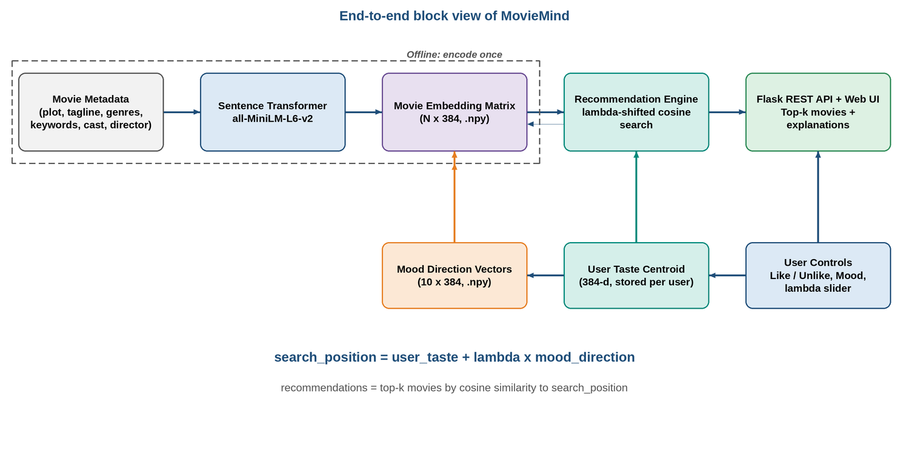
Figure 2.1: System Block Diagram

2.3 System Architecture (Data Flow Diagram)
Figure 2.2 expands the block diagram into a data-flow view. The offline pipeline reads the movie database, builds a rich text per movie, encodes it and stores two matrices: movie_embeddings.npy (N × 384) and mood_vectors.npy (10 × 384). The online pipeline updates the taste centroid when a user likes a movie, and on a recommendation request loads the stored matrices, forms the shifted search position, scores all movies by cosine similarity, filters and ranks them, and attaches explanations.
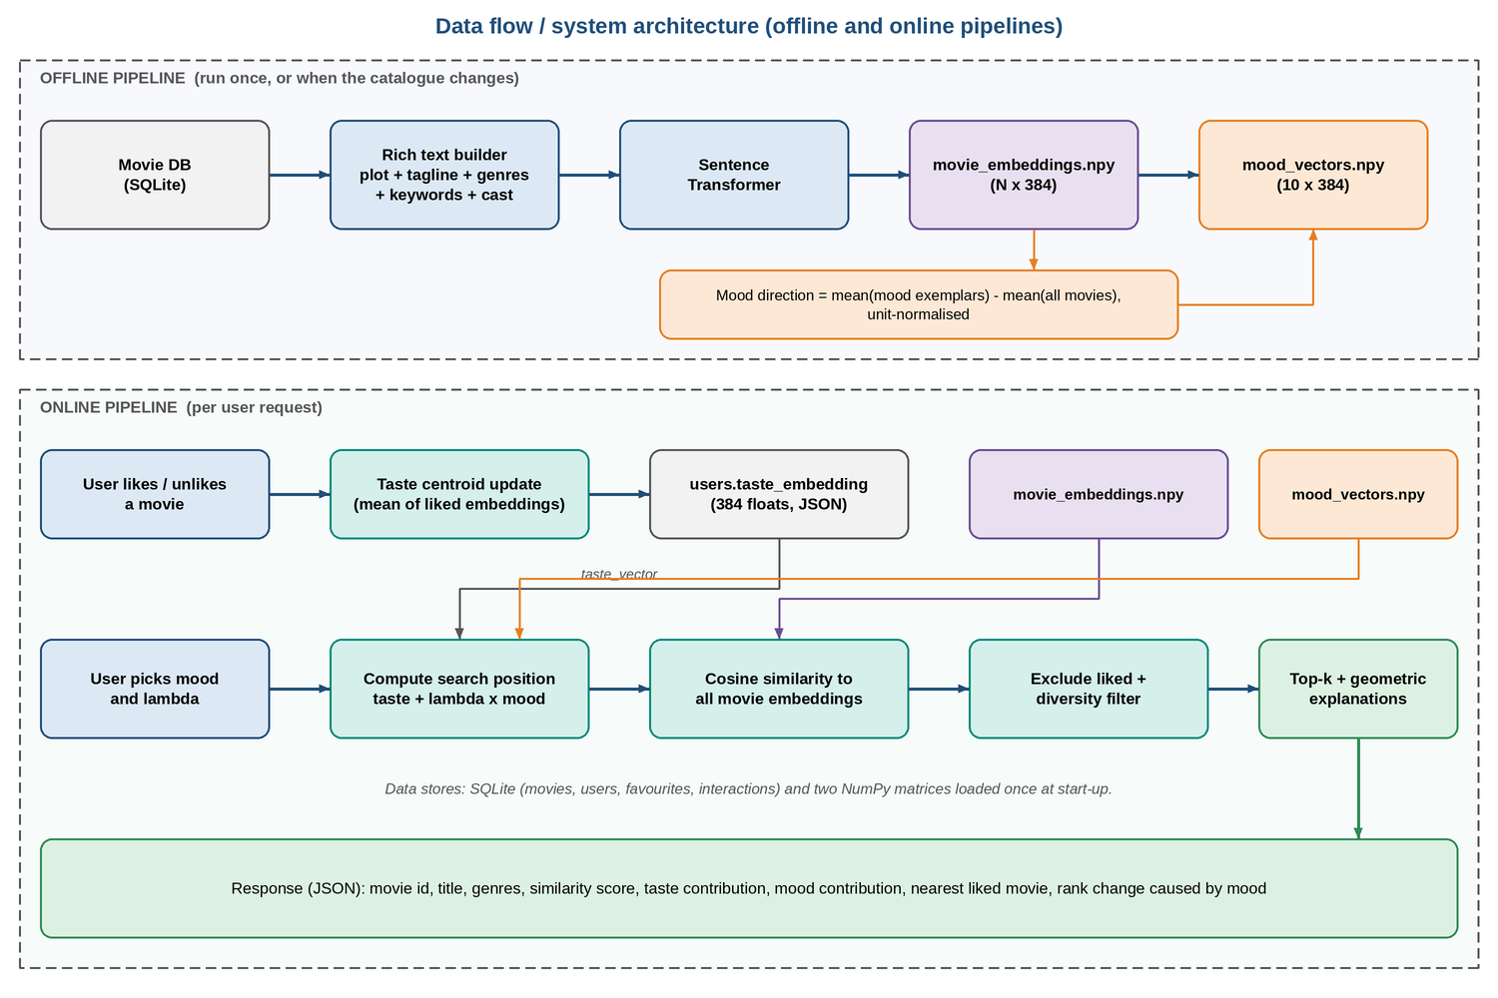
Figure 2.2: Data Flow / System Architecture Diagram
The offline stage runs once per catalogue change. The online stage performs no model inference: it is vector arithmetic over matrices already held in memory, which is why latency stays low.

2.4 Use Case Diagram
Figure 2.3 identifies two actors. The User signs up and logs in, browses and searches movies, likes or unlikes movies, selects a mood, adjusts the λ slider, views recommendations and views the explanation for each. Selecting a mood and adjusting λ extend the recommendation view, and viewing an explanation is part of viewing recommendations. The Administrator manages the movie catalogue and rebuilds the embeddings and mood vectors when the catalogue changes.
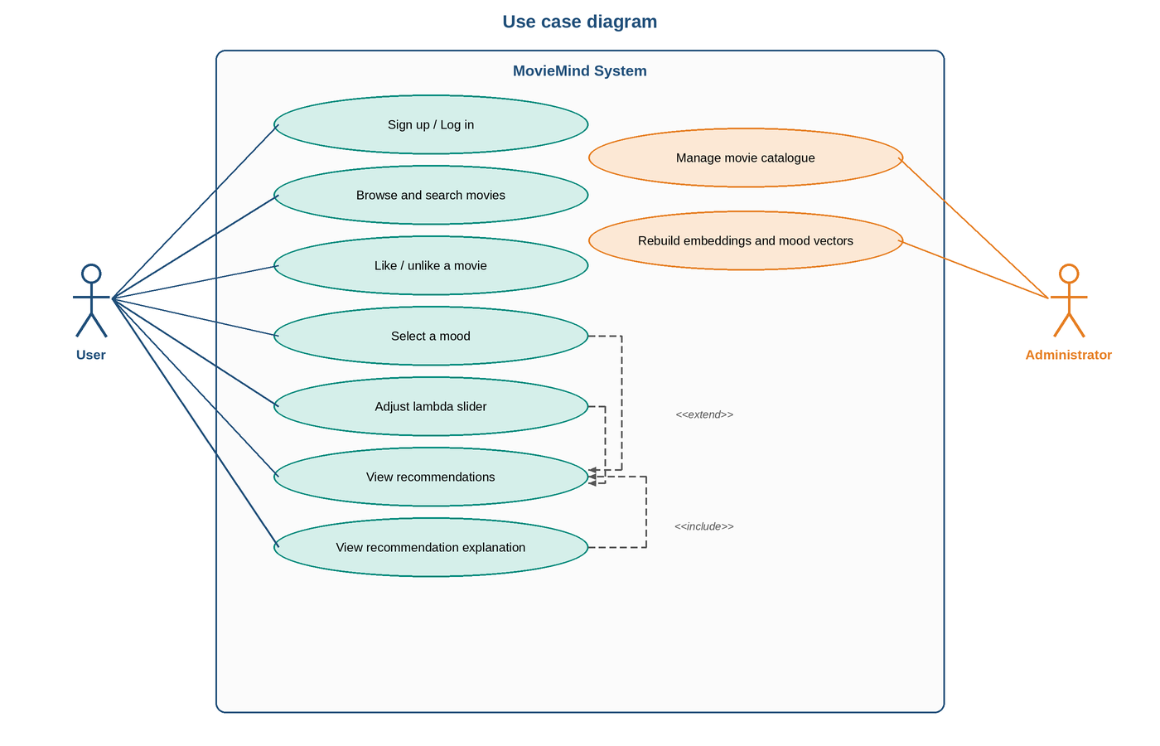
Figure 2.3: Use Case Diagram

2.5 Activity Diagram (Algorithm Flowchart)
Figure 2.4 shows the algorithm executed for each recommendation request. The taste vector is loaded (or the global mean is used for a new user). If a mood is selected and λ is greater than zero, the search position is the taste vector plus λ times the mood direction; otherwise it is the taste vector alone. Similarities to all movies are computed, already-liked movies are removed, the list is sorted, a diversity filter is applied and explanations are computed for the top k.
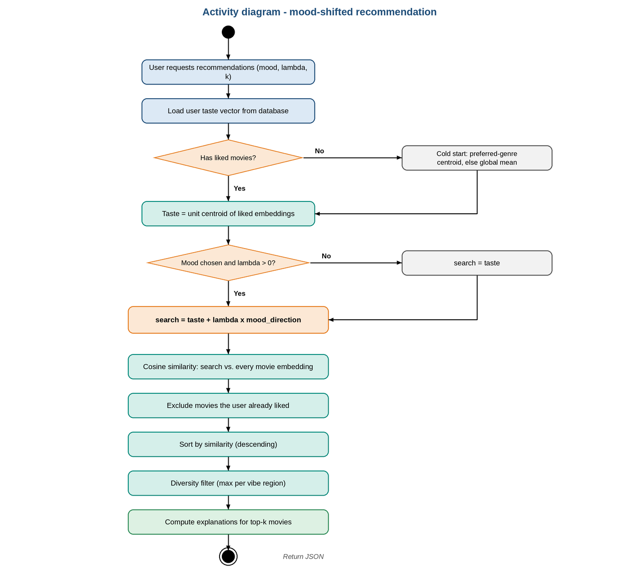
Figure 2.4: Activity Diagram - Mood-Shifted Recommendation

2.6 UML Collaboration Diagram
Figure 2.5 shows the objects that collaborate on one request. The browser sends the request to the recommendation route (message 1). The route loads the user and taste vector from the database (2) and calls the recommendation engine (3). The engine reads the movie embeddings and mood vector from the embedding store (4) and asks the explainer for contributions (5, 6). The ranked movies with explanations return to the route (7), which sends JSON to the browser (8). Liking or unliking a movie separately triggers the taste updater.
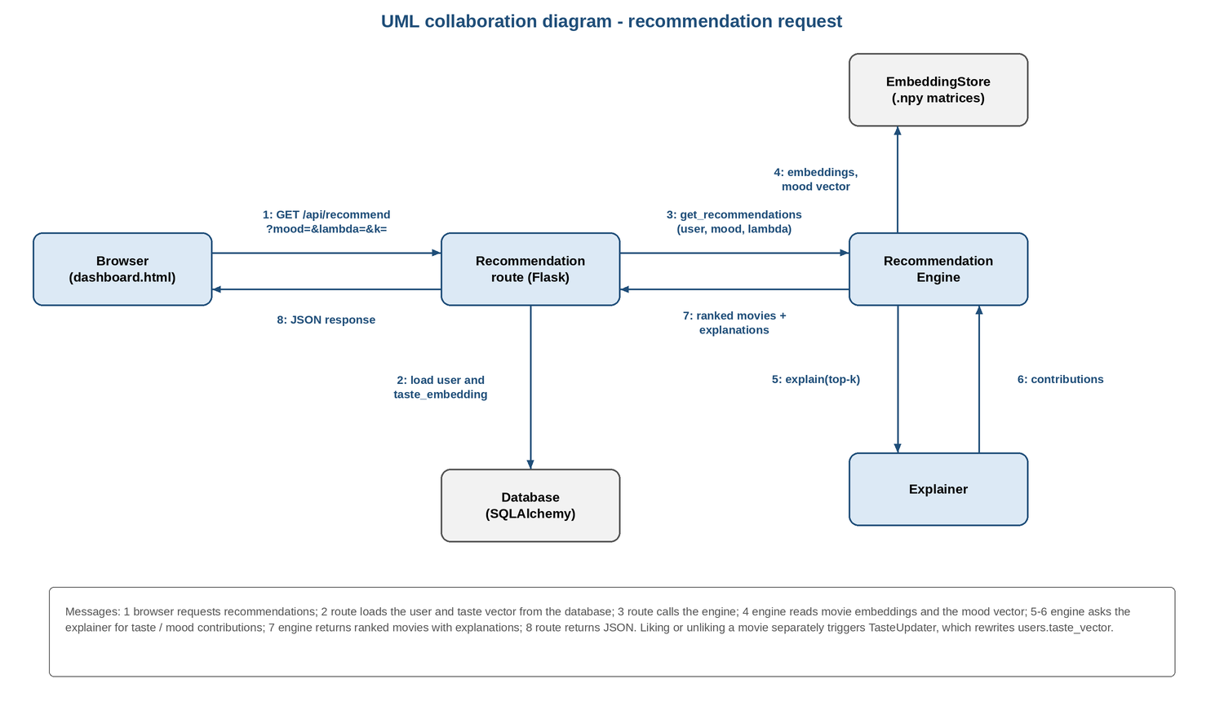
Figure 2.5: UML Collaboration Diagram

2.7 UML Class Diagram
Figure 2.6 shows the key classes. User, Movie, UserFavorite and UserInteraction are the persistent SQLAlchemy models; User.taste_embedding is a new column holding 384 floats as JSON; the v1 genre dictionary in taste_vector is kept for the baseline. EmbeddingStore loads the two NumPy matrices and exposes embeddings and mood directions. TasteUpdater maintains the centroid. RecommendationEngine performs the λ-shifted search and the diversity filter, and RecommendationExplainer computes the geometric explanation. build_embeddings.py is the offline script.
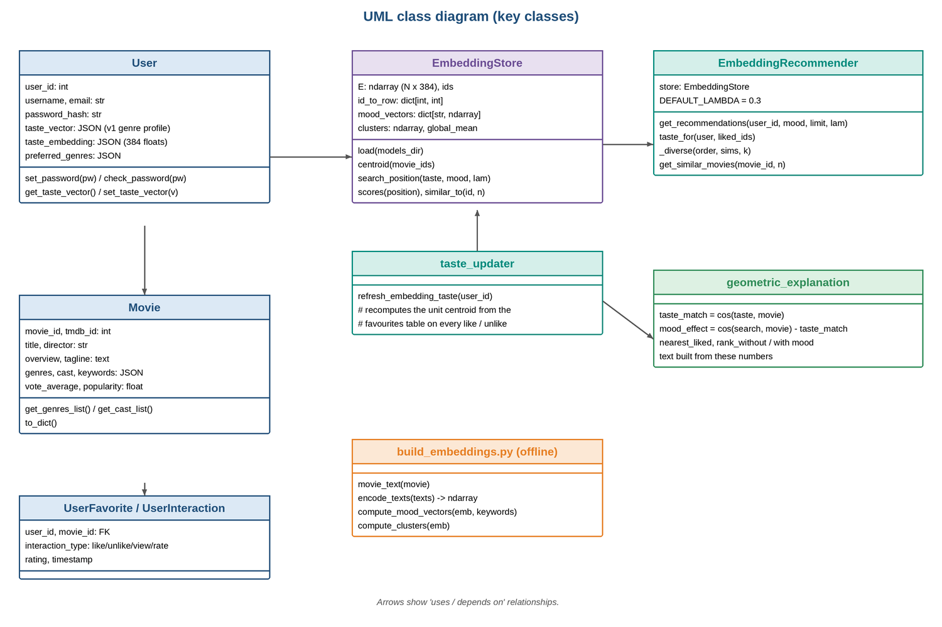
Figure 2.6: UML Class Diagram

2.8 Database Design
The relational schema of v1 is retained. One column is added, users.taste_embedding, holding a JSON list of 384 floating-point numbers; a small start-up check adds it to databases created before v2. Table 2.1 lists the tables.
Table 2.1: Database Tables
Table | Key columns | Notes
movies | movie_id (PK), tmdb_id, title, release_year, overview, tagline, genres, cast, keywords, director, vote_average, popularity, poster_path | Metadata from TMDB; genres / cast / keywords stored as JSON text
users | user_id (PK), username, email, password_hash, preferred_genres, taste_vector, taste_embedding | taste_vector: v1 genre profile; taste_embedding: JSON list of 384 floats (v2)
user_favorites | id (PK), user_id (FK), movie_id (FK), added_at | One row per liked movie; basis of the centroid
user_interactions | id (PK), user_id (FK), movie_id (FK), interaction_type, rating, timestamp | view / like / unlike / rate events

2.9 API Design
Existing endpoints are retained and the recommendation endpoint gains optional lambda and mood parameters. Table 2.2 lists the REST endpoints.
Table 2.2: REST API Endpoints
Endpoint | Method | Description
/api/auth/signup, /login, /logout, /check | POST / GET | Registration, authentication, session check
/api/recommend?mood=&lambda=&limit= | GET | Personalised recommendations with geometric explanations (λ new in v2; 400 if λ is outside 0–1 or the mood is unknown)
/api/similar/<id> | GET | Movies nearest to a given movie in embedding space
/api/movies, /api/movies/<id> | GET | Browse, search, details
/api/moods, /api/genres | GET | Mood options and genre list
/api/user/favorites | GET / POST / DELETE | List, add (like), remove (unlike) favourites
/api/user/taste | GET | Current taste vector summary
/api/user/taste/reset | POST | Reset taste vector
/api/user/profile, /history | GET / PUT | Profile and interaction history

CHAPTER 3
SYSTEM IMPLEMENTATION

3.1 Module Description
The system is organised into six cooperating modules. This decomposition keeps the code maintainable, allows each module to be tested independently and makes it easy to change one part, for example swapping the embedding model, without touching the rest.

3.1.1 Data Preparation Module
This module loads movie records from the SQLite database (populated from TMDB metadata and the MovieLens identifiers) and builds one text string per movie by concatenating the overview, tagline, genres (repeated to give them weight), keywords, director and top cast. Movies without any description are skipped because they would be placed at an arbitrary position in the space. The catalogue used in this project contains 4,988 enriched movies.

3.1.2 Embedding Generation Module
Implemented by scripts/build_embeddings.py, this module loads all-MiniLM-L6-v2, encodes every movie text in batches and L2-normalises the output so that cosine similarity reduces to a dot product. The result is saved as movie_embeddings.npy together with a mapping from movie id to row index. Encoding is a one-time offline step.

3.1.3 Taste Module
This module replaces the genre-based exponential moving average. When a user likes a movie, the taste vector is recomputed as the mean of the embeddings of all liked movies and saved to users.taste_embedding. When a movie is unliked, the centroid is recomputed from scratch from the remaining likes rather than by subtracting a vector, which avoids accumulated error. For a user with no likes the global mean embedding is used (cold start). Before the mood shift, the centroid is normalised to unit length so that λ has the same meaning for every user.

3.1.4 Mood Direction Module
For each of the ten moods the module selects exemplar movies using keyword and metadata rules (for example, for "excited": fast-paced, action-packed, high-stakes, adrenaline, relentless) and computes the direction as mean(exemplar embeddings) − mean(all embeddings), normalised to unit length. The ten vectors are stored in mood_vectors.npy. Because the directions are learned from the catalogue, they can be recomputed whenever the catalogue changes.
Table 3.1 gives the number of exemplar movies found for each mood in the 4,988-movie catalogue; every mood has several hundred, and the script refuses to build a mood with fewer than 30.
Table 3.1: Exemplar Movies per Mood
Mood | Exemplars | Mood | Exemplars
Happy | 617 | Thrilled | 682
Sad | 403 | Nostalgic | 500
Excited | 535 | Adventurous | 345
Relaxed | 481 | Thoughtful | 501
Romantic | 420 | Scared | 456

Figure 3.1 shows how a mood direction is obtained from the global mean and the mean of the mood's exemplars.
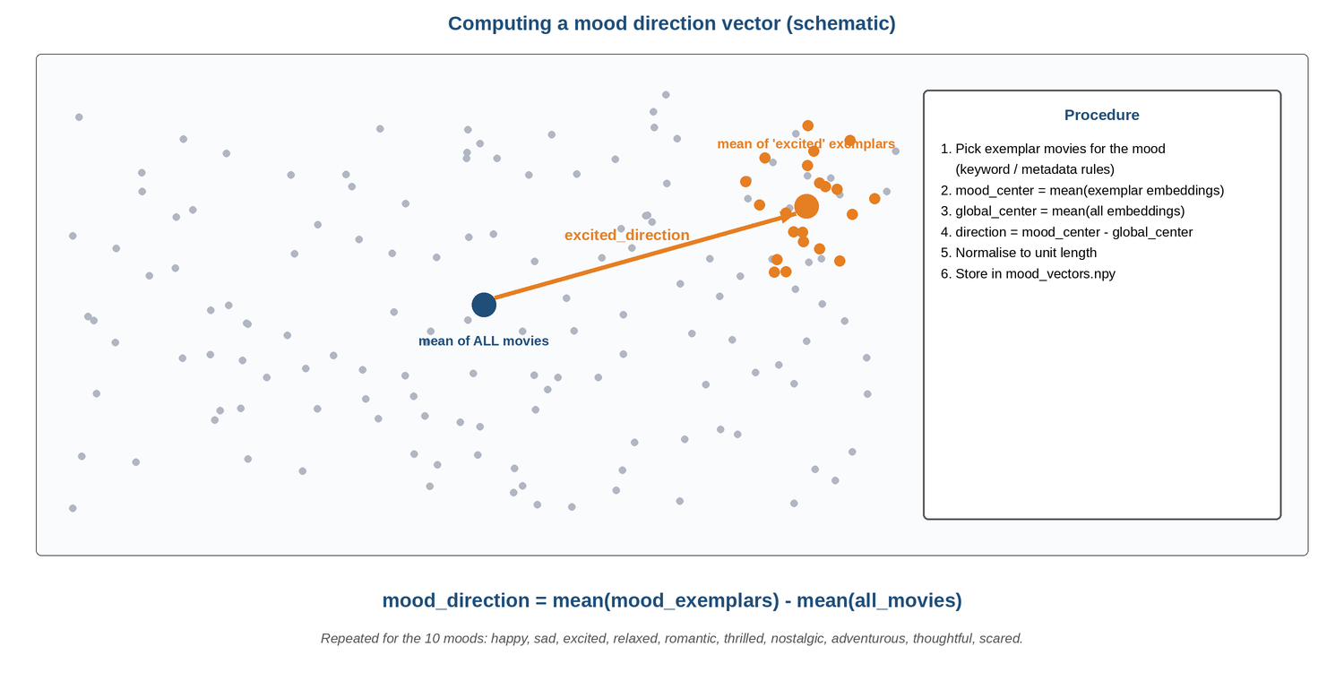
Figure 3.1: Computing a Mood Direction Vector (schematic)

3.1.5 Recommendation Engine Module
Given a user, an optional mood, λ and k, the engine forms the search position, computes cosine similarity against all movie embeddings, excludes liked movies, sorts and applies a diversity filter. The filter limits how many results may come from the same region of the space (at most max(2, k/3) per cluster, where clusters are obtained offline by k-means over the movie embeddings). Complexity is O(N × 384) per request.
Figure 3.2 shows how increasing λ moves the search position from the user's taste toward the mood region.
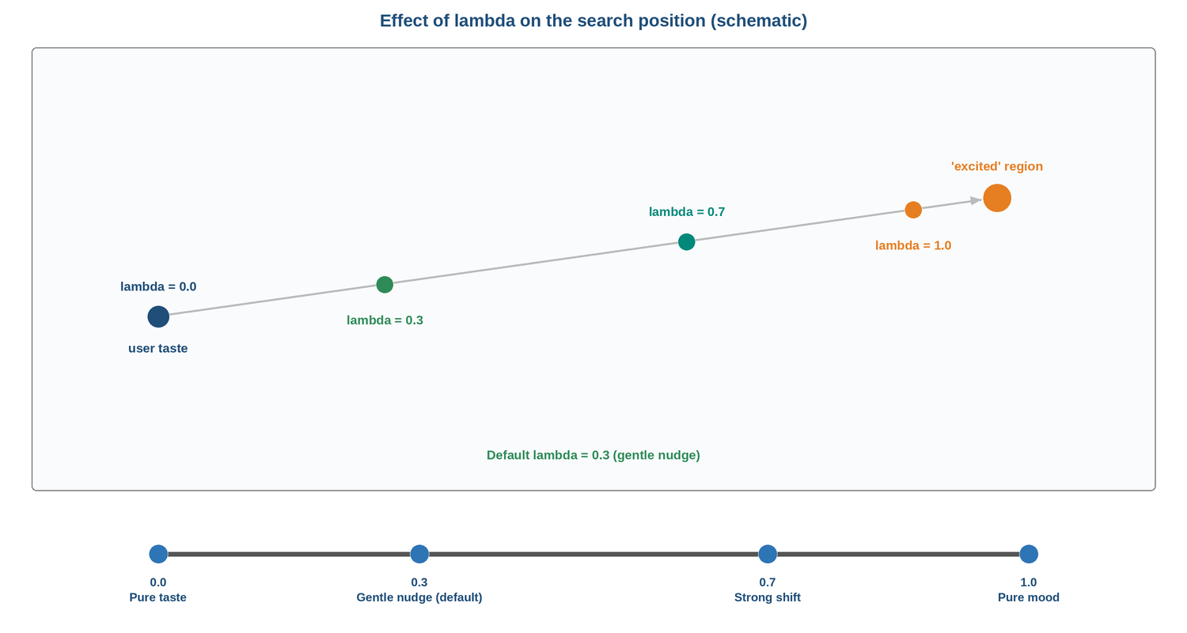
Figure 3.2: Effect of λ on the Search Position (schematic)

3.1.6 Explanation Module
For each recommended movie m the module computes: taste contribution = cos(user_taste, m); mood contribution = cos(search_position, m) − cos(user_taste, m); and nearest liked movie = the liked movie with the highest cosine similarity to m. It also reports how much the mood shift moved the movie in the ranking. These values are rendered as a sentence in the interface.

3.2 Module Interaction Summary
Table 3.2 consolidates the modules, their responsibilities and the modules they exchange data with.
Table 3.2: Module Interaction Summary
Module | Primary Responsibility | Interacts With
Data Preparation | Build rich text per movie | Embedding Generation
Embedding Generation | Encode text to 384-d vectors, save matrix | Data Preparation, Mood Direction
Taste | Maintain user centroid | Recommendation Engine, Database
Mood Direction | Compute and store mood vectors | Embedding Generation, Recommendation Engine
Recommendation Engine | λ-shifted search, filtering, ranking | Taste, Mood Direction, Explanation
Explanation | Geometric reasons for each result | Recommendation Engine

3.3 Testing Strategy
Testing follows a bottom-up strategy. Unit tests check each module in isolation (shape and normalisation of embeddings, correctness of the centroid and its recomputation on unlike, the identity λ = 0 ⇒ pure taste, exclusion of liked movies, the diversity cap). Integration tests then call the REST API end to end. The v1 project already contained 55 automated tests (test_api.py, test_models.py, test_ml.py); v2 adds 18 in tests/test_embeddings.py, so the suite now has 73 tests, all of which pass. During this work an existing test-isolation fault was also found and fixed: the fixtures changed the database URL after the application had been created, so the tests ran against the real database and db.drop_all() would have erased it; conftest.py now forces an in-memory database. Table 3.3 lists the principal v2 test cases with their expected and observed results.
Table 3.3: Test Cases and Results
Test ID | Test Case | Expected Result | Observed
TC-01 | Embedding matrix shape and norm | N × 384, every row unit length | Pass (4,988 × 384)
TC-02 | Synonym similarity ("bank heist" vs "robbery") | Cosine clearly higher than TF-IDF (which is ~0) | Pass
TC-03 | New user, no likes | Valid recommendations (cold start) | Pass
TC-04 | One like | Taste vector equals that movie's embedding | Pass
TC-05 | Unlike a movie | Centroid equals mean of remaining likes | Pass
TC-06 | λ = 0 with a mood selected | Ranking identical to no-mood ranking | Pass (also identical in the full evaluation)
TC-07 | Liked movies in results | None returned | Pass
TC-08 | Diversity cap | No cluster exceeds max(2, k/3) | Pass
TC-09 | Mood shift direction | Mood-aligned movies rise in rank as λ increases | Pass
TC-10 | λ outside [0, 1] | HTTP 400 with clear message | Pass (also for unknown mood)
TC-11 | Explanation fields | taste, mood contribution and nearest liked present | Pass
TC-12 | Request latency (5,000 movies) | Well under 1 s on CPU | Pass: 4.5 ms median (API)

3.4 Deployment and Installation Procedure
Table 3.4 gives the procedure to install and run the system on a new machine.
Table 3.4: Deployment and Installation Procedure
Step | Action | Notes
1 | Clone the repository and create a virtual environment | python -m venv venv; activate it
2 | Install dependencies: pip install -r requirements.txt | Includes sentence-transformers>=3.0.0
3 | Copy .env.example to .env and set SECRET_KEY, TMDB_API_KEY | TMDB key only needed to fetch metadata
4 | python scripts/setup_database.py, then scripts/load_movies.py | Creates tables and loads movies
5 | python scripts/build_embeddings.py | Downloads model once; writes movie_embeddings.npy and mood_vectors.npy
6 | python run.py | Starts Flask on port 5000
7 | Open http://localhost:5000, sign up, like movies | Dashboard shows mood selector and λ slider

CHAPTER 4
TECHNOLOGY STACK

4.1 Software Components
MovieMind is a pure software project; no special hardware is used. Figure 4.1 shows the layered architecture of the technology stack, from the presentation layer down to the data sources.
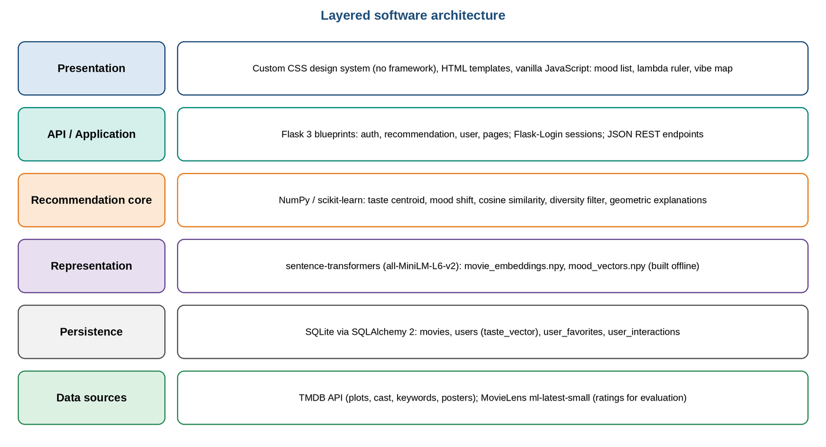
Figure 4.1: Layered Software Architecture

4.1.1 Sentence Transformer (all-MiniLM-L6-v2)
The encoder maps text to a 384-dimensional vector. It is a distilled model [2] with six Transformer layers, trained to produce sentence embeddings suitable for semantic similarity [1]. It was chosen because it is small (about 80 MB), runs on a CPU and gives a good speed-quality trade-off for semantic search. Table 4.1 lists its main properties.
Table 4.1: Embedding Model Properties
Property | Value
Model | sentence-transformers/all-MiniLM-L6-v2
Output dimension | 384
Transformer layers | 6
Approximate size | ~80 MB
Hardware needed | CPU is sufficient
Query-time model use | None (embeddings are pre-computed)
Storage for 4,988 movies | 4,988 × 384 × 4 bytes ≈ 7.66 MB

Figure 4.2 shows the encoding pipeline.
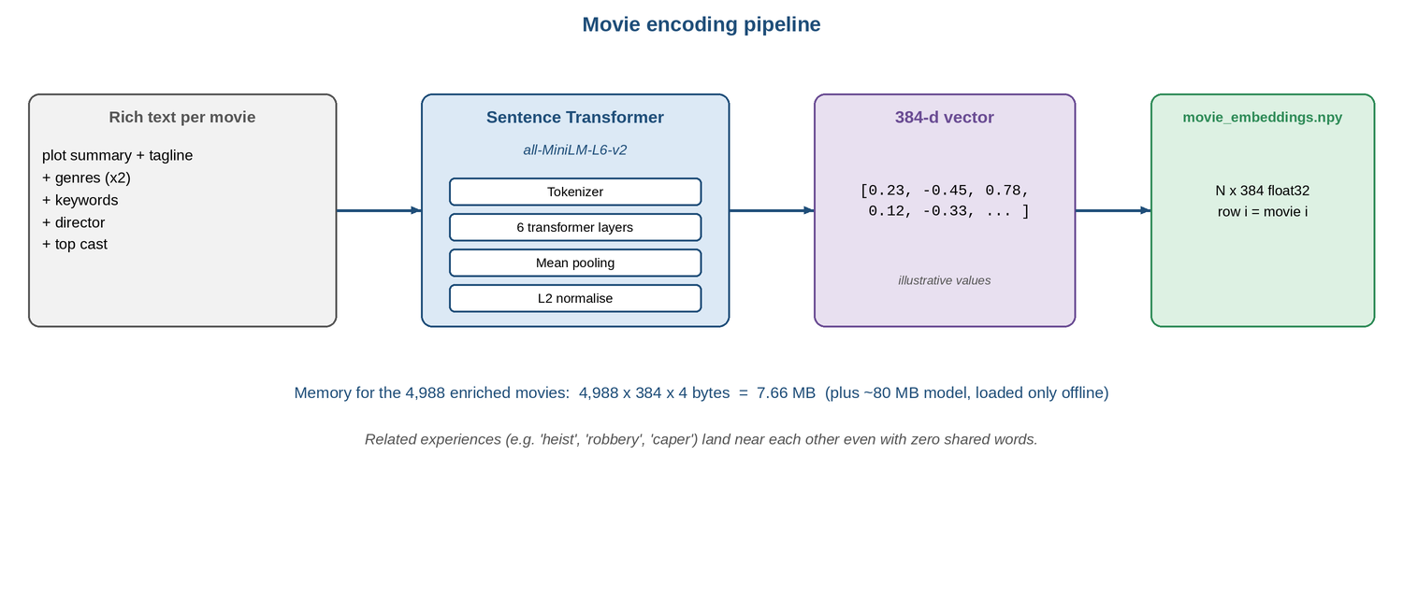
Figure 4.2: Movie Encoding Pipeline

4.1.2 NumPy and scikit-learn
NumPy performs the vector arithmetic: centroids, mean differences, normalisation and the matrix–vector product that yields all cosine similarities. scikit-learn provides the TF-IDF vectoriser and cosine-similarity utilities used by the v1 baseline and the k-means clustering used by the diversity filter [12].

4.1.3 Flask, SQLAlchemy and SQLite
Flask serves the REST API and HTML pages and Flask-Login manages sessions. SQLAlchemy maps Python classes to SQLite tables. SQLite needs no server and suits a single-machine project; the same models can be pointed at another database through the DATABASE_URL setting.

4.1.4 Front End
The interface is a purpose-built design system written in plain CSS and vanilla JavaScript; Bootstrap and stock icon fonts were removed. It uses a warm paper-and-ink palette with one accent pair that has a fixed meaning (teal for the user’s taste, vermilion for mood), a serif display face (Fraunces), a grotesk body face (Instrument Sans) and a monospaced face (JetBrains Mono) for numbers, hairline rules instead of shadows and gradients, an 8-px spacing scale and three corner radii. Icons are a small set of custom inline SVG shapes. The dashboard is built around two controls: a typographic mood list and a λ ruler (0 to 1, step 0.05, default 0.3) beside a small “vibe map” that shows the search position moving from the user’s taste toward the chosen mood as the ruler moves. Each recommendation card shows its explanation sentence and a two-part bar (teal = taste match, vermilion = what the mood added). Text meets a minimum 5.0:1 contrast ratio, controls are keyboard-operable, and the layout reflows to a phone width.

4.1.5 Data Sources
Movie metadata (overview, tagline, cast, keywords, director, poster) comes from the TMDB API [14]. Ratings used for evaluation come from MovieLens [3]. The MovieLens ml-latest-small release included in the project contains 100,836 ratings by 610 users on 9,742 movies; 4,988 of these movies have enriched TMDB metadata and form the recommendation catalogue.

4.2 Software Tools
Table 4.2: Tools Used in the Project
Tool | Role in Project
Python 3.10+ / venv | Implementation and environment isolation
sentence-transformers | Loading all-MiniLM-L6-v2 and encoding text
VS Code / Claude Code | Editing and code assistance
pytest | Unit and integration tests
Jupyter | Exploratory analysis and evaluation notebooks
Git | Version control
draw.io / Pillow | Diagrams used in this report

4.3 Communication Protocol Stack
The browser and server communicate over HTTP using JSON for API calls. The back end calls TMDB over HTTPS only during data loading. Inside the server, calls between modules are ordinary Python function calls; the large matrices are loaded once at start-up and reused. Table 4.3 summarises the layers.
Table 4.3: Communication Layers and Measured Latency
Layer | Medium | Protocol / Format | Measured
Browser → Flask | Local network / localhost | HTTP, JSON, session cookie | Not separately measured
Flask → recommender | In-process | Python call | Included below
Recommender compute | In-memory NumPy | Matrix–vector product, sort, diversity | 0.48 ms median, 0.57 ms p95
Whole /api/recommend request | Flask test client | Auth, SQLite reads, ranking, explanations, JSON | 4.5 ms median, 6.6 ms p95
Loader → TMDB | Internet | HTTPS REST (offline step) | Not on request path

4.4 Resource and Cost Estimation
Every component is open source and runs locally, so the monetary cost is zero. Table 4.4 estimates the computing resources.
Table 4.4: Resource Estimate
Item | Estimate | Basis
Embedding matrix | 7.662 MB | 4,988 × 384 float32 (measured)
Mood vectors | 15.36 KB | 10 × 384 float32 (measured)
Application memory | 194 MB peak | Flask + NumPy + scikit-learn with matrices loaded (measured)
Per-user taste vector | ≈ 3 KB as JSON | 384 floats
Encoding model on disk | ≈ 80 MB | Model card
One-time encoding time | 137.62 s | CPU only, 4,988 movies (measured)
Per-request compute | O(N × 384) ≈ 1.9 M multiply-adds | N = 4,988
Licence / API cost | None | Open-source components; TMDB free tier for metadata

4.5 Comparison with Alternative Embedding Choices
Table 4.5: Comparison with Alternative Representations
Representation | Dimension | Strength | Drawback | Verdict
TF-IDF | Thousands (sparse) | Fast, simple | No synonyms, no semantics | Baseline (v1)
all-MiniLM-L6-v2 (chosen) | 384 | Small, CPU-friendly, good quality | English-focused | Best fit
Larger Sentence Transformer | 768 and above | Possibly richer | Larger, slower encoding | Possible future upgrade
Hosted embedding API | Varies | Strong quality | Paid, needs network, privacy concerns | Rejected

4.6 Privacy, Security and Reliability
Passwords are stored only as salted hashes. All user-specific endpoints require login. The only personal data stored is the username, e-mail and the list of liked movies; the taste vector is a numerical summary of those likes. Because the model and data run locally, no viewing data leaves the machine. For reliability, the matrices are loaded once and validated at start-up (row count must equal the number of encoded movies), and the application falls back to popularity-ranked results if the embeddings are missing.

4.7 Scalability
A full scan costs O(N × 384) per request, which is trivial for thousands of movies and still practical for hundreds of thousands. Beyond that, an approximate nearest-neighbour index (for example FAISS or HNSW) can replace the full scan without changing the λ-shifted search, because only the query vector changes.

4.8 Overall Technical Justification
The stack was chosen to meet four needs: semantic quality (Sentence Transformer), transparency (vector geometry instead of a learned black box), low cost (local, free components) and ease of extension (single recommendation path). Each of these also supports the evaluation, because every design choice can be switched off, for example λ = 0 for "no mood" or TF-IDF for "no embeddings", to isolate its effect.

CHAPTER 5
SCREENSHOTS

5.1 System Configuration
Table 5.1 records the configuration used for the v2 system, so that the screenshots and results that follow can be interpreted precisely.
Table 5.1: System Configuration Parameters
Parameter | Value
Embedding model | all-MiniLM-L6-v2 (384-d)
Catalogue size | 4,988 movies
Moods | 10 (happy, sad, excited, relaxed, romantic, thrilled, nostalgic, adventurous, thoughtful, scared)
Default λ | 0.3 (range 0.0 to 1.0)
Recommendations per request (k) | 10
Diversity cap | max(2, k/3) per cluster
Similarity | Cosine
Backend / DB | Flask 3, SQLite

5.2 Application Screenshots
[The three images below are placeholders for screenshots of the running application; replace them with captures taken from the final v2 build.]

Figure 5.1: Login and Sign-up Page [placeholder]
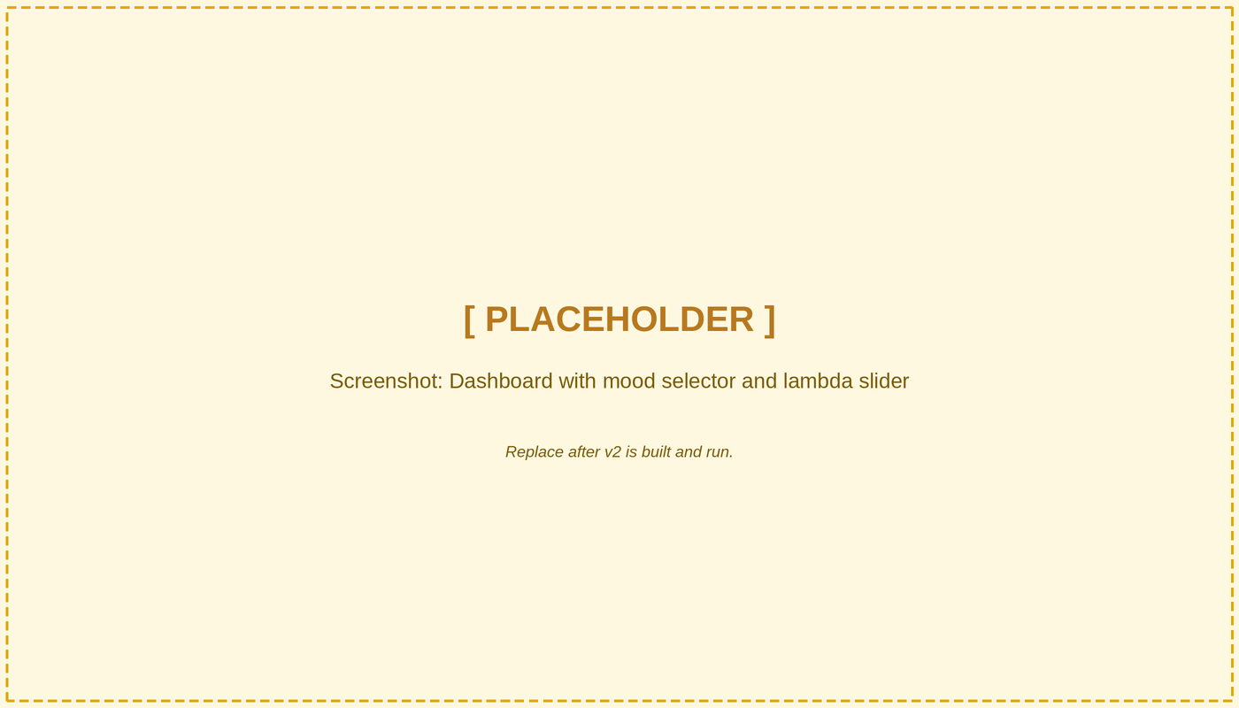
Figure 5.2: Dashboard with Mood Selector and λ Slider [placeholder]

Figure 5.3: Recommendations with Geometric Explanations [placeholder]

5.3 Console Output
The offline build prints the shapes, timing and exemplar counts. The following is the real output of python scripts/build_embeddings.py on the project machine (CPU only):
Encoding 4988 movies with all-MiniLM-L6-v2 ...
embeddings (4988, 384) float32 in 137.6s (7.66 MB)
mood exemplar counts: {"happy": 617, "sad": 403, "excited": 535, "relaxed": 481,
"romantic": 420, "thrilled": 682, "nostalgic": 500, "adventurous": 345,
"thoughtful": 501, "scared": 456}
20 clusters; sizes min/max = 133/433
Saved to data/models

5.4 System Response and Validation
The screenshots together show the behaviour verified during development:
- the dashboard accepts a mood and a λ value and re-ranks results when either changes;
- each recommendation shows its explanation (taste match, mood effect, nearest liked movie);
- setting λ to 0 produces the same list regardless of the selected mood;
- the offline script reports the matrix shapes and time taken.

CHAPTER 6
SAMPLE CODING
This chapter lists the core Python code of the v2 recommendation pipeline. The listings are extracted automatically from the project source files, so they are exactly the code that produced the results in Chapter 7. The code is organised in the same modules as Chapter 3.

6.1 Embeddings and Mood Vectors
# app/ml/embeddings.py (offline functions)

def movie_text(movie):
"""Rich text for one movie: plot + tagline + genres (x2) + keywords + director + top cast."""
genres = ' '.join(movie.get_genres_list())
parts = [movie.overview, movie.tagline, genres, genres,
' '.join(movie.get_keywords_list()), movie.director,
' '.join(movie.get_cast_list()[:5])]
return ' '.join(p for p in parts if p)

def encode_texts(texts, model_name=MODEL_NAME, batch_size=64, show_progress=True):
"""Encode texts to L2-normalised float32 embeddings (cosine == dot product)."""
from sentence_transformers import SentenceTransformer
model = SentenceTransformer(model_name, device='cpu')
emb = model.encode(texts, batch_size=batch_size, normalize_embeddings=True,
show_progress_bar=show_progress, convert_to_numpy=True)
return emb.astype('float32')

def mood_exemplar_rows(keyword_lists, mood):
"""Row indices of movies whose TMDB keywords hit this mood's rule set."""
rules = set(MOOD_KEYWORDS[mood])
return [i for i, kws in enumerate(keyword_lists) if rules.intersection(k.lower() for k in kws)]

def compute_mood_vectors(emb, keyword_lists, min_exemplars=MIN_EXEMPLARS):
"""mood_direction = unit( mean(exemplars) - mean(all) ). Returns (matrix, counts)."""
global_mean = emb.mean(axis=0)
vecs, counts = [], {}
for mood in MOODS:
rows = mood_exemplar_rows(keyword_lists, mood)
counts[mood] = len(rows)
if len(rows) < min_exemplars:
raise ValueError(f"mood '{mood}' has only {len(rows)} exemplars (< {min_exemplars}); widen its keywords")
d = emb[rows].mean(axis=0) - global_mean
vecs.append(d / np.linalg.norm(d))
return np.vstack(vecs).astype('float32'), counts

def compute_clusters(emb, n_clusters=N_CLUSTERS, seed=0):
"""K-means 'vibe regions' used by the diversity filter."""
from sklearn.cluster import KMeans
return KMeans(n_clusters=n_clusters, n_init=10, random_state=seed).fit_predict(emb).astype('int32')

6.2 Embedding Store and Mood-Shifted Search
# app/ml/embeddings.py (EmbeddingStore methods)

def unit(v):
v = np.asarray(v, dtype='float32')
n = float(np.linalg.norm(v))
return v / n if n > 0 else v

centroid(self, movie_ids):
"""Unit centroid of the given movies' embeddings; global mean if none are known."""
rows = [self.id_to_row[int(m)] for m in movie_ids if int(m) in self.id_to_row]
return unit(self.E[rows].mean(axis=0)) if rows else self.global_mean.copy()

search_position(self, taste, mood=None, lam=0.3):
"""unit(taste) + lam * mood_direction (taste alone if no mood or lam == 0)."""
pos = unit(taste)
d = self.mood_direction(mood)
if d is not None and lam > 0:
pos = pos + float(lam) * d
return pos

scores(self, position):
"""Cosine similarity to every movie (rows are unit length)."""
return self.E @ unit(position)

6.3 User Taste Centroid
# app/ml/taste_updater.py

def refresh_embedding_taste(user_id, store=None):
"""
v2 taste: unit centroid of the embeddings of every movie the user currently likes.

Always recomputed from the favourites table, so an unlike never has to "subtract"
a vector. A user with no likes gets the global mean embedding (cold start).
Returns the centroid as a NumPy array, or None if embeddings are not built.
"""
from app.ml.embeddings import get_store
store = store or get_store()
user = User.query.get(user_id)
if store is None or user is None:
return None
liked = [f.movie_id for f in UserFavorite.query.filter_by(user_id=user_id).all()]
taste = store.centroid(liked)
user.set_taste_embedding(taste)
db.session.commit()
return taste

6.4 Recommendation Engine
# app/ml/embedding_recommender.py (EmbeddingRecommender)

get_recommendations(self, user_id, mood=None, limit=10, lam=DEFAULT_LAMBDA, exclude_favorites=True):
user = User.query.get(user_id)
if not user:
raise ValueError(f'User {user_id} not found')
if mood and mood.lower() not in self.store.mood_vectors:
raise ValueError(f"Unknown mood '{mood}'")
mood = mood.lower() if mood else None
store = self.store

liked_ids = [f.movie_id for f in UserFavorite.query.filter_by(user_id=user_id).all()]
liked_rows = [store.id_to_row[i] for i in liked_ids if i in store.id_to_row]
taste = self.taste_for(user, liked_ids)

sims = store.scores(store.search_position(taste, mood, lam))
sims_plain = store.scores(taste)
if exclude_favorites:
sims[liked_rows] = -np.inf
sims_plain[liked_rows] = -np.inf

order = np.argsort(-sims)
rank_with = np.empty(len(order), dtype='int64'); rank_with[order] = np.arange(1, len(order) + 1)
order0 = np.argsort(-sims_plain)
rank_plain = np.empty(len(order0), dtype='int64'); rank_plain[order0] = np.arange(1, len(order0) + 1)

picked = self._diverse(order, sims, limit)
movies = {m.movie_id: m for m in Movie.query.filter(Movie.movie_id.in_([int(store.ids[r]) for r in picked])).all()}
liked_titles = {m.movie_id: m.title for m in Movie.query.filter(Movie.movie_id.in_(liked_ids)).all()} if liked_ids else {}

results = []
for r in picked:
movie = movies.get(int(store.ids[r]))
if movie is None:
continue
ex = geometric_explanation(store, r, taste, mood, lam, liked_rows, liked_titles,
int(rank_plain[r]), int(rank_with[r]))
results.append({
'movie_id': movie.movie_id,
'title': movie.title,
'release_year': movie.release_year,
'genres': movie.get_genres_list(),
'overview': movie.overview,
'poster_url': movie.get_poster_url(),
'vote_average': movie.vote_average,
'director': movie.director,
'cast': movie.get_cast_list()[:3],
'score': round(float(sims[r]), 3),
'explanation': ex['text'],
'explanation_detail': ex,
})
return results

_diverse(self, order, sims, k):
cap, counts, picked = max(2, k // 3), {}, []
for r in order:
if not np.isfinite(sims[r]):
break
c = int(self.store.clusters[r])
if counts.get(c, 0) < cap:
picked.append(int(r)); counts[c] = counts.get(c, 0) + 1
if len(picked) == k:
break
return picked

6.5 Geometric Explanations
# app/ml/explainer.py

def geometric_explanation(store, row, taste, mood, lam, liked_rows, titles,
rank_without_mood=None, rank_with_mood=None):
"""
Explain one recommendation from vector relationships.

taste_match = cos(user_taste, movie)
mood_effect = cos(search_position, movie) - cos(user_taste, movie)
nearest_liked = argmax over liked movies of cos(movie, liked)

titles: dict movie_id -> title (used only to name the nearest liked movie).
"""
import numpy as np
from app.ml.embeddings import unit

m = store.E[row]
taste_u = unit(taste)
pos = unit(store.search_position(taste_u, mood, lam))
taste_match = float(m @ taste_u)
mood_effect = float(m @ pos) - taste_match

nearest = None
if liked_rows:
sims = store.E[liked_rows] @ m
j = int(np.argmax(sims))
nearest = {'movie_id': int(store.ids[liked_rows[j]]),
'title': titles.get(int(store.ids[liked_rows[j]])),
'similarity': round(float(sims[j]), 3)}

moved = None
if rank_without_mood is not None and rank_with_mood is not None:
moved = int(rank_without_mood - rank_with_mood) # >0 = moved up because of mood

parts = []
if nearest and nearest['title']:
parts.append(f"Close to {nearest['title']}, which you liked")
elif not liked_rows:
parts.append("Near the centre of the catalogue - like a few films to sharpen this")
if mood and lam > 0:
if moved and moved > 0:
parts.append(f"{mood} mood lifted it {moved} place{'s' if moved != 1 else ''}")
elif mood_effect > 0.005:
parts.append(f"nudged toward {mood}")
else:
parts.append(f"stays put under a {mood} nudge")
parts.append(f"taste match {taste_match:.2f}")

return {
'taste_match': round(taste_match, 3),
'mood_effect': round(mood_effect, 3),
'nearest_liked': nearest,
'rank_without_mood': rank_without_mood,
'rank_with_mood': rank_with_mood,
'text': ' · '.join(parts),
}

6.6 REST Endpoint
# app/routes/recommendation.py

def get_recommendations():
"""
Get personalized recommendations for current user

Query params:
lambda: Mood strength 0.0-1.0 (default 0.3)
mood: Optional mood string (happy, sad, excited, relaxed, romantic, thrilled, nostalgic, adventurous, thoughtful, scared)
limit: Number of recommendations (default 10, max 50)

Returns:
List of recommended movies with explanations
"""
# Get query parameters
mood = request.args.get('mood')
limit = request.args.get('limit', 10, type=int)
limit = min(max(limit, 1), 50) # Clamp between 1 and 50

# lambda: how far the mood moves the search away from the user's taste (0 = pure taste, 1 = pure mood)
lam_raw = request.args.get('lambda', DEFAULT_LAMBDA)
try:
lam = float(lam_raw)
except (TypeError, ValueError):
return jsonify({'error': 'lambda must be a number between 0 and 1'}), 400
if not 0.0 <= lam <= 1.0:
return jsonify({'error': 'lambda must be between 0 and 1'}), 400

try:
recommender = get_recommender()
if getattr(recommender, 'engine', '') == 'v2-embedding':
recommendations = recommender.get_recommendations(
user_id=current_user.user_id, mood=mood, limit=limit, lam=lam
)
else: # v1 fallback (no embeddings built)
recommendations = recommender.get_recommendations(
user_id=current_user.user_id, mood=mood, limit=limit
)

return jsonify({
'recommendations': recommendations,
'count': len(recommendations),
'mood': mood,
'lambda': lam,
'engine': getattr(recommender, 'engine', 'v1-tfidf')
}), 200

except ValueError as e:
return jsonify({'error': str(e)}), 400
except Exception as e:
return jsonify({'error': f'Failed to get recommendations: {str(e)}'}), 500

6.7 API Quick Reference
Table 6.1: Recommendation Endpoint Parameters (liked movies are always excluded)
Parameter | Type | Default | Meaning
mood | string | none | One of the ten moods; omitted means no mood shift; unknown mood returns 400
lambda | float 0.0–1.0 | 0.3 | Strength of the mood shift; outside the range returns 400
limit | integer | 10 | Number of recommendations (1–50)

CHAPTER 7
RESULT AND DISCUSSION

7.1 Experimental Setup
The evaluation is an offline experiment on the MovieLens ml-latest-small dataset [3], restricted to the 4,988 catalogue movies that have enriched metadata. These carry 75,303 ratings from all 610 users. For each user, ratings are ordered by time: the earliest 80% form the training history and the latest 20% the test set. A test movie is relevant if the user rated it 4.0 or higher, and a training movie counts as liked on the same rule. All movies the user rated in training are excluded from every system's candidate list. Users with fewer than 8 liked training movies or no relevant test movie are skipped, which leaves 531 of 610 users. Everything is deterministic (fixed random seed) and reproducible with python scripts/evaluate.py.
Systems compared (top-10 lists): POP the movies most liked in the training data, as a reference; B1 the v1 engine (TF-IDF and genre hybrid similarity, genre profile updated by exponential moving average, mood as a genre boost); B2 semantic centroid with no mood (λ = 0); B3 semantic centroid with mood applied as a v1-style genre boost; and Proposed the mood-shifted search with λ = 0.3.
MovieLens contains no mood labels, so a proxy is needed. For each user the proxy mood is the mood direction closest (by cosine) to the drift of their recent viewing: the mean embedding of their last 5 liked training movies minus the mean embedding of all their liked training movies. It uses no test data. Two controls are reported: a random mood for each user, and, as a clearly labelled diagnostic that cannot be achieved in practice, an oracle mood chosen from the user's held-out relevant movies, which gives an upper bound on what a perfectly known mood could do. Metrics are HR@10, NDCG@10, Diversity@10 (one minus the mean pairwise cosine of the list) and Serendipity@10 (relevant hits whose genres miss the user's three most-watched genres, divided by 10). 95% confidence intervals come from 2,000 bootstrap resamples of users.

7.2 Result
The headline result is negative for the proposed method under the proxy mood. At λ = 0.3 the mood-shifted search reaches HR@10 = 0.073 and NDCG@10 = 0.010, against 0.109 and 0.013 for the same semantic search with no mood (B2). The paired difference over the same users is HR@10 -0.036 (95% CI -0.064 to -0.009; 16 users better, 35 worse, 480 unchanged), so the loss is statistically distinguishable from zero. A random mood performs about as well as the proxy mood (HR@10 0.083), which shows the proxy carries little usable information about what the user goes on to like.
Two further results stand out. First, the simple popularity reference (HR@10 = 0.373) is far above every content-based system, and the v1 engine (B1, 0.156) is above the semantic centroid (B2, 0.109). Second, when the mood is known exactly (oracle diagnostic) the mechanism works: HR@10 rises from 0.109 at λ = 0 to 0.149 at λ = 0.5 and 0.145 at λ = 0.7, with an interior optimum rather than a monotonic trend. The oracle uses the test items, so these values show that a correctly chosen direction helps, not that the system achieves them.

7.3 Performance Metrics
Table 7.1: Recommendation Quality at k = 10 (531 users; 95% bootstrap CI for HR)
Method | HR@10 (95% CI) | NDCG@10 | Diversity@10 | Serendipity@10
POP: most liked in training (reference) | 0.373 (0.333–0.414) | 0.097 | 0.760 | 0.018
B1: TF-IDF + genre (v1) | 0.156 (0.126–0.186) | 0.028 | 0.768 | 0.005
B2: semantic centroid, no mood (λ = 0) | 0.109 (0.085–0.139) | 0.013 | 0.529 | 0.000
B3: semantic centroid + genre-table mood | 0.083 (0.060–0.105) | 0.010 | 0.550 | 0.000
Proposed: mood-shifted, λ = 0.3, proxy mood | 0.073 (0.053–0.098) | 0.010 | 0.530 | 0.001
Control: λ = 0.3, random mood | 0.083 (0.060–0.107) | 0.010 | 0.536 | 0.001

Table 7.2: Paired Difference, Proposed (λ = 0.3, proxy mood) minus B2 (same users)
Metric | Mean difference | 95% CI | Users better / worse / equal
HR | -0.0358 | -0.0640 to -0.0094 | 16 / 35 / 480
NDCG | -0.0032 | -0.0063 to -0.0001 | 26 / 42 / 463
Diversity | +0.0012 | -0.0013 to +0.0039 | 252 / 279 / 0
Serendipity | +0.0002 | -0.0006 to +0.0011 | 3 / 2 / 526

Table 7.3: Effect of λ on HR@10 for Three Mood Sources (oracle uses test items; upper bound only)
λ | Proxy mood | Random mood | Oracle mood | Diversity (proxy)
0.0 | 0.109 | 0.109 | 0.109 | 0.529
0.1 | 0.109 | 0.111 | 0.117 | 0.529
0.3 | 0.073 | 0.083 | 0.121 | 0.530
0.5 | 0.077 | 0.073 | 0.149 | 0.532
0.7 | 0.068 | 0.068 | 0.145 | 0.535
1.0 | 0.066 | 0.062 | 0.119 | 0.544

Table 7.4: Diagnostics (not proposed methods): Quality Prior and Diversity Filter on the Semantic Centroid
Variant | HR@10 | NDCG@10
B2 + quality prior, weight 0.0 | 0.109 | 0.013
B2 + quality prior, weight 0.05 | 0.124 | 0.016
B2 + quality prior, weight 0.15 | 0.141 | 0.021
B2 + quality prior, weight 0.3 | 0.164 | 0.027
B2 without the diversity filter | 0.092 | 0.012

Table 7.5: Latency and Resource Measurements
Metric | Value | How measured
Recommender compute (median / p95) | 0.48 / 0.57 ms | score + sort + diversity, 200 users
Whole /api/recommend request (median / p95) | 4.5 / 6.6 ms | Flask test client, 100 requests, 5 likes, includes DB and explanations
One-time encoding of the catalogue | 137.62 s | build_embeddings.py, CPU only
Application memory (peak) | 194 MB | Flask + NumPy + scikit-learn with matrices loaded

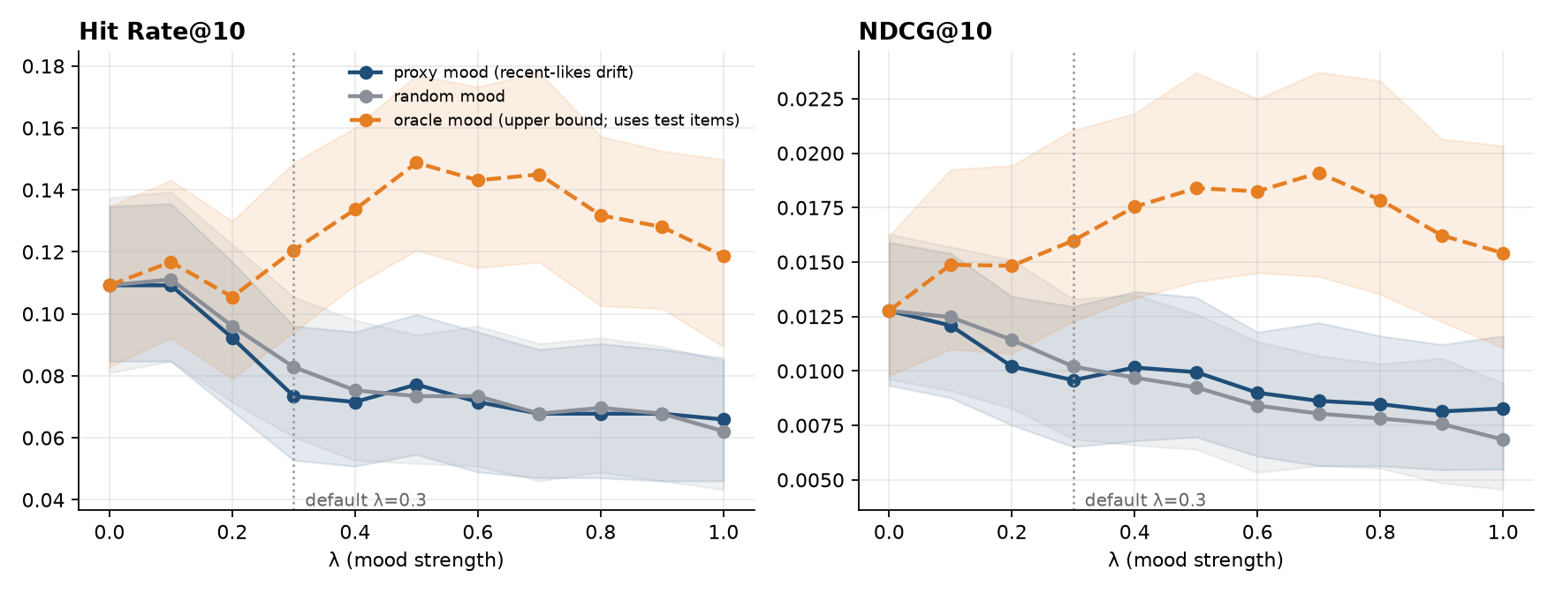
Figure 7.1: HR@10 and NDCG@10 versus λ for proxy, random and oracle moods (shaded: 95% CI)
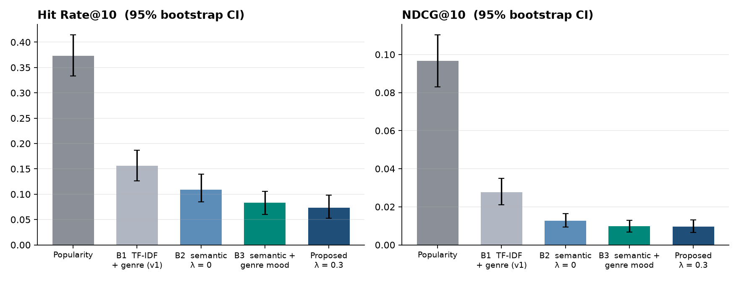
Figure 7.2: Comparison of Baselines and Proposed Method (95% bootstrap CI)

7.4 Discussion
The four hypotheses stated in advance were checked against the measured results. Two of them are not supported and one is supported only in a restricted sense.
- H1, semantic embeddings beat TF-IDF: not supported on accuracy. The semantic centroid (B2, HR@10 0.109) is below the v1 engine (B1, 0.156). The diagnostic in Table 7.4 explains why: v1 also scores each movie by its average rating, a popularity-like prior that correlates with whether a user later rates a film 4 or higher, whereas embeddings capture what a film is like, not how well it is regarded. Giving B2 the same kind of prior (weight 0.3, chosen after the fact and not tuned) raises it to 0.164, above B1. Embeddings do match meaning better (Section 1.1, test TC-02), but meaning alone does not predict ratings.
- H2, a moderate mood shift does not hurt accuracy: not supported with the proxy mood. HR@10 falls from 0.109 at λ = 0 to 0.066 at λ = 1 and the proxy mood is no better than a random one. Diversity rises only slightly (0.529 to 0.544).
- H3, mood as a direction beats mood as a genre filter: not demonstrated. B3 (0.083) and the proposed method (0.073) both sit below B2, and their intervals overlap, so no ordering can be claimed between them.
- H4, the best λ is interior: supported only for the oracle mood. With the oracle mood HR@10 peaks at λ ≈ 0.5 to 0.7 (0.149 to 0.145) and falls again toward λ = 1; with the proxy and random moods there is no interior optimum.
What the experiment does and does not show. The machinery behaves as designed: λ = 0 reproduces the no-mood ranking exactly, mood vectors move rankings toward their exemplars, and a correctly chosen mood improves held-out hit rate. What the offline data cannot show is that a mood the user chooses improves their experience, because in this dataset the mood is unobserved and the proxy for it is weak. In the application the viewer states the mood and the strength, so the proxy problem is specific to offline evaluation; whether the shifted lists are preferred is a question for a user study, not for ratings accuracy, since a deliberate change of mood is by construction a move away from past taste. The popularity result is a reminder that content-only methods should be combined with a quality or collaborative signal before being judged on accuracy.

7.5 Limitations of the Current Prototype
- Weak mood proxy: the recent-likes drift did not outperform a random mood, so the evaluation cannot show the benefit of mood; explicit mood labels or session data are needed.
- Subjective mood exemplars: exemplar movies are chosen by TMDB keyword rules (several hundred per mood), which reflect the designer's judgement; crowd-sourced mood labels would be more reliable.
- One mood at a time: real emotional states are blends; multi-mood blending is future work.
- No quality or collaborative signal in the recommender: content embeddings alone trail a popularity reference and the v1 engine on hit rate (Table 7.1).
- English-centred encoder: the model is trained mainly on English text.
- Offline, small dataset: MovieLens ml-latest-small has 610 users, of whom 531 qualified; it is a development dataset and not suited to claims about large-scale performance [3]. No user study was run.
- Post-hoc diagnostics: the oracle mood and the quality-prior variants were added after the first results were seen. They are reported as explanations, not as tuned methods, and should be replicated on separate data.

CHAPTER 8
CONCLUSION AND FUTURE ENHANCEMENT

8.1 Conclusion
This project built MovieMind v2, a recommender in which movies, users and moods share one semantic embedding space and a recommendation is the set of movies nearest to unit(user_taste) + λ × mood_direction. The design replaces genre dictionaries and hard-coded mood tables with Sentence-Transformer embeddings, a centroid user model and data-derived mood directions, adds a user-controllable mood intensity, and produces explanations from the same geometry. The system was implemented end to end (offline pipeline, taste updates, recommender, API, a redesigned interface with a λ ruler) and verified by 73 automated tests; a request takes a median of 4.5 ms on a CPU.
The offline evaluation gave a mixed and honest picture. With a mood that is known exactly, the λ-shifted search improved the held-out hit rate from 0.109 to as much as 0.149, so the mechanism is sound. With the only mood signal available in MovieLens, a proxy from recent likes, the shift did not help (HR@10 0.073 against 0.109 without mood), and content embeddings alone trailed a popularity reference (0.373) and the v1 engine (0.156), which carries a rating prior. The claims that are therefore supported are the engineering and design contributions: a unified space, mood as a continuous directional shift, a user-controllable λ and geometry-based explanations. The claim that mood modulation improves recommendation quality remains untested and needs real mood data or a user study.

8.2 Applications
- Streaming and video-on-demand platforms: a mood slider on the home screen that re-ranks a personalised list.
- Digital libraries and cinemas: content-based suggestions for catalogues with little rating data.
- Education and research: a transparent reference system for studying affect-aware recommendation.
- Other media domains: the same λ-shifted search can be applied to music, books or podcasts by changing the encoder and mood exemplars.

8.3 Future Enhancement

8.3.0 Quality and Collaborative Signals
Combine the semantic search with a rating prior and a collaborative embedding. The diagnostics in Chapter 7 show that a quality term alone closes most of the gap to v1, so this is the most promising first step.

8.3.1 Multi-Mood Blending
Allow blends such as 60% excited and 40% nostalgic, so that the search position is the taste vector plus a weighted sum of mood directions.

8.3.2 Learning λ per User
Learn the best λ for each person from whether they like mood-shifted recommendations, instead of using one global default.

8.3.3 Hybrid Collaborative and Semantic Embeddings
Combine the content centroid with a collaborative embedding learned from ratings, for example in a two-tower model.

8.3.4 Temporal Mood Decay
Let λ fade gradually after a mood is selected, reflecting how a transient emotional state passes.

8.3.5 Multilingual Support
Use a multilingual encoder so that non-English descriptions are represented properly.

8.3.6 Crowd-Sourced Mood Labels
Replace keyword-based exemplars with labels collected from viewers, and recompute directions periodically.

8.3.7 User Study and Real Mood Data
Collect explicit mood choices and satisfaction from real participants, which is the only way to test whether mood-shifted lists are preferred and to replace the weak offline proxy.

8.3.8 Cross-Domain Application
Apply the framework to music, books or podcasts.

8.4 Societal and Ethical Considerations
Privacy. Because encoding and recommendation run locally and the stored taste vector is only a numeric summary of likes, the design is privacy-friendly compared with services that send viewing data to third parties. Passwords are stored as hashes and personal endpoints need authentication.
Filter bubbles. A pure-taste recommender can keep showing similar content. λ and the diversity filter let the user choose how far to move from their usual neighbourhood, which gives the user control rather than hiding the trade-off.
Bias. Embeddings inherit biases of their training text and of the catalogue, which over-represents popular and English-language films. Results should be audited before any real deployment.
Emotional inference. The system uses a mood the user selects; it does not infer emotion from behaviour or sensors, which avoids intrusive affect detection.
Environmental cost. All heavy computation is a one-time CPU encoding of a few thousand short texts; query-time cost is a single matrix product, so the energy footprint is small.

8.5 Deployment Considerations
A production deployment would need an approximate nearest-neighbour index for large catalogues, incremental encoding of newly added movies, monitoring of recommendation quality and latency, and periodic recomputation of mood directions. A phased rollout, beginning with an opt-in mood slider and comparing engagement with the existing list, would show whether the approach helps real viewers before it is widened.

CHAPTER 9
REFERENCES
[1] N. Reimers and I. Gurevych, "Sentence-BERT: Sentence embeddings using Siamese BERT-networks," in Proc. 2019 Conf. Empirical Methods in Natural Language Processing and 9th Int. Joint Conf. Natural Language Processing (EMNLP-IJCNLP), Hong Kong, China, 2019, pp. 3982–3992, doi: 10.18653/v1/D19-1410.
[2] W. Wang, F. Wei, L. Dong, H. Bao, N. Yang and M. Zhou, "MiniLM: Deep self-attention distillation for task-agnostic compression of pre-trained transformers," arXiv:2002.10957, 2020.
[3] F. M. Harper and J. A. Konstan, "The MovieLens datasets: History and context," ACM Trans. Interact. Intell. Syst., vol. 5, no. 4, Art. 19, Dec. 2015, doi: 10.1145/2827872.
[4] P. Lops, M. de Gemmis and G. Semeraro, "Content-based recommender systems: State of the art and trends," in Recommender Systems Handbook, F. Ricci, L. Rokach, B. Shapira and P. B. Kantor, Eds. New York, NY, USA: Springer, 2011, pp. 73–105, doi: 10.1007/978-0-387-85820-3_3.
[5] O. Barkan and N. Koenigstein, "Item2Vec: Neural item embedding for collaborative filtering," in Proc. IEEE 26th Int. Workshop on Machine Learning for Signal Processing (MLSP), Salerno, Italy, 2016. arXiv:1603.04259.
[6] X. He, L. Liao, H. Zhang, L. Nie, X. Hu and T.-S. Chua, "Neural collaborative filtering," in Proc. 26th Int. Conf. World Wide Web (WWW), Perth, Australia, 2017, pp. 173–182, doi: 10.1145/3038912.3052569.
[7] T. Hasan and R. Bunescu, "A survey of affective recommender systems: Modeling attitudes, emotions, and moods for personalization," arXiv:2508.20289 [cs.IR], Aug. 2025.
[8] K. Järvelin and J. Kekäläinen, "Cumulated gain-based evaluation of IR techniques," ACM Trans. Inf. Syst., vol. 20, no. 4, pp. 422–446, Oct. 2002, doi: 10.1145/582415.582418.
[9] M. Kaminskas and D. Bridge, "Diversity, serendipity, novelty, and coverage: A survey and empirical analysis of beyond-accuracy objectives in recommender systems," ACM Trans. Interact. Intell. Syst., vol. 7, no. 1, 2016, doi: 10.1145/2926720.
[10] T. Mikolov, W.-t. Yih and G. Zweig, "Linguistic regularities in continuous space word representations," in Proc. 2013 Conf. North American Chapter of the Association for Computational Linguistics: Human Language Technologies (NAACL-HLT), Atlanta, GA, USA, 2013, pp. 746–751.
[11] T. Mikolov, K. Chen, G. Corrado and J. Dean, "Efficient estimation of word representations in vector space," arXiv:1301.3781, 2013.
[12] F. Pedregosa et al., "Scikit-learn: Machine learning in Python," J. Mach. Learn. Res., vol. 12, pp. 2825–2830, 2011.
[13] Pallets Projects, "Flask documentation." [Online]. Available: https://flask.palletsprojects.com
[14] The Movie Database (TMDB), "TMDB API documentation." [Online]. Available: https://www.themoviedb.org

Patent / Paper Publication Proof
[Insert proof of paper submission or publication here, if applicable. Remove this page otherwise.]

GLOSSARY OF TERMS
Embedding: A list of numbers (here 384) that represents the meaning of a text so that similar meanings are close together.
Sentence Transformer: A neural network that maps a sentence or paragraph to a single embedding vector.
Cosine similarity: A measure of how closely two vectors point in the same direction; 1 means identical direction.
Centroid: The mean of a set of vectors; here, the average of liked-movie embeddings, used as the user's taste.
Mood direction: A unit vector from the average movie toward the average of a mood's exemplar movies.
λ (lambda): The weight, between 0 and 1, of the mood direction when it is added to the taste vector.
TF-IDF: A weighting of words by frequency in a document and rarity across documents; ignores word meaning.
Cold start: The situation in which a new user or item has no history to base a recommendation on.
Hit Rate@K: The fraction of users for whom at least one relevant item appears in the top K.
NDCG@K: A ranking metric that rewards relevant items placed higher in the top K list.
Diversity: How different the recommended items are from each other.
Serendipity: How often relevant recommendations are also unexpected for the user.

