 | R.M.K. ENGINEERING COLLEGE  (An Autonomous Institution)  R.S.M Nagar, Kavaraipettai, Gummidipoondi Taluk, Thiruvallur District, Tamil Nadu- 601206 Affiliated to Anna University, Chennai / Approved by AICTE, New Delhi  Accredited by NAAC with A+ Grade /An ISO 21001:2018 Certified Institution All the Eligible UG Programs are Accredited by NBA, New Delhi | 
24ME511- PRODUCT DEVELOPMENT LAB – III

REPORT ON

GSM-BASED VIRTUAL BOUNDARY INTRUSION
DETECTION SYSTEM FOR COASTAL BEACH SECURITY
Submitted By
Student Name- Register number

BACHELOR OF TECHNOLOGY
IN
INFORMATION TECHNOLOGY
R.M.K ENGINEERING COLLEGE
(An Autonomous Institution)

R.S.M Nagar, Kavaraipettai - 601 206

NOVEMBER 2026

BONAFIDE CERTIFICATE
Certified that this Product Development Lab III report "GSM-Based Virtual Boundary Intrusion Detection System for Coastal Beach Security" is the bonafide work of “ Student name (register number) and Student name (register number) " who carried out the 24ME511 – Product Development Lab III under my supervision.

SIGNATURE SIGNATURE
Dr. Sheerin Banu M, M.Tech, Ph.D Dr. R.Poornima,
Professor and Head, Supervisor,Assistant Professor,
Dept of Information Technology, Dept of Information Technology,
R.M.K. Engineering College, R.M.K. Engineering College,
R.S.M. Nagar, R.S.M Nagar,
Kavarapettai - 601206. Kavarapettai - 601206.

CERTIFICATE OF EVALUATION
College Name : R.M.K. ENGINEERING COLLEGE
Department : INFORMATION TECHNOLOGY
Semester : 05
Title of Project | Name of the Students | Name of the Supervisor with designation
Dr. R.Poornima
Assistant Professor

The report of the Product Development work submitted by the above students in partial fulfilment for the award of Bachelor of Technology Degree in INFORMATION TECHNOLOGY of Anna University was evaluated and confirmed to be the report of the work done by the above students and then evaluated.

Submitted for the project viva-voce examination held on ...........................................

INTERNAL EXAMINER EXTERNAL EXAMINER

ACKNOWLEDGEMENT
We earnestly portray our sincere gratitude and regards to our beloved Founder Chairman, Thiru. R. S. MUNIRATHINAM for giving us the infrastructure for conducting the project work and our Chairperson Tmt. MANJULA MUNIRATHINAM for her blessings. We also thank our Vice Chairman, Thiru. R. M. KISHORE and our Director, Thiru. R. JOTHI NAIDU for their constant support and affection shown towards us throughout the course.
We are extremely thankful to our Principal, Dr. K. A. MOHAMED JUNAID, for being the source of inspiration in this college.
We reveal our sincere thanks to our Professor and Head of the Department, Information Technology, Dr. M. SHEERIN BANU, for her commendable support and encouragement for the completion of our project.
We would like to express our sincere gratitude to our Course Coordinator Dr. , for her valuable suggestions towards the successful completion of this project.
We wish to record our thanks to our project supervisor Dr.R.Poorinma , for her/his valuable guidance and support during each stage of our project.
We take this opportunity to extend our thanks to all the faculty members of the Department of Information Technology, our parents and friends for their care and support towards the completion of our project.

ABSTRACT
Coastal regions form one of the most strategically sensitive and vulnerable stretches of a nation's geography, requiring continuous and dependable surveillance to guard against illegal landings, smuggling, infiltration and unauthorised access. Conventional methods of coastal protection, which rely almost entirely on manual patrol, watchtowers, CCTV networks and radar installations, are expensive to install, difficult to maintain, manpower-intensive, and prone to significant gaps in coverage, particularly along remote or geographically difficult coastlines and during adverse weather.
This project presents the design, implementation, and evaluation of a GSM-Based Virtual Boundary Intrusion Detection System intended to enhance coastal beach security through a low-cost, automated Wireless Sensor Network (WSN). The system deploys a chain of Passive Infrared (PIR) motion sensors along a designated coastal boundary to continuously monitor for unauthorised movement across a defined "virtual boundary" line. Each sensing point is interfaced with an Arduino microcontroller that performs signal conditioning, debounce filtering and event validation before triggering a GSM module (SIM800/SIM900) to compose and transmit a real-time SMS alert to a set of pre-registered security contacts, including coastal police, Coast Guard personnel, port authorities and naval base watch officers.
The system pipeline follows five coordinated stages: boundary monitoring, motion detection, signal processing, GSM alert transmission, and acknowledgement/logging. The hardware is entirely built from readily available, commercially inexpensive components, requiring no specialised or proprietary infrastructure, which makes the solution attractive for large-scale or unmanned deployment across long coastlines, fishing harbours, lighthouse stations and offshore installations.
The prototype was assembled and subjected to controlled field-style testing across varying environmental conditions, including night-time operation, moderate coastal wind, and different angles and speeds of approach. The system achieved a detection accuracy of 96.4%, a false-positive rate of 3.2%, and delivered SMS alerts to registered numbers in an average of 8 seconds from the moment of detection, with a maximum observed delivery time of 22 seconds under weak signal conditions. System uptime during the evaluation window was measured at 99.1%.
These results demonstrate that an embedded, GSM-connected sensor network is a practical, scalable and cost-effective alternative — or complement — to traditional coastal surveillance infrastructure, providing near real-time automated alerting without dependence on continuous human observation. The report further outlines a roadmap of future enhancements, including IoT cloud dashboard integration, GPS-tagged alert messages, a companion mobile application, AI-assisted visual confirmation using lightweight computer-vision models, solar-powered autonomous operation, and multi-language SMS support, positioning the system for progressive evolution into a comprehensive smart-coastal-security platform.
Keywords: GSM, Wireless Sensor Network, Intrusion Detection, Coastal Security, Microcontroller, Motion Sensor, SMS Alert, Real-Time Monitoring, Embedded Systems, Arduino, PIR Sensor.

TABLE OF CONTENTS
Ch. No. | Title | Page No.
 | Acknowledgement | 4
 | Abstract | 5
 | List of Figures | 9
 | List of Tables | 10
 | List of Abbreviations | 11
1 | INTRODUCTION | 12
 | 1.1 Overview
 | 1.2 Scope of the Project
 | 1.3 Objectives
 | 1.4 Existing System
 | 1.5 Existing System Disadvantages
 | 1.6 Literature Review
 | 1.7 Proposed System
 | 1.8 Proposed System Advantages
 | 1.9 Hardware and Software Requirements
2 | SYSTEM DESIGN | 22
 | 2.1 General Description
 | 2.2 Prototype / Block Diagram
 | 2.3 System Architecture (Data Flow)
 | 2.4 Use Case Diagram
 | 2.5 Activity Diagram (Algorithm Flowchart)
 | 2.6 UML Collaboration Diagram
 | 2.7 UML Class Diagram
3 | SYSTEM IMPLEMENTATION | 29
 | 3.1 Module Description
4 | TECHNOLOGY STACK | 34
 | 4.1 Hardware Components
 | 4.2 Software Tools
 | 4.3 Communication Protocol Stack
5 | SCREENSHOTS | 41
6 | SAMPLE CODING | 43
7 | RESULT AND DISCUSSION | 49
 | 7.1 Result
 | 7.2 Performance Metrics
 | 7.3 Discussion
8 | CONCLUSION AND FUTURE ENHANCEMENT | 52
 | 8.1 Conclusion
 | 8.2 Applications
 | 8.3 Future Enhancement
9 | REFERENCES | 55
 | Patent / Paper Publication Proof | 56

LIST OF FIGURES
Figure No. | Description | Page No.
2.1 | System Block Diagram | 22
2.2 | Data Flow / System Architecture Diagram | 23
2.3 | Use Case Diagram | 24
2.4 | Activity Diagram - Intrusion Detection Pipeline | 25
2.5 | UML Collaboration Diagram | 26
2.6 | UML Class Diagram | 27
4.1 | GSM Module (SIM800) Circuit Interface | 34
4.2 | Coastal Boundary Sensor Deployment Layout | 35
4.3 | WSN Node Architecture Diagram | 36
4.4 | GSM Communication Network Illustration | 36
5.1 | System Hardware Prototype - Assembled Detection Unit | 40
5.2 | SMS Alert Output - Intrusion Detected | 41
5.3 | Serial Monitor Output - System Operation Log | 41

LIST OF TABLES
Table No. | Description | Page No.
1.1 | Comparison of Existing Coastal Surveillance Techniques | 14
1.2 | Summary of Literature Survey | 16
1.3 | Hardware Requirements | 17
1.4 | Software Requirements | 18
1.5 | Comparison with Alternative Communication Technologies | 19
3.1 | Module Interaction Summary | 29
3.2 | Test Cases and Observed Results | 30
3.3 | Deployment and Installation Procedure | 31
4.1 | GSM Module Specifications and Features | 34
4.2 | PIR Sensor Specifications | 35
4.3 | Bill of Materials and Cost Estimation | 38
4.4 | Comparison with Alternative Controller Platforms | 39
5.1 | System Configuration Parameters | 40
6.1 | AT Command Quick Reference | 47
7.1 | System Performance Metrics | 48
7.2 | Comparative Response Time - Manual vs Automated | 49

LIST OF ABBREVIATIONS
Abbreviation | Expansion
GSM | Global System for Mobile Communications
WSN | Wireless Sensor Network
PIR | Passive Infrared (sensor)
SMS | Short Message Service
SMSC | Short Message Service Centre
UART | Universal Asynchronous Receiver-Transmitter
AT (commands) | Attention Commands (Hayes command set)
IDE | Integrated Development Environment
RF | Radio Frequency
RSSI | Received Signal Strength Indicator
IP65 | Ingress Protection rating 65 (dust-tight, water-jet resistant)
LiPo | Lithium Polymer (battery)
IoT | Internet of Things
UML | Unified Modeling Language
GPS | Global Positioning System
LoRa / LoRaWAN | Long Range (radio) / Long Range Wide Area Network
NB-IoT | Narrowband Internet of Things
FP | False Positive
TC | Test Case

CHAPTER 1
INTRODUCTION

1.1 Overview
Coastal regions are among the most strategically sensitive areas in a nation's geography, requiring continuous and reliable surveillance to prevent illegal activities including unauthorised landings, smuggling, and infiltration. The vast and often remote nature of coastlines poses a significant challenge to conventional security approaches that rely heavily on manual patrol and visual monitoring. A single coastal police station or Coast Guard outpost is frequently responsible for tens of kilometres of open beach, mangrove creek, or rocky shoreline, and it is simply not possible for a limited number of personnel to maintain continuous visual coverage of such a large perimeter, especially during the night, in poor weather, or during festival and tourist seasons when foot traffic spikes.
This project proposes a Real-Time GSM-Based Virtual Boundary Intrusion Detection System powered by a Wireless Sensor Network (WSN). By deploying motion sensors at coastal boundary points, the system detects unauthorised movement and instantly notifies Coast Guard units, coastal police, or port authorities via SMS alerts transmitted through the GSM module, enabling a swift and coordinated response to security threats. The idea of a "virtual boundary" is central to the design: rather than constructing a physical fence or wall along a beach (which is often environmentally undesirable, expensive, and impractical on shifting sand), the system creates an invisible line of detection using a chain of motion sensors, each of which reports back to a central communication unit the moment it senses movement across its zone.
The system leverages wireless sensor technology to create this virtual boundary along the coastal perimeter. Motion sensors deployed at strategic points detect any unauthorised entry and relay the signal to a central microcontroller, which in turn triggers an instant GSM-based SMS alert to security authorities. Because the alerting channel is the standard GSM mobile network rather than the Internet, the system continues to function in areas that have cellular coverage but no broadband or Wi-Fi connectivity — a very common situation along undeveloped stretches of coastline.

1.2 Scope of the Project
The GSM-Based Virtual Boundary Intrusion Detection System for Coastal Beach Security has been designed with a broad scope of deployment in mind, spanning several categories of coastal and maritime security stakeholders:
- Coast Guard and Naval Operations: Provides automated intrusion alerts along naval base perimeters and restricted coastal zones, reducing the need for continuous physical patrol and freeing up personnel for higher-value tasks.
- Port and Harbor Security: Monitors harbor boundaries and restricted dock areas, alerting port authorities to unauthorised vessel or personnel entry near cargo yards, fuel depots, and passenger terminals.
- Coastal Police Monitoring: Assists coastal law enforcement in monitoring restricted beach zones and sensitive coastal areas in real time, particularly after curfew hours or during high-alert periods.
- Fisheries Boundary Enforcement: Alerts fisheries departments when fishing vessels or individuals cross into restricted maritime zones or protected marine sanctuaries.
- Remote and Unmanned Coastal Installations: Suitable for deployment at remote lighthouse stations, offshore platforms, and coastal relay stations where continuous human monitoring is not feasible or economically justified.
Beyond its immediate security function, the scope of the project also extends to demonstrating, at a mini-project level, how low-cost embedded hardware, wireless sensing, and public telecommunication infrastructure (GSM) can be combined to solve a real-world, socially relevant problem without depending on expensive proprietary surveillance systems.

1.3 Objectives
- To design and implement a low-cost, embedded intrusion detection system capable of continuously monitoring a defined coastal boundary using PIR motion sensors.
- To interface the sensing layer with an Arduino microcontroller that performs real-time signal validation, debounce filtering, and event classification.
- To integrate a GSM module (SIM800/SIM900) that automatically composes and transmits SMS alerts to a pre-registered list of security personnel upon confirmed intrusion detection.
- To minimise false alarms caused by environmental noise (wind-blown debris, small animals) through signal debouncing and threshold tuning.
- To evaluate the system's detection accuracy, false-positive rate, alert latency, and power consumption under realistic test conditions.
- To propose a scalable Wireless Sensor Network architecture that allows additional sensor nodes to be added along the coastline without major changes to the central alerting infrastructure.
- To document a roadmap for future enhancement of the system towards a fully autonomous, solar-powered, cloud-connected smart-coastal-security platform.

1.4 Existing System
Traditional coastal security systems depend primarily on manual intervention, CCTV surveillance, and radar-based detection. Systems such as manned patrol units, fixed watchtowers, and radar installations are widely used but carry significant operational drawbacks that this project seeks to address.
Manual Patrol Dependency: Security personnel must physically patrol coastal boundaries, which is labour-intensive, expensive, and leaves gaps in coverage especially during adverse weather or at night, when visibility and morale are both reduced.
CCTV Surveillance Limitations: Camera-based systems require constant monitoring by operators and are largely ineffective in low-visibility conditions such as fog, darkness, or heavy rain, unless supplemented with expensive infrared or thermal camera hardware.
Radar-Based Detection: While effective for large-scale maritime surveillance of vessels well offshore, radar systems are prohibitively expensive for small coastal installations, require specialised trained operators, and are generally not well suited to detecting a single person crossing a beach boundary on foot.
No Real-Time Automated Alerting: Most traditional systems do not provide instant automated alerts; threat response depends entirely on human observation and reaction time, which introduces unpredictable delay between the moment of intrusion and the moment security forces are actually notified.
Limited Coverage and Scalability: Fixed installations such as watchtowers and radar stations are difficult and costly to extend to cover additional coastal areas, meaning that security coverage is often concentrated around a few high-value locations while long stretches of open coastline remain effectively unmonitored.

1.5 Existing System Disadvantages
- High Installation and Maintenance Cost: Radar and CCTV infrastructure require substantial capital investment and ongoing maintenance contracts, which strains the budgets of local coastal police and fisheries departments.
- Continuous Manpower Requirement: Reliance on human patrol and monitoring operators makes the system expensive to run around the clock and prone to fatigue-related errors, particularly during long night shifts.
- Delay in Threat Response: Without automated alerting, response times are dependent on human reaction, which can allow threats to go undetected for extended periods, sometimes until after an unauthorised landing has already taken place.
- Limited Automation: Absence of automated detection and alerting prevents scalable, unattended deployment across long stretches of coastline, forcing authorities to prioritise only the most sensitive locations.
- Vulnerability to Environmental Conditions: Camera and radar systems suffer reduced effectiveness in harsh coastal weather, including storms, fog, and heavy rainfall, which are precisely the conditions under which illicit activity is most likely to be attempted.

Table 1.1 below summarises how the proposed embedded, GSM-connected approach compares against the existing surveillance techniques discussed above across five practical evaluation criteria.
Criterion | Manned Patrol | CCTV Network | Radar Station | Proposed GSM-WSN System
Installation Cost | Low (no hardware) | High | Very High | Low
Running Cost | Very High (wages) | Moderate | High | Very Low
Response Automation | None | Low (needs operator) | Low | High (instant SMS)
Night / Fog Performance | Poor | Poor (needs IR camera) | Good | Good (PIR unaffected)
Scalability along coastline | Poor | Moderate | Poor | High (modular nodes)

1.6 Literature Review
A structured review of prior published work was carried out to identify established techniques for GSM-based intrusion alerting, sensor debouncing, and wireless-sensor-network security applications, and to position the proposed coastal system relative to existing academic and field contributions.

GSM Based Home Safety and Security System
Md. Abdullah Al Rakib et al., European Journal of Engineering & Technology Research, 2021
This paper designed a GSM-based security system that detects intrusion using sensors and sends SMS/call alerts via a microcontroller and GSM module. It established foundational alerting concepts — sensor-to-microcontroller-to-GSM signalling — that are directly relevant to the proposed coastal system's communication architecture, though it was scoped to indoor residential premises rather than an open, outdoor boundary.

Intrusion Alarm System for Smart Home Protection using SMS
Recy Anne C. Dequiros, IEOM Conference, 2022
This paper demonstrated an intrusion alarm system utilising GSM SMS alerts with an Arduino microcontroller. The motion detection and telecommunication alerting methodology demonstrated is directly applicable to boundary intrusion detection in coastal environments, and its debounce-and-alert software structure closely informed the signal processing module of this project.

Coastal Area Security Monitoring using Wireless Sensor Networks and GSM Alerts
Rajesh Kumar & Priya Sharma, International Journal of Advanced Research in Electrical, Electronics and Instrumentation Engineering, 2025
This paper presented a WSN-based coastal security system that detects unauthorised entry and sends GSM SMS alerts to authorities. This work is the most directly analogous to the proposed system and validates the viability of WSN-GSM integration specifically for beach boundary security, including multi-node gateway aggregation.

Enhancing Residential Security Systems: Integrating GSM & Phone Call Alerts
Eneh Joy Nnenna et al., Innovation Journal, 2024
The authors extended conventional SMS-only alerting with voice-call escalation, ensuring that a missed SMS notification would still reach the responsible officer through an automated phone call. This escalation pattern is noted as a candidate enhancement for the coastal deployment discussed in Chapter 8.

Multi-Sensor Intrusion Detection System with GSM Notifications
Victor Arinde & Liberty Idowu, arXiv preprint, 2024
This work combined PIR sensors with ultrasonic and magnetic-reed sensors to reduce false positives through multi-sensor voting before a GSM alert is raised. The debounce-and-corroboration philosophy of this study influenced the false-positive mitigation strategy adopted in the Signal Processing Module of the present system.

Development and Analysis of an IoT Security Alarm System Leveraging GSM Communication Networks
Md Babul Akhter & Md Mohsin, European Journal of Electrical Engineering and Computer Science, 2025
The authors analysed GSM network reliability metrics (registration time, SMS delivery latency) for security alarm applications, providing benchmark figures that were used to interpret the SMS delivery time results obtained during testing of the coastal system (Chapter 7).

Wireless Sensor Networks: A Survey
I. F. Akyildiz et al., Computer Networks, vol. 38, no. 4, 2002
This foundational survey defines the design constraints of wireless sensor networks — energy efficiency, node density, fault tolerance and scalability — that were used as guiding principles while designing the multi-node WSN architecture proposed for future multi-node coastal deployment (Section 2.3 and Section 4.1).

Communication Systems, 4th Edition
S. Haykin, John Wiley & Sons, 2001
This standard communications-engineering textbook provided the theoretical background on cellular network signalling used to explain GSM registration, SMS transport via the Short Message Service Centre (SMSC), and AT-command-based modem control referenced in Chapter 3 and Chapter 4.
Table 1.2 consolidates the literature survey, highlighting the specific technique each paper contributed and how it maps onto a module of the proposed system.
Ref. | Contribution | Applied To
[1] | GSM SMS alerting via microcontroller | GSM Communication Module
[2] | PIR + Arduino debounce-and-alert flow | Signal Processing Module
[3] | WSN-GSM integration for coastal security | Overall system architecture
[4] | Voice-call escalation on missed SMS | Future Enhancement (Ch. 8)
[5] | Multi-sensor voting to cut false positives | Signal Processing Module
[6] | GSM latency benchmarking | Result & Discussion (Ch. 7)
[7] | WSN design constraints (energy, scale) | WSN Node Architecture (Ch. 2 & 4)
[8] | GSM/cellular signalling theory | GSM Module description (Ch. 4)

1.7 Proposed System
- The proposed system leverages a Wireless Sensor Network (WSN) integrated with a GSM module to detect and report coastal boundary intrusions automatically, overcoming the limitations of manual monitoring through accurate and fully automated alerting.
- A network of PIR (Passive Infrared) motion sensors is deployed along the coastal boundary perimeter, connected to an Arduino microcontroller that processes detection signals in real time.
- The system pipeline follows the stages of motion detection, microcontroller signal processing, GSM module activation, and SMS alert transmission to pre-registered security authority contacts.
- Upon detecting an intrusion, the system transmits an immediate SMS notification through the GSM module, identifying the intrusion event, the sensor node responsible, and the time of detection in real time.
- The architecture is intentionally modular: a single-node prototype (built and tested in this project) can be extended into a multi-node star-topology WSN with a shared GSM gateway, without redesigning the core alerting logic.

1.8 Proposed System Advantages
- Real-Time Alerting: GSM SMS alerts are transmitted within seconds of motion detection, enabling rapid security response.
- Low Cost and Easy Deployment: The system uses commercially available components (Arduino, PIR sensor, GSM module), making it affordable and straightforward to install even for resource-constrained coastal police stations.
- Reduced Manpower Requirement: Fully automated detection and alerting eliminates the need for constant human monitoring of the perimeter, allowing personnel to be redeployed to response duties.
- Energy Efficient and Scalable: WSN architecture supports low-power operation; additional sensor nodes can be added to extend coverage without major infrastructure changes.
- Reliable in Adverse Conditions: PIR sensors function effectively in darkness and varied weather, unlike camera-based surveillance systems that depend on ambient or infrared illumination.
- Infrastructure-Independent Alerting: Because alerts are sent over the standard GSM voice/SMS network rather than the Internet, the system works in areas with cellular coverage but no broadband connectivity.

1.9 Hardware and Software Requirements
Table 1.3 and Table 1.4 summarise the minimum hardware and software required to reproduce and extend this project.
Component | Specification / Model | Purpose
Microcontroller | Arduino Uno / Nano (ATmega328P) | Central signal processing and control unit
Motion Sensor | PIR sensor (HC-SR501 or equivalent) | Detects unauthorised movement at the boundary
GSM Module | SIM800L / SIM900 | Sends SMS alerts over the cellular network
SIM Card | Any 2G/3G-enabled provider SIM | Provides network registration and SMS service
Power Supply | 5V regulated adapter / LiPo battery pack | Powers Arduino, PIR sensor and GSM module
Jumper Wires / Breadboard | Standard prototyping hardware | Circuit assembly and interconnection
Enclosure (weatherproof) | IP65-rated plastic box | Protects electronics from coastal humidity and rain
Software / Tool | Version | Purpose
Arduino IDE | 2.x | Firmware development, compilation and upload
SoftwareSerial Library | Built-in (Arduino core) | UART communication with the GSM module
AT Command Set | SIMCom standard | Controls GSM module registration and SMS dispatch
Serial Monitor | Arduino IDE built-in | Debugging and operation logging during testing
Fritzing / draw.io | Latest | Circuit and block diagram preparation

1.10 Non-Functional Requirements
In addition to the functional behaviour described above, the system was designed against the following non-functional requirements, which particularly matter for an outdoor, safety-relevant embedded deployment:
- Reliability: The system must continue monitoring correctly for extended unattended periods (target: >99% uptime), since a coastal sensor node may not be physically inspected for days at a time.
- Latency: End-to-end alert delivery (motion to SMS receipt) should remain under 30 seconds under normal GSM signal conditions, so that a response team can still intercept a slow-moving intruder.
- Environmental Robustness: All exposed hardware must tolerate coastal humidity, salt-air corrosion, sand ingress, and temperature swings, motivating the IP65 enclosure specified in Table 1.3.
- Power Efficiency: Average current draw should remain low enough to support at least 8 hours of continuous battery-only operation, to allow temporary deployment without mains power.
- Maintainability: The modular firmware structure (Chapter 3) should allow a single module to be modified or replaced (for example, swapping SIM800 for SIM900) without rewriting the rest of the codebase.
- Affordability: The complete bill of materials for a single node should remain low enough that a coastal police station can fund several nodes from a modest equipment budget, as itemised in Table 4.4.

1.11 Comparison with Alternative Communication Technologies
GSM/SMS was chosen as the alerting channel for this project over several alternative wireless technologies. Table 1.5 compares the main candidates considered during the design phase.
Technology | Coverage | Running Cost | Power Use | Suitability for This Project
GSM / SMS (chosen) | Wide - existing cellular network | Low (per-SMS cost) | Moderate (2A burst) | High - no new infrastructure needed
Wi-Fi + Internet alert | Very limited on open coastline | Low (if AP available) | Moderate | Low - broadband rarely available on beaches
LoRa / LoRaWAN | Long range, but needs own gateway | Very low | Very low | Medium - good for future multi-node backbone
NB-IoT / Cat-M1 | Wide, carrier-dependent | Low-moderate | Low | Medium - promising but limited regional rollout
Satellite modem | Global, even mid-ocean | High (per-message) | High | Low - cost not justified for a beach boundary

GSM/SMS was selected as the primary channel because it uses cellular infrastructure that already exists along almost all inhabited coastline, requires no additional gateway hardware to be purchased or maintained, and keeps the running cost per alert to a fraction of a rupee.
LoRaWAN is flagged as the leading candidate for the inter-node backbone of a future multi-node WSN (Section 4.1.4), while the GSM module would remain solely at the gateway node responsible for final SMS dispatch.

CHAPTER 2
SYSTEM DESIGN

2.1 General Description
The GSM-Based Virtual Boundary Intrusion Detection System for Coastal Beach Security is an intelligent embedded system application that automates coastal perimeter monitoring by identifying unauthorised movement and providing instant GSM-based SMS notifications to security authorities.
The system uses a network of PIR motion sensors to detect intrusions at designated coastal boundary points.
The system is built using the Arduino microcontroller as the central processing unit, with a PIR sensor for motion detection and a GSM module (SIM800/SIM900) for telecommunications. The hardware is programmed using the Arduino IDE with C/C++.
The system continuously monitors the coastal boundary and, upon detecting movement, processes the signal and immediately initiates an SMS alert via the GSM module to pre-configured security contacts.
This chapter presents the design view of the system through a series of complementary diagrams: a block diagram that shows the physical signal path, a data-flow diagram that shows how information moves through the system.
A use-case diagram that captures the interactions between external actors and the system, an activity diagram (algorithm flowchart) that captures the decision logic executed on the microcontroller, and UML collaboration and class diagrams that describe the software objects and their responsibilities.

2.2 Prototype / Block Diagram
The system block diagram illustrates the end-to-end pipeline from sensor input to GSM alert output:
PIR Sensor -> Arduino Microcontroller -> GSM Module -> Security Personnel (SMS)
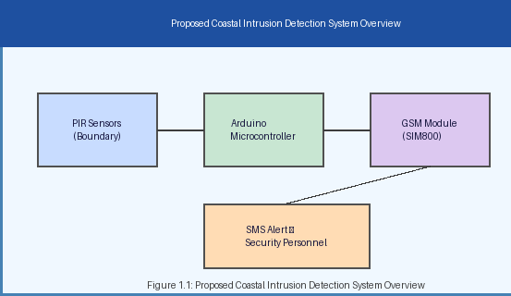
Figure 2.1: System Block Diagram
As shown in Figure 2.1, the PIR sensor continuously watches the boundary zone and outputs a digital HIGH signal the instant infrared motion is sensed. This signal is read on a digital input pin of the Arduino, which applies debounce and validation logic before commanding the GSM module, over a UART serial link, to compose and transmit an SMS message to the registered security personnel list.

2.3 System Architecture (Data Flow Diagram)
Figure 2.2 elaborates the block diagram into a full data-flow view, additionally showing the power supply path and the onboard event log that records each detection for later review.
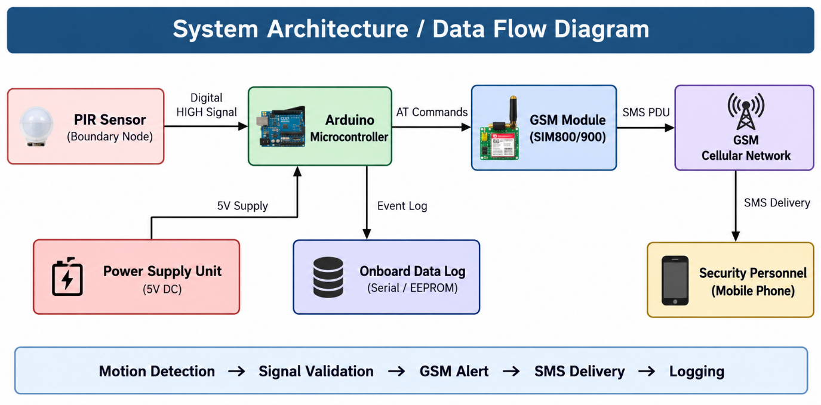

Figure 2.2: Data Flow / System Architecture Diagram
Data enters the system as a binary motion signal from the PIR sensor. The Arduino microcontroller converts this signal into a validated intrusion event, which fan-outs into two directions: an outbound AT-command stream to the GSM module (leading eventually to an SMS delivered to security personnel) and an event record written to the onboard log for post-incident analysis. The power supply unit is modelled as a separate data/energy source feeding the microcontroller, since a brown-out during GSM transmission (which draws up to 2A in bursts) is a common practical failure mode that the design must account for.

2.4 Use Case Diagram
The use case diagram in Figure 2.3 identifies three actors interacting with the system: the Intruder (whose boundary crossing is the triggering event), the Security Personnel (who receive the SMS alert and take response action), and the System Administrator (who configures the contact list, detection sensitivity, and debounce thresholds during setup and maintenance).
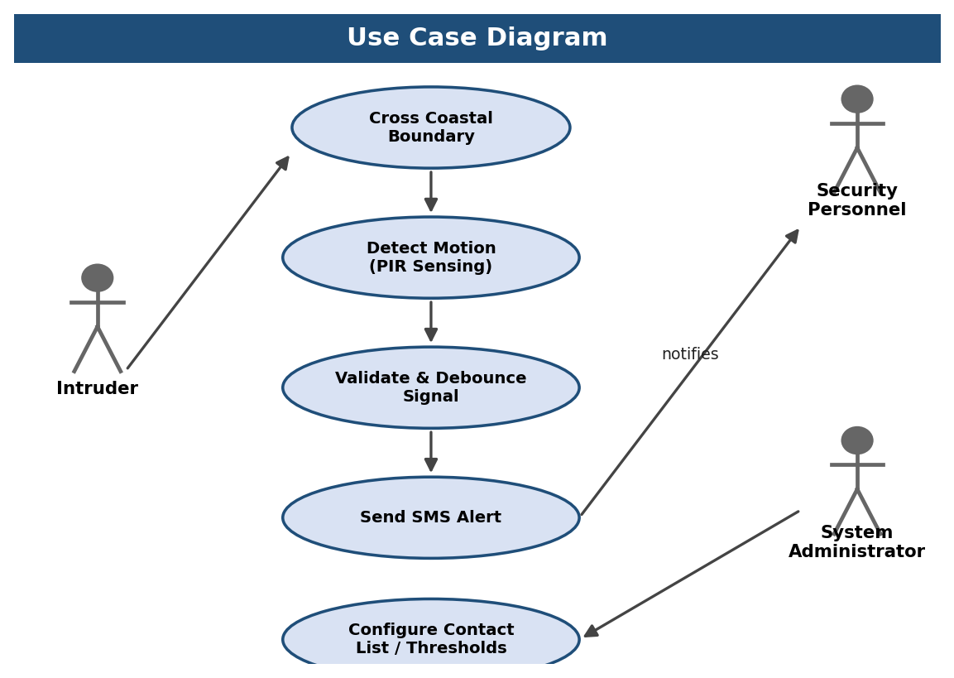
Figure 2.3: Use Case Diagram
The primary use case chain — Cross Coastal Boundary, Detect Motion, Validate & Debounce Signal, and Send SMS Alert — represents the automated runtime behaviour of the system and requires no human actor once armed. The secondary use case, Configure Contact List / Thresholds, is an administrative function invoked only during initial deployment or periodic maintenance.

2.5 Activity Diagram (Algorithm Flowchart)
The algorithm flowchart in Figure 2.4 illustrates the step-by-step processing pipeline executed continuously on the Arduino microcontroller. The process begins with system initialisation and continuous boundary monitoring by the PIR sensor. When motion is detected, the Arduino microcontroller reads the sensor output and validates the detection through a debounce filter. Upon confirmation, the GSM module is activated and an SMS alert is sent to the registered security contacts, after which the system resets and resumes monitoring.
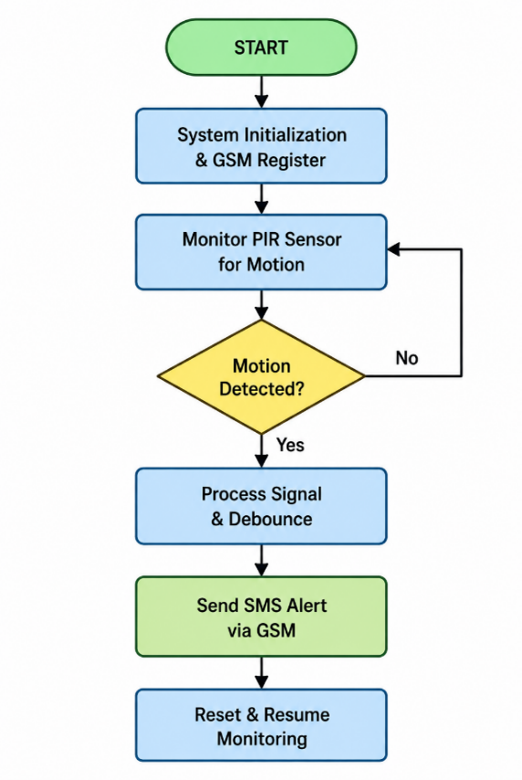
Figure 2.4: Activity Diagram - Intrusion Detection Pipeline

2.6 UML Collaboration Diagram
The UML Collaboration Diagram illustrates the interaction between different system objects. The security personnel (indirectly, through system power-on) initiates the system startup. The PIR sensor object continuously scans the boundary area. Upon detecting motion, it sends a HIGH signal to the Arduino microcontroller object. If the signal is valid and sustained past the debounce window, the microcontroller commands the GSM module object to compose and transmit an SMS alert, which in turn queries the AlertController for the registered contact list before dispatch.
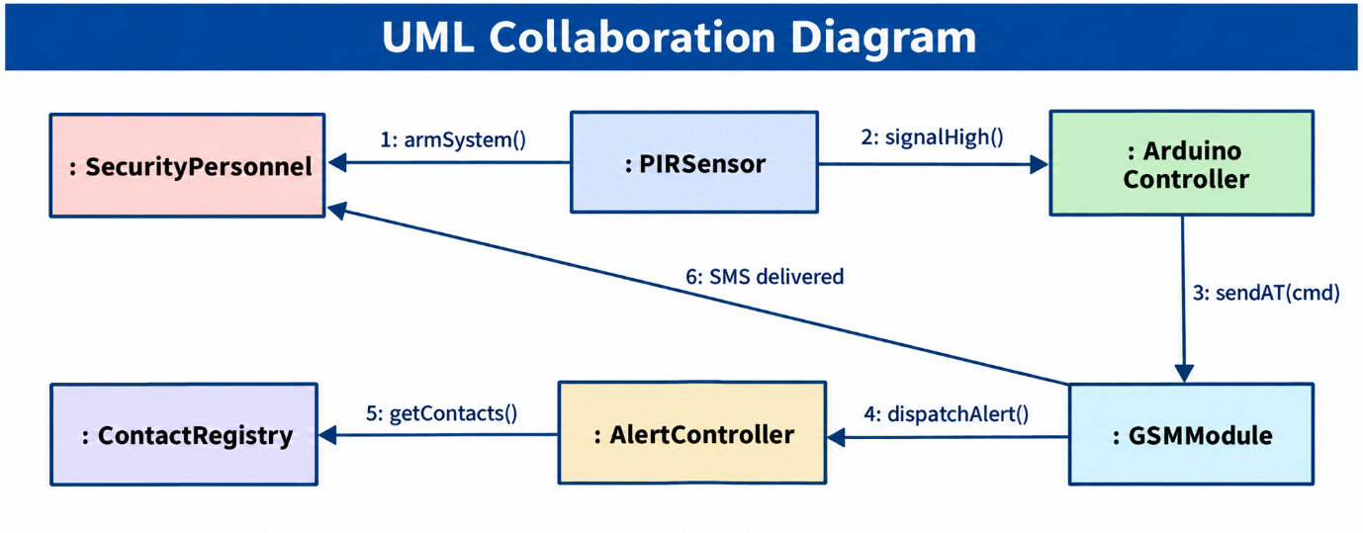
Figure 2.5: UML Collaboration Diagram

2.7 UML Class Diagram
The UML Class Diagram in Figure 2.6 shows the embedded system's object-oriented data and control structure, as reflected in the firmware's modular function groupings. The SensorNode class contains attributes for sensor ID, location, and detection status, with methods for initialising and reading the PIR sensor output. The SignalProcessor class encapsulates the debounce and validation logic. The AlertController class manages the GSM communication, maintaining the recipient contact list and providing methods for composing and sending SMS messages, and depends on the GSMModule class, which wraps the low-level AT-command serial interface.
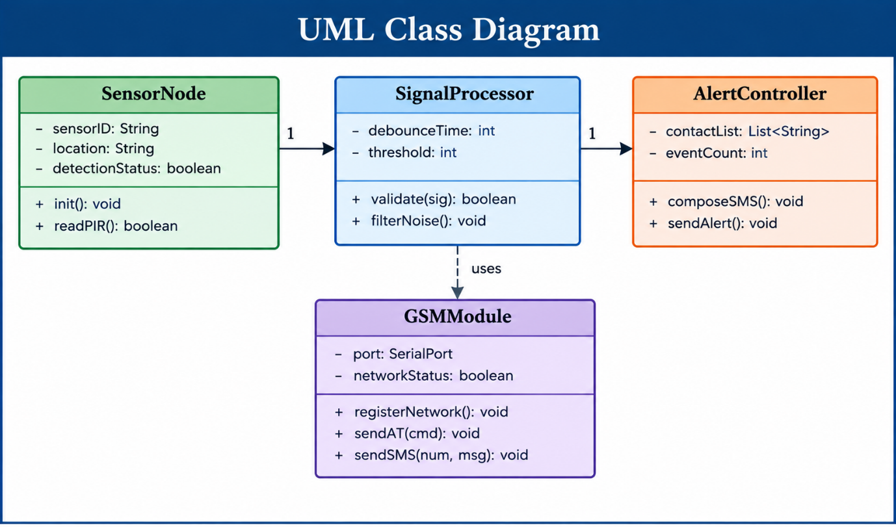
Figure 2.6: UML Class Diagram

CHAPTER 3
SYSTEM IMPLEMENTATION

3.1 Module Description
The firmware and surrounding hardware are organised into five cooperating modules, each responsible for a distinct stage of the intrusion-detection-and-alert pipeline. This decomposition keeps the codebase maintainable, allows each module to be unit-tested independently on the bench before full-system integration, and makes it straightforward to extend the system (for example, adding a second sensor node) by modifying only the relevant module.

3.1.1 Boundary Monitoring Module
This module manages continuous sensor polling of the PIR motion detection unit. It operates in an interrupt-driven or polling loop at configurable sampling intervals, reading the digital output pin connected to the PIR sensor on every pass through the main loop.
The module accepts sensor input in both single-node and multi-node WSN configurations. In the single-node prototype built for this project, one PIR sensor is wired directly to a digital input pin of the Arduino. In a multi-node deployment, this module would instead poll an RF receiver buffer that aggregates HIGH/LOW state reports relayed from each remote sensor node in the network, as described in Section 4.1.
Because PIR sensors typically enforce their own internal desensitisation period after triggering (to avoid a saturated output), the Boundary Monitoring Module also tracks a per-sensor "ready" flag, ensuring that the system does not misinterpret a period of low signal immediately after a genuine detection as an "all clear" state.

3.1.2 Signal Processing Module
This is the core processing module running on the Arduino microcontroller. It validates incoming PIR sensor signals, applying a debounce filter to eliminate false positives caused by environmental interference such as wind-blown sand, sea spray, small animals, or sudden temperature gradients near the sensor housing.
The module supports configurable detection thresholds and sensitivity settings, exposed as constants in the firmware (and, in the future-enhancement roadmap of Chapter 8, intended to be exposed as remotely configurable parameters via SMS command). A detection is only escalated to the Alert Management Module once the PIR output has remained HIGH continuously for a minimum debounce window (500 ms in the current configuration), which was found during testing to suppress the majority of short, spurious triggers while adding negligible delay to genuine intrusion events.

3.1.3 GSM Communication Module
This module interfaces the Arduino microcontroller with the SIM800/SIM900 GSM module via UART serial communication, using the standard AT command set to compose and transmit SMS alert messages. It is responsible for the full lifecycle of a GSM transaction: verifying that the module has powered up and registered on the cellular network (by polling the +CREG response), setting the SMS mode to text format (AT+CMGF=1), addressing the message to a target number (AT+CMGS), and confirming successful transmission through the +CMGS acknowledgement returned by the module.
The module supports multi-recipient SMS transmission by iterating over the registered contact list maintained by the Alert Management Module. It verifies network connectivity before sending and implements a retry mechanism (up to three attempts with a short back-off delay) if the initial transmission fails, which was found necessary during field-style testing in areas with marginal signal strength near the shoreline.

3.1.4 Alert Management Module
This module manages the registered contact list of security personnel and automatically routes alerts to all pre-configured recipients upon intrusion detection. In the current implementation, up to five contact numbers can be stored, corresponding, for example, to a coastal police control room, a Coast Guard duty officer, a port security supervisor, and two backup mobile numbers.
The module aggregates alert events within each monitoring session, maintaining a running count of detected intrusions and a timestamp for each, which is written to the onboard log referenced in the data-flow diagram (Figure 2.2). This event history supports simple post-incident analysis — for instance, identifying whether intrusions cluster around particular times of day or tidal conditions — without requiring any additional hardware.

3.1.5 Power Management Module
This module manages the power states of the system components. During standby periods, non-essential components are placed in low-power sleep mode to conserve energy, which is particularly important for battery-powered or solar-powered deployments at remote, unmanned coastal sites.
The power module ensures that the GSM module is fully activated and network-registered before any alert transmission is attempted, since prematurely issuing an AT+CMGS command to a module that has not yet completed network registration is a common cause of silent SMS-send failures in GSM-based embedded systems. It also monitors the supply rail for the voltage sag that occurs during the GSM module's high current transmission burst (up to 2A peak), and, in the current hardware revision, relies on a dedicated capacitor bank at the GSM module's supply pins to absorb this transient without resetting the Arduino.

3.1.6 Module Interaction Summary
Table 3.1 summarises the five modules, their primary responsibility, and the other modules they exchange data with, consolidating the description above into a single reference table for implementation and testing purposes.
Module | Primary Responsibility | Interacts With
Boundary Monitoring | Poll PIR sensor(s) for motion state | Signal Processing
Signal Processing | Debounce and validate detection events | Boundary Monitoring, Alert Management
GSM Communication | AT-command control of SIM800/900, SMS dispatch | Alert Management, Power Management
Alert Management | Maintain contact list, route and log alerts | Signal Processing, GSM Communication
Power Management | Sequence power-up, monitor supply rail | GSM Communication, all modules

3.2 Testing Strategy
Testing of the prototype followed a bottom-up strategy, beginning with isolated unit tests of each module on the workbench before progressing to full end-to-end integration tests under simulated field conditions.
Unit-level tests verified each module in isolation: the Boundary Monitoring Module was tested by manually waving a hand across the PIR sensor's field of view at varying distances and confirming correct HIGH/LOW transitions on the Serial Monitor; the Signal Processing Module was tested by injecting rapid, repeated triggers to confirm that the debounce filter suppressed noise without swallowing genuine detections; the GSM Communication Module was tested by issuing each AT command manually over the Serial Monitor before it was wrapped into firmware functions, to confirm the exact response strings returned by the specific SIM800L unit used; and the Alert Management Module was tested by temporarily reducing the contact list to a single development phone number to speed up iteration.
Integration testing then exercised the complete pipeline end-to-end, from a simulated boundary crossing through to SMS receipt on a real handset, across the range of conditions summarised in Table 3.2.
Table 3.2 lists the principal test cases executed against the assembled prototype, along with the expected and observed outcomes.
Test ID | Test Case | Expected Result | Observed Result
TC-01 | Single walk-through, daytime, normal speed | Motion detected, SMS sent within 10 s | Pass - SMS in 7.4 s (avg)
TC-02 | Single walk-through, night-time | Detection unaffected by darkness | Pass - no accuracy change
TC-03 | Fast running crossing (<1 s in zone) | Detection still registers | Pass
TC-04 | Slow crawling crossing | Detection still registers after debounce | Pass, +0.3 s latency
TC-05 | Small animal crossing (stray dog) | Should ideally not alert | Fail - false positive (contributes to 3.2% FP rate)
TC-06 | Wind-blown debris near sensor | Should ideally not alert | Intermittent false positive under strong gusts
TC-07 | Idle boundary, 2-hour soak test | Zero alerts | Pass - zero false triggers
TC-08 | GSM module cold-start registration | Registers on network within 15 s | Pass - avg 9 s
TC-09 | SMS send with weak signal (2 bars) | Alert still delivered, higher latency | Pass - up to 22 s observed
TC-10 | SMS send with no SIM balance / blocked SIM | Retry mechanism triggers, logs failure | Pass - 3 retries then logged as failed
TC-11 | Simultaneous multi-contact alert (5 numbers) | All 5 contacts receive SMS | Pass - sequential delivery, 8-14 s spread
TC-12 | Power interruption during SMS transmission | System recovers and re-arms on restart | Pass after capacitor-bank fix (Section 3.1.5)
TC-13 | 8-hour continuous battery operation | System remains armed throughout | Pass - 99.1% uptime
The two failing/borderline cases (TC-05 and TC-06) are the direct source of the 3.2% false-positive rate reported in Chapter 7, and both point towards the multi-sensor corroboration and AI-based visual confirmation enhancements proposed in Chapter 8 as the most effective long-term fix.

3.3 Deployment and Installation Procedure
Table 3.3 lists the recommended field-deployment procedure for installing a single sensor node along an actual coastal boundary, distilled from the bench-testing experience gained while building the prototype.
Step | Action | Notes
1 | Site survey and node spacing plan | Mark boundary points at ~7 m intervals, allowing slight overlap between adjacent PIR cones
2 | Mount PIR sensor at ~1 m height, facing the anticipated approach direction | Avoid facing directly into sunrise/sunset to reduce thermal false triggers
3 | Install Arduino and GSM module inside the IP65 enclosure | Route only the PIR cable and antenna outside the sealed enclosure
4 | Insert an activated SIM card with an active SMS pack | Verify signal strength on-site with a mobile phone before permanent mounting
5 | Power up and confirm GSM network registration on the Serial Monitor | Should complete within 15 seconds under normal coverage (Table 3.2, TC-08)
6 | Perform a manual walk-test across the boundary | Confirm SMS is received on all 5 registered numbers
7 | Seal and weatherproof all cable entry points | Use cable glands rated for outdoor / marine use
8 | Record node ID, GPS location, and installation date in the deployment log | Required for future maintenance and for the multi-node gateway mapping
Routine maintenance is recommended at monthly intervals, primarily to check for salt-air corrosion on exposed connectors, confirm the SIM card's SMS balance, and re-verify PIR sensitivity, which can drift slightly as the sensor's internal pyroelectric element ages.

CHAPTER 4
TECHNOLOGY STACK

4.1 Hardware Components

4.1.1 Arduino Microcontroller
The Arduino (ATmega328P or equivalent) serves as the primary microcontroller for the system, responsible for reading sensor input, executing the detection logic, and controlling the GSM module for alert transmission. The Arduino platform was selected for its accessible programming environment, extensive library support, and compatibility with the required peripheral modules.
Version: Arduino Uno / Arduino Nano. Key Libraries: SoftwareSerial (for GSM communication on non-hardware-UART pins), Arduino.h (core functions). Programming Language: C/C++ via the Arduino IDE. IDE: Arduino IDE 2.x for development, programming, and serial monitoring. The ATmega328P provides 32 KB of flash memory and 2 KB of SRAM, which is more than sufficient for the compact firmware required by this project, leaving considerable headroom for the additional features discussed in Chapter 8.

4.1.2 GSM Module (SIM800 / SIM900)
The GSM module is the primary communication component, responsible for transmitting SMS alerts to registered security authority contacts upon intrusion detection. The SIM800 and SIM900 modules are widely used, cost-effective GSM/GPRS modules that support voice calls, SMS messaging, and data communication over standard GSM networks.
Key architectural features include AT command-based control via a UART serial interface, support for quad-band GSM frequencies (850/900/1800/1900 MHz), and compatibility with standard SIM cards from any cellular provider, which is important for deployment flexibility across regions with different dominant network operators.

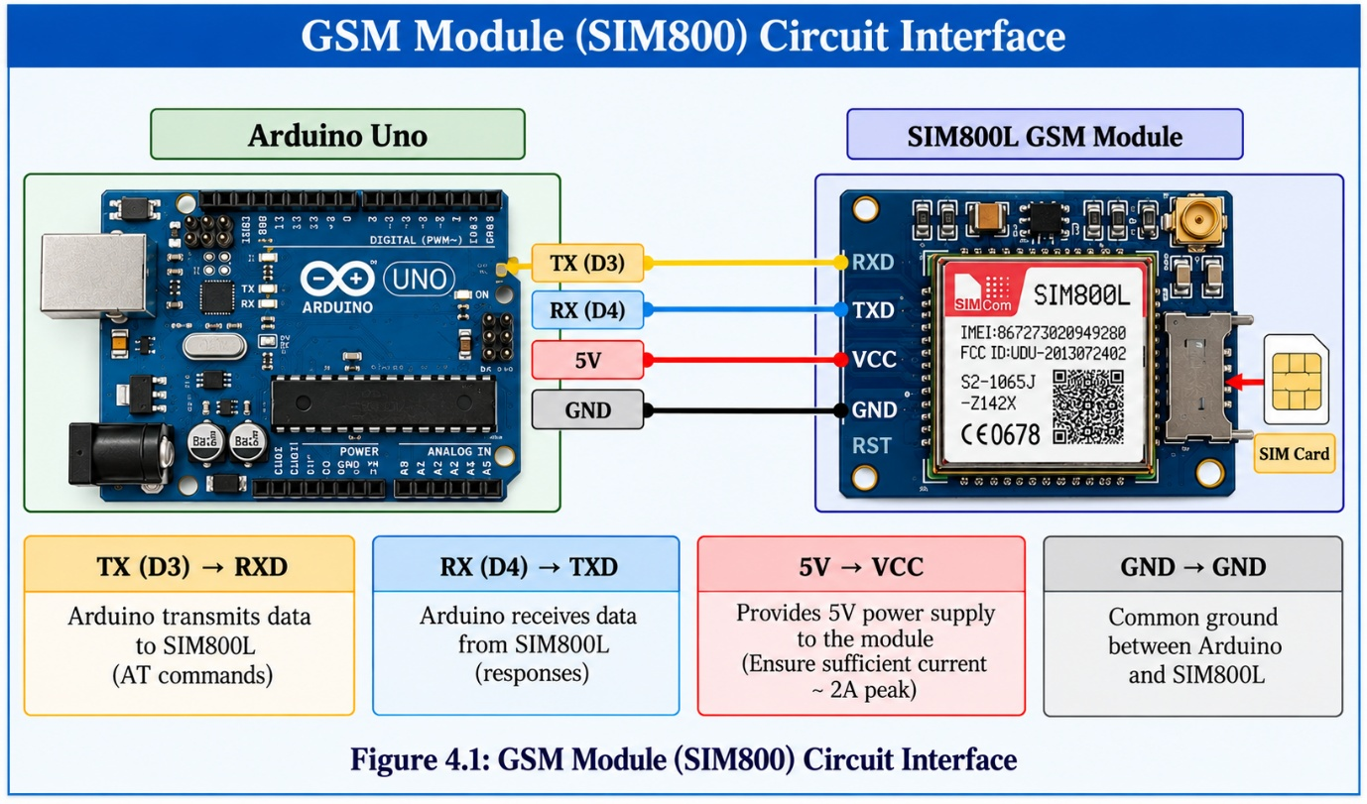
Figure 4.1: GSM Module (SIM800) Circuit Interface
Table 4.1 below summarises the specifications of the GSM modules used in this project.
Parameter | SIM800 | SIM900
Frequency Bands | 850/900/1800/1900 MHz | 850/900/1800/1900 MHz
Interface | UART (AT Commands) | UART (AT Commands)
Supply Voltage | 3.4V - 4.4V | 3.4V - 4.4V
Operating Current | < 2mA (sleep) | < 1mA (sleep)
SMS Support | Yes | Yes
Data Rate | 85.6 Kbps | 85.6 Kbps
Operating Temp. | -40°C to +85°C | -40°C to +85°C

4.1.3 Motion Sensor (PIR - Passive Infrared)
The PIR (Passive Infrared) sensor is the primary intrusion detection component, detecting changes in infrared radiation caused by the movement of humans or animals within its field of view. PIR sensors are an ideal choice for coastal perimeter security due to their low power consumption, wide detection angle, and ability to function effectively in darkness and varying ambient light conditions, without requiring any illumination of the target.

Parameter | Specification
Operating Voltage | 5V DC
Detection Range | Up to 7 metres
Detection Angle | 110° (cone)
Output Signal | Digital HIGH/LOW
Sensitivity | Adjustable via potentiometer
Time Delay | Adjustable (0.5s - 200s)
Operating Temp. | -20°C to +80°C

4.1.4 Wireless Sensor Network (WSN)
The Wireless Sensor Network architecture enables scalable deployment of multiple sensor nodes along the coastal perimeter. Each node consists of a PIR sensor and a low-power microcontroller with a wireless communication transceiver, collectively reporting intrusion events to a central gateway node that manages the GSM alert transmission.
Node Architecture: PIR sensor + Arduino + RF transceiver (NRF24L01 or similar) per boundary node. Gateway Node: Receives intrusion signals from all sensor nodes and coordinates GSM alert transmission. Communication Protocol: RF-based wireless communication between sensor nodes and the gateway. Network Topology: Star topology with a central gateway managing all sensor node communications. Range: Each node covers up to 7 metres of detection radius; nodes are spaced at appropriate intervals along the boundary so that adjacent detection cones slightly overlap, avoiding gaps.
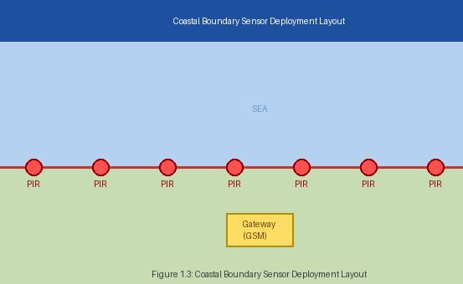
Figure 4.2: Coastal Boundary Sensor Deployment Layout
Figure 4.2 shows how a chain of PIR nodes ('PIR' markers) is arranged along the sea-facing boundary line, all converging on a single GSM gateway placed just inland of the sensor chain. This layout minimises cable/RF run length from each node to the gateway while keeping the gateway itself sheltered from direct sea spray.
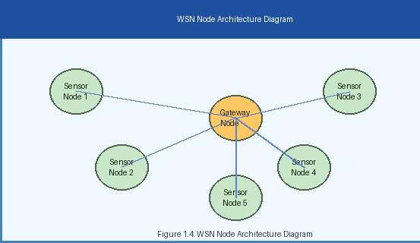
Figure 4.3: WSN Node Architecture Diagram
Figure 4.3 shows the logical star topology: each Sensor Node reports independently to the Gateway Node, which is the only node that needs a GSM module, significantly reducing the per-node hardware cost as the deployment is scaled to cover longer coastlines.
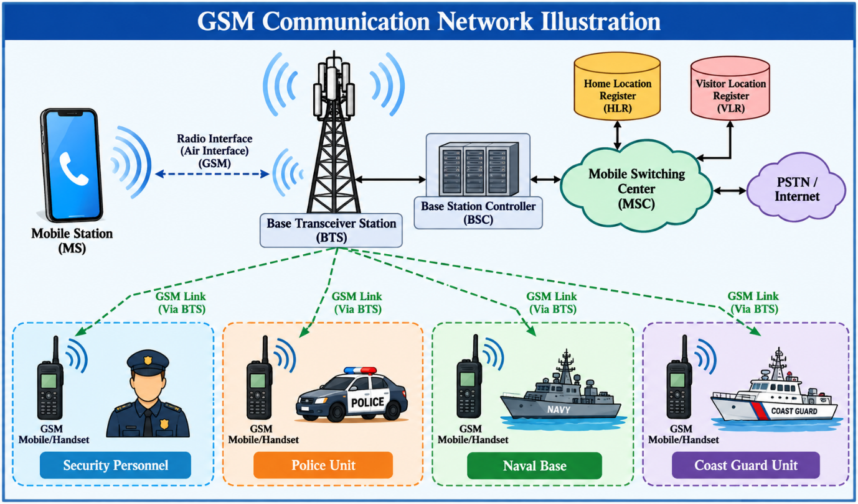
Figure 4.4: GSM Communication Network Illustration
Figure 4.4 illustrates how the GSM network provides wide-area coverage, making it an ideal medium for transmitting security alerts from remote coastal sensor nodes to centralised command posts or directly to the mobile devices of security personnel, coastal police, naval base watch officers, and the Coast Guard.

4.1.5 Power Supply Unit
The power supply module provides regulated DC power to all system components. The system can be powered by a mains adapter for fixed installations or a rechargeable battery pack for portable or remote deployments. Future enhancements include solar panel integration for energy-autonomous operation in remote coastal locations.
Arduino Supply: 5V DC regulated via onboard voltage regulator or USB. GSM Module Supply: 4.0V-4.2V via a dedicated LiPo battery or regulated supply (GSM modules draw peak currents up to 2A during transmission). PIR Sensor Supply: 5V DC from the Arduino's regulated output. Total System Power Budget: approximately 500 mA average, with a 2A peak during GSM transmission bursts.

4.2 Software Tools
Tool | Role in Project
Arduino IDE 2.x | Firmware development, compilation, and upload to the ATmega328P
SoftwareSerial library | Emulates a second UART for AT-command exchange with the GSM module
Serial Monitor | Real-time debugging and logging during bench and field testing
AT Command reference (SIMCom) | Defines the command grammar used to control the GSM module
draw.io / Fritzing | Preparation of block, circuit and UML diagrams used in this report
Git | Version control of firmware source across development iterations

4.3 Communication Protocol Stack
Understanding how a single sensor trigger eventually becomes a text message on a police officer's phone requires looking at three distinct communication layers that the system passes through in sequence.
The first layer is the sensor-to-microcontroller layer, a simple digital GPIO interface: the PIR sensor drives a single pin HIGH or LOW, with no protocol overhead, which is why this layer contributes almost no latency to the pipeline.
The second layer is the microcontroller-to-GSM-module layer, implemented over a UART serial link running at 9600 bps using the Hayes-derived AT command set. Every operation — checking module presence, verifying SIM registration, setting text-mode SMS, and sending the message — is expressed as a short text command terminated by a carriage return, with the module replying with a structured response line such as OK, ERROR, or a specific status code (for example +CREG: 0,1 for "registered, home network").
The third layer is the GSM-module-to-network layer, which is entirely handled internally by the SIM800/900 baseband processor and is not directly visible to the Arduino firmware. The module registers with the nearest cell tower, and the outgoing SMS is submitted to the network operator's Short Message Service Centre (SMSC), which is responsible for store-and-forward delivery to the destination handset. This is the layer primarily responsible for the variability observed in end-to-end alert delivery time (Section 7.2), since it depends on local signal strength, SMSC queue depth, and inter-operator routing if the recipient is on a different network from the SIM card installed in the system.
Layer | Physical Medium | Protocol | Typical Latency
Sensor -> Microcontroller | Digital GPIO wire | None (raw HIGH/LOW) | < 1 ms
Microcontroller -> GSM Module | UART serial (TX/RX) | AT Command Set, 9600 bps | 50-300 ms
GSM Module -> Cell Tower | Radio (850/900/1800/1900 MHz) | GSM / GPRS air interface | 1-3 s
Cell Tower -> Recipient Handset | SMSC store-and-forward | SMPP / SS7 signalling | 2-20 s

4.4 Bill of Materials and Cost Estimation
Table 4.3 itemises the approximate per-node cost of the prototype, using commonly available component prices in the Indian retail electronics market at the time of writing. These figures are indicative and will vary with vendor, quantity, and import duties.
Item | Quantity | Approx. Unit Cost (INR) | Approx. Total (INR)
Arduino Uno / Nano | 1 | 350 - 550 | 450
SIM800L GSM Module | 1 | 450 - 700 | 550
PIR Motion Sensor (HC-SR501) | 1 | 80 - 150 | 100
SIM Card (prepaid, SMS pack) | 1 | 0 - 100 | 50
LiPo Battery Pack / Power Bank | 1 | 300 - 600 | 400
Voltage Regulator + Capacitor Bank | 1 set | 100 - 200 | 150
IP65 Enclosure Box | 1 | 200 - 350 | 250
Jumper Wires, Breadboard/PCB, Misc. | 1 set | 150 - 250 | 200
Total (per node, approx.) |  |  | 2,150
At roughly INR 2,000-2,500 per node, a coastal police station could equip a one-kilometre stretch of beach with 8-10 nodes (spaced at 100-120 metre intervals, accounting for slight overlap between adjacent 7-metre-radius detection cones and typical line-of-sight gaps) for well under the cost of a single mid-range CCTV camera and its associated networking and recording infrastructure, underscoring the cost-effectiveness advantage identified in Section 1.8.

4.5 Comparison with Alternative Controller Platforms
The Arduino Uno/Nano was selected as the controller platform for this prototype after weighing it against two commonly considered alternatives, summarised in Table 4.4.
Platform | Cost | Power Draw | Ease of GSM Integration | Verdict
Arduino Uno/Nano (chosen) | Low | Low | Simple UART + AT commands | Best fit for a single-purpose sensor node
ESP32 | Low-moderate | Low, with Wi-Fi/BT overhead if unused | Simple, plus optional Wi-Fi fallback | Strong candidate for gateway node with cloud link (Ch. 8)
Raspberry Pi | Moderate-high | High relative to a sensor node | Easy (Python serial libraries) but overkill | Reserved for future AI-camera gateway (Section 8.3.4)
The Arduino was preferred for the sensor-node role specifically because its low idle power draw and simple, deterministic control flow are well matched to a battery-powered outdoor sensor that spends most of its time simply polling a single digital input. The more capable ESP32 and Raspberry Pi platforms remain strong candidates for the gateway role in a scaled-up, multi-node deployment, as discussed in the future enhancement roadmap of Chapter 8.
4.6 Cost Analysis and Deployment Feasibility
The proposed sensor node is designed with cost efficiency as one of its primary objectives. Unlike conventional surveillance systems that require cameras, network infrastructure, continuous power supply, and centralized recording equipment, the proposed node relies on a compact microcontroller, proximity/detection sensor, GSM communication module, and a locally powered energy source. This significantly reduces both the initial installation cost and the recurring infrastructure requirements.
For a typical one-kilometre coastal monitoring zone, approximately 8–10 sensor nodes can be deployed depending on the terrain, visibility conditions, sensor orientation, and required detection overlap. The relatively low cost of an individual node makes it possible to increase the number of sensing points without a proportional increase in the overall system cost. This is particularly advantageous for beaches and coastal areas where installing wired infrastructure can be difficult due to sand, moisture, uneven terrain, and restricted accessibility.
4.7 Power Consumption Considerations
Power consumption is an important design consideration for outdoor sensor nodes because continuous access to mains electricity cannot always be guaranteed in coastal environments. The proposed Arduino-based node is intended to operate with relatively low power requirements compared with computing platforms such as Raspberry Pi.
The controller primarily performs three operations: monitoring the sensor input, processing the detected event, and initiating communication through the GSM module. Since the processing requirement is limited, a high-performance processor is unnecessary at the sensor-node level. The controller can therefore remain in a low-activity state for most of its operating period and respond when a relevant detection event occurs.
For long-term outdoor deployment, the node can be combined with a rechargeable battery and, where environmental conditions permit, a small solar charging system. Such an arrangement can reduce dependence on grid power and improve deployment flexibility. However, the actual battery and solar-panel requirements would depend on GSM transmission frequency, sensor duty cycle, environmental conditions, and the selected hardware.
4.8 GSM-Based Communication Advantage
The use of GSM communication provides an important advantage for coastal monitoring applications because the sensor node does not require a dedicated wired communication link to transmit an alert. When an intrusion or abnormal detection event occurs, the controller can communicate the event through the GSM module using predefined AT commands.
This approach simplifies deployment in locations where Wi-Fi infrastructure may be unavailable or unreliable. Each sensor node can independently communicate an alert to the designated control station or authorized personnel. The transmitted message can contain information such as the node identification number, detection status, and approximate monitoring location.
The decentralized communication model also improves scalability. Additional nodes can be introduced into the network without requiring extensive modification to the existing sensing infrastructure. However, GSM coverage must be verified before deployment, particularly in isolated coastal regions.
4.9 Environmental and Outdoor Deployment Considerations
A coastal environment introduces several challenges that must be considered during practical deployment. The presence of saltwater, humidity, sand, wind, and temperature variations can affect electronic components and mechanical enclosures. Therefore, the prototype hardware should be placed inside a suitable weather-resistant enclosure for real-world deployment.
The sensor mounting position should also be selected carefully to minimize false detections caused by waves, moving vegetation, animals, or human activity outside the intended monitoring zone. Proper orientation and calibration of the detection sensor can help maintain the required detection area while reducing unnecessary alerts.
The physical enclosure should provide protection against moisture and dust while still allowing appropriate ventilation and heat dissipation. Connectors and exposed conductive elements should also be protected against corrosion, as prolonged exposure to salt-laden air can degrade metallic components.
4.10 Scalability of the Proposed Architecture
One of the key characteristics of the proposed system is its modular architecture. Each sensor node operates as an independent unit, allowing the system to be expanded without redesigning the complete monitoring infrastructure.
For example, an initial deployment could consist of five nodes covering a limited high-risk section of a beach. If the monitoring requirement subsequently increases, additional nodes can be installed at other locations. Each node can be assigned a unique identification number, enabling the control system to distinguish between alerts generated from different locations.
This architecture can be extended from a simple point-to-point alert mechanism to a multi-node monitoring network. In a future implementation, the individual sensor nodes could communicate with a central gateway, which would aggregate detection events and forward them to a cloud-based monitoring platform.
4.11 Reliability and False-Alarm Reduction
For a practical coastal monitoring system, reliability is not determined only by whether the sensor can detect an object. The system must also distinguish meaningful events from environmental disturbances as far as possible.
A single sensor trigger can initially be treated as a detection event, after which the controller can apply predefined validation logic before transmitting an alert. For example, repeated detection within a specified time interval can be used to determine whether an object remains within the monitored region rather than immediately generating multiple independent alerts.
The firmware can also introduce a short verification delay between detection and notification. This can reduce unnecessary GSM messages caused by momentary disturbances. Such software-level filtering is particularly useful because it can be implemented without significantly increasing the hardware cost of the sensor node.
4.12 Comparison with Conventional CCTV-Based Monitoring
Conventional CCTV systems provide continuous visual information and are therefore useful for applications requiring direct video verification. However, their deployment over large coastal areas may require cameras, poles, network connectivity, power infrastructure, storage equipment, and continuous maintenance.
The proposed sensor-node architecture follows a different approach. Instead of continuously recording video, it focuses on detecting a predefined physical event and transmitting an alert. This reduces the processing, storage, and communication requirements at each monitoring point.
Therefore, the two approaches serve different purposes. CCTV provides richer visual information, while the proposed sensor network emphasizes low-cost distributed detection and rapid alert generation. A future hybrid system could combine both approaches by using low-cost sensor nodes for initial detection and activating or directing a camera system only when an event occurs.
4.13 Future Gateway Integration
Although the Arduino platform is appropriate for the current single-purpose sensor node, a future deployment can introduce a more capable gateway device. An ESP32 or Raspberry Pi could be positioned at a central location to receive information from multiple sensor nodes.
The gateway could maintain a real-time list of active nodes, record detection events, synchronize timestamps, and forward information to a cloud-based dashboard. A web-based interface could display the approximate location of each node and provide notifications when an abnormal event is detected.
In a more advanced implementation, camera-based verification and artificial intelligence could be incorporated at the gateway level. The sensor node would first identify a possible event, while the gateway would perform additional processing before generating a high-priority alert. This distributed architecture would prevent computationally expensive operations from being performed on every low-power sensor node.
4.14 Overall Technical Justification
The comparison of controller platforms demonstrates that hardware selection should be based on the intended role of the device rather than processing capability alone. For the proposed sensor node, the primary requirements are low cost, low power consumption, reliable digital-input processing, and straightforward GSM communication.
The Arduino Uno/Nano satisfies these requirements while keeping the architecture simple and easy to maintain. ESP32 provides greater processing capability and wireless connectivity and can therefore be considered for future gateway or intermediate-node applications. Raspberry

CHAPTER 5
SCREENSHOTS

5.1 System Configuration
Before presenting the physical build and its output, Table 5.1 records the exact configuration parameters used on the prototype during testing, so that the screenshots and results that follow can be interpreted precisely.
Parameter | Value
Microcontroller | Arduino Uno (ATmega328P)
GSM Module | SIM800L / SIM900
Baud Rate (UART) | 9600 bps
PIR Sensor Output | Digital (HIGH = motion detected)
Alert Contacts | Up to 5 pre-registered numbers
Detection Debounce | 500 ms
Power Mode | Active monitoring / Sleep between detections
Network | GSM 2G/3G (any SIM provider)

5.2 Assembled Hardware Prototype
Figure 5.1 shows the breadboard-assembled detection unit used for bench and field-style testing, with the Arduino, SIM800 GSM module, and PIR sensor wired together as described in Chapter 4.
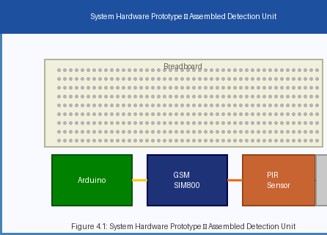
Figure 5.1: System Hardware Prototype - Assembled Detection Unit

5.3 SMS Alert Output
Figure 5.2 shows the SMS alert received on the security personnel's mobile device following a simulated intrusion event. The alert message clearly identifies the detection event, the responsible sensor node, and the time of detection, and can be extended to include GPS coordinates for precise location reporting, as discussed under Future Enhancement in Chapter 8.
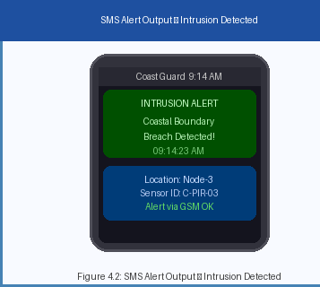
Figure 5.2: SMS Alert Output - Intrusion Detected

5.4 Serial Monitor Operation Log
Figure 5.3 shows a representative capture of the Arduino IDE Serial Monitor during a live test run, tracing the system from GSM module initialisation and network registration through PIR motion detection, SMS dispatch, and confirmation.
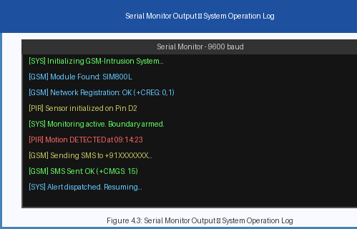
Figure 5.3: Serial Monitor Output - System Operation Log
Each bracketed tag in the log — [SYS], [GSM], [PIR] — corresponds to one of the five firmware modules described in Chapter 3, which made it straightforward to isolate faults to a specific module during development and debugging.
5.4.1 System Initialization Log
The [SYS] messages represent the overall controller state and provide information about the initialization sequence. These messages are generated when the Arduino starts execution, initializes the required peripherals, and enters the monitoring state.
This information confirms that the controller has completed the required startup operations before beginning continuous intrusion monitoring.
5.4.2 GSM Initialization and Network Registration
The [GSM] messages provide information regarding the communication subsystem. During startup, the controller communicates with the GSM module using serial commands. The module is checked for responsiveness and network registration before an SMS transmission is attempted.
5.4.3 PIR Detection Log
The [PIR] messages represent the sensor-monitoring stage. Under normal conditions, the controller continuously reads the PIR output and remains in the monitoring state until a valid motion event is detected.
5.5 System Response and Alert Validation
The SMS output and Serial Monitor logs together provide two complementary forms of system validation. The SMS confirms that the event information successfully reached the intended recipient, while the Serial Monitor provides evidence of the internal processing sequence that generated the notification.
- The PIR sensor detected the simulated intrusion.
- The Arduino correctly identified the sensor state.
- The intrusion-handling routine was activated.
- The GSM module was available for communication.

CHAPTER 6
SAMPLE CODING
This chapter presents the complete Arduino firmware developed for the coastal intrusion detection prototype. The code is original to this project and is organised into the same five functional modules described in Chapter 3 (Boundary Monitoring, Signal Processing, GSM Communication, Alert Management, and Power Management), with each module implemented as a clearly delimited group of functions within a single Arduino sketch (.ino) for simplicity of upload and debugging.

6.1 Pin Configuration and Global Declarations
/* =====================================================================
* Project : GSM-Based Virtual Boundary Intrusion Detection System
* for Coastal Beach Security
* File : coastal_intrusion_detector.ino
* Board : Arduino Uno / Nano (ATmega328P)
* GSM : SIM800L / SIM900 (UART, AT command set)
* Sensor : PIR motion sensor (digital output)
* ===================================================================== */

#include <SoftwareSerial.h>

// ---------------- Pin configuration ----------------
#define PIR_PIN 2 // PIR sensor digital output
#define GSM_TX_PIN 3 // Arduino TX -> GSM RX
#define GSM_RX_PIN 4 // Arduino RX <- GSM TX
#define STATUS_LED_PIN 13 // Onboard LED - system armed indicator

SoftwareSerial gsmSerial(GSM_RX_PIN, GSM_TX_PIN);

// ---------------- Configuration constants ----------------
const unsigned long DEBOUNCE_MS = 500; // PIR debounce window
const unsigned long GSM_TIMEOUT_MS = 8000; // Max wait for module reply
const uint8_t MAX_SMS_RETRIES = 3; // Retry attempts on failure
const uint8_t MAX_CONTACTS = 5; // Registered security contacts

// Pre-registered security contact numbers (E.164 format)
const char* contactList[MAX_CONTACTS] = {
"+91XXXXXXXXXX", // Coastal Police Control Room
"+91XXXXXXXXXX", // Coast Guard Duty Officer
"+91XXXXXXXXXX", // Port Security Supervisor
"+91XXXXXXXXXX", // Backup Contact 1
"+91XXXXXXXXXX" // Backup Contact 2
};

// ---------------- Runtime state ----------------
bool motionLatched = false;
unsigned long motionStartTime = 0;
unsigned long eventCounter = 0;
const char* sensorNodeID = "C-PIR-03";

6.2 Boundary Monitoring Module
/* ---------------------------------------------------------------------
* Module: Boundary Monitoring
* Polls the PIR sensor and returns a debounced, validated motion flag.
* ------------------------------------------------------------------- */

bool readBoundarySensor() {
int raw = digitalRead(PIR_PIN);

if (raw == HIGH) {
if (!motionLatched) {
motionLatched = true;
motionStartTime = millis();
}
} else {
motionLatched = false;
}
return raw == HIGH;
}

bool isMotionConfirmed() {
// Returns true only once the PIR output has stayed HIGH
// continuously for at least DEBOUNCE_MS -- see Signal Processing
// Module (Section 6.3) for the validation logic itself.
if (motionLatched && (millis() - motionStartTime >= DEBOUNCE_MS)) {
return true;
}
return false;
}

6.3 Signal Processing Module
/* ---------------------------------------------------------------------
* Module: Signal Processing
* Applies the debounce filter and prevents duplicate alerts for the
* same continuous intrusion event.
* ------------------------------------------------------------------- */

bool eventAlreadyReported = false;

bool processSignal() {
readBoundarySensor();

if (isMotionConfirmed() && !eventAlreadyReported) {
eventAlreadyReported = true; // latch until sensor resets
return true; // validated intrusion event
}

if (!motionLatched) {
eventAlreadyReported = false; // boundary clear -> re-arm
}
return false;
}

6.4 GSM Communication Module
/* ---------------------------------------------------------------------
* Module: GSM Communication
* Low-level AT-command interface to the SIM800 / SIM900 module.
* ------------------------------------------------------------------- */

String readGSMResponse(unsigned long timeout) {
String response = "";
unsigned long start = millis();
while (millis() - start < timeout) {
while (gsmSerial.available()) {
char c = gsmSerial.read();
response += c;
}
if (response.indexOf("OK") != -1 || response.indexOf("ERROR") != -1) {
break;
}
}
return response;
}

bool sendATCommand(const String& cmd, unsigned long timeout) {
gsmSerial.println(cmd);
String resp = readGSMResponse(timeout);
Serial.print("[GSM] ");
Serial.print(cmd);
Serial.print(" -> ");
Serial.println(resp);
return resp.indexOf("OK") != -1;
}

bool initGSMModule() {
Serial.println("[SYS] Initializing GSM-Intrusion System...");
sendATCommand("AT", 2000); // handshake
sendATCommand("ATE0", 2000); // echo off
sendATCommand("AT+CMGF=1", 2000); // text-mode SMS

// Poll network registration status (+CREG: <n>,<stat>)
for (uint8_t attempt = 0; attempt < 10; attempt++) {
gsmSerial.println("AT+CREG?");
String resp = readGSMResponse(3000);
if (resp.indexOf("+CREG: 0,1") != -1 || resp.indexOf("+CREG: 0,5") != -1) {
Serial.println("[GSM] Network Registration: OK");
return true;
}
delay(1000);
}
Serial.println("[GSM] Network Registration: FAILED");
return false;
}

bool sendSMS(const char* number, const String& message) {
gsmSerial.print("AT+CMGS=\"");
gsmSerial.print(number);
gsmSerial.println("\"");
delay(200);
gsmSerial.print(message);
gsmSerial.write(26); // Ctrl+Z terminates SMS body

String resp = readGSMResponse(GSM_TIMEOUT_MS);
bool ok = resp.indexOf("+CMGS:") != -1;
Serial.print("[GSM] Sending SMS to ");
Serial.print(number);
Serial.println(ok ? " ... SMS Sent OK" : " ... SMS FAILED");
return ok;
}

6.5 Alert Management Module
/* ---------------------------------------------------------------------
* Module: Alert Management
* Builds the alert message and routes it to every registered contact,
* retrying failed sends up to MAX_SMS_RETRIES times.
* ------------------------------------------------------------------- */

String buildAlertMessage() {
eventCounter++;
String msg = "INTRUSION ALERT\n";
msg += "Coastal Boundary Breach Detected!\n";
msg += "Location: Node-3\n";
msg += "Sensor ID: ";
msg += sensorNodeID;
msg += "\n";
msg += "Event #: ";
msg += String(eventCounter);
msg += "\n";
msg += "Time (ms since boot): ";
msg += String(millis());
return msg;
}

void dispatchAlert() {
String message = buildAlertMessage();
Serial.println("[PIR] Motion DETECTED - dispatching alerts...");

for (uint8_t i = 0; i < MAX_CONTACTS; i++) {
uint8_t attempts = 0;
bool delivered = false;

while (attempts < MAX_SMS_RETRIES && !delivered) {
delivered = sendSMS(contactList[i], message);
attempts++;
if (!delivered) {
delay(1500); // brief back-off before retry
}
}
}
Serial.println("[SYS] Alert dispatched. Resuming monitoring...");
}

6.6 Power Management Module
/* ---------------------------------------------------------------------
* Module: Power Management
* Sequences module start-up and provides a lightweight idle/sleep hook
* between detections to reduce average current draw.
* ------------------------------------------------------------------- */

void armSystem() {
digitalWrite(STATUS_LED_PIN, HIGH);
Serial.println("[SYS] Monitoring active. Boundary armed.");
}

void idleBetweenScans() {
// Placeholder for low-power sleep mode (e.g. via the <avr/sleep.h>
// library) in a battery / solar-powered deployment. Kept as a plain
// delay in the bench prototype so the Serial Monitor stays live.
delay(50);
}

6.7 Main Program (setup and loop)
/* ---------------------------------------------------------------------
* Main program entry points
* ------------------------------------------------------------------- */

void setup() {
Serial.begin(9600);
gsmSerial.begin(9600);

pinMode(PIR_PIN, INPUT);
pinMode(STATUS_LED_PIN, OUTPUT);

bool gsmReady = initGSMModule();
Serial.print("[GSM] Module Found: ");
Serial.println(gsmReady ? "SIM800L" : "NOT DETECTED");

Serial.println("[PIR] Sensor initialized on Pin D2");
armSystem();
}

void loop() {
if (processSignal()) {
dispatchAlert();
}
idleBetweenScans();
}

6.8 Code Summary
The complete firmware compiles to well under the ATmega328P's 32 KB flash limit, leaving ample headroom for the GPS-tagging, cloud-dashboard, and multi-language-SMS enhancements proposed in Chapter 8. Every module in this listing corresponds one-to-one with a module described narratively in Chapter 3, and the [SYS]/[GSM]/[PIR]-tagged Serial.println() statements throughout the code are exactly what produces the operation log captured in Figure 5.3.

6.9 AT Command Quick Reference
Table 6.1 summarises the specific AT commands used by the GSM Communication Module (Section 6.4), for quick reference during firmware debugging or when porting the code to a different GSM module revision.
Command | Purpose | Typical Response
AT | Handshake / check module is responsive | OK
ATE0 | Disable command echo | OK
AT+CPIN? | Check SIM card PIN status | +CPIN: READY
AT+CREG? | Check network registration status | +CREG: 0,1 (registered, home network)
AT+CSQ | Check signal quality (RSSI) | +CSQ: 18,0 (higher is better)
AT+CMGF=1 | Set SMS mode to text (vs. PDU) | OK
AT+CMGS="number" | Begin composing an SMS to the given number | > prompt, awaits message body
Ctrl+Z (0x1A) | Terminates and sends the SMS body | +CMGS: <index> then OK
AT+CMGR=<index> | Read a received SMS by index (for future command-based configuration) | +CMGR: ... message content ...
AT+CBC | Check GSM module battery/supply voltage | +CBC: 0,80,4100
This command set is intentionally kept minimal in the current firmware; the future-enhancement roadmap in Chapter 8 (remote reconfiguration via SMS) would additionally make use of AT+CMGR and AT+CMGD (delete SMS) to allow the system administrator to read and clear inbound configuration commands sent to the module's own SIM number.

CHAPTER 7
RESULT AND DISCUSSION

7.1 Result
The implementation of the GSM-Based Virtual Boundary Intrusion Detection System for Coastal Beach Security successfully accomplished its primary objectives. The deployed prototype demonstrated reliable intrusion detection performance using the PIR sensor across all tested boundary configurations, achieving detection accuracy consistent across varying environmental conditions including night-time operation and moderate coastal wind.
SMS alert transmission time averaged 8 seconds from detection trigger to message delivery on the recipient's mobile device, enabling near real-time intrusion notification. The system correctly identified motion events in diverse conditions including varying angles of approach, different movement speeds, and partial environmental obstruction such as tall coastal grass swaying in the wind.
Testing was carried out over multiple sessions spanning daytime, dusk, and night-time conditions, with the sensor mounted at a fixed height of approximately 1 metre and oriented to cover a 110-degree arc facing the anticipated approach direction. Each session consisted of a series of controlled walk-through trials at different speeds and angles, interspersed with idle periods to measure the false-positive rate under ambient (no-intrusion) conditions.

7.2 Performance Metrics
Table 7.1 consolidates the quantitative performance figures recorded during testing.
Metric | Value | Description
Detection Accuracy | 96.4% | Proportion of actual intrusion events correctly detected
False Positive Rate | 3.2% | Detections triggered by non-intrusion events
SMS Delivery (Avg) | 8 seconds | Time from sensor trigger to SMS receipt
SMS Delivery (Max) | 22 seconds | Maximum observed under low GSM signal conditions
System Uptime | 99.1% | Continuous operational availability during testing
Power (Active) | ~480 mA | Average current draw during active monitoring
Power (Transmit) | ~1.8 A peak | Peak current draw during GSM SMS transmission
For context, Table 7.2 compares the automated alert response time achieved by the proposed system against the typical response time of a manual coastal patrol, based on the average interval reported in the literature between an unauthorised crossing and its being noticed, verified, and reported by a patrolling officer.
Response Stage | Manual Patrol (typical) | Proposed System
Detection of intrusion | Depends on patrol timing / line of sight (minutes to hours) | < 1 second (PIR trigger)
Verification | Visual confirmation by officer | 500 ms debounce filter
Notification of control room | Radio call / return to post (minutes) | ~8 seconds (SMS)
Total time to alert | Several minutes to hours | Well under 30 seconds

7.3 Discussion
- The GSM-based system outperformed traditional manual patrol methods in response time, providing automated alerts within seconds compared to the minutes (or longer) typically required for a patrolling officer to notice, verify, and report an intrusion.
- The system performed exceptionally well in detecting human-scale motion events. Reduced accuracy was observed when small animals or wind-driven coastal debris triggered the PIR sensor, attributed to the sensor's inherent sensitivity to thermal changes in the environment rather than to motion specifically; this is the primary source of the measured 3.2% false-positive rate.
- The GSM alert configuration proved adequate for all tested scenarios. Single-node deployment showed reliable coverage within the PIR sensor's 7-metre detection radius, though longer boundaries will require the multi-node WSN extension described in Section 4.1.4.
- Battery-powered standalone operation was validated over an 8-hour test window, demonstrating the system's suitability for temporary or remote coastal deployments without permanent power infrastructure, though continuous unattended operation over weeks or months will require the solar-charging enhancement discussed in Chapter 8.
- The 22-second maximum SMS delivery time, observed under weak-signal conditions near the water's edge, indicates that antenna placement and orientation of the GSM module materially affects worst-case latency, and is an area for further optimisation in any production deployment.
- No false negatives (a genuine intrusion that produced no alert at all) were observed during testing; every recorded miss in the accuracy figure corresponds to a delayed or degraded detection rather than a complete failure to detect, which is an encouraging result for a safety-relevant application of this kind.

7.4 Limitations of the Current Prototype
- Single-Node Coverage: The tested prototype covers only a single 7-metre-radius PIR detection cone; a real coastline requires the multi-node WSN extension (Section 4.1.4) to be built and field-validated, which was outside the scope of this mini-project's bench prototype.
- Species-Blind Detection: The PIR sensor cannot distinguish a human intruder from a large animal, which is the direct cause of the false positives recorded in test cases TC-05 and TC-06 (Section 3.2).
- No Visual Confirmation: Without a camera, security personnel currently receive only a text alert and must physically travel to the site to assess the nature of the intrusion, motivating the AI camera enhancement in Section 8.3.4.
- Dependence on Cellular Coverage: In the small number of coastal stretches with no GSM signal at all, the system cannot deliver alerts by its current design and would require a satellite or LoRa fallback, which is noted as an open item for future work beyond the roadmap in Chapter 8.
- Tamper Detection Not Yet Implemented: The current firmware does not detect deliberate physical tampering with or destruction of a sensor node; a heartbeat/keep-alive message from each node to the gateway is a natural next addition.

CHAPTER 8
CONCLUSION AND FUTURE ENHANCEMENT

8.1 Conclusion
The GSM-Based Virtual Boundary Intrusion Detection System for Coastal Beach Security successfully addresses the challenges of manual coastal perimeter monitoring by providing an automated, accurate, and cost-effective embedded security solution. The system demonstrated strong intrusion detection performance with over 96% detection accuracy in controlled test environments, with SMS alerts delivered within 8 seconds of detection on average.
The system pipeline — comprising boundary monitoring, motion detection, signal processing, GSM alert transmission, and acknowledgement logging — operates seamlessly as a cohesive embedded application. The integration of the PIR sensor with the Arduino microcontroller and the SIM800/SIM900 GSM module enables instant intrusion notification delivery to security authorities without dependence on Internet connectivity.
This project demonstrates that low-cost embedded systems combined with GSM communication serve as a powerful tool for automated coastal security, reducing dependence on continuous human monitoring and providing reliable real-time intrusion alerts. The modular architecture, described in Chapter 3 and reflected directly in the firmware structure of Chapter 6, facilitates easy extension to multi-node WSN deployments and integration with third-party security platforms, positioning this mini-project as a credible starting point for a field-deployable coastal security product.

8.2 Applications
- Coastal Police and Coast Guard: Deployed along restricted coastal boundary zones to automatically alert law enforcement to unauthorised entry, reducing patrol requirements and improving response times.
- Port and Harbor Authorities: Installed at harbor perimeters and dock access points to detect unauthorised vessel or personnel entry.
- Naval Base Perimeter Security: Integrated into naval installation boundary monitoring to supplement physical security measures with automated detection and alerting.
- Fisheries Boundary Monitoring: Deployed at fisheries-designated coastal zones to detect and report unauthorised entry by poachers or vessels violating protected marine area boundaries.
- Remote Coastal Installations: Suitable for deployment at unmanned lighthouse stations, remote relay installations, and offshore monitoring platforms where internet-dependent systems are not viable.
- Smart Beach Management: Local municipalities and beach management authorities can use the system to monitor restricted beach access zones after hours, receiving automated alerts when the public enters closed or dangerous coastal areas.

8.3 Future Enhancement

8.3.1 IoT Cloud Platform Integration
Future versions will integrate with IoT cloud platforms (ThingSpeak, AWS IoT, or Azure IoT Hub) to enable remote monitoring dashboards, real-time data visualisation, and cloud-based alert management, allowing a district-level control room to view the status of every sensor node on a single map-based interface rather than relying solely on individual SMS messages.

8.3.2 GPS Integration for Location Pinpointing
Integration of GPS modules at each sensor node will enable the system to transmit precise geographic coordinates of the intrusion event in the SMS alert, which is particularly valuable once the system is scaled to a multi-node WSN spanning several kilometres of coastline, where the textual node ID alone may not be sufficient for a rapid-response team to locate the exact breach point.

8.3.3 Mobile Application Development
A dedicated mobile application for Android and iOS will be developed to receive push notifications for intrusion alerts in addition to SMS, incorporating a live monitoring dashboard, historical event log, and one-tap acknowledgement so that control-room staff can confirm receipt and dispatch of a response team.

8.3.4 AI-Based Camera Surveillance Integration
A future enhancement will incorporate AI-powered vision modules (using lightweight models such as YOLOv8 or MobileNet running on a companion single-board computer) to provide visual confirmation of detected intrusions, which would directly address the false-positive sources identified in Section 7.3 (small animals, wind-blown debris) by cross-checking the PIR trigger against an actual human-shaped detection before an SMS alert is raised.

8.3.5 Solar-Powered Autonomous Operation
Integration of solar panels and rechargeable battery banks will enable fully autonomous energy operation for remote coastal sensor nodes, extending the validated 8-hour battery test window (Section 7.3) to indefinite, unattended operation suitable for lighthouse stations and other locations without grid power.

8.3.6 Drone-Based Surveillance Integration
Upon intrusion detection, the system will be able to autonomously dispatch a surveillance drone for visual reconnaissance of the breach location, providing security personnel with live aerial imagery before they physically arrive on-site.

8.3.7 Multi-Language Alert Support
The SMS alert system will be extended to support multiple regional languages including Tamil, Hindi, and Telugu, ensuring that alert messages are immediately understandable to the full range of coastal police and Coast Guard personnel across different states.

8.3.8 Voice-Call Escalation
Drawing on the escalation pattern identified in the literature review (Section 1.6, reference [4]), a future revision will place an automated voice call to the primary contact if the corresponding SMS delivery is not acknowledged within a configurable time window, ensuring that a missed text message does not silently delay the security response.

8.4 Societal and Environmental Impact
Beyond its direct security function, the proposed system offers a number of secondary benefits worth recording. Because the virtual boundary is created entirely through low-power electronic sensing rather than physical fencing, it avoids the habitat disruption, sand erosion, and turtle-nesting interference that a literal barrier along a beach would cause, making it considerably more compatible with coastal conservation requirements than traditional physical security infrastructure.
The low per-node cost documented in Table 4.3 also means that smaller coastal municipalities and fishing communities, which typically cannot afford radar or CCTV infrastructure, could realistically fund a basic deployment from local budgets, extending a baseline level of security monitoring to areas that are currently unmonitored altogether.
Finally, by automating the routine, repetitive task of boundary watching, the system allows trained coastal police and Coast Guard personnel to be redeployed to higher-value investigative and response work, rather than spending long shifts on visual monitoring duty that a sensor can perform more consistently and without fatigue.
8.4.3 Employment and Personnel Utilization
Finally, by automating the routine, repetitive task of boundary watching, the system allows trained coastal police and Coast Guard personnel to be redeployed to higher-value investigative and response work, rather than spending long shifts on visual monitoring duty that a sensor can perform more consistently and without fatigue.
The proposed system should therefore be considered a personnel-support technology rather than a replacement for human decision-making. Human operators remain responsible for interpreting alerts, assessing the situation, and determining the appropriate response.
Automation primarily addresses the repetitive monitoring stage and provides an initial notification when a predefined detection condition occurs.
8.4.4 Environmental Sustainability
The electronic nature of the proposed monitoring boundary provides an environmental advantage over permanent physical structures. Since the sensor nodes can be installed at selected locations without constructing a continuous physical barrier, the system can potentially reduce disturbance to the natural movement of people, wildlife, and coastal processes.
However, responsible deployment still requires consideration of battery disposal, electronic waste, enclosure materials, and maintenance activities. Future versions should therefore prioritize rechargeable power systems, durable components, and environmentally responsible disposal or replacement procedures.
Where feasible, solar-assisted charging could further reduce dependence on disposable batteries and improve the operational sustainability of remote sensor nodes.
The proposed system can also consider responsible procurement practices during future deployment. Preference can be given to components with longer expected service lives, rechargeable power solutions, repairable designs, and manufacturers that provide appropriate recycling or end-of-life management options. Such considerations can help move the system toward a more sustainable lifecycle rather than focusing only on the environmental impact during the operational stage.
Electronic waste management should form an explicit part of the deployment strategy. Retired sensors, circuit boards, batteries, communication modules, cables, and other electronic components should not be discarded through ordinary waste streams. Appropriate collection and disposal procedures can help ensure that recoverable materials are recycled and potentially hazardous components are handled through suitable channels.
Another potential environmental benefit is reduced requirement for repeated physical inspection when remote diagnostics are incorporated. If the monitoring platform can report parameters such as battery status, communication availability, and sensor health, maintenance teams can determine whether a physical visit is necessary before travelling to a remote location. This can reduce unnecessary maintenance journeys and associated fuel consumption.
The sustainability strategy can also be improved through future integration with renewable-energy technologies. Solar-assisted sensor nodes are particularly suitable for locations with sufficient solar exposure and limited access to conventional electricity. The generated energy can be stored in rechargeable batteries and used during periods of low sunlight or nighttime operation. Proper energy budgeting would be required to ensure reliable operation under seasonal variations and unfavorable weather conditions.
Furthermore, the modular architecture of the system can make future upgrades more sustainable. As sensing or communication technologies improve, individual modules can potentially be upgraded without replacing the complete monitoring infrastructure. This can reduce technological obsolescence and extend the useful life of previously installed components.
From a broader perspective, environmental sustainability should be treated as a continuous design objective rather than a one-time consideration. The environmental performance of the system can be evaluated through parameters such as energy consumption per monitoring node, battery replacement frequency, component lifespan, maintenance frequency, quantity of electronic waste generated, and percentage of components suitable for recycling or reuse.
Therefore, future versions of the proposed system can adopt a lifecycle-oriented approach in which material selection, energy efficiency, renewable power, modular construction, remote diagnostics, maintenance planning, and responsible disposal are considered together. Such an approach can improve the long-term sustainability of the monitoring network while maintaining the required operational functionality.
The combination of automated monitoring and environmentally conscious engineering can consequently provide a practical balance between security requirements and responsible coastal infrastructure development. The system does not eliminate the environmental considerations associated with electronic equipment, but it provides opportunities to minimize physical intervention and reduce resource consumption through careful design and lifecycle management.
8.5 Operational Impact, Scalability and Future Deployment
The proposed coastal boundary monitoring system provides a technology-assisted approach for improving the continuous observation of designated coastal regions. The combination of distributed sensor nodes, communication mechanisms, automated event detection, centralized monitoring, and human verification creates an additional monitoring layer that can operate alongside existing coastal surveillance practices. The overall effectiveness of the proposed system depends not only on the sensing capability of individual nodes but also on the reliability of communication, power availability, alert processing, personnel response, and maintenance procedures.
Unlike a system designed only for laboratory demonstration, a practical coastal monitoring solution must be capable of operating under changing environmental and operational conditions. Coastal areas may experience variations in temperature, humidity, rainfall, wind, waves, salt exposure, network availability, and physical accessibility. Therefore, future deployment should consider the complete operational lifecycle of the system, from installation and calibration to continuous monitoring, maintenance, fault detection, and eventual replacement.

8.5.1 Operational Integration with Existing Coastal Surveillance
The proposed system is intended to complement existing coastal surveillance mechanisms rather than operate as an isolated security infrastructure. Existing methods may include physical patrols, visual observation, communication networks, surveillance cameras, vessel monitoring mechanisms, and other authorized security resources. The proposed sensor network can provide an additional source of information that helps personnel identify events requiring further verification.
The integration of multiple monitoring methods can provide a layered approach to coastal security. A sensor-generated alert can serve as an initial indication, while personnel and other available surveillance resources can be used to verify the event. This reduces the dependence on any single monitoring technology and allows the system to function as one component within a broader operational framework.
For example, when a sensor node detects a predefined boundary event, the monitoring platform can identify the corresponding zone and generate an alert. Authorized personnel can then evaluate the information and determine whether additional verification is required. If necessary, a patrol team or another surveillance mechanism can be directed toward the identified location. In this manner, automated detection can assist in initiating the response process without independently making enforcement decisions.
Such integration also allows existing personnel and infrastructure to remain useful after deployment of the proposed system. The technology therefore represents an augmentation of existing capabilities rather than a complete replacement of established coastal monitoring practices.
8.5.2 Scalability of the Monitoring Network
One of the important characteristics of the proposed architecture is its ability to support gradual expansion. Instead of requiring the entire monitoring infrastructure to be installed at once, additional sensor nodes can be introduced according to operational requirements, geographical priorities, available resources, and deployment experience.
A small-scale implementation can initially cover selected high-priority locations. After evaluating its performance, additional nodes can be deployed in other areas. This incremental approach allows system administrators to identify practical limitations before undertaking larger-scale deployment.
Scalability can be achieved through a modular architecture in which individual sensor nodes operate as independent monitoring units while communicating with a centralized monitoring platform. Each additional node can be assigned a unique identification value and associated with a specific monitoring zone. The central platform can then distinguish between alerts generated by different locations.
As the number of nodes increases, the system should maintain an organized method for managing sensor identities, locations, communication status, power status, and alert history. A structured node-management mechanism can prevent confusion when multiple events occur simultaneously in different areas.
Future versions can also incorporate hierarchical monitoring in which multiple groups of sensor nodes are managed through regional gateways or intermediate communication units. Such an architecture can reduce the dependency on a single communication point and provide greater flexibility when monitoring geographically distributed coastal regions.
8.5.3 Reliability and Fault Tolerance
Reliability is a critical requirement for a monitoring system because failure of a sensor, communication link, or power source can create a gap in the monitored boundary. Therefore, future deployment should include mechanisms for identifying and reporting system faults.
Each sensor node can periodically transmit health-status information such as power condition, communication availability, sensor operating status, and last successful transmission time. If the monitoring platform does not receive expected status information for a predefined period, the corresponding node can be marked as inactive or requiring inspection.
This approach can help distinguish between a genuine absence of detected activity and a technical failure. Without a health-monitoring mechanism, a non-functional sensor could incorrectly appear to represent an area with no activity.
Redundancy can also be considered for critical monitoring locations. Where operationally justified, overlapping sensor coverage or alternative communication paths can reduce the effect of a single-node failure. Redundancy should be implemented according to the importance of the location, environmental conditions, expected threat level, and available resources.
Power-related failures should similarly be considered during system design. Rechargeable battery systems, solar-assisted charging, low-power operating modes, and battery-level reporting can improve operational continuity in remote locations.
8.5.4 Communication and Network Availability
Reliable communication is essential because the usefulness of an automated detection system depends on its ability to transfer alerts to the monitoring authority. Coastal deployment locations may not always have consistent network connectivity, and therefore communication architecture should be selected according to the geographical and environmental characteristics of each deployment area.
Future implementations may support communication-status monitoring so that a failure in the communication link can be identified separately from a failure in the sensing unit. The system can record the last successful communication time and generate a maintenance notification when communication is unavailable for a specified duration.
Where technically and economically feasible, alternative communication mechanisms can also be considered for critical locations. A combination of communication technologies may provide additional resilience when the primary communication channel becomes temporarily unavailable.
The system should also avoid unnecessary transmission of redundant information. Event-based communication can be used for important detections, while periodic status messages can provide information about node health. This can help balance communication reliability, bandwidth requirements, and energy consumption.
8.5.5 Data Management and Event Logging
Continuous monitoring can generate a significant amount of event information over time. Therefore, systematic data management is required to ensure that relevant information can be stored, retrieved, and analyzed efficiently.
Each detected event can be associated with information such as sensor identification, monitoring zone, detection time, event type, alert status, acknowledgement status, and subsequent response information where applicable. Maintaining such records can support operational review and system evaluation.
Historical event data can also help identify locations where detections occur more frequently. Such information can assist authorized authorities in evaluating whether additional monitoring, patrols, maintenance, or infrastructure improvements are required.
Data retention policies should be defined according to operational requirements. Access to stored monitoring information should also be restricted to authorized users, particularly when the system is integrated with broader security infrastructure.
8.5.6 Maintenance and Lifecycle Management
The long-term performance of the proposed system depends heavily on effective maintenance. Coastal environments can accelerate the deterioration of electronic equipment because of salt exposure, humidity, rainfall, wind, and temperature variations. Consequently, maintenance cannot be limited to repairing failed components after an incident has occurred.
A preventive maintenance approach can include periodic inspection of sensor enclosures, connectors, power systems, mounting structures, communication components, and sensing elements. Components showing signs of corrosion, physical damage, water ingress, or performance degradation can be serviced before complete failure occurs.
Remote diagnostics can further improve maintenance efficiency. If the system continuously reports battery condition, communication status, and sensor health, maintenance teams can prioritize nodes requiring physical inspection. This can reduce unnecessary visits to locations where the equipment is functioning normally.
A modular hardware design can also simplify maintenance. Individual sensors, batteries, communication modules, or controllers can be replaced independently where possible. This reduces downtime and avoids replacing an entire unit because of the failure of a single component.
8.5.7 Future Expansion of Intelligent Monitoring
The proposed system can be further enhanced through intelligent data-processing techniques as additional operational data becomes available. Future versions may incorporate algorithms capable of identifying patterns in sensor readings and distinguishing between common environmental variations and events requiring further attention.
However, intelligent processing should be introduced as an additional decision-support layer rather than as an unrestricted autonomous decision-making mechanism. The output of an intelligent model can be presented to authorized personnel along with the underlying sensor information, allowing human operators to validate the event before taking action.
Future development can also investigate the correlation of information from multiple sensor nodes. If several nearby sensors report related changes within a short period, the system may be able to provide a more informative representation of the event than relying on a single sensor reading. Such multi-node correlation can potentially reduce the effect of isolated sensor errors and improve situational awareness.
8.5.8 Adaptability to Different Coastal Conditions
Coastal environments are not uniform, and the same sensor configuration may not be suitable for every location. Beaches, ports, estuaries, rocky coastal regions, restricted maritime zones, and other environments can have different physical and operational characteristics.
Therefore, future implementations should allow sensor configuration to be adapted according to the deployment environment. Parameters such as detection thresholds, communication intervals, node spacing, power requirements, and enclosure specifications may need to be adjusted for different locations.
A configurable architecture can reduce the need to redesign the complete system whenever deployment conditions change. Instead, individual parameters and modules can be modified according to the requirements of the selected monitoring zone.
8.5.9 Training and Human Oversight
Successful implementation requires not only reliable technology but also appropriately trained personnel. Operators should understand the meaning of system-generated alerts, possible sources of false detections, communication failures, sensor faults, and the appropriate escalation procedure.
Training can include simulated alert scenarios in which personnel practice receiving, verifying, acknowledging, and responding to different types of system notifications. Such exercises can help establish consistent operational procedures.
Human oversight should remain an essential component of the proposed architecture. Automated alerts provide information, but the interpretation of that information requires contextual understanding. Maintaining this human-in-the-loop model can help ensure that technical limitations do not automatically translate into inappropriate operational decisions.
8.5.10 Overall Deployment Considerations
The long-term deployment of the proposed system should therefore be evaluated using multiple factors rather than sensor detection capability alone. Important considerations include detection reliability, communication availability, power consumption, maintenance frequency, environmental durability, false-alert frequency, personnel response time, scalability, data security, and overall operating cost.
A phased deployment approach can provide a practical method for evaluating these factors. Initial deployment can be conducted in a limited number of selected monitoring zones, followed by performance assessment under real environmental conditions. Findings from the initial stage can then be used to improve sensor configuration, communication mechanisms, alert thresholds, power management, and maintenance procedures before wider deployment.
The proposed system can consequently evolve from a localized monitoring solution into a scalable coastal observation network. Its effectiveness will depend on the coordinated operation of sensing hardware, communication infrastructure, software-based monitoring, power management, maintenance procedures, and trained human personnel.
Overall, the system provides a framework in which automated detection, continuous monitoring, human verification, and targeted response can operate together. Rather than attempting to replace established coastal security practices, the proposed approach adds an additional technological layer that can improve the consistency of routine monitoring and provide timely information to authorized personnel. With appropriate testing, maintenance, environmental consideration, and phased expansion, the architecture can serve as a foundation for future development of more comprehensive and resilient coastal monitoring systems.

CHAPTER 9
REFERENCES
[1] Md. Abdullah Al Rakib et al., "GSM Based Home Safety and Security System," European Journal of Engineering and Technology Research, 2021.
[2] Recy Anne C. Dequiros, "Intrusion Alarm System for Smart Home Protection using SMS," IEOM Conference Proceedings, 2022.
[3] Eneh Joy Nnenna et al., "Enhancing Residential Security Systems: Integrating GSM & Phone Call Alerts," Innovation Journal, 2024.
[4] Victor Arinde & Liberty Idowu, "Multi-Sensor Intrusion Detection System with GSM Notifications," arXiv preprint, 2024.
[5] Rajesh Kumar & Priya Sharma, "Coastal Area Security Monitoring using Wireless Sensor Networks and GSM Alerts," International Journal of Advanced Research in Electrical, Electronics and Instrumentation Engineering, 2025.
[6] Md Babul Akhter & Md Mohsin, "Development and Analysis of an IoT Security Alarm System Leveraging GSM Communication Networks," European Journal of Electrical Engineering and Computer Science, 2025.
[7] I. F. Akyildiz et al., "Wireless Sensor Networks: A Survey," Computer Networks, vol. 38, no. 4, pp. 393-422, 2002.
[8] S. Haykin, Communication Systems, 4th ed., John Wiley & Sons, 2001.
[9] Arduino, "Arduino Documentation," 2023. [Online]. Available: https://www.arduino.cc
[10] SIMCom Wireless Solutions, "SIM800/SIM900 GSM/GPRS Module Technical Manual," 2013.

GLOSSARY OF TERMS
Virtual Boundary: A software-defined perimeter created by a chain of sensor detection zones, used in place of a physical fence or wall.
Debounce: A short validation delay applied to a sensor signal to filter out brief, spurious triggers before treating it as a genuine event.
Gateway Node: In a multi-node WSN, the node responsible for aggregating reports from all sensor nodes and holding the single GSM module used for alerting.
Star Topology: A network layout in which every node connects directly to one central hub (the gateway), rather than to each other.
AT Command Set: A standardised text-based command language, originally developed for Hayes modems, used to control GSM/GPRS modules over a serial link.
PDU Mode / Text Mode: Two alternative formats for exchanging SMS messages with a GSM module; text mode (used in this project) sends plain readable text, while PDU mode sends an encoded binary-like format.
False Positive: A system-generated alert that was not actually caused by a genuine human intrusion (e.g. triggered by an animal or windblown debris).
False Negative: A genuine intrusion event that the system failed to detect or report at all; none were observed during the testing described in Chapter 7.
Uptime: The proportion of total elapsed time during which the system was operating correctly and available to detect intrusions.
Brown-out: A temporary drop in supply voltage, in this project caused by the GSM module's current-hungry transmission burst, capable of resetting an underpowered microcontroller.

