Cross-Dataset Generalisation for Fake News Detection Using Reproducible Transformer-Based Baselines

Boyu Lu
School of Computer Science
University of Galway

Supervisor(s)
Dr. Josephine Griffith

In partial fulfilment of the requirements for the degree of MSc in Software Design and Development
May 2026

DECLARATION
I, Boyu Lu, hereby declare that this thesis, titled "Cross-Dataset Generalisation for Fake News Detection Using Reproducible Transformer-Based Baselines", and the work presented in it are my own except where explicitly stated otherwise. This work has not been previously submitted, in part or whole, to any university or institution for any degree, diploma, or other qualification.
Signature: __________________________
Date: ______________________________

Abstract
Fake news detection has become an important task in natural language processing because unreliable information can spread quickly across online platforms. Many existing studies report strong performance when models are trained and tested within the same dataset. However, strong in-domain performance does not necessarily show that a detector will remain reliable when applied to another dataset with different topics, label rules, or writing styles.
This dissertation investigates reproducible fake news detection baselines with a focus on a binary fake news detection task and cross-dataset behaviour. The project compares a traditional TF-IDF and Logistic Regression baseline with transformer-based models including BERT, RoBERTa, and their class-weighted loss variants. The evaluation reports Accuracy, Macro-F1, confusion matrices, and class-level recall, with special attention to FAKE recall because missing fake news can be more harmful than false alarms.
The LIAR experiments show that weighted RoBERTa obtains the highest mean Accuracy and Macro-F1 among the completed local baselines across five random seeds, although the gap to weighted BERT is modest. Weighted BERT obtains a lower Macro-F1 but a higher FAKE recall, showing a trade-off between overall performance and minority-class sensitivity. Prior work such as TELLER [9] reports higher LIAR performance using an LLM-based reasoning pipeline; this dissertation does not reproduce TELLER, and the reasoning-atom pilot below is only a simplified, exploratory probe inspired by it.
The strict transfer experiments train on LIAR and evaluate on FakeNewsNet titles without target-domain adaptation. Under this setting, the weighted transformer baselines fall below a trivial majority-class (always-REAL) baseline on both Accuracy and Macro-F1, and a matched unweighted BERT control shows that distribution shift is the dominant cause of the failure. The thesis further evaluates intermediate target-domain fine-tuning as an adaptation strategy and includes a simplified TELLER-like LLM reasoning-atom pilot experiment. With 20% FakeNewsNet intermediate fine-tuning, weighted RoBERTa reaches a five-seed mean Macro-F1 of 0.7463 on the held-out target test split, while the TELLER-like pilot shows that coarse LLM-generated atoms do not remove cross-dataset bias by themselves.
Keywords: Fake news detection; Class imbalance; Cross-dataset generalisation; Transformer fine-tuning; Baseline evaluation; Distribution shift

Contents
1 Introduction 1
1.1 Background 1
1.2 Problem Statement 1
1.3 Aim and Objectives 2
1.4 Research Questions 2
1.5 Outcomes 2
1.6 Thesis Structure 3
2 Literature Review 4
3 Methodology 9
4 LIAR In-Domain Experiments 16
5 Error Analysis and Further Experiments 21
6 Cross-Dataset Evaluation 25
7 Discussion 36
8 Conclusion 42
References 45
Appendices 48

List of Figures
4.1 LIAR in-domain performance comparison across local baselines 18
4.2 REAL and FAKE recall trade-off on the LIAR test set 18
5.1 Qualitative taxonomy of recurring LIAR error patterns 21
6.1 Macro-F1 on LIAR and FakeNewsNet combined titles 27
6.2 Class-level recall on FakeNewsNet combined titles 28
6.3 Majority baseline comparison on FakeNewsNet combined titles 28
6.4 Prediction bias under strict transfer 31
A.1 Reproducible experiment file structure and output artifacts 51

List of Tables
1.1 Research questions 2
3.1 Experiment map 10
3.2 Dataset splits and label distributions for LIAR and FakeNewsNet 11
3.3 Binary label mapping 12
3.4 Baseline models 12
3.5 Main transformer hyperparameter settings 13
4.1 Main LIAR results 16
4.2 Class-level recall for local models with saved recall metrics 18
5.1 Representative LIAR error cases discussed in the main text 23
6.1 LIAR in-domain comparison before transfer 26
6.2 LIAR-to-FakeNewsNet title transfer results 26
6.3 Majority-class (always-REAL) reference baseline on FakeNewsNet minimal titles 26
6.4 Within-FakeNewsNet subpart transfer (TF-IDF and weighted RoBERTa) 29
6.5 Integrated comparison of in-domain, direct transfer, intermediate fine-tuning, and TELLER-like pilot results 33
7.1 This dissertation's transfer results compared with prior cross-domain fake-news work 37
A.1 Classification metric summaries used in the dissertation 48
B.1 Available confusion matrices and matrix sources 49
C.1 Reproducible hyperparameter settings 49
D.1 Representative LIAR error-analysis examples 50

Chapter 1
Introduction

1.1 Background
The rapid spread of online information has made fake news detection an important research problem. False or misleading claims can influence public opinion, political debate, health behaviour, and trust in institutions. Manual fact-checking remains essential, but it is slow and cannot easily match the speed and scale of online content. Automatic fake news detection therefore aims to support the identification of unreliable information using natural language processing methods.
Fake news detection is a difficult task because veracity is not always visible from the text alone. A short political statement may require context, evidence, speaker history, or domain knowledge before it can be judged correctly. Datasets such as LIAR provide labelled claims and make supervised learning possible, but they also introduce challenges such as fine-grained labels, ambiguous label boundaries, and domain-specific language.
Recent transformer-based models such as BERT and RoBERTa have improved text classification performance in many NLP tasks. However, strong performance on one benchmark does not guarantee that a model will generalise to another dataset. This problem is especially important in fake news detection because datasets differ in topic, source, label scheme, and text style.

1.2 Problem Statement
Many fake news detection studies focus on in-domain evaluation, where the model is trained and tested on splits from the same dataset. This setting is useful, but it can overestimate real-world reliability. A detector trained on LIAR political statements may not perform equally well on datasets such as FakeNewsNet or MultiFC, where the content type, domain, and annotation process differ.
Another issue is class imbalance and class-level behaviour. A model may achieve acceptable Accuracy while still missing many FAKE examples. In practical fake news detection, this is a serious limitation because false negatives can allow misinformation to pass undetected. Therefore, evaluation should include Macro-F1 and class-level recall, not Accuracy alone.

1.3 Aim and Objectives
The aim of this dissertation is to evaluate how selected LIAR-trained text classifiers perform in-domain and when transferred to FakeNewsNet titles, with attention to FAKE recall and the role of class weighting.
- Build and evaluate a traditional TF-IDF + Logistic Regression baseline on the LIAR binary classification task for comparative benchmarking.
- Fine-tune standard BERT and RoBERTa baselines locally under identical train, validation, and test splits.
- Evaluate the impact of class-weighted loss functions on Macro-F1 and FAKE recall under class imbalance.
- Analyse remaining error patterns in the best-performing local baselines to identify statement-only limitations.
- Summarise advanced LLM-based systems such as TELLER from the literature and explain why their reported results are not directly comparable with locally fine-tuned classifiers.
- Compare LIAR-trained classifiers on FakeNewsNet titles under strict transfer, and report the gap against a trivial always-REAL class-prior baseline.

1.4 Research Questions
Table 1.1. Research questions.
ID | Research question | Purpose
RQ1 | How well do traditional and transformer-based classifiers perform on LIAR binary fake news detection? | Establish reliable in-domain baselines.
RQ2 | Does class-weighted training improve Macro-F1 or FAKE recall? | Study class-sensitive model behaviour.
RQ3 | What kinds of LIAR test items are most often misclassified by the best-performing local model, and do these patterns suggest limits of statement-only modelling? | Understand model limitations beyond aggregate scores.
RQ4 | To what extent are LIAR-trained local baselines directly comparable with LLM-based frameworks such as TELLER, given differences in system design? | Avoid presenting LLM-based frameworks and locally fine-tuned classifiers as if they were directly comparable systems.
RQ5 | How well do LIAR-trained baselines transfer to FakeNewsNet minimal titles? | Measure cross-dataset reliability directly.

1.5 Outcomes
- A reproducible LIAR binary classification setup using fixed train, validation, and test splits.
- A comparative evaluation of TF-IDF, BERT, class-weighted BERT, RoBERTa, and class-weighted RoBERTa baselines.
- A five-seed experimental evaluation reporting mean and standard deviation for transformer baselines to capture seed variance.
- A class-sensitive analysis showing that class-weighted loss functions improve minority-class (FAKE) recall but result in modest Macro-F1 variations.
- An analytical comparison highlighting system-design and reproducibility differences between local classifiers and LLM-based reasoning frameworks.
- A strict LIAR-to-FakeNewsNet title transfer evaluation that demonstrates a severe generalisation drop and benchmarks it against a trivial always-REAL baseline.
- An identification of research gaps in current literature concerning reproducible cross-dataset fake news detection.

1.6 Thesis Structure
Chapter 2 summarises datasets, traditional and transformer-based fake news detection, LLM-based reasoning systems, class imbalance, robustness, and cross-dataset generalisation. Chapter 3 describes the dataset preparation, TF-IDF/BERT/RoBERTa model setups, training setup, and evaluation protocol. Chapter 4 reports the LIAR in-domain experiments. Chapter 5 presents error analysis and preliminary checks on context input and decision-threshold tuning. Chapter 6 reports the strict LIAR-to-FakeNewsNet title transfer evaluation, intermediate target-domain fine-tuning, and a simplified TELLER-like reasoning-atom pilot. Chapter 7 discusses findings and limitations. Chapter 8 concludes the dissertation.

Chapter 2
Literature Review

2.1 Fake News Detection Datasets and LIAR
Research in fake news detection depends heavily on labelled datasets, which differ in scope, label scheme, and domain coverage.
LIAR (Wang [1]). LIAR contains 12,836 English political statements collected from PolitiFact (2007-2016), each labelled by fact-checkers with one of six truthfulness values (true, mostly-true, half-true, barely-true, false, pants-on-fire) and accompanied by speaker and context metadata. Statements are short (median about 18 words). Its value is a large, naturally occurring political corpus with fine-grained labels; its main difficulty is that the six-way scheme creates ambiguous boundaries (especially half-true vs barely-true), which most later work reduces to a binary real/fake task following Wang's original suggestion. Reported baseline performance in the original paper is low (about 27% accuracy on the six-way task with text only [1]).
FakeNewsNet (Shu et al. [2]). FakeNewsNet pairs news content with social-context signals (article text, propagation paths, user engagement) for two domains, political (PolitiFact) and entertainment (GossipCop). Its multi-domain structure makes it well suited to studying cross-domain behaviour. The full dataset goes beyond claim text, but the publicly redistributable "minimal" release provides mainly titles and labels, because the social-context features require external collection and are restricted by platform terms. This distinction is important when comparing studies that use article content or social context with studies that use only short text.
MultiFC (Augenstein et al. [3]). MultiFC aggregates 36,534 claims from 26 English fact-checking sites with evidence text, spanning politics, science, and entertainment. The best reported Macro-F1 in the original paper is 49.2%, illustrating how hard cross-source veracity prediction is; its main weakness is inconsistent annotation standards across the 26 sites.
Dataset-centred survey (Kuntur et al. [23]). This survey argues that dataset quality, label design, diversity, and bias strongly shape model reliability. It provides broad dataset guidance rather than a specific transfer experiment.
Across these datasets, domain, label scheme, and information type vary widely, so a model trained on one may not perform on another - the central motivation for studying cross-dataset generalisation (developed in 2.5).

2.2 Traditional and Transformer-Based Fake News Detection
The field has moved from hand-crafted linguistic features to fine-tuned pre-trained language models.
Linguistic-feature approaches. Rashkin et al. [4] analysed linguistic cues on LIAR and found that deceptive statements use more hedging and subjective language; simple n-gram/feature models capture some signal but are highly domain-specific. Their PolitiFact case study, using the 6-point factuality scale with MaxEnt and LSTM models, shows that automatic fact-checking is hard for simple models and leaves clear room for improvement. Perez-Rosas et al. [5] introduced two fake-news datasets (FakeNewsAMT and Celebrity) and used lexical, syntactic, readability, and psycholinguistic features, reaching within-domain accuracy up to about 76%, but performance drops sharply out of domain - for example, an all-features classifier falls from 0.74 within-domain to about 0.60 across domains. This provides early evidence that within-domain fake-news accuracy does not necessarily imply cross-domain robustness.
Pre-trained transformers. Devlin et al. [6] introduced BERT, which learns bidirectional context via masked-language-modelling and next-sentence-prediction pre-training and is then fine-tuned per task. Liu et al. [7] introduced RoBERTa, which removes next-sentence prediction, trains on more data with larger batches and dynamic masking, and improves over BERT on standard NLP benchmarks - GLUE, RACE, and SQuAD (general language-understanding benchmarks, not fake-news datasets, hence not covered in 2.1). On these benchmarks, the best RoBERTa model reaches 88.5 on the public GLUE leaderboard and is state-of-the-art on 4 of 9 GLUE tasks (MNLI, QNLI, RTE, STS-B), while matching state-of-the-art on SQuAD and RACE [7]. For transfer settings, the key limitation is that BERT-style classifiers are normally fine-tuned on a fixed training distribution and are not guaranteed to transfer when the test distribution differs.
Multi-dataset comparison (Papageorgiou et al. [8]). This study compared traditional, BERT-based, and LLM-based methods on several fake-news datasets including LIAR and FakeNewsNet, and found that performance varies substantially across datasets - for example, the two-class FakeNewsNet and ISOT datasets are classified with high accuracy (up to about 99%), while the six-way LIAR dataset is much harder. The paper also reports that LLM-generated fake news can reduce the effectiveness of state-of-the-art text-based detectors, with F1 dropping by up to about 38%. Crucially, it evaluates each dataset separately (train and test within the same dataset) rather than testing transfer from one dataset to another; multi-dataset evaluation therefore does not measure cross-dataset transfer directly.

2.3 LLM and Reasoning-Based Fake News Detection
Recent work uses LLMs for explanation, structured reasoning, and logic-guided prediction rather than direct classification.
TELLER (Liu et al. [9]). TELLER is a two-part framework: a cognition system that prompts an LLM with human-designed logical predicates to produce structured "logic atoms" (small true/false factual or logical statements about the claim, e.g. "the claim cites a verifiable source"), and a decision system that learns rules to aggregate those atoms into a prediction. On the LIAR binary task it reports accuracy 0.6773 and Macro-F1 0.6697, above standard fine-tuned BERT/RoBERTa baselines. It is a different kind of system from a standard fine-tuned classifier because of its LLM-generated intermediate representation and learned rule-based decision layer.
ARG (Hu et al. [10]). Hu et al. show that GPT-3.5 prompted to predict directly underperforms a fine-tuned BERT (Macro-F1): on Weibo21 (Chinese), best GPT-3.5 0.725 vs BERT 0.753; on GossipCop (English), 0.702 vs 0.765. Their Adaptive Rationale Guidance (ARG) network, which feeds LLM-generated rationales as a side input to the small fine-tuned model, outperforms SLM-only, LLM-only, and SLM+LLM-combination baselines on both datasets [10]. This frames the LLM as an advisor rather than a detector.
Prompting comparison (Pelrine et al. [11]). Evaluating on several misinformation datasets, they show GPT-4 can match or beat prior state-of-the-art in some settings, but that GPT-4 and RoBERTa-large generalise differently across datasets, so LLM-only prompting is not uniformly better than fine-tuned smaller models - consistent with Hu et al. [10].
Program/step reasoning (Pan et al. [12]). Pan et al. (PROGRAMFC) decompose a complex claim into executable reasoning steps (verify a date, compare numbers, retrieve evidence) that are aggregated into a verdict. On the HOVER multi-hop fact-checking benchmark it outperforms seven baselines, improving Macro-F1 by roughly 10-15% on two- to four-hop claims, while improving explainability.
Overall, LLM/reasoning approaches improve explainability and sometimes accuracy, but they target a different problem from short-text classifier transfer.

2.4 Class Imbalance and Evaluation Metrics
Models trained on imbalanced data tend to favour the majority class, hurting minority-class performance.
Henning et al. [13] survey class-imbalance methods in NLP (oversampling, undersampling, augmentation, loss weighting) and find class-weighted loss often effective for text classification; they also argue accuracy is misleading under imbalance and recommend Macro-F1. Johnson and Khoshgoftaar [14] survey imbalance methods for deep learning more broadly and find weighted loss consistently competitive, with the best choice depending on imbalance severity and task.
On LIAR, the binary mapping yields mild imbalance; unaddressed, this tends to raise REAL recall but lower FAKE recall. Because a missed fake item (false negative) is usually costlier than a false alarm, FAKE recall is an important metric alongside Macro-F1.
Two methodological points from the wider literature also inform how results should be reported: Dodge et al. [24] show that fine-tuning the same model with different random seeds gives substantially different results, motivating multi-seed reporting with mean and standard deviation; and Swayamdipta et al. [25] (dataset cartography) show that training dynamics can separate easy, hard, and ambiguous examples, which helps interpret label-boundary errors such as half-true vs barely-true in LIAR.

2.5 Robustness and Cross-Dataset Generalisation
This section reviews robustness and cross-dataset generalisation work by stating each study's approach, dataset(s), and reported result.
Robustness survey - general NLP, not fake-news-specific (Wang et al. [15]). Wang et al. survey robustness problems in NLP, including domain shift, adversarial examples, and dataset bias. As survey evidence rather than a fake-news experiment, it does not report a single fake-news benchmark score; its relevance is the documented finding that fine-tuned models often exploit dataset-specific shortcuts rather than general signals, producing brittle behaviour under distribution shift.
DAPT (Gururangan et al. [16]). Domain-adaptive pre-training continues pre-training on in-domain unlabelled text before task fine-tuning. Gururangan et al. evaluate this protocol across eight classification tasks in four domains (biomedical, computer science, news, and reviews), reporting consistent gains over RoBERTa in both high-resource and low-resource settings, with further gains from task-adaptive pre-training. The study is not fake-news-specific, but it provides benchmark evidence that target-domain language exposure can reduce domain mismatch before supervised fine-tuning.
Embracing domain differences (Silva et al. [17]). Silva et al. evaluate cross-domain fake-news detection on a combined PolitiFact + GossipCop + CoAID dataset. Single-domain detectors transfer poorly to unseen domains; their dual-subspace method (domain-specific + cross-domain embeddings) reports up to 7.55% F1 improvement over single-space baselines, and about 25% F1 improvement for rarely-appearing domains. A limitation for text-only transfer studies is that the method relies on Twitter propagation graphs that are not available in all fake-news datasets.
Domain-invariant features (Castelo et al. [18]). Builds classifiers on topic-independent features (readability, web-markup) that transfer more reliably across topical domains than lexical models. On datasets including US-Election2016 and PolitiFact the topic-agnostic classifier reaches about 0.86 and 0.83 accuracy respectively and outperforms content-based detectors across domains, at the cost of some in-domain accuracy.
Continual learning (Han et al. [19]). Treats cross-domain detection as sequential learning with Elastic Weight Consolidation and Gradient Episodic Memory on a propagation-graph network. Using only propagation structure (no text), the GNN reaches roughly 0.80-0.84 F1, and the continual-learning regularisation reduces but does not remove the cross-domain drop. Assumes known domain identity and sequential arrival.
Adversarial cross-domain (Wei et al. [20]). Wei et al. propose FADED, a dual-granularity adversarial method that models document-level and entity-level representations to reduce domain bias. It is evaluated on reconstructed New-MultiFC and combined FND-3 unseen-domain benchmarks, where it reports state-of-the-art average F1 against prior cross-domain baselines. The result is directly relevant to fake-news domain generalisation, but the method is a specialised adversarial architecture rather than a simple text-only baseline.
Mixture-of-experts (Liguori et al. [21], MERMAID). MERMAID learns from known domains and classifies unseen-domain examples using a mixture-of-experts approach, close to zero-shot domain generalisation. On four real-world fake-news datasets it improves over baselines by up to about 30% when very little target-domain data is available. The result supports the value of domain-aware adaptation, while also showing that strong transfer performance often depends on more complex ensemble designs.
Dataset bias, in- vs cross-dataset (Kishi et al. [22]). Explicitly distinguishes in-dataset from cross-dataset evaluation across Kaggle, FakeNewsNet, ISOT, and NELA-GT datasets. In-dataset Macro-F1 is very high (up to about 0.99), but cross-dataset transfer drops sharply (around a 17-point F1 drop), and coarse publisher-level labels improve generalisation - direct evidence that performance depends strongly on dataset-specific bias and annotation policy.
Multi-dataset variability (Papageorgiou et al. [8]). As in 2.2, the large performance variation across datasets reinforces that no current method generalises robustly, though the evaluation is multi-dataset rather than strictly cross-domain.
Taken together, cross-domain fake-news detection is an active area, but most solutions add specialised components (propagation graphs, adversarial training, mixtures of experts) and are often evaluated on social-media datasets with non-text signals.

2.6 Research Gap
The review shows real progress: large benchmarks exist [1, 2, 3]; transformers improved in-domain performance [6, 7]; LLM/reasoning systems push accuracy and explainability further [9, 10]; and the role of class imbalance and metric choice is understood [13]. Cross-domain fake-news detection is also actively studied [16, 17, 18, 19, 20, 21, 22], so the gap is not that nobody studies transfer. The gap is narrower and methodological:
1. Most strong cross-domain methods rely on non-text signals or specialised architectures. Works such as Silva [17], Han [19], and Wei [20] use propagation graphs or adversarial/ensemble designs. There is comparatively little on how plain, reproducible text-only transformer baselines behave under a strict change of dataset, which is the realistic setting when only claim/title text is available (as in the FakeNewsNet minimal release).
2. Transfer is often reported without basic controls. Cross-dataset results are frequently given without a trivial majority-class baseline as a sanity check, and without a matched unweighted control, so it is hard to separate genuine transfer ability from class-prior effects and loss-weighting effects.
3. The interaction between class imbalance, evaluation metric, and transfer is under-reported. When a model moves to a target with a different class ratio, the effect on FAKE recall and Macro-F1 can differ from the in-domain case [13]; this interaction is rarely measured directly.
4. Seed variance is under-reported. Single-run transfer numbers can be unstable [24]; multi-seed mean/standard-deviation reporting is needed for reliable comparison.
This dissertation addresses (1)-(4) by evaluating reproducible text-only baselines (TF-IDF, BERT, RoBERTa, and their weighted variants) under a strict LIAR->FakeNewsNet-title transfer protocol, reporting class-sensitive metrics against a majority-class baseline and a matched unweighted control over five seeds, and then testing whether limited target-domain fine-tuning recovers performance.
Chapter 3
Methodology

3.1 Overview and Experiment Map
This dissertation uses a staged experimental design. It first establishes reliable in-domain baselines on the LIAR dataset, then tests how those models behave when they are moved to a different dataset (FakeNewsNet titles), and finally tests whether a small amount of target-domain supervision can recover the lost performance. Two supporting studies - a descriptive dataset-shift analysis and an exploratory LLM reasoning-atom pilot - are included to explain and contextualise the main results.
The design is deliberately controlled and reproducible: all LIAR models use the same binary label mapping, the same train/validation/test splits, and the same input field, so that differences come from the model and the training setup rather than from changing several variables at once.
Table 3.1 maps every experiment in this dissertation to the models used, the datasets, the main metrics, and the purpose of the experiment. The remainder of Chapter 3 describes the datasets (3.2), models and configuration (3.3), the shared training and evaluation setup (3.4), and then the protocol and aim of each experiment (3.5).

Table 3.1. Experiment map.
ID | Experiment | Models | Train -> Test | Metrics | Purpose
E1 | In-domain baselines | TF-IDF, BERT, RoBERTa (+weighted) | LIAR train -> LIAR test | Acc, Macro-F1, recalls | Establish source-domain baselines.
E2 | Class weighting | Weighted vs unweighted BERT/RoBERTa | LIAR train -> LIAR test | Macro-F1, FAKE recall | Test FAKE-recall trade-off.
E3 | Zero-shot transfer | TF-IDF; BERT/RoBERTa controls | LIAR train -> FakeNewsNet titles | Acc, Macro-F1, recalls | Test strict cross-dataset transfer.
E4 | Intermediate FT | Weighted RoBERTa | LIAR -> 5/10/20% FNN train -> held-out FNN test | Acc, Macro-F1, recalls | Test target-domain adaptation.
E5 | Dataset-shift analysis | Corpus analysis | LIAR statements vs FNN titles | Length, overlap, log-odds | Explain the domain/style gap.
E6 | Reasoning-atom pilot | DeepSeek atoms + LR/RF | LIAR/FNN pilot samples | Acc, Macro-F1, recalls | Exploratory current setup only.
E7 | Within-FakeNewsNet subpart transfer | TF-IDF + weighted LR (RoBERTa optional) | PolitiFact <-> GossipCop (train one subpart -> test the other) | Acc, Macro-F1, recalls | Test domain transfer between FakeNewsNet's own subparts.

Reading of Table 3.1: E1-E2 establish what the models can do in-domain; E3 tests whether that performance survives a strict change of dataset; E4 is the main adaptation experiment; E5 explains the E3 failure; E6 is a small exploratory pilot; and E7 tests transfer between FakeNewsNet's own subparts (PolitiFact and GossipCop). Experiments E4-E7 are recent additions and are the reason this chapter has been updated.

3.2 Datasets

3.2.1 LIAR dataset (source)
LIAR is the source dataset; its content and label scheme are described in Section 2.1 and are not repeated here. This chapter states only how it is used: the project keeps the official LIAR train/validation/test split, applies the binary REAL/FAKE mapping of Section 3.2.3, and uses the statement field as the only input. The resulting split sizes and label balance are shown in Table 3.2.
The input field is the statement text only. Speaker and context metadata are available but are not used in the main reported baselines, because the dissertation first aims to compare text-only models under a controlled setting.

3.2.2 FakeNewsNet Minimal titles (target)
FakeNewsNet Minimal is the target dataset; it is introduced in Section 2.1, so this chapter only describes how it is used. It is used as title-only text with binary REAL/FAKE labels; after cleaning, the combined target set contains 23,196 titles drawn from two source subparts, PolitiFact (political) and GossipCop (entertainment), and is larger and more imbalanced than LIAR (Table 3.2). Both forms are used: the combined set for the main LIAR-to-FakeNewsNet transfer (E3-E4), and the two subparts separately for the within-FakeNewsNet transfer experiment (E7).
Because only titles are available, the transfer experiment is explicitly a LIAR-statement -> FakeNewsNet-title transfer, not full-article fake-news detection. For example, a target item is a short headline such as "Star spotted leaving hospital after secret surgery", which differs in length, register, and topic from a LIAR statement such as "Says X voted to raise taxes 23 times." This format mismatch is a limitation, but it also makes the experiment a strong test of whether short-text patterns learned on LIAR generalise to a different dataset family.

3.2.3 Binary label mapping
The six LIAR labels are mapped to a binary REAL/FAKE task (Table 3.3). The mapping is fixed for all LIAR models so that the task is consistent with common binary fake-news settings and compatible with the binary FakeNewsNet labels.
Table 3.2. Dataset splits and label distributions for LIAR and FakeNewsNet.
Dataset | Split | REAL Count (%) | FAKE Count (%) | Total Rows
LIAR (Source) | Train | 5,752 (56.17%) | 4,488 (43.83%) | 10,240
LIAR (Source) | Validation | 668 (52.02%) | 616 (47.98%) | 1,284
LIAR (Source) | Test | 714 (56.35%) | 553 (43.65%) | 1,267
FakeNewsNet (Target) | PolitiFact Titles | 624 (59.09%) | 432 (40.91%) | 1,056
FakeNewsNet (Target) | GossipCop Titles | 16,817 (75.96%) | 5,323 (24.04%) | 22,140
FakeNewsNet (Target) | Combined Titles | 17,441 (75.19%) | 5,755 (24.81%) | 23,196

Table 3.3. Binary label mapping.
Binary label | Original LIAR labels
REAL | true; mostly-true; half-true
FAKE | barely-true; false; pants-on-fire

3.3 Models and Configuration
The dissertation compares five baselines, summarised in Table 3.4. They are chosen to move from a simple transparent reference (TF-IDF + Logistic Regression) to standard fine-tuned transformers (BERT, RoBERTa), and then to their class-weighted variants, so that any improvement can be attributed to a specific change rather than to several changes at once.
Table 3.4. Baseline models.
Model | Type | Loss | Role in the study
TF-IDF + Logistic Regression | Sparse lexical + linear | - (deterministic) | Transparent, reproducible reference point
BERT-base | Fine-tuned transformer | Cross-entropy | Standard transformer baseline
Weighted BERT | Fine-tuned transformer | Class-weighted CE | Tests class-weighting on FAKE recall
RoBERTa-base | Fine-tuned transformer | Cross-entropy | Stronger pre-training baseline
Weighted RoBERTa | Fine-tuned transformer | Class-weighted CE | Best in-domain model; used for transfer and adaptation

All transformers are bert-base-uncased / roberta-base from HuggingFace Transformers, fine-tuned as sequence classifiers on the binary LIAR task. The weighted variants keep the same architecture and replace standard cross-entropy with class-weighted cross-entropy (weights from the training split only; see 3.4). Hyperparameters are listed in Table 3.5.
Table 3.5. Main transformer hyperparameter settings.
Setting | Value used in main transformer experiments
Pre-trained models | bert-base-uncased; roberta-base
Input text | LIAR statement field; FakeNewsNet title field for target testing
Maximum sequence length | 128 tokens
Training batch size | 16
Evaluation batch size | 32 in notebooks; 64 in cross-dataset scripts
Epochs | 3 for source training; 2 target epochs in intermediate fine-tuning
Optimizer | AdamW
Learning rate | 2e-5
Weight decay | 0.01
Warmup ratio | 0.1
Random seeds | 42, 52, 62, 72, 82
Checkpoint selection | Best validation Macro-F1, with validation Accuracy as a tie-breaker where implemented
Hardware | NVIDIA GeForce RTX 3060 Laptop GPU with CUDA-enabled PyTorch

3.4 Shared Training and Evaluation Setup
Splits and checkpoint selection. Models are fit on the LIAR train split; the validation split is used for checkpoint selection; the test split is evaluated only after the best validation checkpoint has been loaded. This prevents the test set from influencing model selection.
Class weights. For weighted models, balanced class weights are computed from the LIAR train split only, as N / (K · n_c) for class c (N training examples, K classes, n_c examples in class c). The weights are applied only inside the training loss and are never computed from validation, test, or FakeNewsNet data.
Seeds. Transformer experiments report the mean and standard deviation over five seeds (42, 52, 62, 72, 82), which is more reliable than a single run because fine-tuning varies with initialisation, data order, and GPU operations.
Metrics. The main metrics are Accuracy and Macro-F1, with confusion matrices and class-level REAL/FAKE recall. Macro-F1 weights both classes equally, so it exposes models that look acceptable on Accuracy while missing FAKE examples. FAKE recall is reported throughout because a false negative lets misleading content pass undetected. (Metrics are computed from the binary confusion matrix.)

3.5 Experimental Protocols

3.5.1 In-domain LIAR baselines and class-weighting (E1, E2)
All five models are trained and tested on LIAR under the shared setup above. The aim is to establish a reliable source-domain reference and to measure whether class-weighted loss raises FAKE recall relative to the unweighted version. Weighted and unweighted BERT/RoBERTa are compared on Macro-F1 and FAKE recall to quantify the trade-off.

3.5.2 Strict cross-dataset transfer (E3)
The transfer experiment trains on LIAR and tests directly on FakeNewsNet titles, with no target-domain data used for training, validation, threshold selection, or checkpoint selection. Transformers select their checkpoint on LIAR validation Macro-F1; the loaded model is then evaluated on LIAR test and on the FakeNewsNet PolitiFact, GossipCop, and combined title sets, and on a held-out title test split used later for E4. Results are compared against an always-REAL majority baseline as a sanity check, and an unweighted BERT control is included so that distribution shift and loss-weighting effects are not conflated. The aim is to measure whether in-domain performance survives a strict change of dataset, i.e. whether the models learned general signals or dataset-specific patterns.

3.5.3 Intermediate target-domain fine-tuning (E4)
This is the main adaptation experiment. Starting from the LIAR-trained weighted RoBERTa, the model is fine-tuned further on a small stratified fraction of the FakeNewsNet target-train titles - 5%, 10%, or 20% - and then evaluated on the held-out FakeNewsNet title test split. The following terms are used precisely:
- Target fraction: the proportion of FakeNewsNet target-train titles used for adaptation (10% about 1,484 titles, 20% about 2,969 titles; the sample is stratified by label, not 1:1 balanced).
- Intermediate fine-tuning: a two-stage protocol - first fine-tune on LIAR, then continue fine-tuning on the target-train subset - with checkpoint selection on FakeNewsNet validation Macro-F1.
- Held-out test: the FakeNewsNet test split (4,640 titles), never used for training, validation, checkpoint selection, or threshold tuning.
The 10% and 20% settings are run over the five-seed set; the 5% setting is reported for seed 42 only and treated as preliminary. The aim is to test whether a small amount of labelled target-domain data recovers the transfer failure from E3, and how much data is needed.

3.5.4 Dataset-shift analysis (E5)
To explain why transfer is hard, LIAR statements and FakeNewsNet titles are compared descriptively (not as predictive features): text length distributions, vocabulary overlap measured by Jaccard similarity over the top-N terms, and the most dataset-distinctive and label-distinctive terms by log-odds. The aim is to characterise the domain and style gap that the transfer models must cross.

3.5.5 Reasoning-atom pilot (E6, exploratory)
As an exploratory probe inspired by reasoning-based detection, an LLM (DeepSeek V4 Flash) is prompted to generate structured "reasoning atoms" for each input, and a simple classifier (Logistic Regression or Random Forest) is trained on those atoms for three settings: LIAR->LIAR, LIAR->FakeNewsNet, and FakeNewsNet->FakeNewsNet. This is run as a small pilot (200- and 1,000-row samples). It is reported as exploratory evidence about the current setup only; it is not a reproduction of TELLER and is not a main contribution of the dissertation.

3.5.6 Within-FakeNewsNet subpart transfer (E7)
FakeNewsNet minimal contains two source subparts, PolitiFact (political) and GossipCop (entertainment). To test whether the domain gap also exists inside the target dataset, each subpart is evaluated in-domain and then transferred to the other, using the same TF-IDF + class-weighted Logistic Regression baseline on title text. The in-domain references use a stratified 80/20 split over five seeds; the transfer settings train on all of one subpart and test on all of the other. The aim is to show whether a model trained on one news domain generalises to another within FakeNewsNet, complementing the LIAR-to-FakeNewsNet transfer.

3.6 Reproducibility
The main experiments can be rerun from the project notebooks and scripts, which are kept in separate files per experiment so that one run does not overwrite another. The seed set is 42/52/62/72/82, checkpoints are selected on validation Macro-F1, and every reported number is traceable to a saved file in the results directory (baseline sweeps, cross-dataset outputs, intermediate fine-tuning outputs, dataset-shift analysis, the reasoning-atom pilot, and error analysis) rather than copied from memory. Step-by-step instructions are in Appendix E.
Chapter 4
LIAR In-Domain Experiments

4.1 Experimental Setup
The experiments use the official LIAR train, validation, and test splits available in the project workspace. Transformer experiments use GPU training. The best checkpoint is selected by validation Macro-F1, and the test set is evaluated only once after the selected checkpoint is loaded.

4.2 Main Results
Table 4.1. Main LIAR results.
Model | Runs | Test Accuracy | Test Macro-F1 | Comment
TF-IDF + Logistic Regression | Deterministic | 0.6235 | 0.6005 | Simple lexical baseline; repeated seeds are identical.
BERT-base | 5 seeds | 0.6425 +/- 0.0095 | 0.6231 +/- 0.0122 | Improves over TF-IDF.
Weighted BERT | 5 seeds | 0.6412 +/- 0.0065 | 0.6322 +/- 0.0090 | Highest mean FAKE recall among the five-seed local baselines.
Weighted RoBERTa | 5 seeds | 0.6522 +/- 0.0074 | 0.6396 +/- 0.0080 | Highest mean Macro-F1 among completed local baselines; modest gap to weighted BERT.
TELLER | Published result | 0.6773 | 0.6697 | Advanced LLM-based framework; partly comparable only.

Table 4.2. Class-level recall for local models with saved recall metrics.
Model | REAL Recall | FAKE Recall | Note
TF-IDF + Logistic Regression | 0.7661 | 0.4394 | Deterministic LIAR test result.
Weighted BERT | 0.7048 +/- 0.0292 | 0.5591 +/- 0.0447 | Five-seed mean; highest FAKE recall among completed local baselines.
Weighted RoBERTa | 0.7443 +/- 0.0153 | 0.5335 +/- 0.0199 | Five-seed mean; highest mean Macro-F1 among completed local baselines.

TELLER is reported only with the published aggregate LIAR Accuracy and Macro-F1 because the paper comparison is not the same locally saved classification-report setting as the project baselines.
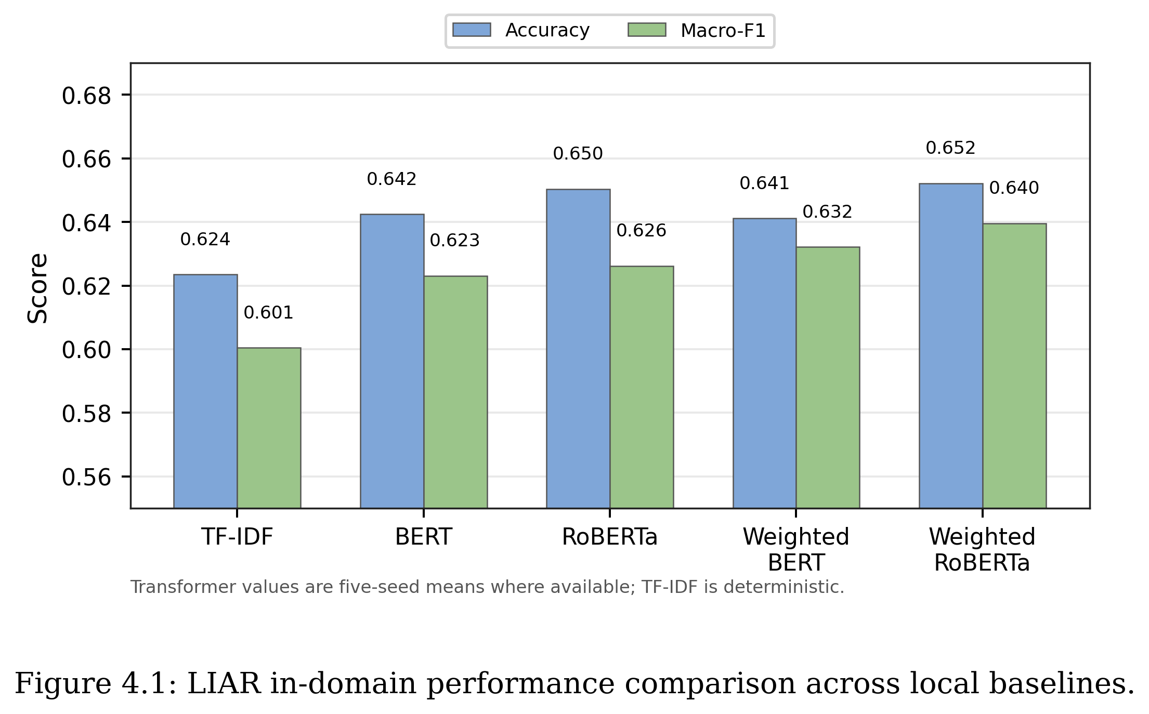
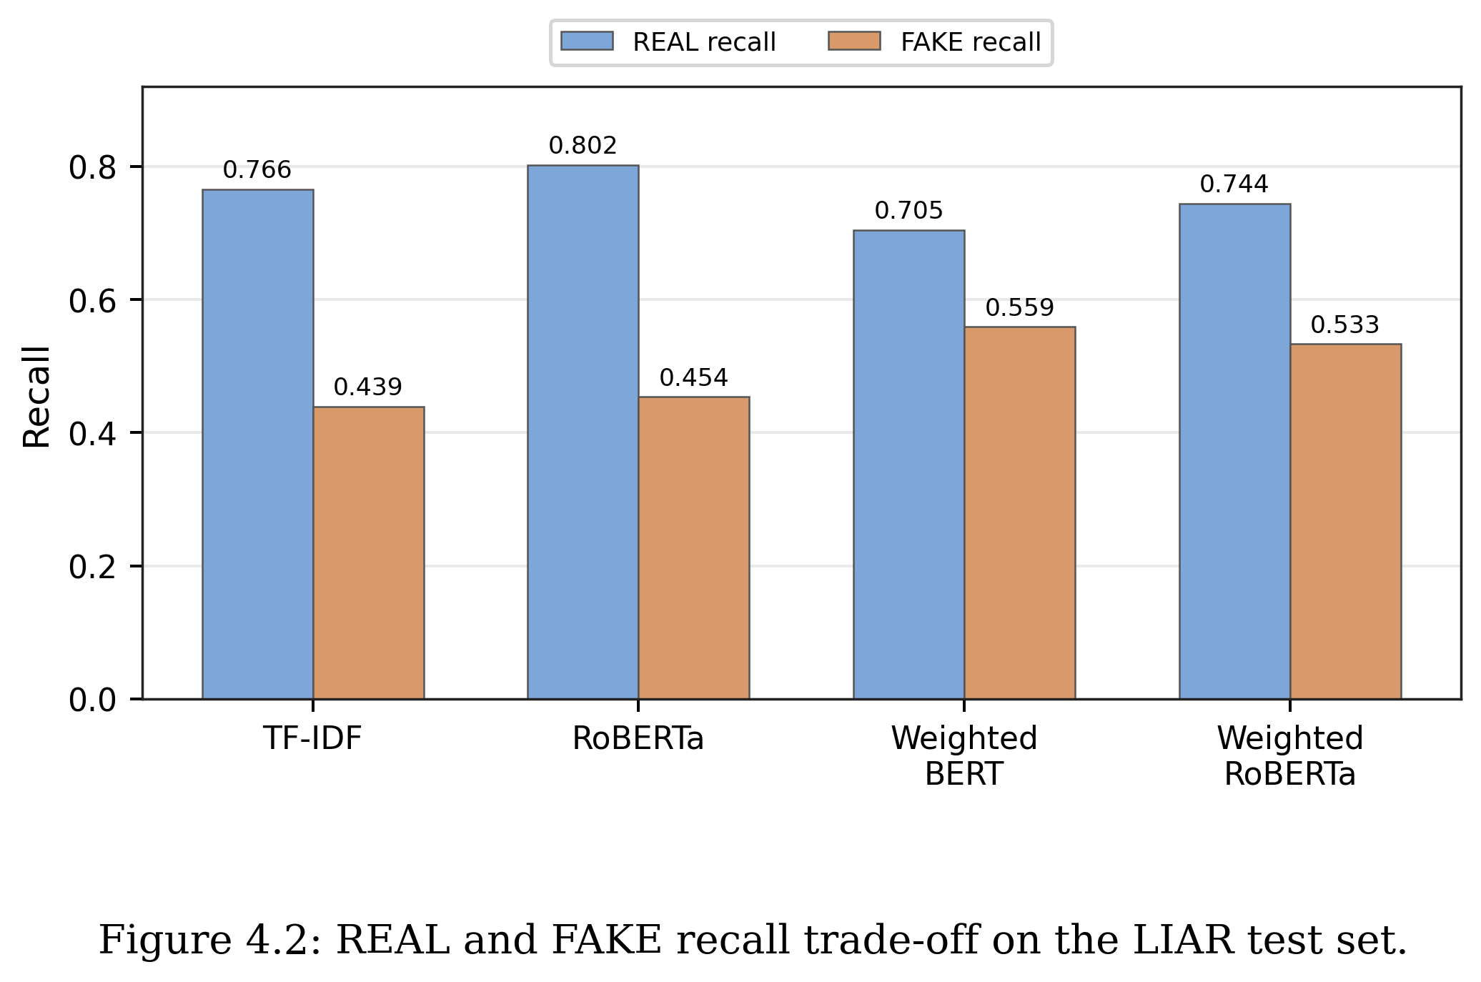

4.3 TF-IDF Baseline
The TF-IDF + Logistic Regression baseline obtains a test Accuracy of 0.6235 and test Macro-F1 of 0.6005. A five-seed determinism check shows identical predictions across seeds. This is expected because the current preprocessing, vectorisation, training, and evaluation pipeline has no meaningful randomness. Therefore, repeating this baseline many times does not provide new statistical evidence.

4.4 BERT and Weighted BERT
The unweighted BERT baseline improves over TF-IDF, with a five-seed mean test Accuracy of 0.6425 and Macro-F1 of 0.6231. Weighted BERT has a similar test Accuracy of 0.6412 but improves Macro-F1 to 0.6322 and reaches FAKE recall of 0.5591. This suggests that class weighting changes the decision boundary and helps the model identify more FAKE examples.

4.5 Weighted RoBERTa
Weighted RoBERTa is the best-performing local baseline by mean Macro-F1, although the gap to weighted BERT is modest. Across five seeds, it obtains a test Accuracy of 0.6522 and Macro-F1 of 0.6396. Its REAL recall is 0.7443, while FAKE recall is 0.5335. This means that RoBERTa gives higher mean overall performance, but it is still relatively conservative in predicting FAKE compared with weighted BERT, and the two transformer variants should be interpreted as comparable rather than clearly separated.

4.6 Comparison with TELLER
TELLER reports stronger LIAR binary performance, with Accuracy 0.6773 and Macro-F1 0.6697. However, TELLER is a different kind of system from the baselines evaluated in this dissertation. Rather than fine-tuning a text classifier directly, it generates structured logic atoms from an input claim using an LLM, then learns logic rules to aggregate those atoms into a prediction. This two-stage pipeline — predicate prompting followed by rule learning — is not directly comparable with a single fine-tuned BERT or RoBERTa model, because any performance difference may reflect the richer intermediate representation rather than a gain in the underlying language model. TELLER is therefore discussed as a prior-work reference rather than as a competing local baseline.

Chapter 5
Error Analysis and Further Experiments

5.1 Motivation
Aggregate metrics do not fully explain model behaviour. Two models can have similar Macro-F1 but make different types of mistakes. Error analysis is therefore used to understand where weighted RoBERTa and weighted BERT still fail. The analysis in this chapter is qualitative, based on a manual review of representative cases drawn from the saved LIAR error file. The patterns described below are recurring failure modes observed across these examples, not the output of an exhaustive automated taxonomy.

5.2 Main Error Patterns
- Numeric claims: statements involving numbers, percentages, or quantities remain difficult because the truth value often depends on external evidence.
- Label-boundary ambiguity: some LIAR labels are close to each other, especially around half-true and barely-true cases.
- Context-dependent statements: short claims may require speaker, event, or evidence context before they can be judged.
- Short statements: very short inputs may not contain enough linguistic signal for a transformer classifier.
- Ambiguous wording: vague or mixed claims can confuse binary REAL/FAKE mapping.
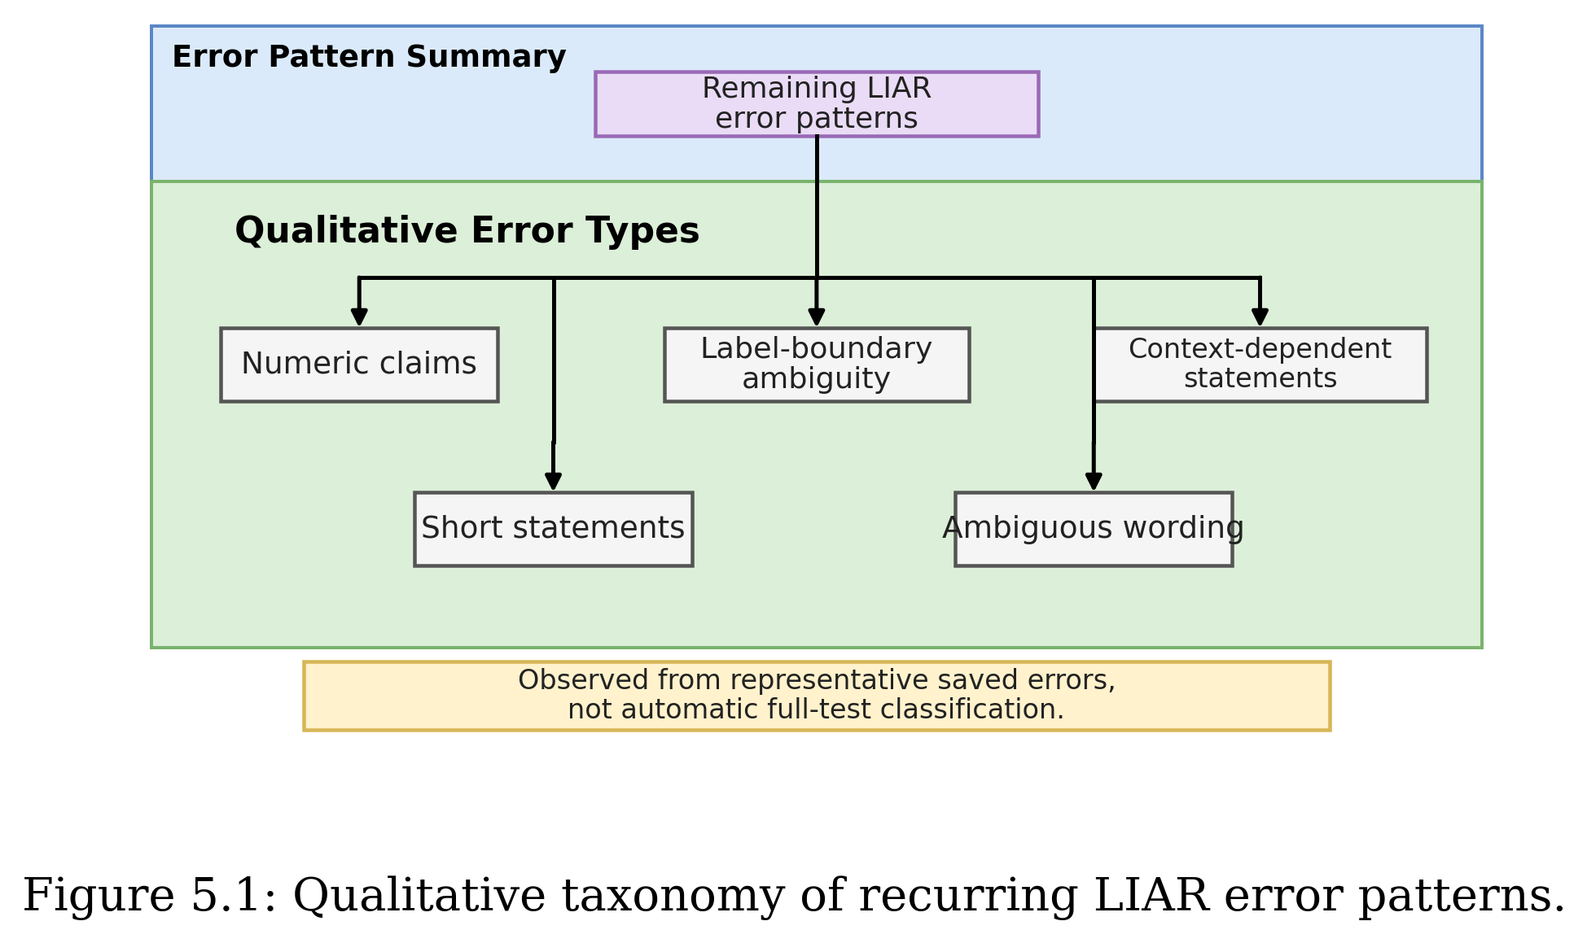

5.3 Weighted BERT and Weighted RoBERTa Trade-off
Weighted RoBERTa achieves higher overall Macro-F1, while weighted BERT produces stronger FAKE recall. Neither model dominates across both metrics, which is precisely why reporting class-level recall alongside Macro-F1 matters. A practitioner who prioritises catching more fake examples would prefer weighted BERT; one who prioritises overall balanced performance would prefer weighted RoBERTa. Accuracy alone would obscure this distinction entirely.

5.4 Preliminary Context Check
A preliminary check was carried out for weighted RoBERTa by comparing statement-only input with a simple concatenation of statement and available context. Exact metrics for this check are not retained in the result files reported in this dissertation, so the check is reported here as a small exploratory comparison rather than a full controlled experiment. The observed pattern was that simple context concatenation did not yield a visible improvement over statement-only input, which suggests that context, if useful, may need a more structured integration method than direct concatenation. A future-work item is to repeat this check with logged metrics so that the comparison can be reported quantitatively.

5.5 Preliminary Threshold Check
A preliminary check was also carried out for weighted RoBERTa using a validation-tuned decision threshold rather than the default 0.5 cut-off. Exact tuned thresholds and the corresponding test-set metrics are not retained in the result files reported in this dissertation, so this check is reported as an exploratory probe rather than as a fully tabulated experiment. The qualitative observation was that the tuned setting redistributed errors between the REAL and FAKE classes - REAL recall went up while FAKE recall went down - without a clear net improvement in Macro-F1. A future-work item is to rerun threshold tuning with logged per-threshold metrics so that the trade-off can be presented as a small table.

5.6 Representative Error Cases
A small number of representative test-set errors are useful in the main text because they make the aggregate error patterns more concrete. The full set of saved examples remains in Appendix D, while Table 5.1 highlights three typical cases.
Table 5.1. Representative LIAR error cases discussed in the main text.
Model | Gold | Pred. | Pattern | Statement
Weighted RoBERTa | FAKE | REAL | Numeric claim | Over the past year ... our 16 counties have hemorrhaged more than 6,000 jobs with no apparent end in sight.
Weighted RoBERTa | REAL | FAKE | Context-dependent claim | I wake up every morning in a house (the White House) that was built by slaves.
Weighted BERT | REAL | FAKE | Label-boundary ambiguity | Says my plan is a property tax cut.

The numeric example shows that a text-only classifier cannot check whether a quantity is correct unless the relevant evidence is present. The context-dependent example shows a different limitation: the sentence can only be judged reliably with background knowledge about the White House. The label-boundary example is shorter and less evidence-rich, so the binary REAL/FAKE mapping hides some of the original LIAR label nuance.

5.7 Summary against RQ3
Overall, the error analysis shows that the remaining mistakes are not random. They are concentrated in numeric claims, label-boundary ambiguity, and context-dependent statements. This supports the later cross-dataset evaluation, because these errors suggest that statement text alone often lacks enough evidence for reliable fake news detection.
The preliminary checks in Sections 5.4 and 5.5 also suggest that simple fixes are not enough. Adding context by concatenation and tuning the prediction threshold did not clearly resolve the remaining problem. The next evaluation therefore asks a sharper question: whether the models can transfer beyond LIAR at all.

Chapter 6
Cross-Dataset Evaluation
This chapter first reports the strict cross-dataset evaluation, where models are trained on LIAR and tested directly on FakeNewsNet minimal titles. It then extends the analysis with intermediate target-domain fine-tuning on FakeNewsNet train subsets and a simplified TELLER-like reasoning-atom pilot. The strict direct-transfer setting uses no FakeNewsNet examples for training, validation, threshold selection, or model selection; the adaptation setting uses only FakeNewsNet train/validation subsets and keeps a held-out FakeNewsNet test split for final evaluation.

6.1 Motivation
In-domain LIAR performance is not enough to show that a fake news detector is reliable. A model may learn dataset-specific language patterns rather than general veracity signals. Cross-dataset evaluation is therefore needed to test whether the model transfers to a different source or domain.

6.2 Target Dataset
FakeNewsNet is used as the first target dataset because it is widely used in fake news detection research and includes PolitiFact and GossipCop sources. The minimal official CSV version contains item identifiers, URLs, titles, and tweet IDs. After cleaning, the title-only target set contains 23,196 rows: 1,056 PolitiFact titles and 22,140 GossipCop titles. Because this version provides titles rather than full article text, the experiment is framed as LIAR statement to FakeNewsNet title transfer.

6.3 Experimental Setup
Three primary transfer baselines are reported--TF-IDF + Logistic Regression, weighted BERT, and weighted RoBERTa--together with an unweighted BERT control that is described in detail in Section 6.8. TF-IDF is trained on LIAR train plus validation using the selected deterministic baseline setup. The transformer baselines use the same five-seed runs as the LIAR experiments, with checkpoint selection based on LIAR validation Macro-F1. For each transformer run, the best LIAR checkpoint is loaded before testing on both LIAR test and FakeNewsNet titles.

Table 6.1. LIAR in-domain comparison before transfer.
Model | Runs | Accuracy | Macro-F1 | REAL Recall | FAKE Recall
TF-IDF | 1 | 0.6235 | 0.6005 | 0.7661 | 0.4394
Weighted RoBERTa | 5 | 0.6522 | 0.6396 | 0.7443 | 0.5335
Weighted BERT | 5 | 0.6412 | 0.6322 | 0.7048 | 0.5591

Table 6.2. LIAR-to-FakeNewsNet title transfer results, including the unweighted BERT control.
Model | Target | Runs | Accuracy | Macro-F1 | REAL Recall | FAKE Recall
TF-IDF | PolitiFact titles | 1 | 0.5152 | 0.5146 | 0.4631 | 0.5903
Weighted RoBERTa | PolitiFact titles | 5 | 0.4795 | 0.4196 | 0.1388 | 0.9718
Weighted BERT | PolitiFact titles | 5 | 0.4835 | 0.4371 | 0.1782 | 0.9245
TF-IDF | GossipCop titles | 1 | 0.4986 | 0.4715 | 0.4771 | 0.5664
Weighted RoBERTa | GossipCop titles | 5 | 0.2619 | 0.2271 | 0.0335 | 0.9836
Weighted BERT | GossipCop titles | 5 | 0.2844 | 0.2601 | 0.0709 | 0.9589
TF-IDF | Combined titles | 1 | 0.4993 | 0.4745 | 0.4766 | 0.5682
Weighted RoBERTa | Combined titles | 5 | 0.2718 | 0.2358 | 0.0372 | 0.9827
Weighted BERT | Combined titles | 5 | 0.2935 | 0.2682 | 0.0747 | 0.9564
Unweighted BERT | PolitiFact titles | 5 | 0.5114 | 0.4805 | 0.2436 | 0.8981
Unweighted BERT | GossipCop titles | 5 | 0.2918 | 0.2710 | 0.0833 | 0.9506
Unweighted BERT | Combined titles | 5 | 0.3018 | 0.2806 | 0.0890 | 0.9467

To interpret the transfer results in Table 6.2, a trivial majority-class reference baseline is also reported. Because FakeNewsNet minimal titles are strongly REAL-skewed, especially in GossipCop, a classifier that always predicts REAL achieves a high target Accuracy without learning anything. Table 6.3 reports Accuracy, Macro-F1, REAL recall, and FAKE recall for this baseline on each target subset. These values are deterministic and follow directly from the target label counts reported in Section 3.2.2.
Table 6.3. Majority-class (always-REAL) reference baseline on FakeNewsNet minimal titles.
Target subset | Accuracy | Macro-F1 | REAL recall | FAKE recall
PolitiFact titles | 0.5909 | 0.3714 | 1.0000 | 0.0000
GossipCop titles | 0.7596 | 0.4317 | 1.0000 | 0.0000
Combined titles | 0.7519 | 0.4292 | 1.0000 | 0.0000

Two observations follow from Table 6.3. First, the majority baseline has a high Accuracy on every target subset, especially on GossipCop and the combined set, simply because FakeNewsNet titles are heavily REAL-skewed. Second, the majority baseline has a Macro-F1 below 0.45 on every subset, because predicting only one class gives a FAKE F1 of zero. This shows directly that Accuracy alone is misleading under this target distribution, and that Macro-F1 must be read alongside class-level recall when comparing transfer baselines.
Comparing Table 6.2 with Table 6.3 also reframes how the four LIAR-trained transfer settings should be read. On combined titles, TF-IDF has lower Accuracy than the majority baseline (0.4993 vs 0.7519) but a slightly higher Macro-F1 (0.4745 vs 0.4292), because it produces non-trivial predictions for both classes. Weighted BERT and weighted RoBERTa, in contrast, fall below the majority baseline on both Accuracy (0.2935 and 0.2718) and Macro-F1 (0.2682 and 0.2358) on the combined target, while still reaching very high FAKE recall by strongly over-predicting FAKE. The unweighted BERT control also falls below the majority baseline on both Accuracy (0.3018) and Macro-F1 (0.2806). This means the transformer transfer results are worse than a trivial REAL-only classifier by Macro-F1 on this target, which is an important corrective to the original LIAR-only ranking.

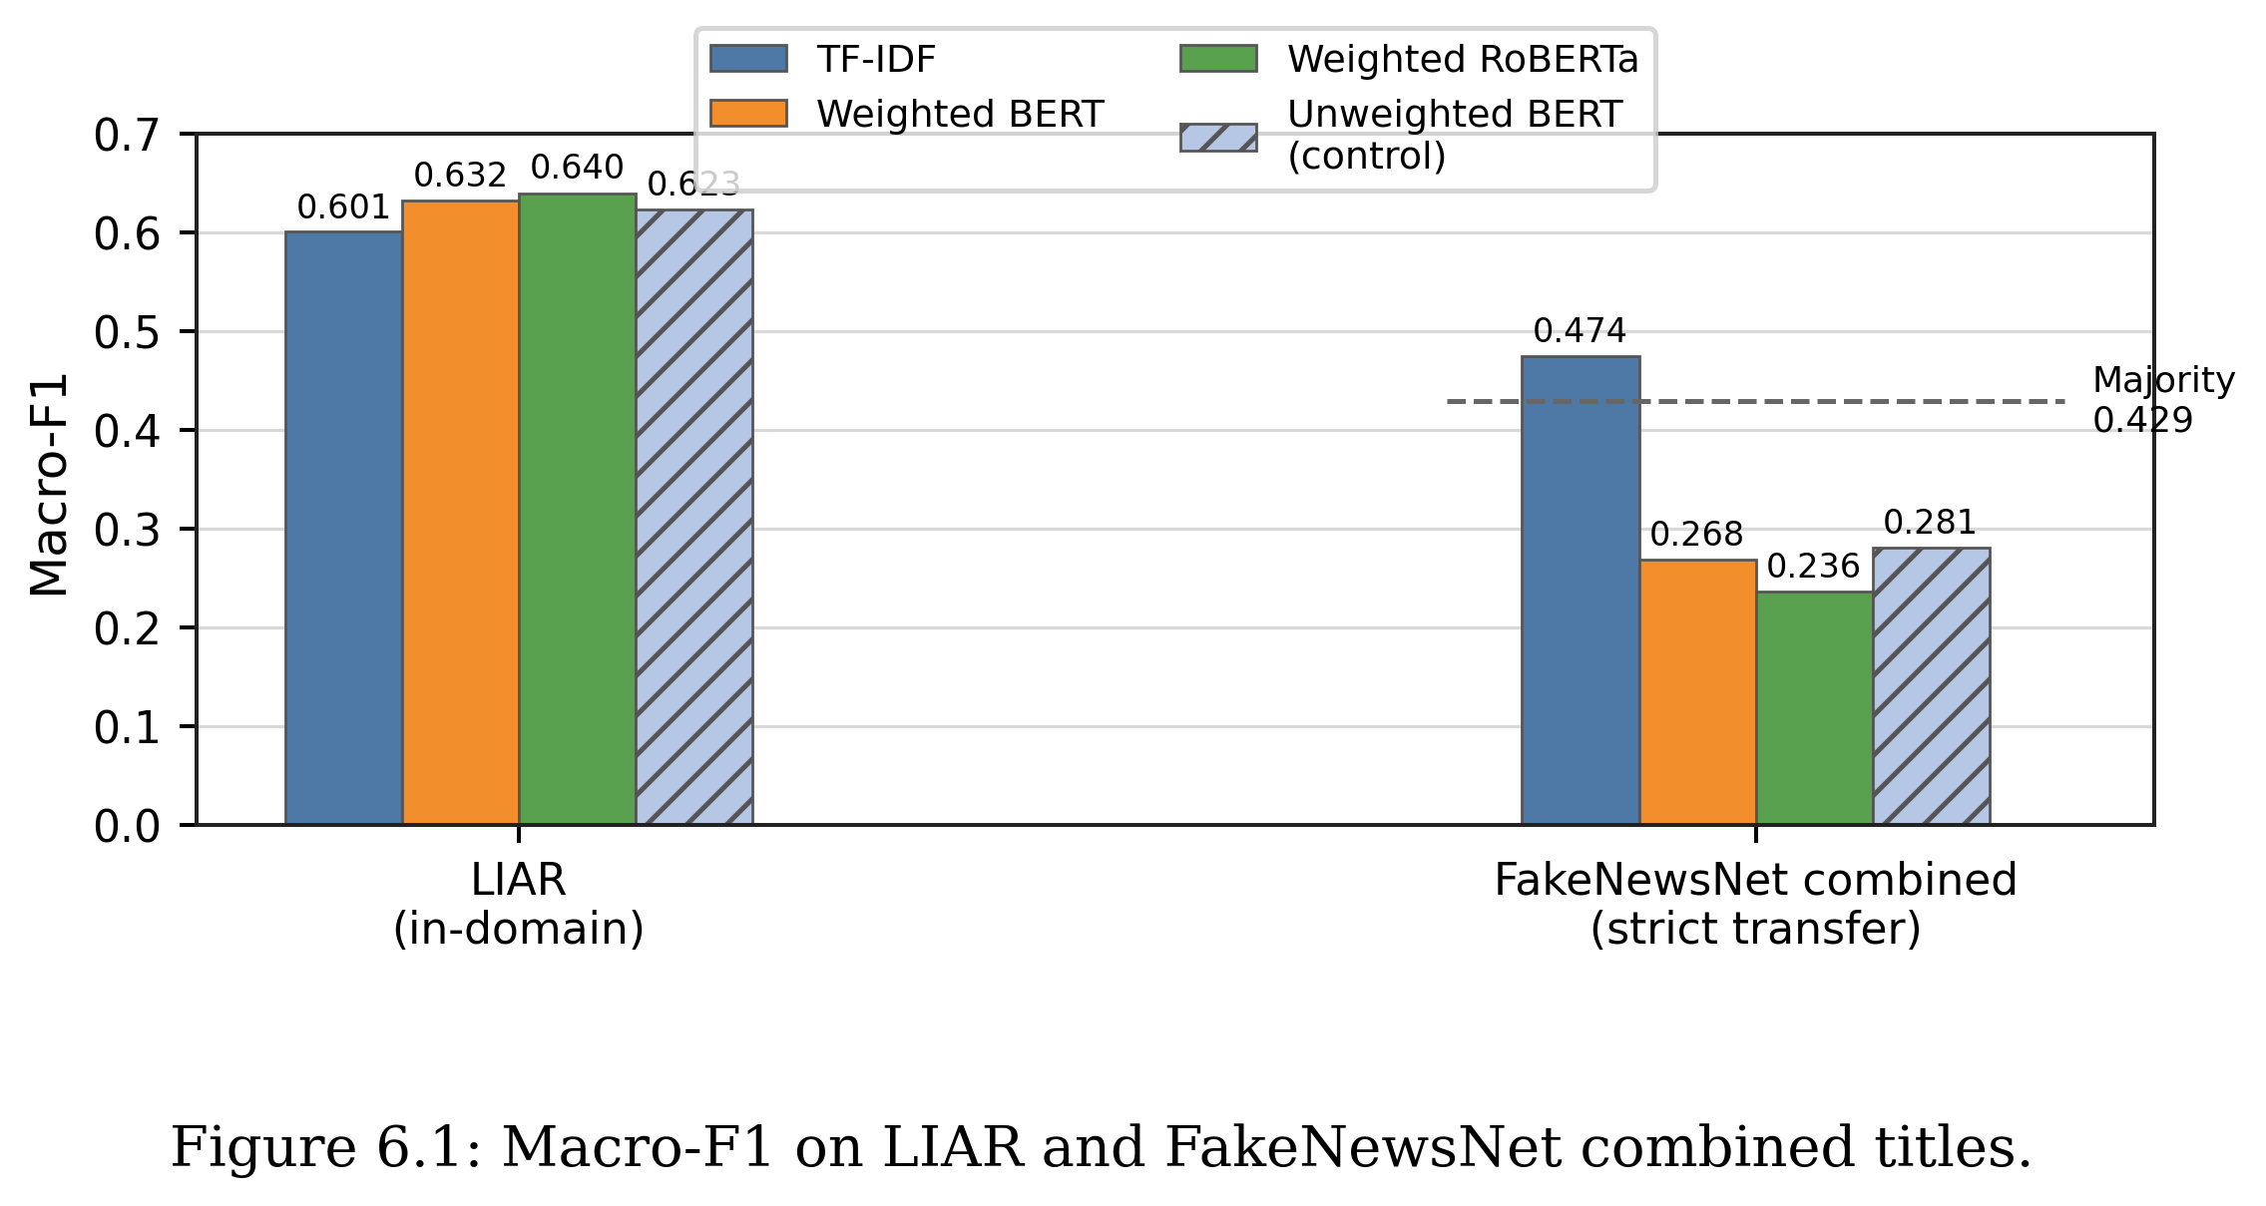
Figure 6.1 compares LIAR in-domain Macro-F1 with strict transfer Macro-F1 on FakeNewsNet combined titles. The four LIAR scores are close together, but the transfer scores separate sharply: TF-IDF remains slightly above the always-REAL majority Macro-F1 reference of 0.4292, while weighted BERT, weighted RoBERTa, and the unweighted BERT control fall below it. The similar transfer scores of weighted and unweighted BERT indicate that class weighting is not the dominant cause of the cross-dataset drop.
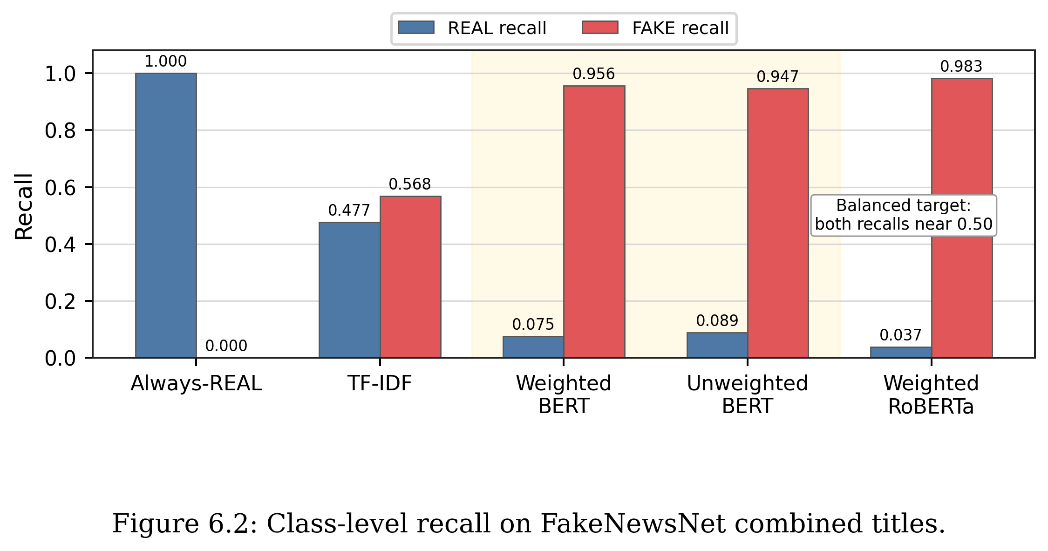
Figure 6.2 explains the low transfer Macro-F1 of the transformer models through class-level recall. Weighted BERT and unweighted BERT sit next to each other and show almost the same pattern: REAL recall remains around 0.08, while FAKE recall stays above 0.94. Removing the class weights therefore does not correct the FAKE-heavy transfer bias.
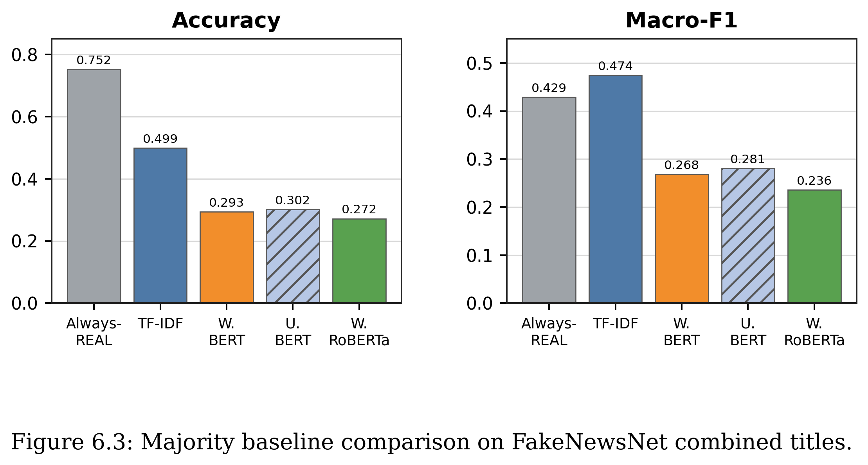
Figure 6.3 compares the completed transfer models with the always-REAL majority baseline on FakeNewsNet combined titles. The majority baseline has the highest Accuracy because the target set is strongly REAL-skewed, while TF-IDF is the only model that marginally exceeds the majority Macro-F1. Weighted BERT and unweighted BERT remain close to each other on both metrics, reinforcing that the weighted loss is not the main explanation for the transfer failure.

6.4 PolitiFact Target Results
On FakeNewsNet PolitiFact titles, TF-IDF reaches 0.5146 Macro-F1, while weighted BERT reaches 0.4371 and weighted RoBERTa reaches 0.4196. The transformer models therefore lose their LIAR advantage even on the politically related target subset. This suggests that matching the broad topic area is not enough; the shift from LIAR statements to FakeNewsNet titles still changes the input distribution and label behaviour.

6.5 GossipCop Target Results
The performance drop is larger on GossipCop titles. TF-IDF reaches 0.4715 Macro-F1, while weighted BERT reaches 0.2601 and weighted RoBERTa reaches 0.2271. This is expected because GossipCop is an entertainment-news domain, whereas LIAR is based on political fact-checking statements. The target text style and topic distribution are therefore further away from the source training data.

6.6 Combined Target Results
All four LIAR-trained baselines, including the unweighted BERT control, drop substantially when moved from LIAR to FakeNewsNet titles. TF-IDF drops from 0.6005 LIAR Macro-F1 to 0.4745 on FakeNewsNet combined titles. Weighted RoBERTa, although highest on LIAR with 0.6396 Macro-F1, drops to 0.2358 on FakeNewsNet combined titles. Weighted BERT drops from 0.6322 to 0.2682. The unweighted BERT control discussed in Section 6.8 reaches 0.2806 Macro-F1 on FakeNewsNet combined titles, which is essentially the same as weighted BERT. Compared with the always-REAL majority baseline in Table 6.3, which obtains 0.4292 Macro-F1 on the combined target, only TF-IDF stays above this trivial reference on Macro-F1 (0.4745); both weighted transformer baselines and the unweighted BERT control fall below it. This is a sharper reading of the transfer failure than the LIAR-only ranking would suggest.
TF-IDF transfers better than the weighted transformers in Macro-F1 on the title-only target set, but it only narrowly exceeds the majority-class baseline (0.4745 vs 0.4292) and remains well below 0.50. None of the completed baselines can therefore be considered robust under this strict transfer setting. The result supports the central research gap of the dissertation: practical fake news detectors need to be evaluated beyond one dataset, and against a trivial class-prior reference, before they can be trusted.

6.7 Within-FakeNewsNet Subpart Transfer
FakeNewsNet minimal combines two source subparts, PolitiFact (political news) and GossipCop (entertainment news), which Sections 6.4-6.6 evaluated together. To check whether the domain gap also exists inside the target dataset, each subpart is evaluated in-domain and transferred to the other (experiment E7), using both the TF-IDF baseline and weighted RoBERTa on title text. Table 6.4 reports the results.
Table 6.4. Within-FakeNewsNet subpart transfer (TF-IDF and weighted RoBERTa, title text only).
Setting | Model | Accuracy | Macro-F1 | REAL recall | FAKE recall
In-domain PolitiFact | TF-IDF | 0.8377 | 0.8329 | 0.8512 | 0.8184
In-domain PolitiFact | weighted RoBERTa | 0.9245 | 0.9205 | 0.9760 | 0.8506
In-domain GossipCop | TF-IDF | 0.8311 | 0.7814 | 0.8609 | 0.7369
In-domain GossipCop | weighted RoBERTa | 0.8437 | 0.7962 | 0.8733 | 0.7502
PolitiFact -> GossipCop | TF-IDF | 0.4244 | 0.4185 | 0.3457 | 0.6729
PolitiFact -> GossipCop | weighted RoBERTa | 0.3018 | 0.2860 | 0.1007 | 0.9371
GossipCop -> PolitiFact | TF-IDF | 0.6193 | 0.5411 | 0.8734 | 0.2523
GossipCop -> PolitiFact | weighted RoBERTa | 0.4725 | 0.4722 | 0.3798 | 0.6065
Both subparts are learnable in-domain (Macro-F1 0.78-0.92), but transfer between them drops sharply (Macro-F1 0.29-0.54), even though both are FakeNewsNet titles. The stronger in-domain model, weighted RoBERTa, transfers worse than TF-IDF (PolitiFact -> GossipCop Macro-F1 0.29 vs 0.42) and reproduces the same FAKE-heavy bias seen in the LIAR-to-FakeNewsNet transfer (REAL recall 0.10, FAKE recall 0.94). This shows the domain gap is not specific to LIAR versus FakeNewsNet: it also separates political from entertainment news within FakeNewsNet, and in-domain strength does not guarantee cross-domain transfer.

6.8 Why Transformers Over-Predict FAKE
The transformer transfer results are especially important because they show that stronger in-domain performance does not guarantee better cross-dataset performance. On FakeNewsNet combined titles, the weighted transformer models predict FAKE too often. This gives very high FAKE recall, but extremely low REAL recall. In other words, the models catch many FAKE title cases but lose the ability to recognise REAL title cases reliably.
An initial candidate explanation, before the control experiment described below, was that the weighted models learn source-domain cues from LIAR that become misleading on FakeNewsNet titles, with the class-weighted loss specifically pushing the decision boundary toward FAKE on out-of-domain inputs. This is the interpretation that the LIAR class weights, which were computed from a roughly balanced source distribution, behave badly when applied to a strongly REAL-skewed target. Under this hypothesis, removing the class weights should noticeably reduce FAKE over-prediction on FakeNewsNet titles.
To test this explanation, an unweighted BERT control was trained on LIAR with the same five-seed protocol, the same validation Macro-F1 checkpoint selection, and the same evaluation pipeline as the weighted BERT model in Table 6.1, but without the inverse-frequency class weights. The unweighted BERT control was then transferred to the same FakeNewsNet PolitiFact, GossipCop, and combined title targets. Table 6.2 reports the resulting five-seed mean metrics, including the GossipCop Macro-F1 value computed from the saved unweighted BERT transfer summary.
The unweighted BERT control behaves very similarly to weighted BERT on the FakeNewsNet target. On combined titles, unweighted BERT obtains Accuracy 0.3018, Macro-F1 0.2806, REAL recall 0.0890, and FAKE recall 0.9467, compared with 0.2935, 0.2682, 0.0747, and 0.9564 for weighted BERT. The improvement in REAL recall when class weights are removed is therefore small (around one percentage point on combined titles, and roughly seven points on PolitiFact titles). Both versions still classify over ninety percent of FakeNewsNet combined titles as FAKE, and both fall below the always-REAL majority baseline in Table 6.3 on both Accuracy and Macro-F1. This means that class weighting is not the main cause of the FAKE over-prediction observed in Section 6.6: removing the weights leaves the same qualitative failure mode in place.
A more plausible explanation is therefore distribution shift between LIAR statements and FakeNewsNet titles, rather than the choice of loss weighting. LIAR contains short political fact-checking claims, often written as direct accusations or factual statements; FakeNewsNet titles are news headlines, with a different style, a different topic distribution, and a different class prior. Both the weighted and unweighted BERT decision boundaries learned on LIAR appear to treat many title patterns as FAKE-like, producing a strong FAKE-heavy transfer bias. This reading is consistent with the recall-plane pattern in the recall comparison in Figure 6.4 and is the central evidence that strong in-domain performance does not imply transferable veracity signals. A complementary unweighted RoBERTa control is the obvious next experiment to confirm that the same effect appears in the RoBERTa family; this is not completed in the current dissertation and is recorded as a remaining methodological item in Section 6.10 and Chapter 7.
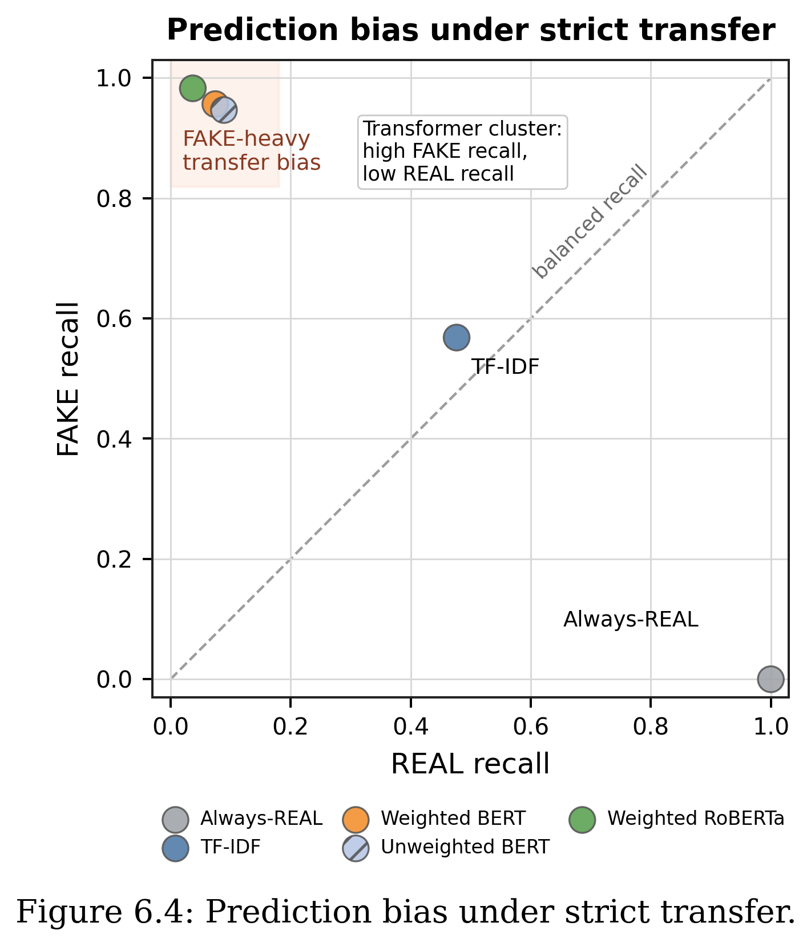

6.9 Intermediate Fine-Tuning with Target-Domain FakeNewsNet Titles
The strict transfer results show that LIAR-trained transformer models do not move reliably to FakeNewsNet titles without adaptation. To test whether a small amount of target-domain supervision can correct this failure mode, an intermediate fine-tuning experiment was added. The weighted RoBERTa model was first trained on LIAR using the same source-domain protocol as the direct transfer experiment. It was then further fine-tuned on stratified fractions of the FakeNewsNet target-train titles before being evaluated on the same held-out FakeNewsNet title test split.
The target-domain fractions were 5%, 10%, and 20% of the FakeNewsNet training split. The 5% setting used 742 target examples, the 10% setting used 1,484 examples, and the 20% setting used 2,969 examples. The same held-out FakeNewsNet test split was used for all intermediate fine-tuning comparisons. This design keeps the direct transfer baseline and the adapted models comparable, while still treating the target test set as unseen.
Table 6.5. Integrated comparison of in-domain, direct transfer, intermediate fine-tuning, and TELLER-like pilot results.
Block | Setting | Acc. | Macro-F1 | REAL Rec. | FAKE Rec. | Note
In-domain | Weighted RoBERTa on LIAR test | 0.6522 | 0.6396 | 0.7443 | 0.5335 | 5-seed LIAR baseline
Direct transfer | LIAR -> FNN combined titles | 0.2718 | 0.2358 | 0.0372 | 0.9827 | 5-seed strict transfer
Direct transfer | LIAR -> held-out FNN test | 0.2725 | 0.2364 | 0.0377 | 0.9842 | 5-seed held-out title-test
Intermediate FT | LIAR -> 5% FNN -> FNN test | 0.7519 | 0.4292 | 1.0000 | 0.0000 | Collapses to REAL
Intermediate FT | LIAR -> 10% FNN -> FNN test | 0.8083 | 0.7035 | 0.9305 | 0.4379 | 5-seed data-efficient recovery
Intermediate FT | LIAR -> 20% FNN -> FNN test | 0.8243 | 0.7463 | 0.9167 | 0.5444 | 5-seed strongest absolute result
TELLER-like pilot | LLM atoms: LIAR -> FNN | 0.5300 | 0.4405 | 0.1300 | 0.9300 | Exploratory only
TELLER-like pilot | LLM atoms: FNN -> FNN | 0.6000 | 0.6000 | 0.5900 | 0.6100 | Target atom upper bound
The intermediate fine-tuning results change the interpretation of the cross-dataset experiment. With no target-domain adaptation, the LIAR-trained weighted RoBERTa model is almost entirely FAKE-biased on the held-out FakeNewsNet test split, with five-seed mean FAKE recall 0.9842 but REAL recall only 0.0377. The 5% target-domain setting does not solve the problem in the seed-42 run; it flips the bias in the opposite direction and predicts nearly all target examples as REAL, producing high Accuracy but a weak Macro-F1 of 0.4292. The five-seed 10% and 20% settings are more meaningful. With 10% target data, mean Macro-F1 rises to 0.7035, and with 20% target data it reaches 0.7463 while preserving high REAL recall and improving FAKE recall to 0.5444.
These results show that the poor direct transfer scores are not simply caused by the target dataset being impossible. Rather, the model needs enough labelled target-domain examples to recalibrate its decision boundary. Intermediate fine-tuning is therefore the main practical response to the strict transfer failure: it turns the cross-dataset result from a negative robustness finding into evidence about how much target supervision is needed before useful transfer appears.

6.10 TELLER-like LLM Reasoning-Atoms Pilot
A second exploratory experiment was added to test a simplified TELLER-like idea. Instead of asking an LLM to decide whether each item was REAL or FAKE, DeepSeek V4 Flash generated structured reasoning atoms such as emotional language, exaggerated claim, specific evidence, source reference, logical consistency, and clickbait style. A separate Logistic Regression or Random Forest classifier then used these atoms as features. This keeps the cognition-style signal generation separate from the final decision model, which is closer to the general TELLER design than direct LLM classification.
The pilot should not be treated as a main contribution or as a reproduction of TELLER. It uses only a small, balanced atom sample and a simplified feature set. Its role is supporting analysis: it tests whether LLM-generated reasoning signals reduce the same cross-domain bias seen in the transformer transfer results. The answer is mixed. The LIAR-atoms to FakeNewsNet-atoms setting reaches only 0.4405 Macro-F1 with Logistic Regression and strongly over-predicts FAKE, with REAL recall 0.1300 and FAKE recall 0.9300. The FakeNewsNet-atoms in-domain pilot reaches 0.6000 Macro-F1, suggesting that the atoms contain some target-domain signal but do not by themselves solve cross-dataset generalisation.

6.11 Summary against RQ5
RQ5 asks how well LIAR-trained baselines transfer to FakeNewsNet minimal titles. Under strict direct transfer, the answer remains weak: the transformer models over-predict FAKE and perform below the always-REAL majority-class reference on the combined target. However, the intermediate fine-tuning experiment shows that this failure can be partly corrected when enough labelled target-domain examples are introduced. Five percent target data is not sufficient in the seed-42 run and collapses toward REAL predictions, but the five-seed 10% and 20% target-domain fine-tuning results substantially improve the held-out FakeNewsNet test result, reaching 0.7035 and 0.7463 Macro-F1 respectively. The final answer to RQ5 is therefore two-part: strict zero-shot transfer is unreliable, but intermediate fine-tuning with a modest labelled target subset can recover useful target-domain performance.

6.12 Limitations of the Transfer Setting
This transfer setting has five main limitations. First, LIAR statements and FakeNewsNet titles are different text fields, so the experiment combines dataset shift with input-format shift. Second, LIAR is mainly political fact-checking, while FakeNewsNet also includes entertainment news, so the topic distributions differ substantially. Third, the label sources are not identical, so labelling protocols differ. Fourth, only the 10% and 20% adaptation settings have been repeated over the five-seed protocol; the 5% setting remains seed-42 evidence and should not be treated as a stable effect-size estimate. Fifth, the TELLER-like reasoning-atom experiment is only a pilot and should be read as supporting analysis, not as a reproduced TELLER system or as the dissertation main contribution.

Chapter 7
Discussion

7.1 Main Findings
Transformer-based models improve over the TF-IDF baseline in the LIAR in-domain setting, but the improvement is moderate rather than dramatic. TF-IDF reaches 0.6005 Macro-F1 on LIAR, while weighted RoBERTa reaches 0.6396 and weighted BERT reaches 0.6322. Pre-trained transformers are stronger, but the LIAR binary task remains genuinely difficult even for modern models.
Class weighting meaningfully changes model decision behaviour. Weighted BERT is not the best model by overall Accuracy, but it obtains the highest mean FAKE recall among the completed five-seed local baselines. A fake news detector should not only maximise average performance; it should also avoid missing too many FAKE examples. This trade-off between overall balance and minority-class sensitivity is only visible through class-level recall, not Macro-F1 alone.
Among the completed local baselines, weighted RoBERTa achieves the highest mean Macro-F1, though the gap to weighted BERT is modest. With a five-seed mean Accuracy of 0.6522 and Macro-F1 of 0.6396, it is the strongest balanced model in the LIAR in-domain setting. Its FAKE recall is lower than weighted BERT, however, so it should not be read as the best model for every use case. Without a paired statistical test on the per-seed Macro-F1 values, the two weighted transformer variants are best interpreted as comparable rather than clearly ranked.
Strong in-domain performance does not transfer automatically, and the failure cannot be explained by class weighting alone. When LIAR-trained models are evaluated on FakeNewsNet minimal titles without adaptation, all completed baselines drop sharply. Both weighted BERT and weighted RoBERTa become strongly biased toward predicting FAKE, producing very high FAKE recall but very poor REAL recall; on the combined target, both fall below the trivial always-REAL majority-class baseline on both Accuracy and Macro-F1. A matched unweighted BERT control, trained with the same five-seed protocol but without class weights, shows nearly the same FAKE-heavy behaviour. Removing the class weights changes the magnitude of the bias only slightly, pointing to distribution shift between LIAR statements and FakeNewsNet titles as the dominant cause.
As a supplementary observation rather than a main experimental finding, TELLER remains best treated as an advanced literature comparison. The local TELLER-like reasoning-atom pilot is useful because it separates LLM-generated cognition-style signals from a simple decision model, but it does not reproduce the full TELLER system. Its results also show a limitation: LLM-generated atoms can still carry domain-specific bias, and the LIAR-atoms to FakeNewsNet-atoms setting remains strongly FAKE-skewed. The pilot therefore supports the dissertation argument about dataset shift rather than replacing the main transformer and intermediate fine-tuning experiments.

7.2 Comparison with Prior Cross-Domain Work
The transfer results in this dissertation can be placed next to prior cross-domain fake-news work (reviewed in Section 2.5). Direct numeric comparison is limited because most prior systems use non-text signals (propagation graphs) or specialised architectures and different datasets, so the comparison is about the pattern and about positioning this work as a reproducible, text-only baseline. Table 7.1 summarises the comparison.
Table 7.1. This dissertation's transfer results compared with prior cross-domain fake-news work.
Work | Datasets | Method | Key reported result | Non-text signals?
Silva et al. [17] | PolitiFact+GossipCop+CoAID | Dual domain-specific / cross-domain embeddings | up to +7.55% F1 (~+25% rare domains) | Yes (propagation)
Castelo et al. [18] | US-Election2016, PolitiFact | Topic-agnostic (readability/markup) features | ~0.86 / 0.83 accuracy; transfers better than content models | Partly (web-markup)
Han et al. [19] | Twitter propagation datasets | Propagation GNN + continual learning | ~0.80-0.84 F1; reduces not removes drop | Yes (propagation)
Wei et al. [20] (FADED) | New-MultiFC, FND-3 | Dual-granularity adversarial training | state-of-the-art avg F1 on unseen domains | No (text), specialised
Liguori et al. [21] (MERMAID) | 4 fake-news datasets | Mixture-of-experts | up to ~30% improvement with little target data | No, ensemble
Kishi et al. [22] | Kaggle, FakeNewsNet, ISOT, NELA-GT | in- vs cross-dataset analysis | in-dataset macro-F1 ~0.99; ~17-pt F1 cross-dataset drop | No
This dissertation | LIAR -> FakeNewsNet titles; FakeNewsNet subparts | Reproducible text-only baselines + intermediate fine-tuning | LIAR in-domain 0.64; LIAR->FNN ~0.24 (below majority); subpart transfer 0.29-0.54; recovered to 0.70/0.75 with intermediate FT | No (titles/statements)
Across the literature the qualitative finding is shared: cross-domain transfer drops substantially (for example, Kishi et al. [22] report about a 17-point F1 drop). This dissertation observes the same drop on a stricter, text-only setting: in-domain Macro-F1 of about 0.83-0.92 falls to about 0.29-0.54 across FakeNewsNet subparts, and LIAR in-domain Macro-F1 0.64 falls to about 0.24 on LIAR-to-FakeNewsNet. Where prior work improves transfer with propagation graphs [17, 19] or adversarial and mixture-of-experts designs [20, 21], this work shows that a simple, cheap intervention - a small amount of target-domain intermediate fine-tuning - recovers most of the lost performance (Macro-F1 0.24 to 0.70/0.75) without social-graph data or a new architecture. Because the datasets, label schemes, and input signals differ, these numbers are not strictly comparable; this work therefore complements rather than competes with these systems.

7.3 Implications
The findings suggest that fake news detection models should not be judged by Accuracy alone. Macro-F1 and class-level recall provide a more informative picture, especially when FAKE recall is important. A model that gives a slightly lower overall score may still be useful if it catches more FAKE cases.
The cross-dataset results have a stronger implication. A model can look strong on LIAR but fail badly when tested on another dataset. Intermediate fine-tuning shows that this failure is not permanent: with 10-20% labelled FakeNewsNet target data, the model can recalibrate and recover much stronger Macro-F1. This means practical fake news detection should report both strict transfer and adaptation results, because zero-shot robustness and target-domain recoverability answer different questions.
The comparison with TELLER also has a practical implication. Stronger published systems should be interpreted together with their system assumptions. If a system uses LLM calls, generated logic atoms, or manual predicate design, then those components are part of the model being evaluated. The local atoms pilot shows that adding LLM-generated reasoning signals does not automatically remove dataset shift or class-bias problems.

7.4 Limitations
The first limitation is that the cross-dataset target uses FakeNewsNet minimal titles rather than full article text. This makes the experiment useful for short-text transfer, but it does not fully represent article-level fake news detection. The performance drop should therefore be interpreted as a transfer result under a title-only target setting.
The second limitation is that only one target dataset family has been tested so far. FakeNewsNet is a useful first target, but a stronger final thesis would ideally include another target dataset or a fuller target-domain baseline. This would reduce the risk of drawing broad conclusions from one source-target pair.
The third limitation is that TELLER has not been reproduced locally. The added reasoning-atom experiment is only a simplified pilot inspired by TELLER-style separation between cognition signals and decision aggregation. It should therefore be used to discuss the limits of LLM-generated signals, not to claim a full TELLER reproduction.
The fourth limitation is that the context and threshold checks in Sections 5.4 and 5.5 are preliminary rather than fully tabulated experiments. Their exact metrics are not recorded in the result files reported in this dissertation, so they are presented as exploratory observations and not as quantitative evidence. Re-running these checks with logged metrics is listed as future work.
A further limitation is that the adaptation analysis is still limited to selected target fractions. The 10% and 20% target-domain settings have now been repeated over the five-seed protocol and are suitable for the main comparison, but the 5% setting remains seed-42 only and may not represent a stable low-data adaptation point. The direct transfer and adaptation results also use title-only FakeNewsNet inputs, so they remain evidence about short-text transfer rather than full-article fake news detection.
Finally, the binary mapping of LIAR simplifies the original six-label structure. This is useful for comparison with binary fake news datasets, but it can hide the uncertainty between labels such as half-true and barely-true. Many errors in the analysis come from this boundary area.

7.5 Future Work
Because the 10% and 20% intermediate fine-tuning reruns are now complete, future work should no longer be framed as validating those two rows. The remaining methodological question is how those adaptation results compare with stronger target-domain baselines and additional controls. The main experimental direction is therefore target-domain evaluation and upper-bound comparison, rather than more zero-shot controls alone.
The most direct next step is to strengthen the target-domain evaluation further. A full FakeNewsNet in-domain transformer baseline, trained directly on the target training split without the LIAR source stage, would provide a clearer upper bound for the intermediate fine-tuning results. If full article text becomes available, the same protocol should also be repeated with richer input.
A second direction is to add another target dataset. This would make the cross-dataset claim stronger because the dissertation would not rely on one source-target pair. MultiFC or another fact-checking dataset could be considered if the label mapping and access conditions are manageable.
A third direction is to explore methods designed for domain robustness, such as domain-adaptive pretraining or more careful context integration. These methods should only be added if there is enough time to evaluate them clearly and avoid turning the dissertation into an uncontrolled model search.
A final direction is to keep TELLER as partial inspiration rather than a main experimental path unless full reproduction becomes feasible. The current atoms pilot is useful for discussing LLM reasoning-signal limitations, but the dissertation main contribution should remain the reproducible baseline, direct-transfer failure analysis, and intermediate fine-tuning recovery experiment.

Chapter 8
Conclusion

8.1 Summary of the Study
This dissertation set out to evaluate reproducible fake news detection baselines on the LIAR dataset, to measure how well those baselines transfer to FakeNewsNet titles, and to test whether intermediate target-domain fine-tuning can recover performance after strict transfer failure. Starting from a deterministic TF-IDF + Logistic Regression reference, the study added BERT, class-weighted BERT, RoBERTa, and class-weighted RoBERTa under consistent binary label mapping, fixed data splits, and a five-seed evaluation protocol. A matched unweighted BERT control was run to isolate the role of class weighting, and a later intermediate fine-tuning experiment tested 5%, 10%, and 20% FakeNewsNet target-domain supervision.
The study also discusses TELLER as a recent advanced framework for fake news detection. TELLER reports stronger LIAR performance than the local baselines, but it uses an LLM-based reasoning pipeline rather than a standard BERT or RoBERTa classifier. It is therefore treated as an advanced literature comparison rather than as a directly reproduced local baseline. A simplified TELLER-like reasoning-atom pilot is included only as supporting analysis, not as a main contribution.

8.2 Answers to the Research Questions
RQ1 asked how traditional and transformer-based classifiers perform on LIAR binary fake news detection. The answer is that transformer models improve over TF-IDF, but the improvement is moderate. Weighted RoBERTa obtains the highest mean Accuracy and Macro-F1 among the completed local baselines, with 0.6522 Accuracy and 0.6396 Macro-F1 across five seeds, although the gap to weighted BERT is modest and was not tested for statistical significance.
RQ2 asked whether class-weighted training improves Macro-F1 or FAKE recall. The answer is mixed but useful. Weighted BERT improves Macro-F1 compared with unweighted BERT and gives the highest mean FAKE recall among the completed local baselines. Weighted RoBERTa has higher mean overall metrics, showing a trade-off between balanced performance and FAKE-class sensitivity.
RQ3 asked what kinds of LIAR test items are most often misclassified by the best-performing local model. A qualitative review of representative errors shows that mistakes cluster around three patterns: numeric claims that require external evidence to verify, context-dependent statements whose truth value depends on background knowledge not present in the text, and label-boundary cases where the original LIAR fine-grained label sits close to the REAL/FAKE boundary. These patterns are consistent across both weighted BERT and weighted RoBERTa and suggest that statement-only text often provides insufficient signal for binary veracity judgement.
RQ4 asked how local baselines should be compared with advanced systems such as TELLER. The answer is a feasibility-level discussion rather than an experimental result: TELLER is only partly comparable because it is an LLM-based reasoning framework, not a standard BERT or RoBERTa classifier, and it has not been reproduced locally in this dissertation. It is therefore treated as an advanced literature comparison rather than a directly evaluated baseline.
RQ5 asked how well LIAR-trained baselines transfer to FakeNewsNet minimal titles. Under strict direct transfer, the answer is weak: weighted BERT and weighted RoBERTa perform well in-domain but over-predict FAKE on FakeNewsNet titles, producing very low REAL recall, and the unweighted BERT control shows that this is not primarily caused by class weighting. However, intermediate target-domain fine-tuning changes the result. Five percent FakeNewsNet fine-tuning remains biased toward REAL predictions in the seed-42 run, but the five-seed 10% and 20% target-domain fine-tuning results substantially improve the held-out FakeNewsNet test result, with the 20% setting reaching 0.7463 Macro-F1.

8.3 Main Outcomes
The first outcome is a reproducible LIAR binary baseline setup with fixed splits, consistent label mapping, and five-seed transformer evaluation. The second outcome is a class-sensitive comparison demonstrating that the model with the highest mean Macro-F1 and the model with the highest mean FAKE recall are not the same model, and that Accuracy alone cannot reveal this distinction. The third outcome is a strict cross-dataset transfer evaluation showing that higher LIAR performance does not guarantee higher FakeNewsNet performance, and that the FAKE over-prediction observed for BERT persists when class weights are removed. The fourth outcome is an intermediate fine-tuning result showing that target-domain supervision can recover performance once enough labelled FakeNewsNet examples are used. The strongest improvement was obtained with 20% FakeNewsNet intermediate fine-tuning, while the simplified TELLER-like pilot showed that coarse LLM-generated reasoning atoms were insufficient to resolve cross-dataset shift.

8.4 Limitations
The main limitation is that the cross-dataset target uses FakeNewsNet minimal titles rather than full article text. This means the transfer and adaptation settings are useful for short-text generalisation, but they do not fully represent article-level fake news detection. Another limitation is that only the 10% and 20% intermediate fine-tuning settings have five-seed support; the 5% setting remains seed-42 only and should be interpreted cautiously. A third limitation is that only one target dataset family has been tested, so the cross-dataset conclusion should be expanded with additional datasets if time and data access allow.
A further limitation is that some advanced systems from the literature, especially TELLER, have not been reproduced locally. This means a published framework with higher reported LIAR scores is discussed rather than directly implemented, so the dissertation should not be read as a direct experimental comparison between TELLER and the local baselines. The simplified reasoning-atom pilot is useful for probing whether LLM-generated signals reduce class bias, but it is not a full TELLER reproduction and remains exploratory. A final methodological limitation is that the matched unweighted-transfer control has been completed for BERT but not yet for RoBERTa; this remains a useful secondary control, although the main next step is now target-domain upper-bound evaluation.

8.5 Future Work
The highest-priority future work is to add a stronger target-domain upper bound. A full FakeNewsNet in-domain transformer baseline, trained and validated directly on FakeNewsNet titles, would show how far the 10% and 20% intermediate fine-tuning results are from a fully target-trained model. It would also clarify whether 20% target-domain adaptation is close to the practical ceiling for this title-only setting or whether substantially more target data remains necessary.
Future work should also investigate why LIAR-trained transformers over-predict FAKE on FakeNewsNet titles. A direct next step would be to compare title-only transfer with full-article transfer if full article text becomes available. Another useful extension would be to add a second target dataset so that the generalisation conclusion is not based on one source-target pair.
Future work could also test domain-adaptive pretraining, better context integration, or simpler reasoning-inspired features. These extensions should be evaluated using the same reproducible structure: fixed train, validation, and test splits; multiple seeds; validation-based checkpoint selection; and class-level metrics. In particular, future LLM-atom experiments should use richer feature definitions and stronger validation before being treated as more than exploratory support.

References
[1] W. Y. Wang. "Liar, Liar Pants on Fire": A New Benchmark Dataset for Fake News Detection. Proceedings of the 55th Annual Meeting of the Association for Computational Linguistics, 2017.
[2] K. Shu, D. Mahudeswaran, S. Wang, D. Lee, and H. Liu. "FakeNewsNet: A Data Repository with News Content, Social Context, and Spatiotemporal Information for Studying Fake News on Social Media." Big Data, 8(3), 2020. arXiv:1809.01286.
[3] I. Augenstein, C. Lioma, D. Wang, L. C. Lima, Casper Hansen, Christian Hansen, and J. G. Simonsen. "MultiFC: A Real-World Multi-Domain Dataset for Evidence-Based Fact Checking of Claims." Proceedings of EMNLP-IJCNLP, 2019.
[4] H. Rashkin, E. Choi, J. Y. Jang, S. Volkova, and Y. Choi. "Truth of Varying Shades: Analyzing Language in Fake News and Political Fact-Checking." Proceedings of EMNLP, 2017.
[5] V. Perez-Rosas, B. Kleinberg, A. Lefevre, and R. Mihalcea. "Automatic Detection of Fake News." Proceedings of COLING, 2018.
[6] J. Devlin, M. W. Chang, K. Lee, and K. Toutanova. "BERT: Pre-training of Deep Bidirectional Transformers for Language Understanding." Proceedings of NAACL-HLT, 2019.
[7] Y. Liu, M. Ott, N. Goyal, J. Du, M. Joshi, D. Chen, O. Levy, M. Lewis, L. Zettlemoyer, and V. Stoyanov. "RoBERTa: A Robustly Optimized BERT Pretraining Approach." arXiv:1907.11692, 2019.
[8] E. Papageorgiou, I. Varlamis, and C. Chronis. "Harnessing Large Language Models and Deep Neural Networks for Fake News Detection." Information, 16(4), Article 297, 2025. DOI: 10.3390/info16040297.
[9] H. Liu, W. Wang, H. Li, and H. Li. "TELLER: A Trustworthy Framework for Explainable, Generalizable and Controllable Fake News Detection." Findings of the Association for Computational Linguistics: ACL 2024, pages 15556-15583, 2024. DOI: 10.18653/v1/2024.findings-acl.919. arXiv:2402.07776.
[10] B. Hu, Q. Sheng, J. Cao, Y. Shi, Y. Li, D. Wang, and P. Qi. "Bad Actor, Good Advisor: Exploring the Role of Large Language Models in Fake News Detection." Proceedings of AAAI, 2024. arXiv:2309.12247.
[11] K. Pelrine, A. Imouza, C. Thibault, M. Reksoprodjo, C. Gupta, J. Christoph, J.-F. Godbout, and R. Rabbany. "Towards Reliable Misinformation Mitigation: Generalization, Uncertainty, and GPT-4." Proceedings of EMNLP, pages 6399-6429, 2023. DOI: 10.18653/v1/2023.emnlp-main.395.
[12] L. Pan, X. Wu, X. Lu, A. Luu, W. Wang, M. Y. Kan, and P. Nakov. "Fact-Checking Complex Claims with Program-Guided Reasoning." Proceedings of ACL, 2023.
[13] S. Henning, W. Beluch, A. Fraser, and A. Friedrich. "A Survey of Methods for Addressing Class Imbalance in Deep-Learning Based Natural Language Processing." Proceedings of EACL, 2023.
[14] J. M. Johnson and T. M. Khoshgoftaar. "Survey on Deep Learning with Class Imbalance." Journal of Big Data, 6, Article 27, 2019.
[15] X. Wang, H. Wang, and D. Yang. "Measure and Improve Robustness in NLP Models: A Survey." Proceedings of NAACL-HLT, pages 4569-4586, 2022. DOI: 10.18653/v1/2022.naacl-main.339.
[16] S. Gururangan, A. Marasovic, S. Swayamdipta, K. Lo, I. Beltagy, D. Downey, and N. A. Smith. "Do not Stop Pretraining: Adapt Language Models to Domains and Tasks." Proceedings of ACL, 2020.
[17] A. Silva, L. Luo, S. Karunasekera, and C. Leckie. "Embracing Domain Differences in Fake News: Cross-Domain Fake News Detection using Multi-modal Data." Proceedings of AAAI, 2021. arXiv:2102.06314.
[18] S. Castelo, T. Almeida, A. Elghafari, A. S. R. Santos, K. Pham, E. F. Nakamura, and J. Freire. "A Topic-Agnostic Approach for Identifying Fake News Pages." WWW 2019 Companion, pages 975-980, 2019. DOI: 10.1145/3308560.3316739.
[19] Y. Han, S. Karunasekera, and C. Leckie. "Graph Neural Networks with Continual Learning for Fake News Detection from Social Media." arXiv:2007.03316, 2020.
[20] W. Wei, Y. Zhang, J. Li, P. Liu, and D. Zhou. "Cross-Domain Fake News Detection based on Dual-Granularity Adversarial Training." Proceedings of COLING, pages 9407-9417, 2025.
[21] A. Liguori, F. S. Pisani, C. Comito, M. Guarascio, and G. Manco. "Breaking Domain Barriers: Mixture of Experts for Cross-Domain Fake News Detection." Machine Learning, 114, Article 188, 2025. DOI: 10.1007/s10994-025-06827-9.
[22] Y. Kishi, Y. Arima, and H. Iyatomi. "Fake News Detection Strategies under Dataset Bias: Using Large-scale Coarse-grained Labels." Proceedings of EACL Student Research Workshop, pages 612-621, 2026. DOI: 10.18653/v1/2026.eacl-srw.47.
[23] S. Kuntur, A. Wroblewska, M. Ganzha, M. Paprzycki, and S. Sachdeva. "Fake News Detection: It is All in the Data!" Applied Sciences, 16(3), Article 1585, 2026. DOI: 10.3390/app16031585.
[24] J. Dodge, G. Ilharco, R. Schwartz, A. Farhadi, H. Hajishirzi, and N. A. Smith. "Fine-Tuning Pretrained Language Models: Weight Initializations, Data Orders, and Early Stopping." arXiv:2002.06305, 2020.
[25] S. Swayamdipta, R. Schwartz, N. Lourie, Y. Wang, H. Hajishirzi, N. A. Smith, and Y. Choi. "Dataset Cartography: Mapping and Diagnosing Datasets with Training Dynamics." Proceedings of EMNLP, pages 9275-9293, 2020. DOI: 10.18653/v1/2020.emnlp-main.746.

Appendices

Appendix A. Full Classification Report Summaries
This appendix records the classification-report-level summary metrics used in the dissertation. Transformer rows are five-seed means unless marked as representative. All result files listed in the final column are stored under the results directory.
Table A.1. Classification metric summaries used in the dissertation.
Model and setting | Accuracy | Macro-F1 | REAL recall | FAKE recall | Source file
TF-IDF on LIAR test | 0.6235 | 0.6005 | 0.7661 | 0.4394 | cross_dataset_model_comparison.md
Weighted BERT on LIAR test | 0.6412 +/- 0.0065 | 0.6322 +/- 0.0090 | 0.7048 +/- 0.0292 | 0.5591 +/- 0.0447 | bert_weighted_seed_sweep_results.md
Weighted RoBERTa on LIAR test | 0.6522 +/- 0.0074 | 0.6396 +/- 0.0080 | 0.7443 +/- 0.0153 | 0.5335 +/- 0.0199 | roberta_weighted_seed_sweep_results.md
TF-IDF on FakeNewsNet combined titles | 0.4993 | 0.4745 | 0.4766 | 0.5682 | cross_dataset_model_comparison.md
Weighted BERT on FakeNewsNet combined titles | 0.2935 +/- 0.0234 | 0.2682 +/- 0.0342 | 0.0747 +/- 0.0414 | 0.9564 +/- 0.0320 | cross_dataset_model_comparison.md
Weighted RoBERTa on FakeNewsNet combined titles | 0.2718 +/- 0.0154 | 0.2358 +/- 0.0229 | 0.0372 +/- 0.0245 | 0.9827 +/- 0.0126 | cross_dataset_model_comparison.md

Appendix B. Confusion Matrices
The following matrices use the layout rows = gold label and columns = predicted label, with label order [REAL, FAKE]. For five-seed transformer experiments, the main dissertation reports mean metrics; representative matrices are included here from saved result files.

Table B.1. Available confusion matrices and matrix sources.
Model and setting | Confusion matrix | Note
TF-IDF on LIAR test | [[547, 167], [310, 243]] | Deterministic baseline.
Weighted RoBERTa on LIAR test, seed 52 | [[531, 183], [247, 306]] | Representative highest-Macro-F1 single run from the five-seed weighted RoBERTa sweep.
Weighted BERT on LIAR test, seed 72 | [[471, 243], [204, 349]] | Representative high-FAKE-recall run; reconstructed from reported class recalls and LIAR test counts.
Weighted RoBERTa on FakeNewsNet combined titles | See figure file weighted_roberta_fakenewsnet_combined_confusion_matrix.png | Five-seed target evaluation summary stored in results/cross_dataset.
Weighted BERT on FakeNewsNet combined titles | See figure file weighted_bert_fakenewsnet_combined_confusion_matrix.png | Five-seed target evaluation summary stored in results/cross_dataset.

Appendix C. Hyperparameter Settings
Table C.1. Reproducible hyperparameter settings.
Component | Setting
Source dataset | LIAR train, validation, and test splits
Target dataset | FakeNewsNet minimal title-only CSV
Binary label mapping | REAL = true, mostly-true, half-true; FAKE = barely-true, false, pants-on-fire
Transformer models | bert-base-uncased; roberta-base
Maximum sequence length | 128
Training batch size | 16
Evaluation batch size | 32 in notebooks; 64 in cross-dataset scripts
Epochs | 3
Optimizer | AdamW
Learning rate | 2e-5
Weight decay | 0.01
Warmup ratio | 0.1
Seeds | 42, 52, 62, 72, 82
Checkpoint selection | Best validation Macro-F1; validation Accuracy as tie-breaker in the saved training code
Weighted loss | Balanced class weights computed from LIAR train split only
Hardware | NVIDIA GeForce RTX 3060 Laptop GPU with CUDA-enabled PyTorch

Appendix D. Example Error Cases
The examples below are selected from the saved LIAR error analysis file. They illustrate common error patterns rather than replacing the full test-set analysis.
Table D.1. Representative LIAR error-analysis examples.
Model | Gold | Predicted | Pattern | Statement
Weighted RoBERTa | REAL | FAKE | Context-dependent | I wake up every morning in a house (the White House) that was built by slaves.
Weighted RoBERTa | FAKE | REAL | Numeric claim | Over the past year ... our 16 counties have hemorrhaged more than 6,000 jobs with no apparent end in sight.
Weighted BERT | REAL | FAKE | Label-boundary ambiguity | Says my plan is a property tax cut.
Weighted BERT | FAKE | REAL | Numeric claim | Texas high school graduation rate went from 27th in the country in 2002, to second highest in the country in 2013.
RoBERTa correct, BERT wrong | REAL | BERT predicted FAKE | Context-dependent | There has never been a panther attack in the history of Florida.
BERT correct, RoBERTa wrong | FAKE | RoBERTa predicted REAL | Numeric claim | If Trump had just put his fathers money in a mutual fund ... hed have $8 billion.

Appendix E. GitHub Reproducibility Instructions
The exact commands may need small path changes depending on the local environment, but the experiment structure is as follows.
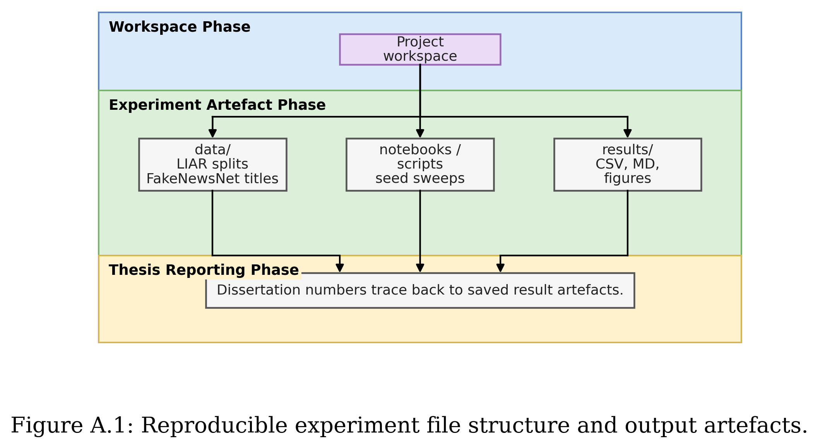
- Install the Python environment with PyTorch, HuggingFace Transformers, scikit-learn, pandas, numpy, matplotlib, seaborn, and python-docx.
- Place LIAR files at data/liar_dataset/train.tsv, data/liar_dataset/valid.tsv, and data/liar_dataset/test.tsv.
- Place the processed FakeNewsNet minimal title file at data/fakenewsnet_minimal/processed/fakenewsnet_minimal_titles.csv.
- Run the TF-IDF baseline notebook or script first to reproduce the deterministic LIAR baseline.
- Run the BERT, weighted BERT, RoBERTa, and weighted RoBERTa notebooks with seeds 42, 52, 62, 72, and 82.
- Run notebooks/10_cross_dataset_transformer_liar_to_fakenewsnet.py for weighted transformer transfer experiments.
- Run notebooks/11_cross_dataset_results_summary_figures.py to regenerate summary tables and figures for Chapter 6.

