Cross-Dataset Generalisation for Fake News Detection Using Reproducible Transformer-Based Baselines

Boyu Lu
School of Computer Science
University of Galway

Supervisor(s)
Dr. Josephine Griffith

In partial fulfilment of the requirements for the degree of MSc in Software Design and Development
May 2026

DECLARATION
I, Boyu Lu, hereby declare that this thesis, titled "Cross-Dataset Generalisation for Fake News Detection Using Reproducible Transformer-Based Baselines", and the work presented in it are my own except where explicitly stated otherwise. This work has not been previously submitted, in part or whole, to any university or institution for any degree, diploma, or other qualification.
Signature: __________________________
Date: ______________________________

Abstract
Fake news detection has become an important task in natural language processing because unreliable information can spread quickly across online platforms. Many existing studies report strong performance when models are trained and tested within the same dataset. However, strong in-domain performance does not necessarily show that a detector will remain reliable when applied to another dataset with different topics, label rules, or writing styles.
This dissertation investigates reproducible fake news detection baselines with a focus on a binary fake news detection task and cross-dataset behaviour. The project compares a traditional TF-IDF and Logistic Regression baseline with transformer-based models including BERT, RoBERTa, and their class-weighted loss variants. The evaluation reports Accuracy, Macro-F1, confusion matrices, and class-level recall, with special attention to FAKE recall because missing fake news can be more harmful than false alarms.
The LIAR experiments show that weighted RoBERTa obtains the highest mean Accuracy and Macro-F1 among the completed local baselines across five random seeds, although the gap to weighted BERT is modest. Weighted BERT obtains a lower Macro-F1 but a higher FAKE recall, showing a trade-off between overall performance and minority-class sensitivity. Prior work such as TELLER [9] reports higher LIAR performance using an LLM-based reasoning pipeline; this dissertation discusses TELLER only as a literature comparison and does not reproduce it.
The strict transfer experiments train on LIAR and evaluate on FakeNewsNet titles without target-domain adaptation. Under this setting, the weighted transformer baselines fall below a trivial majority-class (always-REAL) baseline on both Accuracy and Macro-F1, and a matched unweighted BERT control shows that distribution shift is the dominant cause of the failure. The thesis further evaluates intermediate target-domain fine-tuning as an adaptation strategy and includes a simplified TELLER-inspired LLM reasoning-atom pilot experiment. With 20% FakeNewsNet intermediate fine-tuning, weighted RoBERTa reaches 0.7447 Macro-F1 on the held-out target test split, while the TELLER-like pilot shows that coarse LLM-generated atoms do not remove cross-dataset bias by themselves.
Keywords: Fake news detection; Class imbalance; Cross-dataset generalisation; Transformer fine-tuning; Baseline evaluation; Distribution shift

Contents
1 Introduction 1
1.1 Background 1
1.2 Problem Statement 1
1.3 Aim and Objectives 2
1.4 Research Questions 2
1.5 Outcomes 3
1.6 Thesis Structure 3
2 Literature Review 4
3 Methodology 13
4 LIAR In-Domain Experiments 21
5 Error Analysis and Further Experiments 25
6 Cross-Dataset Evaluation 29
7 Discussion 38
8 Conclusion 42
References 45
Appendices 48

List of Figures
3.1 Overall experimental pipeline for cross-dataset fake news detection 14
3.2 Binary label mapping and class distribution across LIAR and FakeNewsNet 16
3.3 Five-seed transformer training and evaluation protocol 18
4.1 LIAR in-domain performance comparison across local baselines 22
4.2 REAL and FAKE recall trade-off on the LIAR test set 23
5.1 Qualitative taxonomy of recurring LIAR error patterns 26
6.1 Macro-F1 on LIAR and FakeNewsNet combined titles 31
6.2 Class-level recall on FakeNewsNet combined titles 32
6.3 Majority baseline comparison on FakeNewsNet combined titles 32
6.4 Prediction bias under strict transfer 35
A.1 Reproducible experiment file structure and output artifacts 51

List of Tables
1.1 Research questions 2
3.1 Dataset splits and label distributions for LIAR and FakeNewsNet 14
3.2 Binary label mapping 15
3.3 Baseline models 17
3.4 Main transformer hyperparameter settings 17
4.1 Main LIAR results 21
4.2 Class-level recall for local models with saved recall metrics 22
5.1 Representative LIAR error cases discussed in the main text 27
6.1 LIAR in-domain comparison before transfer 30
6.2 LIAR-to-FakeNewsNet title transfer results 30
6.3 Majority-class (always-REAL) reference baseline on FakeNewsNet minimal titles 30
A.1 Classification metric summaries used in the dissertation 48
B.1 Available confusion matrices and matrix sources 49
C.1 Reproducible hyperparameter settings 49
D.1 Representative LIAR error-analysis examples 50

Chapter 1
Introduction

1.1 Background
The rapid spread of online information has made fake news detection an important research problem. False or misleading claims can influence public opinion, political debate, health behaviour, and trust in institutions. Manual fact-checking remains essential, but it is slow and cannot easily match the speed and scale of online content. Automatic fake news detection therefore aims to support the identification of unreliable information using natural language processing methods.
Fake news detection is a difficult task because veracity is not always visible from the text alone. A short political statement may require context, evidence, speaker history, or domain knowledge before it can be judged correctly. Datasets such as LIAR provide labelled claims and make supervised learning possible, but they also introduce challenges such as fine-grained labels, ambiguous label boundaries, and domain-specific language.
Recent transformer-based models such as BERT and RoBERTa have improved text classification performance in many NLP tasks. However, strong performance on one benchmark does not guarantee that a model will generalise to another dataset. This problem is especially important in fake news detection because datasets differ in topic, source, label scheme, and text style.

1.2 Problem Statement
Many fake news detection studies focus on in-domain evaluation, where the model is trained and tested on splits from the same dataset. This setting is useful, but it can overestimate real-world reliability. A detector trained on LIAR political statements may not perform equally well on datasets such as FakeNewsNet or MultiFC, where the content type, domain, and annotation process differ.
Another issue is class imbalance and class-level behaviour. A model may achieve acceptable Accuracy while still missing many FAKE examples. In practical fake news detection, this is a serious limitation because false negatives can allow misinformation to pass undetected. Therefore, evaluation should include Macro-F1 and class-level recall, not Accuracy alone.

1.3 Aim and Objectives
The aim of this dissertation is to evaluate how selected LIAR-trained text classifiers perform in-domain and when transferred to FakeNewsNet titles, with attention to FAKE recall and the role of class weighting.
- Build and evaluate a traditional TF-IDF + Logistic Regression baseline on the LIAR binary classification task for comparative benchmarking.
- Fine-tune standard BERT and RoBERTa baselines locally under identical train, validation, and test splits.
- Evaluate the impact of class-weighted loss functions on Macro-F1 and FAKE recall under class imbalance.
- Analyse remaining error patterns in the best-performing local baselines to identify statement-only limitations.
- Summarise advanced LLM-based systems such as TELLER from the literature and explain why their reported results are not directly comparable with locally fine-tuned classifiers.
- Compare LIAR-trained classifiers on FakeNewsNet titles under strict transfer, and report the gap against a trivial always-REAL class-prior baseline.

1.4 Research Questions
Table 1.1. Research questions.
ID | Research question | Purpose
RQ1 | How well do traditional and transformer-based classifiers perform on LIAR binary fake news detection? | Establish reliable in-domain baselines.
RQ2 | Does class-weighted training improve Macro-F1 or FAKE recall? | Study class-sensitive model behaviour.
RQ3 | What kinds of LIAR test items are most often misclassified by the best-performing local model, and do these patterns suggest limits of statement-only modelling? | Understand model limitations beyond aggregate scores.
RQ4 | To what extent are LIAR-trained local baselines directly comparable with LLM-based frameworks such as TELLER, given differences in system design? | Avoid presenting LLM-based frameworks and locally fine-tuned classifiers as if they were directly comparable systems.
RQ5 | How well do LIAR-trained baselines transfer to FakeNewsNet minimal titles? | Measure cross-dataset reliability directly.

1.5 Outcomes
- A reproducible LIAR binary classification setup using fixed train, validation, and test splits.
- A comparative evaluation of TF-IDF, BERT, class-weighted BERT, RoBERTa, and class-weighted RoBERTa baselines.
- A five-seed experimental evaluation reporting mean and standard deviation for transformer baselines to capture seed variance.
- A class-sensitive analysis showing that class-weighted loss functions improve minority-class (FAKE) recall but result in modest Macro-F1 variations.
- An analytical comparison highlighting system-design and reproducibility differences between local classifiers and LLM-based reasoning frameworks.
- A strict LIAR-to-FakeNewsNet title transfer evaluation that demonstrates a severe generalisation drop and benchmarks it against a trivial always-REAL baseline.
- An identification of research gaps in current literature concerning reproducible cross-dataset fake news detection.

1.6 Thesis Structure
Chapter 2 summarises datasets, traditional and transformer-based fake news detection, LLM-based reasoning systems, class imbalance, robustness, and cross-dataset generalisation. Chapter 3 describes the dataset preparation, TF-IDF/BERT/RoBERTa model setups, training setup, and evaluation protocol. Chapter 4 reports the LIAR in-domain experiments. Chapter 5 presents error analysis and preliminary checks on context input and decision-threshold tuning. Chapter 6 reports the strict LIAR-to-FakeNewsNet title transfer evaluation, intermediate target-domain fine-tuning, and a simplified TELLER-like reasoning-atoms pilot. Chapter 7 discusses findings and limitations. Chapter 8 concludes the dissertation.

Chapter 2
Literature Review

2.1 Fake News Detection Datasets and LIAR
Research in fake news detection has depended heavily on the availability of labelled datasets. Several benchmark datasets have been established, each with different scope, label schemes, and domain coverage.
Wang [1] introduced the LIAR dataset, one of the most widely used benchmarks in fake news detection research. LIAR was collected from PolitiFact.com and contains 12,836 labelled political statements. All statements are in English and were collected from PolitiFact between 2007 and 2016. Statements are typically short, with a median length of about 18 words; the dataset also provides speaker metadata and a context field that are not used in this dissertation. Each statement was assessed by expert fact-checkers and assigned one of six truthfulness labels: true, mostly-true, half-true, barely-true, false, and pants-on-fire. Metadata including speaker identity, political affiliation, and the context of the statement is also provided. The value of LIAR is significant: it offers a large-scale, naturally occurring political fake news corpus with fine-grained truthfulness labels. However, the six-class scheme presents a challenge for binary classification models, as the boundary between adjacent labels - particularly between half-true and barely-true - is ambiguous. This boundary ambiguity makes the task both harder and more realistic. Many subsequent studies map the six labels into a binary scheme (real / fake), following Wang's original suggestion.
Shu et al. [2] released FakeNewsNet, a dataset that goes beyond claim text to include social context information such as article content, news propagation paths, and user engagement signals on social media. FakeNewsNet covers two domains: political news (sourced from PolitiFact) and entertainment news (sourced from GossipCop). The multi-domain structure of FakeNewsNet makes it particularly suitable for studying cross-domain generalisation. However, the social context features require external data access and are not always easy to use in all experimental settings, especially when only claim text is available.
Augenstein et al. [3] presented MultiFC at EMNLP 2019, the largest publicly available dataset of naturally occurring fact-checked claims at the time. MultiFC aggregates claims from 26 English-language fact-checking websites, annotated by expert journalists, and includes associated evidence text. The dataset covers multiple domains - politics, science, and entertainment - and is notable for its diversity of sources and label schemes. MultiFC achieved a best Macro-F1 of only 49.2% in the original paper, reflecting how challenging cross-source veracity prediction is. The main limitation of MultiFC is the inconsistency in annotation standards across 26 different websites, which adds label noise and makes direct comparison between sources difficult.
These datasets vary considerably in domain, label scheme, and the kind of information they provide. This variation means that a model trained on LIAR may not perform well on FakeNewsNet or MultiFC, and vice versa. The mismatch between datasets - in terms of language style, topic focus, and annotation criteria - is a core motivation for studying cross-dataset generalisation.
Kuntur et al. [23] reviewed fake news detection from a dataset-centred perspective, arguing that dataset quality, label design, dataset diversity, and bias strongly shape model reliability. This is important for the present project because the main experimental problem is not only model selection, but also whether a model trained on one dataset remains meaningful when applied to another dataset. The limitation of this survey is that it provides broad dataset guidance rather than a direct LIAR-to-FakeNewsNet transfer experiment.

2.2 Traditional and Transformer-Based Fake News Detection
The field of fake news detection has evolved from hand-crafted feature approaches to pre-trained language model fine-tuning. Each stage has contributed to our understanding of how linguistic signals relate to truthfulness.
Early studies showed that language style itself carries veracity signals. Rashkin et al. [4] analysed the linguistic characteristics of fake news across different truthfulness levels, using the LIAR dataset. They found that deceptive statements tend to use more hedging language, stronger subjective sentiment, and fewer assertive phrases compared to truthful statements. This work demonstrated that even relatively simple linguistic features - captured by n-gram models - can be informative for veracity prediction. However, these models are highly domain-specific: features that distinguish true and false statements in political discourse may not transfer to entertainment or scientific domains.
Perez-Rosas et al. [5] further explored the use of linguistic features - including lexical, syntactic, and psycholinguistic features - for fake news detection. Their results confirmed that feature-based classifiers can achieve meaningful performance, but they also showed that performance drops significantly when models are tested on out-of-domain data. This finding highlighted the generalisation problem as a fundamental challenge for feature-based approaches.
A major shift occurred with the introduction of pre-trained language models. Devlin et al. [6] proposed BERT (Bidirectional Encoder Representations from Transformers), which learns contextual text representations through pre-training on large corpora using two objectives: masked language modelling (MLM) and next sentence prediction (NSP). BERT demonstrated strong performance across a wide range of NLP tasks through fine-tuning on task-specific labelled data. The contribution of BERT is foundational: it showed that deep bidirectional context modelling can capture subtle semantic nuances that earlier models missed. While BERT established strong bidirectional representations, subsequent work like RoBERTa demonstrated that its pre-training configuration could be further optimized by training on larger datasets, using larger batches, and removing the next sentence prediction task.
Liu et al. [7] introduced RoBERTa (Robustly Optimized BERT Pretraining Approach), which revisited and improved BERT's pre-training by training on larger datasets, removing the NSP objective, and using dynamic masking. RoBERTa achieved state-of-the-art results on GLUE, RACE, and SQuAD benchmarks, outperforming BERT while using the same model architecture. RoBERTa has since become a strong baseline for text classification tasks, including fake news detection, due to its improved language understanding. The limitation of RoBERTa and similar models is that they are fine-tuned on a fixed training domain and may not generalise well when the test distribution differs significantly.
Papageorgiou et al. [8] conducted a large-scale comparison of current methods across multiple fake news datasets, including LIAR and FakeNewsNet. The study compared traditional models, BERT-based classifiers, and LLM-based approaches, finding that performance varies substantially across datasets. This multi-dataset evaluation highlights that no single model achieves consistently strong results across all benchmarks. Importantly, this study evaluates each dataset separately - training and testing on the same dataset - rather than testing strict cross-dataset transfer. The distinction matters: multi-dataset evaluation does not directly measure a model's ability to transfer from one domain to another.
Table 2.1. Summary of prior literature on fake news classification and dataset benchmarks.
Study | Model(s) Used | Dataset(s) | Reported Metric(s) | Key Findings & Limitations
Wang [1] | SVM, Logistic Regression | LIAR (6-class) | ~27.7% Accuracy | Baseline paper; metadata improves accuracy slightly but text-only remains low.
Rashkin et al. [4] | MaxEnt, Naive Bayes, LSTM | LIAR (binary) | ~62.0% Macro-F1 | Found stylistic/sentiment patterns; highly specific to political domain.
Perez-Rosas [5] | SVM (Linguistic/Lexical features) | Custom, FakeNewsNet | ~70.0% - 80.0% Accuracy | Achieves strong in-domain performance but drops 15-20 points out-of-domain.
Devlin et al. [6] | BERT-Base / Large | GLUE benchmarks | - | Established bidirectional representation fine-tuning; no transfer tested.
Liu et al. [7] | RoBERTa-Base | GLUE, SQuAD | - | Optimised BERT pre-training; transfer under distribution shift not evaluated.
Papageorgiou [8] | BERT, Traditional, LLMs | LIAR, FakeNewsNet | ~65.0% - 68.0% Accuracy | Evaluated multiple datasets independently; did not run strict zero-shot transfer.

2.3 LLM and Reasoning-Based Fake News Detection
Recent advances in large language models have opened new directions for fake news detection. Rather than relying solely on fine-tuned classifiers, a growing body of research explores the use of LLMs for generating explanations, structured reasoning, and logic-guided predictions.
Liu et al. [9] proposed TELLER, an LLM-based framework published at Findings of ACL 2024. TELLER addresses three limitations of existing approaches: the lack of explainability in neural classifiers, poor generalisation across domains, and the risks of integrating LLMs without control mechanisms. The framework operates through two systems: a cognition system, which uses human-designed logical predicates to prompt an LLM and generate structured logic atoms from the input claim; and a decision system, which learns generalizable logic rules to aggregate these atoms and produce a prediction. On the LIAR binary task, TELLER reports an accuracy of 0.6773 and Macro-F1 of 0.6697, which is higher than standard BERT and RoBERTa fine-tuned baselines. TELLER is therefore a useful prior-work comparison, but it is a different kind of system from the local baselines in this dissertation: it uses an LLM-generated intermediate representation and a learned rule-based decision component, whereas this project fine-tunes standard text classifiers. Reproducing TELLER would require separate implementation and validation of its predicate-prompting pipeline, so it is discussed as prior work rather than treated as a directly evaluated baseline.
Hu et al. [10] examined the dual role of LLMs in the fake news ecosystem - as a potential tool for generating disinformation (the "bad actor" role) and as a tool for detecting it (the "good advisor" role). Their empirical study shows that GPT-3.5 prompted directly to predict fake or real news consistently underperforms a fine-tuned BERT on both Chinese and English benchmarks (Weibo21 and GossipCop), but that LLM-generated rationales - defined as natural-language explanations produced by an LLM for each input claim - when used as a side input to a small fine-tuned model rather than as the predictor, produce a stronger system than either model alone. Their proposed Adaptive Rationale Guidance (ARG) network frames the LLM as an advisor rather than a detector. The main limitation is that ARG still requires LLM access during training; the choice between proprietary APIs and locally hosted open-source LLMs determines the practical reproducibility cost.
Pelrine et al. [11] provided one of the first systematic comparisons of LLM prompting strategies for fake news detection across multiple datasets. Their results showed that LLM-only baselines, even with carefully designed prompts, do not consistently match fine-tuned smaller models on standard benchmarks. This finding is consistent with Hu et al. [10] and supports the more cautious view that LLMs alone are not yet a drop-in replacement for fine-tuned classifiers in this task. The limitation of this work is that it does not propose a new system, but its diagnostic value is clear.
Pan et al. [12] proposed a fact-checking system in which a complex claim is converted into a sequence of executable, Python-like reasoning steps. These steps call sub-tasks such as verifying a date, comparing numbers, or retrieving evidence, and the sub-task outputs are then aggregated into a final verdict. This method demonstrates that explicit reasoning procedures can improve both accuracy and explainability on complex, multi-step claims. The limitation is that this approach answers a different problem from short-text classifier transfer and is not directly comparable with the local baselines evaluated here.
Overall, LLM-based and reasoning-based approaches improve explainability and, in some setups, accuracy. They are important comparators, but they answer a different implementation question from this dissertation's controlled local-baseline evaluation. Reproducing TELLER was outside the scope of this dissertation because it would require implementing and validating a separate LLM predicate-prompting pipeline; this was not pursued.

2.4 Class Imbalance and Evaluation Metrics
Class imbalance is a common challenge in fake news detection datasets. Models trained on imbalanced data tend to favour the majority class, leading to poor performance on the minority class.
Henning et al. [13] conducted a comprehensive survey of class imbalance problems in NLP, reviewing methods including oversampling, undersampling, data augmentation, and loss function weighting. The survey found that class-weighted loss functions are often effective in practice for text classification tasks, as they directly adjust the contribution of each class during training without requiring data modification. The paper also discusses the choice of evaluation metric: accuracy is misleading under class imbalance, and Macro-F1 - which weights each class equally - is recommended as a more informative metric.
Johnson and Khoshgoftaar [14] surveyed class imbalance approaches specifically in the context of deep learning, covering a wider range of techniques including ensemble methods and cost-sensitive learning. They found that the optimal strategy depends on the degree of imbalance and the task, but that weighted loss functions are consistently competitive across scenarios.
In the context of fake news detection on LIAR, the binary mapping from six labels can produce a slight class imbalance depending on the mapping chosen. Models trained without addressing this imbalance tend to have higher REAL recall but lower FAKE recall. Since the real-world cost of missing a fake news item (false negative) is typically higher than wrongly flagging a real item (false positive), FAKE recall is an important supplementary metric alongside Macro-F1.

2.5 Robustness and Cross-Dataset Generalisation
Cross-dataset generalisation is one of the most important unsolved problems in fake news detection. A model that performs well on one dataset often drops significantly when tested on another.
Wang et al. [15] surveyed robustness research in NLP, covering domain shift, adversarial examples, and dataset bias. The survey found that models fine-tuned on a specific dataset often rely on dataset-specific patterns (shortcuts or spurious correlations) rather than general linguistic signals of truthfulness. This leads to brittle behaviour when the test distribution differs from training. In fake news detection, different datasets come from different sources, platforms, and annotation processes, which creates substantial distribution shifts between them.
Gururangan et al. [16] proposed Domain-Adaptive Pretraining (DAPT), a method in which a pre-trained language model is further pre-trained on domain-specific unlabelled text before task-specific fine-tuning. DAPT showed consistent improvements across a range of domain-specific tasks, suggesting that bridging the gap between the general pre-training distribution and the target task domain can improve both in-domain and cross-domain performance. This approach is directly relevant to cross-dataset fake news detection: by adapting the language model to the language style of a target dataset before fine-tuning, it may be possible to reduce the performance drop caused by domain shift.
Silva et al. [17] proposed a method that explicitly addresses cross-domain fake news detection by embracing domain differences rather than treating them as noise. Working on a combined dataset of PolitiFact (politics), GossipCop (entertainment), and CoAID (COVID-19), they empirically demonstrate that news from different domains differs significantly in both word usage and propagation patterns, and that single-domain detectors transfer poorly to unseen domains. Their framework maps each news record into two parallel embedding subspaces - one domain-specific, one cross-domain - and reports up to 7.55% F1 improvement over single-space baselines on the cross-domain dataset, with around 25% F1 improvement for rarely-appearing domains. The main limitation, from the perspective of a text-only project, is that the framework relies on Twitter propagation graphs, which are not part of LIAR and are no longer easy to re-collect.
Castelo et al. [18] took a different approach to the same problem, selecting a small set of features (such as readability and web-markup features) that are domain-invariant by construction, and showed that a classifier built on these features transfers more reliably across topical domains than a model trained on domain-specific lexical signals. The trade-off is the opposite of Silva et al. [17]: by discarding domain-specific information, Castelo et al. lose accuracy on individual in-domain test sets in exchange for stability across domains.
Han et al. [19] framed cross-domain fake news detection as a continual learning problem, in which a model sees a sequence of domains and must avoid catastrophic forgetting of earlier ones. They applied Elastic Weight Consolidation and Gradient Episodic Memory on top of a propagation-graph neural network, and showed that continual-learning regularisation reduces but does not eliminate the cross-domain performance drop. Their main limitations are the assumption that domain identity is known at training time and the assumption that domains arrive sequentially, neither of which holds in a typical real-world news stream.
Papageorgiou et al. [8] provided evidence from multi-dataset evaluation that performance varies substantially across different fake news datasets, reinforcing the conclusion that no current method achieves robust cross-dataset generalisation. While their evaluation is multi-dataset rather than strictly cross-domain (models are trained on each dataset separately), the observed variability in results supports the argument that cross-dataset generalisation remains an open problem.
Wei et al. [20] directly addressed cross-domain fake news detection for unseen domains using dual-granularity adversarial training. Their method models both document-level and entity-level representations to reduce domain-specific bias, and they argue that entity-label relationships can change across domains. This paper is highly relevant because it treats cross-domain fake news detection as a central problem rather than a secondary evaluation. Its limitation for the present dissertation is that it proposes a specialised adversarial architecture, while the current project focuses on reproducible baseline transfer.
Liguori et al. [21] proposed MERMAID, a mixture-of-experts approach for cross-domain fake news detection. Their formulation is close to zero-shot domain generalisation: models learn from known domains and classify examples from unseen domains. This supports the importance of the LIAR-to-FakeNewsNet setting in this dissertation. However, MERMAID is a more complex ensemble framework than the standard BERT and RoBERTa baselines used here, so it is best treated as future-work literature rather than as a direct baseline.
Kishi et al. [22] studied fake news detection under dataset bias and explicitly distinguished in-dataset and cross-dataset evaluation. Their results show that detection performance depends strongly on dataset-specific biases and annotation policies. This directly supports the interpretation of the current transfer results: a model may perform acceptably on LIAR but fail on FakeNewsNet because the datasets encode different content distributions and labelling assumptions.
Dodge et al. [24] showed that fine-tuning pretrained language models can vary substantially across random seeds, including weight initialisation and training data order. This supports the five-seed evaluation protocol used in this dissertation. A single fine-tuned BERT or RoBERTa run may give an unstable view of model quality, so mean and standard deviation provide a more reliable comparison.
Swayamdipta et al. [25] introduced dataset cartography, using training dynamics to identify easy-to-learn, hard-to-learn, and ambiguous examples. Although not specific to fake news detection, this work helps interpret the LIAR error analysis: label-boundary cases such as half-true and barely-true claims can be understood as ambiguous examples rather than simple model mistakes.

2.6 Research Gap
The literature reviewed above shows that fake news detection has made substantial progress in several areas. Large benchmark datasets are now available [1, 2, 3]. Transformer-based models have improved in-domain performance considerably compared to feature-based approaches [6, 7]. More advanced systems have pushed performance further using LLM-based reasoning and explainability [9]. The importance of class imbalance and evaluation metric choice is well understood [13].
However, several gaps remain.
First, most existing studies evaluate models only within a single dataset. Performance on in-domain LIAR [1], for example, does not tell us how well the model would perform on FakeNewsNet [2] or MultiFC [3]. Systematic cross-dataset generalisation - training on one dataset and testing on another - remains underexplored for transformer-based models. Existing cross-domain work [17, 19, 18] is concentrated on social-media datasets with propagation graphs and does not directly address the case of short-statement, text-only datasets like LIAR.
Second, the impact of dataset-level differences - in label scheme, domain, and annotation style - on cross-dataset performance is not well understood. Recent work has started to address cross-domain fake news detection more directly [20, 21, 22], but these studies often use specialised architectures or multi-domain training assumptions. There is a distinct gap in literature regarding: (1) how LIAR-trained classifiers transfer to class-imbalanced targets like FakeNewsNet minimal titles under zero-shot transfer, (2) the absence of a trivial majority-class baseline as a sanity check for transfer quality, and (3) the role of class-weighted training in mitigating or exacerbating transfer performance drops. This leaves space for a controlled, reproducible baseline study that makes the transfer failure visible and isolates the effects of loss weighting before adding complex domain adaptation layers.

Third, advanced systems such as TELLER [9] and ARG [10] improve performance but are not directly comparable with standard local classifiers because they use different system designs, intermediate representations, and reasoning pipelines. Pelrine et al. [11] further show that prompting LLMs directly does not consistently match fine-tuned smaller models. There is therefore a need for a clear local-baseline reference before attributing gains to more complex reasoning frameworks.
Fourth, the relationship between class imbalance, evaluation metrics, and cross-domain transfer is not fully studied. When a model is transferred to a new dataset with a different class ratio, the effect on FAKE recall and Macro-F1 may differ from the in-domain case observed by Henning et al. [13], and this interaction has not been systematically reported.
Fifth, seed variance and dataset ambiguity are often underreported in fake news detection experiments. Dodge et al. [24] show why multiple fine-tuning seeds are important for pretrained language models, while Swayamdipta et al. [25] show that ambiguous and hard-to-learn examples can reveal dataset quality issues. These points are directly relevant to LIAR, where several binary errors occur near the boundary between half-true and barely-true claims.
These gaps motivate further work on reliable in-domain baselines and systematic cross-dataset transfer for fake news detection. A particular need is to report transfer results with class-sensitive metrics, majority-class sanity checks, and matched unweighted controls, so that domain shift and loss-weighting effects are not conflated.

Chapter 3
Methodology

3.1 Overview
This dissertation uses a staged experimental design. The first stage builds reliable in-domain baselines on the LIAR dataset. The second stage analyses whether class-weighted training changes model behaviour, especially for the FAKE class. The third stage measures whether models trained on LIAR statements remain useful when applied to FakeNewsNet titles without any adaptation, against an always-REAL class-prior baseline.
The design keeps the project controlled and reproducible. All main models use the same binary label mapping, the same LIAR train, validation, and test splits, and the same statement field as input. This makes the comparison between TF-IDF, BERT, weighted BERT, and weighted RoBERTa controlled rather than changing several variables at the same time.
The cross-dataset setting is deliberately strict. No FakeNewsNet examples are used for training, validation, threshold selection, or checkpoint selection. This means the target-domain result measures transfer from LIAR rather than adaptation to FakeNewsNet, establishing a rigorous zero-shot benchmark for transferability limits.
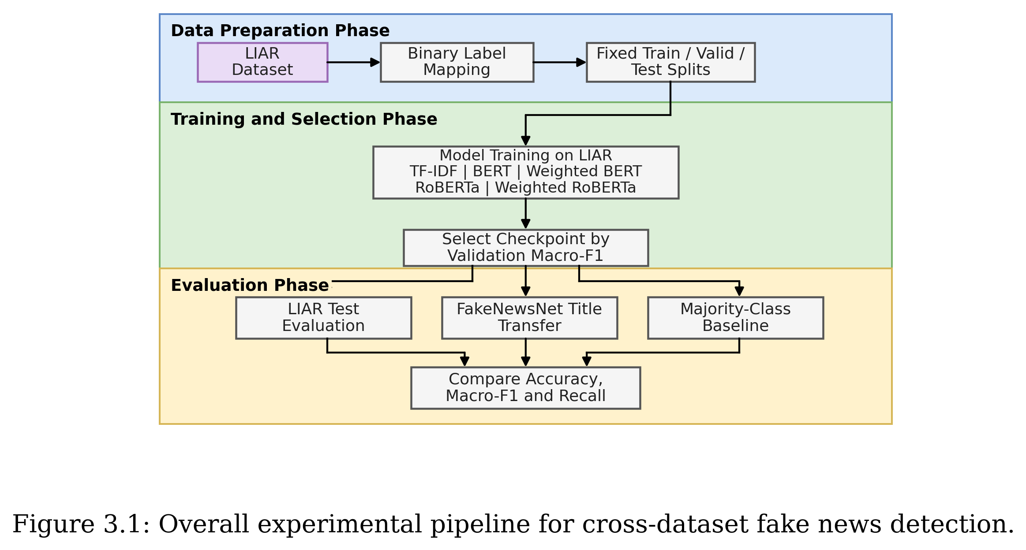

3.2 Datasets

3.2.1 LIAR Dataset
The main source dataset is LIAR. It contains short political statements collected from PolitiFact and labelled by fact-checkers. The original dataset has six labels: true, mostly-true, half-true, barely-true, false, and pants-on-fire. These labels are useful because they capture degrees of truthfulness, but they also create difficult boundary cases.
This project keeps the official LIAR split structure. The dataset split and label distributions after binary mapping are summarized in Table 3.1.
Table 3.1. Dataset splits and label distributions for LIAR and FakeNewsNet.
Dataset | Split | REAL Count (%) | FAKE Count (%) | Total Rows
LIAR (Source) | Train | 5,752 (56.17%) | 4,488 (43.83%) | 10,240
 | Validation | 668 (52.02%) | 616 (47.98%) | 1,284
 | Test | 714 (56.35%) | 553 (43.65%) | 1,267
FakeNewsNet (Target) | PolitiFact Titles | 624 (59.09%) | 432 (40.91%) | 1,056
 | GossipCop Titles | 16,817 (75.96%) | 5,323 (24.04%) | 22,140
 | Combined Titles | 17,441 (75.19%) | 5,755 (24.81%) | 23,196
The input field is the statement text. This is the same field used by the original TF-IDF baseline and by all transformer baselines in this project. Other LIAR metadata fields are not used in the main reported baseline results, because the dissertation first aims to compare text-only models under a controlled setting.

3.2.2 FakeNewsNet Minimal Titles
FakeNewsNet minimal is used as the first target dataset for cross-dataset evaluation. The processed file used in this project is data/fakenewsnet_minimal/processed/fakenewsnet_minimal_titles.csv. It contains title text and binary labels from the minimal release rather than full article bodies.
After cleaning, the target set contains 23,196 titles. The combined target set is much larger and more imbalanced than LIAR, as detailed in Table 3.1.
Because FakeNewsNet minimal provides titles rather than full article content, the transfer experiment should be interpreted carefully. The experiment is LIAR statement to FakeNewsNet title transfer, not full-article fake news detection. This limitation is important, but the experiment still tests whether short-text patterns learned from LIAR transfer to a different dataset family.

3.3 Binary Label Mapping
The original LIAR six-way labels are mapped to a binary REAL versus FAKE task. The mapping follows the existing project baseline and is kept fixed for all LIAR models. The purpose is to make the task consistent with common binary fake news detection settings and compatible with the binary labels in FakeNewsNet minimal.
Table 3.2. Binary label mapping.
Binary label | Original LIAR labels
REAL | true, mostly-true, half-true
FAKE | barely-true, false, pants-on-fire

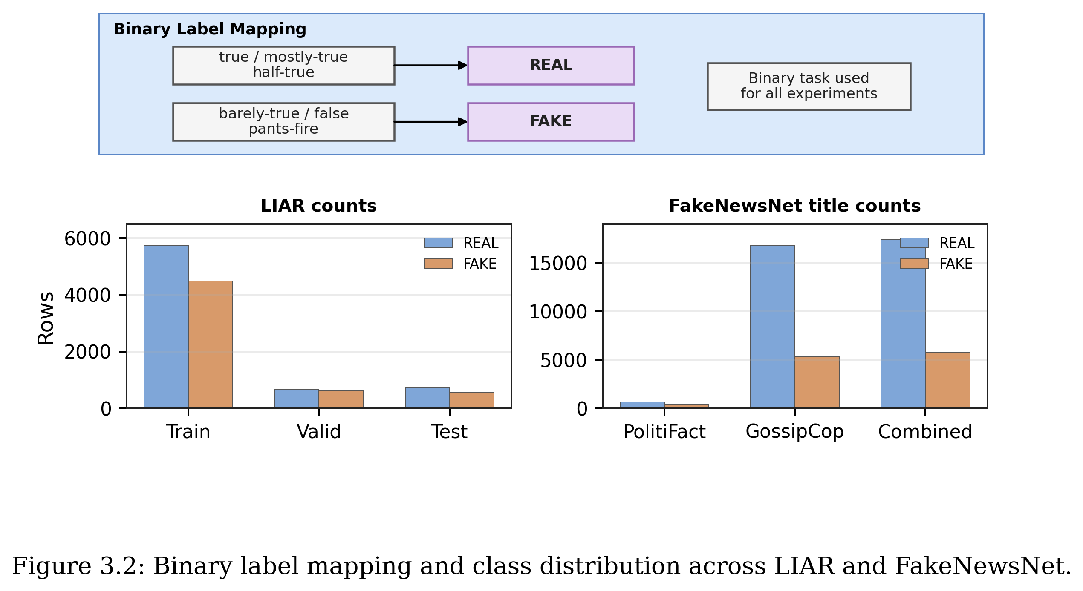

3.4 Model Configuration
For the TF-IDF baseline, the statement text is converted into sparse lexical features and classified using Logistic Regression. This gives a simple and deterministic reference point. It is important because any transformer improvement should be judged against a transparent baseline, not only against other neural models.
For the transformer baselines, the project uses bert-base-uncased and roberta-base from HuggingFace Transformers. Each model is fine-tuned as a sequence classifier on the binary LIAR task. Weighted BERT and weighted RoBERTa keep the same architecture but replace the standard cross-entropy loss with class-weighted cross-entropy during training.

Table 3.3. Baseline models.
Model | Description | Purpose
TF-IDF + Logistic Regression | Sparse lexical baseline using n-gram features. | Provides a simple deterministic baseline.
BERT-base | Fine-tuned transformer classifier. | Tests a standard pre-trained language model.
Weighted BERT | BERT with class-weighted training loss. | Tests whether weighting improves FAKE recall.
RoBERTa-base | Optimised BERT-style transformer. | Tests a stronger transformer baseline.
Weighted RoBERTa | RoBERTa with class-weighted training loss. | Highest mean Macro-F1 among completed LIAR local baselines.

Table 3.4. Main transformer hyperparameter settings.
Setting | Value used in main transformer experiments
Pre-trained models | bert-base-uncased; roberta-base
Input text | LIAR statement field; FakeNewsNet title field for target-only testing
Maximum sequence length | 128 tokens
Training batch size | 16
Evaluation batch size | 32 in notebooks; 64 in cross-dataset scripts
Epochs | 3
Optimizer | AdamW
Learning rate | 2e-5
Weight decay | 0.01
Warmup ratio | 0.1
Random seeds | 42, 52, 62, 72, 82
Checkpoint selection | Best validation Macro-F1, with validation Accuracy used as a tie-breaker in the saved training code
Hardware | NVIDIA GeForce RTX 3060 Laptop GPU with CUDA-enabled PyTorch

3.5 Training Setup
The LIAR train split is used for model fitting. The validation split is used for checkpoint selection. The test split is held out and evaluated only after the best validation checkpoint has been selected and loaded back into the model. This prevents the test set from influencing model selection.
For weighted models, class weights are computed from the LIAR train split only using the balanced formula: number of training examples divided by the product of number of classes and the training count for each class. The resulting weights are applied only inside the training loss. They are not computed from validation, test, or FakeNewsNet rows.
The transformer models are trained for three epochs with AdamW, learning rate 2e-5, weight decay 0.01, and a linear warmup schedule using a warmup ratio of 0.1. The maximum sequence length is 128 tokens. The training batch size is 16, which is suitable for the available 6GB NVIDIA RTX 3060 Laptop GPU. Evaluation uses a larger batch size where memory allows.
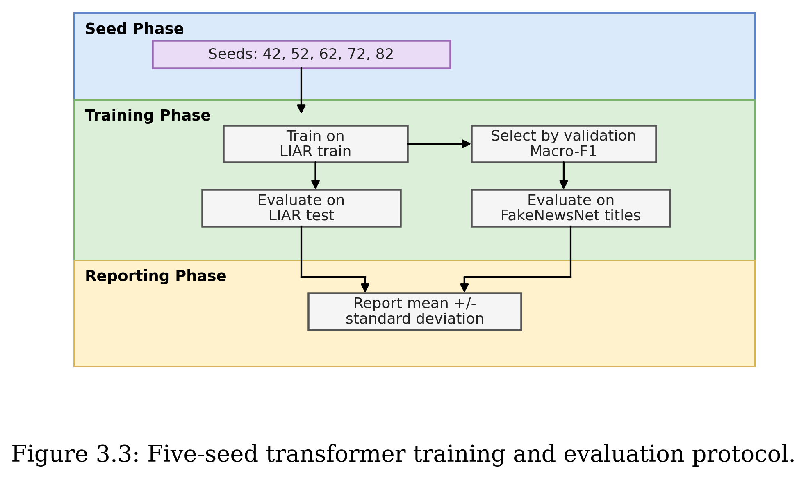

3.6 Cross-Dataset Transfer Protocol
The transfer experiment trains on LIAR and tests directly on FakeNewsNet minimal titles. The transformer models first select the best checkpoint using LIAR validation Macro-F1. After this checkpoint is loaded, the model is evaluated on LIAR test and then on FakeNewsNet PolitiFact titles, GossipCop titles, and the combined target set.
This protocol is different from multi-dataset evaluation in which a model may be trained and tested separately inside each dataset. Here, the source and target datasets are separated: LIAR is the source dataset, and FakeNewsNet minimal is the target dataset. The strict setting is useful because it exposes whether a model has learned dataset-specific patterns rather than more general signals.

3.7 Evaluation Metrics
The main metrics are Accuracy and Macro-F1. Accuracy measures the proportion of correct predictions, while Macro-F1 gives equal importance to the REAL and FAKE classes. Macro-F1 is important because the class distribution is not perfectly balanced and because a model can look acceptable by Accuracy while still missing many FAKE examples.
The dissertation also reports confusion matrices and class-level recall when available. REAL recall measures the proportion of REAL examples correctly predicted as REAL. FAKE recall measures the proportion of FAKE examples correctly predicted as FAKE. FAKE recall is especially important because false negatives allow fake or misleading content to pass undetected.
For transformer seed sweeps, the dissertation reports the mean and standard deviation across five random seeds. This is more reliable than reporting one selected run, because neural fine-tuning can vary across random initialisation, data order, and GPU operations.
The metrics are computed from the binary confusion matrix, where TP and TN are correct FAKE and REAL predictions respectively, and FP and FN are the two error types.
$$Accuracy = (TP + TN) / (TP + TN + FP + FN)$$
$$Precision_c = TP_c / (TP_c + FP_c), Recall_c = TP_c / (TP_c + FN_c)$$
$$F1_c = 2 * Precision_c * Recall_c / (Precision_c + Recall_c)$$
$$Macro-F1 = (F1_REAL + F1_FAKE) / 2$$
For weighted-loss models, the training loss uses a balanced class weight for each class c. The class weight is computed only from the training split.
$$w_c = N / (K * n_c)$$
Here, N is the number of training examples, K is the number of classes, and n_c is the number of training examples in class c. This formula increases the contribution of the minority class without using validation or test information.

3.8 Reproducibility
The project is designed so that the main experiments can be rerun from notebooks or scripts. The original TF-IDF notebooks are kept separate from the transformer notebooks. BERT, weighted BERT, RoBERTa, weighted RoBERTa, and cross-dataset experiments are stored in separate files so that one experiment does not overwrite another.
The main seed set is 42, 52, 62, 72, and 82. The same seed set is used for the five-run BERT, weighted BERT, and weighted RoBERTa experiments. Checkpoints are selected using validation Macro-F1, and the selected best_state_dict is loaded before test evaluation.
The reported files in the results directory contain the saved summary tables, cross-dataset outputs, intermediate fine-tuning outputs, LLM reasoning-atoms pilot outputs, and error analysis. This means the dissertation numbers can be traced back to generated result files rather than being copied from memory.

Chapter 4
LIAR In-Domain Experiments

4.1 Experimental Setup
The experiments use the official LIAR train, validation, and test splits available in the project workspace. Transformer experiments use GPU training. The best checkpoint is selected by validation Macro-F1, and the test set is evaluated only once after the selected checkpoint is loaded.

4.2 Main Results
Table 4.1. Main LIAR results.
Model | Runs | Test Accuracy | Test Macro-F1 | Comment
TF-IDF + Logistic Regression | Deterministic | 0.6235 | 0.6005 | Simple lexical baseline; repeated seeds are identical.
BERT-base | 5 seeds | 0.6425 +/- 0.0095 | 0.6231 +/- 0.0122 | Improves over TF-IDF.
Weighted BERT | 5 seeds | 0.6412 +/- 0.0065 | 0.6322 +/- 0.0090 | Highest mean FAKE recall among the five-seed local baselines.
Weighted RoBERTa | 5 seeds | 0.6522 +/- 0.0074 | 0.6396 +/- 0.0080 | Highest mean Macro-F1 among completed local baselines; modest gap to weighted BERT.
TELLER | Published result | 0.6773 | 0.6697 | Advanced LLM-based framework; partly comparable only.

Table 4.2. Class-level recall for local models with saved recall metrics.
Model | REAL Recall | FAKE Recall | Note
TF-IDF + Logistic Regression | 0.7661 | 0.4394 | Deterministic LIAR test result.
Weighted BERT | 0.7048 +/- 0.0292 | 0.5591 +/- 0.0447 | Five-seed mean; highest FAKE recall among completed local baselines.
Weighted RoBERTa | 0.7443 +/- 0.0153 | 0.5335 +/- 0.0199 | Five-seed mean; highest mean Macro-F1 among completed local baselines.

TELLER is reported only with the published aggregate LIAR Accuracy and Macro-F1 because the paper comparison is not the same locally saved classification-report setting as the project baselines.
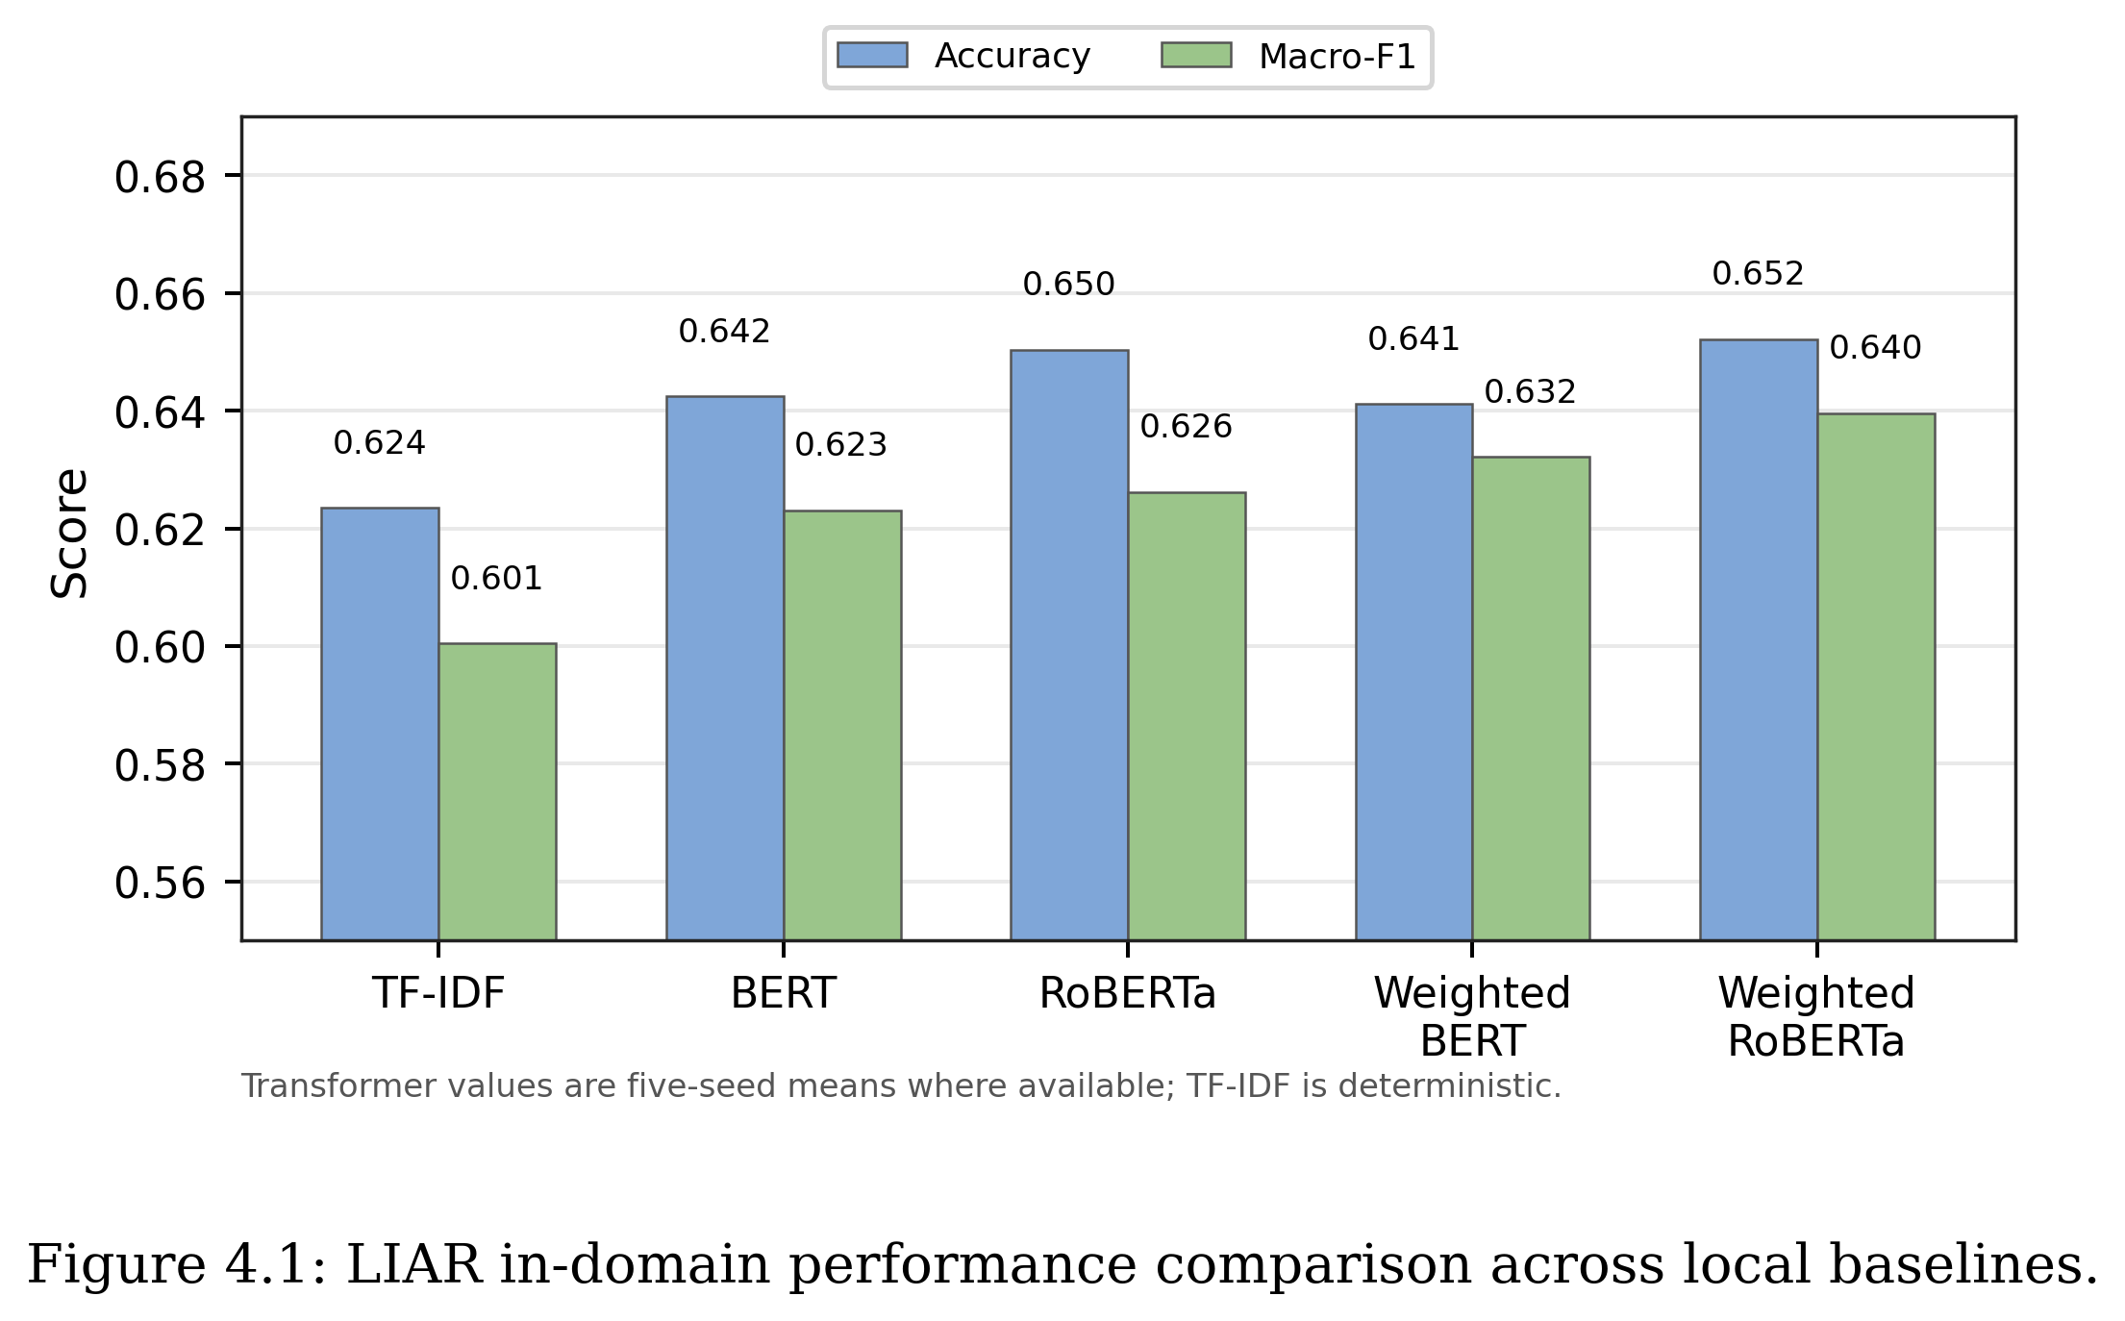
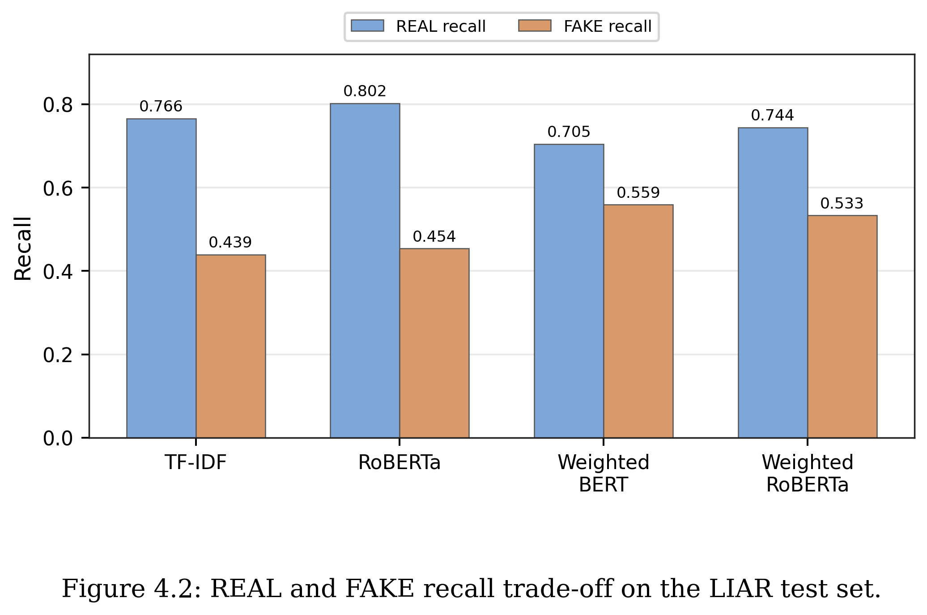

4.3 TF-IDF Baseline
The TF-IDF + Logistic Regression baseline obtains a test Accuracy of 0.6235 and test Macro-F1 of 0.6005. A five-seed determinism check shows identical predictions across seeds. This is expected because the current preprocessing, vectorisation, training, and evaluation pipeline has no meaningful randomness. Therefore, repeating this baseline many times does not provide new statistical evidence.

4.4 BERT and Weighted BERT
The unweighted BERT baseline improves over TF-IDF, with a five-seed mean test Accuracy of 0.6425 and Macro-F1 of 0.6231. Weighted BERT has a similar test Accuracy of 0.6412 but improves Macro-F1 to 0.6322 and reaches FAKE recall of 0.5591. This suggests that class weighting changes the decision boundary and helps the model identify more FAKE examples.

4.5 Weighted RoBERTa
Weighted RoBERTa is the best-performing local baseline by mean Macro-F1, although the gap to weighted BERT is modest. Across five seeds, it obtains a test Accuracy of 0.6522 and Macro-F1 of 0.6396. Its REAL recall is 0.7443, while FAKE recall is 0.5335. This means that RoBERTa gives higher mean overall performance, but it is still relatively conservative in predicting FAKE compared with weighted BERT, and the two transformer variants should be interpreted as comparable rather than clearly separated.

4.6 Comparison with TELLER
TELLER reports stronger LIAR binary performance, with Accuracy 0.6773 and Macro-F1 0.6697. However, TELLER is a different kind of system from the baselines evaluated in this dissertation. Rather than fine-tuning a text classifier directly, it generates structured logic atoms from an input claim using an LLM, then learns logic rules to aggregate those atoms into a prediction. This two-stage pipeline — predicate prompting followed by rule learning — is not directly comparable with a single fine-tuned BERT or RoBERTa model, because any performance difference may reflect the richer intermediate representation rather than a gain in the underlying language model. TELLER is therefore discussed as a prior-work reference rather than as a competing local baseline.

Chapter 5
Error Analysis and Further Experiments

5.1 Motivation
Aggregate metrics do not fully explain model behaviour. Two models can have similar Macro-F1 but make different types of mistakes. Error analysis is therefore used to understand where weighted RoBERTa and weighted BERT still fail. The analysis in this chapter is qualitative, based on a manual review of representative cases drawn from the saved LIAR error file. The patterns described below are recurring failure modes observed across these examples, not the output of an exhaustive automated taxonomy.

5.2 Main Error Patterns
- Numeric claims: statements involving numbers, percentages, or quantities remain difficult because the truth value often depends on external evidence.
- Label-boundary ambiguity: some LIAR labels are close to each other, especially around half-true and barely-true cases.
- Context-dependent statements: short claims may require speaker, event, or evidence context before they can be judged.
- Short statements: very short inputs may not contain enough linguistic signal for a transformer classifier.
- Ambiguous wording: vague or mixed claims can confuse binary REAL/FAKE mapping.
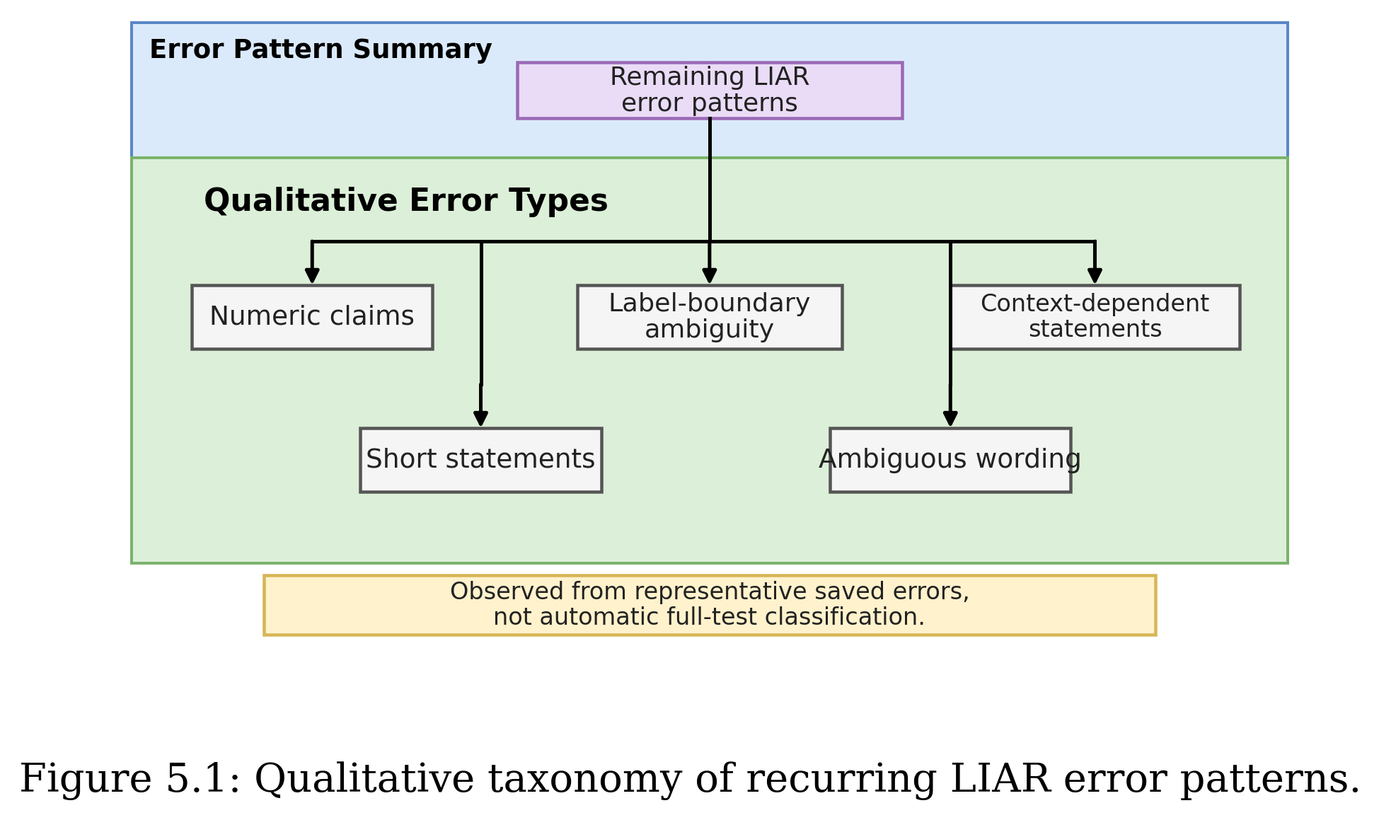

5.3 Weighted BERT and Weighted RoBERTa Trade-off
Weighted RoBERTa achieves higher overall Macro-F1, while weighted BERT produces stronger FAKE recall. Neither model dominates across both metrics, which is precisely why reporting class-level recall alongside Macro-F1 matters. A practitioner who prioritises catching more fake examples would prefer weighted BERT; one who prioritises overall balanced performance would prefer weighted RoBERTa. Accuracy alone would obscure this distinction entirely.

5.4 Preliminary Context Check
A preliminary check was carried out for weighted RoBERTa by comparing statement-only input with a simple concatenation of statement and available context. Exact metrics for this check are not retained in the result files reported in this dissertation, so the check is reported here as a small exploratory comparison rather than a full controlled experiment. The observed pattern was that simple context concatenation did not yield a visible improvement over statement-only input, which suggests that context, if useful, may need a more structured integration method than direct concatenation. A future-work item is to repeat this check with logged metrics so that the comparison can be reported quantitatively.

5.5 Preliminary Threshold Check
A preliminary check was also carried out for weighted RoBERTa using a validation-tuned decision threshold rather than the default 0.5 cut-off. Exact tuned thresholds and the corresponding test-set metrics are not retained in the result files reported in this dissertation, so this check is reported as an exploratory probe rather than as a fully tabulated experiment. The qualitative observation was that the tuned setting redistributed errors between the REAL and FAKE classes - REAL recall went up while FAKE recall went down - without a clear net improvement in Macro-F1. A future-work item is to rerun threshold tuning with logged per-threshold metrics so that the trade-off can be presented as a small table.

5.6 Representative Error Cases
A small number of representative test-set errors are useful in the main text because they make the aggregate error patterns more concrete. The full set of saved examples remains in Appendix D, while Table 5.1 highlights three typical cases.
Table 5.1. Representative LIAR error cases discussed in the main text.
Model | Gold | Pred. | Pattern | Statement
Weighted RoBERTa | FAKE | REAL | Numeric claim | Over the past year ... our 16 counties have hemorrhaged more than 6,000 jobs with no apparent end in sight.
Weighted RoBERTa | REAL | FAKE | Context-dependent claim | I wake up every morning in a house (the White House) that was built by slaves.
Weighted BERT | REAL | FAKE | Label-boundary ambiguity | Says my plan is a property tax cut.

The numeric example shows that a text-only classifier cannot check whether a quantity is correct unless the relevant evidence is present. The context-dependent example shows a different limitation: the sentence can only be judged reliably with background knowledge about the White House. The label-boundary example is shorter and less evidence-rich, so the binary REAL/FAKE mapping hides some of the original LIAR label nuance.

5.7 Summary against RQ3
Overall, the error analysis shows that the remaining mistakes are not random. They are concentrated in numeric claims, label-boundary ambiguity, and context-dependent statements. This supports the later cross-dataset evaluation, because these errors suggest that statement text alone often lacks enough evidence for reliable fake news detection.
The preliminary checks in Sections 5.4 and 5.5 also suggest that simple fixes are not enough. Adding context by concatenation and tuning the prediction threshold did not clearly resolve the remaining problem. The next evaluation therefore asks a sharper question: whether the models can transfer beyond LIAR at all.

Chapter 6
Cross-Dataset Evaluation
This chapter first reports the strict cross-dataset evaluation, where models are trained on LIAR and tested directly on FakeNewsNet minimal titles. It then extends the analysis with intermediate target-domain fine-tuning on FakeNewsNet train subsets and a simplified TELLER-like reasoning-atoms pilot. The strict direct-transfer setting uses no FakeNewsNet examples for training, validation, threshold selection, or model selection; the adaptation setting uses only FakeNewsNet train/validation subsets and keeps a held-out FakeNewsNet test split for final evaluation.

6.1 Motivation
In-domain LIAR performance is not enough to show that a fake news detector is reliable. A model may learn dataset-specific language patterns rather than general veracity signals. Cross-dataset evaluation is therefore needed to test whether the model transfers to a different source or domain.

6.2 Target Dataset
FakeNewsNet is used as the first target dataset because it is widely used in fake news detection research and includes PolitiFact and GossipCop sources. The minimal official CSV version contains item identifiers, URLs, titles, and tweet IDs. After cleaning, the title-only target set contains 23,196 rows: 1,056 PolitiFact titles and 22,140 GossipCop titles. Because this version provides titles rather than full article text, the experiment is framed as LIAR statement to FakeNewsNet title transfer.

6.3 Experimental Setup
Three primary transfer baselines are reported--TF-IDF + Logistic Regression, weighted BERT, and weighted RoBERTa--together with an unweighted BERT control that is described in detail in Section 6.7. TF-IDF is trained on LIAR train plus validation using the selected deterministic baseline setup. The transformer baselines use the same five-seed runs as the LIAR experiments, with checkpoint selection based on LIAR validation Macro-F1. For each transformer run, the best LIAR checkpoint is loaded before testing on both LIAR test and FakeNewsNet titles.

Table 6.1. LIAR in-domain comparison before transfer.
Model | Runs | Accuracy | Macro-F1 | REAL Recall | FAKE Recall
TF-IDF | 1 | 0.6235 | 0.6005 | 0.7661 | 0.4394
Weighted RoBERTa | 5 | 0.6522 | 0.6396 | 0.7443 | 0.5335
Weighted BERT | 5 | 0.6412 | 0.6322 | 0.7048 | 0.5591

Table 6.2. LIAR-to-FakeNewsNet title transfer results, including the unweighted BERT control.
Model | Target | Runs | Accuracy | Macro-F1 | REAL Recall | FAKE Recall
TF-IDF | PolitiFact titles | 1 | 0.5152 | 0.5146 | 0.4631 | 0.5903
Weighted RoBERTa | PolitiFact titles | 5 | 0.4795 | 0.4196 | 0.1388 | 0.9718
Weighted BERT | PolitiFact titles | 5 | 0.4835 | 0.4371 | 0.1782 | 0.9245
TF-IDF | GossipCop titles | 1 | 0.4986 | 0.4715 | 0.4771 | 0.5664
Weighted RoBERTa | GossipCop titles | 5 | 0.2619 | 0.2271 | 0.0335 | 0.9836
Weighted BERT | GossipCop titles | 5 | 0.2844 | 0.2601 | 0.0709 | 0.9589
TF-IDF | Combined titles | 1 | 0.4993 | 0.4745 | 0.4766 | 0.5682
Weighted RoBERTa | Combined titles | 5 | 0.2718 | 0.2358 | 0.0372 | 0.9827
Weighted BERT | Combined titles | 5 | 0.2935 | 0.2682 | 0.0747 | 0.9564
Unweighted BERT | PolitiFact titles | 5 | 0.5114 | 0.4805 | 0.2436 | 0.8981
Unweighted BERT | GossipCop titles | 5 | 0.2918 | 0.2710 | 0.0833 | 0.9506
Unweighted BERT | Combined titles | 5 | 0.3018 | 0.2806 | 0.0890 | 0.9467

To interpret the transfer results in Table 6.2, a trivial majority-class reference baseline is also reported. Because FakeNewsNet minimal titles are strongly REAL-skewed, especially in GossipCop, a classifier that always predicts REAL achieves a high target Accuracy without learning anything. Table 6.3 reports Accuracy, Macro-F1, REAL recall, and FAKE recall for this baseline on each target subset. These values are deterministic and follow directly from the target label counts reported in Section 3.2.2.
Table 6.3. Majority-class (always-REAL) reference baseline on FakeNewsNet minimal titles.
Target subset | Accuracy | Macro-F1 | REAL recall | FAKE recall
PolitiFact titles | 0.5909 | 0.3714 | 1.0000 | 0.0000
GossipCop titles | 0.7596 | 0.4317 | 1.0000 | 0.0000
Combined titles | 0.7519 | 0.4292 | 1.0000 | 0.0000

Two observations follow from Table 6.3. First, the majority baseline has a high Accuracy on every target subset, especially on GossipCop and the combined set, simply because FakeNewsNet titles are heavily REAL-skewed. Second, the majority baseline has a Macro-F1 below 0.45 on every subset, because predicting only one class gives a FAKE F1 of zero. This shows directly that Accuracy alone is misleading under this target distribution, and that Macro-F1 must be read alongside class-level recall when comparing transfer baselines.
Comparing Table 6.2 with Table 6.3 also reframes how the four LIAR-trained transfer settings should be read. On combined titles, TF-IDF has lower Accuracy than the majority baseline (0.4993 vs 0.7519) but a slightly higher Macro-F1 (0.4745 vs 0.4292), because it produces non-trivial predictions for both classes. Weighted BERT and weighted RoBERTa, in contrast, fall below the majority baseline on both Accuracy (0.2935 and 0.2718) and Macro-F1 (0.2682 and 0.2358) on the combined target, while still reaching very high FAKE recall by strongly over-predicting FAKE. The unweighted BERT control also falls below the majority baseline on both Accuracy (0.3018) and Macro-F1 (0.2806). This means the transformer transfer results are worse than a trivial REAL-only classifier by Macro-F1 on this target, which is an important corrective to the original LIAR-only ranking.

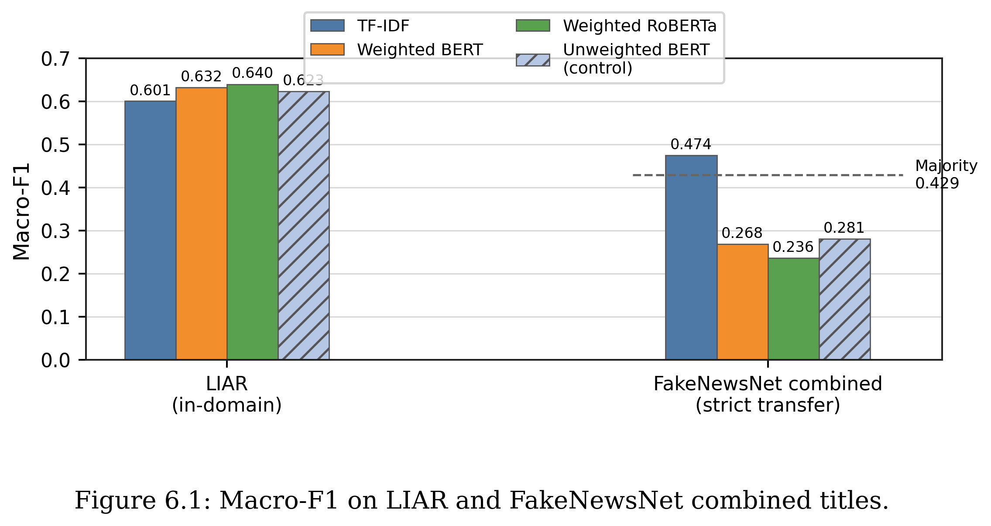
Figure 6.1 compares LIAR in-domain Macro-F1 with strict transfer Macro-F1 on FakeNewsNet combined titles. The four LIAR scores are close together, but the transfer scores separate sharply: TF-IDF remains slightly above the always-REAL majority Macro-F1 reference of 0.4292, while weighted BERT, weighted RoBERTa, and the unweighted BERT control fall below it. The similar transfer scores of weighted and unweighted BERT indicate that class weighting is not the dominant cause of the cross-dataset drop.
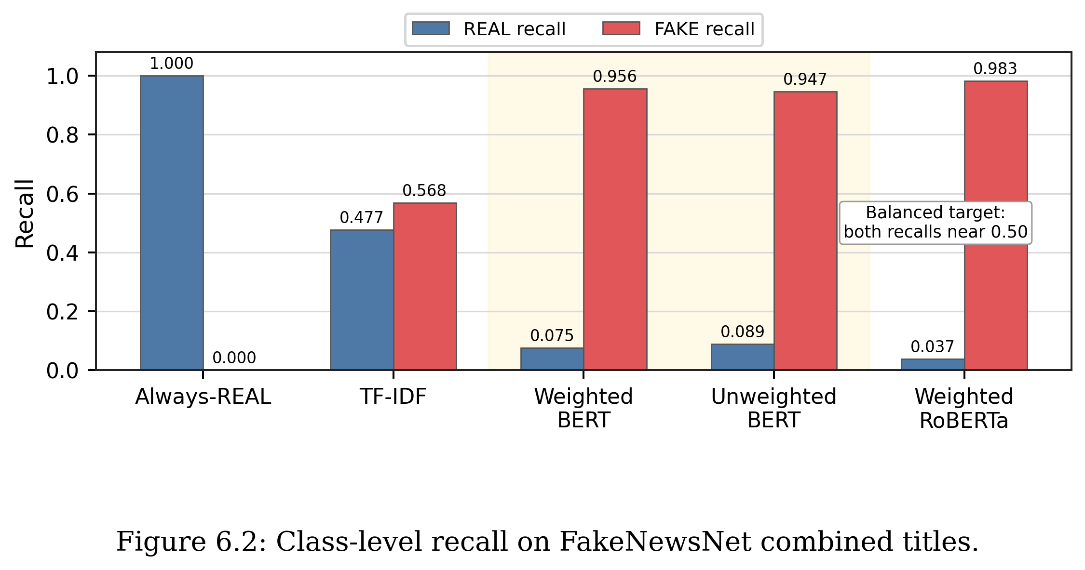
Figure 6.2 explains the low transfer Macro-F1 of the transformer models through class-level recall. Weighted BERT and unweighted BERT sit next to each other and show almost the same pattern: REAL recall remains around 0.08, while FAKE recall stays above 0.94. Removing the class weights therefore does not correct the FAKE-heavy transfer bias.
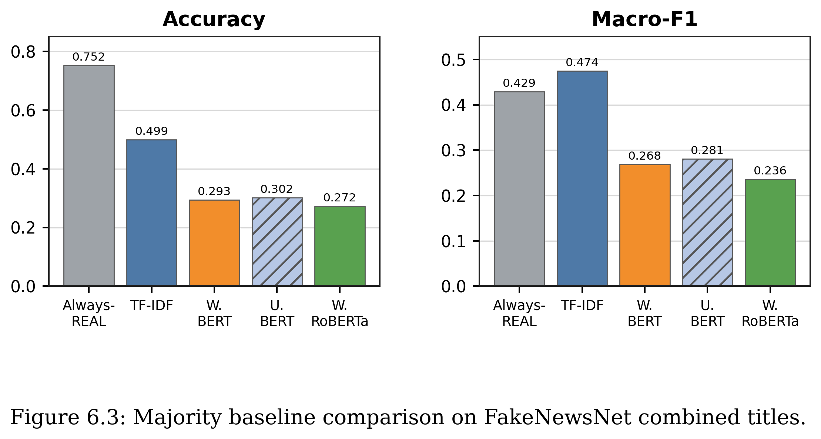
Figure 6.3 compares the completed transfer models with the always-REAL majority baseline on FakeNewsNet combined titles. The majority baseline has the highest Accuracy because the target set is strongly REAL-skewed, while TF-IDF is the only model that marginally exceeds the majority Macro-F1. Weighted BERT and unweighted BERT remain close to each other on both metrics, reinforcing that the weighted loss is not the main explanation for the transfer failure.

6.4 PolitiFact Target Results
On FakeNewsNet PolitiFact titles, TF-IDF reaches 0.5146 Macro-F1, while weighted BERT reaches 0.4371 and weighted RoBERTa reaches 0.4196. The transformer models therefore lose their LIAR advantage even on the politically related target subset. This suggests that matching the broad topic area is not enough; the shift from LIAR statements to FakeNewsNet titles still changes the input distribution and label behaviour.

6.5 GossipCop Target Results
The performance drop is larger on GossipCop titles. TF-IDF reaches 0.4715 Macro-F1, while weighted BERT reaches 0.2601 and weighted RoBERTa reaches 0.2271. This is expected because GossipCop is an entertainment-news domain, whereas LIAR is based on political fact-checking statements. The target text style and topic distribution are therefore further away from the source training data.

6.6 Combined Target Results
All four LIAR-trained baselines, including the unweighted BERT control, drop substantially when moved from LIAR to FakeNewsNet titles. TF-IDF drops from 0.6005 LIAR Macro-F1 to 0.4745 on FakeNewsNet combined titles. Weighted RoBERTa, although highest on LIAR with 0.6396 Macro-F1, drops to 0.2358 on FakeNewsNet combined titles. Weighted BERT drops from 0.6322 to 0.2682. The unweighted BERT control discussed in Section 6.7 reaches 0.2806 Macro-F1 on FakeNewsNet combined titles, which is essentially the same as weighted BERT. Compared with the always-REAL majority baseline in Table 6.3, which obtains 0.4292 Macro-F1 on the combined target, only TF-IDF stays above this trivial reference on Macro-F1 (0.4745); both weighted transformer baselines and the unweighted BERT control fall below it. This is a sharper reading of the transfer failure than the LIAR-only ranking would suggest.
TF-IDF transfers better than the weighted transformers in Macro-F1 on the title-only target set, but it only narrowly exceeds the majority-class baseline (0.4745 vs 0.4292) and remains well below 0.50. None of the completed baselines can therefore be considered robust under this strict transfer setting. The result supports the central research gap of the dissertation: practical fake news detectors need to be evaluated beyond one dataset, and against a trivial class-prior reference, before they can be trusted.

6.7 Why Transformers Over-Predict FAKE
The transformer transfer results are especially important because they show that stronger in-domain performance does not guarantee better cross-dataset performance. On FakeNewsNet combined titles, the weighted transformer models predict FAKE too often. This gives very high FAKE recall, but extremely low REAL recall. In other words, the models catch many FAKE title cases but lose the ability to recognise REAL title cases reliably.
An initial candidate explanation, before the control experiment described below, was that the weighted models learn source-domain cues from LIAR that become misleading on FakeNewsNet titles, with the class-weighted loss specifically pushing the decision boundary toward FAKE on out-of-domain inputs. This is the interpretation that the LIAR class weights, which were computed from a roughly balanced source distribution, behave badly when applied to a strongly REAL-skewed target. Under this hypothesis, removing the class weights should noticeably reduce FAKE over-prediction on FakeNewsNet titles.
To test this explanation, an unweighted BERT control was trained on LIAR with the same five-seed protocol, the same validation Macro-F1 checkpoint selection, and the same evaluation pipeline as the weighted BERT model in Table 6.1, but without the inverse-frequency class weights. The unweighted BERT control was then transferred to the same FakeNewsNet PolitiFact, GossipCop, and combined title targets. Table 6.2 reports the resulting five-seed mean metrics, including the GossipCop Macro-F1 value computed from the saved unweighted BERT transfer summary.
The unweighted BERT control behaves very similarly to weighted BERT on the FakeNewsNet target. On combined titles, unweighted BERT obtains Accuracy 0.3018, Macro-F1 0.2806, REAL recall 0.0890, and FAKE recall 0.9467, compared with 0.2935, 0.2682, 0.0747, and 0.9564 for weighted BERT. The improvement in REAL recall when class weights are removed is therefore small (around one percentage point on combined titles, and roughly seven points on PolitiFact titles). Both versions still classify over ninety percent of FakeNewsNet combined titles as FAKE, and both fall below the always-REAL majority baseline in Table 6.3 on both Accuracy and Macro-F1. This means that class weighting is not the main cause of the FAKE over-prediction observed in Section 6.6: removing the weights leaves the same qualitative failure mode in place.
A more plausible explanation is therefore distribution shift between LIAR statements and FakeNewsNet titles, rather than the choice of loss weighting. LIAR contains short political fact-checking claims, often written as direct accusations or factual statements; FakeNewsNet titles are news headlines, with a different style, a different topic distribution, and a different class prior. Both the weighted and unweighted BERT decision boundaries learned on LIAR appear to treat many title patterns as FAKE-like, producing a strong FAKE-heavy transfer bias. This reading is consistent with the recall-plane pattern in the recall comparison in Figure 6.4 and is the central evidence that strong in-domain performance does not imply transferable veracity signals. A complementary unweighted RoBERTa control is the obvious next experiment to confirm that the same effect appears in the RoBERTa family; this is not completed in the current dissertation and is recorded as a remaining methodological item in Section 6.9 and Chapter 7.
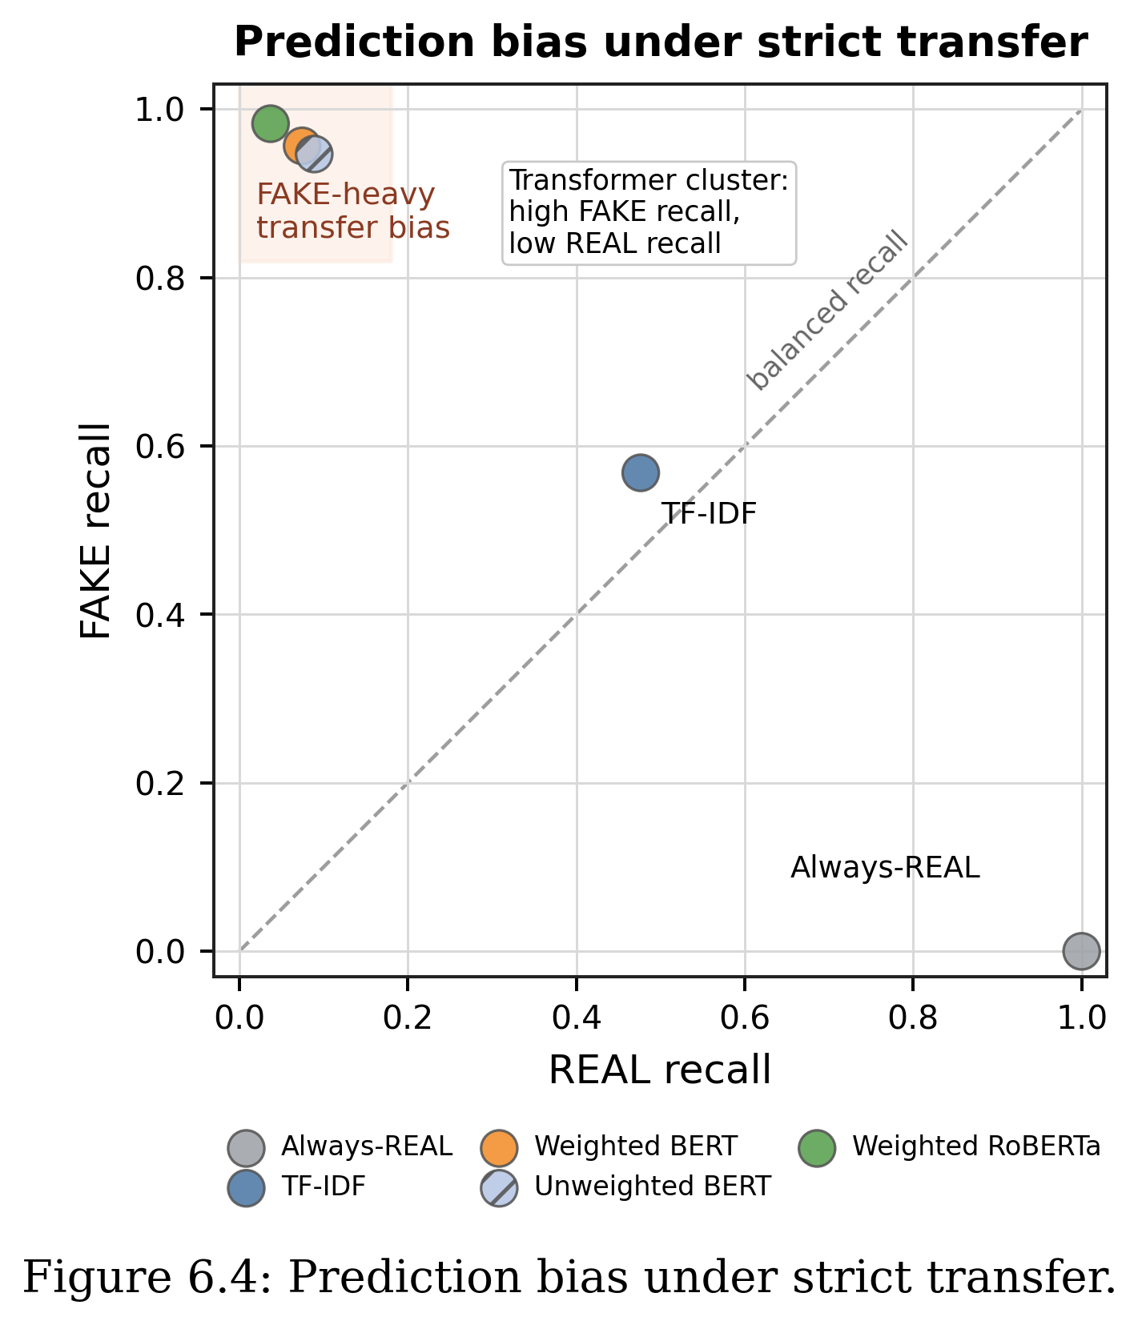
6.8 Intermediate Fine-Tuning with Target-Domain FakeNewsNet Titles
The strict transfer results show that LIAR-trained transformer models do not move reliably to FakeNewsNet titles without adaptation. To test whether a small amount of target-domain supervision can correct this failure mode, an intermediate fine-tuning experiment was added. The weighted RoBERTa model was first trained on LIAR using the same source-domain protocol as the direct transfer experiment. It was then further fine-tuned on balanced subsets of the FakeNewsNet training titles before being evaluated once on a held-out FakeNewsNet test split.
The target-domain fractions were 5%, 10%, and 20% of the FakeNewsNet training split. The 5% setting used 742 target examples, the 10% setting used 1,484 examples, and the 20% setting used 2,969 examples. The same held-out FakeNewsNet test split was used for all intermediate fine-tuning comparisons. This design keeps the direct transfer baseline and the adapted models comparable, while still treating the target test set as unseen.
Table 6.4. Integrated comparison of in-domain, direct transfer, intermediate fine-tuning, and TELLER-like pilot results.
Block | Setting | Acc. | Macro-F1 | REAL Rec. | FAKE Rec. | Note
In-domain | Weighted RoBERTa on LIAR test | 0.6522 | 0.6396 | 0.7443 | 0.5335 | 5-seed LIAR baseline
Direct transfer | LIAR -> FNN combined titles | 0.2718 | 0.2358 | 0.0372 | 0.9827 | 5-seed strict transfer
Direct transfer | LIAR -> held-out FNN test | 0.2601 | 0.2178 | 0.0183 | 0.9930 | Seed 42, same split as FT
Intermediate FT | LIAR -> 5% FNN -> FNN test | 0.7519 | 0.4292 | 1.0000 | 0.0000 | Collapses to REAL
Intermediate FT | LIAR -> 10% FNN -> FNN test | 0.8125 | 0.7141 | 0.9304 | 0.4553 | Effective adaptation
Intermediate FT | LIAR -> 20% FNN -> FNN test | 0.8231 | 0.7447 | 0.9157 | 0.5421 | Best current result
TELLER-like pilot | LLM atoms: LIAR -> FNN | 0.5300 | 0.4405 | 0.1300 | 0.9300 | Exploratory only
TELLER-like pilot | LLM atoms: FNN -> FNN | 0.6000 | 0.6000 | 0.5900 | 0.6100 | Target atom upper bound
The intermediate fine-tuning results change the interpretation of the cross-dataset experiment. With no target-domain adaptation, the LIAR-trained weighted RoBERTa model is almost entirely FAKE-biased on the held-out FakeNewsNet test split, with FAKE recall 0.9930 but REAL recall only 0.0183. The 5% target-domain setting does not solve the problem; it flips the bias in the opposite direction and predicts nearly all target examples as REAL, producing high Accuracy but a weak Macro-F1 of 0.4292. The 10% and 20% settings are more meaningful. With 10% target data, Macro-F1 rises to 0.7141, and with 20% target data it reaches 0.7447 while preserving both high REAL recall and improved FAKE recall.
These results show that the poor direct transfer scores are not simply caused by the target dataset being impossible. Rather, the model needs enough labelled target-domain examples to recalibrate its decision boundary. Intermediate fine-tuning is therefore the main practical response to the strict transfer failure: it turns the cross-dataset result from a negative robustness finding into evidence about how much target supervision is needed before useful transfer appears.
6.9 TELLER-like LLM Reasoning-Atoms Pilot
A second exploratory experiment was added to test a simplified TELLER-like idea. Instead of asking an LLM to decide whether each item was REAL or FAKE, DeepSeek V4 Flash generated structured reasoning atoms such as emotional language, exaggerated claim, specific evidence, source reference, logical consistency, and clickbait style. A separate Logistic Regression or Random Forest classifier then used these atoms as features. This keeps the cognition-style signal generation separate from the final decision model, which is closer to the general TELLER design than direct LLM classification.
The pilot should not be treated as a main contribution or as a reproduction of TELLER. It uses only a small, balanced atom sample and a simplified feature set. Its role is supporting analysis: it tests whether LLM-generated reasoning signals reduce the same cross-domain bias seen in the transformer transfer results. The answer is mixed. The LIAR-atoms to FakeNewsNet-atoms setting reaches only 0.4405 Macro-F1 with Logistic Regression and strongly over-predicts FAKE, with REAL recall 0.1300 and FAKE recall 0.9300. The FakeNewsNet-atoms in-domain pilot reaches 0.6000 Macro-F1, suggesting that the atoms contain some target-domain signal but do not by themselves solve cross-dataset generalisation.

6.10 Summary against RQ5
RQ5 asks how well LIAR-trained baselines transfer to FakeNewsNet minimal titles. Under strict direct transfer, the answer remains weak: the transformer models over-predict FAKE and perform below the always-REAL majority-class reference on the combined target. However, the intermediate fine-tuning experiment shows that this failure can be partly corrected when enough labelled target-domain examples are introduced. Five percent target data is not sufficient and collapses toward REAL predictions, but 10% and 20% target-domain fine-tuning substantially improve the held-out FakeNewsNet test result, reaching 0.7141 and 0.7447 Macro-F1 respectively. The final answer to RQ5 is therefore two-part: strict zero-shot transfer is unreliable, but intermediate fine-tuning with a modest labelled target subset can recover useful target-domain performance.

6.11 Limitations of the Transfer Setting
This transfer setting has five main limitations. First, LIAR statements and FakeNewsNet titles are different text fields, so the experiment combines dataset shift with input-format shift. Second, LIAR is mainly political fact-checking, while FakeNewsNet also includes entertainment news, so the topic distributions differ substantially. Third, the label sources are not identical, so labelling protocols differ. Fourth, the intermediate fine-tuning results are currently reported for a single seed and should be repeated across multiple seeds before being treated as final effect-size estimates. Fifth, the TELLER-like reasoning-atoms experiment is only a pilot and should be read as supporting analysis, not as a reproduced TELLER system or as the dissertation main contribution.

Chapter 7
Discussion

7.1 Main Findings
Transformer-based models improve over the TF-IDF baseline in the LIAR in-domain setting, but the improvement is moderate rather than dramatic. TF-IDF reaches 0.6005 Macro-F1 on LIAR, while weighted RoBERTa reaches 0.6396 and weighted BERT reaches 0.6322. Pre-trained transformers are stronger, but the LIAR binary task remains genuinely difficult even for modern models.
Class weighting meaningfully changes model decision behaviour. Weighted BERT is not the best model by overall Accuracy, but it obtains the highest mean FAKE recall among the completed five-seed local baselines. A fake news detector should not only maximise average performance; it should also avoid missing too many FAKE examples. This trade-off between overall balance and minority-class sensitivity is only visible through class-level recall, not Macro-F1 alone.
Among the completed local baselines, weighted RoBERTa achieves the highest mean Macro-F1, though the gap to weighted BERT is modest. With a five-seed mean Accuracy of 0.6522 and Macro-F1 of 0.6396, it is the strongest balanced model in the LIAR in-domain setting. Its FAKE recall is lower than weighted BERT, however, so it should not be read as the best model for every use case. Without a paired statistical test on the per-seed Macro-F1 values, the two weighted transformer variants are best interpreted as comparable rather than clearly ranked.
Strong in-domain performance does not transfer automatically, and the failure cannot be explained by class weighting alone. When LIAR-trained models are evaluated on FakeNewsNet minimal titles without adaptation, all completed baselines drop sharply. Both weighted BERT and weighted RoBERTa become strongly biased toward predicting FAKE, producing very high FAKE recall but very poor REAL recall; on the combined target, both fall below the trivial always-REAL majority-class baseline on both Accuracy and Macro-F1. A matched unweighted BERT control, trained with the same five-seed protocol but without class weights, shows nearly the same FAKE-heavy behaviour. Removing the class weights changes the magnitude of the bias only slightly, pointing to distribution shift between LIAR statements and FakeNewsNet titles as the dominant cause.
As a supplementary observation rather than a main experimental finding, TELLER remains best treated as an advanced literature comparison. The local TELLER-like reasoning-atoms pilot is useful because it separates LLM-generated cognition-style signals from a simple decision model, but it does not reproduce the full TELLER system. Its results also show a limitation: LLM-generated atoms can still carry domain-specific bias, and the LIAR-atoms to FakeNewsNet-atoms setting remains strongly FAKE-skewed. The pilot therefore supports the dissertation argument about dataset shift rather than replacing the main transformer and intermediate fine-tuning experiments.

7.2 Implications
The findings suggest that fake news detection models should not be judged by Accuracy alone. Macro-F1 and class-level recall provide a more informative picture, especially when FAKE recall is important. A model that gives a slightly lower overall score may still be useful if it catches more FAKE cases.
The cross-dataset results have a stronger implication. A model can look strong on LIAR but fail badly when tested on another dataset. Intermediate fine-tuning shows that this failure is not permanent: with 10-20% labelled FakeNewsNet target data, the model can recalibrate and recover much stronger Macro-F1. This means practical fake news detection should report both strict transfer and adaptation results, because zero-shot robustness and target-domain recoverability answer different questions.
The comparison with TELLER also has a practical implication. Stronger published systems should be interpreted together with their system assumptions. If a system uses LLM calls, generated logic atoms, or manual predicate design, then those components are part of the model being evaluated. The local atoms pilot shows that adding LLM-generated reasoning signals does not automatically remove dataset shift or class-bias problems.

7.3 Limitations
The first limitation is that the cross-dataset target uses FakeNewsNet minimal titles rather than full article text. This makes the experiment useful for short-text transfer, but it does not fully represent article-level fake news detection. The performance drop should therefore be interpreted as a transfer result under a title-only target setting.
The second limitation is that only one target dataset family has been tested so far. FakeNewsNet is a useful first target, but a stronger final thesis would ideally include another target dataset or a fuller target-domain baseline. This would reduce the risk of drawing broad conclusions from one source-target pair.
The third limitation is that TELLER has not been reproduced locally. The added reasoning-atoms experiment is only a simplified pilot inspired by TELLER-style separation between cognition signals and decision aggregation. It should therefore be used to discuss the limits of LLM-generated signals, not to claim a full TELLER reproduction.
The fourth limitation is that the context and threshold checks in Sections 5.4 and 5.5 are preliminary rather than fully tabulated experiments. Their exact metrics are not recorded in the result files reported in this dissertation, so they are presented as exploratory observations and not as quantitative evidence. Re-running these checks with logged metrics is listed as future work.
A further limitation is that the intermediate fine-tuning experiment is currently single-seed. The 10% and 20% target-domain settings are promising, but they should be repeated across the same five-seed protocol used for the main LIAR baselines before the exact improvement size is treated as stable. The direct transfer and adaptation results also use title-only FakeNewsNet inputs, so they remain evidence about short-text transfer rather than full-article fake news detection.
Finally, the binary mapping of LIAR simplifies the original six-label structure. This is useful for comparison with binary fake news datasets, but it can hide the uncertainty between labels such as half-true and barely-true. Many errors in the analysis come from this boundary area.

7.4 Future Work
The highest-priority remaining next step is to repeat the intermediate fine-tuning experiment across multiple seeds, especially for the 10% and 20% target-domain settings. This would test whether the observed recovery from direct-transfer failure is stable rather than seed-specific. A secondary methodological control is to complete the matched unweighted RoBERTa direct-transfer run, but the main experimental direction is now target-domain adaptation rather than additional zero-shot controls.
The most direct next step is to strengthen the target-domain evaluation further. A full FakeNewsNet in-domain transformer baseline, trained directly on the target training split without the LIAR source stage, would provide a clearer upper bound for the intermediate fine-tuning results. If full article text becomes available, the same protocol should also be repeated with richer input.
A second direction is to add another target dataset. This would make the cross-dataset claim stronger because the dissertation would not rely on one source-target pair. MultiFC or another fact-checking dataset could be considered if the label mapping and access conditions are manageable.
A third direction is to explore methods designed for domain robustness, such as domain-adaptive pretraining or more careful context integration. These methods should only be added if there is enough time to evaluate them clearly and avoid turning the dissertation into an uncontrolled model search.
A final direction is to keep TELLER as partial inspiration rather than a main experimental path unless full reproduction becomes feasible. The current atoms pilot is useful for discussing LLM reasoning-signal limitations, but the dissertation main contribution should remain the reproducible baseline, direct-transfer failure analysis, and intermediate fine-tuning recovery experiment.

Chapter 8
Conclusion

8.1 Summary of the Study
This dissertation set out to evaluate reproducible fake news detection baselines on the LIAR dataset, to measure how well those baselines transfer to FakeNewsNet titles, and to test whether intermediate target-domain fine-tuning can recover performance after strict transfer failure. Starting from a deterministic TF-IDF + Logistic Regression reference, the study added BERT, class-weighted BERT, RoBERTa, and class-weighted RoBERTa under consistent binary label mapping, fixed data splits, and a five-seed evaluation protocol. A matched unweighted BERT control was run to isolate the role of class weighting, and a later intermediate fine-tuning experiment tested 5%, 10%, and 20% FakeNewsNet target-domain supervision.
The study also discusses TELLER as a recent advanced framework for fake news detection. TELLER reports stronger LIAR performance than the local baselines, but it uses an LLM-based reasoning pipeline rather than a standard BERT or RoBERTa classifier. It is therefore treated as an advanced literature comparison rather than as a directly reproduced local baseline. A simplified TELLER-inspired reasoning-atom pilot is included only as supporting analysis, not as a main contribution.

8.2 Answers to the Research Questions
RQ1 asked how traditional and transformer-based classifiers perform on LIAR binary fake news detection. The answer is that transformer models improve over TF-IDF, but the improvement is moderate. Weighted RoBERTa obtains the highest mean Accuracy and Macro-F1 among the completed local baselines, with 0.6522 Accuracy and 0.6396 Macro-F1 across five seeds, although the gap to weighted BERT is modest and was not tested for statistical significance.
RQ2 asked whether class-weighted training improves Macro-F1 or FAKE recall. The answer is mixed but useful. Weighted BERT improves Macro-F1 compared with unweighted BERT and gives the highest mean FAKE recall among the completed local baselines. Weighted RoBERTa has higher mean overall metrics, showing a trade-off between balanced performance and FAKE-class sensitivity.
RQ3 asked what kinds of LIAR test items are most often misclassified by the best-performing local model. A qualitative review of representative errors shows that mistakes cluster around three patterns: numeric claims that require external evidence to verify, context-dependent statements whose truth value depends on background knowledge not present in the text, and label-boundary cases where the original LIAR fine-grained label sits close to the REAL/FAKE boundary. These patterns are consistent across both weighted BERT and weighted RoBERTa and suggest that statement-only text often provides insufficient signal for binary veracity judgement.
RQ4 asked how local baselines should be compared with advanced systems such as TELLER. The answer is a feasibility-level discussion rather than an experimental result: TELLER is only partly comparable because it is an LLM-based reasoning framework, not a standard BERT or RoBERTa classifier, and it has not been reproduced locally in this dissertation. It is therefore treated as an advanced literature comparison rather than a directly evaluated baseline.
RQ5 asked how well LIAR-trained baselines transfer to FakeNewsNet minimal titles. Under strict direct transfer, the answer is weak: weighted BERT and weighted RoBERTa perform well in-domain but over-predict FAKE on FakeNewsNet titles, producing very low REAL recall, and the unweighted BERT control shows that this is not primarily caused by class weighting. However, intermediate target-domain fine-tuning changes the result. Five percent FakeNewsNet fine-tuning remains biased toward REAL predictions, but 10% and 20% target-domain fine-tuning substantially improve the held-out FakeNewsNet test result, with the 20% setting reaching 0.7447 Macro-F1.

8.3 Main Outcomes
The first outcome is a reproducible LIAR binary baseline setup with fixed splits, consistent label mapping, and five-seed transformer evaluation. The second outcome is a class-sensitive comparison demonstrating that the model with the highest mean Macro-F1 and the model with the highest mean FAKE recall are not the same model, and that Accuracy alone cannot reveal this distinction. The third outcome is a strict cross-dataset transfer evaluation showing that higher LIAR performance does not guarantee higher FakeNewsNet performance, and that the FAKE over-prediction observed for BERT persists when class weights are removed. The fourth outcome is an intermediate fine-tuning result showing that target-domain supervision can recover performance once enough labelled FakeNewsNet examples are used. The strongest improvement was obtained with 20% FakeNewsNet intermediate fine-tuning, while the simplified TELLER-like pilot showed that coarse LLM-generated reasoning atoms were insufficient to resolve cross-dataset shift.

8.4 Limitations
The main limitation is that the cross-dataset target uses FakeNewsNet minimal titles rather than full article text. This means the transfer and adaptation settings are useful for short-text generalisation, but they do not fully represent article-level fake news detection. Another limitation is that the intermediate fine-tuning results are currently single-seed and should be repeated across multiple seeds before the exact improvement size is treated as stable. A third limitation is that only one target dataset family has been tested, so the cross-dataset conclusion should be expanded with additional datasets if time and data access allow.
A further limitation is that some advanced systems from the literature, especially TELLER, have not been reproduced locally. This means a published framework with higher reported LIAR scores is discussed rather than directly implemented, so the dissertation should not be read as a direct experimental comparison between TELLER and the local baselines. The simplified reasoning-atoms pilot is useful for probing whether LLM-generated signals reduce class bias, but it is not a full TELLER reproduction and remains exploratory. A final methodological limitation is that the matched unweighted-transfer control has been completed for BERT but not yet for RoBERTa; this remains a useful secondary control, although the main next step is now multi-seed intermediate fine-tuning.

8.5 Future Work
The highest-priority remaining next step is to repeat the intermediate fine-tuning experiment across multiple seeds, especially for the 10% and 20% target-domain settings. This would test whether the observed recovery from direct-transfer failure is stable rather than seed-specific. A secondary methodological control is to complete the matched unweighted RoBERTa direct-transfer run, but the main experimental direction is now target-domain adaptation rather than additional zero-shot controls.
Future work should also investigate why LIAR-trained transformers over-predict FAKE on FakeNewsNet titles. A direct next step would be to compare title-only transfer with full-article transfer if full article text becomes available. Another useful extension would be to add a second target dataset so that the generalisation conclusion is not based on one source-target pair.
Future work could also test domain-adaptive pretraining, better context integration, or simpler reasoning-inspired features. These extensions should be evaluated using the same reproducible structure: fixed train, validation, and test splits; multiple seeds; validation-based checkpoint selection; and class-level metrics. In particular, future LLM-atom experiments should use richer feature definitions and stronger validation before being treated as more than exploratory support.

References
[1] W. Y. Wang. "Liar, Liar Pants on Fire": A New Benchmark Dataset for Fake News Detection. Proceedings of the 55th Annual Meeting of the Association for Computational Linguistics, 2017.
[2] K. Shu, D. Mahudeswaran, S. Wang, D. Lee, and H. Liu. "FakeNewsNet: A Data Repository with News Content, Social Context, and Spatiotemporal Information for Studying Fake News on Social Media." Big Data, 8(3), 2020. arXiv:1809.01286.
[3] I. Augenstein, C. Lioma, D. Wang, L. C. Lima, Casper Hansen, Christian Hansen, and J. G. Simonsen. "MultiFC: A Real-World Multi-Domain Dataset for Evidence-Based Fact Checking of Claims." Proceedings of EMNLP-IJCNLP, 2019.
[4] H. Rashkin, E. Choi, J. Y. Jang, S. Volkova, and Y. Choi. "Truth of Varying Shades: Analyzing Language in Fake News and Political Fact-Checking." Proceedings of EMNLP, 2017.
[5] V. Perez-Rosas, B. Kleinberg, A. Lefevre, and R. Mihalcea. "Automatic Detection of Fake News." Proceedings of COLING, 2018.
[6] J. Devlin, M. W. Chang, K. Lee, and K. Toutanova. "BERT: Pre-training of Deep Bidirectional Transformers for Language Understanding." Proceedings of NAACL-HLT, 2019.
[7] Y. Liu, M. Ott, N. Goyal, J. Du, M. Joshi, D. Chen, O. Levy, M. Lewis, L. Zettlemoyer, and V. Stoyanov. "RoBERTa: A Robustly Optimized BERT Pretraining Approach." arXiv:1907.11692, 2019.
[8] E. Papageorgiou, I. Varlamis, and C. Chronis. "Harnessing Large Language Models and Deep Neural Networks for Fake News Detection." Information, 16(4), Article 297, 2025. DOI: 10.3390/info16040297.
[9] H. Liu, W. Wang, H. Li, and H. Li. "TELLER: A Trustworthy Framework for Explainable, Generalizable and Controllable Fake News Detection." Findings of the Association for Computational Linguistics: ACL 2024, pages 15556-15583, 2024. DOI: 10.18653/v1/2024.findings-acl.919. arXiv:2402.07776.
[10] B. Hu, Q. Sheng, J. Cao, Y. Shi, Y. Li, D. Wang, and P. Qi. "Bad Actor, Good Advisor: Exploring the Role of Large Language Models in Fake News Detection." Proceedings of AAAI, 2024. arXiv:2309.12247.
[11] K. Pelrine, A. Imouza, C. Thibault, M. Reksoprodjo, C. Gupta, J. Christoph, J.-F. Godbout, and R. Rabbany. "Towards Reliable Misinformation Mitigation: Generalization, Uncertainty, and GPT-4." Proceedings of EMNLP, pages 6399-6429, 2023. DOI: 10.18653/v1/2023.emnlp-main.395.
[12] L. Pan, X. Wu, X. Lu, A. Luu, W. Wang, M. Y. Kan, and P. Nakov. "Fact-Checking Complex Claims with Program-Guided Reasoning." Proceedings of ACL, 2023.
[13] S. Henning, W. Beluch, A. Fraser, and A. Friedrich. "A Survey of Methods for Addressing Class Imbalance in Deep-Learning Based Natural Language Processing." Proceedings of EACL, 2023.
[14] J. M. Johnson and T. M. Khoshgoftaar. "Survey on Deep Learning with Class Imbalance." Journal of Big Data, 6, Article 27, 2019.
[15] X. Wang, H. Wang, and D. Yang. "Measure and Improve Robustness in NLP Models: A Survey." Proceedings of NAACL-HLT, pages 4569-4586, 2022. DOI: 10.18653/v1/2022.naacl-main.339.
[16] S. Gururangan, A. Marasovic, S. Swayamdipta, K. Lo, I. Beltagy, D. Downey, and N. A. Smith. "Do not Stop Pretraining: Adapt Language Models to Domains and Tasks." Proceedings of ACL, 2020.
[17] A. Silva, L. Luo, S. Karunasekera, and C. Leckie. "Embracing Domain Differences in Fake News: Cross-Domain Fake News Detection using Multi-modal Data." Proceedings of AAAI, 2021. arXiv:2102.06314.
[18] S. Castelo, T. Almeida, A. Elghafari, A. S. R. Santos, K. Pham, E. F. Nakamura, and J. Freire. "A Topic-Agnostic Approach for Identifying Fake News Pages." WWW 2019 Companion, pages 975-980, 2019. DOI: 10.1145/3308560.3316739.
[19] Y. Han, S. Karunasekera, and C. Leckie. "Graph Neural Networks with Continual Learning for Fake News Detection from Social Media." arXiv:2007.03316, 2020.
[20] W. Wei, Y. Zhang, J. Li, P. Liu, and D. Zhou. "Cross-Domain Fake News Detection based on Dual-Granularity Adversarial Training." Proceedings of COLING, pages 9407-9417, 2025.
[21] A. Liguori, F. S. Pisani, C. Comito, M. Guarascio, and G. Manco. "Breaking Domain Barriers: Mixture of Experts for Cross-Domain Fake News Detection." Machine Learning, 114, Article 188, 2025. DOI: 10.1007/s10994-025-06827-9.
[22] Y. Kishi, Y. Arima, and H. Iyatomi. "Fake News Detection Strategies under Dataset Bias: Using Large-scale Coarse-grained Labels." Proceedings of EACL Student Research Workshop, pages 612-621, 2026. DOI: 10.18653/v1/2026.eacl-srw.47.
[23] S. Kuntur, A. Wroblewska, M. Ganzha, M. Paprzycki, and S. Sachdeva. "Fake News Detection: It is All in the Data!" Applied Sciences, 16(3), Article 1585, 2026. DOI: 10.3390/app16031585.
[24] J. Dodge, G. Ilharco, R. Schwartz, A. Farhadi, H. Hajishirzi, and N. A. Smith. "Fine-Tuning Pretrained Language Models: Weight Initializations, Data Orders, and Early Stopping." arXiv:2002.06305, 2020.
[25] S. Swayamdipta, R. Schwartz, N. Lourie, Y. Wang, H. Hajishirzi, N. A. Smith, and Y. Choi. "Dataset Cartography: Mapping and Diagnosing Datasets with Training Dynamics." Proceedings of EMNLP, pages 9275-9293, 2020. DOI: 10.18653/v1/2020.emnlp-main.746.

Appendices

Appendix A. Full Classification Report Summaries
This appendix records the classification-report-level summary metrics used in the dissertation. Transformer rows are five-seed means unless marked as representative. All result files listed in the final column are stored under the results directory.
Table A.1. Classification metric summaries used in the dissertation.
Model and setting | Accuracy | Macro-F1 | REAL recall | FAKE recall | Source file
TF-IDF on LIAR test | 0.6235 | 0.6005 | 0.7661 | 0.4394 | cross_dataset_model_comparison.md
Weighted BERT on LIAR test | 0.6412 +/- 0.0065 | 0.6322 +/- 0.0090 | 0.7048 +/- 0.0292 | 0.5591 +/- 0.0447 | bert_weighted_seed_sweep_results.md
Weighted RoBERTa on LIAR test | 0.6522 +/- 0.0074 | 0.6396 +/- 0.0080 | 0.7443 +/- 0.0153 | 0.5335 +/- 0.0199 | roberta_weighted_seed_sweep_results.md
TF-IDF on FakeNewsNet combined titles | 0.4993 | 0.4745 | 0.4766 | 0.5682 | cross_dataset_model_comparison.md
Weighted BERT on FakeNewsNet combined titles | 0.2935 +/- 0.0234 | 0.2682 +/- 0.0342 | 0.0747 +/- 0.0414 | 0.9564 +/- 0.0320 | cross_dataset_model_comparison.md
Weighted RoBERTa on FakeNewsNet combined titles | 0.2718 +/- 0.0154 | 0.2358 +/- 0.0229 | 0.0372 +/- 0.0245 | 0.9827 +/- 0.0126 | cross_dataset_model_comparison.md

Appendix B. Confusion Matrices
The following matrices use the layout rows = gold label and columns = predicted label, with label order [REAL, FAKE]. For five-seed transformer experiments, the main dissertation reports mean metrics; representative matrices are included here from saved result files.

Table B.1. Available confusion matrices and matrix sources.
Model and setting | Confusion matrix | Note
TF-IDF on LIAR test | [[547, 167], [310, 243]] | Deterministic baseline.
Weighted RoBERTa on LIAR test, seed 52 | [[531, 183], [247, 306]] | Representative highest-Macro-F1 single run from the five-seed weighted RoBERTa sweep.
Weighted BERT on LIAR test, seed 72 | [[471, 243], [204, 349]] | Representative high-FAKE-recall run; reconstructed from reported class recalls and LIAR test counts.
Weighted RoBERTa on FakeNewsNet combined titles | See figure file weighted_roberta_fakenewsnet_combined_confusion_matrix.png | Five-seed target evaluation summary stored in results/cross_dataset.
Weighted BERT on FakeNewsNet combined titles | See figure file weighted_bert_fakenewsnet_combined_confusion_matrix.png | Five-seed target evaluation summary stored in results/cross_dataset.

Appendix C. Hyperparameter Settings
Table C.1. Reproducible hyperparameter settings.
Component | Setting
Source dataset | LIAR train, validation, and test splits
Target dataset | FakeNewsNet minimal title-only CSV
Binary label mapping | REAL = true, mostly-true, half-true; FAKE = barely-true, false, pants-on-fire
Transformer models | bert-base-uncased; roberta-base
Maximum sequence length | 128
Training batch size | 16
Evaluation batch size | 32 in notebooks; 64 in cross-dataset scripts
Epochs | 3
Optimizer | AdamW
Learning rate | 2e-5
Weight decay | 0.01
Warmup ratio | 0.1
Seeds | 42, 52, 62, 72, 82
Checkpoint selection | Best validation Macro-F1; validation Accuracy as tie-breaker in the saved training code
Weighted loss | Balanced class weights computed from LIAR train split only
Hardware | NVIDIA GeForce RTX 3060 Laptop GPU with CUDA-enabled PyTorch

Appendix D. Example Error Cases
The examples below are selected from the saved LIAR error analysis file. They illustrate common error patterns rather than replacing the full test-set analysis.
Table D.1. Representative LIAR error-analysis examples.
Model | Gold | Predicted | Pattern | Statement
Weighted RoBERTa | REAL | FAKE | Context-dependent | I wake up every morning in a house (the White House) that was built by slaves.
Weighted RoBERTa | FAKE | REAL | Numeric claim | Over the past year ... our 16 counties have hemorrhaged more than 6,000 jobs with no apparent end in sight.
Weighted BERT | REAL | FAKE | Label-boundary ambiguity | Says my plan is a property tax cut.
Weighted BERT | FAKE | REAL | Numeric claim | Texas high school graduation rate went from 27th in the country in 2002, to second highest in the country in 2013.
RoBERTa correct, BERT wrong | REAL | BERT predicted FAKE | Context-dependent | There has never been a panther attack in the history of Florida.
BERT correct, RoBERTa wrong | FAKE | RoBERTa predicted REAL | Numeric claim | If Trump had just put his fathers money in a mutual fund ... hed have $8 billion.

Appendix E. GitHub Reproducibility Instructions
The exact commands may need small path changes depending on the local environment, but the experiment structure is as follows.
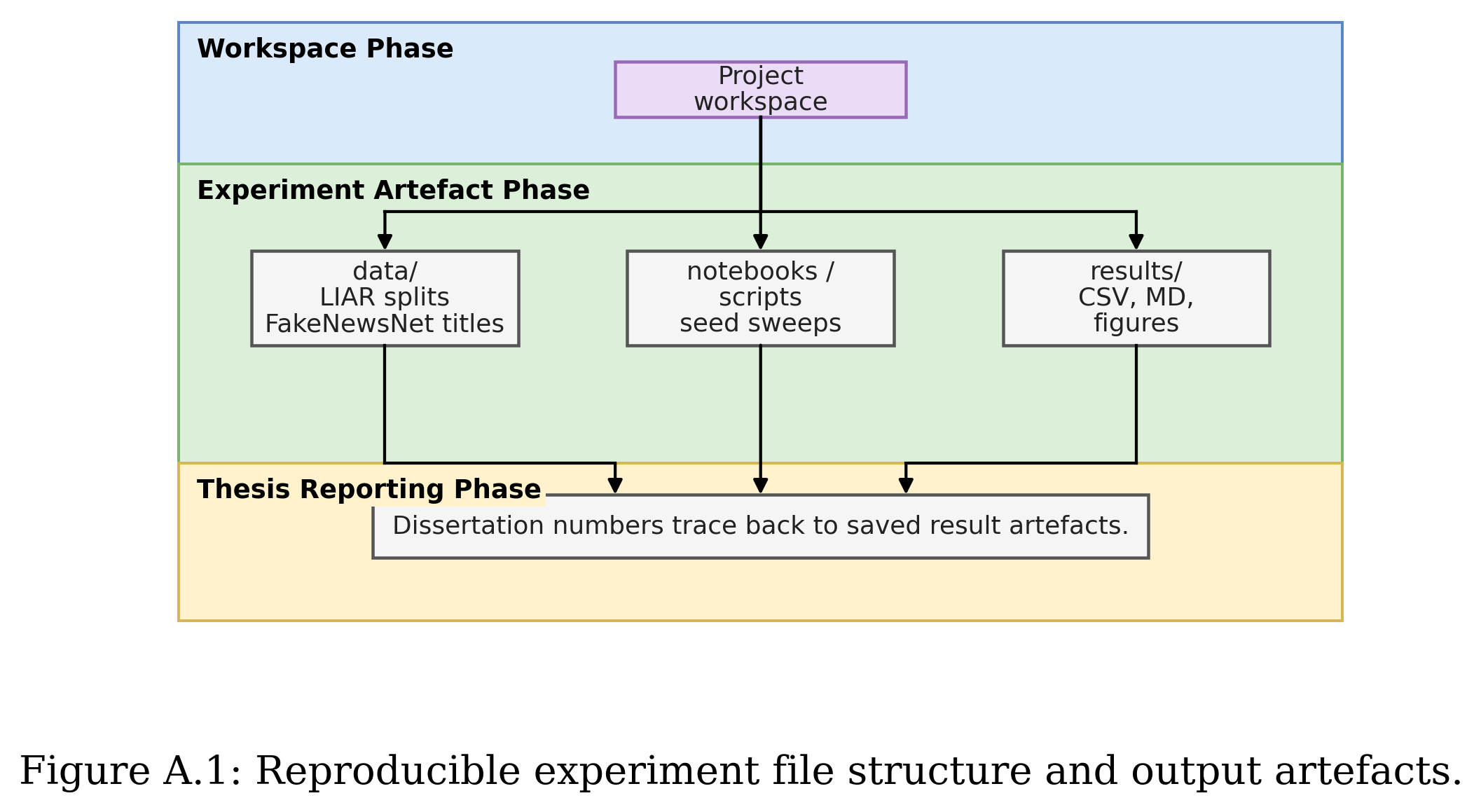
- Install the Python environment with PyTorch, HuggingFace Transformers, scikit-learn, pandas, numpy, matplotlib, seaborn, and python-docx.
- Place LIAR files at data/liar_dataset/train.tsv, data/liar_dataset/valid.tsv, and data/liar_dataset/test.tsv.
- Place the processed FakeNewsNet minimal title file at data/fakenewsnet_minimal/processed/fakenewsnet_minimal_titles.csv.
- Run the TF-IDF baseline notebook or script first to reproduce the deterministic LIAR baseline.
- Run the BERT, weighted BERT, RoBERTa, and weighted RoBERTa notebooks with seeds 42, 52, 62, 72, and 82.
- Run notebooks/10_cross_dataset_transformer_liar_to_fakenewsnet.py for weighted transformer transfer experiments.
- Run notebooks/11_cross_dataset_results_summary_figures.py to regenerate summary tables and figures for Chapter 6.

