Auto-Tune Studio Installation Manual
Version 0.2.1 | 29 September 2026 | Stable freeze
The official online installation paths are the accepted Docker GPU image on GitHub Container Registry and a controlled source installation. The Windows ZIP has passed private acceptance testing but is not published as a public download. First installation and first training require network access, and restricted networks need a working VPN. Every path requires an available NVIDIA GPU; CPU fallback is not provided.

1 Installation Options
- Docker GPU (recommended): pull the accepted public image from GHCR and start it with the repository Compose configuration.
- Source installation: for developers who can prepare a controlled Python 3.10 environment with CUDA-enabled PyTorch and the locked project dependencies.
- Windows ZIP (private evaluation): for a standalone Windows 10 or 11 GPU workstation. Contact Aika for the matching package and SHA-256 information.

2 Requirements and Package Verification
- 64-bit Windows 10 or 11, or a 64-bit Linux host supported by NVIDIA Container Toolkit.
- A supported NVIDIA GPU and working driver.
- At least 12 GiB free for first installation, plus space for datasets, weights, and results.
- A browser that can open http://127.0.0.1:8000/.
- Keep API keys out of packages, configuration files, commands, logs, screenshots, and Git repositories.
- Keep the network available during the first Windows or Docker installation and the first training run. Use a working VPN where direct access is restricted so Ultralytics can download first-use weights. LLM analysis and tuning require continued access to the external API.
For private Windows delivery, verify the exact package size and full SHA-256 supplied by Aika before extracting it. Do not use packages obtained from unofficial mirrors or third parties.

3 Windows ZIP Installation (Private Evaluation)
The Windows ZIP is not hosted in the public GitHub repository or its Releases. The following procedure applies only after Aika provides the accepted package and checksum for the requested version.
1. Extract AutoTuneStudio-Setup-0.2.1.zip to a normal folder. Do not run scripts from an archive preview.
2. Confirm install.bat, start.bat, upgrade.bat, uninstall.bat, and integrity lock files are present.
3. Double-click install.bat and keep the window open while the private runtime is created from bundled dependencies.
4. After the success message, use the desktop shortcut or the installed start.bat.
5. Open http://127.0.0.1:8000/ and confirm the Studio home page appears.
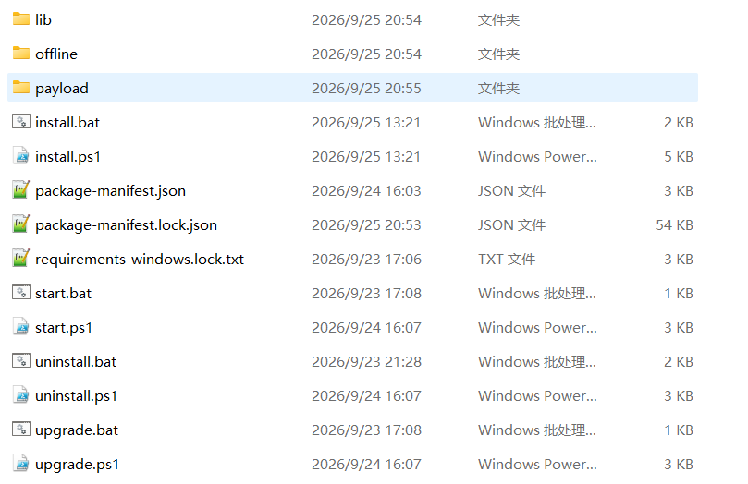
Figure 1 Extracted Windows delivery directory
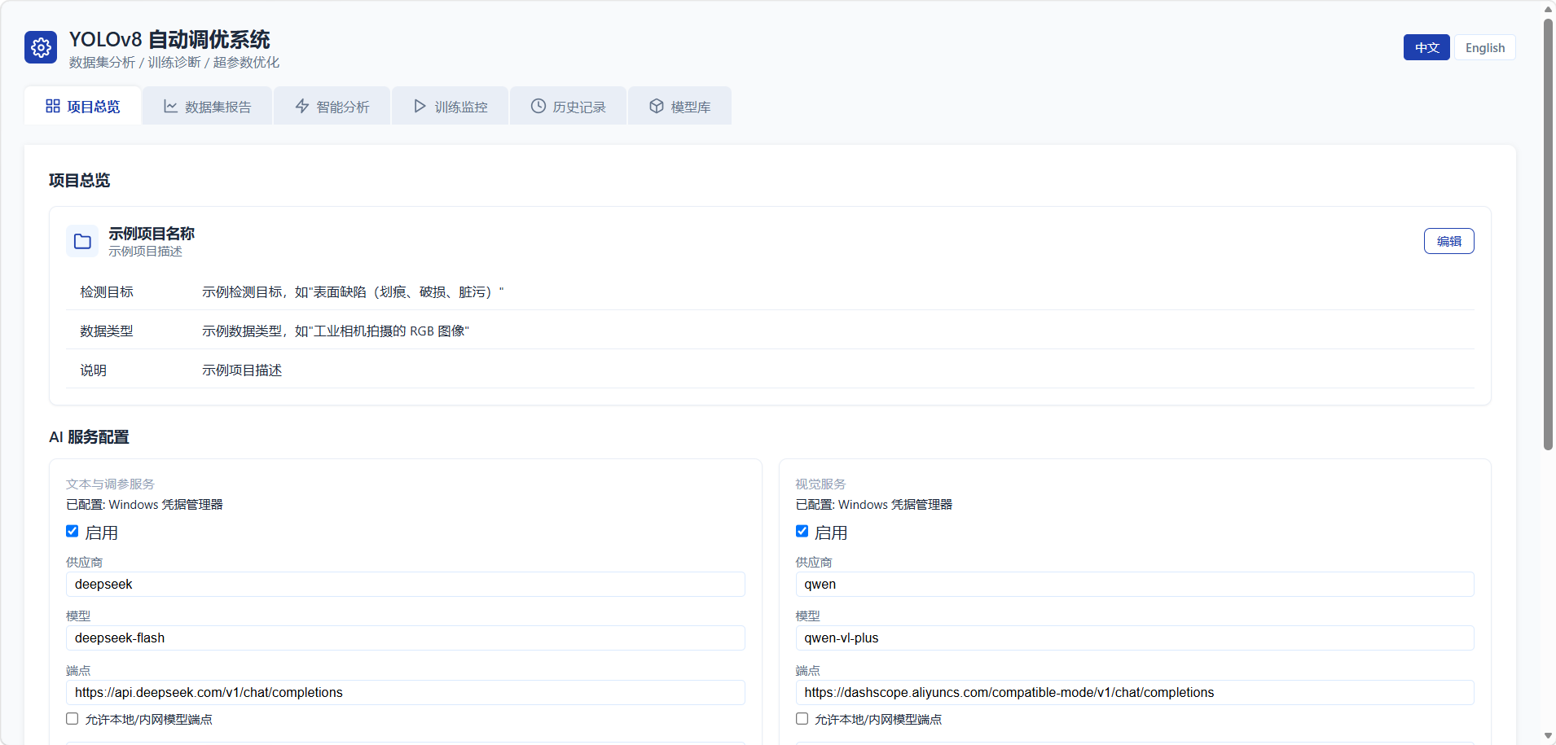
Figure 2 Studio home page after a successful Windows installation

3.1 Repair Upgrade and Uninstall
- Running install.bat again for the same complete version only repairs launchers and shortcuts.
- Run upgrade.bat from a verified new package. If the dependency lock is unchanged, only application files are replaced; otherwise a side-by-side runtime is verified before switching.
- Run uninstall.bat from the installed directory. Keep user data by default; delete it only after a verified backup.
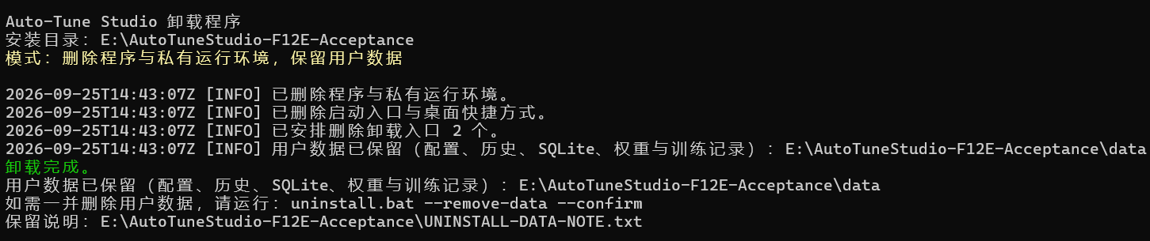
Figure 3 Default uninstall result with user data retained

4 Docker GPU Installation (Recommended)
The offline Docker delivery has two required files. The image TAR contains the runnable image. The source/configuration ZIP provides compose.yaml, controlled directory mappings, and startup configuration. Extract the ZIP and run Compose from the directory that directly contains compose.yaml; importing the image alone does not provide a Compose configuration.
Offline order: verify both files, load the image, tag it as auto-tune:local, extract the configuration ZIP, enter its root directory, then run docker compose up -d --no-build.
Online pull: docker pull ghcr.io/luzhaohao/auto-tune-studio:0.2.1; docker tag ghcr.io/luzhaohao/auto-tune-studio:0.2.1 auto-tune:local; docker compose up -d --no-build.
Recommended online installation from GitHub Container Registry:
docker pull ghcr.io/luzhaohao/auto-tune-studio:0.2.1
docker tag ghcr.io/luzhaohao/auto-tune-studio:0.2.1 auto-tune:local
docker compose up -d --no-build
If the host cannot access GHCR directly, obtain the image archive through an approved private delivery channel, verify its checksum, and import it:
docker load -i AutoTuneStudio-Docker-0.2.1-image.tar
docker image inspect auto-tune:0.2.1
docker tag auto-tune:0.2.1 auto-tune:local
To build from the source delivery package:
docker build --pull=false -t auto-tune:local .

4.1 Persistent Data
Host directory | Container directory | Purpose
docker-data/config | /data/config | Configuration
docker-data/log | /opt/auto-tune/log | Audit, reports, SQLite
docker-data/detect | /opt/auto-tune/detect | Detect results
docker-data/runs | /opt/auto-tune/runs | Other run results
docker-data/models/weights | /opt/auto-tune/models/weights | Weights and ONNX
docker-data/datasets | /data/datasets | Datasets

4.2 Start and Verify
docker compose up -d --no-build
docker compose ps
curl http://127.0.0.1:8000/healthz
Expected response: {"status":"ok","product":"auto-tune-studio"}. Confirm healthy status, correct port mapping, NVIDIA GPU reservation, and 1 GiB shared memory.
A complete first-run check verifies healthy container status, the health endpoint, the web page, saved API connection, mounted datasets and weights, NVIDIA GPU visibility, and one minimal 1-epoch standard training. For full business acceptance, also run a minimal HPO study, formal training with the best HPO parameters, and one LLM tuning flow.
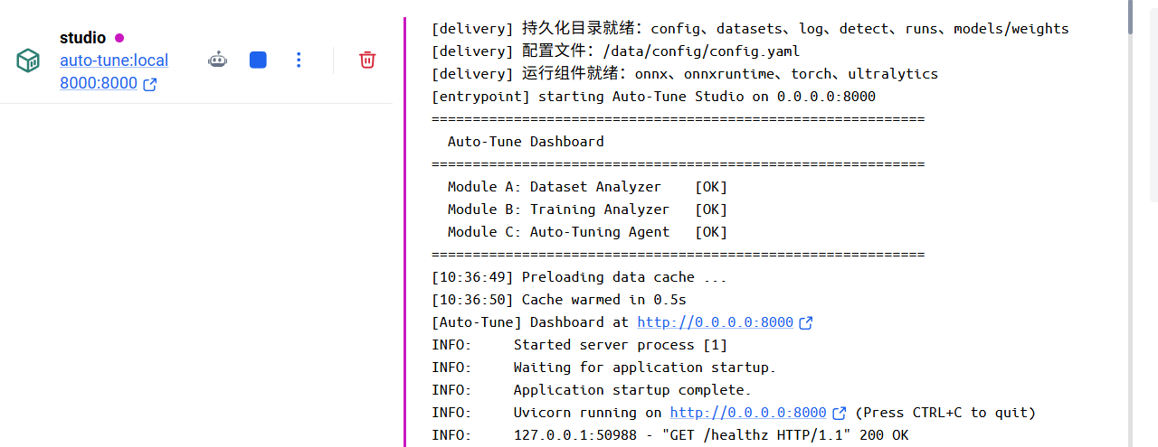
Figure 4 Container status and startup log
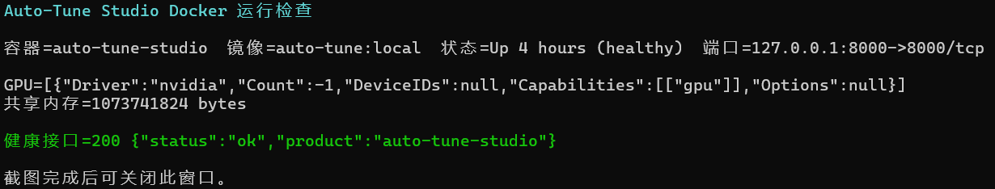
Figure 5 GPU shared memory and health check
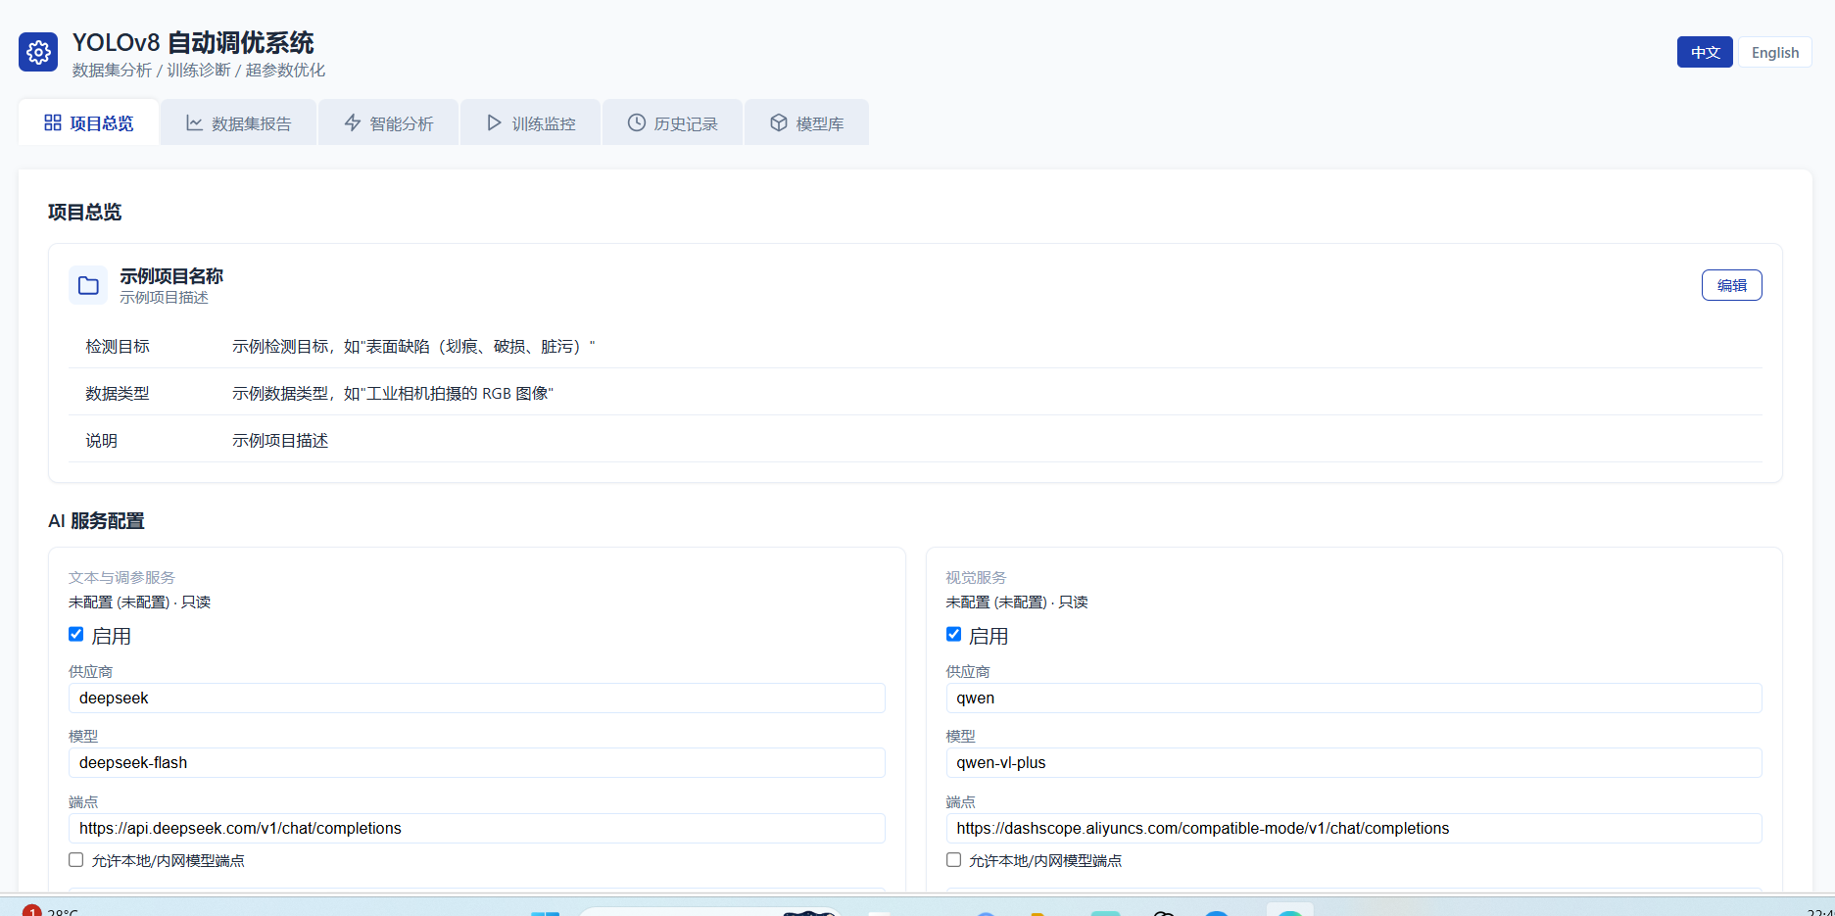
Figure 6 Studio home page in Docker
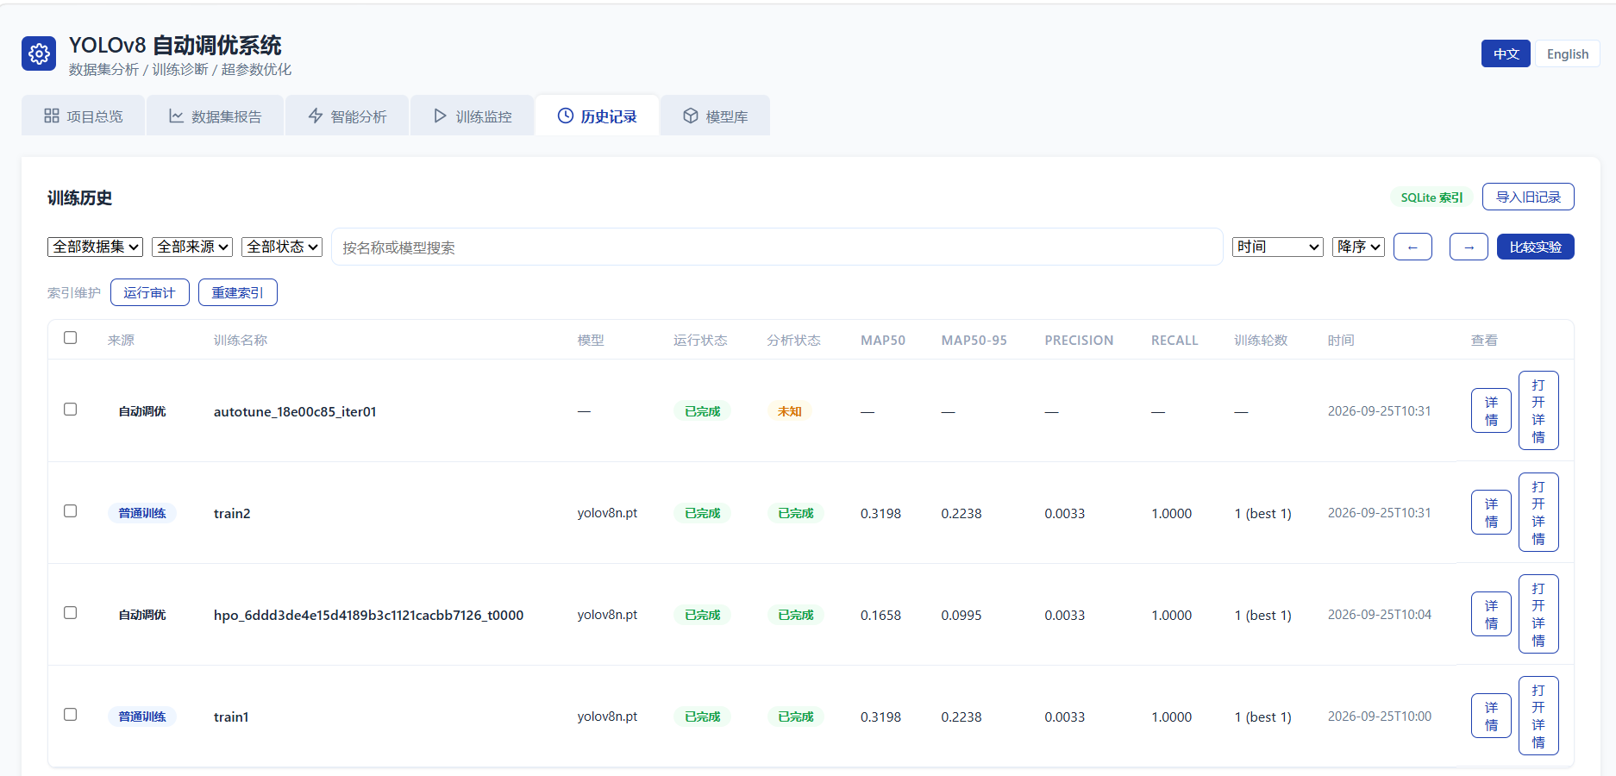
Figure 7 Training and tuning history retained after restart

4.3 Source Installation
Conda users can create the complete controlled Python 3.10 GPU environment and start Studio:
conda env create -f environment.yml
conda activate auto_tune
python -m auto_tune.main
Python 3.10/venv users must install CUDA PyTorch from the official CUDA 12.1 wheel index before the locked project dependencies:
python -m venv .venv
.\.venv\Scripts\Activate.ps1
python -m pip install --index-url https://download.pytorch.org/whl/cu121 torch==2.5.1 torchvision==0.20.1
python -m pip install -r requirements.txt
python -m auto_tune.main
Both source paths are developer workflows, not one-click end-user installers. Confirm the NVIDIA GPU before starting and do not silently fall back to CPU training.

5 First Start Checklist
1. Enter project information.
2. Save text or vision API credentials in the Studio settings and test the connection.
3. Select and analyze a dataset, then create an immutable training snapshot.
4. Upload or select a trusted controlled weight.
5. Run one minimal GPU training job before longer work.

6 FP32 ONNX Check
1. Choose a trusted uploaded .pt weight in the model library.
2. Confirm the trusted source and select Export ONNX.
3. The supported export is FP32 with imgsz 640, opset 17, dynamic false, simplify false, and nms false.
4. Verify the output name, size, source model, and download link. Existing targets are never overwritten.

7 Troubleshooting and Safety
- GPU unavailable: check the driver, NVIDIA runtime, and docker run --gpus all. Do not switch to CPU.
- Insufficient disk: do not delete datasets, weights, results, or Docker volumes without a backup.
- Page unavailable: inspect the sanitized startup log, health endpoint, port use, docker compose ps, and docker compose logs.
- Never expose this single-user Studio directly as a public multi-user service.
- Support requests should include version, installation method, stable error code, reproduction steps, and sanitized logs only.

