Auto-Tune Studio User Manual
Version 0.2.0 | 26 September 2026
This manual covers the accepted single-user, single-machine YOLOv8 Detect workflow. Install and start Studio first by following the Installation Manual.

1 Recommended Workflow
Project information -> AI service configuration -> dataset analysis and snapshot -> controlled weight -> standard training, HPO, or LLM tuning -> monitor and history -> optional manual ONNX export.

2 Project Information
1. Open Project Overview and select Edit.
2. Enter a meaningful project name, description, detection target, and data type.
3. Save and confirm the project card. Do not edit audit files or run directories directly.
Figure 1 Studio home page and primary navigation
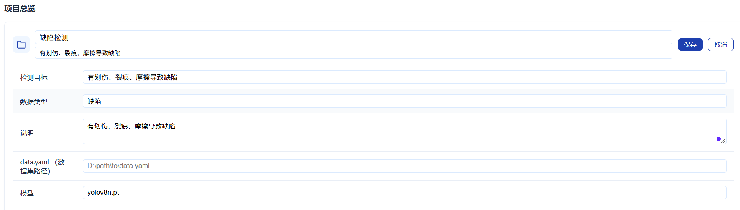
Figure 2 Editing and saving project information

3 AI Service Configuration
- Enable Text and Tuning Service, then enter provider, model, and HTTPS endpoint.
- Enter a new API key and select Save Key. Studio never displays the saved secret again.
- Save non-sensitive settings and run Test Connection before LLM analysis or tuning.
- Configure the vision service only when image-assisted diagnosis is needed.
- Never place keys in config.yaml, scripts, logs, screenshots, chats, or Git.
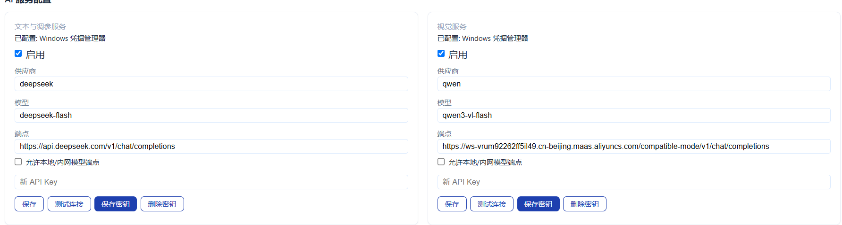
Figure 3 Text and vision AI service configuration

4 Dataset Analysis and Snapshot
1. Open Dataset Analysis Report and browse to a YOLO Detect dataset directory.
2. Run analysis and review image, label, blur, box, class balance, and spatial-distribution findings.
3. Correct missing or invalid data before training.
4. Set validation ratio and random seed, then create a training snapshot.
5. Proceed only when the snapshot is valid; never edit a published snapshot manually.
Figure 4 Dataset directory selection
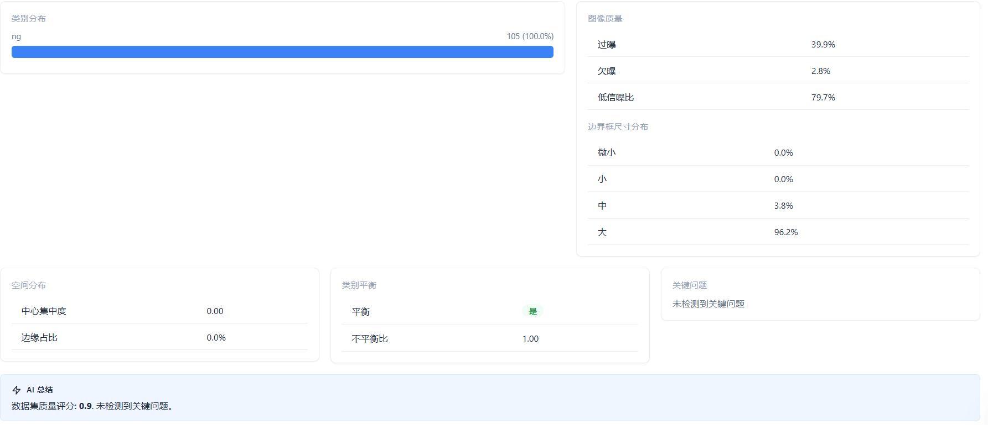
Figure 5 Dataset quality and annotation results
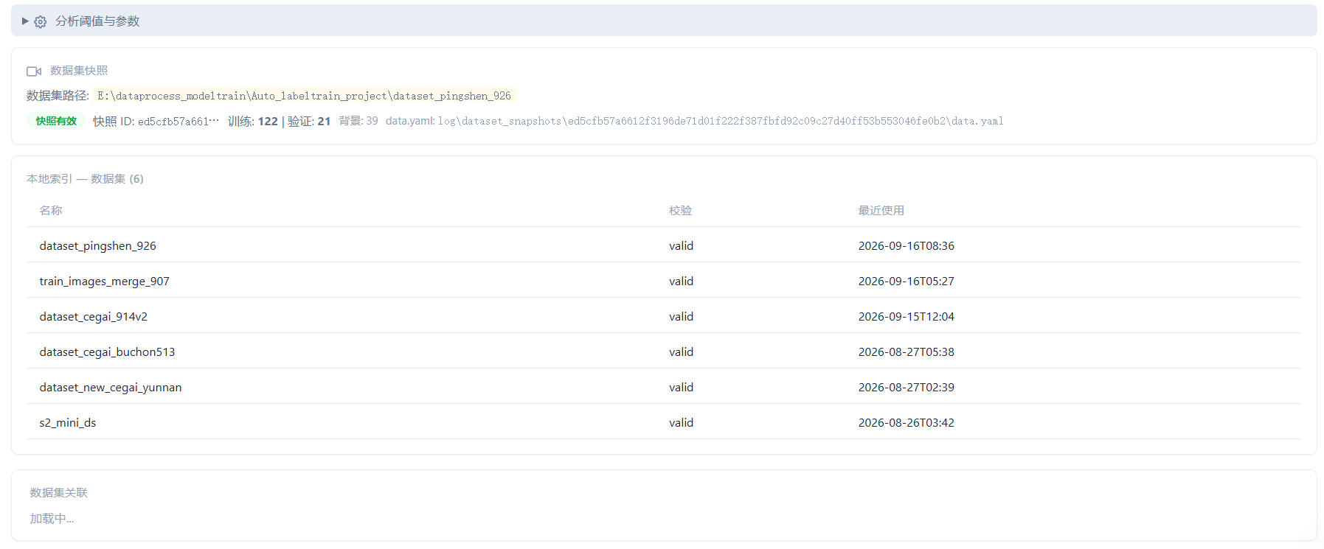
Figure 6 Valid dataset snapshots

5 Model Library and ONNX Export
- Upload only trusted .pt weights compatible with the current Ultralytics version.
- Verify file name, size, SHA-256, and source type.
- Standard training and HPO select initial weights from the controlled library.
- For ONNX, select a trusted uploaded weight and choose Export ONNX. The first release supports FP32 only with imgsz 640 and opset 17.
- Wait for Completed, then verify and download the artifact. Existing files are not overwritten.
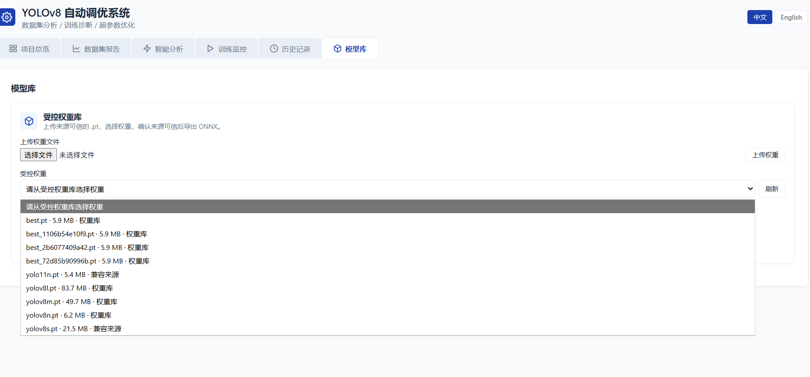
Figure 7 Controlled model library
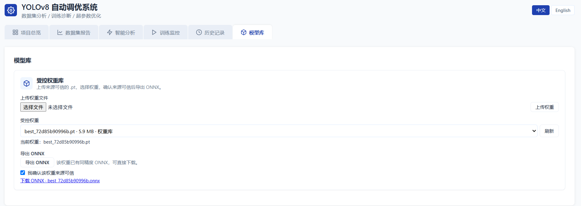
Figure 8 Completed FP32 ONNX export

6 LLM Tuning
1. Complete at least one usable reference training run.
2. In Smart Training, analyze the reference run and choose LLM Parameter Tuning.
3. Review the diagnosis and proposed parameter changes, then confirm training.
4. Suggestions execute only after evidence, semantic, guardrail, and audit checks pass.
5. After completion, verify the overall best result. keep_params means the AI intentionally retained the reference parameters.
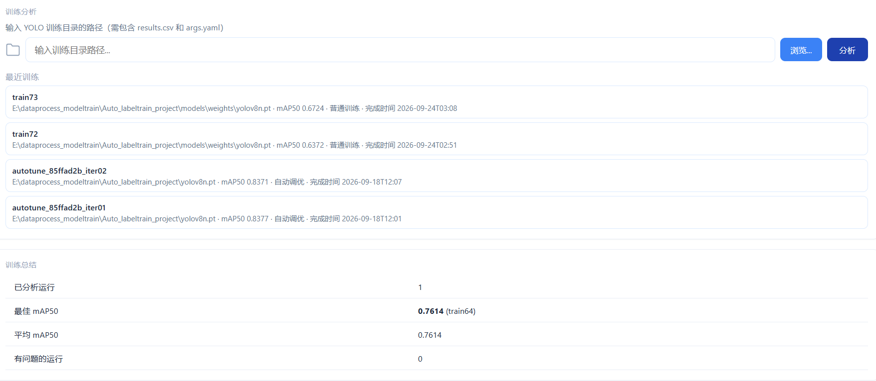
Figure 9 LLM reference run and analysis
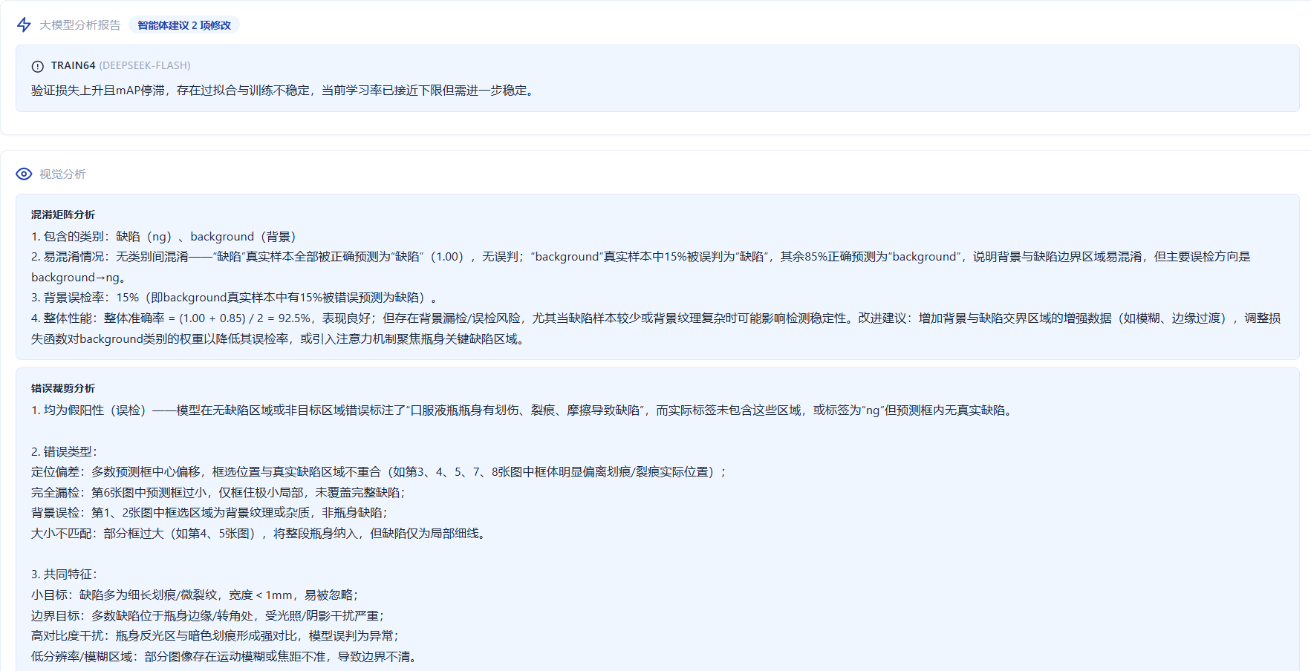
Figure 10 LLM diagnosis
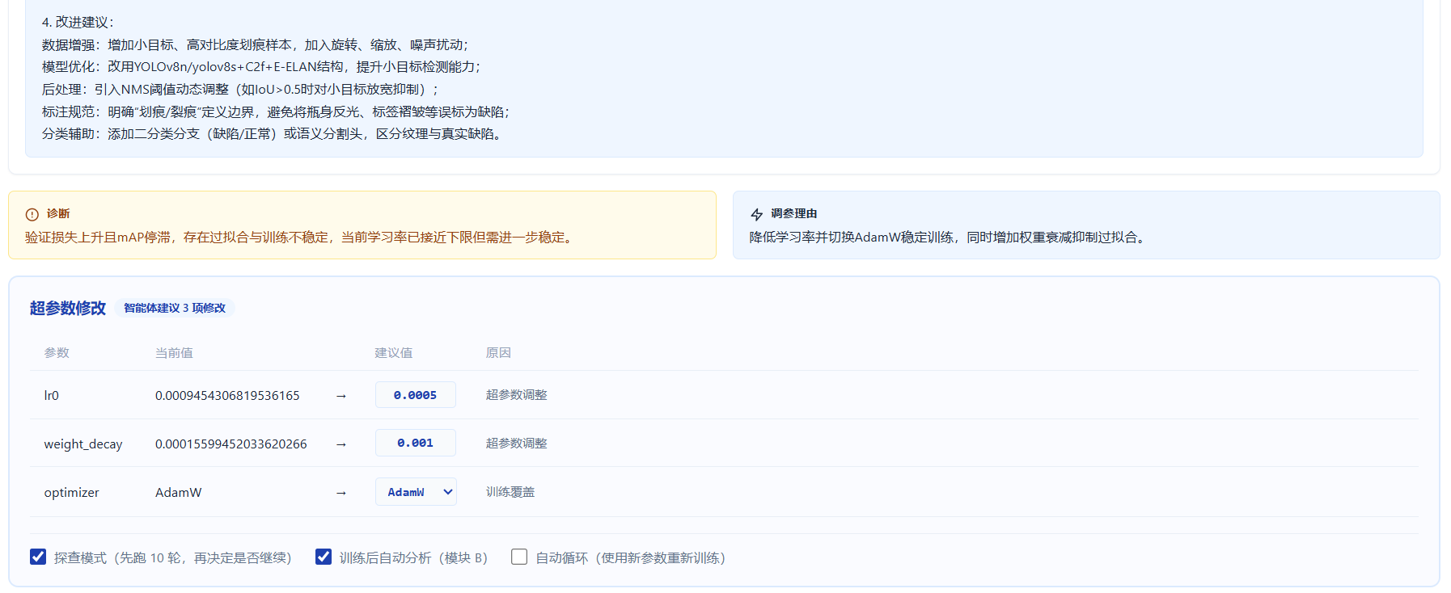
Figure 11 Proposed parameter changes
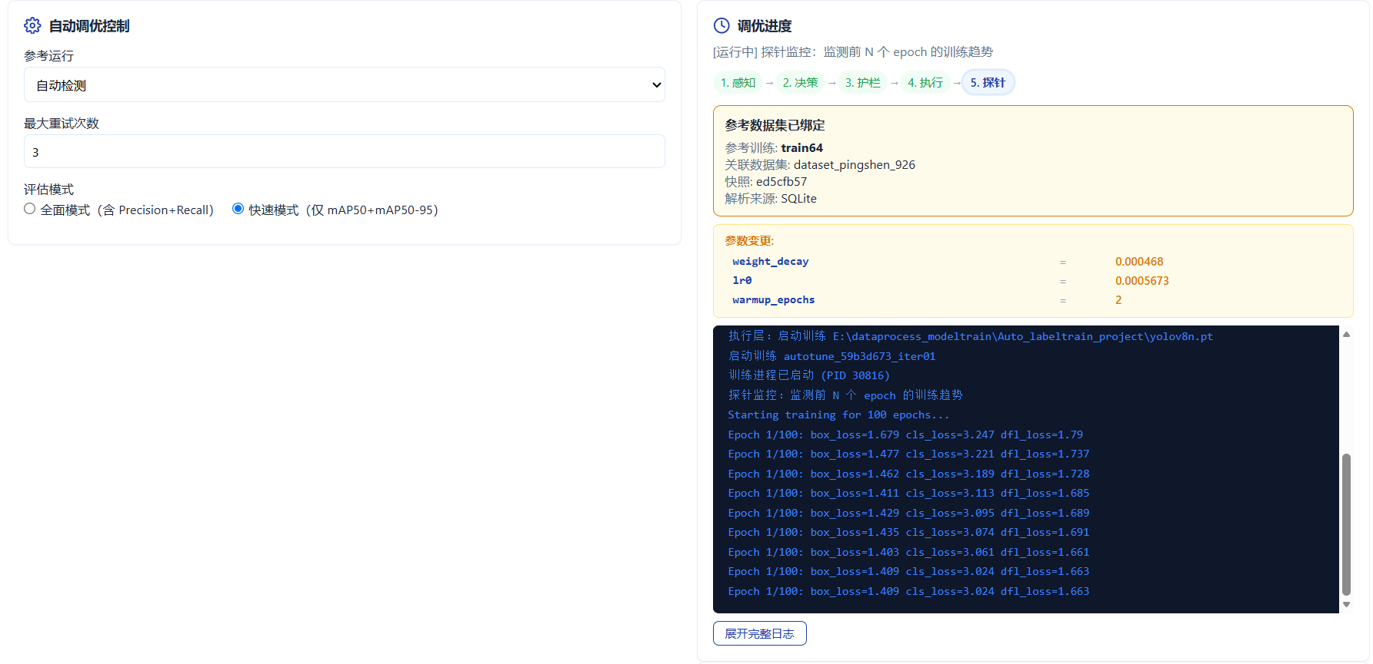
Figure 12 LLM tuning configuration and status
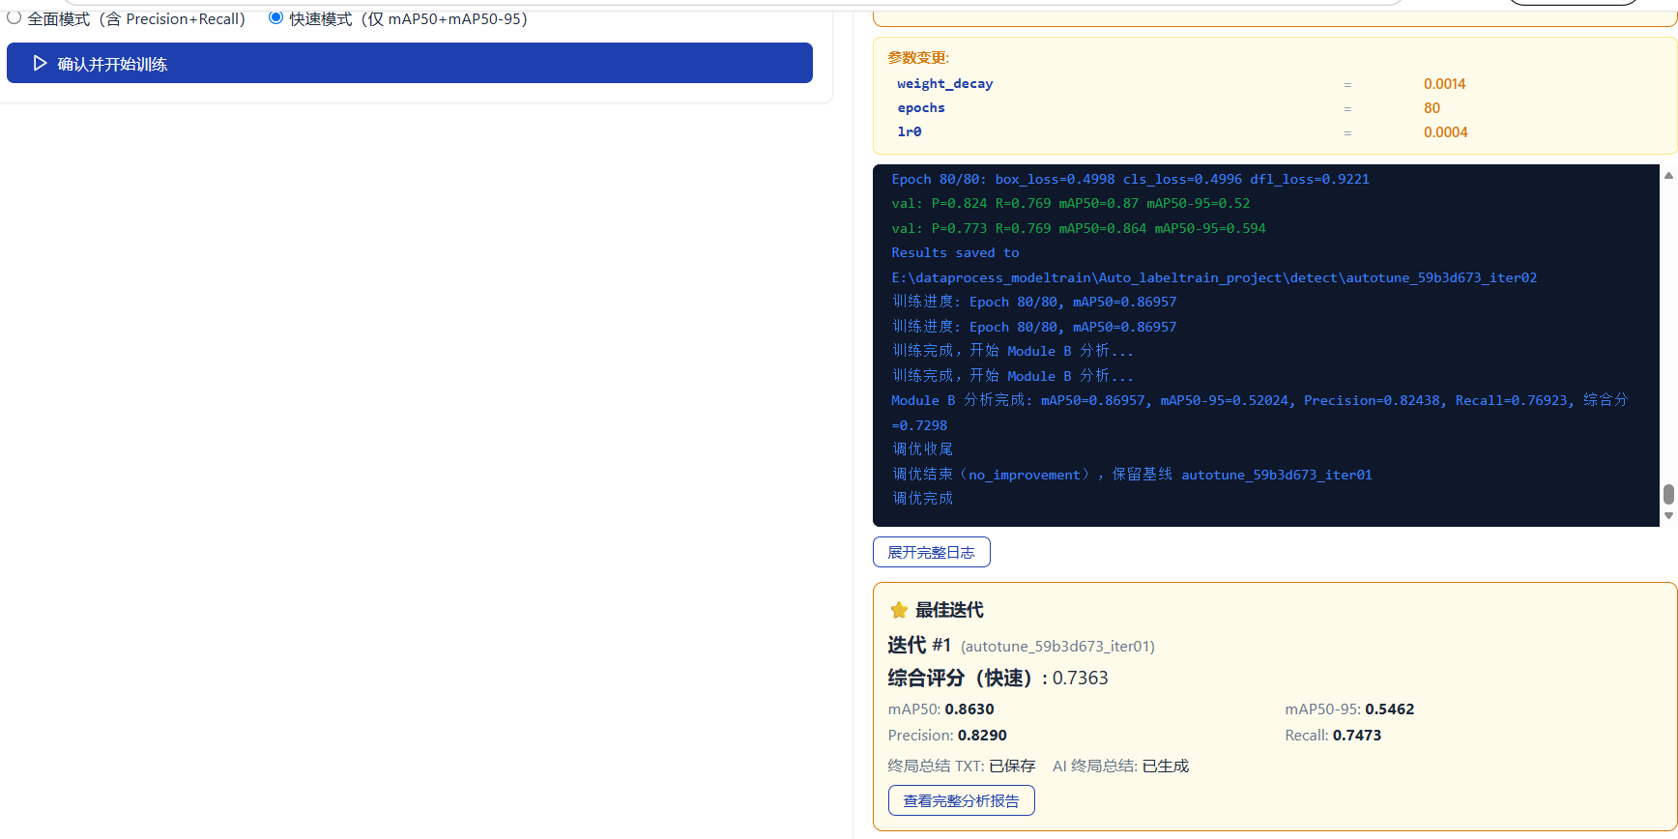
Figure 13 Actual LLM-tuned training result

7 HPO Tuning
1. Choose HPO Algorithm Tuning. No LLM key is required.
2. Set trial count and epochs, then select a published snapshot and controlled initial weight.
3. Review advanced options such as sampler, image size, batch, seed, and timeout.
4. Create and start the study once. If submission is uncertain, check HPO History before retrying.
5. Monitor trials, stop or resume the same study when necessary, and review ranking after completion.
6. Use the best parameters for formal training when a final model is required.
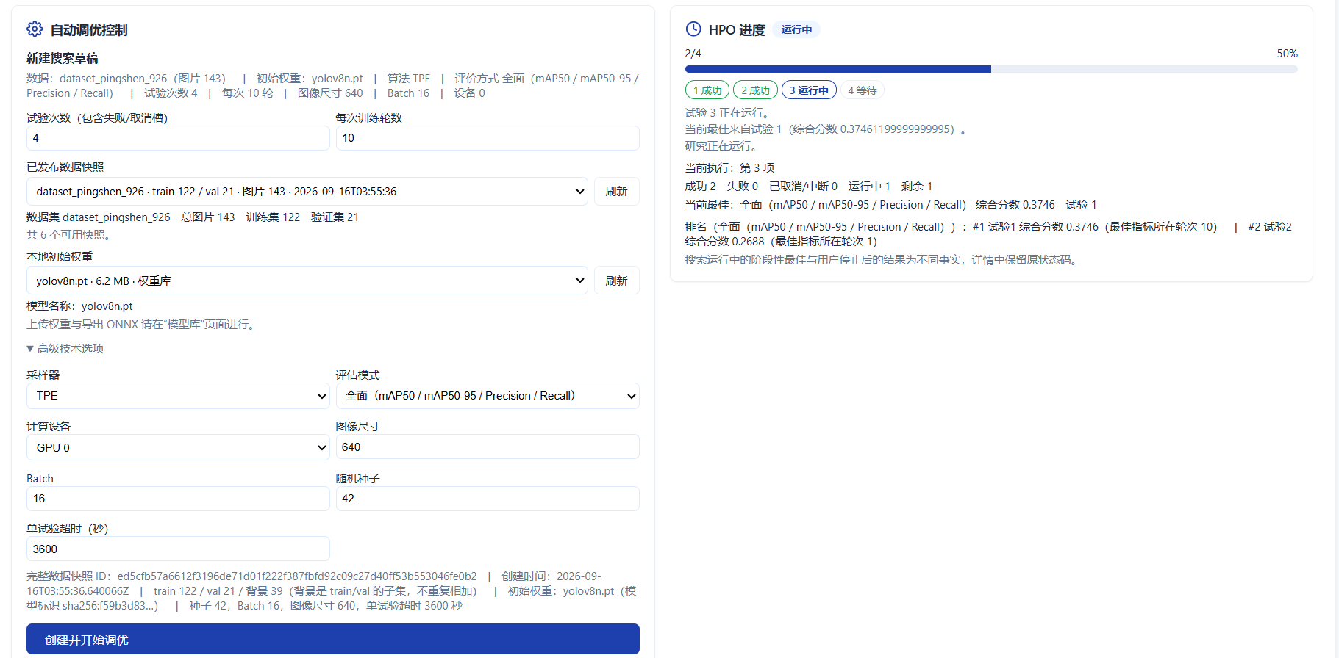
Figure 14 HPO study and progress
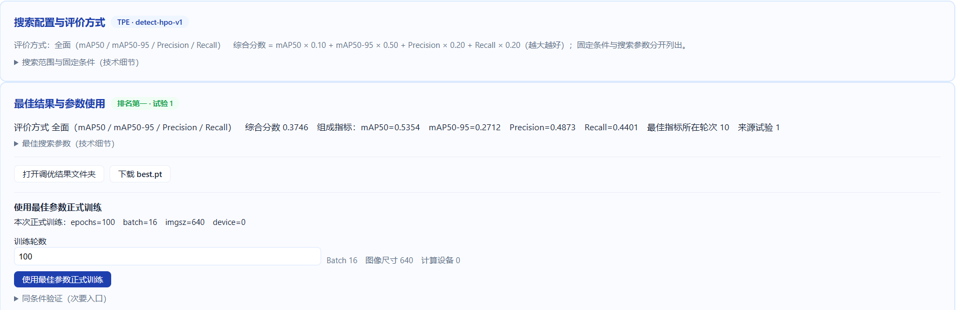
Figure 15 HPO ranking and best parameters
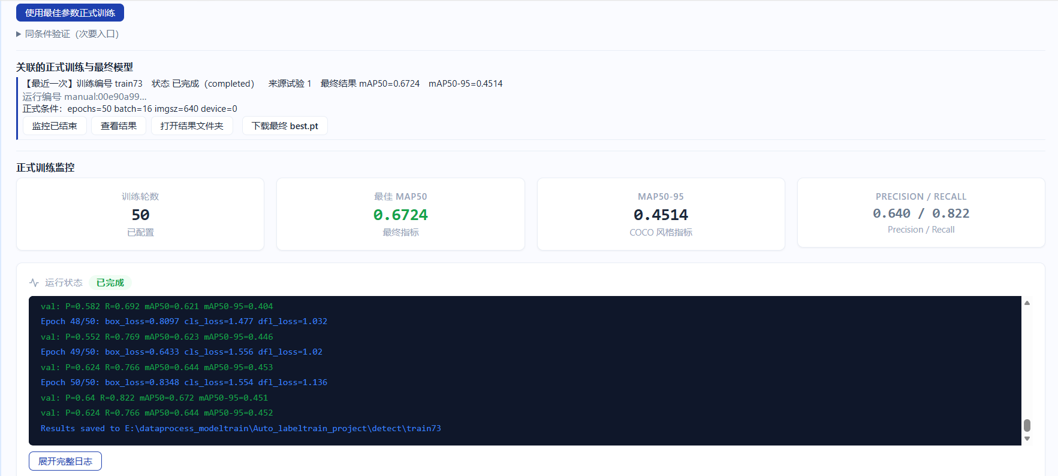
Figure 16 Formal training with HPO best parameters

8 Standard Training
1. Confirm a valid dataset snapshot.
2. Open Training Monitor and select Start New Training.
3. Choose the snapshot and controlled weight, then set epochs, imgsz, and batch.
4. Start training and monitor status, epochs, metrics, and concise logs. Use Stop Training rather than killing processes.
5. After completed, verify mAP50, mAP50-95, precision, recall, final status, and report access.
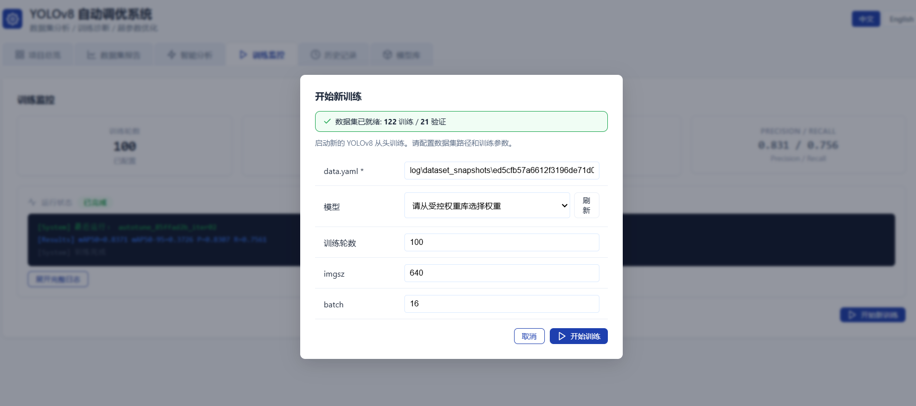
Figure 17 Standard training parameters
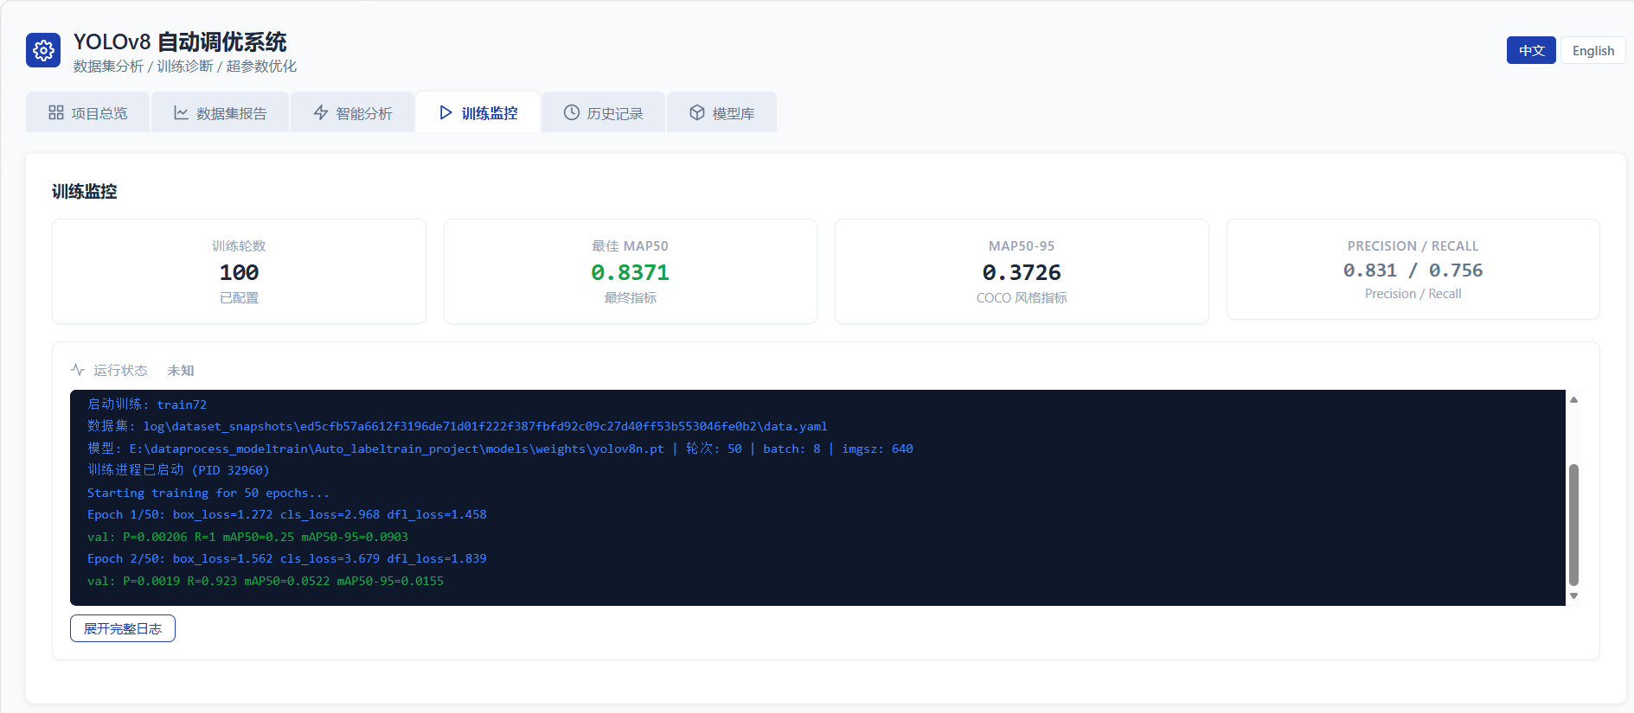
Figure 18 Training monitor and metrics

9 History and Comparison
- Filter by dataset, source, and state; search by run name or model; sort by time, name, or metric.
- Open a record to inspect identity, snapshot, model, effective parameters, metrics, status, logs, report, and tuning audit.
- Compare two to five runs only when snapshot, initial weight, evaluation mode, and training conditions are comparable.
- SQLite Index is the normal query view; JSON Fallback remains readable but may limit search and pagination.
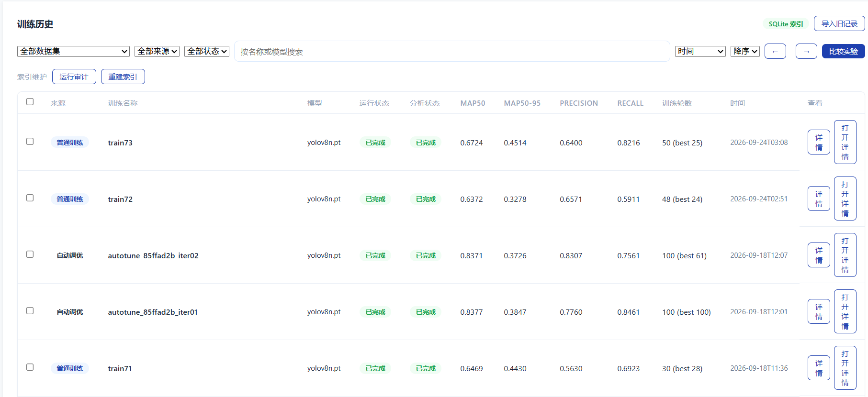
Figure 19 Training history filters and results
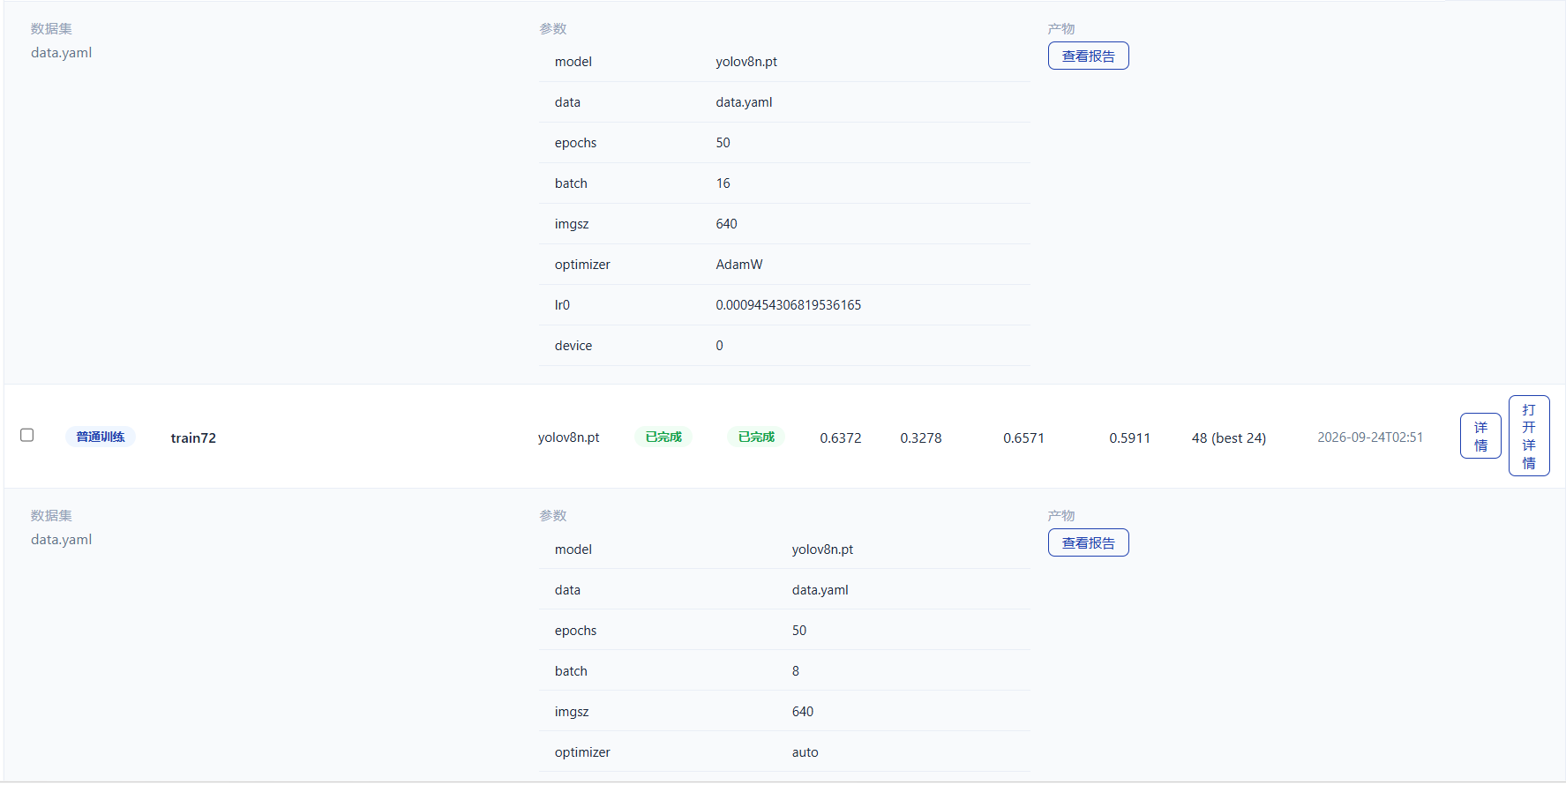
Figure 20 Multi-run parameter and metric comparison
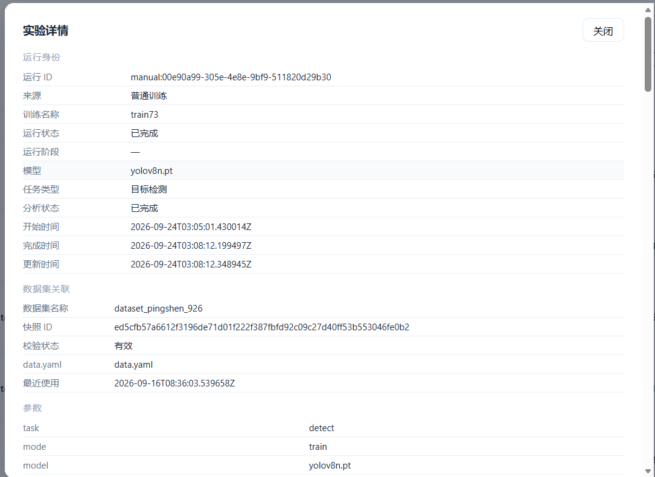
Figure 21 Experiment detail and provenance

10 Status Meanings
Status | Meaning
completed | Finished normally
failed | Review the stable error code and full log before retrying
cancelled | Stopped by the user
keep_params | LLM retained the reference parameters and may finish without training
Request result unknown | Check history before submitting again
Snapshot damaged or unresolved | Create a new valid snapshot before training

11 Operating Boundaries
- Do not modify snapshots, run directories, or audit records during training.
- Do not publish real configurations, datasets, weights, outputs, logs, or credentials.
- Do not expose the single-machine Studio as a multi-user service.
- Standard training, HPO, and LLM tuning are independent strategies; do not pass HPO results to LLM for another decision.
- For installation, Docker deployment, upgrade, and uninstall, use the Installation Manual.

