## Lists creating and updating elements

getwd()

getwd()

setwd("E://Advanced R/lists")

getwd()

util <- read.csv("mu.CSV")

head(util, 12)

str(util)

summary(util)

summary(RL1)

The output shows the amount of idle time for the machine

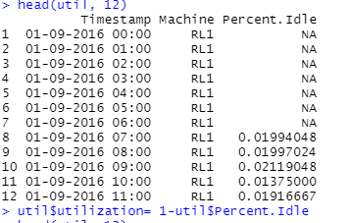

##Code wuill share the utilization of the machines

util$utilization= 1-util$Percent.Idle

head(util, 12)

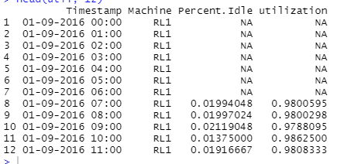

The utilization shows how much the machine was not working at that time