**PnP Automation**

**Step 1: Create a new Visual Studio Project**

1. Open Visual Studio.
2. Click on "Create a new project."
3. Select "Console App (.NET Framework)" as the project template.
4. Choose the appropriate framework, such as ".NET Framework 4.8".
5. Provide a name for your project and click "Create."

**Step 2: Install PnP Core SDK**

1. Open the Package Manager Console (**Tools -> NuGet Package Manager -> Package Manager Console**).
2. Run the following command to install the PnP Core SDK: Install-Package SharePointPnPCoreOnline

**Step 3: Prepare XML Templates**

Create XML templates for your site, lists, and libraries. You can use the PnP PowerShell commands to export the existing site structure to a PnP Provisioning template or create a template manually. Save these templates in your project folder.

Below is the example that’s how your template file should look like.

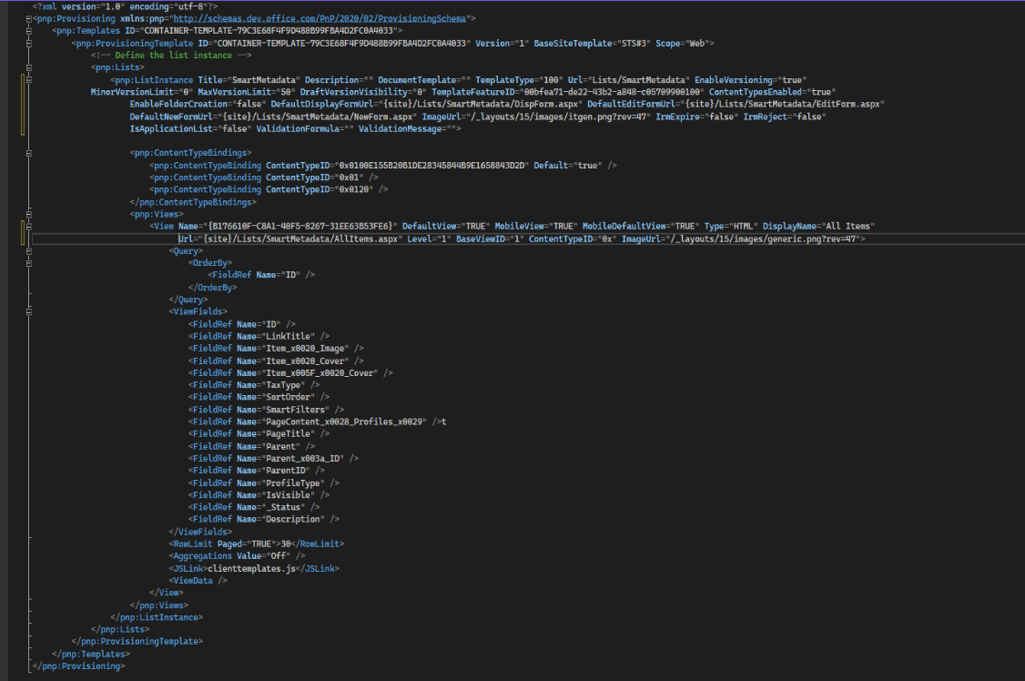

### Step 4: Add Code to Apply Templates

Replace the content of your “**Program.cs”** file with the following code:  
using System;

using System.IO;

using Microsoft.SharePoint.Client;

using OfficeDevPnP.Core;

using OfficeDevPnP.Core.Framework.Provisioning.Connectors;

using OfficeDevPnP.Core.Framework.Provisioning.Model;

using OfficeDevPnP.Core.Framework.Provisioning.Providers.Xml;

namespace SPSiteProvosioning

{

class Program

{

//Here you will write your logic according to requirement and flow

}

}

### Step 5: Build and Run

After running the build successfully you will see a command prompt on which you can provide input or see the end results (According to your flow).