Case a) Range = 5

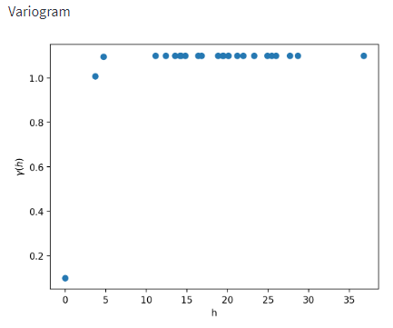

Case b) Range = 15

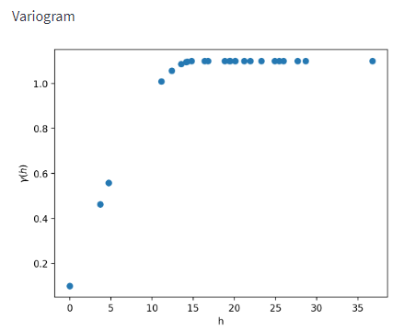

Case c) Range = 30

Case d) Range = 60



