VIETNAM GENERAL CONFEDERATION OF LABOR
TON DUC THANG UNIVERSITY
FACULTY OF INFORMATION TECHNOLOGY



PHUNG HUU LUAN – 524H0167

MIDTERM REPORT

WEB PROGRAMMING & APPLICATIONS

GitHub Repository: https://github.com/luan0217091310-gif/WebAssembly
Project Demo Video:

HO CHI MINH CITY, 2026
VIETNAM GENERAL CONFEDERATION OF LABOR
TON DUC THANG UNIVERSITY
FACULTY OF INFORMATION TECHNOLOGY



PHUNG HUU LUAN – 524H0167

MIDTERM REPORT

WEB PROGRAMMING & APPLICATIONS

GitHub Repository: https://github.com/luan0217091310-gif/WebAssembly
Project Demo Video:

Advised by
Dr. Van-Vang Le
HO CHI MINH CITY, 2026
ACKNOWLEDGEMENT

We would like to express our sincere gratitude to Dr. Van-Vang Le, our instructor and mentor, for his valuable guidance and support throughout the midterm project of our course Web Programming & Applications. He has been very helpful and patient in providing us with constructive feedback and suggestions to improve our work on WebAssembly for High Performance. He has also encouraged us to explore advanced technical layers and technologies to enhance our system's functionality and performance. We have learned a lot from his expertise and experience in web development and software engineering. We are honored and privileged to have him as our teacher and supervisor.

Ho Chi Minh city, 9th May 2026.
Author
(Signature and full name)

Luan
Phung Huu Luan

DECLARATION OF AUTHORSHIP
We hereby declare that this is our own project and is guided by Dr. Van-Vang Le. The content research and results contained herein are central and have not been published in any form before. The data in the tables for analysis, comments and evaluation are collected by the main authors from different sources, which are clearly stated in the reference section. In addition, the project also uses some comments, assessments as well as data of other authors, other organizations with citations and annotated sources. If something wrong happens, we will take full responsibility for the content of our project. Ton Duc Thang University is not related to the infringing rights, the copyrights that we give during the implementation process (if any).
Ho Chi Minh city, 9th May 2026
Author
(Signature and full name)

Luan
Phung Huu Luan

TABLE OF CONTENT
CHAPTER 1. INTRODUCTION 1
CHAPTER 2. THEORETICAL SURVEY 2
2.1 WebAssembly Technology 2
2.2 System Architecture 3
2.3 Comparative Analysis 5
2.3.1 WebAssembly vs. Pure JavaScript 5
2.3.2 WebAssembly vs. Alternative Approaches 6
CHAPTER 3. REQUIREMENT ANALYSIS 8
3.1 Functional Requirements 8
3.2 Non-Functional Requirements 9
CHAPTER 4. SYSTEM DESIGN 10
4.1 Database Schema 10
4.2 API Endpoints 11
4.3 Data Flow 11
CHAPTER 5. RESULTS AND DISCUSSION 13
5.1 Core Logic Implementation 13
5.1.1 C++ Image Processing Source 13
5.1.2 WAT: WebAssembly Text Format 14
5.1.3 Loading Wasm in JavaScript (app.js) 14
5.1.4 Benchmark Measurement: JS vs. Wasm 14
5.1.5 PHP Front Controller Routing 15
5.1.6 Secure Database Operations with PDO 16
5.1.7 Auto-Detecting Deployment Environment 16
5.2 Deployment 16
CHAPTER 6. CONCLUSION 19
CHAPTER 7. APPENDIX: PROJECT FILE STRUCTURE 20
REFERENCES 21

INTRODUCTION
Modern web applications increasingly require intensive client-side computation — real-time image manipulation, cryptography, signal processing — tasks that JavaScript handles poorly due to its interpreted nature and garbage collection overhead. The emergence of WebAssembly (Wasm), ratified as a W3C standard in December 2019, enables near-native execution speed directly inside the browser sandbox, compiled from languages such as C, C++, and Rust [1].
This project implements Topic 7: WebAssembly for High Performance, demonstrating the compilation of an image-processing algorithm from C++ into a .wasm binary and its integration into a full-stack PHP MVC web application. Users upload an image, select a pixel filter (Invert or Grayscale), and execute it via either Pure JavaScript or the WebAssembly module. A benchmarking tool measures execution time across multiple iterations and logs results to a MySQL database through a RESTful PHP API — with a localStorage fallback when the database is offline.
Primary contributions of this project:
- Two functionally identical pixel-processing algorithms implemented in both JavaScript and WebAssembly (compiled from C++) for a controlled, side-by-side performance comparison.
- A PHP MVC back-end with three JSON API endpoints for persisting, retrieving, and clearing benchmark data.
- Full dual-environment deployment: XAMPP (localhost) and InfinityFree (production) with automatic environment detection.

THEORETICAL SURVEY

WebAssembly Technology
WebAssembly (Wasm) is a portable, binary instruction format designed as a compilation target for statically-typed languages such as C, C++, and Rust. Unlike JavaScript, which is parsed and JIT-compiled at runtime with heuristic optimization, Wasm arrives at the browser already in a compact binary that can be decoded into machine code in a single deterministic pass, eliminating JIT warm-up variance.
Key characteristics of WebAssembly:
Property | Description
Format | Binary .wasm (compact) and text .wat (human-readable S-expressions)
Execution | Browser-native AOT/JIT — no plugin, no installation
Memory | Linear ArrayBuffer — deterministic, GC-free, byte-addressable
Interop | Invoked from JavaScript via WebAssembly.instantiate()
Security | Same-origin sandbox — no direct OS or filesystem access
Standard | W3C Recommendation, December 2019; supported in all major browsers

Compilation pipeline used in this project: The C++ source code is manually authored and converted into WebAssembly Text Format (.wat) for academic transparency and auditability. This text format is then assembled into a compact 271-byte .wasm binary using the wat2wasm tool. Finally, the browser performs Ahead-Of-Time (AOT) compilation to native machine code during instantiation.
Linear Memory and pixel data exchange: WebAssembly uses a WebAssembly.Memory object, which is a resizable ArrayBuffer shared between the Wasm module and JavaScript. The process for image manipulation follows these steps:
- JavaScript reads RGBA bytes from Canvas.getImageData() into a Uint8ClampedArray.
- These bytes are copied into Wasm linear memory via Uint8Array.set(data).
- The exported Wasm function mutates the bytes in-place using efficient pointer arithmetic.
- The processed results are copied back to JavaScript and rendered on the screen.
Grayscale luminosity formula (ITU-R BT.601): To optimize performance in tight inner loops, the grayscale conversion uses integer-only arithmetic: $gray = (R × 77 + G × 150 + B × 29) >> 8$. The bit-shift $>> 8$ effectively replaces a floating-point division by 256, which is a critical optimization for both C++ and JavaScript implementations.

System Architecture
The system follows a modern web architecture, integrating a high-performance client-side module with a structured PHP MVC backend.
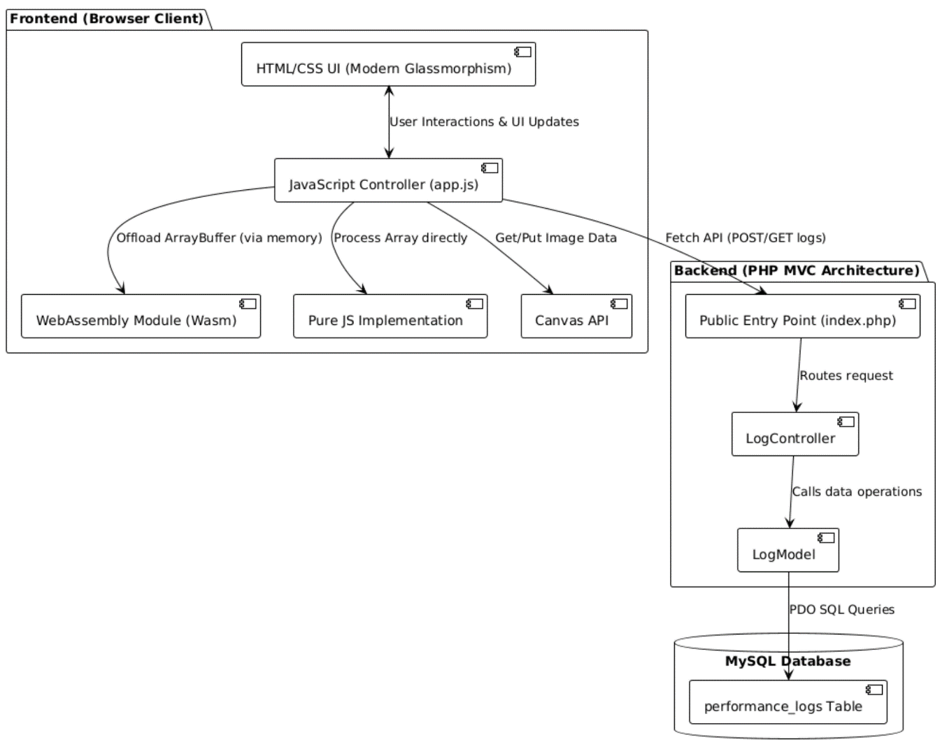
Figure 1: Overall System Architecture Diagram
Architectural Layers Description:
- Layer 1 — User Browser (Client-Side): The browser hosts the primary logic. JavaScript (app.js) orchestrates UI updates, image loading onto <canvas>, timing measurements via $performance.now()$, and API communication.
- Layer 2 — WebAssembly Module: The $image_processing.wasm$ binary handles the heavy lifting by exporting invert and grayscale functions that work directly on shared linear memory.
- Layer 3 — PHP MVC Backend: A custom Front Controller ($index.php$) routes requests to the appropriate controllers to manage performance logs without using heavy external frameworks.
- Layer 4 — Database Layer: A MySQL database persists benchmark results, with a localStorage fallback implemented on the client side to ensure resilience if the server is offline.
System Components Table:

Component | File | Role
Front Controller | public/index.php | URL parsing and dynamic controller dispatch
Log API | LogController.php | JSON endpoints for logging and retrieving data
Data Access | LogModel.php | PDO CRUD operations on the database
Client Logic | public/js/app.js | Image handling, benchmarking, and charting
Wasm Binary | image_processing.wasm | High-performance compiled C++ filters

Comparative Analysis

WebAssembly vs. Pure JavaScript
The central comparison in this project is between two client-side computation strategies for per-pixel image processing.
Criterion | Pure JavaScript | WebAssembly (from C++)
Execution speed | JIT-compiled with GC pauses; slower on tight loops. | Near-native; no GC; deterministic compile output.
Memory model | V8 managed heap; overhead on typed arrays. | Linear ArrayBuffer; direct byte addressing; no GC.
Development effort | Zero — runs natively in any browser. | Compilation step required: C++ → WAT → .wasm.
Debugging | Full Chrome/Firefox DevTools support. | Requires .wat inspection; limited breakpoints.
Startup cost | None. | One-time WebAssembly.instantiate() compile (~few ms).
Interop overhead | None. | Must copy pixel data to and from Wasm linear memory.
Use case fit | DOM manipulation, event handling, light logic. | Heavy math, image/signal processing, cryptography.

Observed benchmark result:
On an image of 500 × 320 pixels, applying the Grayscale filter, averaged over 10 iterations:
- JavaScript: 10.02 ms compute time, 10.23 ms total time.
- WebAssembly: 1.99 ms compute time, 2.49 ms total time.
- Conclusion: Pure computation in WebAssembly is approximately 5.04× faster than JavaScript.

WebAssembly vs. Alternative Approaches
Beyond pure JavaScript, there are several other technologies available for processing intensive workloads.
Technology | Comparison Analysis
Server-side PHP (GD library) | Requires HTTP round-trip (50–200 ms latency); server CPU bears the load; cannot show real-time preview without reloading the page.
WebGL / GPU shaders | Faster for parallelizable operations; vastly more complex API (GLSL shaders); not suitable for arbitrary sequential per-pixel logic.
Web Workers (JS) | Adds non-blocking concurrency, but JavaScript inside a Worker is still slow for heavy numeric loops; Wasm can also run inside Workers.
Native desktop app (C++/Electron) | Maximum speed; requires user installation; not immediately browser-deployable.
TensorFlow.js / ONNX.js | Designed specifically for ML inference; heavyweight runtime (~5 MB+); extreme overkill for simple pixel arithmetic.

Conclusion: For sequential, per-pixel arithmetic with no data dependency or branching, WebAssembly is the optimal client-side technology. It is measurably faster than JavaScript and requires no server round-trips, albeit at the cost of a more complex build pipeline.

REQUIREMENT ANALYSIS

Functional Requirements
The system must satisfy the following functional requirements to ensure a complete and testable application for the end-user:
ID | Requirement Description | Implemented
FR-01 | Upload an image via file picker or drag-and-drop onto the canvas. | Yes
FR-02 | Select an image filter to apply: Invert or Grayscale. | Yes
FR-03 | Execute the selected filter using Pure JavaScript. | Yes
FR-04 | Execute the selected filter using the compiled WebAssembly module. | Yes
FR-05 | Run repeated benchmarks (1–50 iterations) and calculate averages. | Yes
FR-06 | Display both compute time and total time immediately after each run. | Yes
FR-07 | Render a proportional bar chart comparing JS vs. Wasm average execution times. | Yes
FR-08 | Log benchmark results securely to the MySQL database via the PHP REST API. | Yes
FR-09 | Fall back to localStorage caching if the database/network is unreachable. | Yes
FR-10 | Allow users to download the processed result image as a PNG file. | Yes
FR-11 | Provide functionality to clear all performance logs (from both DB and localStorage). | Yes
FR-12 | Support Light/Dark mode toggle with user preference persisted in localStorage. | Yes

Non-Functional Requirements
Beyond functional features, the system adheres to strict performance, security, and deployment constraints:
ID | Requirement Description
NFR-01 | Privacy: All image processing runs strictly client-side — no pixel data is ever transmitted to the server.
NFR-02 | Security: The PHP back-end must utilize PDO prepared statements to structurally prevent SQL injection attacks.
NFR-03 | Portability: Auto-detect the execution environment (localhost vs. production) to eliminate manual configuration changes during deployment.
NFR-04 | Hosting Compatibility: The system must function flawlessly on InfinityFree shared hosting without requiring SSH or root access.
NFR-05 | UX/UI: The interface must provide clear status indicators, toast notifications, and automatically disable action buttons during heavy processing to prevent race conditions.

SYSTEM DESIGN

Database Schema
The application relies on a single relational table to persist benchmark metrics.
- Database: webassembly (Local) / if0_41858047_webassembly (Production)
- Table: performance_logs
Column | Type | Constraint | Description
$$id$$ | INT | PK, AUTO_INCREMENT | Unique identifier for each log entry.
$$method$$ | VARCHAR(50) | NOT NULL | Execution method ('js' or 'wasm').
$$filter_type$$ | VARCHAR(50) | NOT NULL | Applied filter ('invert' or 'grayscale').
$$execution_time_ms$$ | FLOAT | NOT NULL | Legacy alias for backward compatibility.
$$compute_time_ms$$ | FLOAT | NULL | Pure algorithm execution time inside the loop (ms).
$$total_time_ms$$ | FLOAT | NULL | Total time including memory transfer overhead (ms).
$$width$$ | INT | NULL | Image width in pixels.
$$height$$ | INT | NULL | Image height in pixels.
$$pixel_count$$ | INT | NULL | Total pixels processed (width × height).
$$iterations$$ | INT | DEFAULT 1 | Number of benchmark runs averaged.
$$created_at$$ | TIMESTAMP | DEFAULT NOW() | Auto-generated timestamp of execution.

API Endpoints
The PHP MVC backend exposes the following RESTful endpoints to interact with the database from the client application:
Endpoint | Method | Action
$$?url=home/index$$ | GET | Render main HTML UI.
$$?url=log/log$$ | POST | Save one benchmark result.
$$?url=log/get$$ | GET | Fetch the last 10 logs (DESC).
$$?url=log/clear$$ | POST | Delete all logs from MySQL.

Data Flow
The data flow dictates how information moves through the application during execution.
Single Filter Execution Flow:
- User uploads an image → FileReader extracts data → drawn onto Canvas.
- `performance.now()` captures the start time (`totalStart`).
- `Canvas.getImageData()` extracts raw RGBA bytes into a `Uint8ClampedArray`.
- JS Path: Mutates the array directly in-place using JS loops.
- Wasm Path: Copies data to Wasm linear memory → executes compiled C++ function → copies modified data back to the JS heap.
- End time is captured and processed visual result is rendered.
- fetch() POSTs the timing metrics to the `?url=log/log` endpoint.
Automated Benchmark Flow (N Iterations):
When the user requests a benchmark, the system loops the single execution flow $N$ times for JavaScript, then $N$ times for WebAssembly. It calculates the minimum, maximum, and average times, updates the proportional UI bar chart, and posts the aggregated summaries to the server.

RESULTS AND DISCUSSION

Core Logic Implementation

C++ Image Processing Source
Both filters use `extern "C"` to prevent C++ name-mangling, ensuring exported Wasm function names remain `invert` and `grayscale` when called from JavaScript. The grayscale formula uses integer-only arithmetic (ITU-R BT.601 coefficients scaled by 256) and a bit-shift instead of division — eliminating floating-point overhead in tight loops.
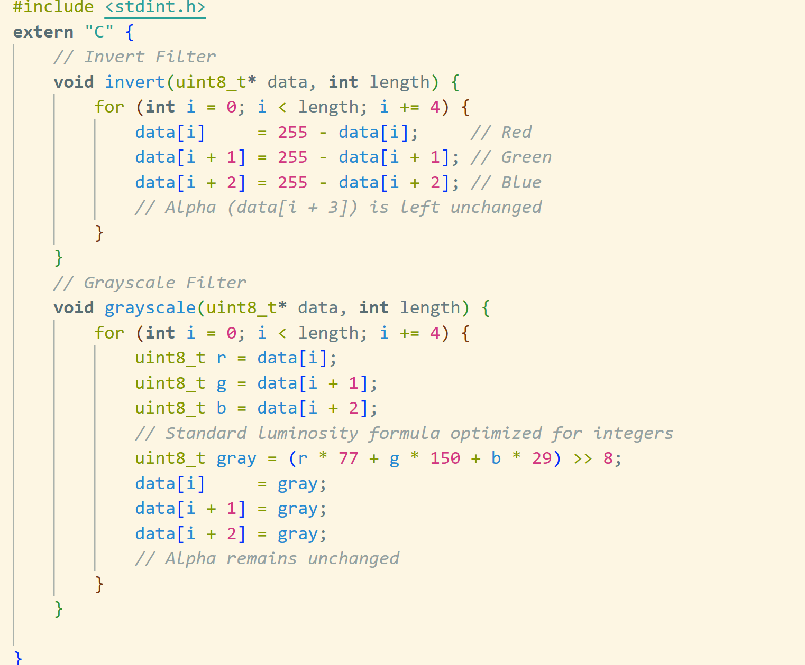
Figure 2: C++ source code for Invert and Grayscale filters

WAT: WebAssembly Text Format
The `.wat` file is the human-readable equivalent of the compiled binary. It reveals the exact memory operations:
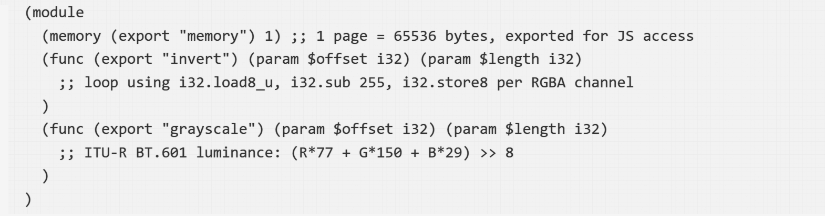
Figure 3: WebAssembly Text Format (.wat) representation
Exporting `memory` lets JavaScript create a `Uint8Array` view directly over the Wasm linear memory buffer, enabling efficient pixel data exchange.

Loading Wasm in JavaScript (app.js)
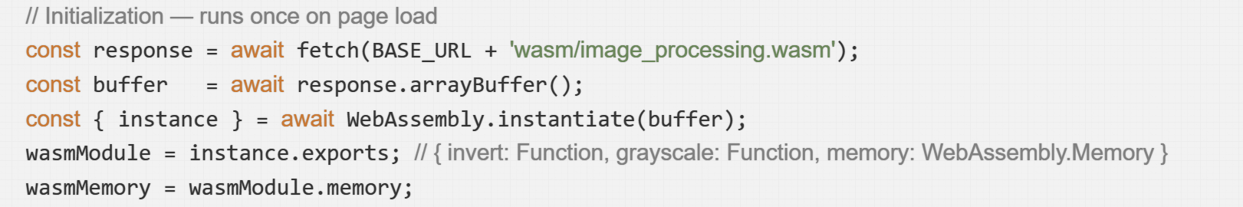
Figure 4: JavaScript initialization logic for WebAssembly
$`WebAssembly.instantiate()`$ triggers one-time AOT compilation inside the browser engine. Subsequent calls to `wasmModule.invert()` execute as native machine code.

Benchmark Measurement: JS vs. Wasm
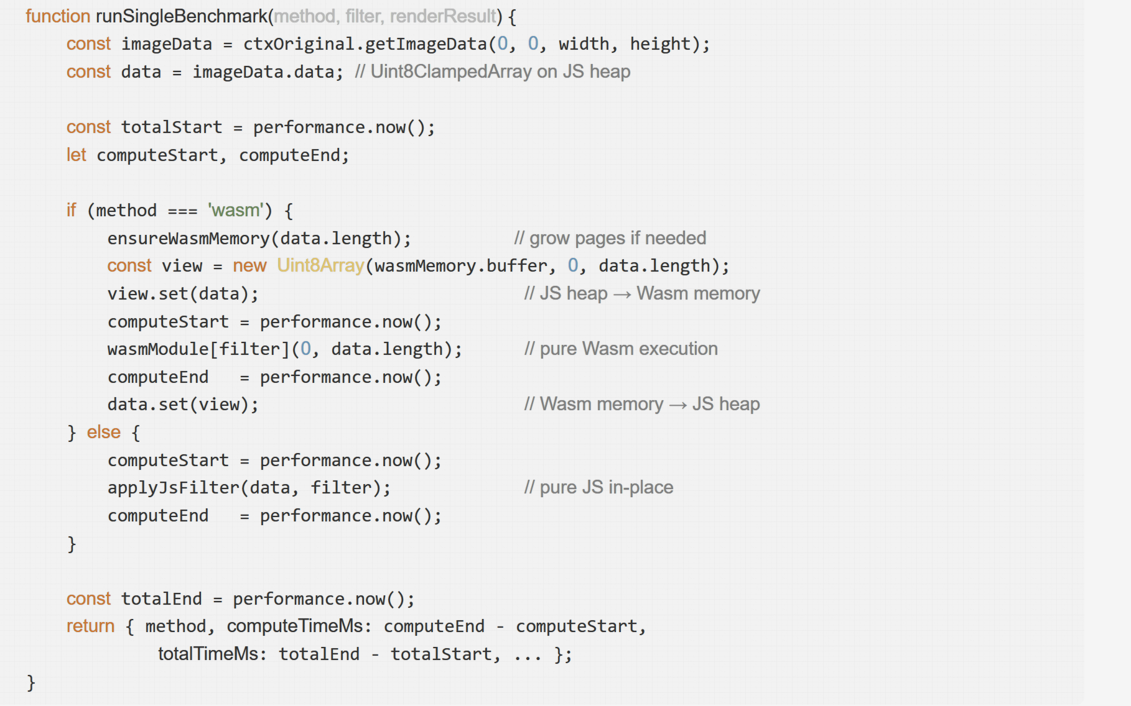
Figure 5: Benchmark execution logic separating compute and total time
This design explicitly separates `computeTimeMs` (pure algorithm) from `totalTimeMs` (including memory copy overhead) — making the JS↔Wasm interop cost quantitatively visible and academically meaningful.

PHP Front Controller Routing
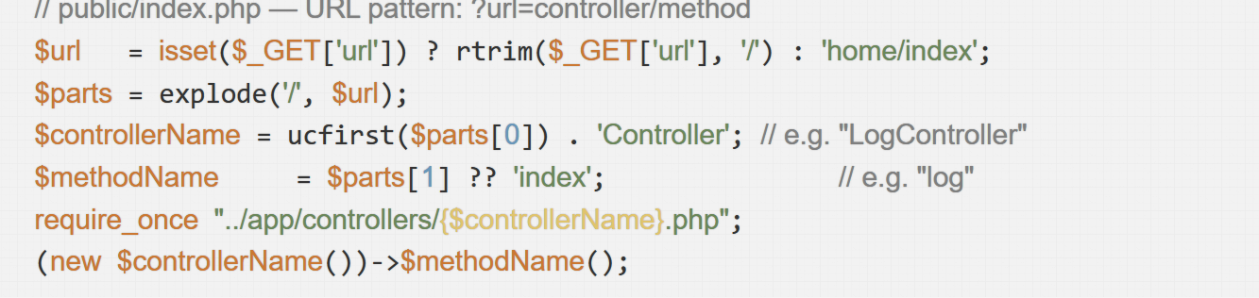
Figure 6: PHP Front Controller pattern implementation for dynamic routing
This Front Controller pattern routes all HTTP requests through one entry point without a framework — $`?url=log/log`$ dynamically resolves to $`LogController::log()`.$

Secure Database Operations with PDO
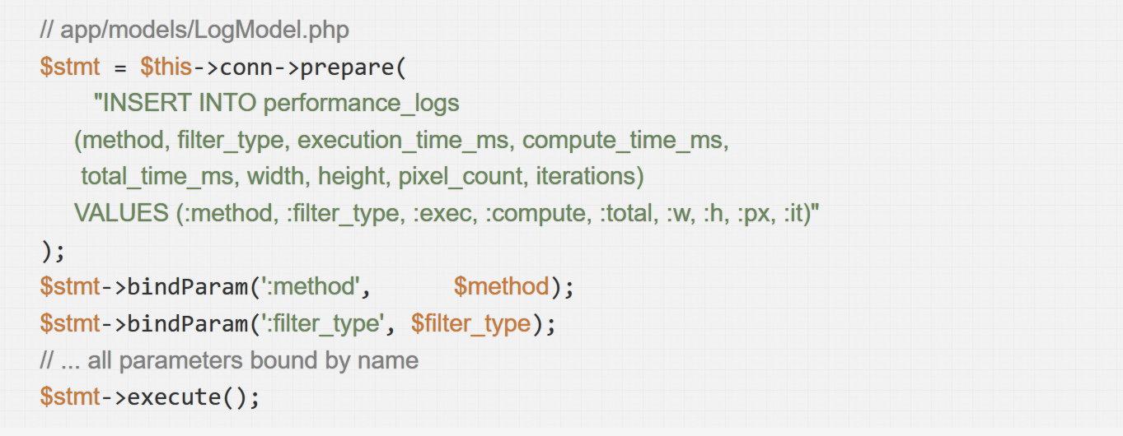
Figure 7: Secure database insertion using PDO prepared statements
Named parameter binding ensures no user data ever touches the SQL string — SQL injection is structurally impossible [2].

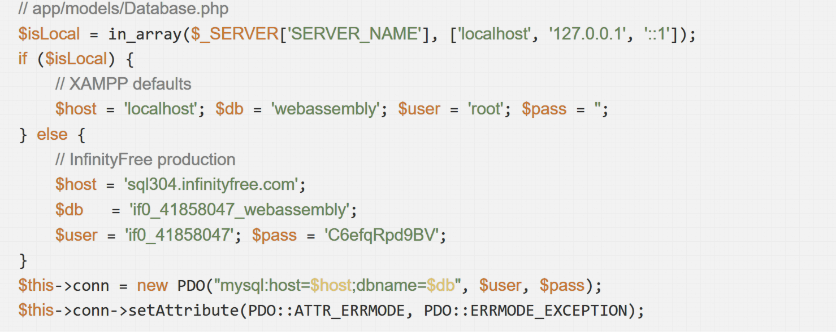
Auto-Detecting Deployment Environment
Figure 8: Environment-based database configuration for XAMPP and InfinityFree

Deployment
Step 1 — Local Development (XAMPP)
The application was initially developed and tested on XAMPP. The database webassembly was created via phpMyAdmin, and the application ran via localhost. [
Step 2 — Production Deployment (InfinityFree)
The project was deployed to InfinityFree shared hosting. The .htaccess file ensured the URL routing remained intact.
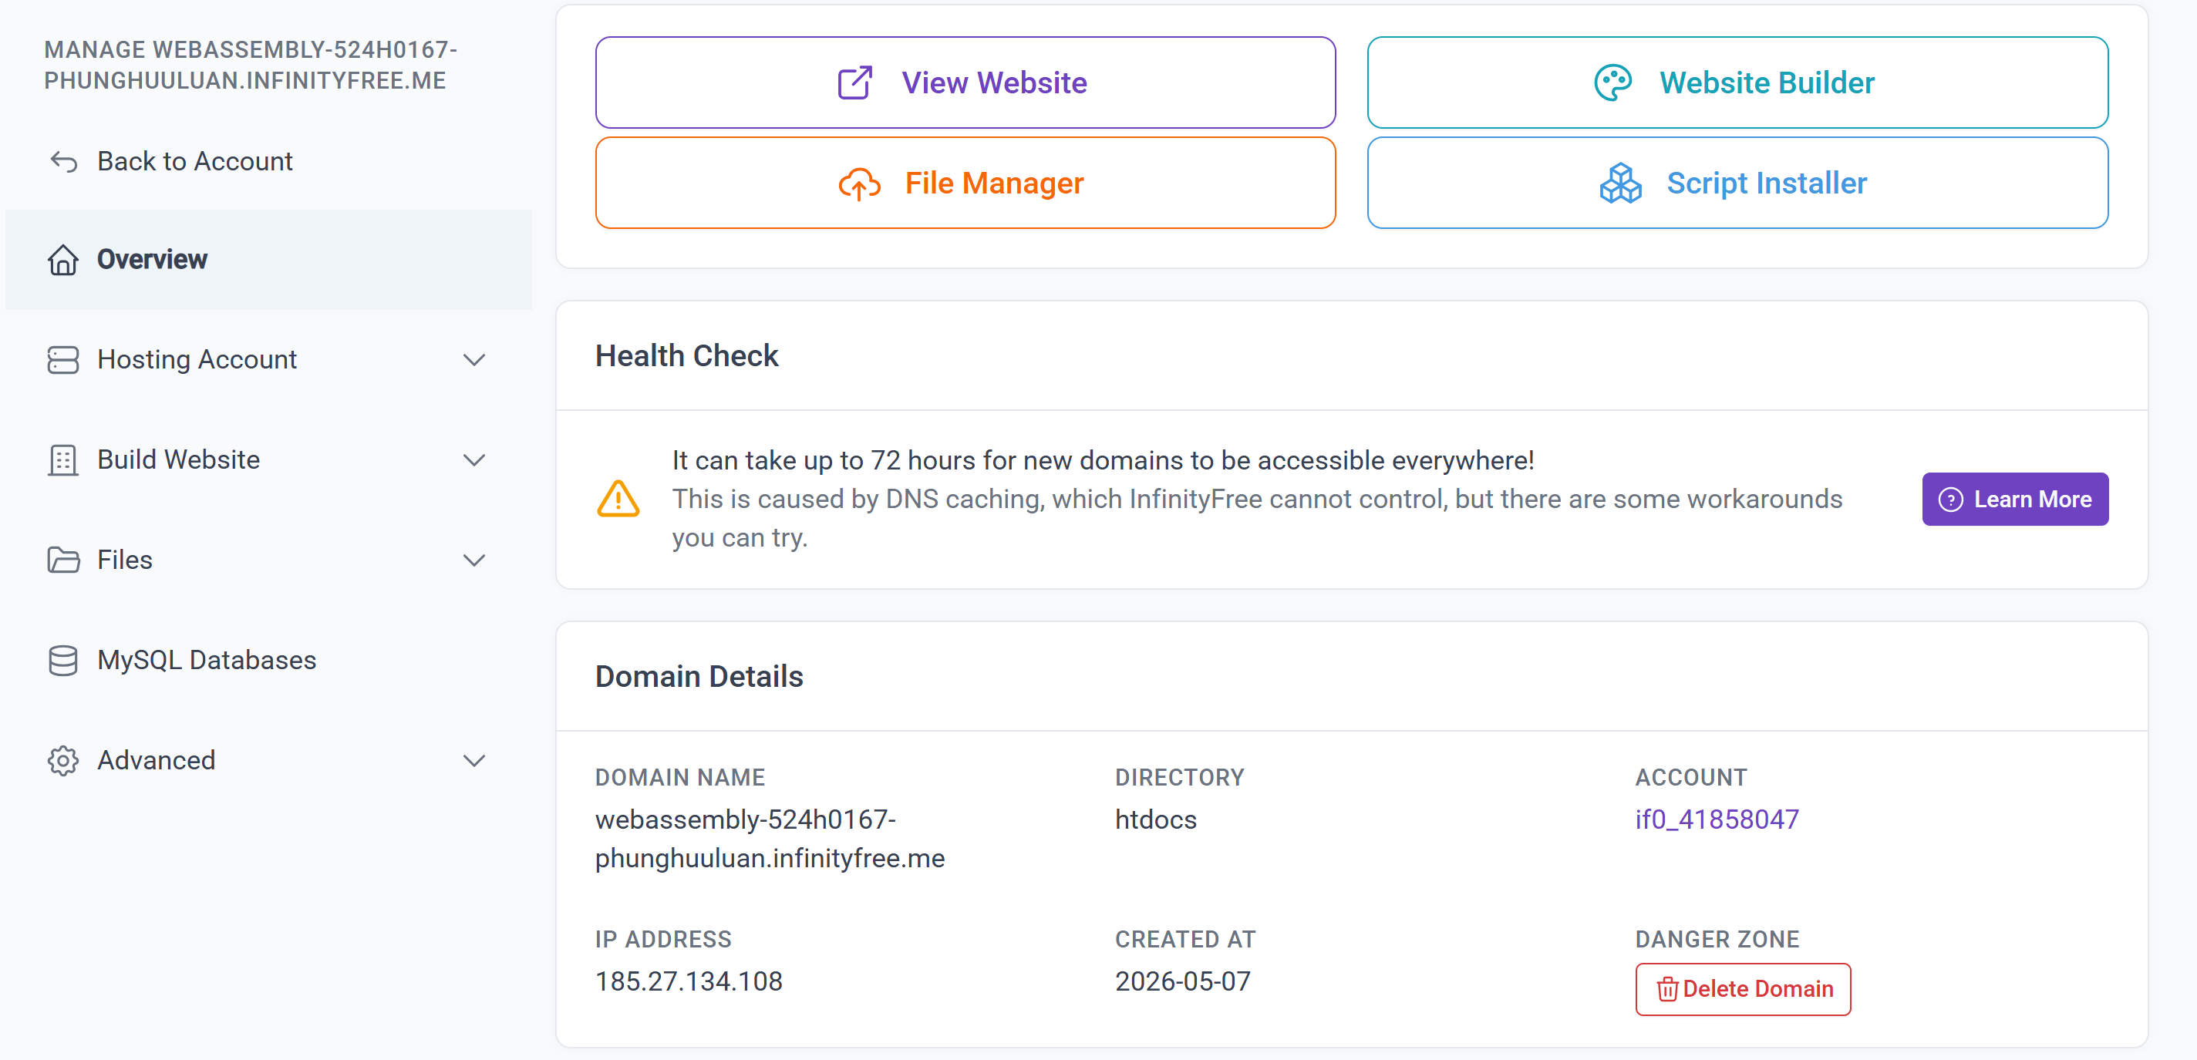
Figure 9: InfinityFree hosting control panel for production deployment
Step 3 — Functional Verification
The deployed system was tested for all core requirements, including processing an image, running a 10-iteration benchmark, and verifying the logs in the MySQL database. Offline capabilities via localStorage were also confirmed by simulating network disconnection.
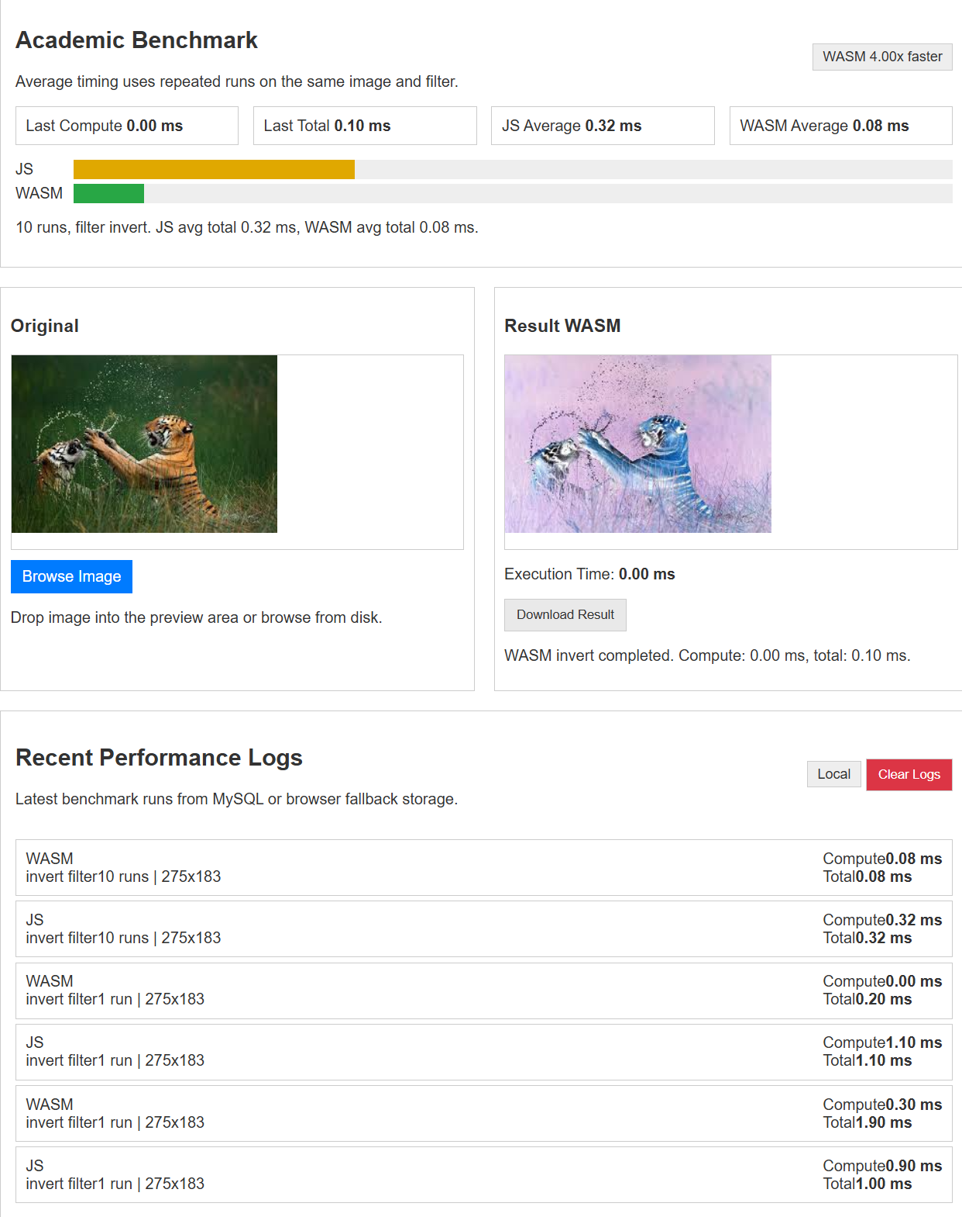
Figure 10: Deployed web application interface showing Wasm vs. JS benchmark results

CONCLUSION
This project successfully demonstrated the full pipeline of WebAssembly integration into a full-stack PHP MVC web application, fulfilling all Topic 7 requirements: C++ algorithm compilation to .wasm, browser-side execution via the WebAssembly JavaScript API, and quantitative performance comparison with equivalent JavaScript.
Key findings:
- Performance: Wasm was 5.04× faster on compute time for a 500×320 image with the Grayscale filter over 10 runs (Wasm 1.99 ms vs. JS 10.02 ms average compute).
- Overhead transparency: Separating computeTimeMs from totalTimeMs quantifies the JS↔Wasm memory copy cost — an insight not visible when measuring only end-to-end time.
- Architecture scalability: The PHP Front Controller pattern centralizes routing without a framework, making the codebase easy to maintain and extend.
- Deployment resilience: The system's ability to auto-detect its environment (localhost vs. production) and utilize a localStorage fallback prevents data loss and minimizes deployment friction.
Limitations and future work:
- Move WebAssembly execution into a Web Worker to keep the UI thread completely unblocked when processing massive, high-resolution images.
- Implement $O\left(n^{2}\right)$complexity filters (e.g., Gaussian blur, Sobel edge detection) where the computational advantage of WebAssembly would be substantially more dramatic.

APPENDIX: PROJECT FILE STRUCTURE

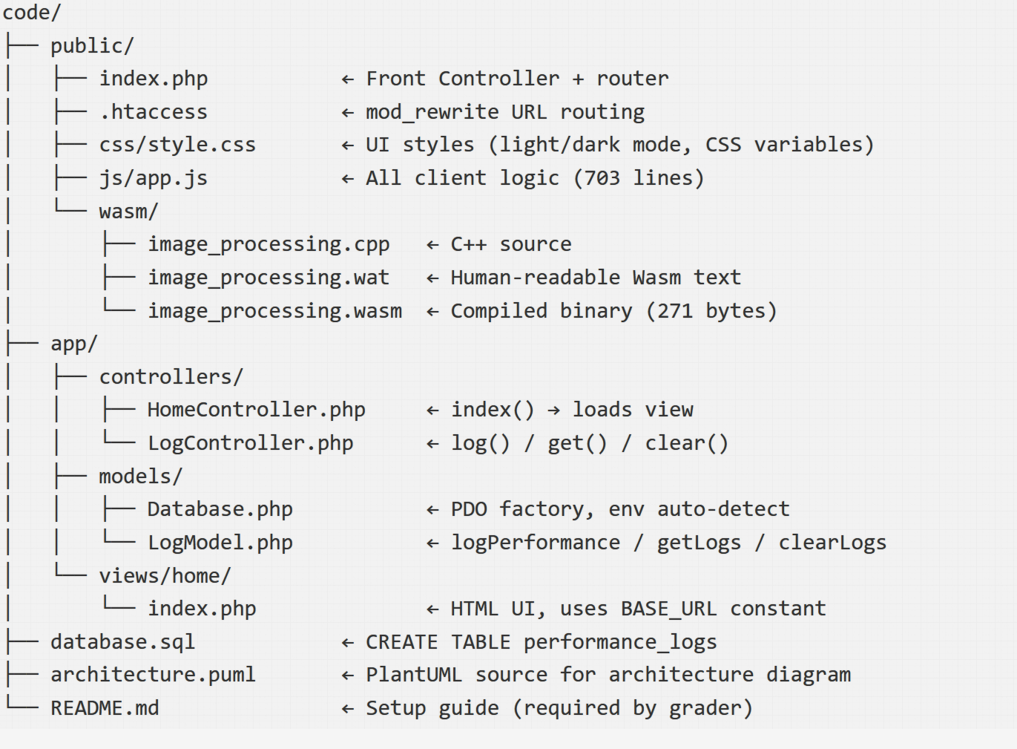
Figure 11: Complete project file structure demonstrating MVC architecture

REFERENCES
[1] WebAssembly Community Group, "WebAssembly Core Specification," W3C Recommendation, Dec. 2019. [Online]. Available: https://www.w3.org/TR/wasm-core-1/
[5] PHP Group, "PDO — PHP Data Objects," PHP Manual, 2026. [Online]. Available: https://www.php.net/manual/en/book.pdo.php

