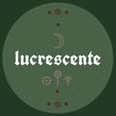
brand & website guidelines
a quiet identity for natural care, handmade ritual and honest ingredients
identity system · digital direction · tone of voice
version 1.0 / september 2026

01 /
the brand at a glance
A practical north star for every page, photograph, caption and customer touchpoint.
CORE IDEA
lucrescente turns everyday hygiene and beauty into a small, thoughtful ritual — where scientific knowledge of plants meets handmade creativity, natural materials and a slower way of caring.
positioning
A Portuguese, mother-and-daughter brand of natural hygiene and beauty products, made by hand at home in small quantities. Lucie brings biological knowledge and formulation rigour; Luana brings artistic sensitivity, presentation and story.
the feeling  calm · grounded · intimate · botanical · tactile · quietly mystical · transparent | the promise  care made slowly, with ingredients we know and choices we can explain.
brand pillars
01 knowledge  Plants and ingredients are approached with curiosity, precision and clear explanation. | 02 making  Small batches, real hands, time to mature and space to adapt products to each person.
03 care  Warm, close communication; useful guidance; respect for the body rather than control of it. | 04 circularity  Reusable containers, repurposed textiles and less waste are built into the experience.
ESSENCE LINE · ciência das plantas, expressão sensível, cuidado feito à mão.

02 /
personality & creative direction
The visual identity should feel like entering a sunlit apothecary at dusk: earthy, soft and just a little celestial.
we are  warm  personal  knowledgeable  artisanal  slow  clean  poetic  responsible | we are not  clinical  corporate  luxurious  sterile  overly rustic  new-age cliché  busy  perfectly polished
the balance to protect
science | clear ingredient knowledge, honest language, useful detail
soul | moon phases, ritual, poetry, softness and wonder
nature | real plants, raw texture, handmade variation and earth tones
cleanliness | generous space, ordered grids, readable type and restraint
CREATIVE RULE
Mysticism is a whisper, not a costume. Use lunar geometry, shadow, rhythm and translucent colour. Avoid crystal-ball clichés, dense zodiac charts, glitter effects, neon purple and faux-gold luxury styling.

03 /
logo system
The wordmark is the expressive signature. Everything around it should remain simple enough to let it breathe.
preferred dark-ground use | lucrescente  light-ground use
usage rules
- Write the brand name as “lucrescente” in lowercase across the website and social copy.
- Use the supplied logo artwork as the primary mark; do not typeset a replacement for final production.
- Give the mark clear space equal to the height of the crescent symbol on all sides.
- Minimum digital size: 96 px for the circular logo; use a simplified crescent/favicon below this size.
- Preferred backgrounds: forest, moss, ivory or quiet photography with a strong overlay.
do not
avoid altering  Do not stretch, outline, bevel, shadow, rotate, recolour individual letters or place the mark inside a competing shape. | avoid visual noise  Do not place it over detailed product imagery without a solid field or sufficiently opaque scrim.
PRODUCTION NOTE
The current raster logo is suitable for web previews. Create a clean SVG master from the original artwork before launch so the wordmark remains sharp at every size.

04 /
colour palette
Pulled from the existing Lucrescente logo and social visuals, then structured into a coherent website system.
night forest  #223925 · primary anchor | botanical moss  #48674D · action / nature | earth taupe  #847A69 · grounded neutral
clay brown  #6F554F · warm support | moon lavender  #BEB2DD · soft celestial | twilight violet  #8C79A8 · accent only
foundation neutrals
warm ivory  #F4F0E8 · main background | paper  #FBF8F2 · card background | soft ink  #2B2926 · main text
recommended proportion
60% warm ivory / paper · 20% forest and moss · 12% earth and clay · 8% lavender and violet
Green establishes trust and natural origin. Earth tones convey materiality and handmade warmth. Lavender carries the moonlit, intuitive layer. Keep violet rare so it feels meaningful.
COLOUR PRINCIPLE
Every screen should be anchored by one dominant family. A green page may receive one lavender accent; a lavender page may receive one earthy accent. Avoid using all colours at equal strength.

05 /
colour combinations & accessibility
Soft does not mean faint. Calm design still needs decisive contrast, especially for product information and calls to action.
combination | contrast | use
white on night forest | 12.50:1 | AA / AAA body text
white on botanical moss | 6.32:1 | AA body text
white on clay brown | 6.80:1 | AA body text
soft ink on moon lavender | 7.32:1 | AA / AAA body text
soft ink on warm ivory | 12.76:1 | AA / AAA body text
white on earth taupe | 4.23:1 | large text only
transparency system
55–68% forest scrim  For white text over photography; preferred for hero sections and product banners. | 35–48% lavender wash  For atmospheric imagery with dark ink text outside the photo or in a solid card.
25–35% moss tint  For decorative image panels without overlaid copy. | 100% text opacity  Never reduce body-copy opacity to create softness; use colour and scale instead.
NON-NEGOTIABLE
Buttons, navigation, form labels and ingredient details must meet WCAG AA. Never place white body text directly on earth taupe or twilight violet without darkening the surface.

06 /
typography
A romantic editorial voice for headlines, supported by a direct humanist sans serif for clarity.
DISPLAY FAMILY
Cormorant Garamond
Use Medium 500 for page titles and major section headings. The contrast and calligraphic detail echo the wordmark without competing with it.
INTERFACE FAMILY
DM Sans
Use Regular 400 for body copy and Medium 500 for navigation, buttons, labels and product metadata. It keeps ingredient information easy to scan.
digital type scale
role | size | line height | weight / tracking
display / hero | clamp(3rem, 7vw, 6rem) | 1.00 | 500
h1 | clamp(2.5rem, 5vw, 4.5rem) | 1.05 | 500
h2 | clamp(2rem, 3.5vw, 3.25rem) | 1.08 | 500
h3 | 1.5rem | 1.18 | 500
body large | 1.125rem | 1.60 | 400
body | 1rem | 1.65 | 400
label | 0.75rem | 1.20 | 500 / +0.10em
TYPESETTING CHARACTER
Use sentence case and lowercase headings in Portuguese. Keep line lengths between 45 and 70 characters. Avoid centre alignment for paragraphs; reserve it for short hero statements and ritual-like pauses.

07 /
photography & art direction
Real products, real hands and real materials. The image language should preserve the intimacy of making at home.
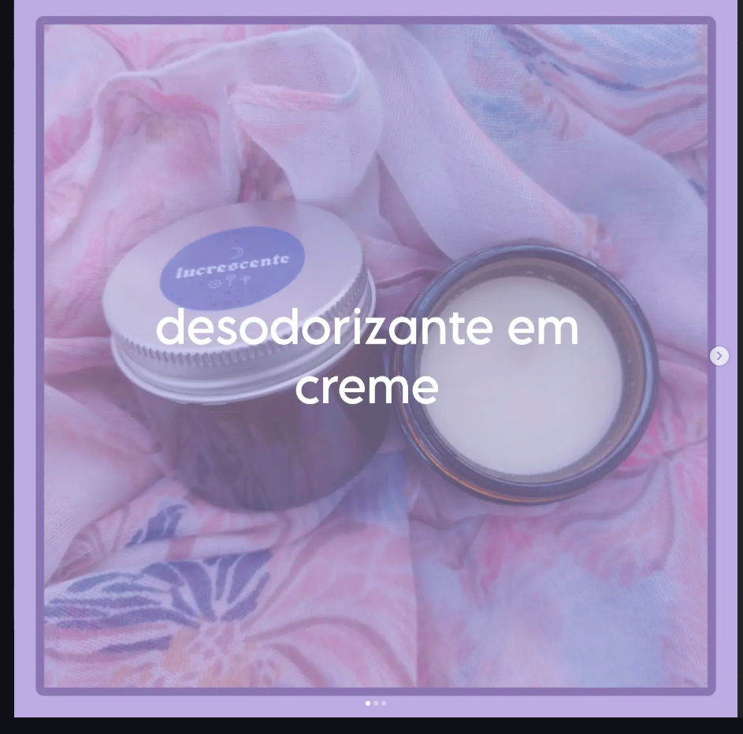  moon lavender wash · intimate product still life | 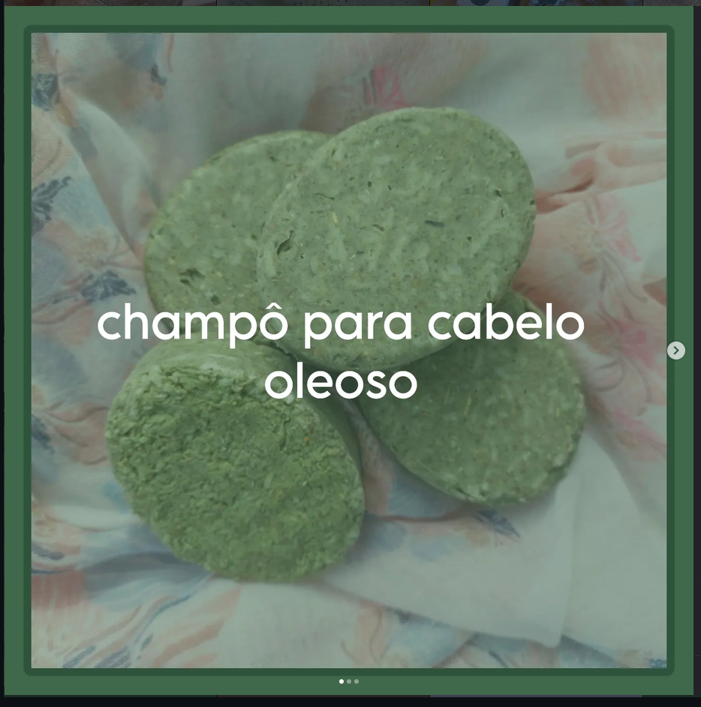  botanical moss wash · tactile, handmade product
shoot for
- Soft side light or window light; gentle shadow with visible texture.
- Natural cloth, wood, stone, ceramic, pressed flowers, plant cuttings and reused containers.
- Close crops of hands mixing, grinding, cutting, pouring, sewing or wrapping.
- A restrained palette in the set itself; one hero material per frame.
- Small imperfections that prove the object was made rather than manufactured.
editing
Keep whites warm-neutral, greens botanical and skin natural. Lower saturation slightly, soften highlights and retain grain and product texture. Colour washes may unify a carousel, but the product must remain recognisable.
AUTHENTICITY RULE
Never use stock photography. Do not invent ingredients, props or textures that suggest a formulation the product does not contain.

08 /
graphic language
Build atmosphere with a small vocabulary repeated consistently: crescent, orbit, frame, veil and botanical trace.
◐ crescent  Primary celestial motif. Use as a pause, divider, favicon or small navigation cue. | ◐ orbit  Fine circular or arcing lines for framing products and suggesting rhythm or cycles.
◐ soft frame  Rounded 16–24 px containers with a 1–2 px tonal border, inspired by the social posts. | ◐ colour veil  Transparent colour over real imagery to create unity without hiding material texture.
◐ botanical trace  Simple line drawings or scanned plant silhouettes, used sparingly and accurately. | ◐ handmade stitch  Occasional dashed detail inspired by sewn reusable cloth wraps; never overused.
shape & line rules
geometry  Circles and rounded rectangles suggest cycles, containers and softness. Use asymmetry inside an ordered grid to retain an artistic, human feeling. | strokes  1 px on mobile, 1–2 px on desktop. Use forest, clay or violet at 35–70% opacity. Avoid heavy black outlines.
RESTRAINT
Use a maximum of two mystical motifs in any viewport. White space is part of the identity; it is the silence around the ritual.

09 /
layout & spacing
Editorial calm comes from rhythm: generous margins, clear hierarchy and a deliberate alternation between airy information and immersive imagery.
grid
desktop | 12 columns · max width 1280 px · 32 px gutters · 64–96 px outer margin
tablet | 8 columns · 24 px gutters · 32–48 px outer margin
mobile | 4 columns · 16 px gutters · 20–24 px outer margin
spacing scale
4 · 8 · 12 · 16 · 24 · 32 · 48 · 64 · 96 · 128 px
Use 96–128 px between major desktop sections and 64–80 px on mobile. Inside cards, use 24–32 px. Keep copy blocks narrow even when the overall grid is wide.
composition patterns
story split  image 7 columns / copy 5 columns; alternate side by section | ingredient index  compact filter bar + airy card grid; avoid dense catalogue styling
product story  large product image + narrative copy + ingredient links; no price or cart patterns | value pause  full-width solid colour field with one short statement and a lunar mark
RESPONSIVE RULE
On mobile, preserve the story order: promise → proof → invitation. Never shrink decorative desktop compositions until they become cramped; restack them and remove non-essential motifs.

10 /
website components
Simple components, treated with colour and space rather than effects.
buttons
vem conhecer →  primary | ver produtos  secondary | fala connosco →  text link
cards
product card  Portrait image · category label · lowercase product name · one-line story · “vem espreitar →”. Keep the whole card clickable. | ingredient card  Botanical crop or ingredient detail · common name · scientific name · origin. Use filters by the eight ingredient categories.
interaction
- Hover: 2–4 px lift or a soft image scale to 1.02; no dramatic glow.
- Transitions: 180–280 ms for controls; 450–700 ms for editorial reveals.
- Focus: visible 2 px violet or forest outline with 3 px offset.
- Carousels: always include arrows, dots, swipe support and pause controls when automatic.
- Forms: large labels above fields, calm error language and clear confirmation states.
COMMERCE BEHAVIOUR
The website is a catalogue and conversation space, not an online shop: no prices, cart, checkout, login or reviews. Calls to action lead naturally to WhatsApp, SMS, phone or email.

11 /
page-by-page direction
A consistent system with enough variation for each part of the story.
início  Immersive promise on ivory; alternating botanical and lavender story sections; favourites; values; ingredients; calm contact invitation. | produtos  Catalogue by category with generous spacing. Each detail page leads with story, then “porque funciona”, ingredients and how to order.
ingredientes  The most knowledge-led area. Use clear filtering, scientific names and restrained botanical imagery. Keep celestial decoration minimal. | sobre nós  Portrait-led and intimate. Present Lucie and Luana as two complementary ways of seeing: science and artistic sensitivity.
cuidados & sustentabilidade  Editorial reading page with short chapters, icons and tactile images of reuse, solid products, textiles and vessels. | contacto  Warm and direct. Make all four contact choices obvious. Reinforce small batches, special quantities and national/international shipping.
homepage opening
RECOMMENDED HERO
feito à mão, com carinho
cuidados simples, feitos com amor e ingredientes que confiamos.
Use a quiet close-up of a real ingredient or making process, with the main copy on a solid ivory field rather than obscuring the photograph.
Primary action: vem conhecer os nossos ingredientes · Secondary action: ver todos os produtos

12 /
tone of voice
Write as if Lucie and Luana are welcoming someone into the making process at home.
voice principles
close  Use “nós”, “cá em casa” and “tu”. Speak person to person, never brand to consumer. | clear  Explain what ingredients do in ordinary language. Keep scientific rigour without sounding clinical.
story-led  Begin with where a product came from, how it is made or why an ingredient was chosen. | honest  State limits and realities: small batches, maturation time, possible stock gaps and what a product is not.
inviting  Close with a gentle direct action: “fala connosco”, “vem espreitar”, “descobre a história”. | lightly poetic  Use warmth and sensory detail, but keep claims precise. Emojis are rare punctuation, used only when they add warmth.
copy example
say this  “cada produto começa por um ingrediente que conhecemos bem — e adoramos partilhar essa história contigo.” | not this  “descubra a nossa gama premium de cosmética sustentável com performance superior.”
CLAIMS DISCIPLINE
Never invent products, ingredients, testimonials, awards or health claims. Deodorants are not antiperspirants. Product language must respect the factual formulation notes supplied by the brand.

13 /
starter design tokens
A practical base for CSS, Figma variables or a component library. Adjust only through the system, never page by page.
:root {
--forest: #223925;
--moss: #48674D;
--earth: #847A69;
--clay: #6F554F;
--bark: #593D37;
--lavender: #BEB2DD;
--violet: #8C79A8;
--ivory: #F4F0E8;
--paper: #FBF8F2;
--ink: #2B2926;
--font-display: 'Cormorant Garamond', Georgia, serif;
--font-ui: 'DM Sans', system-ui, sans-serif;
--radius-card: 20px;
--radius-control: 999px;
--shadow-soft: 0 18px 50px rgb(34 57 37 / 0.10);
--content-max: 80rem;
}
component defaults
- Primary button: forest / white · pill radius · 48–52 px height · 16–20 px horizontal padding.
- Card: paper surface · 1 px moss at 18% · 20 px radius · 24–32 px padding.
- Image frame: 16–24 px radius · 2 px tonal border · no heavy drop shadow.
- Navigation: lowercase DM Sans Medium · 14–15 px · 44 px minimum tap target.
- Section label: DM Sans Medium · 12 px · 0.10em tracking · moss or violet.
BUILD ORDER
Set tokens first, then typography, layout primitives and components. Build pages only after the shared system is stable; this prevents the site from drifting into a different visual style section by section.

14 /
final creative checklist
Use this page as the review gate before publishing any website section or social asset.
✓ | The brand name appears as “lucrescente” in lowercase.
✓ | The design feels natural, clean and intimate before it feels mystical.
✓ | Only one colour family dominates the screen; accents are restrained.
✓ | The crescent or celestial motif supports the content rather than decorating every gap.
✓ | All product imagery is real and the product remains recognisable beneath any colour wash.
✓ | Body copy is left aligned, readable and set at full opacity.
✓ | Buttons and text meet WCAG AA contrast and have visible keyboard focus.
✓ | Copy uses “nós” and “tu”, tells a small story and ends with a human invitation.
✓ | No prices, cart, checkout, login, reviews or invented claims appear.
✓ | Reuse, small batches and ingredient transparency are visible parts of the experience.
NORTH STAR
lucrescente should feel made with knowledge, held with care and lit by a quiet crescent moon.
source basis · supplied logo, social visuals and website content brief

