Milestone One: Predicting Transaction Amount and Detecting Threats Across Two Datasets: Credit-Card Transactions and Network Intrusions
Luan Bui
DX799S
June 21, 2026

1. Problem Statement and Description
This project studies two datasets from two industries that share one goal: separating normal activity from costly anomalies. The first is the Kaggle Credit Card Transaction Fraud dataset (Chhetri, 2024). The Credit Card Transaction Fraud dataset contains 55,000 card transactions described by customer, card, and transaction features. It represents the financial-services industry where card fraud costs tens of billions of dollars a year and every percentage point of detection matters. The second is the UNSW-NB15 network-intrusion dataset (Moustafa & Slay, 2015). It is a benchmark of network flows labeled normal or attack which represents the cybersecurity industry where intrusion-detection systems must flag malicious traffic in real time. On each dataset I pursue a regression question and a classification question. For the credit card dataset I predict the transaction amount and whether a transaction is fraud. For the UNSW dataset I predict a flow's duration and whether it is an attack. Together they let me apply every course technique to genuinely different data and the contrast between them is the central finding of this report. The work could support a bank's spend-modeling and fraud screening and a security team's automated intrusion detection.

2. Modeling Techniques: Breadth and Depth
I applied all six techniques to both datasets. The summary table reports the headline result for each
I explicitly treat Week 2’s regularization and Week 6’s random forest in depth. The remaining four techniques are covered for breadth below.

Breadth: the six techniques

Polynomial and interaction terms (Week 1)
Polynomial terms let a straight line bend a little. Interaction terms let two features team up. I added both to the regression models. For the credit card data I predicted the log of the transaction amount. The plain features scored 0.66. Adding the merchant categories raised it to 0.81. Adding the squared and interaction terms raised it to 0.875. So the curves and combinations clearly helped. For the UNSW data I predicted the log of the flow duration. Here the same trick barely moved the score, from 0.649 to 0.667. The reason was the data itself. Some features had very long tails. Squaring them created a few huge values that threw off the model so I only kept the safe ones. The lesson is simple, polynomial terms help when the real pattern is a gentle curve. They do not help much when the pattern is messy.

Lasso, ridge, and elastic net (Week 2)
These three methods add a penalty for large coefficients. Ridge shrinks every coefficient toward zero. Lasso can push some all the way to zero. Elastic net blends the two. I ran all of them on the same two regression targets. The scores barely changed. Credit card stayed at 0.875 and UNSW stayed at about 0.650. With this much data the plain model was already good, so the penalty did not add accuracy. What it added was simplicity. Lasso removed 9 features on credit card and 8 on UNSW. A smaller model is easier to explain. So the real win here is a cleaner model, not a higher score.

Forward and backward selection, PCR, and PLSR (Week 3)
These methods try to do the job with fewer inputs. Forward and backward selection keep only the most useful features. PCR and PLSR squeeze the features into a few combined components. I tried them all on both regression targets. Credit card compressed nicely. Just 8 features still scored 0.77. PLSR matched the full model with only 13 components, while PCR needed 23. So credit card really only needs a handful of inputs. UNSW was the opposite. Cutting to 8 features dropped the score to about 0.57. PLSR still needed about 51 of the 54 components. Almost nothing could be removed. This surprised me. UNSW has many repeated features, but its signal is still spread out. Repeated is not the same as reducible.

Logistic regression and feature scaling (Week 4)
Logistic regression is a simple classifier. It gives the probability that a record is fraud or an attack. It works best when the features are on the same scale. I tested that first. Without scaling the model ran 2,000 steps and never settled. With scaling it finished in 21 steps. The coefficients were also easier to compare. Then I trained it on both targets. Credit card was almost perfect, with a ROC-AUC of 1.00 and an F1 of 0.995. UNSW was strong but realistic, with a ROC-AUC of 0.965 and an F1 of 0.919. The weakness is the straight boundary. On UNSW it cannot catch every attack without raising more false alarms. Figure 1 shows that gap.
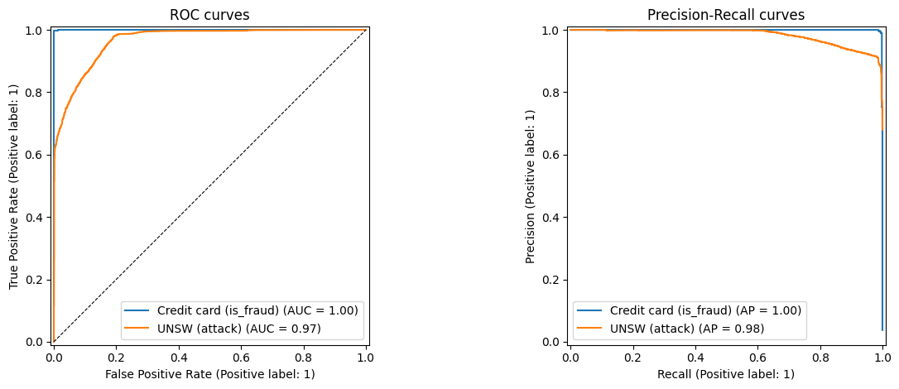
Figure 1. Logistic regression ROC (left) and precision-recall (right) curves. Credit-card fraud (near-perfect) versus the realistic UNSW attack problem.

Support vector machines (Week 5)
A support vector machine finds the widest gap between the two classes. The kernel trick lets it use a curved gap instead of a straight one. I tried a straight version and a curved version. On UNSW the curved version did better, 0.969 versus 0.954. So the real boundary is not straight. On credit card both versions were near perfect because the classes barely overlap. The kernel trick did not help there. The main weakness is speed. The method gets slow with many rows so I trained it on a smaller sample.

Decision trees and random forests (Week 6)
A decision tree asks a chain of yes or no questions. One deep tree just memorizes the training data which means it is overfitting. A random forest fixes that. It grows many different trees and averages their votes. I tuned the forest and it was the best model in the whole project on UNSW. It reached a ROC-AUC of 0.990 and an F1 of 0.959. That beat both logistic regression and the SVM. On credit card it was near perfect like the others. It wins on UNSW because it can combine many features at once. That is the one thing the simpler models could not do.

Depth 1: Regularized regression on UNSW (Week 2)
UNSW is the best place to study regularization. Week 1 found severe multicollinearity here including a perfectly redundant pair (is_ftp_login equals ct_ftp_cmd, with infinite VIF) and tight byte and packet clusters. I tuned ridge across a logarithmic alpha grid from 0.01 to 100,000 with five-fold cross-validation, then plotted test RMSE against alpha (Figure 2, left). The curve is a textbook bias-variance valley. RMSE falls as the penalty grows, bottoms out near alpha of 1.4, then rises as the penalty over-shrinks. The best alpha is small but not zero so the features mostly carry their own signal. The right panel held a surprise. On the redundant pair, ordinary least squares did not blow up. Scikit-learn uses an SVD solver that splits the weight evenly, about 0.015 each. So here the value of regularization is sparsity, not rescuing coefficients. Lasso set 8 of 54 features to zero at the same R-squared of 0.650.
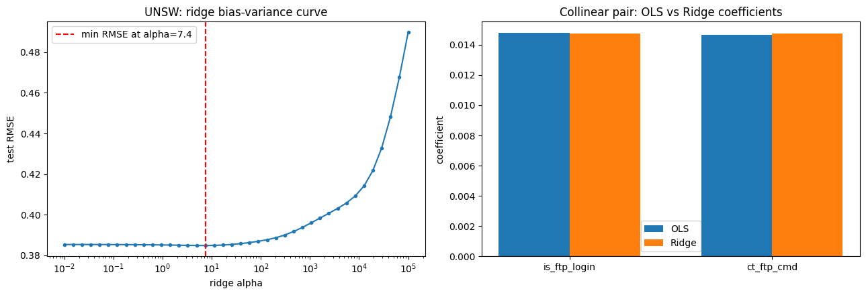
Figure 2. UNSW ridge depth. Left: the bias-variance curve (test RMSE vs alpha) bottoms near alpha = 1.4. Right: OLS and ridge both split the perfectly collinear pair evenly.

Depth 2: Random forest on UNSW (Week 6)
The random forest is the best classifier in the project so I tuned it with care. I used randomized search over the number of trees, the depth, the minimum leaf size, and the features per split. The winning model had 378 trees, depth 24, a minimum leaf of 3, and the square root of the features per split. It reached a test ROC-AUC of 0.990 and an F1 of 0.959. That beat logistic regression and the SVM. The key setting is the features per split. Using only a few random features at each split makes the trees different so averaging them cancels the noise. A single deep tree cannot do that. The importances are also telling. No single feature dominates. This matches the Week 3 finding that the signal is spread out which is why the forest wins. The confusion matrix (Figure 3) shows the errors. Most are normal flows marked as attacks, the false-alarm cost a security team must manage.
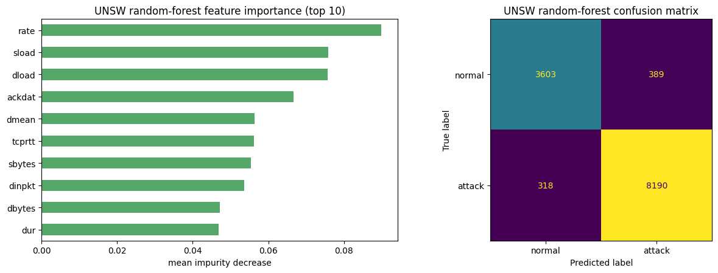
Figure 3. UNSW random forest: feature importances (left, no single dominant feature) and the test confusion matrix (right).

3. Overfitting
Every model used the same guardrails but the need for them varied by dataset. That contrast is a result in itself. I held out 25 percent of the data for testing and tuned with cross-validation on the training part only. Classification splits were stratified to keep the class balance. Each model also had its own control. Ridge, lasso, and elastic net shrink the coefficients. The SVM uses the soft-margin C and the RBF gamma. The forest uses depth, leaf size, and bagging with random features. Two experiments make overfitting easy to see. First, I trained an RBF SVM on only 200 points and raised gamma. Training AUC went to a perfect 1.0 while test AUC fell to 0.54. The model just memorized the points. Second, I swept a single tree's depth (Figure 4). Training AUC climbed to 1.0 on both datasets but the gap to the test score was much wider on UNSW than on credit card. Real overlapping classes overfit easily. Clean separable ones barely do.
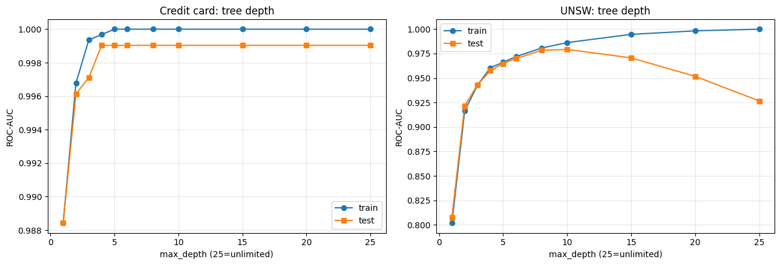
Figure 4. Decision-tree depth vs train/test AUC. The train/test gap (overfitting) is far wider on the realistic UNSW data than on the separable credit-card data.

4. Metrics and Hyperparameter Tuning
The metric followed the task. For regression I used R-squared and RMSE on the log targets. For classification I avoided plain accuracy. The credit card data is only 3.8 percent fraud, so a model could score 96 percent by never predicting fraud. Instead I led with ROC-AUC which does not depend on a threshold, plus precision, recall, and F1. On UNSW I report F1 on the attack class because false alarms and missed attacks are both costly. I focused the tuning on the two depth models and the SVM and left the simpler baselines at sensible defaults on purpose. For the random forest I used randomized search. The chosen values were 378 trees for a stable average, depth 24 for rich rules, a minimum leaf of 3 to limit overfitting, and the square root of features per split to keep the trees varied. For the SVM, C of 100 and gamma of 0.01 mean a firm margin with a smooth boundary. For logistic regression, credit card chose strong regularization because the signal is clean while UNSW chose a milder penalty to use more features.

5. Exploratory Data Analysis
EDA drove the modeling. Both regression targets were strongly right-skewed so I modeled their logs. The credit card amount's skew fell from 5.8 to 0.1 which makes a linear model reasonable. Correlation and VIF analysis showed moderate redundancy in the credit card features and severe redundancy in UNSW. That is why I tried regularization and dimension reduction. It also set my expectation that UNSW would compress which later turned out only half true. Class-balance checks shaped the classification work. The 3.8 percent fraud rate and 68 percent attack rate led me to use stratified splits, class weighting, and ROC-AUC and F1 instead of accuracy. Most importantly, EDA caught that some credit card flags, like CVV mismatch and prior fraud flags, are zero for every legitimate transaction. That near-perfect rule warned me that the data is synthetic and would separate almost perfectly. So I read its perfect scores as a property of the data.

6. Expected vs. Unexpected Results
Some results were expected. Scaling sped up logistic regression. The random forest led on UNSW. The synthetic credit card target was easy for every model. But four results surprised me. First, polynomial terms helped the credit card model more than the more nonlinear UNSW model. UNSW's nonlinearity is complex, not a simple curve. Second, dimension reduction mostly failed on UNSW even though it is very redundant. PLSR still needed about 51 of 54 components. So heavy redundancy is not the same as low dimensionality. Third, ordinary least squares handled the redundant pair fine because its SVD solver returns an even split. Fourth, the complex SVM barely beat plain logistic regression on UNSW. Only the random forest made a real difference. The harder dataset was the more useful one. On UNSW, model choice and tuning actually mattered. The credit card data flattered every method because it was built from rules.

Appendix A: Statement on the Use of AI
I used an AI assistant to help debug the Python in the six Jupyter notebooks. I also used it to help edit for clarification.

Appendix B: References
Chhetri, S. (2024). Credit card transaction fraud data [Data set]. Kaggle. https://www.kaggle.com/datasets/sarveshchhetri/credit-card-transaction-fraud-data
Hoogland, D. (n.d.). UNSW-NB15 (cleaned parquet) [Data set]. Kaggle. https://www.kaggle.com/datasets/dhoogla/unswnb15
Moustafa, N., & Slay, J. (2015). UNSW-NB15: A comprehensive data set for network intrusion detection systems. Military Communications and Information Systems Conference (MilCIS), 1-6.

Appendix C: Jupyter Notebooks (Weeks 1-6)
https://github.com/luanbui/DX799S

