**ME 5554 / AOE5754 / ECE5754**

**Applied Linear Systems**

**HW2**

Luan Cong Doan

[luandoan@vt.edu](mailto:luandoan@vt.edu)

**1. Place the following nonlinear ODE into first-order form:**

$$M\ddot{x}\left(t\right)+B\dot{x}{\left(t\right)}^{2}+Kx\left(t\right)=u_{1}\left(t\right)+G(t)$$

$$G\dot{x}\left(t\right)+L\dot{}\left(t\right)=u_{2}\left(t\right)-R\left(t\right)x(t)$$

Define: $x_{1}(t)=x(t)$

$x_{2}(t)=\dot{x}\left(t\right)={\dot{x}}_{1}(t)$

$x_{3}(t)=\left(t\right)$

$y(t)=\left(t\right)$

So: $M{\dot{x}}_{2}\left(t\right)+Bx_{2}{\left(t\right)}^{2}+Kx_{1}=u_{1}\left(t\right)+Gx_{3}(t)$

$Gx_{2}\left(t\right)+L{\dot{x}}_{3}(t)=u_{2}\left(t\right)-Rx_{3}(t)x_{1}(t)$

The resulting nonlinear state equation plus output equation then are:

${\dot{x}}_{1}\left(t\right)=x_{2}(t)$

${\dot{x}}_{2}\left(t\right)=-\frac{K}{M}x_{1}(t)-\frac{B}{M}x_{2}{\left(t\right)}^{2}+\frac{G}{M}x_{3}\left(t\right)+\frac{1}{M}u_{1}(t)$

${\dot{x}}_{3}\left(t\right)=-\frac{R}{L}x_{1}\left(t\right)x_{3}\left(t\right)-\frac{G}{L}x_{2}\left(t\right)+\frac{1}{L}u_{2}(t)$

$y(t)=x_{3}\left(t\right)$

Assume that at initial condition t = to:

We have: ${\dot{\tilde{x}}}_{1}\left(t\right)=x_{0}$

${\dot{\tilde{x}}}_{2}\left(t\right)=0$

${\dot{\tilde{x}}}_{3}\left(t\right)={}_{0}$

with: ${\tilde{x}}_{2}(t)=x_{0}$

$-\frac{K}{M}{\tilde{x}}_{0}\left(t\right)-\frac{B}{M}{\tilde{x}}_{0}{\left(t\right)}^{2}+\frac{G}{M}{\tilde{}}_{0}\left(t\right)+\frac{1}{M}\left[Kx_{0}\left(t\right)+Bx_{0}{\left(t\right)}^{2}-G{}_{0}(t)\right]=0$

${\tilde{x}}_{3}(t)=-\frac{R}{L}{\tilde{x}}_{1}\left(t\right){\tilde{x}}_{3}\left(t\right)-\frac{G}{L}{\tilde{x}}_{2}\left(t\right)+\frac{1}{L}{\tilde{u}}_{2}\left(t\right)$.

⇔ ${\tilde{x}}_{3}(t)=-\frac{R}{L}x_{0}\left(t\right){}_{0}\left(t\right)-\frac{G}{L}x_{0}\left(t\right)+\frac{1}{L}\left\lceil R{}_{0}\left(t\right)x_{0}\left(t\right)+Gx_{o}+L{}_{0}\right\rceil$

⇔ ${\tilde{x}}_{3}(t)={}_{0}$

It follows directly that deviation variables are specified by:

$x_{}(t)=\left[\begin{matrix}x\left(t\right)-\tilde{x}(t) \\ \dot{x}\left(t\right)-\dot{\tilde{x}}(t) \\ \left(t\right)-\tilde{}(t)\end{matrix}\right]$

$u\left(t\right)=\left[\begin{matrix}u_{1}\left(t\right)+Kx_{0}\left(t\right)+Bx_{0}{\left(t\right)}^{2}-G{}_{0}(t) \\ u_{2}\left(t\right)-R{}_{0}\left(t\right)x_{0}\left(t\right)-Gx_{o}-L{}_{0}\end{matrix}\right]$

$y_{}\left(t\right)=\left(t\right)-\tilde{}(t)$

With:

$f\left(x,u\right)=\left[\begin{matrix}f_{1}(x_{1},x_{2},x_{3},u_{1},u_{2}) \\ f_{2}(x_{1},x_{2},x_{3},u_{1},u_{2}) \\ f_{3}(x_{1},x_{2},x_{3},u_{1},u_{2})\end{matrix}\right]$

$=\left[\begin{matrix}x_{2} \\ -\frac{K}{M}x_{1}(t)-\frac{B}{M}x_{2}{\left(t\right)}^{2}+\frac{G}{M}x_{3}\left(t\right)+\frac{1}{M}u_{1}(t) \\ -\frac{R}{L}x_{1}\left(t\right)x_{3}\left(t\right)-\frac{G}{L}x_{2}\left(t\right)+\frac{1}{L}u_{2}(t)\end{matrix}\right]$

Partial differentiation yields:

$\frac{∂f}{∂x}(x,u)=\left[\begin{matrix}0 & 1 & 0 \\ -\frac{K}{M} & -\frac{2B}{M} & \frac{G}{M} \\ -\frac{R}{L}x_{3} & -\frac{G}{L} & -\frac{R}{L}x_{1}\end{matrix}\right]$

$\frac{∂f}{∂u}\left(x,u\right)=\left[\begin{matrix}0 \\ \frac{1}{M} \\ \frac{1}{L}\end{matrix}\right]$

$\frac{∂h}{∂x}\left(x,u\right)=\left[\begin{matrix}1 & 0 & 0\end{matrix}\right]$

$\frac{∂h}{∂u}\left(x,u\right)=\left[0\right]$

Evaluating at the nominal trajectory gives:

$A\left(t\right)=\frac{∂f}{∂x}\left[\tilde{x}\left(t\right),\tilde{u}(t)\right]=\left[\begin{matrix}0 & 1 & 0 \\ -\frac{K}{M} & -\frac{2B}{M} & \frac{G}{M} \\ -\frac{R}{L}{}_{0} & -\frac{G}{L} & -\frac{R}{L}x_{0}\end{matrix}\right]$

$B\left(t\right)=\frac{∂f}{∂u}\left[\tilde{x}\left(t\right),\tilde{u}(t)\right]=\left[\begin{matrix}0 \\ \frac{1}{M} \\ \frac{1}{L}\end{matrix}\right]$

$C\left(t\right)=\frac{∂h}{∂x}\left[\tilde{x}\left(t\right),\tilde{u}(t)\right]=\left[\begin{matrix}1 & 0 & 0\end{matrix}\right]$

$D\left(t\right)=\frac{∂h}{∂u}\left[\tilde{x}\left(t\right),\tilde{u}(t)\right]=\left[0\right]$

**2. Given the following State Equation and initial condition:**

$\left[\begin{matrix}{\dot{x}}_{1}(t) \\ {\dot{x}}_{2}(t)\end{matrix}\right]=\left[\begin{matrix}0 & -5 \\ 1 & -2\end{matrix}\right]\left[\begin{matrix}x_{1}(t) \\ x_{2}(t)\end{matrix}\right]+\left[\begin{matrix}0 \\ 1\end{matrix}\right]u(t)$ with $x_{0}=\left\lceil \begin{matrix}1 \\ -1\end{matrix}\right\rceil$

**2a.** Use the Matlab function EXPM() to compute a numerical representation for the Matrix Exponential.

A = [0 -5; 1 -2]; % state space matrix

t = linspace(0,5,10); % time vector

phi = zeros(2,2,10); % create temperate matrix

for i = 1:10

phi(:,:,i) = expm(A*t(i));

end

Result:

phi(:,:,1) = 1 0

0 1

phi(:,:,2) = 0.5117 -1.2855

0.2571 -0.0025

phi(:,:,3) = -0.0687 -0.6545

0.1309 -0.3305

phi(:,:,4) = -0.2034 0.0900

-0.0180 -0.1674

phi(:,:,5) = -0.0809 0.2613

-0.0523 0.0236

phi(:,:,6) = 0.0258 0.1034

-0.0207 0.0671

phi(:,:,7) = 0.0398 -0.0334

0.0067 0.0264

phi(:,:,8) = 0.0118 -0.0510

0.0102 -0.0086

phi(:,:,9) = -0.0071 -0.0150

0.0030 -0.0131

phi(:,:,10) = -0.0075 0.0092

-0.0018 -0.0038

**2b.** Use the Symbolic Toolbox with the EXPM() function in Matlab to generate a symbolic representation for the Matrix Exponential:

syms a b c d t;

A = [a b;c d];

PhiB = expm(A*t);

**2c.** Numerically evaluate the symbolic representation from 2b using the same time vector from 2a:

A(1,1) = 0; A(1,2) = -5;

A(2,1) = 1; A(2,2) = -2; % numerical elements in A

PB = expm(A*t); % re-calculate

T = linspace(0,5,10); % time vector

p11 = PB(1,1);

p12 = PB(1,2);

p21 = PB(2,1);

p22 = PB(2,2);

for i = 1:10

PB1(i) = double(subs(p11,{t},T(i)));

PB2(i) = double(subs(p12,{t},T(i)));

PB3(i) = double(subs(p21,{t},T(i)));

PB4(i) = double(subs(p22,{t},T(i)));

end

Result:

>> PB11

PB11 =

1.0000 0.5117 -0.0687 -0.2034 -0.0809 0.0258 0.0398 0.0118 -0.0071 -0.0075

>> PB12

PB12 =

0 -1.2855 -0.6545 0.0900 0.2613 0.1034 -0.0334 -0.0510 -0.0150 0.0092

>> PB21

PB21 =

0 0.2571 0.1309 -0.0180 -0.0523 -0.0207 0.0067 0.0102 0.0030 -0.0018

>> PB22

PB22 =

1.0000 -0.0025 -0.3305 -0.1674 0.0236 0.0671 0.0264 -0.0086 -0.0131 -0.0038

**2d.** Generate an analytic representation for the Matrix Exponential using Laplace Transforms:

We have: $A=\left[\begin{matrix}0 & -5 \\ 1 & -2\end{matrix}\right]$

Taking Laplace transform for an analytic representation: $L^{-1}\left\{{[sI-A]}^{-1}\right\}$

$\left[sI-A\right]=\left[\begin{matrix}s & 5 \\ -1 & s+2\end{matrix}\right]$

${\left[sI-A\right]}^{-1}={\left[\begin{matrix}s & 5 \\ -1 & s+2\end{matrix}\right]}^{-1}=\frac{1}{detA}\left[\begin{matrix}s+2 & -5 \\ 1 & s\end{matrix}\right]$

$=\left[\begin{matrix}\frac{s+2}{s^{2}+2s+5} & \frac{-5}{s^{2}+2s+5} \\ \frac{1}{s^{2}+2s+5} & \frac{s}{s^{2}+2s+5}\end{matrix}\right]$

So:

$L^{-1}\left\{\frac{s+2}{s^{2}+2s+5}\right\}=L^{-1}\left\{\frac{s+2}{{(s+1)}^{2}+2^{2}}\right\}=L^{-1}\left\{\frac{s+1}{{(s+1)}^{2}+2^{2}}+\frac{1}{{(s+1)}^{2}+2^{2}}\right\}$

$=e^{-t}.\left(cos2t+\frac{1}{2}sin2t\right)$

$L^{-1}\left\{\frac{-5}{s^{2}+2s+5}\right\}=L^{-1}\left\{-\frac{5}{2}\frac{2}{{(s+1)}^{2}+2^{2}}\right\}=-\frac{5}{2}.e^{-t}.sin2t$

$L^{-1}\left\{\frac{1}{s^{2}+2s+5}\right\}=L^{-1}\left\{\frac{1}{2}\frac{2}{{(s+1)}^{2}+2^{2}}\right\}=\frac{1}{2}.e^{-t}.sin2t$

$L^{-1}\left\{\frac{s}{s^{2}+2s+5}\right\}=L^{-1}\left\{\frac{s+1}{{(s+1)}^{2}+2^{2}}-\frac{1}{{(s+1)}^{2}+2^{2}}\right\}=e^{-t}.\left(cos2t-\frac{1}{2}sin2t\right)$

Final result:

$L^{-1}\left\{{[sI-A]}^{-1}\right\}=\left[\begin{matrix}e^{-t}.\left(cos2t+\frac{1}{2}sin2t\right) & -\frac{5}{2}.e^{-t}.sin2t \\ \frac{1}{2}.e^{-t}.sin2t & e^{-t}.\left(cos2t-\frac{1}{2}sin2t\right)\end{matrix}\right]$

Test with Matlab: A = [0 -5; 1 -2];

syms s;

R = s*eye(2) - A;

RI = inv(R);

PD = ilaplace(RI);

Result:

>> PD

PD =

[ exp(-t)*(cos(2*t) + sin(2*t)/2), -(5*sin(2*t)*exp(-t))/2]

[ (sin(2*t)*exp(-t))/2, exp(-t)*(cos(2*t) - sin(2*t)/2)]

**2e.** Numerically evaluate the symbolic representation from 2d using the same time vector from 2a:

T = linspace(0,5,10); % time vector

for i = 1:10

PD11(i) = double(subs(PD(1,1),{t},T(i)));

PD12(i) = double(subs(PD(1,2),{t},T(i)));

PD21(i) = double(subs(PD(2,1),{t},T(i)));

PD22(i) = double(subs(PD(2,2),{t},T(i)));

end

Results:

>> PD11

PD11 =

1.0000 0.5117 -0.0687 -0.2034 -0.0809 0.0258 0.0398 0.0118 -0.0071 -0.0075

>> PD12

PD12 =

0 -1.2855 -0.6545 0.0900 0.2613 0.1034 -0.0334 -0.0510 -0.0150 0.0092

>> PD21

PD21 =

0 0.2571 0.1309 -0.0180 -0.0523 -0.0207 0.0067 0.0102 0.0030 -0.0018

>> PD22

PD22 =

1.0000 -0.0025 -0.3305 -0.1674 0.0236 0.0671 0.0264 -0.0086 -0.0131 -0.0038

**2f.** Use Matlab to generate a plot of all elements in the Matrix Exponential:

First element: first row + first column

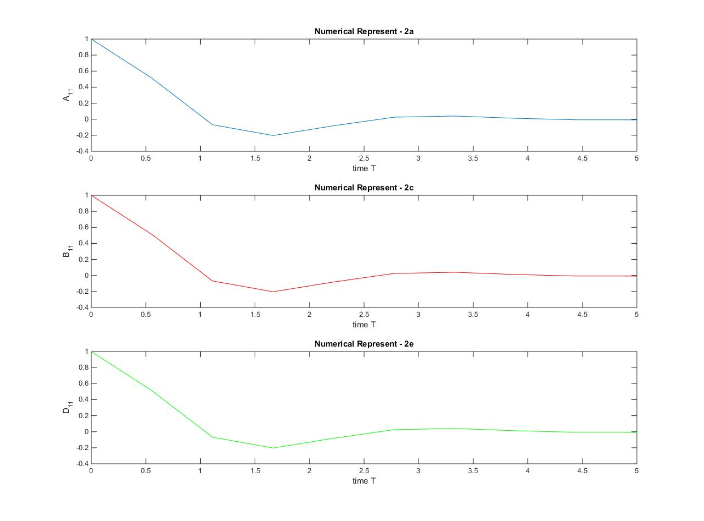

Second element: first row + second column:

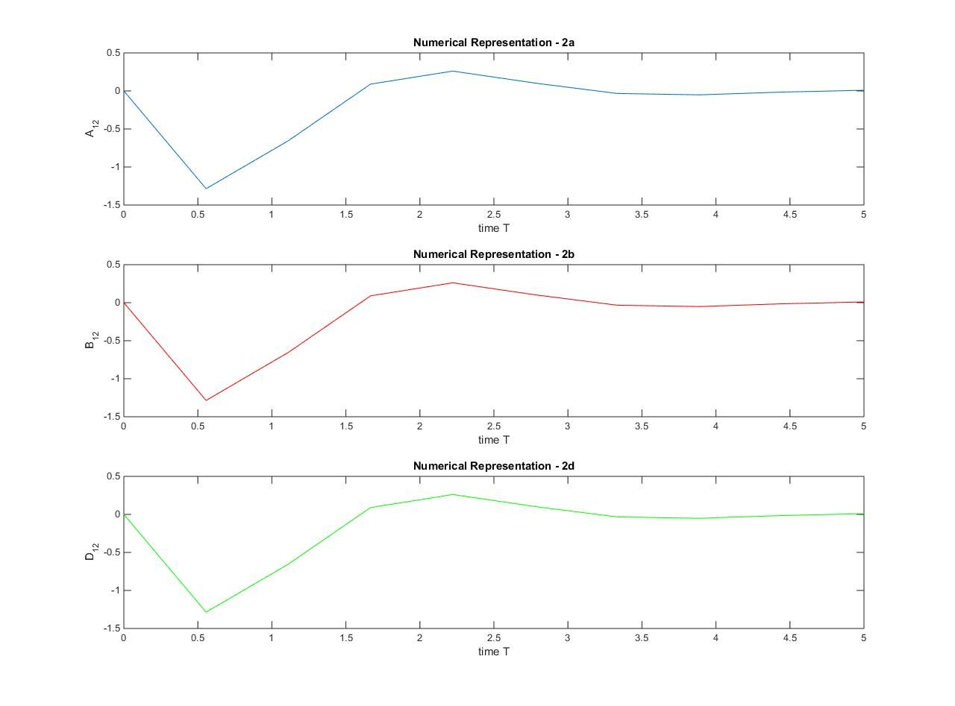

Third element: second row + first column:

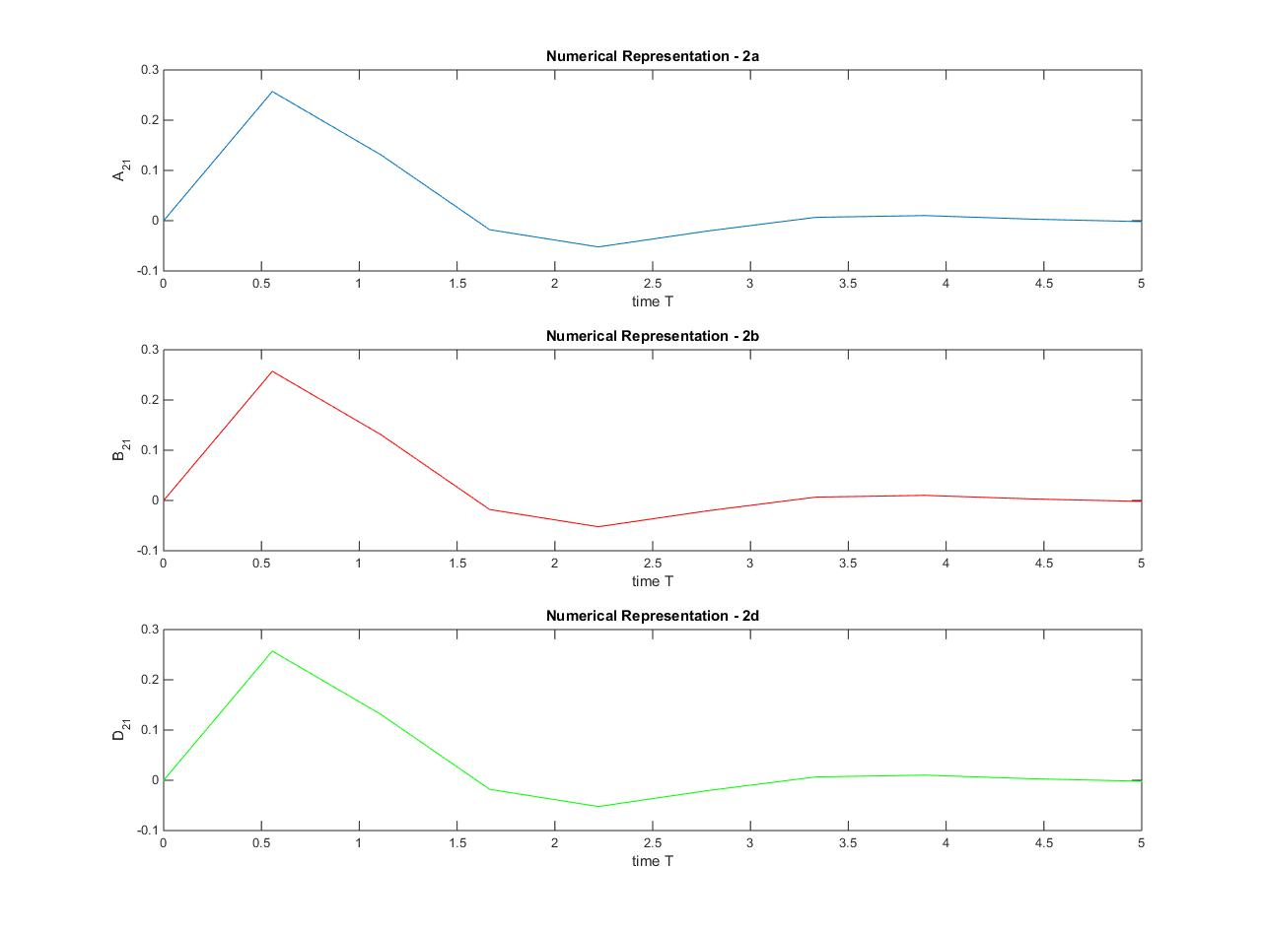

Forth element: second row + second column:

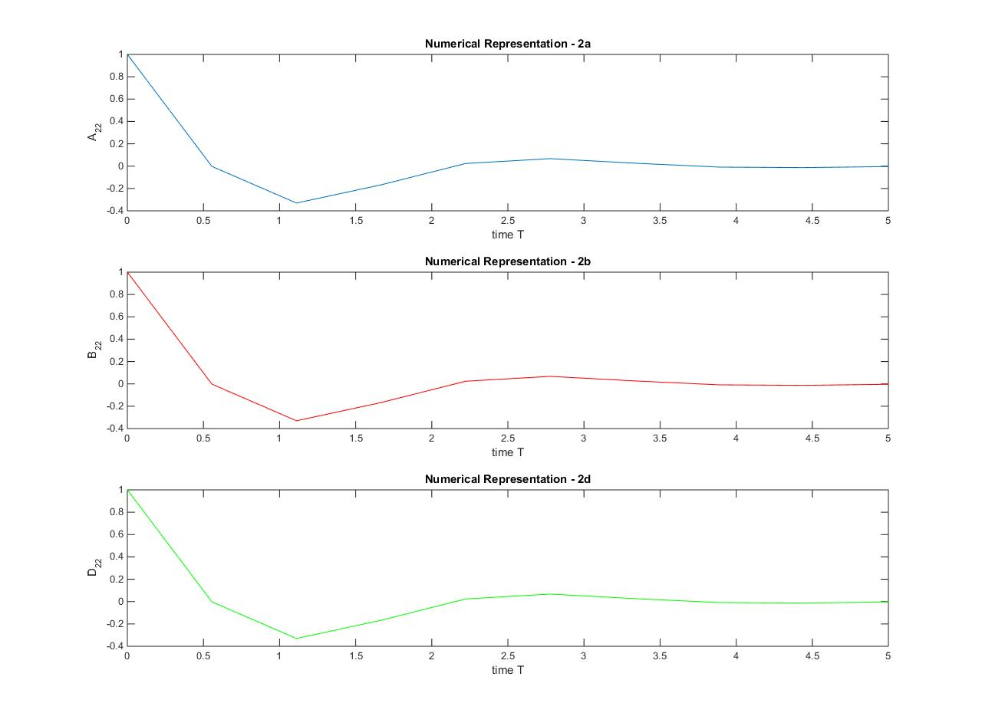

**3. Use any of the result from problem 2 to compute and plot the state trajectory for the Initial Value response of this dynamic system:**

- Use the result from problem 2b with assume that input u(t) = 0. We have:

A = [0 -5;1 -2];

syms t;

x0 = [1; -1];

PB = expm(A*t); % expm(A*t)

T = linspace(0,5,10); % time vector

x_t = PB*x0;

for i = 1:10

x_t11(i) = double(subs(x_t(1,1),{t},T(i)));

x_t21(i) = double(subs(x_t(2,1),{t},T(i)));

end

plot(T,x_t11,T,x_t21,'r');

xlabel('time T');

ylabel('X');

title('State Trajectory');

legend('x_1','x_2');

Result:

