

HUI ONLINE

Software Requirement Specification

Project Code: HUI ONLINE (HOL)

Document Code: HỤI ONLINE version 2.0

|  |  |
| --- | --- |
| GROUP 5 | |
| Group members | Trần Kim Hiếu-Team Leader-SE140907  Nguyễn Bá Tâm-Team Member-SE141017  Hồ Quốc Khải-Team Member-SE140998  Hứa Minh Luân-Team Member-SE140887 |
| Supervisor | Lại Đức Hùng |

**Hồ Chí Minh, Ngày 14 tháng 07 năm 2021**

Record of change

*A - Added M - Modified D - Deleted

|  |  |  |  |  |
| --- | --- | --- | --- | --- |
| Effective Date | Changed Items | A* M, D | Change Description | New Version |
| 02/12/2016 | Initial | a | Add project over view |  |
|  |  |  |  |  |
|  |  |  |  |  |
|  |  |  |  |  |
|  |  |  |  |  |
|  |  |  |  |  |
|  |  |  |  |  |
|  |  |  |  |  |
|  |  |  |  |  |
|  |  |  |  |  |
|  |  |  |  |  |
|  |  |  |  |  |
|  |  |  |  |  |
|  |  |  |  |  |
|  |  |  |  |  |
|  |  |  |  |  |
|  |  |  |  |  |
|  |  |  |  |  |
|  |  |  |  |  |
|  |  |  |  |  |
|  |  |  |  |  |

TABLE OF CONTENTS

1 Introduction 6

1.1 Purpose 6

1.2 Scope 6

1.3 Definitions, Acronyms, and Abbreviations 6

1.4 References 6

1.5 Overview 6

2 Overall Description 7

2.1 Product perspective 7

2.2 Product FEATURES 7

2.3 USER CHARACTERISTICS 7

2.4 Constraints 8

3 FUNCTIONAL Requirements 9

3.1 <Guest> Register an account 9

3.2 <Guest> Login 11

3.3 <Authenticated User> View profile 13

3.4 <Authenticated User> Edit profile 14

3.5 <Authenticated User> Logout 16

3.6 <Admin> Get the list of verification requests 17

3.7 <Admin> Search a verification request 19

3.8 <Admin> View a verification request detail 21

3.9 <Admin> Verify an account 23

3.10 <Admin> Reject a verification request 24

3.11 <Admin> Get the list of feedbacks 26

3.12 <Admin> Search a feedback 28

3.13 <Admin> View a feedback 30

3.14 <Admin> Disable an user 32

3.15 <Admin> View DAY HUI detail 34

3.16 <HUI manager> Create a DAY HUI 36

3.17 <HUI manager> Search a DAY HUI manager created 38

3.18 <HUI manager> Get the list of DAY HUI 41

3.19 <HUI manager> Get the list of members want to join 42

3.20 <HUI manager> View information of member 44

3.21 <HUI manager> Approve member to DAY HUI 46

3.22 <HUI manager> Disapprove member 47

3.23 <HUI manager> View DAY HUI detail 49

3.24 <HUI manager> Invite member to DAY HUI 51

3.25 <HUI manager> Edit new DAY HUI 53

3.26 <HUI manager> View call HUI detail 56

3.27 <HUI manager> Approve member borrow HUI 58

3.28 <HUI manager> Reject member borrow HUI 60

3.29 <HUI manager> View others profile 62

3.30 <HUI manager> Send feedback 64

3.31 <HUI member> Get the list of DAY HUI member joined 65

3.32 <HUI member> Search a DAY HUI member joined 67

3.33 <HUI member> View DAY HUI detail 69

3.34 <HUI member> Call HUI 71

3.35 <HUI member> Pay HUI 73

3.36 <HUI member> View others profile 75

3.37 <HUI member> Send feedback 77

3.38 <HUI member> View history 79

3.39 <HUI member> Find DAY HUI 80

3.40 <HUI member> View information of DAY HUI 82

3.41 <HUI member> Join a DAY HUI 84

4 NON-FUNCTIONAL Requirements 86

4.1 Usability 86

4.2 Reliability 86

4.3 Performance 86

4.4 Supportability 86

<Supportability Requirement One> 86

4.5 Design Constraints 86

<Design Constraint One> 86

4.6 On-line User Documentation and Help System Requirements 86

4.7 Purchased Components 87

4.8 Interfaces 87

User Interfaces 87

Hardware Interfaces 87

Software Interfaces 87

Communications Interfaces 87

4.9 Licensing Requirements 87

4.10 Legal, Copyright, and Other Notices 87

4.11 Applicable Standards 88

5 Supporting Information 89

# Introduction

This section gives a scope description and overview of everything included in this SRS document.

Also, the purpose for this document is described and a list of abbreviations and definitions is provided.

## Purpose

The purpose of this document is to build an online system specifically for Vietnamese people to be able to play "HUI" anywhere without meeting face-to-face.

## Scope

The purpose of the management system "HUI online" is to easily manage and create a convenient and easy-to-use application for users who want to play "HUI" anywhere without meeting face to face.

Above all, we hope to provide a comfortable user experience along with the best features available.

## Definitions, Acronyms, and Abbreviations

UC: Use case

## References

Book: Software requirements Third Edition

Software Requirements template: [SWR302_HungLD](http://lms-undergrad.fpt.edu.vn/course/view.php?id=1257)

https://developers.facebook.com/docs/

## Overview

The remainder of this document includes three chapters.

The second one provides an overview of the system functionality and system interaction. This chapter also introduces their interaction with the system.

The third chapter provides the functional Requirements.

The fourth chapter deals with Usability and Reliability of the system or mobile application. System performance and response speed to requests from web applications.

# Overall Description

## Product perspective

A distributed “HUI-online” database system stores the following information.

**HuiMember description:** It includes MemberID , Fullname , DateOfBirth , Sex , Phone , PlaceOfOrigin , PlaceOfResidence , ImageOfCitizenIdentityCard , BankAccountNumber , AccountID , DayHuiID.

**HuiManager description :** It includes ManagerID , Fullname , DateOfBirth , Sex , Phone , PlaceOfOrigin , PlaceOfResidence , ImageOfCitizenIdentityCard , BankAccountNumber , AccountID .

**Admin description :** It includes AdminID , Fullname , DateOfBirth , Sex, Phone , Address, AccountID.

## Product FEATURES

The major features of “HUI-online” database system as shown in below [**entity–relationship model**](https://en.wikipedia.org/wiki/Entity%E2%80%93relationship_model) (**ER model**)

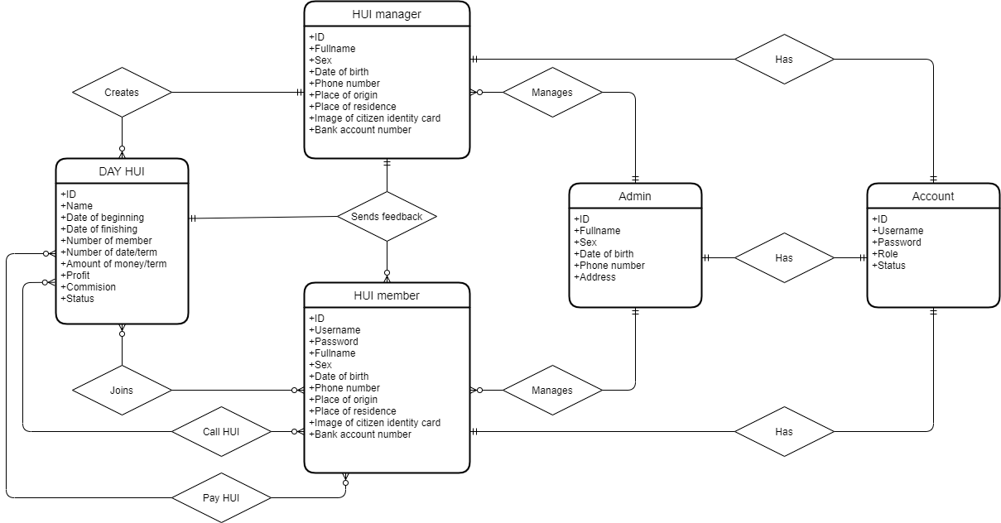

## USER CHARACTERISTICS

Basic knowledge is adequate to use this application. The user interface will be friendly enough to guide the user.

## Constraints

Required for Login successful. As for the developer constraints, Information must be kept confidential.

# FUNCTIONAL Requirements

## <Guest> Register an account

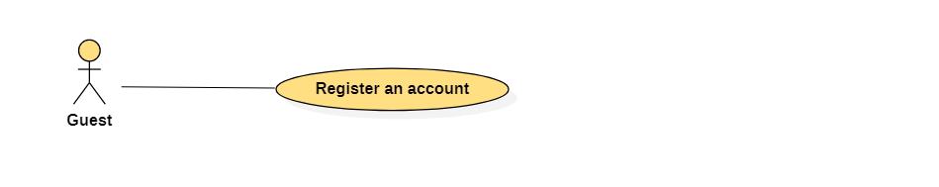

|  |  |  |  |
| --- | --- | --- | --- |
| **USE CASE – HUI online_UC_01** | | | |
| **Use Case No.** | **HUI online_UC_01** | **Use Case Version** | 2.0 |
| **Use Case Name** | Register an account | | |
| **Author** | Nguyen Ba Tam | | |
| **Date** | 07/07/2021 | **Priority** | Normal |
| **Actor:**   * Guest   **Summary:**   * This use case allows guest to register an account   **Goal**   * Create a new account   **Trigger:**   * Guest clicks “Sign Up” button   **Precondition:**   * N/A   **Post Conditions:**   * Success: The new account is created successfully   **Main Success Scenario:**   |  |  |  | | --- | --- | --- | | **Step** | **Actor Action** | **System Response** | | 1 | Guest clicks “Don’t have an account?” link | The system shows a form:   * Username: textbox, required, min length: 6, max length: 20 * Password: password, required, min length: 6, max length 20 * Confirm password: password, required, min length: 6, max length: 20 * Fullname: textbox, required, max length: 50 * Date of birth: datetime picker * Sex: radio button(Male, Female, Other) * Phone number: textbox, required, cell phone number * Place of origin: textbox, required * Place of residence: textbox, required * Image of citizen identity card: file picker, image format * Bank account number: textbox * Role: radio button(manager, member) * Clear: button clear form fields when clicks * Sign Up: button | | 2 | Hui manager inputs information and clicks “Sign Up” button | * The system validates the data   [Exception 1,2]   * The system create new account and show success message |   **Exception:**   |  |  |  | | --- | --- | --- | | **No** | **Actor Action** | **System Response** | | 1 | Duplicate value of “Username” | Show error message “Duplicate username” | | 2 | Value of “Confirm password” is not equal value of “Password” | Show error message “The password confirm does not match” |   **Relationship:** N/A  **Business rule:**   * After registered: * Status of account is “New” * User must wait Admin to verify an account * When system creates new account successfully, shows messages “Create account successfully. Please wait for Admin approval” | | | |

## <Guest> Login

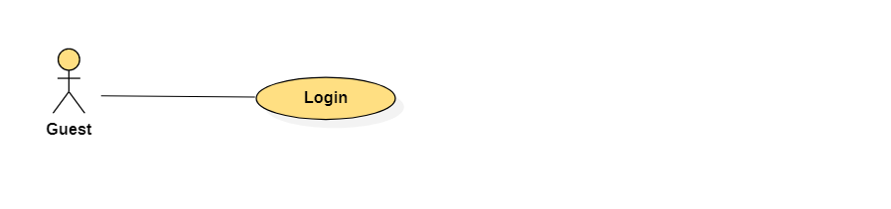

|  |  |  |  |
| --- | --- | --- | --- |
| **USE CASE – HUI online_UC_02** | | | |
| **Use Case No.** | **HUI online_UC_02** | **Use Case Version** | 2.0 |
| **Use Case Name** | Login | | |
| **Author** | Nguyen Ba Tam | | |
| **Date** | 07/07/2021 | **Priority** | Normal |
| **Actor:**   * Guest   **Summary:**   * This use case allows guest to login into system   **Goal**   * Authentication and authorization   **Trigger:**   * Guest clicks “Login” button   **Precondition:**   * Guest has not logged into the system   **Post Conditions:**   * Success: Guest login into the system successfully   **Main Success Scenario:**   |  |  |  | | --- | --- | --- | | **Step** | **Actor Action** | **System Response** | | 1 | Guest clicks “Login” link | The system shows a form:   * Username: textbox, required * Password: password, required * Login: button * Don’t have an account?: link | | 2 | HUI manager inputs information and clicks “Login” button | The system validates the data  [Exception 1,2] |   **Exception:**   |  |  |  | | --- | --- | --- | | **No** | **Actor Action** | **System Response** | | 1 | Account has not been activated | Show error message “Account has not been activated” | | 2 | Invalid username or password | Show error message “Invalid username or password” |   **Relationship:** N/A  **Business rule:**   * Logged in account expire duration is 2 hours * Only active account can login into the system | | | |

## <Authenticated User> View profile

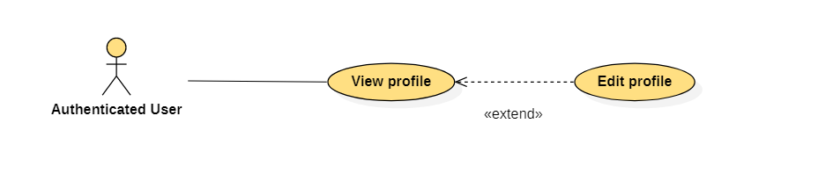

|  |  |  |  |
| --- | --- | --- | --- |
| **USE CASE – HUI online_UC_03** | | | |
| **Use Case No.** | **HUI online_UC_03** | **Use Case Version** | 2.0 |
| **Use Case Name** | View profile | | |
| **Author** | Nguyen Ba Tam | | |
| **Date** | 07/07/2021 | **Priority** | Normal |
| **Actor:**   * Authenticated User   **Summary:**   * This use case allows authenticated user to view profile   **Goal**   * Authenticated user can view profile   **Trigger:**   * Authenticated user clicks “View profile” link   **Precondition:**   * User must login into the system   **Post Conditions:**   * Success: The profile of user is shown successfully   **Main Success Scenario:**   |  |  |  | | --- | --- | --- | | **Step** | **Actor Action** | **System Response** | | 1 | Authenticated User clicks “View profile” link | The system shows a form:   * Average rating: label * Amount of rating: label * Username: label * Fullname: label * Sex: label * Phone number: label * Place of origin: label * Place of residence: label * Image of citizen identity card: image * Bank account number: label * Role: label * Edit: button |   **Exception:** N/A  **Relationship:**   * The use case “View profile” extends the use case “Edit profile”   **Business rule:**   * The system must display “Average rating” as star * When Authenticated User mouse over “Average rating”, the system shows:   + 5 star [meter bar] [percent]   + 4 star [meter bar] [percent]   + 3 star [meter bar] [percent]   + 2 star [meter bar] [percent]   + 1 star [meter bar] [percent] | | | |

## <Authenticated User> Edit profile



|  |  |  |  |
| --- | --- | --- | --- |
| **USE CASE – HUI online_UC_04** | | | |
| **Use Case No.** | **HUI online_UC_04** | **Use Case Version** | 2.0 |
| **Use Case Name** | Edit profile | | |
| **Author** | Nguyen Ba Tam | | |
| **Date** | 07/07/2021 | **Priority** | Normal |
| **Actor:**   * Authenticated User   **Summary:**   * This use case allows authenticated user to edit profile   **Goal**   * Authenticated user can edit profile   **Trigger:**   * Authenticated user clicks “Edit” button   **Precondition:**   * User must login into the system   **Post Conditions:**   * Success: Autheticated User updates profile successfully   **Main Success Scenario:**   |  |  |  | | --- | --- | --- | | **Step** | **Actor Action** | **System Response** | | 1 | Authenticated User clicks “Edit” button | The system shows a form:   * Username: textbox, required, min length: 6, max length: 20 * Password: password, required, min length: 6, max length 20 * Confirm password: password, required, min length: 6, max length: 20 * Phone number: textbox, required, cell phone number * Place of residence: textbox, required * Image of citizen identity card: file picker, image format * Bank account number: textbox * Clear: button clear form fields when clicks * Save: button | | 2 | Authenticated User edits information and clicks “Save” button | The system validates the data  [Exception 1,2]  The system update information of account and show success message |   **Exception:**   |  |  |  | | --- | --- | --- | | **No** | **Actor Action** | **System Response** | | 1 | Duplicate value of “Username” | Show error message “Duplicate username” | | 2 | Value of “Confirm password” is not equal value of “Password” | Show error message “The password confirm does not match” |   **Relationship:**   * The use case “Edit profile” extended by the use case “View profile”   **Business rule:**   * When authenticated user clicks “Save” button: * The system update information of account * Show message “Update successfully” | | | |

## <Authenticated User> Logout

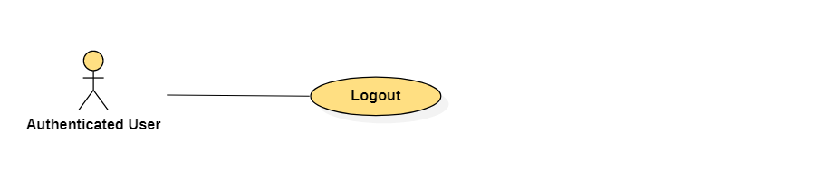

|  |  |  |  |
| --- | --- | --- | --- |
| USE CASE – HUI online_UC_05 | | | |
| Use Case No. | HUI online_UC_05 | Use Case Version | 2.0 |
| Use Case Name | Logout | | |
| Author | Nguyen Ba Tam | | |
| Date | 07/07/2021 | Priority | Normal |
| Actor:   * Authenticated User   Summary:   * This use case allows the Authenticated User to logout   Goal   * Authenticated User can logout   Trigger:   * Authenticated User clicks “Logout” link   Precondition:   * User must login into the system   Post Conditions:   * Success: Authenticated User logout successfully   Main Success Scenario:   |  |  |  | | --- | --- | --- | | Step | Actor Action | System Response | | 1 | Authenticated User clicks “Logout” link | The system show success message |   Exception: N/A  Relationship: N/A  Business rule:   * After logged out, user access the system as role “Guest” * Return user to home success after logged out | | | |

## <Admin> Get the list of verification requests

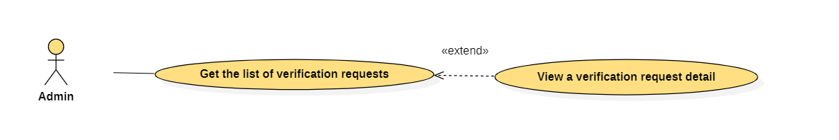

|  |  |  |  |
| --- | --- | --- | --- |
| USE CASE – HUI online_UC_06 | | | |
| Use Case No. | HUI online_UC_06 | Use Case Version | 2.0 |
| Use Case Name | Get the list of verification requests | | |
| Author | Nguyen Ba Tam | | |
| Date | 07/07/2021 | Priority | Normal |
| Actor:   * Admin   Summary:   * This use case allows the Admin to get the list of verification requests   Goal   * Admin can get the list of verification requests   Trigger:   * Admin clicks “List of verification requests” link   Precondition:   * Guest must login into the system with role Admin   Post Conditions:   * Success: The system shows the list of verification requests successfully   Main Success Scenario:   |  |  |  | | --- | --- | --- | | Step | Actor Action | System Response | | 1 | Admin clicks “List of verification requests” link | The system shows:   * Search by date: datetime picker * Search: button   The system shows the list of verification requests, each item includes:   * No: label * Full name: label * Role: label * Date: label * View detail: link |   Exception: N/A  Relationship:   * The use case “Get the list of verification requests” extends the use case “View a verification detail”   Business rule:   * No is a number (1,2,3,4,…) * The list of verification requests must be order by date * List first 10 available item in the system: paging is required | | | |

## <Admin> Search a verification request

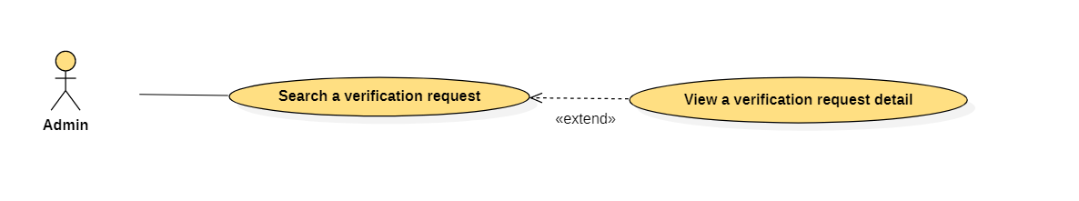

|  |  |  |  |
| --- | --- | --- | --- |
| USE CASE – HUI online_UC_07 | | | |
| Use Case No. | HUI online_UC_07 | Use Case Version | 2.0 |
| Use Case Name | Search a verification request | | |
| Author | Nguyen Ba Tam | | |
| Date | 07/07/2021 | Priority | Normal |
| Actor:   * Admin   Summary:   * This use case allows the Admin to search a verification request   Goal   * Admin can search a verification request   Trigger:   * Admin clicks “Search” button   Precondition:   * Guest must login into the system with role Admin   Post Conditions:   * Success: The system shows the list of verification requests successfully   Main Success Scenario:   |  |  |  | | --- | --- | --- | | Step | Actor Action | System Response | | 1 | Admin selects a date | The system shows:   * Search by date: datetime picker * Search: button | | 2 | Admin clicks “Search” button | The system shows a table, each item includes:   * No: label * Fullname: label * Role: label * Date: label * Status: label * View detail: link |   Exception: N/A  Relationship:   * The use case “Search a verification request” extends the use case “View a verification detail”   Business rule:   * Value of “Search by date” datetime picker must be less than or equal current date * “No” label is a number (1,2,3,4,…) * Value of “Status” label must be “New” or “Verified” or “Rejected” * The list of verification requests must be order by date * List first 10 available item in the system: paging is required | | | |

## <Admin> View a verification request detail

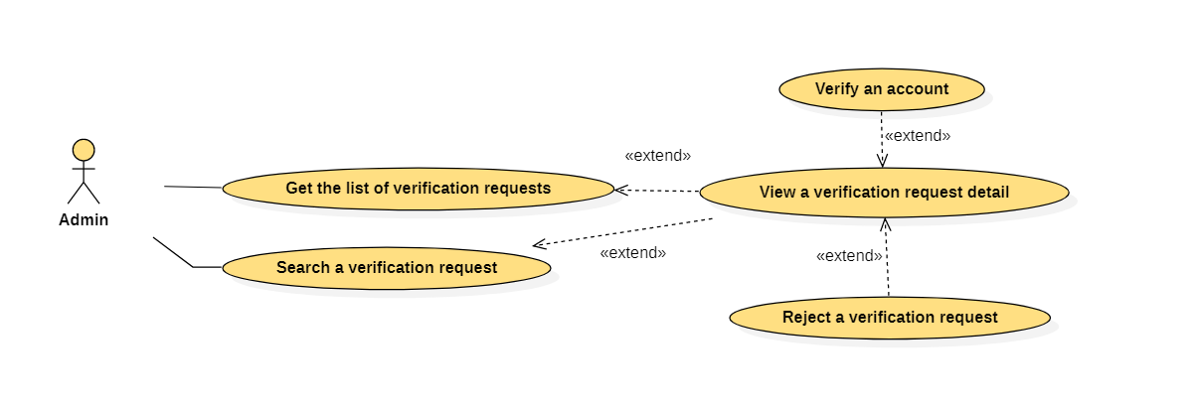

|  |  |  |  |
| --- | --- | --- | --- |
| USE CASE – HUI online_UC_08 | | | |
| Use Case No. | HUI online_UC_08 | Use Case Version | 2.0 |
| Use Case Name | View a verification request detail | | |
| Author | Nguyen Ba Tam | | |
| Date | 07/07/2021 | Priority | Normal |
| Actor:   * Admin   Summary:   * This use case allows the Admin to view a verification request detail   Goal   * Admin can view a verification request detail   Trigger:   * Admin clicks “View detail” link   Precondition:   * Guest must login into the system with role Admin   Post Conditions:   * Success: The information of verification request detail is shown successfully   Main Success Scenario:   |  |  |  | | --- | --- | --- | | Step | Actor Action | System Response | | 1 | Admin clicks “View detail” link | The system shows:   * Fullname: label * Date of birth: label * Sex: label * Phone number: label * Place of origin: label * Place of residence: label * Image of citizen identity card: image * Role: label * Status: label * Verify: button * Reject: button |   Exception: N/A  Relationship:   * The use case “View a verification request detail” extended by the use case “Get the list of verification requests” * The use case “View a verification request detail” extended by the use case “Search a verification request” * The use case “View a verification request detail” extends the use case “Verify an account” * The use case “View a verification request detail” extends the use case “Reject a verification request”   Business rule:   * If status of verification request detail is “Verified” or “Rejected”: * “Verify” button is not shown on screen * “Reject” button is not shown on screen | | | |

## <Admin> Verify an account



|  |  |  |  |
| --- | --- | --- | --- |
| USE CASE – HUI online_UC_09 | | | |
| Use Case No. | HUI online_UC_09 | Use Case Version | 2.0 |
| Use Case Name | Verify an account | | |
| Author | Nguyen Ba Tam | | |
| Date | 07/07/2021 | Priority | Normal |
| Actor:   * Admin   Summary:   * This use case allows the Admin to verify an account   Goal   * Admin can verify an account   Trigger:   * Admin clicks “Verify” button   Precondition:   * Guest must login into the system with role Admin   Post Conditions:   * Success: The new account is verified successfully   Main Success Scenario:   |  |  |  | | --- | --- | --- | | Step | Actor Action | System Response | | 1 | Admin clicks “Verify” button | The system verifies an account and shows success message |   Exception: N/A  Relationship:   * The use case “Verify an account” extended by the use case “View a verification request detail”   Business rule:   * If Admin clicks “Verify” button: * The system shows message “Verify successfully” * Status of account in datase changes to “Verified” | | | |

## <Admin> Reject a verification request



|  |  |  |  |
| --- | --- | --- | --- |
| USE CASE – HUI online_UC_10 | | | |
| Use Case No. | HUI online_UC_10 | Use Case Version | 2.0 |
| Use Case Name | Reject a verification request | | |
| Author | Nguyen Ba Tam | | |
| Date | 07/07/2021 | Priority | Normal |
| Actor:   * Admin   Summary:   * This use case allows the Admin to reject a verification request   Goal   * Admin can reject a verification request   Trigger:   * Admin clicks “Reject” button   Precondition:   * Guest must login into the system with role Admin   Post Conditions:   * Success: Admin reject a verification request successfully   Main Success Scenario:   |  |  |  | | --- | --- | --- | | Step | Actor Action | System Response | | 1 | Admin clicks “Reject” button | The system shows a form:   * Reason: textbox, required * Reject: button | |  | Admin clicks “Reject” button | The system validates data and shows success message |   Exception: N/A  Relationship:   * The use case “Reject a verification request” extended by the use case “View a verification request detail”   Business rule:   * Admin must inputs the reason * Admin clicks “Reject” button: * The system shows message “Reject successfully” * Status of account in datase changes to “Rejected” | | | |

## <Admin> Get the list of feedbacks

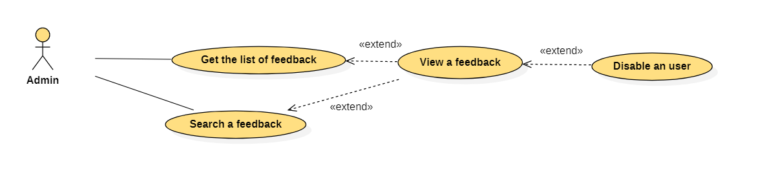

|  |  |  |  |
| --- | --- | --- | --- |
| USE CASE – HUI online_UC_11 | | | |
| Use Case No. | HUI online_UC_11 | Use Case Version | 2.0 |
| Use Case Name | Get the list of feedbacks | | |
| Author | Hua Minh Luan | | |
| Date | 07/07/2021 | Priority | Normal |
| Actor:   * Admin   Summary:   * This use case allows the Admin to get the list of feedbacks   Goal   * Admin can get the list of feedbacks   Trigger:   * Admin clicks “Feedback” link   Precondition:   * Guest must login into the system with role Admin   Post Conditions:   * Success: The list of feedbacks is shown successfully   Main Success Scenario:   |  |  |  | | --- | --- | --- | | Step | Actor Action | System Response | | 1 | Admin clicks “Feedback” link | The system shows:   * Search by: dropdown list(Search by reason, Search by date) * Search: button   The system shows list of feedback, each item includes:   * No: label * From: label * To: label * Day Hui: label * Rate: label * Reason: label * Date: label * View detail: link |   Exception: N/A  Relationship:   * The use case “Get the list of feed backs” extends the use case “View a feedback”   Business rule:   * “No” label: a number(1,2,3,4,…) * “From” label : The person sends feedback * “To” label: The person was estimated feedback * “Rate” label: “1/5” or “2/5” or “3/5” or “4/5” or “5/5” | | | |

## <Admin> Search a feedback



|  |  |  |  |
| --- | --- | --- | --- |
| USE CASE – HUI online_UC_12 | | | |
| Use Case No. | HUI online_UC_12 | Use Case Version | 2.0 |
| Use Case Name | Search a feedback | | |
| Author | Hua Minh Luan | | |
| Date | 07/07/2021 | Priority | Normal |
| Actor:   * Admin   Summary:   * This use case allows the Admin to search a feedback   Goal   * Admin can search a feedback   Trigger:   * Admin clicks “Search” button   Precondition:   * Guest must login into the system with role Admin   Post Conditions:   * Success: The list of feedbacks is shown successfully   Main Success Scenario:   |  |  |  | | --- | --- | --- | | Step | Actor Action | System Response | | 1 | Admin clicks “Feedback” link | The system shows:   * Search by: dropdown list(Search by reason, Search by date) * Search: button | | 2 | Admin inputs data and clicks “Search” button | The system shows list of feedback, each item includes:   * No: label * From: label * To: label * Day Hui: label * Rate: label * Reason: label * Date: label * View detail: link |   Exception: N/A  Relationship:   * The use case “Search a feedback” extends the use case “View a feedback”   Business rule:   * If Admin selects “Search by reason”: A dropdown list reason appears * If Admin selects “Search by date”: A datetime picker appears * “No” label: a number(1,2,3,4,…) * “From” label : The person sends feedback * “To” label: The person was estimated feedback * “Rate” label: “1/5” or “2/5” or “3/5” or “4/5” or “5/5” | | | |

## <Admin> View a feedback

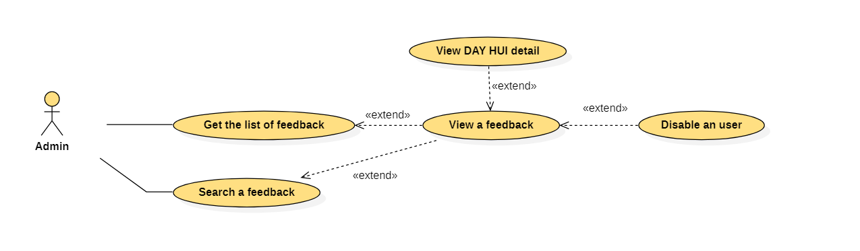

|  |  |  |  |
| --- | --- | --- | --- |
| USE CASE – HUI online_UC_13 | | | |
| Use Case No. | HUI online_UC_13 | Use Case Version | 2.0 |
| Use Case Name | View a feedback | | |
| Author | Hua Minh Luan | | |
| Date | 07/07/2021 | Priority | Normal |
| Actor:   * Admin   Summary:   * This use case allows the Admin to view a feedback   Goal   * Admin can view a feedback   Trigger:   * Admin clicks “View detail” link   Precondition:   * Guest must login into the system with role Admin   Post Conditions:   * Success: The information of feedback is shown successfully   Main Success Scenario:   |  |  |  | | --- | --- | --- | | Step | Actor Action | System Response | | 1 | Admin clicks “View detail” link | The system shows:   * Day Hui: link * From: label * To: label * Reason: label * Rate: label * Date: label * Description: label * Disable: button   If person sends feedback is a member:   * A table about Pay Hui, each item includes: * Amount: label * Date: label * Information of loan Hui: * Amount: label * Date: label |   Exception: N/A  Relationship:   * The use case “View a feedback” extended by the use case “Get the list of feedback” * The use case “View a feedback” extended by the use case “Search a feedback” * The use case “View a feedback” extends the use case “Disable an user” * The use case “View a feedback” extends the use case “View DAY HUI detail”   Business rule:   * “From” label : The person sends feedback * “To” label: The person was estimated feedback * When Admin mouse over “To label”, the system shows: * Average rating: label * Amount of rating: label * Fullname: label * Date of birth : label * Sex: label * Phone number: label * Place of origin: label * Place of residence: label * Image of citizen identity card: image * Role: label * The system must display “Average rating” as star * When Admin mouse over “Average rating”, the system shows:   + 5 star [meter bar] [percent]   + 4 star [meter bar] [percent]   + 3 star [meter bar] [percent]   + 2 star [meter bar] [percent]   + 1 star [meter bar] [percent] * “Rate” label: “1/5” or “2/5” or “3/5” or “4/5” or “5/5” | | | |

## <Admin> Disable an user



|  |  |  |  |
| --- | --- | --- | --- |
| USE CASE – HUI online_UC_14 | | | |
| Use Case No. | HUI online_UC_14 | Use Case Version | 2.0 |
| Use Case Name | Disable an user | | |
| Author | Hua Minh Luan | | |
| Date | 07/07/2021 | Priority | Normal |
| Actor:   * Admin   Summary:   * This use case allows the Admin to disable an user   Goal   * Admin can disable an user   Trigger:   * Admin clicks “Ok” button   Precondition:   * Guest must login into the system with role Admin   Post Conditions:   * Success: Admin disable a bad user successfully   Main Success Scenario:   |  |  |  | | --- | --- | --- | | Step | Actor Action | System Response | | 1 | Admin clicks “Disable” button | The system shows comfirm message:   * Ok: button * Cancel: button | | 2 | Admin clicks “Ok” | The system disables an user and shows success message |   Exception: N/A  Relationship:   * The use case “Disable an user” extended by the use case “View a feedback”   Business rule:   * Admin must confirm the action before system chang status of account to “Inactive” * Success message: “Disable successfully” | | | |

## <Admin> View DAY HUI detail



|  |  |  |  |
| --- | --- | --- | --- |
| USE CASE – HUI online_UC_15 | | | |
| Use Case No. | HUI online_UC_15 | Use Case Version | 2.0 |
| Use Case Name | View DAY HUI detail | | |
| Author | Hua Minh Luan | | |
| Date | 07/07/2021 | Priority | Normal |
| Actor:   * Admin   Summary:   * This use case allows Admin to view DAY HUI detail   Goal   * Admin can view DAY HUI detail   Trigger:   * Admin clicks “Day Hui” link   Precondition:   * Guest must login into the system with role Admin   Post Conditions:   * Success: Information of DAY HUI is shown successfully   Main Success Scenario:   |  |  |  | | --- | --- | --- | | Step | Actor Action | System Response | | 1 | Admin clicks “Day Hui” link | Information of DAY HUI:   * Name: label * Date of beginning: label * Date of finishing: label * Amount of money/term: label * Number of date/term: label * Commission: label * Total: label   A table with header cells in the top row and first column:   * First column: label (Name of member) * Top row: label (Number of month) * Cell: label (amount of money/month) |   Relationship:   * The use case “View DAY HUI detail” extended by use case “View a feedback”   Business rule:   * Commission must show amount of money * If Admin clicks a cell, the system shows member pay HUI detail in this month. Each line includes: * Date: label * Amount: label | | | |

## <HUI manager> Create a DAY HUI

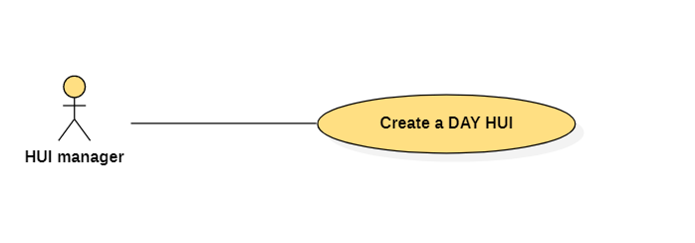

|  |  |  |  |
| --- | --- | --- | --- |
| USE CASE – HUI online_UC_16 | | | |
| Use Case No. | HUI online_UC_16 | Use Case Version | 2.0 |
| Use Case Name | Create a DAY HUI | | |
| Author | Hua Minh Luan | | |
| Date | 07/07/2021 | Priority | Normal |
| Actor:   * HUI manager   Summary:   * This use case allows the HUI manager to create a new DAY HUI   Goal   * The new DAY HUI is created   Trigger:   * HUI manager clicks “+ Create new DAY HUI” button   Precondition:   * Guest must login into the system with role HUI manager   Post Conditions:   * Success: The new DAY HUI is created successfully   Main Success Scenario:   |  |  |  | | --- | --- | --- | | Step | Actor Action | System Response | | 1 | HUI manager clicks  “+ Create new DAY HUI” button | The system shows a form:   * Name of DAY HUI: textbox, required, min length:6, max length: 50 * Number of member: textbox, required * Date of beginning: datetime picker, required * Date of finishing: datetime picker, required * Number of date/term: dropdown list(1..30), required * Amount of money/term: textbox, required * Commission(%): textbox, required * Create: button * Cancel: button | | 2 | HUI manager inputs information and clicks “Create” button | * The system validates the data   [Exception 1,2,3,4,5,6,7,8]   * The system creates the new DAY HUI and shows success message |   Exception:   |  |  |  | | --- | --- | --- | | No | Actor Action | System Response | | 1 | Length of “Name of DAY HUI” is not in range, lower than min | Show error message “Name of DAY HUI must be at least 6 characters” | | 2 | Length of “Name of DAY HUI” is not in range, higher than max | Show error message “Name of DAY HUI must be less than 50 characters” | | 3 | Value of “Number of member” is not positive integer | Show error message “Number of member must be a positive integer” | | 4 | Time is nots picked in “Date of beginning” datetime picker | Show error message “Date of beginning must be selected” | | 5 | Time is not picked in “Date of finishing” datetime picker | Show error message “Date of finishing must be selected” | | 6 | “Number of date/term” dropdown list is not selected | Show error message “Number of date/term must be selected” | | 7 | Value of “Amount of money/term” is not positive integer | Show error message “Amount of money/term must be a positive integer” | | 8 | Value of “Commisstion(%)” is not positive integer | Show error message “Commisstion(%) must be a positive integer” |   Relationship: N/A  Business rule:   * Date of beginning must be greater than current date * Date of finishing must be greater than date of beginning * When HUI manager clicks “Create” button:   + The system creates the new DAY HUI in database   + The system shows message “A DAY HUI is created successfully” | | | |

## <HUI manager> Search a DAY HUI manager created

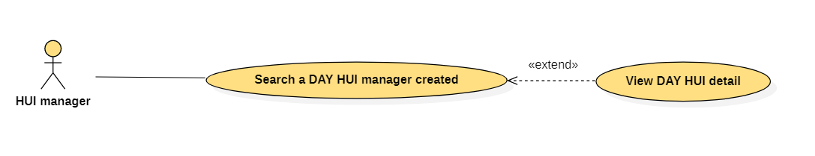

|  |  |  |  |
| --- | --- | --- | --- |
| USE CASE – HUI online_UC_17 | | | |
| Use Case No. | HUI online_UC_17 | Use Case Version | 2.0 |
| Use Case Name | Search a DAY HUI manager created | | |
| Author | Hua Minh Luan | | |
| Date | 07/07/2021 | Priority | Normal |
| Actor:   * HUI manager   Summary:   * This use case allows the HUI manager to search a DAY HUI manager created   Goal   * Search DAY HUI results is shown   Trigger:   * HUI manager clicks “Search” button   Precondition:   * Guest must login into the system with role HUI manager   Post Conditions:   * Success: List of suitable results is shown successfully   Main Success Scenario:   |  |  |  | | --- | --- | --- | | Step | Actor Action | System Response | | 1 | HUI manager selects dropdown | The system shows a form:   * All: link * Search by: dropdown list (Search by name, Search by status, Search by date) * Search button | | 2 | HUI manager fills data into the form |  | | 3 | HUI manager clicks “Search” button | The system shows list of results, each item includes:   * Name: label * Date of beginning: label * Date of finishing: label * View detail: link |   Relationship:   * The use case “Search a DAY HUI manager created” extends use case “View DAY HUI detail”   Business rule:   * If HUI manager chooses “Search by name” in dropdown, the system expands:   + Name: textbox * If HUI manager chooses “Search by date” in dropdown, the system expands:   + From: date picker   + To: date picker * If HUI manager chooses “Search by status” in dropdown: * Status: dropdown list (New, Prepared, In process, Old) * If HUI manager searches DAY HUI by name:   + The list of DAY HUI is searched by like name   + The list of DAY HUI order by name * If HUI manager searches DAY HUI by date: * Date of beginning of each DAY HUI must be between “From” datepicker and “To” datepicker   + The list of DAY HUI order by date of beginning * List first 10 available item in the system: paging is required | | | |

## <HUI manager> Get the list of DAY HUI

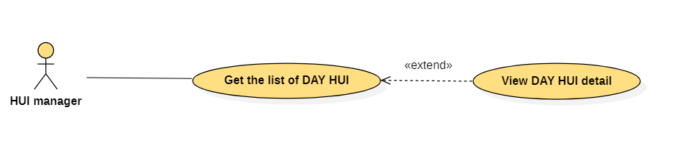

|  |  |  |  |
| --- | --- | --- | --- |
| USE CASE – HUI online_UC_18 | | | |
| Use Case No. | HUI online_UC_18 | Use Case Version | 2.0 |
| Use Case Name | Get the list of DAY HUI | | |
| Author | Hua Minh Luan | | |
| Date | 07/07/2021 | Priority | Normal |
| Actor:   * HUI manager   Summary:   * This use case allows HUI manager to get the list of DAY HUI   Goal   * The list of DAY HUI is shown   Trigger:   * HUI manager clicks “All” link   Precondition:   * Guest must login into the system with role HUI manager   Post Conditions:   * Success: System shows the list of DAY HUI successfully   Main Success Scenario:   |  |  |  | | --- | --- | --- | | Step | Actor Action | System Response | | 1 | HUI manager clicks “All” link | The system shows list of results, each item includes:   * Name: label * Date of beginning: label * Date of finishing: label * View detail: link |   Relationship:   * The use case “Get the list of DAY HUI” extends the use case “View DAY HUI detail”   Business rule:   * The list of DAY HUI must be order by date of beginning * List first 10 available item in the system: paging is required | | | |

## <HUI manager> Get the list of members want to join

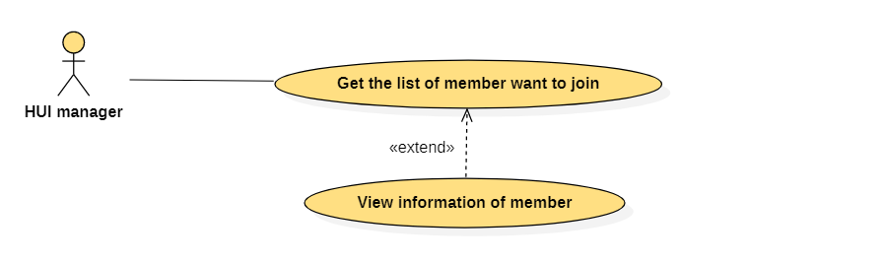

|  |  |  |  |
| --- | --- | --- | --- |
| USE CASE – HUI online_UC_19 | | | |
| Use Case No. | HUI online_UC_19 | Use Case Version | 2.0 |
| Use Case Name | Get the list of members want to join | | |
| Author | Hua Minh Luan | | |
| Date | 07/07/2021 | Priority | Normal |
| Actor:   * HUI manager   Summary:   * This use case allows HUI manager to get the list of members want to join   Goal   * The list of members want to join is shown   Trigger:   * HUI manager clicks “Join HUI” link   Precondition:   * Guest must login into the system with role HUI manager   Post Conditions:   * Success: System shows the list of members wan to join successfully   Main Success Scenario:   |  |  |  | | --- | --- | --- | | Step | Actor Action | System Response | | 1 | HUI manager clicks “Join HUI” link in menu navigation bar | The system shows the list of member want to join, each item includes:   * Fullname: label * Name of DAY HUI: label * Request Date: label * View detail: link |   Relationship:   * The use case “Get the list of members want to join” extends the use case “View information of member”   Business rule:   * The list of members want to join must be order by request date * List first 10 available item in the system: paging is required | | | |

## <HUI manager> View information of member

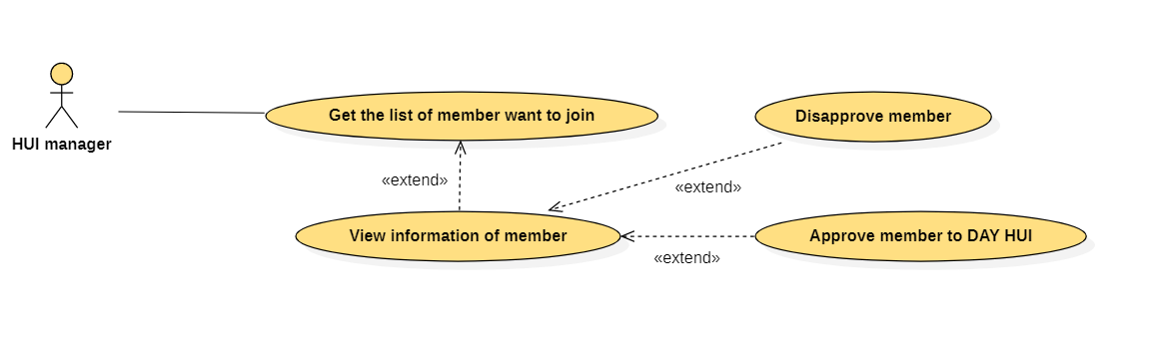

|  |  |  |  |
| --- | --- | --- | --- |
| USE CASE – HUI online_UC_20 | | | |
| Use Case No. | HUI online_UC_20 | Use Case Version | 2.0 |
| Use Case Name | View information of member | | |
| Author | Hua Minh Luan | | |
| Date | 07/07/2021 | Priority | Normal |
| Actor:   * HUI manager   Summary:   * This use case allows HUI manager to view information of member want to join   Goal   * Information of member is shown   Trigger:   * HUI manager clicks “ View detail” link   Precondition:   * Guest must login into the system with role HUI manager   Post Conditions:   * Success: System shows information of member wan to join successfully   Main Success Scenario:   |  |  |  | | --- | --- | --- | | Step | Actor Action | System Response | | 1 | HUI manager clicks “View detail” link | The system shows information of member want to join, includes:   * Average rating: label * Amount of rating: label * Fullname: label * Date of birth: label * Sex: label * Phone number: label * Place of origin: label * Place of residence: label * Image of citizen identity card: image * Request date: label * Approve: button * Disapprove: button |   Relationship:   * The use case “View information of member” extended by use case “Get the list of member want to join” * The use case “View information of member” extends the use case “Disapprove member” * The user case “View information of member” extends the use case “Approve member to DAY HUI”   Business rule:   * The system must display “Average rating” as star * When HUI manager mouse over “Average rating”, the system shows:   + 5 star [meter bar] [percent]   + 4 star [meter bar] [percent]   + 3 star [meter bar] [percent]   + 2 star [meter bar] [percent]   + 1 star [meter bar] [percent] | | | |

## <HUI manager> Approve member to DAY HUI



|  |  |  |  |
| --- | --- | --- | --- |
| USE CASE – HUI online_UC_21 | | | |
| Use Case No. | HUI online_UC_21 | Use Case Version | 2.0 |
| Use Case Name | Approve member to DAY HUI | | |
| Author | Tran Kim Hieu | | |
| Date | 07/07/2021 | Priority | Normal |
| Actor:   * HUI manager   Summary:   * This use case allows HUI manager to approve member to DAY HUI   Goal   * HUI manager can approve member to DAY HUI   Trigger:   * HUI manager clicks “Approve” button   Precondition:   * Guest must login into the system with role HUI manager   Post Conditions:   * Success: System add member to DAY HUI successfully   Main Success Scenario:   |  |  |  | | --- | --- | --- | | Step | Actor Action | System Response | | 1 | HUI manager clicks “Approve” button | The system adds member to DAY HUI and shows success message |   Relationship:   * The use case “Approve member to DAY HUI” extended by use case “View information of member”   Business rule:   * When HUI manager clicks “Approve” button: * System shows message “Approve member to DAY HUI successfully” * Redirect to “Join HUI” screen * This member must not show in the list of member want to join | | | |

## <HUI manager> Disapprove member



|  |  |  |  |
| --- | --- | --- | --- |
| USE CASE – HUI online_UC_22 | | | |
| Use Case No. | HUI online_UC_22 | Use Case Version | 2.0 |
| Use Case Name | Disapprove member | | |
| Author | Tran Kim Hieu | | |
| Date | 07/07/2021 | Priority | Normal |
| Actor:   * HUI manager   Summary:   * This use case allows HUI manager to disapprove member want to join   Goal   * HUI manager can disapprove member want to join in DAY HUI   Trigger:   * HUI manager clicks “Disapprove” button   Precondition:   * Guest must login into the system with role HUI manager   Post Conditions:   * Success: HUI manager disapproves member want to join in DAY HUI successfully   Main Success Scenario:   |  |  |  | | --- | --- | --- | | Step | Actor Action | System Response | | 1 | HUI manager clicks “Disapprove” button | The system shows success message |   Relationship:   * The use case “Disapprove member” extended by use case “View information of member”   Business rule:   * When HUI manager clicks “Disapprove” button: * System shows message “Disapprove member successfully” * Redirect to “Join HUI” screen * This member must not show in the list of member want to join | | | |

## <HUI manager> View DAY HUI detail

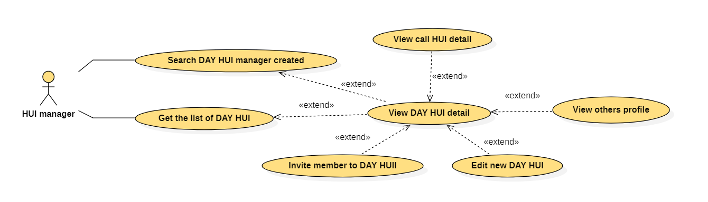

|  |  |  |  |
| --- | --- | --- | --- |
| USE CASE – HUI online_UC_23 | | | |
| Use Case No. | HUI online_UC_23 | Use Case Version | 2.0 |
| Use Case Name | View DAY HUI detail | | |
| Author | Tran Kim Hieu | | |
| Date | 07/07/2021 | Priority | Normal |
| Actor:   * HUI manager   Summary:   * This use case allows HUI manager to view DAY HUI detail   Goal   * HUI manager can view DAY HUI detail   Trigger:   * HUI manager clicks “View detail” link   Precondition:   * Guest must login into the system with role HUI manager   Post Conditions:   * Success: Information of DAY HUI is shown successfully   Main Success Scenario:   |  |  |  | | --- | --- | --- | | Step | Actor Action | System Response | | 1 | HUI manager clicks “View detail” link | Information of DAY HUI:   * Name: label * Date of beginning: label * Date of finishing: label * Amount of money/term: label * Number of date/term: label * Commission: label * + Invite member: button * Edit: button   A table with header cells in the top row and first column:   * [Name of member]: link (first column) * [Number of month]: link (top row) * [Amount of money/month]: link (cell) |   Relationship:   * The use case “View DAY HUI detail” extended by use case “Get the list of DAY HUI” * The use case “View DAY HUI detail” extended by use case “Search DAY HUI manager created” * The use case “View DAY HUI detail” extends use case “View call HUI detail” * The use case “View DAY HUI detail” extends use case “Invite member to DAY HUI” * The use case “View DAY HUI detail” extends use case “Edit new DAY HUI” * The use case “View DAY HUI detail” extends use case “View others profile”   Business rule:   * Commission must show amount of money * If HUI manager clicks a cell, the system shows member pay HUI detail in this month. Each line include: * Date: label * Amount: label * Each name of member in the table must be a link * Number of column depends on number of member * Number of row depends on number of month | | | |

## <HUI manager> Invite member to DAY HUI

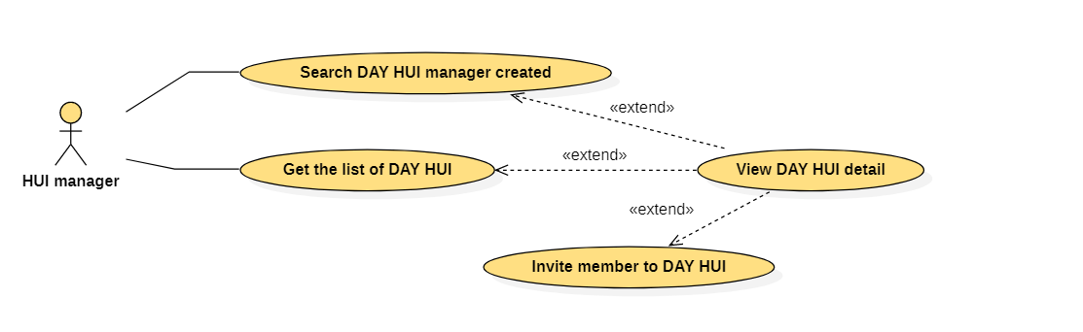

|  |  |  |  |
| --- | --- | --- | --- |
| USE CASE – HUI online_UC_24 | | | |
| Use Case No. | HUI online_UC_24 | Use Case Version | 2.0 |
| Use Case Name | Invite member to DAY HUI | | |
| Author | Tran Kim Hieu | | |
| Date | 07/07/2021 | Priority | Normal |
| Actor:   * HUI manager   Summary:   * This use case allows HUI manager to invite member to DAY HUI   Goal   * HUI manager can invite member to DAY HUI   Trigger:   * HUI manager clicks “+ Invite member” button   Precondition:   * Guest must login into the system with role HUI manager   Post Conditions:   * Success: Member is invited to DAY HUI successfully   Main Success Scenario:   |  |  |  | | --- | --- | --- | | Step | Actor Action | System Response | | 1 | HUI manager clicks “+ Invite member” button | The system requires the following input from HUI manager includes:   * ID: textbox, required * Invite: button * Cancel: button   [Exception: 1] | | 2 | HUI manager clicks “Invite” button | The system adds member to DAY HUI and shows success message |   Exception:   |  |  |  | | --- | --- | --- | | No | Actor Action | System Response | | 1 | Value of “ID” is invalid | Show error message “Invalid ID of member!” |   Relationship:   * The use case “Invite member to DAY HUI” extended by the use case “View DAY HUI detail”   Business rule:   * If HUI manager clicks “Invite” button: * The system shows message “Invite member successfully” * Redirect DAY HUI detail screen * The member have to appear in table * If HUI manager clicks “Cancel” button: Redirect DAY HUI detail screen * If DAY HUI is full and HUI manager clicks “+ Invite member ”, the system shows message “DAY HUI is full. You can not invite more member” | | | |

## <HUI manager> Edit new DAY HUI

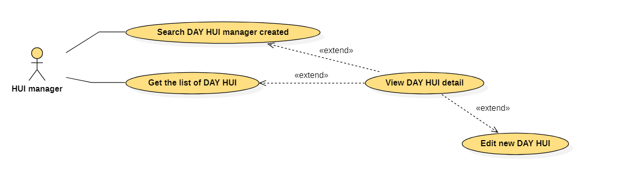

|  |  |  |  |
| --- | --- | --- | --- |
| USE CASE – HUI online_UC_25 | | | |
| Use Case No. | HUI online_UC_25 | Use Case Version | 2.0 |
| Use Case Name | Edit new DAY HUI | | |
| Author | Tran Kim Hieu | | |
| Date | 07/07/2021 | Priority | Normal |
| Actor:   * HUI manager   Summary:   * This use case allows HUI manager to edit new DAY HUI   Goal   * HUI manager can edit new DAY HUI   Trigger:   * HUI manager clicks “Edit” button   Precondition:   * Guest must login into the system with role HUI manager   Post Conditions:   * Success: HUI manage edits new DAY HUI successfully   Main Success Scenario:   |  |  |  | | --- | --- | --- | | Step | Actor Action | System Response | | 1 | HUI manager clicks “Edit” button | The system shows information of DAY HUI to edit, includes:   * Name of DAY HUI: textbox, required, min length:6, max length: 50 * Number of member: textbox, required * Date of beginning: datetime picker, required * Date of finishing: datetime picker, required * Number of date/term: dropdown list(1..30), required * Amount of money/term: textbox, required * Commission(%): textbox, required * Save: button * Cancel: button   [Exception 1,2,3,4,5,6,7,8] | | 2 | HUI manager clicks “Save” button | The system updates information of DAY HUI and shows success message |   Exception:   |  |  |  | | --- | --- | --- | | No | Actor Action | System Response | | 1 | Length of “Name of DAY HUI” is not in range, lower than min | Show error message “Name of DAY HUI must be at least 6 characters” | | 2 | Length of “Name of DAY HUI” is not in range, higher than max | Show error message “Name of DAY HUI must be less than 50 characters” | | 3 | Value of “Number of member” is not positive integer | Show error message “Number of member must be a positive integer” | | 4 | Time is nots picked in “Date of beginning” datetime picker | Show error message “Date of beginning must be selected” | | 5 | Time is not picked in “Date of finishing” datetime picker | Show error message “Date of finishing must be selected” | | 6 | “Number of date/term” dropdown list is not selected | Show error message “Number of date/term must be selected” | | 7 | Value of “Amount of money/term” is not positive integer | Show error message “Amount of money/term must be a positive integer” | | 8 | Value of “Commisstion(%)” is not positive integer | Show error message “Commisstion(%) must be a positive integer” |   Relationship:   * The use case “Edit new DAY HUI” extended by the use case “View DAY HUI detail”   Business rule:   * If status of DAY HUI is not “New” and HUI manager clicks “Edit” button: * The system shows message “You can not edit information of DAY HUI” * If HUI manager clicks “Save” button, the system shows: * Redirect DAY HUI detail screen * Message “Update information of DAY HUI successfully” * If HUI manager clicks “Cancel” button: Redirect DAY HUI detail screen | | | |

## <HUI manager> View call HUI detail

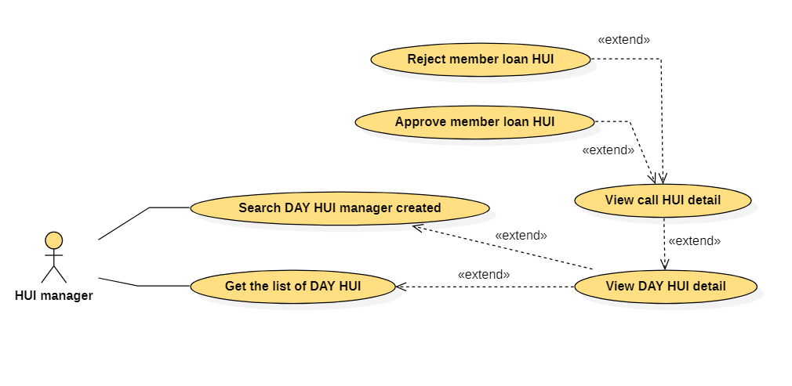

|  |  |  |  |
| --- | --- | --- | --- |
| USE CASE – HUI online_UC_26 | | | |
| Use Case No. | HUI online_UC_26 | Use Case Version | 2.0 |
| Use Case Name | View call HUI detail | | |
| Author | Tran Kim Hieu | | |
| Date | 07/07/2021 | Priority | Normal |
| Actor:   * HUI manager   Summary:   * This use case allows HUI manager to view call HUI detail   Goal   * HUI manager can view call HUI detail   Trigger:   * HUI manager clicks “[Number of month]” link   Precondition:   * Guest must login into the system with role HUI manager   Post Conditions:   * Success: Call HUI detail is shown successfully   Main Success Scenario:   |  |  |  | | --- | --- | --- | | Step | Actor Action | System Response | | 1 | HUI manager clicks “[Number of month]” link | The systhem shows a list, each item includes:   * Name: label * Amount of money: label   If amount of money is highest, the system expands:   * Approve: button * Reject: button |   Exception: N/A  Relationship:   * The use case “View call HUI detail” extended by the use case “View DAY HUI detail” * The use case “View call HUI detail” extends the use case “Approve member borrow HUI” * The use case “View call HUI detail” extends the use case “Reject member borrow HUI”   Business rule:   * Number of item in list depends on number of member | | | |

## <HUI manager> Approve member borrow HUI



|  |  |  |  |
| --- | --- | --- | --- |
| USE CASE – HUI online_UC_27 | | | |
| Use Case No. | HUI online_UC_27 | Use Case Version | 2.0 |
| Use Case Name | Approve member borrow HUI | | |
| Author | Tran Kim Hieu | | |
| Date | 07/07/2021 | Priority | Normal |
| Actor:   * HUI manager   Summary:   * This use case allows HUI manager to approve member borrow HUI   Goal   * HUI manager can approve member borrow HUI   Trigger:   * HUI manager clicks “Ok” button   Precondition:   * Guest must login into the system with role HUI manager   Post Conditions:   * Success: HUI manager approves member borrow HUI successfully   Main Success Scenario:   |  |  |  | | --- | --- | --- | | Step | Actor Action | System Response | | 1 | HUI manager clicks “Approve” button | The system shows comfirm message:   * Ok: button * Cancel: button | | 2 | HUI manager clicks “Ok” button | The system sends money to member and show success message |   Exception: N/A  Relationship:   * The use case “Approve member borrow HUI” extended by the use case “View call HUI detail”   Business rule:   * When system sends money to member, system must send commission to HUI manager * Success message: “Approve successfully” | | | |

## <HUI manager> Reject member borrow HUI



|  |  |  |  |
| --- | --- | --- | --- |
| USE CASE – HUI online_UC_28 | | | |
| Use Case No. | HUI online_UC_28 | Use Case Version | 2.0 |
| Use Case Name | Reject member borrow HUI | | |
| Author | Tran Kim Hieu | | |
| Date | 07/07/2021 | Priority | Normal |
| Actor:   * HUI manager   Summary:   * This use case allows HUI manager to reject member borrow HUI   Goal   * HUI manager can reject member borrow HUI   Trigger:   * HUI manager clicks “Ok” button   Precondition:   * Guest must login into the system with role HUI manager   Post Conditions:   * Success: HUI manager rejects member borrow HUI successfully   Main Success Scenario:   |  |  |  | | --- | --- | --- | | Step | Actor Action | System Response | | 1 | HUI manager clicks “Reject” button | The system shows comfirm message:   * Ok: button * Cancel: button | | 2 | HUI manager clicks “Ok” button | The system shows success message |   Exception: N/A  Relationship:   * The use case “Reject member borrow HUI” extended by the use case “View call HUI detail”   Business rule:   * If HUI manager rejects member borrow HUI with highest amount of money, the system expands on item with closest amount of money: * Approve: button * Reject: button * Success message: “Reject successfully” | | | |

## <HUI manager> View others profile

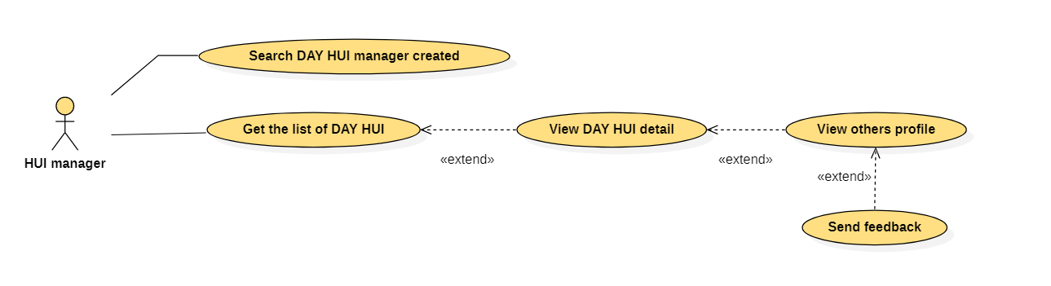

|  |  |  |  |
| --- | --- | --- | --- |
| USE CASE – HUI online_UC_29 | | | |
| Use Case No. | HUI online_UC_29 | Use Case Version | 2.0 |
| Use Case Name | View others profile | | |
| Author | Tran Kim Hieu | | |
| Date | 07/07/2021 | Priority | Normal |
| Actor:   * HUI manager   Summary:   * This use case allows HUI manager to view others profile   Goal   * HUI manager can view others profile   Trigger:   * HUI manager clicks “[Name of member]” link   Precondition:   * Guest must login into the system with role HUI manager   Post Conditions:   * Success: Profile of member is shown successfully   Main Success Scenario:   |  |  |  | | --- | --- | --- | | Step | Actor Action | System Response | | 1 | HUI manager clicks “[Name of member]” link | The system shows:   * Average rating: label * Amount of rating: label * Username: label * Fullname: label * Sex: label * Phone number: label * Place of origin: label * Place of residence: label * Image of citizen identity card: image * Bank account number: label * Role: label * Feedback: link |   Exception: N/A  Relationship:   * The use case “View others profile” extended by the use case “View DAY HUI detail” * The use case “View others profile” extends the use case “Send feedback”   Business rule:   * The system must display “Average rating” as star * When Authenticated User mouse over “Average rating”, the system shows:   + 5 star [meter bar] [percent]   + 4 star [meter bar] [percent]   + 3 star [meter bar] [percent]   + 2 star [meter bar] [percent] * 1 star [meter bar] [percent] | | | |

## <HUI manager> Send feedback



|  |  |  |  |
| --- | --- | --- | --- |
| USE CASE – HUI online_UC_30 | | | |
| Use Case No. | HUI online_UC_30 | Use Case Version | 2.0 |
| Use Case Name | Send feedback | | |
| Author | Tran Kim Hieu | | |
| Date | 07/07/2021 | Priority | Normal |
| Actor:   * HUI manager   Summary:   * This use case allows HUI manager to send feedback   Goal   * HUI manager can send feedback   Trigger:   * HUI manager clicks “Send” button   Precondition:   * Guest must login into the system with role HUI manager   Post Conditions:   * Success: HUI manager sends feedback successfully   Main Success Scenario:   |  |  |  | | --- | --- | --- | | Step | Actor Action | System Response | | 1 | HUI manager clicks “Feedback” link | The system shows:   * Fullname: label * Rate: 5 star icon * Reason: dropdown list (Trustworthy, Good, Pay HUI late, Does not Pay HUI, Other) * Send: button | | 2 | HUI manager clicks “Send” button | The system validates data and shows success message |   Exception: N/A  Relationship:   * The use case “Send feedback” extended by the use case “View others profile”   Business rule:   * HUI manager must select amount of star * If HUI manager selects “Other” in dropdown list, the system expands: Description: textarea, required * HUI manager only evaluates each member 1 time in a particular Day Hui * Succes message: “Send feedback successfully” | | | |

## <HUI member> Get the list of DAY HUI member joined

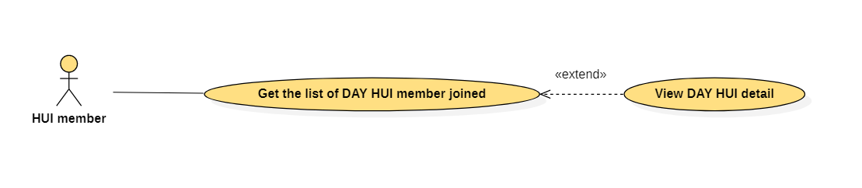

|  |  |  |  |
| --- | --- | --- | --- |
| USE CASE – HUI online_UC_31 | | | |
| Use Case No. | HUI online_UC_31 | Use Case Version | 2.0 |
| Use Case Name | Get the list of DAY HUI member joined | | |
| Author | Tran Kim Hieu | | |
| Date | 07/07/2021 | Priority | Normal |
| Actor:   * HUI member   Summary:   * This use case allows HUI member to get the list of DAY HUI member joined   Goal   * HUI member can get the list of DAY HUI member joined   Trigger:   * HUI member clicks “Day Hui” link   Precondition:   * Guest must login into the system with role HUI member   Post Conditions:   * Success: The list of Day Hui member joined is shown successfully   Main Success Scenario:   |  |  |  | | --- | --- | --- | | Step | Actor Action | System Response | | 1 | HUI manager clicks “Day Hui” link | The system shows a form:   * Search by: dropdown list(Search by name, Search by date) * Search: button   The system shows the list of DAY HUI member joined, each item includes:   * Day Hui: label * Hui manager: label * Date of beginning: label * Date of finishing: label * Amount of money/month: label * View detail: link |   Exception: N/A  Relationship:   * The use case “Get the list of DAY HUI member joined” extends the use case “View DAY HUI detail”   Business rule:   * The list of DAY HUI member joined must be sorted in descending order by date of beginning * List first 10 available item in the system: paging is required | | | |

## <HUI member> Search a DAY HUI member joined

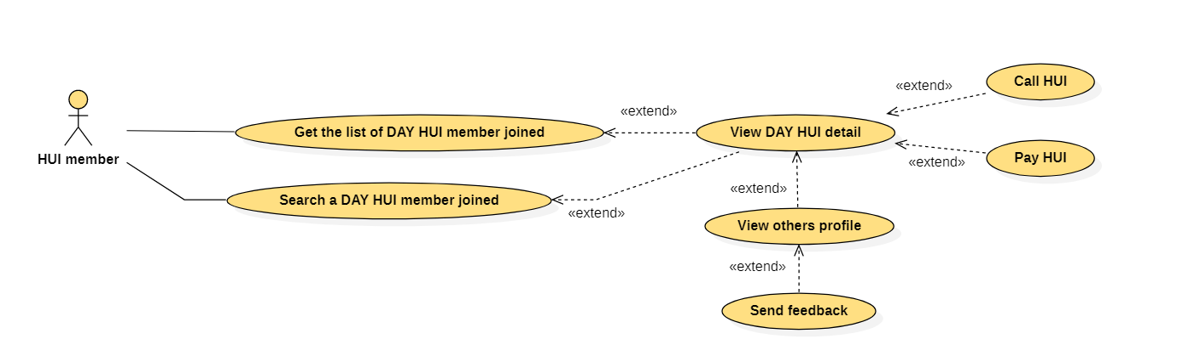

|  |  |  |  |
| --- | --- | --- | --- |
| USE CASE – HUI online_UC_32 | | | |
| Use Case No. | HUI online_UC_32 | Use Case Version | 2.0 |
| Use Case Name | Search a DAY HUI member joined | | |
| Author | Ho Quoc Khai | | |
| Date | 07/07/2021 | Priority | Normal |
| Actor:   * HUI member   Summary:   * This use case allows HUI member to search a DAY HUI member joined   Goal   * HUI member can search a DAY HUI member joined   Trigger:   * HUI member clicks “Search” button   Precondition:   * Guest must login into the system with role HUI member   Post Conditions:   * Success: The list of Day Hui member joined is shown successfully   Main Success Scenario:   |  |  |  | | --- | --- | --- | | Step | Actor Action | System Response | | 1 | HUI member clicks “Day Hui” link | The system shows a form:   * Search by: dropdown list(Search by name, Search by date) * Search: button | | 2 | HUI member inputs data and clicks “Search” button | The system shows the list of DAY HUI member joined, each item includes:   * Day Hui: label * Hui manager: label * Date of beginning: label * Date of finishing: label * Amount of money/month: label * View detail: link |   Exception: N/A  Relationship:   * The use case “Search a DAY HUI member joined” extends the use case “View DAY HUI detail”   Business rule:   * If HUI member selects “Search by name”, the system expands: * Name: textbox * If HUI member selects “Search by date”, the system expands: * From: datetime picker * To: datetime picker * If HUI member searches by name: A list result which contain the search keyword * If HUI member searches by date: “Date of beginning” and “Date of finishing” must be between “From” and “To” datetime picker * The list of DAY HUI member joined must be sorted in descending order by date of beginning * List first 10 available item in the system: paging is required | | | |

## <HUI member> View DAY HUI detail



|  |  |  |  |
| --- | --- | --- | --- |
| USE CASE – HUI online_UC_33 | | | |
| Use Case No. | HUI online_UC_33 | Use Case Version | 2.0 |
| Use Case Name | View DAY HUI detail | | |
| Author | Ho Quoc Khai | | |
| Date | 07/07/2021 | Priority | Normal |
| Actor:   * HUI member   Summary:   * This use case allows HUI member to view DAY HUI detail   Goal   * HUI member can view DAY HUI detail   Trigger:   * HUI member clicks “View detail” link   Precondition:   * Guest must login into the system with role HUI member   Post Conditions:   * Success: The information of DAY HUI is shown successfully   Main Success Scenario:   |  |  |  | | --- | --- | --- | | Step | Actor Action | System Response | | 1 | HUI member clicks “View detail” link | The system shows :   * HUI manager: link * Day Hui: label * Date of beginning: label * Date of finishing: label * Amount of money/term: label * Number of date/term: label * Commission: label * Pay Hui: button * Call Hui: button * A list of members: * Name: link * A table, each item includes: * Month: label * Amount: link * Date: label |   Exception: N/A  Relationship:   * The use case “View DAY HUI detail” extended by the use case “Get the list of DAY HUI member joined” * The use case “View DAY HUI detail” extended by the use case “Search a DAY HUI member joined” * The use case “View DAY HUI detail” extends the use case “View others profile” * The use case “View DAY HUI detail” extends the use case “Call HUI” * The use case “View DAY HUI detail” extends the use case “Pay HUI”   Business rule:   * If HUI member mouse hovers “Amount” link, the system shows the list: * Amount of money/term: label * Date: label * If HUI member borrows HUI in a month, this month is yellow color * “Pay Hui” button is only shown when current date is a date to pay Hui * “Call Hui” button is only shown when current date is a date to call Hui | | | |

## <HUI member> Call HUI



|  |  |  |  |
| --- | --- | --- | --- |
| USE CASE – HUI online_UC_34 | | | |
| Use Case No. | HUI online_UC_34 | Use Case Version | 2.0 |
| Use Case Name | Call HUI | | |
| Author | Ho Quoc Khai | | |
| Date | 07/07/2021 | Priority | Normal |
| Actor:   * HUI member   Summary:   * This use case allows HUI member to call Hui   Goal   * HUI member can call Hui   Trigger:   * HUI member clicks “Ok” button   Precondition:   * Guest must login into the system with role HUI member   Post Conditions:   * Success: HUI member calls Hui successfully   Main Success Scenario:   |  |  |  | | --- | --- | --- | | Step | Actor Action | System Response | | 1 | HUI member clicks “Call Hui” button | The system shows a form:   * Amount: textbox, required * Call: button | | 2 | HUI member clicks “Call” button | The system shows a confirm message:   * Ok: button * Cancel: button | | 3 | HUI member clicks “Ok” | The system shows message “Call Hui successfully” |   Exception: N/A  Relationship:   * The use case “Call HUI” extended by the use case “View DAY HUI detail”   Business rule:   * If HUI member borrowed Hui successfully, member can not call Hui any more | | | |

## <HUI member> Pay HUI



|  |  |  |  |
| --- | --- | --- | --- |
| USE CASE – HUI online_UC_35 | | | |
| Use Case No. | HUI online_UC_35 | Use Case Version | 2.0 |
| Use Case Name | Pay HUI | | |
| Author | Ho Quoc Khai | | |
| Date | 07/07/2021 | Priority | Normal |
| Actor:   * HUI member   Summary:   * This use case allows HUI member to pay Hui   Goal   * HUI member can pay Hui   Trigger:   * HUI member clicks “Ok” button   Precondition:   * Guest must login into the system with role HUI member   Post Conditions:   * Success: HUI member pays Hui successfully   Main Success Scenario:   |  |  |  | | --- | --- | --- | | Step | Actor Action | System Response | | 1 | HUI member clicks “Pay Hui” button | The system shows a confirm message:   * Ok: button * Cancel: button | | 2 | HUI member clicks “Ok” | The system sends money from HUI member to Day Hui automated  The system shows message “Pay Hui successfully” |   Exception: N/A  Relationship:   * The use case “Pay HUI” extended by the use case “View DAY HUI detail”   Business rule:   * HUI member must pay HUI on time * If HUI member pays HUI late, member must take responsible for this action | | | |

## <HUI member> View others profile



|  |  |  |  |
| --- | --- | --- | --- |
| USE CASE – HUI online_UC_36 | | | |
| Use Case No. | HUI online_UC_36 | Use Case Version | 2.0 |
| Use Case Name | View others profile | | |
| Author | Ho Quoc Khai | | |
| Date | 07/07/2021 | Priority | Normal |
| Actor:   * HUI member   Summary:   * This use case allows HUI member to view others profile   Goal   * HUI member can view others profile   Trigger:   * HUI member clicks “Hui manager” link to view HUI manager profile * HUI member clicks “Name” link to view other members profile in Day Hui   Precondition:   * Guest must login into the system with role HUI member   Post Conditions:   * Success: HUI member view others profile successfully   Main Success Scenario:   |  |  |  | | --- | --- | --- | | Step | Actor Action | System Response | | 1 | HUI member clicks “Hui manager” link | The system shows:  The system shows a form:   * Average rating: label * Amount of rating: label * Username: label * Fullname: label * Sex: label * Phone number: label * Place of origin: label * Place of residence: label * Image of citizen identity card: image * Bank account number: label * Role: label * Send feedback: link |   Exception: N/A  Relationship:   * The use case “View others profile” extended by the use case “View DAY HUI detail”   Business rule:   * HUI member can clicks “Name” link to view other members profile * The system must display “Average rating” as star * When HUI member mouse hovers “Average rating”, the system shows:   + 5 star [meter bar] [percent]   + 4 star [meter bar] [percent]   + 3 star [meter bar] [percent]   + 2 star [meter bar] [percent]   + 1 star [meter bar] [percent] | | | |

## <HUI member> Send feedback



|  |  |  |  |
| --- | --- | --- | --- |
| USE CASE – HUI online_UC_37 | | | |
| Use Case No. | HUI online_UC_37 | Use Case Version | 2.0 |
| Use Case Name | Send feedback | | |
| Author | Ho Quoc Khai | | |
| Date | 07/07/2021 | Priority | Normal |
| Actor:   * HUI member   Summary:   * This use case allows HUI member to send feedback   Goal   * HUI member can send feedback   Trigger:   * HUI member clicks “Send” button   Precondition:   * Guest must login into the system with role HUI member   Post Conditions:   * Success: HUI member sends feedback successfully   Main Success Scenario:   |  |  |  | | --- | --- | --- | | Step | Actor Action | System Response | | 1 | HUI member clicks “Send feedback” link | The system show a form:   * Fullname: label * Rate: 5 star icon * Reason: dropdown list (Trustworthy, Good, Rob Hui, Manage bad, Other) * Send: button | | 2 | HUI member selects reason and clicks “Send” | The system validates data and shows success message |   Exception: N/A  Relationship:   * The use case “Send feedback” extended by the use case “View others profile”   Business rule:   * HUI member must select amount of star * If HUI member selects “Other” in dropdown list, the system expands: * Description: textarea, required * HUI member only evaluates manager 1 time in a particular Day Hui * Succes message: “Send feedback successfully” | | | |

## <HUI member> View history

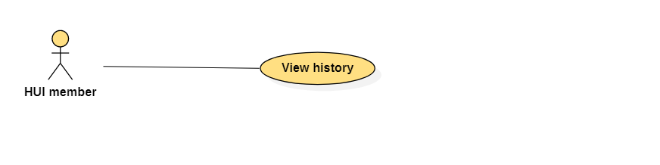

|  |  |  |  |
| --- | --- | --- | --- |
| USE CASE – HUI online_UC_38 | | | |
| Use Case No. | HUI online_UC_38 | Use Case Version | 2.0 |
| Use Case Name | View history | | |
| Author | Ho Quoc Khai | | |
| Date | 07/07/2021 | Priority | Normal |
| Actor:   * HUI member   Summary:   * This use case allows HUI member to view history   Goal   * HUI member can view history   Trigger:   * HUI member clicks “History” link   Precondition:   * Guest must login into the system with role HUI member   Post Conditions:   * Success: History is shown successfully   Main Success Scenario:   |  |  |  | | --- | --- | --- | | Step | Actor Action | System Response | | 1 | HUI member clicks “History” link | The system shows the list Day Hui, each item includes:   * DayHui: label * Manager: label * Date of beginning: label * Date of finishing: label * Number of member: label * Amount of money/term: label * Commission: label |   Exception: N/A  Relationship: N/A  Business rule:   * List 10 first available Day Hui: paging is required * The list Day Hui must be sorted descending order by date of beginning | | | |

## <HUI member> Find DAY HUI

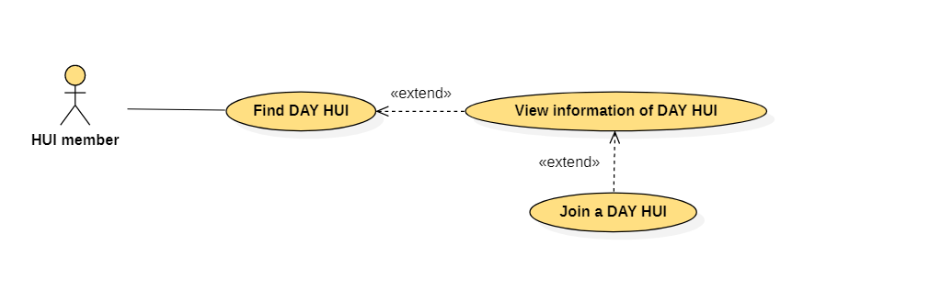

|  |  |  |  |
| --- | --- | --- | --- |
| USE CASE – HUI online_UC_39 | | | |
| Use Case No. | HUI online_UC_39 | Use Case Version | 2.0 |
| Use Case Name | Find DAY HUI | | |
| Author | Ho Quoc Khai | | |
| Date | 07/07/2021 | Priority | Normal |
| Actor:   * HUI member   Summary:   * This use case allows HUI member to find Day Hui   Goal   * HUI member can find Day Hui   Trigger:   * HUI member clicks “Find” button   Precondition:   * Guest must login into the system with role HUI member   Post Conditions:   * Success: The list of Day Hui is shown successfully   Main Success Scenario:   |  |  |  | | --- | --- | --- | | Step | Actor Action | System Response | | 1 | HUI member inputs and clicks “Find” button | The system shows the list Day Hui, each item includes:   * DayHui: label * Date of beginning: label * Date of finishing: label * Number of member: label * Amount of money/term: label * View detail: link |   Exception: N/A  Relationship:   * The use case “Find DAY HUI” extends the use case “View information of DAY HUI”   Business rule:   * List 10 first available Day Hui: paging is required * The list Day Hui must be sorted descending order by date of beginning | | | |

## <HUI member> View information of DAY HUI



|  |  |  |  |
| --- | --- | --- | --- |
| USE CASE – HUI online_UC_40 | | | |
| Use Case No. | HUI online_UC_40 | Use Case Version | 2.0 |
| Use Case Name | View information of DAY HUI | | |
| Author | Ho Quoc Khai | | |
| Date | 07/07/2021 | Priority | Normal |
| Actor:   * HUI member   Summary:   * This use case allows HUI member to view information of DAY HUI   Goal   * HUI member can view information of DAY HUI   Trigger:   * HUI member clicks “View detail” link   Precondition:   * Guest must login into the system with role HUI member   Post Conditions:   * Success: The information of Day Hui is shown successfully   Main Success Scenario:   |  |  |  | | --- | --- | --- | | Step | Actor Action | System Response | | 1 | HUI member inputs and clicks “View detail” link | The system shows:   * Average rating: label * Amount of rating: label * Manager: label * DayHui: label * Date of beginning: label * Date of finishing: label * Number of member: label * Number of date/term: label * Amount of money/term: label * Commission: label * Join: button |   Exception: N/A  Relationship:   * The use case “View information of DAY HUI” extended by the use case “Find DAY HUI” * The use case “View information of DAY HUI” extends the use case “Join a DAY HUI”   Business rule:   * The system must display “Average rating” as star * When HUI member mouse hovers “Average rating”, the system shows:   + 5 star [meter bar] [percent]   + 4 star [meter bar] [percent]   + 3 star [meter bar] [percent]   + 2 star [meter bar] [percent]   + 1 star [meter bar] [percent] | | | |

## <HUI member> Join a DAY HUI



|  |  |  |  |
| --- | --- | --- | --- |
| USE CASE – HUI online_UC_41 | | | |
| Use Case No. | HUI online_UC_41 | Use Case Version | 2.0 |
| Use Case Name | Join a DAY HUI | | |
| Author | Ho Quoc Khai | | |
| Date | 07/07/2021 | Priority | Normal |
| Actor:   * HUI member   Summary:   * This use case allows HUI member to join a DAY HUI   Goal   * HUI member can join a DAY HUI   Trigger:   * HUI member clicks “join” button   Precondition:   * Guest must login into the system with role HUI member   Post Conditions:   * Success: HUI member sends request to HUI manager successfully   Main Success Scenario:   |  |  |  | | --- | --- | --- | | Step | Actor Action | System Response | | 1 | HUI member clicks “Join” button | The system sends request to HUI manager and shows success message |   Exception: N/A  Relationship:   * The use case “Join a DAY HUI” extended by the use case “View information of DAY HUI”   Business rule:   * HUI manager must receive request when HUI member clicks “Join” button * The success message is “Please wait for manager to join” | | | |

# NON-FUNCTIONAL Requirements

## Usability

* Website’s UI is fit for each browser on each device
* User can use after 2 hours training

## Reliability

* The system can run properly without crash.
* Mobile application and web admin can be operate while API is activated.

## Performance

* System has successfully test with basic standard
* Requests from web application are responded in less than 5 seconds at 4 Mbps bandwidth speed and 1GHz processing speed of CPU.

## Supportability

[This section indicates any requirements that will enhance the supportability or maintainability of the system being built, including coding standards, naming conventions, class libraries, maintenance access, and maintenance utilities.]

### <Supportability Requirement One>

[The requirement description goes here.]

## Design Constraints

[This section indicates any design constraints on the system being built. Design constraints represent design decisions that have been mandated and must be adhered to. Examples include software languages, software process requirements, prescribed use of developmental tools, architectural and design constraints, purchased components, class libraries, and so on.]

### <Design Constraint One>

[The requirement description goes here.]

## On-line User Documentation and Help System Requirements

[Describes the requirements, if any, for o-line user documentation, help systems, help about notices, and so forth.]

## Purchased Components

[This section describes any purchased components to be used with the system, any applicable licensing or usage restrictions, and any associated compatibility and interoperability or interface standards.]

## Interfaces

[This section defines the interfaces that must be supported by the application. It should contain adequate specificity, protocols, ports and logical addresses, and the like, so that the software can be developed and verified against the interface requirements.]

### User Interfaces

[Describe the user interfaces that are to be implemented by the software.]

### Hardware Interfaces

[This section defines any hardware interfaces that are to be supported by the software, including logical structure, physical addresses, expected behavior, and so on.]

### Software Interfaces

[This section describes software interfaces to other components of the software system. These may be purchased components, components reused from another application or components being developed for subsystems outside of the scope of this SRS but with which this software application must interact.]

### Communications Interfaces

[Describe any communications interfaces to other systems or devices such as local area networks, remote serial devices, and so forth.]

## Licensing Requirements

[Defines any licensing enforcement requirements or other usage restriction requirements that are to be exhibited by the software.]

## Legal, Copyright, and Other Notices

[This section describes any necessary legal disclaimers, warranties, copyright notices, patent notices, wordmark, trademark, or logo compliance issues for the software.]

## Applicable Standards

[This section describes by reference any applicable standard and the specific sections of any such standards which apply to the system being described. For example, this could include legal, quality and regulatory standards, industry standards for usability, interoperability, internationalization, operating system compliance, and so forth.]

# Supporting Information

[The supporting information makes the SRS easier to use. It includes:

Table of contents

Index

Appendices

These may include use-case storyboards or user-interface prototypes. When appendices are included, the SRS should explicitly state whether or not the appendices are to be considered part of the requirements.]